**Inflate the Rate**

Breakout Room 2

Fernando Flores

Amir Vasquez

Luan Dinh

Kate Spitzer

We found an API with currency exchange data (FOREX), and started to wonder if we could compare exchange rates of different countries over time, and see some sort of trend, or similarities. We then added a comparison to inflation rate data from those countries and wondered if there was a correlation.

* How do currency exchange rates vary across countries? (assuming exchange to the US Dollar)

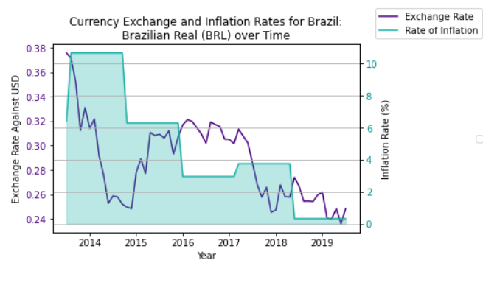Very predictably, we found that currency exchange rates in different countries move constantly, and none of the countries we looked at showed any patterns against the others. Obviously, the currencies are all backed differently, the economy of each country varies widely, and internal and external economic factors affect each currency differently. Also, each currency is measured on a different scale, so comparisons are difficult.

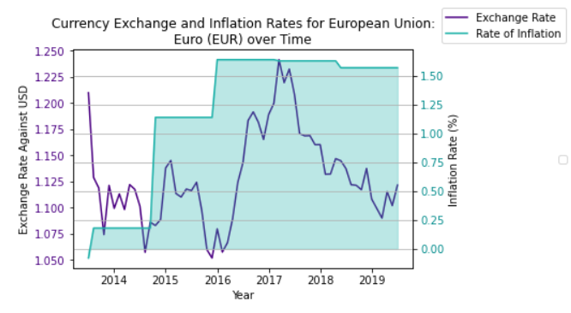

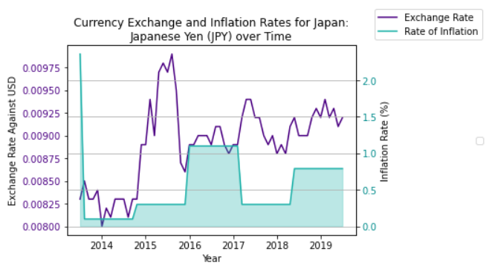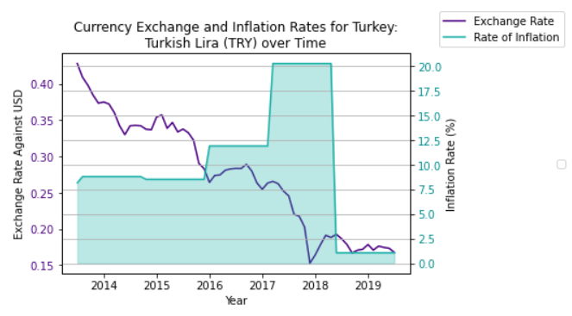

* Is there a correlation between currency exchange rate and a country’s inflation rate?

Considering the data that we had to work with, it again was difficult to accurately determine a correlation between these datasets. We were able to collect data for currency exchange with greater granularity than inflation rate, which skewed our calculations. We could choose to take a snapshot of currency exchange rate and inflation year-end, which only gave us 6 points of comparison – not much to draw a likely correlation, or we could gather month-by-month data for currency exchange, which more accurately shows movement of that data over time, and replicate the inflation rate data to fill in the missing months. This, again, would not be an accurate calculation of the correlation, but would give us more datapoints to work with.

Ultimately, from our graphs and calculations, we were not able to detect a correlation between the two datasets, however, based on research that we did, we learned that there is, in fact, a correlation between inflation rate and currency exchange rate, but they do not move together. In other words, as inflation rate changes, it has an effect on the currency exchange rate, but the changes are much slower to occur, so a direct comparison of our time series would probably never show that correlation.

