- Given the provided data, what are three conclusions that we can draw about crowdfunding campaigns?
- The “arts” seem to benefit greatly from crowdfunding campaigns once the data is filtered by both category and sub-category.
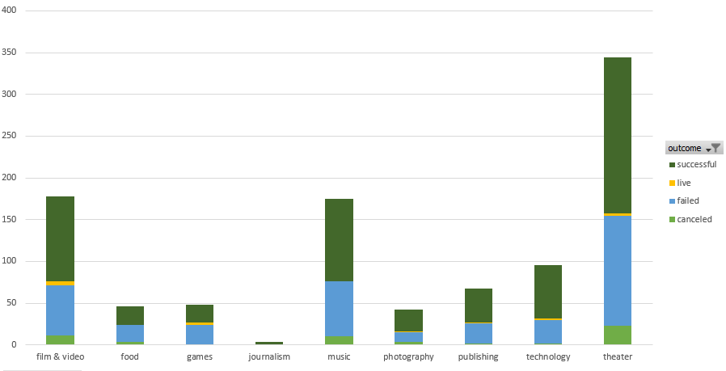
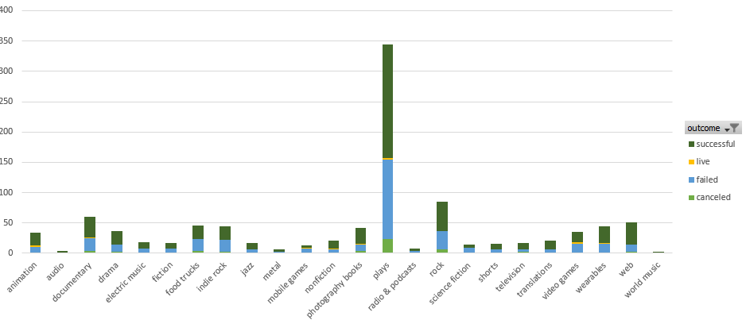
With “theatre” category and “plays” sub-category benefitting the most from the crowdfund platform. While there were still many failed campaigns, there were also many successes.
- By filtering out “plays” in sub-category, it seems there is more of a level playing field for other categories. This leads me to wonder if the data was pulled more from certain categories/subcategories than others, leading to an underrepresentation of other crowdfunded campaigns in these categories.
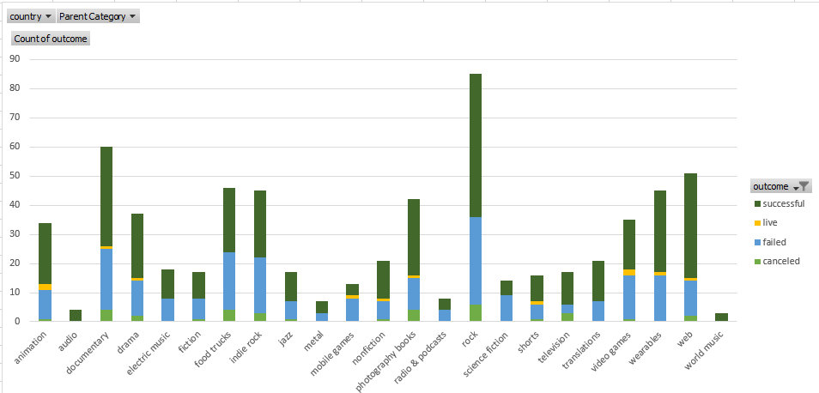
- It seems a fair conclusion we can draw from this dataset is that category/subcategory doesn’t necessarily lead to a successful campaign. The data alone is missing key elements of campaigns, despite being an interesting metric to observe. While “Theatre” is the most popular parent category in this data set, there are a very similar amount of ‘successes’ and ‘failures.’ It would be interesting to see these tables built with a larger scope of data, to see if there is more that can be learned purely from the data set itself.

- What are some limitations of this dataset?

Some of the limitations of this dataset seem to be lack of further data provided. The data skews so highly toward “theatre/plays,” “film & video,” and “music,” that it seems there may be a large part of data missing for other categories. It also seems unlikely that crowdfunding campaigns have a higher success rate than failed rate, given the ability for anyone to create a campaign. The biggest limitation is really the scope of the data set, which is likely always going to be an issue data scientists run into in these scenarios. It does seem risky to draw any concrete and solid conclusions from a data set this narrow.

- What are some other possible tables and/or graphs that we could create, and what additional value would they provide?
Another table/graph that could prove insightful is one measuring success/failure vs. time spent up for crowd funding. From a glance at this data, it seems that for many of the successful campaigns, they took only a few days to reach their success goal. It could also be interesting to see if there is any correlation between successful campaigns and “staff_pick” and “spotlight”. Would the additional boost in eyes on the campaign sway the outcome? It seems impossible that it wouldn’t sway an outcome, as it would allow for a broader audience to come across that particular campaign.

