
SMOLDER: forecasting next-three-day wildfire risk for continental Australia at 1 km with a dual-branch ConvLSTM (2015–2020)
Korbinian Müller
Department of Remote Sensing (AG Braun), Institute of Geography, Friedrich-Alexander-Universität Erlangen–Nürnberg (FAU), Erlangen, Germany
Correspondence: Korbinian Müller (korbinian.mueller@fau.de)
Plain-language summary
Fire agencies need to know where fire is likely in the coming days. SMOLDER is a computer model trained on satellite and weather maps of Australia from 2015 to 2019 and tested on 2020. Each day it gives every 1 km pixel of land a risk score for fire in the next three days. On an average day of 2020, the 0.07 % of the land with the highest scores (about 5400 km², a little more than twice the size of the Australian Capital Territory) contained 30 % of the fire of the next three days, and about one in seven of the flagged pixels burned. A simple rule of thumb, ‘expect fire next to recent fire’, needed twice the area to catch slightly less fire. The model is therefore good at telling where burning fires will spread or flare up again. It almost never foresees fires that start far from existing fires, which made up two fifths of the fire in 2020. Foreseeing those needs other information, such as lightning.

Abstract. Whether a wildfire starts and spreads depends on the amount and dryness of the fuel, which change over months, and on the fire weather, which changes over days. This study presents SMOLDER (Slow-Memory Operator with Linked Dual branches for Estimating fire Risk), a deep learning model with one branch for each time scale. For every 1 km land pixel of continental Australia, it forecasts whether a satellite will detect fire within the next three days. One branch reads 144 days of leaf area index, soil moisture and precipitation, the other 14 days of weather, vegetation greenness and recent fire. All inputs were checked for information from after the day of the forecast. Trained on 2015 to 2018, tuned on 2019 and evaluated on 2020, the model is compared with a persistence baseline that ranks pixels by their distance to recent fire. In 2020 its area under the precision-recall curve was 0.1206, 3.3 times that of the baseline (0.0361) and about 380 times the base rate of 0.0317 %, and its daily value was higher on 348 of 350 days. With one score threshold chosen on 2019, SMOLDER flags 0.071 % of the land per day and catches 30.5 % of the fire, where the baseline flags 0.140 % and catches 27.8 %. Of the fire it catches, 91.1 % lies within 3 km of recent fire, and of the 41.7 % of the fire that starts more than 10 km away it catches 0.6 %. SMOLDER therefore forecasts where existing fires spread and flare up again, not where new fires start. In practice, such a ranking can guide surveillance and crews around burning fires, whereas new ignitions still call for fire danger ratings and lightning data. Code, weights and evaluation data are openly available.
1 Introduction
Fire activity can be described as the result of four ‘switches’ that must all be on at once: enough fuel, fuel dry enough to burn, weather that lets fire spread, and an ignition, usually lightning or people (Bradstock, 2010). Fuel amount and dryness change slowly. The moisture of living plants depends on soil moisture, leaf area and vegetation type and changes over weeks to months (Yebra et al., 2013; Nolan et al., 2016), whereas dead leaves, grass and twigs dry out or wet up within days in response to rain, the dryness of the air and temperature (Matthews, 2014). Fire occurs only when several such thresholds are crossed at once, and the thresholds differ between vegetation types (Nolan et al., 2016; McNorton and Di Giuseppe, 2024). Satellites and weather reanalyses, consistent reconstructions of past weather from observations and models, now describe both time scales for whole continents (Chuvieco et al., 2004; Yebra et al., 2013), which makes data-driven forecasts of fire possible.
Deep learning models, which learn such relationships from large amounts of example data instead of following hand-written rules, are increasingly used for this task. Many of them receive the fire that is already burning as an input (e.g. Huot et al., 2022; Gerard et al., 2023). Such a model can reach a high score simply by predicting that fire continues where it is. Its skill therefore has to be judged against this ‘persistence’ forecast and separately for fire at new places. Fire is also extremely rare at the scale of single pixels, so scores depend strongly on how the evaluation is set up, and inputs derived from satellite products can, unnoticed, contain information from after the day of the forecast, which makes a model look better than it is.
This paper presents SMOLDER (Slow-Memory Operator with Linked Dual branches for Estimating fire Risk), a model that forecasts for every 1 km land pixel of continental Australia whether a satellite will detect fire within the next three days. The emphasis is on a fair evaluation: for the whole continent, at the true rarity of fire, against persistence, and as a function of the distance to existing fire. Three questions are asked: how much better than persistence is the model, which part of the fire can it anticipate, and what does it rely on?
2 Data
2.1 Study region and grid
The study area is continental Australia without Tasmania, and the study period is 2015 to 2020. All datasets (Table 1) were brought to the grid of the SMIPS soil moisture product, 3474 × 4110 pixels of 0.01° (about 1 km, or 1.1 km² on average), of which 6.9 million are land, and stored as yearly data cubes in the .zarr format, following the SeasFire cube (Karasante et al., 2025).
2.2 Input layers and their timing
Fire. Fire comes from the VIIRS 375 m active fire product, which records fires that burn while the satellite passes overhead (Schroeder et al., 2014). Vegetation fires of nominal or high confidence were aggregated to daily binary (fire or no fire) maps on the 1 km grid. The maps of the three days after a forecast form the target, the quantity to be predicted, and the maps up to the issue day form the fire history. The same detections provide the fire radiative power (FRP), a measure of fire intensity, stored per pixel and day as summed FRP, number of detections and share of night detections, and the fuel age, the number of days since a pixel last burned, capped at 1095 days.
Table 1. Datasets, their native resolution, the model branch they enter and what they tell the model.
Variable | Dataset | Resolution | Branch | What it tells the model
Active fires, fire radiative power | VIIRS 375 m active fires (Schroeder et al., 2014; Giglio, 2024) | 375 m, daily | target, fast | where fire burns, how intensely, time since last fire
Leaf area index (LAI) | HiQ-LAI (Yan et al., 2024) | 500 m, 8-day | slow | density of the canopy, continuity of the fuel
NDVI | MODIS MOD09A1 (Vermote, 2021) | 500 m, 8-day | fast | greenness, which falls as grass dries out
Soil moisture | SMIPS (Stenson et al., 2021) | 1 km, daily | slow | how dry the landscape is
Precipitation | ANUClimate 2.0 (Hutchinson et al., 2021) | 1 km, daily | slow | rain that wets fuel and grows grass
Wind, VPD, air temperature | BARRA-C2 (Su et al., 2024, 2025) | 4.4 km, hourly | fast | fire weather: drying of fuel, spread of fire
Biomass | ESA CCI Biomass (Santoro and Cartus, 2025) | 100 m, annual | both | amount of fuel
Land cover | Copernicus LC100 (Buchhorn et al., 2020) | 100 m, annual | both | type of vegetation
Climate zones | Köppen–Geiger (Beck et al., 2023) | 1 km | both | climate and fire regime
Terrain | ETOPO1 (NOAA National Geophysical Data Center, 2009) | about 1.8 km | both | slopes steer wind and fire

Weather. The weather comes from the BARRA-C2 reanalysis at 4.4 km as daily values, resampled bilinearly to 1 km: the mean 10 m wind speed and its two components, the maximum 2 m air temperature and the vapour pressure deficit (VPD) at that temperature. VPD measures how strongly the air draws moisture from plants and dead fuel and so controls how quickly fuels dry (Clarke et al., 2022), and wind drives the spread of fire (Cruz and Alexander, 2019).
Vegetation, soil and terrain. The leaf area index (LAI), the leaf area per unit of ground area, describes how dense the canopy is and how continuous the fuel (Yebra et al., 2013). Because HiQ-LAI smooths every 8-day composite with the three before and after it (Yan et al., 2024), each day is given the newest composite that started at least 31 days earlier. NDVI measures how green the vegetation is and falls when grass dries out, or cures (Chuvieco et al., 2004). Each day is given the newest MOD09A1 composite whose eight days have all passed, so that it is at most seven days old. The SMIPS soil moisture index gives the fraction to which the upper 90 cm of the soil is filled, and ANUClimate 2.0 the daily precipitation. Biomass approximates the fuel load, land cover and climate zones separate fuel types and fire regimes, and terrain steers wind and fire (Sharples et al., 2012). A forecast uses the biomass map of the year before the issue day and the land-cover map of two years before, because each land-cover map is made from three years of data.
2.3 Keeping information from the future out of the inputs
A forecast may only use what is known on the day it is issued. If an input already contains the trace of a fire, for example a drop in greenness caused by the fire itself, a model can appear to predict a fire that it has in fact already seen. Such look-ahead, also called leakage, can enter satellite and reanalysis products unnoticed in four ways. Composites are often labelled by their first day but contain later days. Products smoothed over time spread an observation to earlier dates. Gap filling with a fit over the whole year carries later observations back, as in the gap-filled MODIS land surface temperature of Zhang et al. (2022). And static maps summarized over the study period contain the years that are forecast. In addition, no target window may cross the boundary between the training, validation and test years.
Each of these was handled by the timing rules of Sect. 2.2: complete composites only, a delay of 31 days for the smoothed LAI, air temperature from the reanalysis instead of a gap-filled land surface temperature, maps that predate the issue day, and no issue days whose target window crosses the end of a year. The climate zones refer to the period 1991 to 2020, but a climate zone cannot encode a single fire.
Two tests then checked the inputs exactly as the model reads them. First, the fire-derived inputs were rebuilt from the raw daily detections and compared pixel by pixel on 60 fire-active patches (18 million comparisons). They differed on at most 1.2 × 10⁻⁶ of the pixels, whereas a fire map shifted by one day differs on 8.3 × 10⁻⁴. Second, all other inputs were examined around 320 new fires of 2019, 40 in each of eight fire regions. For a forecast issued 1 to 3 days before a fire is first detected, the fire lies in the target window, so an input without look-ahead cannot show it. The input at the fire pixel was compared with a ring 15 to 40 pixels around it, relative to 16 days before the detection, and counted as clean if this standardized signal stayed below 3. Every input passed (largest value 2.4). Applied to versions of NDVI and LAI that do contain look-ahead, the same test detects it. It finds strong look-ahead, but it cannot prove the absence of a weak one.
3 Methods
3.1 Forecast task and data split
A forecast is issued for a day D, the issue day. For every land pixel, the model gives a score between 0 and 1 for the event that at least one VIIRS active fire is detected there on day D+1, D+2 or D+3. All inputs refer to day D or earlier. The score ranks pixels by risk and is not a calibrated probability. The years 2015 to 2018 were used for training (1283 issue days), 2019 for validation (349) and 2020 for testing (350). Whole years were held out rather than random days, because fires last for days and neighbouring days would otherwise share the same fires. Everything that had to be chosen, that is the inputs, the training settings, the final model and the thresholds of Sect. 3.2, was fixed on 2019. The test year was evaluated twice, once for a provisional version of the model and once for the final model, and nothing was chosen from either evaluation. The architecture and the loss go back to earlier development in which 2020 had also been consulted, so in this respect 2020 is not fully untouched.
3.2 How skill is measured
Each issue day, the model gives every land pixel a score, and the pixels with the highest scores can be flagged. Each pixel then falls into one of four outcomes: caught fire (flagged and burned), missed fire (burned, not flagged), false alarm (flagged, no fire) and other land. The measures that summarize these outcomes are explained in Box 1. Because fire is so rare, all scores are read relative to the base rate. The main summary measure is the AUC-PR, because it is decided by the top of the ranking, where a user would look. Thresholds are chosen by F₂, which suits a use in which a missed fire costs more than a false alarm.
All measures were computed for the whole continent on every valid issue day (6.9 million land pixels per day), with the national map assembled from overlapping tiles of 384 pixels. AUC-PR and ROC-AUC were computed over all days together, with all fire pixels and a weighted sample of one in 500 of the others, and the AUC-PR also per day. The forecast is compared with a persistence baseline that ranks every land pixel by its distance to the nearest fire detected on the issue day or the two days before (recent fire). This is what an analyst without a model would do: watch the surroundings of current fires. The baseline is evaluated in the same way, and the share of days on which SMOLDER has the higher daily AUC-PR is given with a 95 % bootstrap interval of the mean daily difference.
Box 1. Key terms
Training, validation, test | The model learns from 2015–2018, all choices are made on 2019, and 2020 is kept aside to measure performance on unseen data, like a final exam.
Look-ahead (leakage) | Information from after the issue day that slips into an input, for example a fire scar. It makes a model look better than it is.
Persistence baseline | The rule of thumb ‘fire is most likely next to recent fire’: pixels are ranked by their distance to recent fire.
Recent fire, new fire | Recent fire is fire detected on the issue day or the two days before. New fire lies more than 3 km from any recent fire.
Base rate | Share of land pixels with fire in the three days after an issue day (0.0317 % in 2020).
Fire caught (recall) | Share of all fire pixels that were flagged.
Precision | Share of flagged pixels that burned. A random selection has a precision equal to the base rate.
AUC-PR (average precision) | Precision averaged over all sizes of the flagged area. It equals the base rate for a random ranking and 1 for a perfect one and is decided by the top of the ranking.
ROC-AUC | Probability that a random fire pixel scores higher than a random pixel without fire (0.5 random, 1 perfect). High for any reasonable ranking, because most land is far from fire.
F₁, F₂ | Combine precision P and recall R: F_{β} = (1+β²)PR/(β²P+R). F₂ weighs missed fire more than false alarms.
ConvLSTM | A neural network that reads a sequence of maps like the frames of a film and keeps a memory for every pixel and its neighbourhood.

Where pixels are flagged, one score threshold is used for all days, so that the flagged area grows and shrinks with the fire situation of each day. It is the threshold with the highest F₂ on the validation year 2019, applied unchanged to 2020. Persistence gets its own threshold in the same way. At this threshold it flags the pixels that burned on the issue day or the two days before and their eight neighbours, that is, all pixels up to 1.4 km from recent fire. Thresholds were not chosen on the training years, because the model fits them better than new data and because their patches hold far more fire than the land does (Sect. 3.4). The validation year is unseen during fitting and is evaluated over the whole continent at the true base rate. To separate fire that continues from fire at new places, the fire caught is also computed by distance to recent fire, and new fire is defined as fire more than 3 km from any recent fire.
3.3 Model inputs
Each sample is a patch of 384 × 384 pixels with two stacks of input maps, one for each branch (Fig. 1a, all input maps in Fig. A1). The slow stack holds 18 consecutive 8-day averages of LAI, soil moisture and precipitation, the newest ending on or before the issue day. The fast stack holds the 14 days up to the issue day: weather (VPD, maximum air temperature, wind speed and direction), NDVI, the fire history and the proximity to recent fire, FRP, the fuel age and the downwind alignment, which is high where the wind blows from a recent fire towards the pixel. Both stacks also contain static layers and the day of the year (full list in Appendix A).
The two time scales follow a lag analysis in which each predictor alone was tested for how well it separates pixels with fire in the next three days from pixels without (ROC-AUC over 2015 to 2019, lags of 0 to 180 days). Leaf area index, NDVI, soil moisture and precipitation did so best at the longest lag tested, about 180 days (leaf area index 0.79 against 0.73 at lag 0), and VPD and air temperature at lags of 1 and 10 days. This partly reflects the seasons: in the tropical savannas of the north, the grass that burns in the dry season grows in the wet season months earlier (Bradstock, 2010). The fire inputs were selected on 2019, and alternatives that were not adopted are listed in Appendix B.
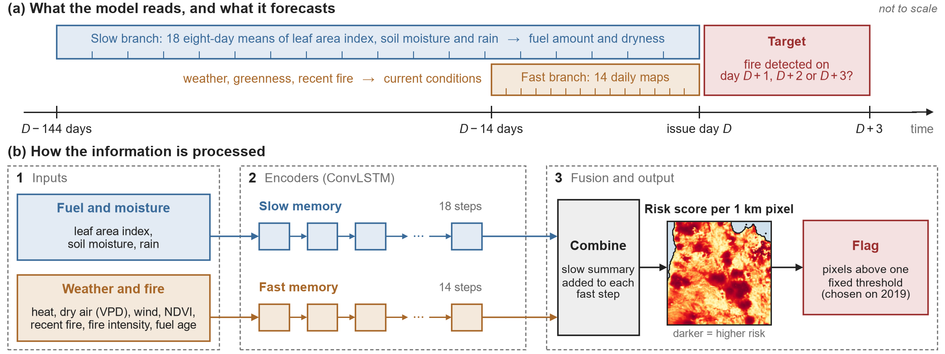
Figure 1. SMOLDER in brief. (a) For an issue day D, the slow branch reads 144 days of fuel and moisture information and the fast branch 14 days of weather, greenness and fire. The target is fire detected on days D+1 to D+3. Terrain, biomass, land cover, climate zone and the day of the year enter both branches. (b) Each branch is a ConvLSTM, which reads its sequence of maps step by step and keeps a memory for every pixel and its neighbourhood. The two are combined into a risk score for every pixel, and the pixels above one fixed threshold are flagged. All input maps are shown in Fig. A1, and the architecture is detailed in Appendix A.
3.4 Model architecture and training
SMOLDER consists of two encoders, one for each branch, a step that combines them and an output layer (Fig. 1b, details in Appendix A). Each encoder is a Convolutional Long Short-Term Memory network, or ConvLSTM (Shi et al., 2015), which reads a sequence of maps step by step, like the frames of a film. For every pixel it keeps a memory (a hidden state of 64 numbers) that it updates at each step from the new inputs and from the memory of the pixel and its 5 × 5 neighbourhood, so that it can learn both how conditions develop over time and how a pixel relates to its surroundings. The slow encoder ends with one summary of the fuel and moisture history per pixel, and the fast encoder gives a summary at each of its 14 steps. A learned transformation of the slow summary is added to each fast summary, and a final layer turns the result into a score between 0 and 1. The map of the last fast step is the forecast. The model has 1.19 million adjustable parameters.
Training adjusts these parameters until the scores match the observed fire as well as possible. The model saw 2000 patches from the training years in each of 50 rounds (epochs), half of them drawn to contain fire, because random patches would hardly ever contain any. So that the model does not rely on the fire record alone, in 30 % of the patches fire had to occur where the newest fire map showed none, and in 30 % of the samples all inputs that reveal recent fire were set to ‘no fire’. The training objective was a weighted binary cross-entropy over land pixels (as in Huot et al., 2022), in which a missed fire pixel counts more than a false alarm, and the weights of the three best epochs on 2019 were averaged (Appendix A).
3.5 Analysis of the inputs
To see which inputs the forecast relies on, each input was shuffled in turn across the land pixels of a patch, in the same way at every time step, on 1500 fire-active patches of 2020. This permutation importance follows Breiman (2001): an input the model relies on cannot be shuffled without damage to the forecast. Two measures are reported, the share of the flagged pixels that are no longer flagged and the relative fall of the AUC-PR. Independently of the model, the inputs before the issue day were compared between caught fire, missed fire, false alarms and other land of the same patch and day.
4 Results
4.1 Skill compared with persistence
Table 2 gives all scores of both rankings. On the validation year 2019 the AUC-PR of SMOLDER was 0.2091, 3.4 times that of the persistence baseline (0.0609), and its daily AUC-PR was higher on all 349 issue days. In the test year 2020 fire was rarer, with a base rate of 0.0317 % against 0.0543 %. The AUC-PR of SMOLDER was 0.1206, 3.3 times that of the baseline (0.0361), and its daily AUC-PR was higher on 348 of 350 days (Fig. C1), with a mean difference of 0.0750 (95 % interval 0.0693 to 0.0807). Relative to the base rate the skill hardly changed between the years (385 and 381 times the base rate for SMOLDER, 112 and 114 times for the baseline).
Table 2. Measures over all issue days and land pixels for SMOLDER (S) and the persistence baseline (P), on the validation year 2019 and the test year 2020. Fire caught at 0.5 % is the share of the fire of the next three days that lies in the 0.5 % of the land with the highest risk, as a mean over the days.
 | 2019 (349 days) |  | 2020 (350 days)
Measure | S | P | S | P
Base rate | 0.0543 % |  | 0.0317 %
AUC-PR | 0.2091 | 0.0609 | 0.1206 | 0.0361
Mean daily AUC-PR | 0.1808 | 0.0595 | 0.1127 | 0.0377
ROC-AUC | 0.9299 | 0.9355 | 0.9302 | 0.9358
AUC-PR, new fire | 0.0093 | 0.0036 | 0.0058 | 0.0022
Fire caught, 0.5 % of land | 54.1 % | 46.2 % | 45.9 % | 39.3 %
New fire caught, 0.5 % | 24.9 % | 8.7 % | 20.7 % | 8.3 %
Days with higher AUC-PR | 100 % |  | 99.4 %

Persistence has a slightly higher ROC-AUC (0.9358 against 0.9302 in 2020), because it ranks all land by distance and so places fire 10 to 25 km from recent fire above all land further away. Within each distance band up to 25 km, SMOLDER orders the land better (ROC-AUC 0.8648 against 0.7016 within 3 km). Above all, SMOLDER ranks the top of the list better, which is what matters to a user: the 0.5 % of the land with the highest score contains 45.9 % of the fire and 20.7 % of the new fire, against 39.3 % and 8.3 % for the baseline (Table 2).
4.2 How much land has to be flagged
With the F₂ threshold of 2019, SMOLDER flags 0.071 % of the land on an average day of 2020 and catches 30.5 % of the fire with a precision of 0.1365 (Table 3), so about one in seven flagged pixels burned. The baseline flags 0.140 % and catches 27.8 % with a precision of 0.0630. SMOLDER thus flags half the area, catches more fire and has 2.2 times the precision. The threshold transferred well between the years: its F₂ on 2020 (0.2445) is practically the best any threshold reaches (0.2447), and it flagged less land in the quieter year (0.071 % against 0.111 %), because the daily flagged area follows the daily amount of fire (rank correlation 0.78).
Figure 2 shows how much land has to be flagged to catch a given share of the fire. To catch half of the 2020 fire with one threshold, SMOLDER had to flag 0.468 % of the land per day on average and persistence 0.979 %, and for three quarters 3.632 % and 7.015 %. Catching 90 % or more required a fifth of the land or more for both. From there on persistence needs less area (95 %: 31 % against 45 %), because the last part of the fire lies far from earlier fire, where ranking by distance works better. At such areas no ranking is useful as a warning.
Table 3. Operating point. The threshold with the highest F₂ was chosen on the validation year 2019 and applied unchanged to 2020. Area: mean share of the land flagged per day. False alarms per fire caught: 6.3, for example, means that for every flagged pixel that burned, 6.3 flagged pixels did not. The ‘caught’ rows give the share of the fire in each band of distance to recent fire that is caught.
 | SMOLDER |  | Persistence
 | 2019 | 2020 | 2019 | 2020
F₂ | 0.3294 | 0.2445 | 0.2214 | 0.1651
F₁ | 0.2615 | 0.1885 | 0.1473 | 0.1027
Fire caught (recall) | 39.8 % | 30.5 % | 33.3 % | 27.8 %
Precision | 0.1946 | 0.1365 | 0.0945 | 0.0630
Area | 0.111 % | 0.071 % | 0.191 % | 0.140 %
False alarms per fire caught | 4.1 | 6.3 | 9.6 | 14.9
Caught ≤ 3 km from recent fire | 78.5 % | 72.0 % | 72.0 % | 72.0 %
Caught 3–10 km away | 15.7 % | 12.5 % | 0.0 % | 0.0 %
Caught > 10 km away | 0.6 % | 0.6 % | 0.0 % | 0.0 %

Fewer fires were caught in 2020 than in 2019 (30.5 % against 39.8 %), mainly because more of the 2020 fire lay more than 10 km from recent fire (41.7 % against 32.6 %). Of the decline, 5.7 to 6.2 percentage points come from this shift and 3.2 to 3.7 points from lower catch rates near fire, depending on the order in which the two are separated.
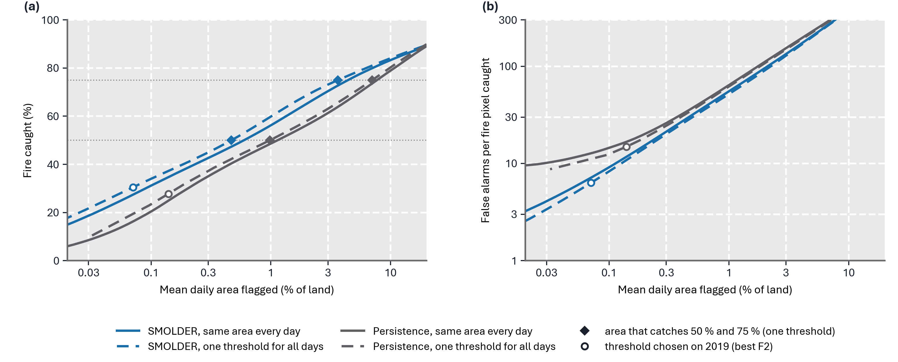
Figure 2. Fire caught and false alarms against the area flagged, test year 2020. (a) Share of the fire of the next three days that lies in the flagged area, against the mean daily share of Australia’s land flagged (higher is better). (b) False alarms per fire pixel caught (lower is better). Solid: the same share of land every day. Dashed: one score threshold for all days, so that the flagged area follows the fire danger of the day. Blue: SMOLDER, grey: persistence. Circles: thresholds chosen on 2019 (best F₂). In 2020 they flag 0.071 % (SMOLDER) and 0.140 % (persistence) of the land per day on average. Diamonds: the mean daily area that catches 50 % and 75 % of the fire with one threshold for all days.
4.3 Skill by distance to recent fire
Most of the skill lies near recent fire (Fig. 3). Persistence catches all fire within 1 km of recent fire and nothing beyond 2 km. SMOLDER catches somewhat less right at the fire (89.6 % of the pixels that burned themselves and 78.8 % of the fire up to 1 km), but also 44.6 % of the fire 2 to 3 km away and 23.9 % at 3 to 5 km, with half the flagged area. Beyond 10 km, where 41.7 % of the 2020 fire lies, neither catches fire (SMOLDER 0.4 % at 10 to 25 km and 0.7 % further away). Of all the fire SMOLDER catches, 91.1 % lies within 3 km of recent fire. Appendix C shows examples of both situations. On 21 November 2020 in northern Queensland SMOLDER caught 75.8 % of 479 fire pixels with 290 false alarms, the baseline 28.2 % with 689. On 6 February 2020 in the south-west of Western Australia, 1065 fire pixels burned without any fire nearby on the days before, and SMOLDER caught 0.7 % of them.
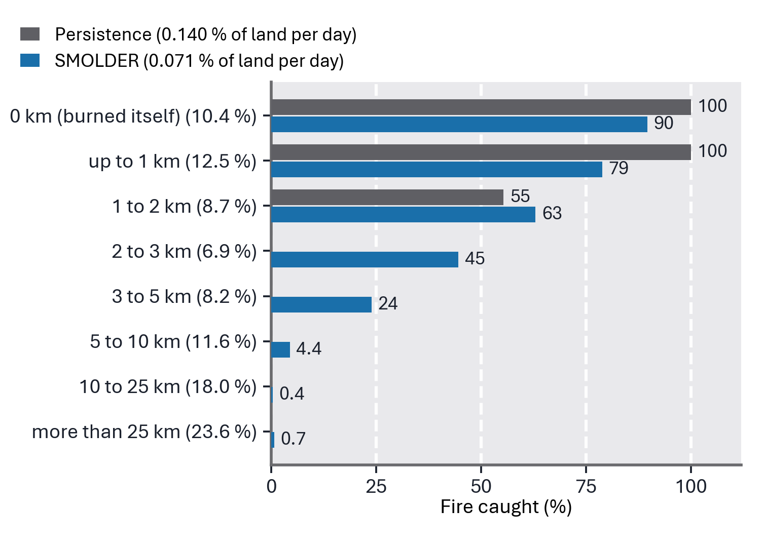
Figure 3. Fire caught in 2020 by distance to the nearest fire detected on the issue day or the two days before (‘0 km’: the pixel itself burned), for persistence and SMOLDER at their thresholds chosen on 2019 (best F₂). In brackets the share of all 2020 fire in each band. Persistence catches no fire beyond 2 km (no bar).
4.4 What the forecast relies on
The three inputs derived from the fire record lead (Fig. 4). When the fire history is shuffled, 83.1 % of the flagged pixels are no longer flagged and the AUC-PR falls by 52.4 %. For the FRP the two values are 52.0 % and 28.9 %, for the fuel age 13.3 % and 7.0 %, and NDVI follows with 15.8 % and 7.1 %. The weather inputs change at most 7.0 % of the flagged pixels and lower the AUC-PR by at most 0.8 %. In short, the model mainly uses where fire burned, how intensely, and how long ago an area last burned. Before the issue day, caught fire burned where the vegetation was greener and denser than in its surroundings (NDVI +0.068, leaf area index +0.24, relative to other land of the same patch) and the soil had dried out, whereas missed fire burned on moister soil with less vegetation (NDVI +0.041, leaf area index +0.13). Air temperature did not distinguish the two.
An upper bound for better weather information was tested on 2019 with a model that also received the actual weather of the three target days, as if the weather forecast were perfect. Its AUC-PR rose only from 0.2062 to 0.2153, and the new fire caught with 0.5 % of the land from 24.8 to 26.4 %. Both runs used an earlier version of the inputs, so only the size of the gain is informative.
5 Discussion and conclusion
5.1 How good is the model?
The absolute numbers look low: in 2020 six of seven flagged pixels did not burn within three days. They have to be read against three facts. First, fire is extremely rare, and the precision of SMOLDER is 431 times the base rate of 2020 (persistence 199 times). Second, much of the fire cannot be predicted from these data by any ranking: of the 41.7 % of the 2020 fire that lay more than 10 km from fire of the days before, SMOLDER caught 0.6 % and persistence none, whereas of the fire within 10 km SMOLDER caught 51.8 % and persistence 47.6 %, with half the flagged area. Third, SMOLDER is better than persistence, the only reference evaluated on the same task, on 348 of 350 days. Scores of other models refer to other tasks: in the WildfireSpreadTS benchmark for next-day fire spread in the United States (Gerard et al., 2023), the best model reaches 1.9 times the average precision of persistence (0.372 against 0.193), but resolution, lead time and evaluated area differ.
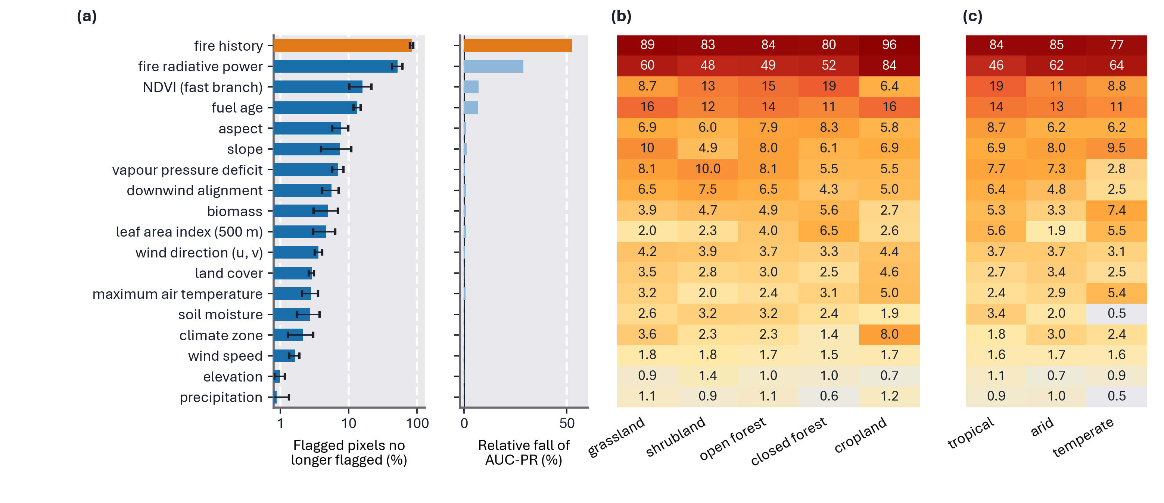
Figure 4. Importance of the inputs, 1500 fire-active patches of 2020. (a) Share of the flagged pixels (threshold chosen on 2019) that are no longer flagged when the input is shuffled (left, with the larger standard deviation over five time blocks and five regions as error bar) and relative fall of AUC-PR (right), (b) by land cover and (c) by climate zone. Longer bars and darker cells mean that the forecast relies more on the input.
The model also has clear weaknesses. Within 3 km of recent fire it catches no more fire than persistence (72.0 % in 2020), and its advantage there is the smaller area. New fire is predicted only weakly (AUC-PR 0.0058 against 0.0022), isolated ignitions not at all, and the catch rates near fire were lower in 2020 than in 2019.
5.2 What the results mean in practice
On an average day of 2020, about 2200 of the 6.9 million land pixels had fire in the following three days. SMOLDER flagged about 4900 pixels (about 5400 km²), of which about 670 burned, 30 % of all the fire. Persistence flagged about 9700, of which about 610 burned. Someone monitoring the flagged pixels would thus watch half the area and see slightly more of the coming fire (Fig. 2). Nearly all of this fire is the spread or re-ignition of fires that are already burning. SMOLDER therefore answers the question ‘where will the fires that are burning now be in the next three days?’, every day and for a whole continent, which could help to decide where to direct aerial surveillance, crews or warnings around active fires. It does not answer the question ‘where will a new fire start?’, which concerned two fifths of the fire of 2020. For that, fire danger ratings, which describe how dangerous the conditions are wherever a fire might start, and information on ignitions such as lightning remain necessary. SMOLDER complements them and does not replace them. Before any operational use, its scores would also have to be converted into calibrated probabilities and tested over more than one year.
5.3 Why new fires are hard to predict
Fire far from earlier fire is hardly predicted, and the likely reasons are a matter of interpretation. The model has learned that places without recent fire are low risk, which is right most of the time and wrong for exactly these fires. And the cause of an isolated ignition, a lightning strike or a human spark, is a point event that leaves no trace in daily 1 km maps: of the four switches of Sect. 1, the inputs describe fuel, dryness and weather, but not ignition. Neither the training nor missing weather seems to be the limit: a stronger loss weight for distant fire lowered the validation score (Appendix B), and even the actual weather of the target days added only about 0.009 to the AUC-PR.
Most of the skill of SMOLDER, and probably of any model that uses recent fire as an input, lies within a few kilometres of fire that is already burning. There the fire inputs decide, while weather and fuel at 1 to 4.4 km and one value per day separate neighbouring pixels only weakly. The predictable part of the problem is fire spread and re-ignition near existing fires, at scales of hundreds of metres and hours, below the resolution of this model. It is better framed as a spread model in a window of about 25 km around active fires, with active fire from geostationary satellites such as Himawari-8/9, which image Australia every 10 minutes at 2 km in the infrared (Bessho et al., 2016), and hourly weather, as in datasets for next-day fire spread (Huot et al., 2022; Gerard et al., 2023). Where and when new fires start is a different, largely probabilistic problem, for which fire danger ratings and ignition models remain the appropriate tools.
5.4 Lessons for building and evaluating such models
Three points from this study apply to data-driven fire forecasts in general. First, inputs derived from satellite products should be checked for information from after the issue day (Sect. 2.3). Composites, temporal smoothing, gap filling and multi-year maps can all carry the trace of a fire back in time, and this cannot be seen in the scores. A check of each input around the first detection of new fires, as done here, finds strong look-ahead with little effort. Second, a model that receives the current fire as an input should be compared with persistence and evaluated by distance to existing fire. Here the share of fire caught falls from 72.0 % within 3 km of recent fire to 0.6 % beyond 10 km, which a single overall score hides. Third, scores should be reported relative to the base rate and at an operating point fixed on other data. From 2019 to 2020 the base rate fell by 42 % and the AUC-PR of both rankings with it, so absolute scores of years or studies with different amounts of fire cannot be compared directly.
5.5 Limitations and future work
The labels are satellite detections, which miss fires under cloud or dense canopy and small or short-lived fires. Only one test year was evaluated, and it includes the end of the 2019/20 Black Summer season (Boer et al., 2020). The model was not compared on the same task with an operational fire danger index or with other learned models, including simpler ones such as gradient-boosted trees on the same inputs, and the variation between repeated training runs was not quantified. Its output is a ranking and not a probability, and the LAI is at least a month old when it enters a forecast. The most promising routes are a spread model at higher resolution around active fires (Sect. 5.3) and, for new fires, inputs that describe ignition, such as daily lightning data.
5.6 Conclusion
SMOLDER produces a daily fire risk ranking for continental Australia at 1 km, and the three questions of the introduction can be answered as follows. First, it is clearly better than persistence: in the test year 2020 its AUC-PR is 3.3 times that of persistence, and with one threshold chosen on 2019 it catches 30.5 % of the fire on 0.071 % of the land per day, where persistence catches 27.8 % on 0.140 %. Second, its skill comes from fire that is already burning: 91.1 % of the fire it catches lies within 3 km of recent fire, and fires that start far from existing fire are hardly predicted. Third, it relies mainly on the fire record, the fire intensity and the time since an area last burned, whereas weather and fuel add little at 1 km and daily resolution. Models of this kind can anticipate how burning fires develop across a whole continent. Anticipating new fires requires information on ignition, and any such model should be judged against persistence, by distance to existing fire and relative to the base rate.
Code and data availability
The code of SMOLDER, the trained model weights and the figures of the supplement are available at https://github.com/kmueller00/smolder-wildfire-australia (MIT licence). The version used in this paper is release v2.0 (tag v2.0, commit e4ab504). The supplement (folder figures/supplement) holds annual risk maps, example forecasts, training curves and maps of the input data. The input data needed to reproduce the evaluation on the test year 2020 (target, fire history, fuel age, fire radiative power, BARRA-C2 weather, NDVI composites, 8-day averages of leaf area index, soil moisture and precipitation, and the static and yearly layers on the 0.01° grid) are archived at Zenodo, https://doi.org/10.5281/zenodo.23158319, as seven archives and a checksum file (24.09 GB, all versions: https://doi.org/10.5281/zenodo.21749289). They are licensed CC BY-SA 4.0, because the precipitation data are derived from ANUClimate 2.0, which is licensed CC BY-SA 4.0. The training and validation years 2015 to 2019 are not archived because of their size. They are built from the public sources of Table 1 with the scripts in the repository. Each input dataset remains under its provider’s licence.
Competing interests
The author declares that there is no conflict of interest.
Acknowledgements
We acknowledge the use of data and imagery from NASA’s Fire Information for Resource Management System (FIRMS), part of NASA’s Earth Science Data and Information System (ESDIS).

References
Beck, H. E., McVicar, T. R., Vergopolan, N., Berg, A., Lutsko, N. J., Dufour, A., Zeng, Z., Jiang, X., van Dijk, A. I. J. M., and Miralles, D. G.: High-resolution (1 km) Köppen–Geiger maps for 1901–2099 based on constrained CMIP6 projections, Scientific Data, 10, 724, https://doi.org/10.1038/s41597-023-02549-6, 2023.
Bessho, K., Date, K., Hayashi, M., Ikeda, A., Imai, T., Inoue, H., Kumagai, Y., Miyakawa, T., Murata, H., Ohno, T., Okuyama, A., Oyama, R., Sasaki, Y., Shimazu, Y., Shimoji, K., Sumida, Y., Suzuki, M., Taniguchi, H., Tsuchiyama, H., Uesawa, D., Yokota, H., and Yoshida, R.: An introduction to Himawari-8/9 – Japan’s new-generation geostationary meteorological satellites, Journal of the Meteorological Society of Japan. Ser. II, 94, 151–183, https://doi.org/10.2151/jmsj.2016-009, 2016.
Boer, M. M., Resco de Dios, V., and Bradstock, R. A.: Unprecedented burn area of Australian mega forest fires, Nature Climate Change, 10, 171–172, https://doi.org/10.1038/s41558-020-0716-1, 2020.
Bradstock, R. A.: A biogeographic model of fire regimes in Australia: current and future implications, Global Ecology and Biogeography, 19, 145–158, https://doi.org/10.1111/j.1466-8238.2009.00512.x, 2010.
Breiman, L.: Random forests, Machine Learning, 45, 5–32, https://doi.org/10.1023/A:1010933404324, 2001.
Buchhorn, M., Smets, B., Bertels, L., De Roo, B., Lesiv, M., Tsendbazar, N.-E., Herold, M., and Fritz, S.: Copernicus Global Land Service: Land Cover 100m: collection 3: epochs 2015–2018: Globe, V3.0.1, Zenodo [data set], https://doi.org/10.5281/zenodo.3939038 (2015), https://doi.org/10.5281/zenodo.3518026 (2016), https://doi.org/10.5281/zenodo.3518036 (2017), https://doi.org/10.5281/zenodo.3518038 (2018), 2020.
Chuvieco, E., Cocero, D., Riaño, D., Martin, P., Martínez-Vega, J., de la Riva, J., and Pérez, F.: Combining NDVI and surface temperature for the estimation of live fuel moisture content in forest fire danger rating, Remote Sensing of Environment, 92, 322–331, https://doi.org/10.1016/j.rse.2004.01.019, 2004.
Clarke, H., Nolan, R. H., Resco de Dios, V., Bradstock, R., Griebel, A., Khanal, S., and Boer, M. M.: Forest fire threatens global carbon sinks and population centres under rising atmospheric water demand, Nature Communications, 13, 7161, https://doi.org/10.1038/s41467-022-34966-3, 2022.
Cruz, M. G. and Alexander, M. E.: The 10 % wind speed rule of thumb for estimating a wildfire’s forward rate of spread in forests and shrublands, Annals of Forest Science, 76, 44, https://doi.org/10.1007/s13595-019-0829-8, 2019.
Gerard, S., Zhao, Y., and Sullivan, J.: WildfireSpreadTS: A dataset of multi-modal time series for wildfire spread prediction, in: Advances in Neural Information Processing Systems 36, Datasets and Benchmarks Track, 74515–74529, https://doi.org/10.52202/075280-3258, 2023.
Giglio, L.: VIIRS/NPP Active Fires 6-Min L2 Swath 375m V002, NASA Land Processes Distributed Active Archive Center [data set], https://doi.org/10.5067/VIIRS/VNP14IMG.002, 2024.
Huot, F., Hu, R. L., Goyal, N., Sankar, T., Ihme, M., and Chen, Y.-F.: Next Day Wildfire Spread: A machine learning dataset to predict wildfire spreading from remote-sensing data, IEEE Transactions on Geoscience and Remote Sensing, 60, 1–13, https://doi.org/10.1109/TGRS.2022.3192974, 2022.
Hutchinson, M., Xu, T., Kesteven, J., Marang, I., and Evans, B.: ANUClimate 2.0, NCI Australia [data set], https://doi.org/10.25914/60a10aa56dd1b, 2021.
Izmailov, P., Podoprikhin, D., Garipov, T., Vetrov, D., and Wilson, A. G.: Averaging weights leads to wider optima and better generalization, in: Proceedings of the 34th Conference on Uncertainty in Artificial Intelligence (UAI 2018), 876–885, 2018.
Karasante, I., Alonso, L., Prapas, I., Ahuja, A., Carvalhais, N., and Papoutsis, I.: SeasFire cube – a multivariate dataset for global wildfire modeling, Scientific Data, 12, 368, https://doi.org/10.1038/s41597-025-04546-3, 2025.
Matthews, S.: Dead fuel moisture research: 1991–2012, International Journal of Wildland Fire, 23, 78–92, https://doi.org/10.1071/WF13005, 2014.
McNorton, J. R. and Di Giuseppe, F.: A global fuel characteristic model and dataset for wildfire prediction, Biogeosciences, 21, 279–300, https://doi.org/10.5194/bg-21-279-2024, 2024.
Milletari, F., Navab, N., and Ahmadi, S.-A.: V-Net: Fully convolutional neural networks for volumetric medical image segmentation, in: 2016 Fourth International Conference on 3D Vision (3DV), 565–571, https://doi.org/10.1109/3DV.2016.79, 2016.
Montes, C., Schulthess, U., and Lashkari, A.: An ERA5-based global dataset of vapor pressure deficit at maximum air temperature over land, version V1, CIMMYT Research Data & Software Repository Network [data set], https://hdl.handle.net/11529/10548556, 2021.
NOAA National Geophysical Data Center: ETOPO1 1 Arc-Minute Global Relief Model, NOAA National Centers for Environmental Information [data set], https://doi.org/10.7289/V5C8276M, 2009.
Nolan, R. H., Boer, M. M., Resco de Dios, V., Caccamo, G., and Bradstock, R. A.: Large-scale, dynamic transformations in fuel moisture drive wildfire activity across southeastern Australia, Geophysical Research Letters, 43, 4229–4238, https://doi.org/10.1002/2016GL068614, 2016.
Santoro, M. and Cartus, O.: ESA Biomass Climate Change Initiative (Biomass_cci): Global datasets of forest above-ground biomass for the years 2007, 2010, 2015, 2016, 2017, 2018, 2019, 2020, 2021 and 2022, v6.0, NERC EDS Centre for Environmental Data Analysis [data set], https://doi.org/10.5285/95913ffb6467447ca72c4e9d8cf30501, 2025.
Schroeder, W., Oliva, P., Giglio, L., and Csiszar, I. A.: The New VIIRS 375 m active fire detection data product: Algorithm description and initial assessment, Remote Sensing of Environment, 143, 85–96, https://doi.org/10.1016/j.rse.2013.12.008, 2014.
Sharples, J. J., McRae, R. H. D., and Wilkes, S. R.: Wind–terrain effects on the propagation of wildfires in rugged terrain: fire channelling, International Journal of Wildland Fire, 21, 282–296, https://doi.org/10.1071/WF10055, 2012.
Shi, X., Chen, Z., Wang, H., Yeung, D.-Y., Wong, W.-K., and Woo, W.-C.: Convolutional LSTM network: A machine learning approach for precipitation nowcasting, in: Advances in Neural Information Processing Systems 28, 802–810, 2015.
Stenson, M., Searle, R., Malone, B., Sommer, A., Renzullo, L., and Di, H.: Australia wide daily volumetric soil moisture estimates, version 1.0, Terrestrial Ecosystem Research Network [data set], https://doi.org/10.25901/b020-nm39, 2021.
Su, C.-H., Rennie, S., Torrance, J., Howard, E., Stassen, C., et al.: BARRA-C2: Development of the kilometre-scale downscaled atmospheric reanalysis over Australia, Bureau Research Report 097, Bureau of Meteorology, Australia, 2024.
Su, C.-H., Torrance, J., Rennie, S., Howard, E., Stassen, C., Warren, R., Smith, A., Dharssi, I., Pepler, A., Tian, S., Lipson, M., Steinle, P., Franklin, C., Le, T., Wang, C., Masoumi, S., and Le Marshall, J.: The Australian regional atmospheric reanalysis system, version 2 – BARRA2, Journal of Southern Hemisphere Earth Systems Science, 75, ES25032, https://doi.org/10.1071/ES25032, 2025.
Vaswani, A., Shazeer, N., Parmar, N., Uszkoreit, J., Jones, L., Gomez, A. N., Kaiser, Ł., and Polosukhin, I.: Attention is all you need, in: Advances in Neural Information Processing Systems 30, 5998–6008, 2017.
Vermote, E.: MODIS/Terra Surface Reflectance 8-Day L3 Global 500m SIN Grid V061, NASA Land Processes Distributed Active Archive Center [data set], https://doi.org/10.5067/MODIS/MOD09A1.061, 2021.
Yan, K., Wang, J., Peng, R., Yang, K., Chen, X., Yin, G., Dong, J., Weiss, M., Pu, J., and Myneni, R. B.: HiQ-LAI: a high-quality reprocessed MODIS leaf area index dataset with better spatiotemporal consistency from 2000 to 2022, Earth System Science Data, 16, 1601–1622, https://doi.org/10.5194/essd-16-1601-2024, 2024.
Yebra, M., Dennison, P. E., Chuvieco, E., Riaño, D., Zylstra, P., Hunt, E. R., Danson, F. M., Qi, Y., and Jurdao, S.: A global review of remote sensing of live fuel moisture content for fire danger assessment: Moving towards operational products, Remote Sensing of Environment, 136, 455–468, https://doi.org/10.1016/j.rse.2013.05.029, 2013.
Zhang, T., Zhou, Y., Zhu, Z., Li, X., and Asrar, G. R.: A global seamless 1 km resolution daily land surface temperature dataset (2003–2020), Earth System Science Data, 14, 651–664, https://doi.org/10.5194/essd-14-651-2022, 2022.

Appendix A: Model inputs, architecture and training
Figure A1 shows the inputs. The two input stacks have the shape (time steps, height, width, channels) (18, 384, 384, 21) for the slow and (14, 384, 384, 33) for the fast encoder. The fast stack contains VPD, maximum air temperature, wind speed, the two wind components, NDVI, the fire history (three binary maps of three days each, the newest ending on the day of the time step, and the proximity to recent fire, exp(−d/5 km)), three FRP layers, the fuel age and the downwind alignment, the cosine of the angle between the wind and the direction from the nearest fire to the pixel. Both stacks contain six static layers (biomass, land mask, elevation, slope, east and north component of the aspect) and the day of the year as sine and cosine, and land cover and climate zone are encoded as learned embeddings of 6 and 4 channels. Each ConvLSTM encoder (Shi et al., 2015) uses 5 × 5 kernels and a hidden state of 64 channels. In the fusion, a learned projection of the final slow state is added to the fast state at every step, the sum is normalized (layer normalization) and the slow state appended, giving 128 channels. Formally this is a cross-attention (Vaswani et al., 2017) with a single key, for which the attention weight is always 1. A 5 × 5 convolution with a sigmoid turns the 128 channels into a score, and the output of the last fast step is the forecast.
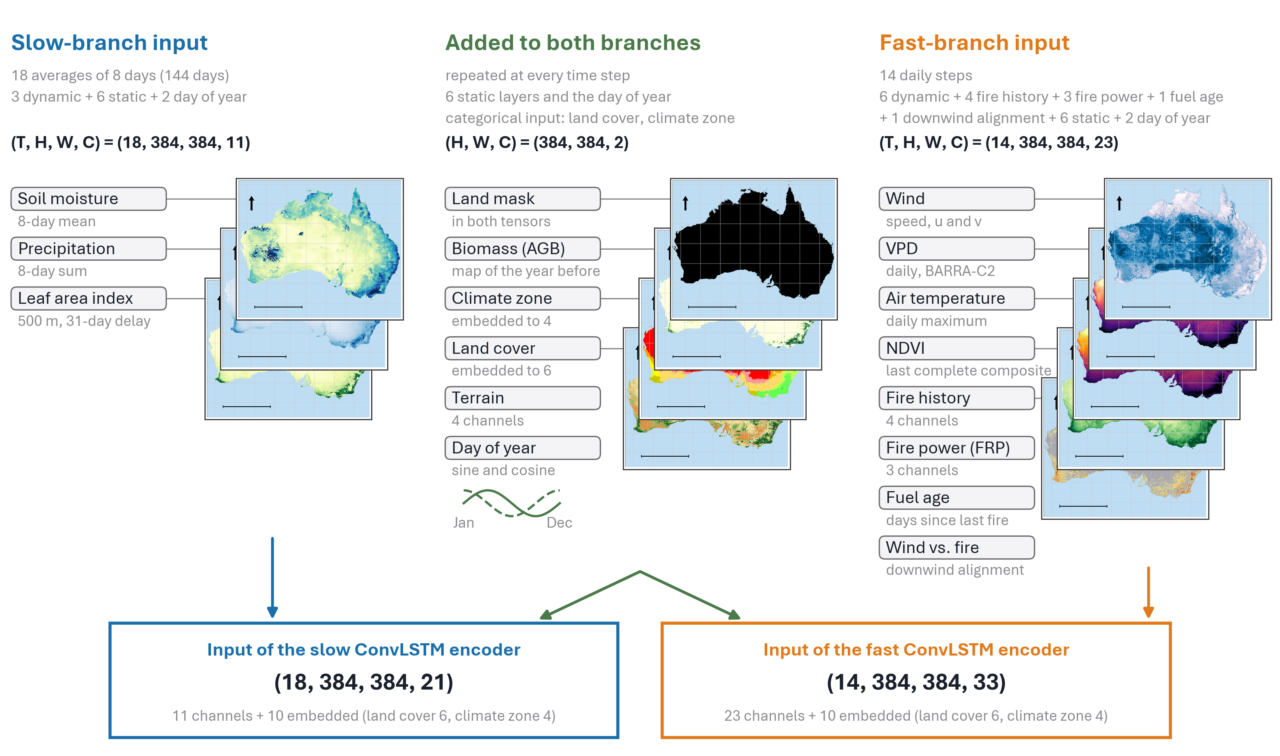
Figure A1. The input data of SMOLDER. Left: the slowly varying inputs of the slow branch (18 eight-day averages). Right: the 14 daily inputs of the fast branch (VPD: vapour pressure deficit, NDVI: normalized difference vegetation index, FRP: fire radiative power). Centre: the layers added to both branches at every time step. Bottom: the stacks that enter the two ConvLSTM encoders after land cover and climate zone have been encoded, with their shape (time steps, height, width, layers). The maps show each variable for the whole of Australia for illustration, the fire layers on grey land. The model reads patches of 384 × 384 pixels.
Training samples are patches drawn from the training years, 2000 per epoch, half of them with at least 45 fire pixels in the target. In 30 % of the patches fire must occur where the newest fire map shows none, and in 30 % of the samples all inputs that reveal recent fire are set to the state of no fire. The loss is the binary cross-entropy over land pixels, with fire pixels weighted 100 times at first, lowered to 20 times over the first 8 epochs, isolated fire pixels counted up to three times, softened targets (0.9 and 0.02), a Dice loss (Milletari et al., 2016) in the first three epochs and the same loss on the 13 earlier fast steps with a weight of 0.3. The model was trained for 50 epochs with AdamW and a cosine learning rate from 3 × 10⁻⁴ to zero, and the weights of the three epochs with the highest validation score (epochs 20, 34 and 37) were averaged, similar in spirit to stochastic weight averaging (Izmailov et al., 2018). Of two models trained with and without random flips and rotations of the patches, the one without had the higher AUC-PR on 2019 (0.2091 against 0.2043) and is the final model.
Appendix B: Alternatives that were tested and not adopted
The fire inputs were chosen on 2019 with gradient-boosted trees on pixels within 25 km of recent fire, in which the score of a preliminary version of the model was a feature on both sides of each comparison. Within 3 km of fire, FRP raised the AUC-PR by 13 %, the wind direction relative to the fire with terrain features by 7 % and the fuel age by 3 %, and at 10 to 25 km the fuel age raised it by 34 %.
Table B1 lists alternatives that were tested on the validation year 2019 and are not part of the final model. Training runs are compared by their best validation AP within the first 10 epochs, for which the reference run reached 0.0898. All four comparisons were made before the input timing of Sect. 2.3 was final, with the same inputs on both sides of each comparison.
Table B1. Alternatives tested on 2019 that are not part of the final model.
Alternative | What was tested | Outcome
Loss weight by distance to earlier fire | Loss of every fire pixel multiplied by 1 + a · min(d/10, 1), with d the distance in pixels to the nearest fire of the last 32 days and a = 5, 10, 20, 40 and 80 | Validation AP 0.0583 to 0.0736, lower than the reference for every a
VPD anomaly | Standardized anomaly of the VPD as an additional input | Validation AP 0.0795, lower than the reference
VPD at 31 km | VPD from the ERA5-based dataset of Montes et al. (2021) instead of BARRA-C2 | Validation AP 0.0794, lower than the reference
Afternoon wind | Wind at 05 UTC, the afternoon in Australia, instead of the daily mean, tested with the gradient-boosted trees of this appendix | No gain in AUC-PR within 3 km of fire (−0.0010, 95 % interval −0.0077 to +0.0052)

Appendix C: Further results and example events
Figure C1 shows the lift of both rankings as a function of the flagged area and the daily AUC-PR through 2020. The lift of SMOLDER lies above that of persistence for every flagged area shown, and the two converge when about a tenth of the land is flagged. The daily AUC-PR of both rankings varies strongly through the year.
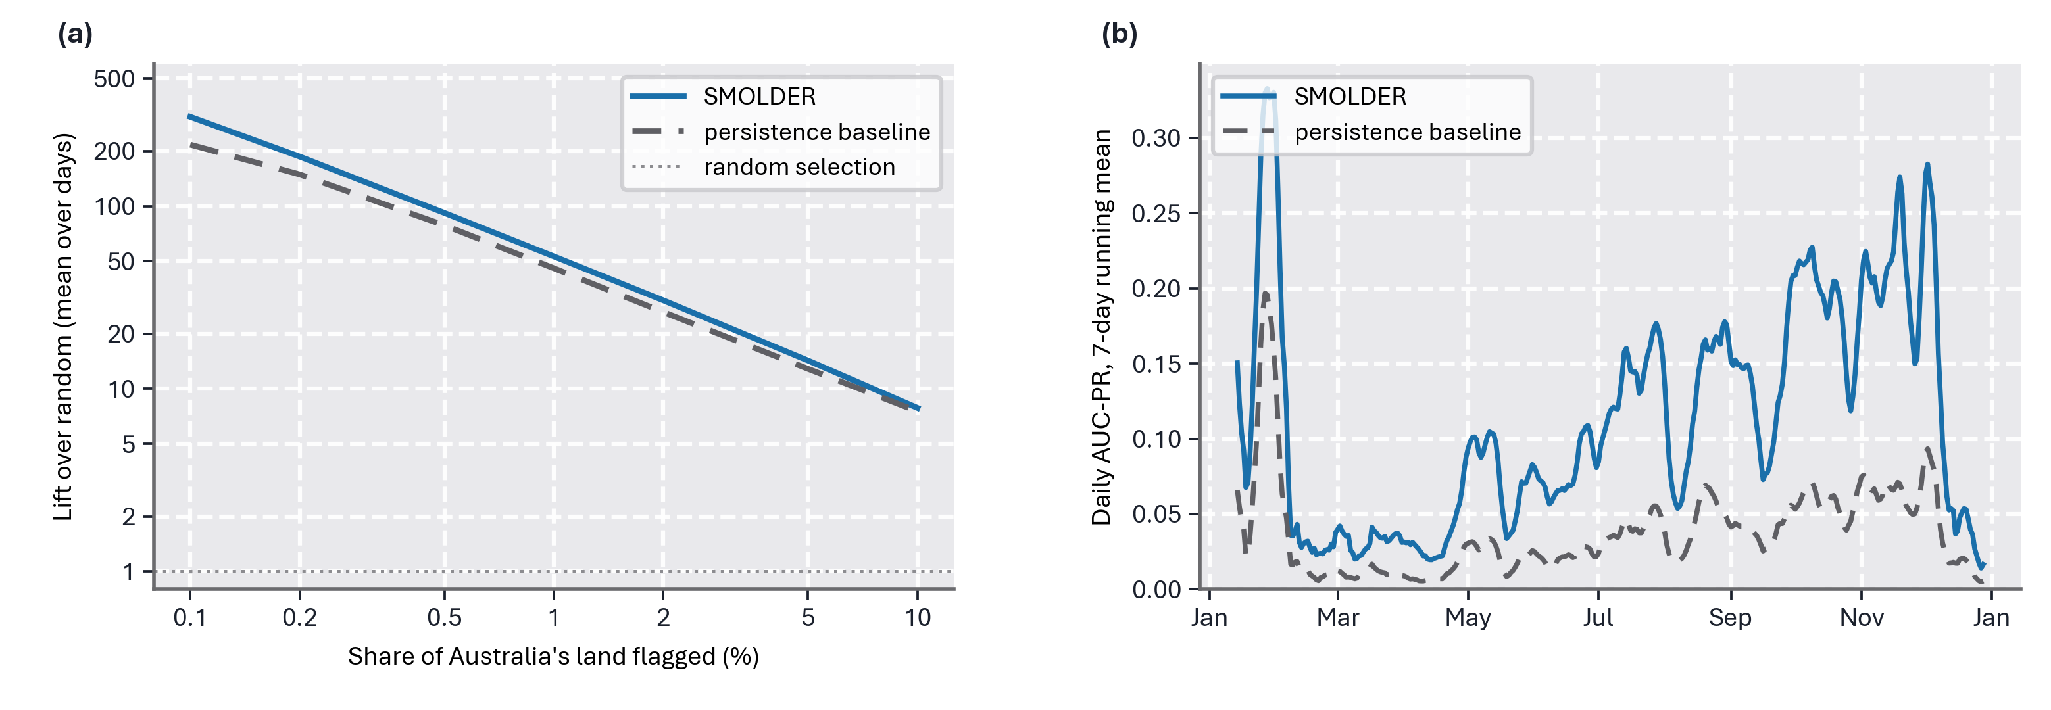
Figure C1. National skill in the test year 2020. (a) Lift of SMOLDER (solid) and of the persistence baseline (dashed), which ranks pixels by their distance to the nearest fire detected on the issue day or the two days before, as a function of the share of Australia’s land that is flagged each day (mean over days). A lift of 100 means that the flagged area holds 100 times more fire than a random area of the same size. (b) Daily AUC-PR of SMOLDER (solid) and of the persistence baseline (dashed), 7-day running means.
Figures C2 to C4 show windows of 192 × 192 km, chosen automatically: the windows in which the F₂ of SMOLDER exceeds that of the baseline the most (ranks 1 to 4 and 5 to 8), and those in which it is lowest, with at most one window per 30 days and 300 km. The examples are not typical. Of all 1844 fire-active windows of 2020, SMOLDER has the higher F₂ in 73 %, but an F₂ of 0.5 or more only in 15 %. In the example maps, a good forecast shows much dark red (fire inside the flagged area), little orange (fire outside it) and little light blue (flagged land that did not burn).
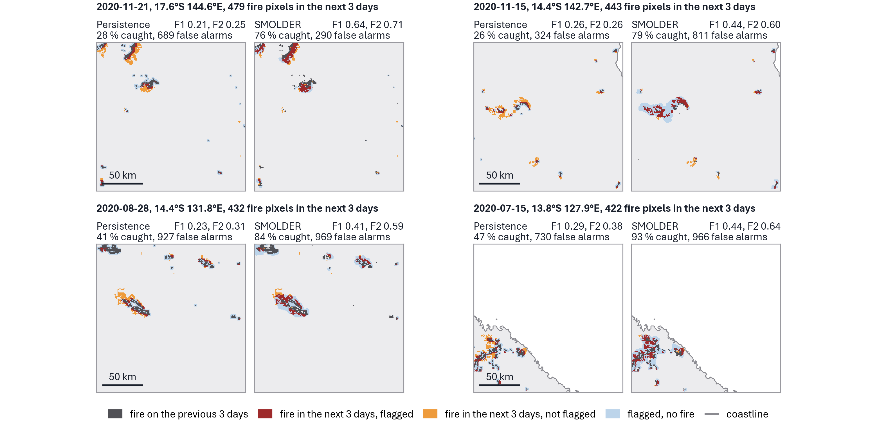
Figure C2. The four fire events of 2020 in which SMOLDER improved most on persistence, each a 192 × 192 km window. Left: persistence, right: SMOLDER, each flagging at its threshold chosen on 2019 (best F₂). Light blue: flagged area without fire. Dark red: fire in the next 3 days inside the flagged area. Orange: fire in the next 3 days outside it. Dark grey: fire on the previous 3 days. Grey line: coastline. Above each event: date of issue, location and the number of fire pixels in the next 3 days. Above each panel: F₁ and F₂ of the ranking within the window, the share of the fire caught and the number of false alarms.
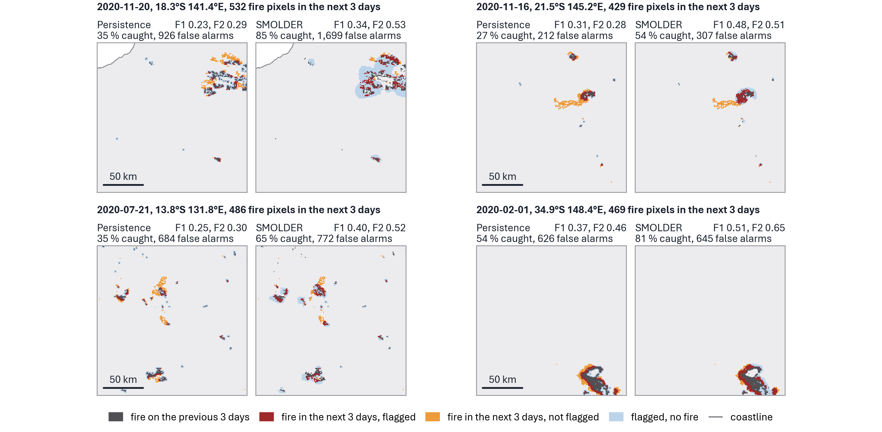
Figure C3. As Fig. C2, for the fire events of 2020 ranked 5 to 8 by the improvement of SMOLDER on persistence.
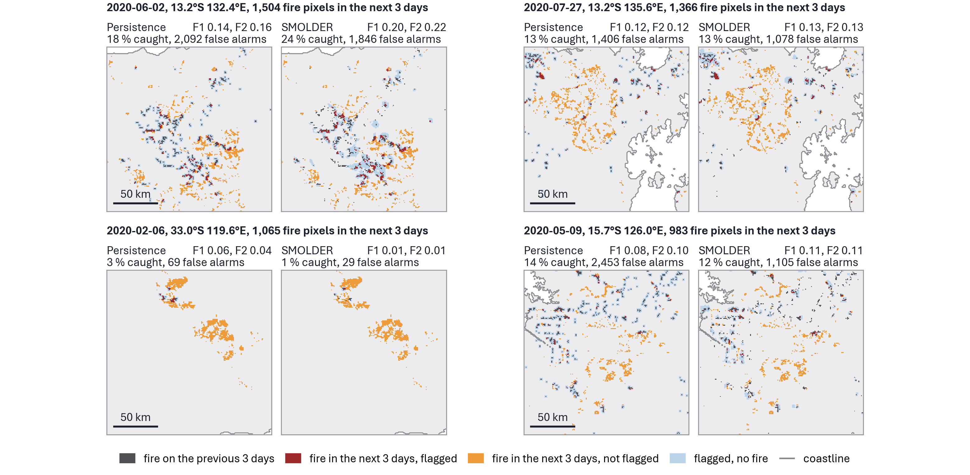
Figure C4. The four fire-active events of 2020 in which SMOLDER did worst, each a 192 × 192 km window. Colours and labels as in Fig. C2.

