ACBSP Standard 4 Write Up

Introduciton
Here is a write up for ACBSP Standard 4. Key assessment outcomes are summarized with corresponding data. All the graphs are stored in Evidence/Graph directory, so please link to them once uploaded.
The rest of this document is organized in the following way. First, MBA assessment outcomes are presented for the entire program.

MBA Assessment Outcomes
For MBA program, we have 4 layers of assessment processes. Namely,
- Summative, direct assessments with external tools (CPC Exams);
- Summative, direct assessments with internal tools (Comprehensive Exams);
- Summative, indirect assessments with internal tools (Exit Survey); and
- Formative, direct assessments with internal tools (Final Exams)
for the eight core objectives. (More explanations about each tool)
Each of the eight core objectives focuses on a particular field, summarized as:
- LO1: Demonstrate ability to solve problems using the tools of accounting
- LO2: Demonstrate ability to solve problems using the tools of economics
- LO3: Demonstrate ability to solve problems using the tools of finance
- LO4: Demonstrate ability to solve problems using the tools of human resource management
- LO5: Demonstrate ability to solve problems using the tools of international business
- LO6: Demonstrate ability to solve problems using the tools of marketing
- LO7: Demonstrate ability to solve problems using the tools of strategic management
- LO8: Employ mathematical and statistical techniques in business decision-making
In the following, first, I shall demonstrate the whole assessment process using one of the objectives. Then, several findings from assessments of other objectives are highlighted. Lastly, the overall trend is discussed briefly.

Demonstrative Case: MBA LO1

Summative Assessment
In order to assess different levels of learning, we utilize both the external and internal assessment tools. As seen in the two graphs below, the external summative assessment is done through the score of Accounting category in the Peregrine CPC exam, while the internal summative assessment is done through the score of Accounting category in the comprehensive exam. The benchmark levels of student achievement are displayed in each graph by a red, horizontal line. The benchmark was established a priori as the U.S. average score (59 percentage score) for the Peregrine CPC exam and 80 percentage score for the comprehensive exam.
etc. etc.
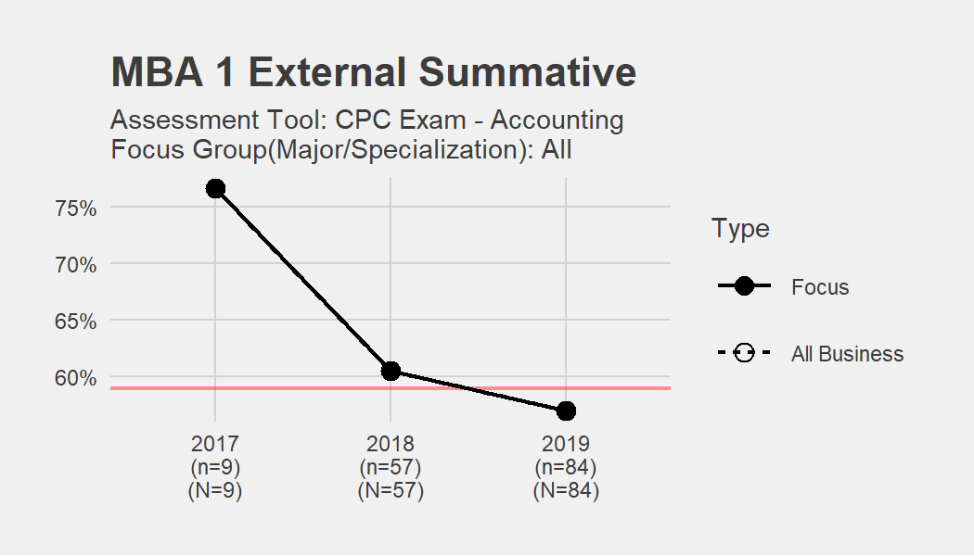
MBA 1
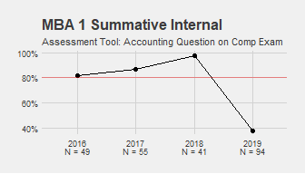

Internal Indirect Assessment
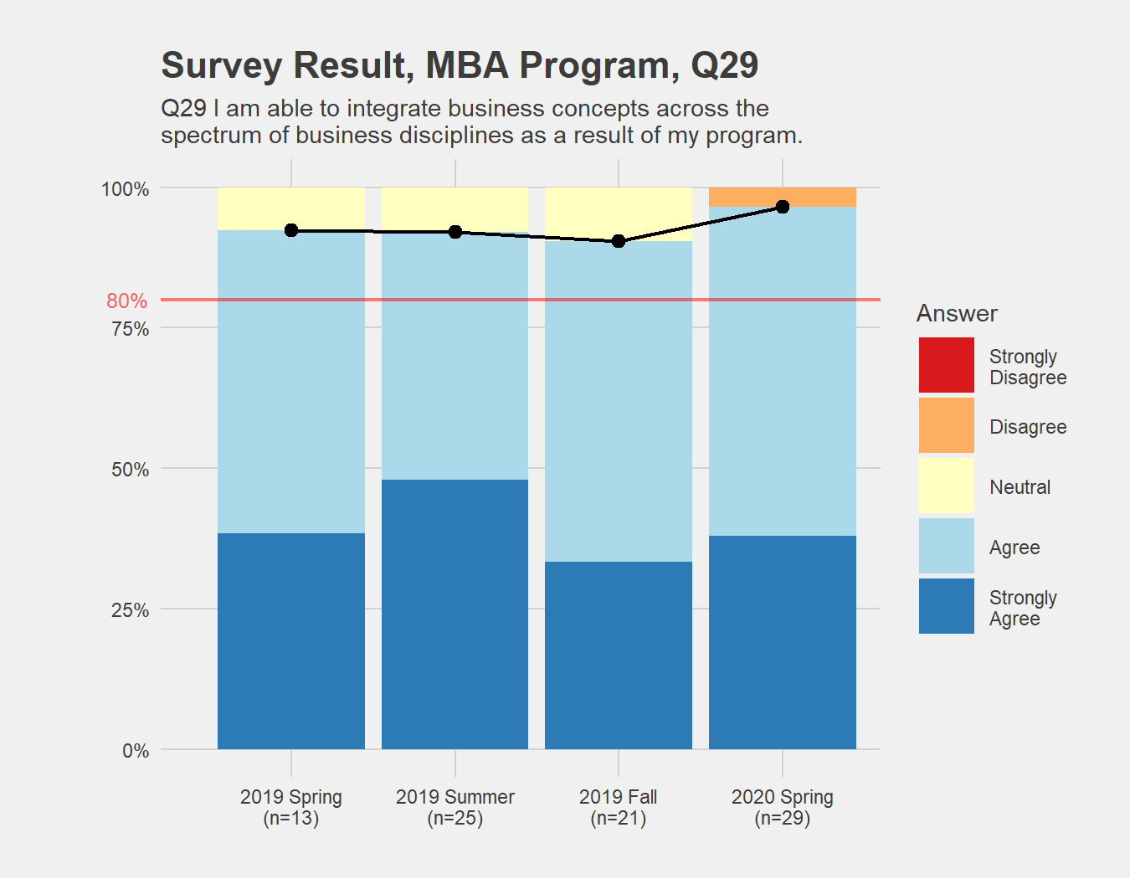
Outcome 1

Formative Assessment
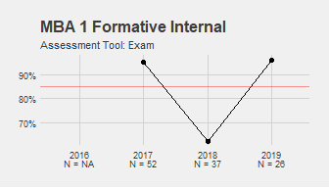

Findings in MBA Assessments
etc. etc.

Overall Trend
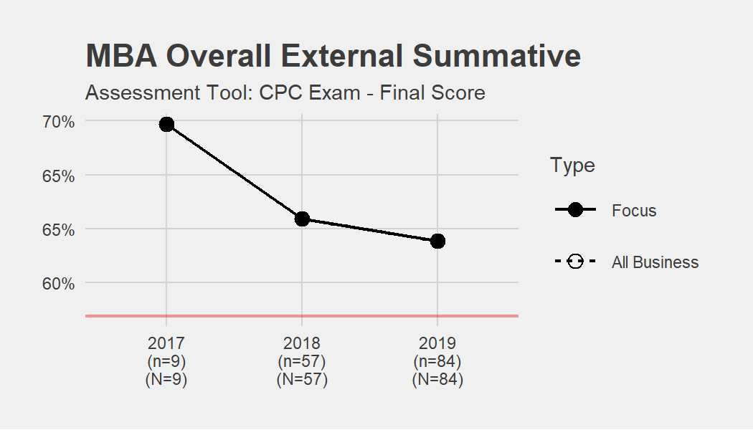
MBA

Undergrad

Core program, Summative

Core, external, direct (Peregrine scores including total as MBA 1)

Core, internal, direct (overall score from BUS499 on one LO only)

Core, internal, indirect (survey outcomes–just what they learned as in MBA)

Major/concentration programs: Pick one or two major for demonstration of program-level assessments and major level assessment

Summative
Core, external, sub-group Program, external, direct (e.g. ACC 1-3) Program, internal, direct BUS499 (e.g. ACC 1-3) Program, internal, indirect Survey outcomes Program, internal, direct Program signature assignment (such as BUS345 for management)

Formative
Core, internal, direct (overall score from one core course where you have data–maybe ECO201/2 or MGT300–just one sample where we have data)

