Assessment Report
8/5/2020
Table of Contents
Objectives 1
Data 1
Report on Program Accounting 3
Trend Over Time 3
Trend Between Internal and External Assessments 5
Differences from Targets 2019-20 6

Objectives
The goal with this document is to develop our narratives for the observed assessment outcomes. (e.g. If recent assessment outcomes are falling, what would be the cause(s)? If you see growing disparities between internal and external assessment outcomes, what changes have you observed?) Please document your discussions and findings by typing them into this Word document.

Data
Internal assessment data are derived from your inputs. Thank you again for your cooperation and contributions. External assessment data are pulled from Peregrine test results.
To remind yourself of the program objectives, please refer to the following table.
PLO | Description | Internal Tool | Extrnal Tool
ACC 1 | Prepare consolidated financial statements in accordance with current accounting principles generally accepted in the United States of America, and learn how each statement is used for business decision making. | Exam question. Students will be required to prepare GAAP based financial statements and non-GAAP financial statements and assess the impacts of GAAP compliance. | CPC Exam - Accounting
ACC 2 | Compare the impact of alternative costing methods. | Exam question. Students will calculate the cost of produced goods using alternative costing systems and assess the implications of costing system applied. | CPC Exam - Accounting
ACC 3 | Apply Federal tax law and regulations in the determination of tax liability. | Students complete a tax return on their final exam from start to finish, and calculate their tax liability using the appropriate forms and formulas. | CPC Exam - Accounting
ACC 4 | Conduct audit tests and document the test and conclusions. | Students will conduct audit tests and document and explain them. | CPC Exam - Accounting
In the f | ollowing section, trends in assessment outcomes are summarized first, then the snapshot of the latest assessments (2019-20) is presented.
Please u | se those data visualizations to develop the narratives of our teaching outcomes and processes, identifying strength and weakness. Any changes in students, instructors, or assessments should be identified.
Moreover | , please keep in mind that we will discuss strategic plans next week. The development of such narratives is ultimately to aid our decisions for the coming academic year and beyond.

Report on Program Accounting

Trend Over Time
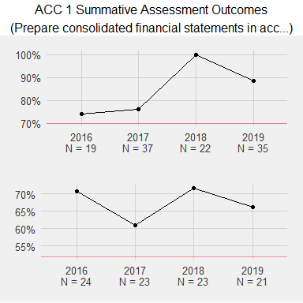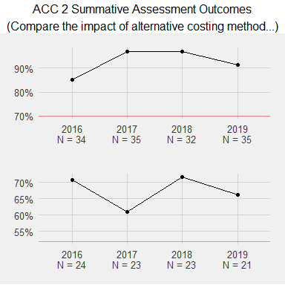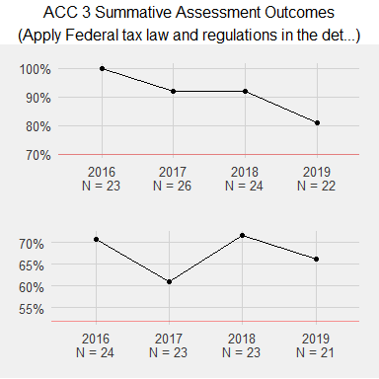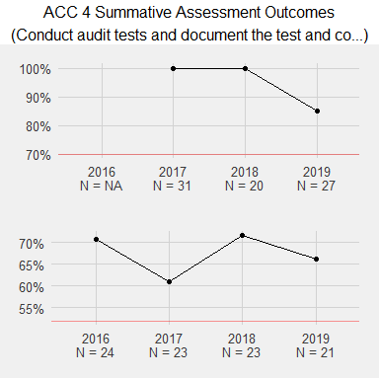

Trend Between Internal and External Assessments
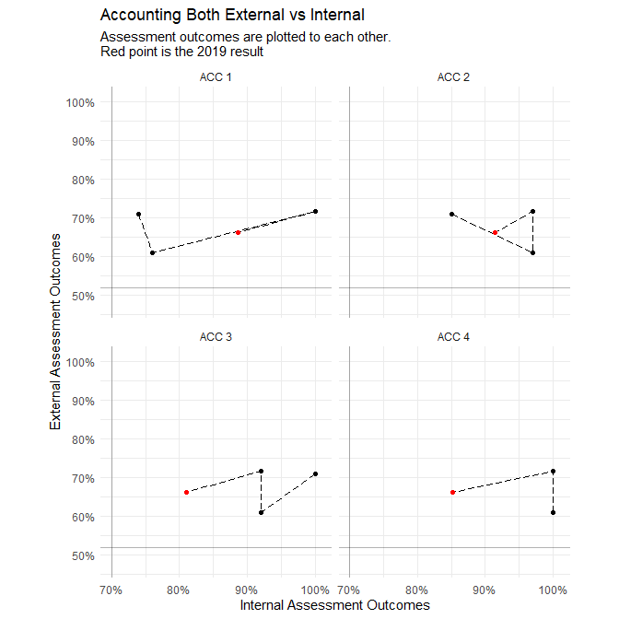

Differences from Targets 2019-20
