Note to Inspect Assessment Data 2
29 July, 2020
Table of Contents
Introduction 1
Objective 1
Data 2
Analysis 3
Accounting 3
Business Core 7
Economics 14
Finance 19
Human Resources Management 22
Management 26
Marketing 30
MIS 34
MBA 34
Next 39

Introduction

Objective
Combine the graphs and tables for presentation. During the department meeting(s), faculty members will gather in groups according to their specialties. Gather relevant information to help their analysis and discussion to create the strategic plans.

Data
Main data file has been updated. Now the mapping worksheet separates internal and external assessments, aligned wit the data worksheet.

Analysis

Accounting
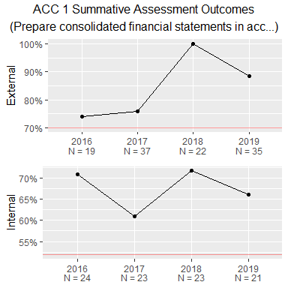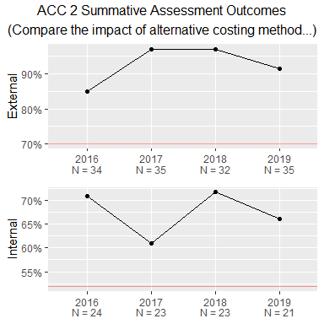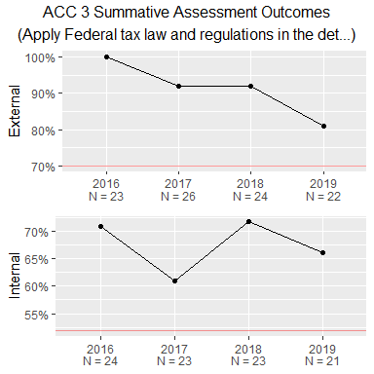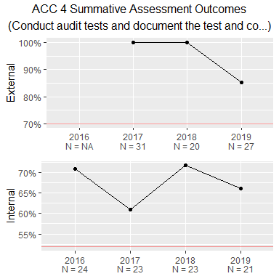
plo | description | internal_tool_description | external_tool_description
ACC 1 | Prepare consolidated financial statements in accordance with current accounting principles generally accepted in the United States of America, and learn how each statement is used for business decision making. | Exam question. Students will be required to prepare GAAP based financial statements and non-GAAP financial statements and assess the impacts of GAAP compliance. | CPC Exam - Accounting
ACC 2 | Compare the impact of alternative costing methods. | Exam question. Students will calculate the cost of produced goods using alternative costing systems and assess the implications of costing system applied. | CPC Exam - Accounting
ACC 3 | Apply Federal tax law and regulations in the determination of tax liability. | Students complete a tax return on their final exam from start to finish, and calculate their tax liability using the appropriate forms and formulas. | CPC Exam - Accounting
ACC 4 | Conduct audit tests and document the test and conclusions. | Students will conduct audit tests and document and explain them. | CPC Exam - Accounting
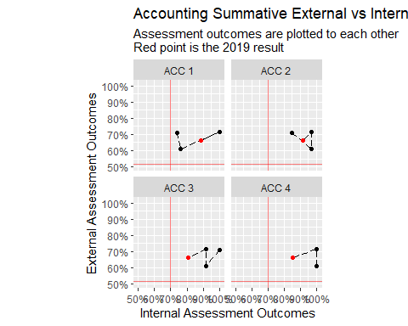
- Both achievement levels remain high and pass the target levels.
- Movements are mostly (except for ACC 1) contained with in 20% ranges.
- However, common trends are toward lower internal assessment
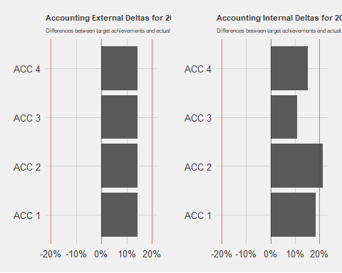
- External assessments 1-4 are the same measure (CPC Exam Accounting score). The outcome is well beyond the target level.
- All the four internal goals have been achieved with significant margins. ACC 2 - compare the impact of alternative costing methods - might need to update the target.

Business Core
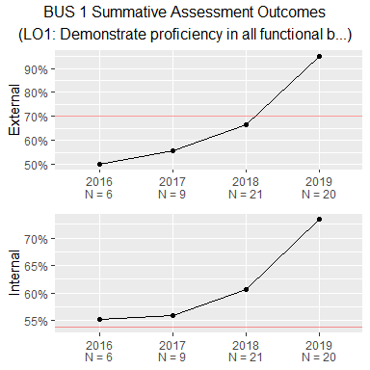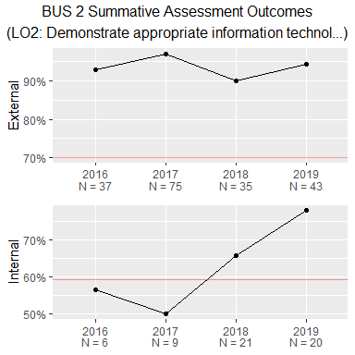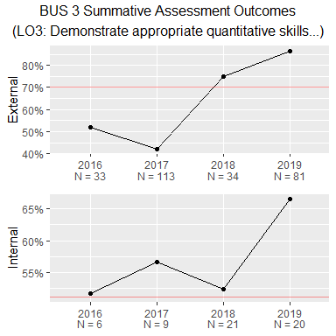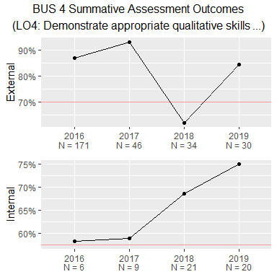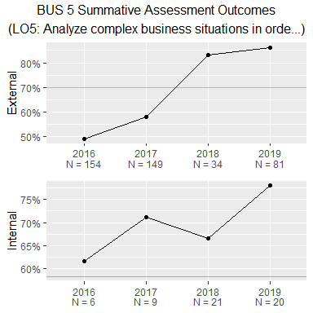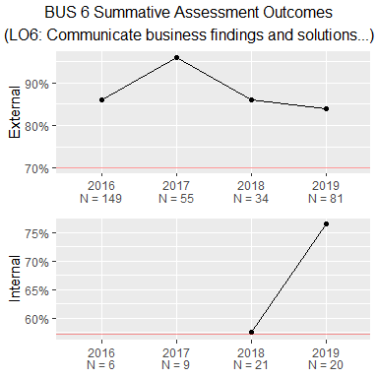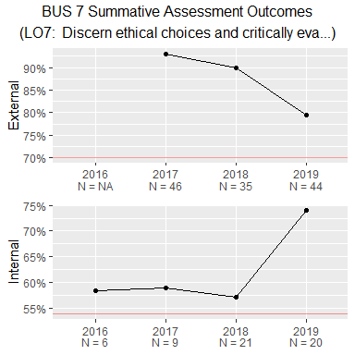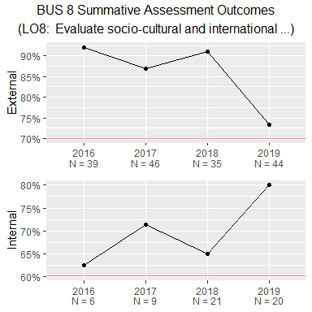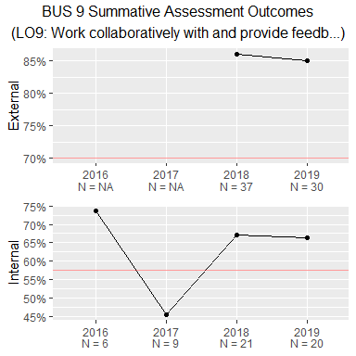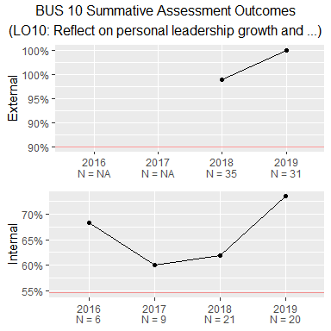
plo | description | internal_tool_description | external_tool_description
BUS 1 | LO1: Demonstrate proficiency in all functional business areas | CPC exam | CPC Exam - Final Score
BUS 2 | LO2: Demonstrate appropriate information technology and information literacy skills | Annotated Bibliography | CPC Exam - Information Management Systems
BUS 3 | LO3: Demonstrate appropriate quantitative skills | Company Profile | CPC Exam - Quantitative Research Techniques and Statistics
BUS 4 | LO4: Demonstrate appropriate qualitative skills | GoVenture AAR | CPC Exam - Legal Environment of Business
BUS 5 | LO5: Analyze complex business situations in order to make sound recommendations. | Company Profile | CPC Exam - Business Integration and Strategic Management
BUS 6 | LO6: Communicate business findings and solutions through effective writing, oral presentations, and graphical illustrations. | Company Profile | CPC Exam - Business Communications
BUS 7 | LO7: Discern ethical choices and critically evaluate the ethical choices of others. | Ethics Case Paper | CPC Exam - Business Ethics
BUS 8 | LO8: Evaluate socio-cultural and international diversity variables in decision making. | Ethics Case Paper | CPC Exam - Management: Human Resource Management
BUS 9 | LO9: Work collaboratively with and provide feedback to others in a team setting. | GoVenture AAR | CPC Exam - Management: Organizational Behavior
BUS 10 | LO10: Reflect on personal leadership growth and potential. | Development Plan | CPC Exam - Business Leadership
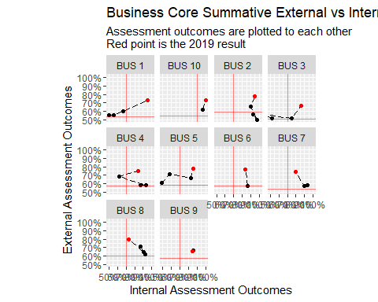
- BUS 1 Summative is measured through Peregrine CPC test. Since external measures the average and internal measures the distribution of final scores, they naturally have a strong positive correlation.
- Almost all PLOs improved in external assessment outcomes, while remained about the same in internal assessment outcomes.
- Exceptionally, BUS 5 analysis of business situations have shown a significant improvement in the internal assessment.
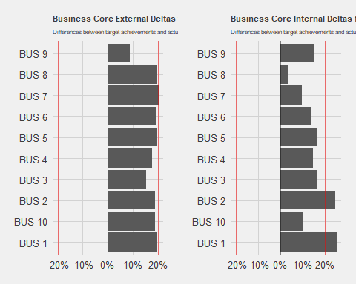
- Most of external assessment outcomes are above their targets by near 20% margin. BUS 9 - ability to work collaboratively, measured through CPC Exam Organizational Behavior - is somewhat lower.
- Likewise, most of internal assessment outcomes are well above their targets, although the variations are much larger than those of external assessments.
- BUS 1 (overall knowledge, measured by CPC Exam score) and BUS 2 (ability of information technology and literacy) may need updates on their targets or re-evaluate the assessments.
- In contrast, BUS 8 (ability to evaluate diversity variables) is exceptionally low and barely passed the target level.
- Note that BUS 10 target level has been updated to 90% rather than 70%, eliminating ‘excess’ level of achievement.

Economics
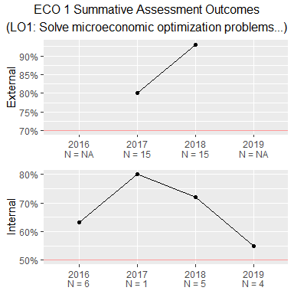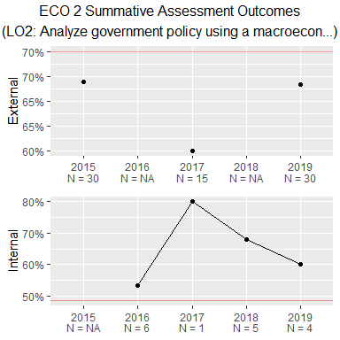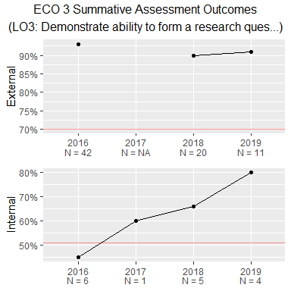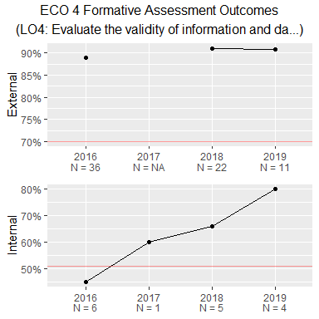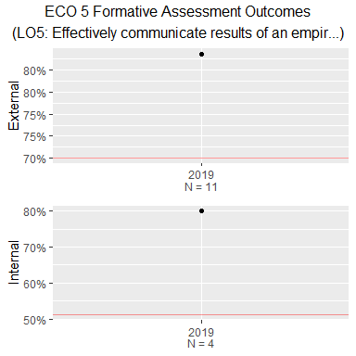
plo | description | internal_tool_description | external_tool_description
ECO 1 | LO1: Solve microeconomic optimization problems | A cumulative final exam which includes separate problems on consumer choice, cost minimization, profit maximization under perfect competition, profit maximization under monopoly, and profit maximization under duopoly. | CPC Exam - Economics: Microeconomics
ECO 2 | LO2: Analyze government policy using a macroeconomic model of the economy | Short answer question on the final exam focusing on application of IS/LM to changes in taxes and governent spending | CPC Exam - Economics: Macroeconomics
ECO 3 | LO3: Demonstrate ability to form a research question, create testable hypotheses, and apply appropriate statistical tools to draw conclusions about their hypotheses. | A semester-long project which involves describing and performing an empirical analysis using regression analysis. The project is broken into multiple parts. Students submit each part, receive instructor and peer feedback, and submit a revised, final version of the project at the end of the course. | CPC Exam - Quantitative Research Techniques and Statistics
ECO 4 | LO4: Evaluate the validity of information and data | A semester-long project which involves describing and performing an empirical analysis using regression analysis. The project is broken into multiple parts. Students submit each part, receive instructor and peer feedback, and submit a revised, final version of the project at the end of the course. | CPC Exam - Quantitative Research Techniques and Statistics
ECO 5 | LO5: Effectively communicate results of an empirical analysis | A semester-long project which involves describing and performing an empirical analysis using regression analysis. The project is broken into multiple parts. Students submit each part, receive instructor and peer feedback, and submit a revised, final version of the project at the end of the course. | CPC Exam - Quantitative Research Techniques and Statistics
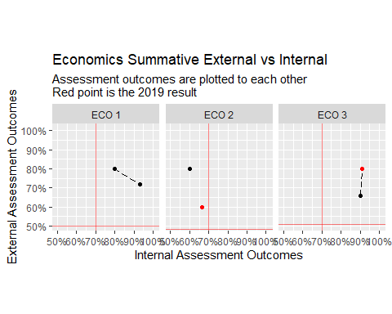
- Lacks consistent observations (either internal or external, or both, are missing).
- Some improvements in external assessment outcomes (ECO 3 ability to form research questions, ECO 4 information/data literacy).
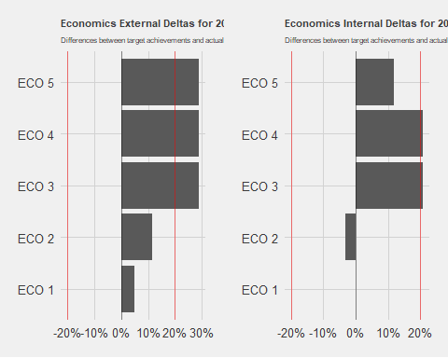
- Note that external ECO 3-5 use the same assessment tool, namely CPC test scores on quantitative research and statistics; also note that internal ECO 1 has no assessment this cycle.
- Both internal and external ECO 3 (ability form research questions with quantitative methods to answer) and ECO 4 (ability to evaluate information and data) have outcomes much higher than the target. Re-evaluations of those targets and/or assessments might be needed.
- ECO 5 (ability to communicate empirical analysis results) shows relatively less achievement in the internal assessment.
- In contrast, ECO 2 (macroeconomic analysis) shows only moderate success in the external and falls short in the internal assessment outcome. This unique disparity calls for an attention. It might be a sign that the knowledge of macroeconomics is not well translated into an application of it.

Finance
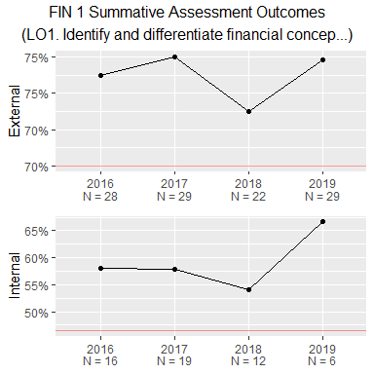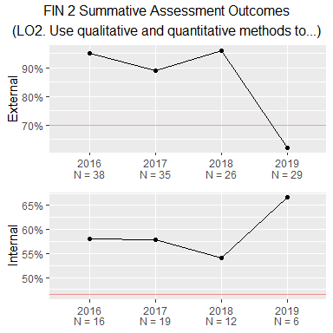
plo | description | internal_tool_description | external_tool_description
FIN 1 | LO1. Identify and differentiate financial concepts, theories, and/or methods that are used in making specific business decisions. | Comprehensive capital budgeting assignment | CPC Exam - Business Finance
FIN 2 | LO2. Use qualitative and quantitative methods to examine the worthiness of a common business issue. | Comprehensive capital budgeting assignment | CPC Exam - Business Finance
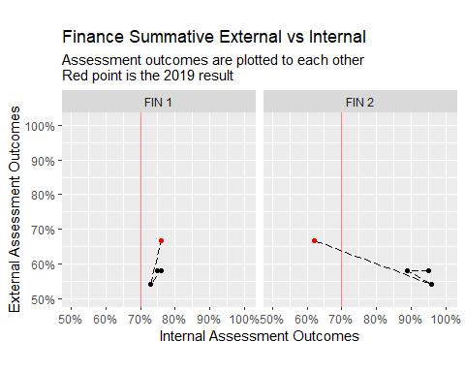
- While both FIN 1 and 2 improved in external assessment outcomes over time, FIN 2 suffered from a lower outcome in FIN 2.
- Note, however, the internal assessment has been done by different set of instructors in 2019 and no internal structure (i.e. rubric rows) is available. So, this change might be attributed to different grading practices.
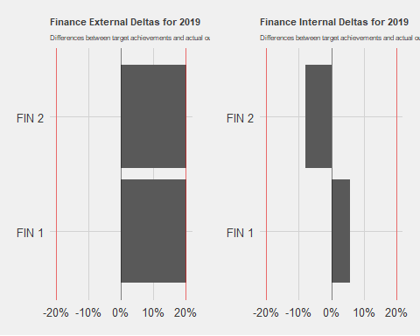

Human Resources Management
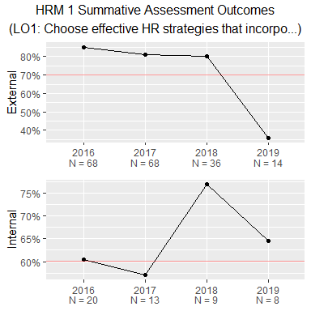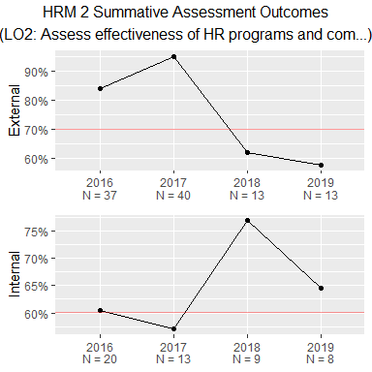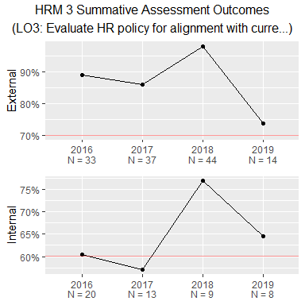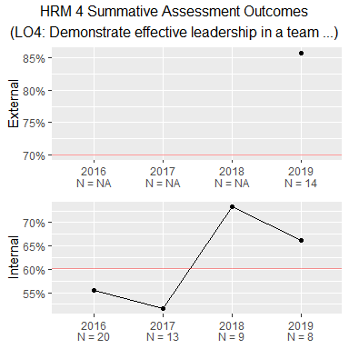
plo | description | internal_tool_description | external_tool_description
HRM 1 | LO1: Choose effective HR strategies that incorporate human and organizational dynamics while leveraging available HR technologies. | Interpretive HR Simulation Results | CPC Exam - Management: Human Resource Management
HRM 2 | LO2: Assess effectiveness of HR programs and compensation and benefits plans across organizational types. | Interpretive HR Simulation Results | CPC Exam - Management: Human Resource Management
HRM 3 | LO3: Evaluate HR policy for alignment with current HR Law and ethical HR practices. | Interpretive HR Simulation Results | CPC Exam - Management: Human Resource Management
HRM 4 | LO4: Demonstrate effective leadership in a team setting. | Interpretive HR Simulation Results | CPC Exam - Business Leadership
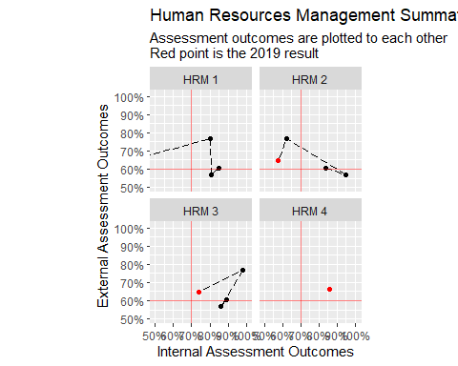
- Internal assessment outcomes in 2019 have declined significantly largely due to the renewed standards.
- External assessment outcomes had moderate fluctuations, but improved to remain above the target level.
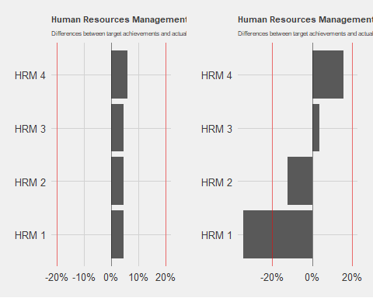

Management
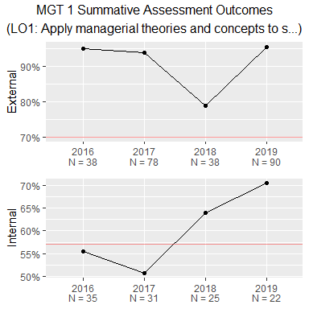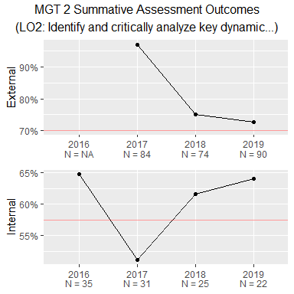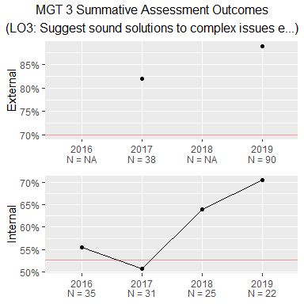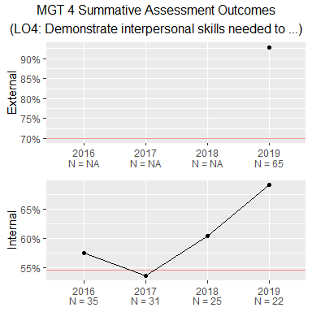
plo | description | internal_tool_description | external_tool_description
MGT 1 | LO1: Apply managerial theories and concepts to solve organizational problems | Ethics Final Paper | CPC Exam - Management
MGT 2 | LO2: Identify and critically analyze key dynamic factors in today’s business environment (e.g. globalization, technological change, climate change, etc. | Ethics Final Paper | CPC Exam - Management: Organizational Behavior
MGT 3 | LO3: Suggest sound solutions to complex issues encountered when managing people and processes in organizations doing business in an inter-connected world. | Ethics Final Paper | CPC Exam - Global Dimensions of Business
MGT 4 | LO4: Demonstrate interpersonal skills needed to work with individuals from various cultures and backgrounds. | Ethics Reflection | CPC Exam - Business Leadership
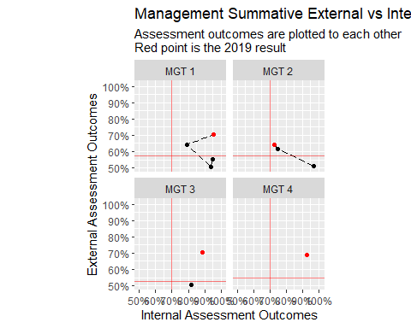
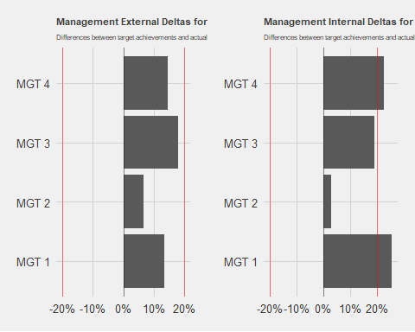

Marketing
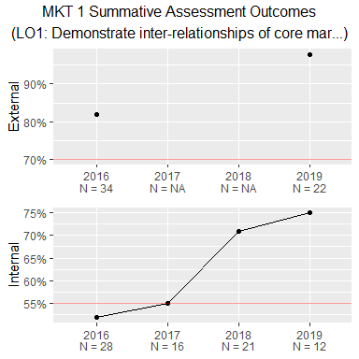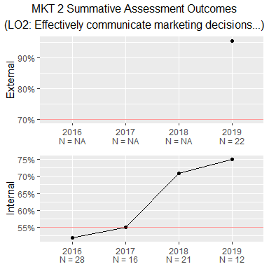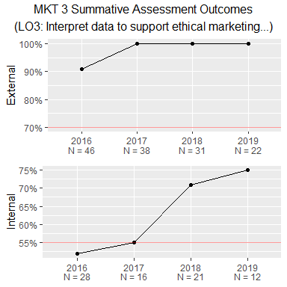
plo | description | internal_tool_description | external_tool_description
MKT 1 | LO1: Demonstrate inter-relationships of core marketing principles | simulation package with 4-5 interim assignments and an end-of-term reflections paper. | CPC Exam - Marketing
MKT 2 | LO2: Effectively communicate marketing decisions and processes | simulation package with 4-5 interim assignments and an end-of-term reflections paper. | CPC Exam - Marketing
MKT 3 | LO3: Interpret data to support ethical marketing decisions across constituencies | simulation package with 4-5 interim assignments and an end-of-term reflections paper. | CPC Exam - Marketing
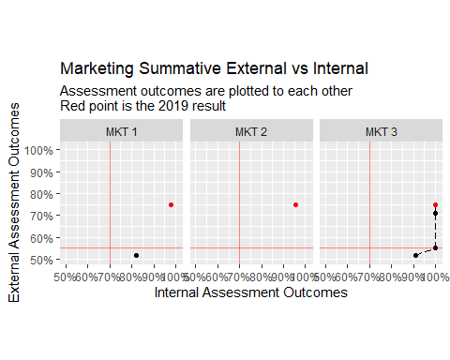
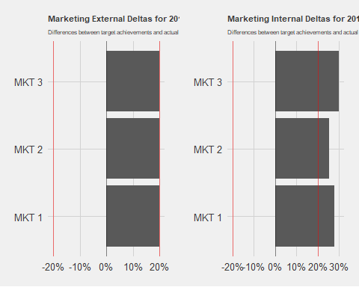

MIS

MBA
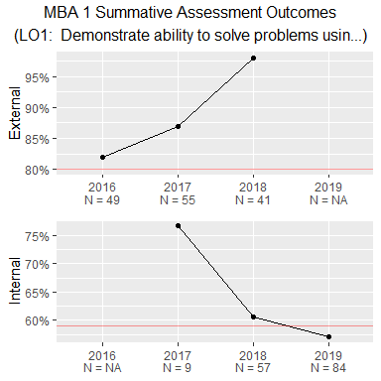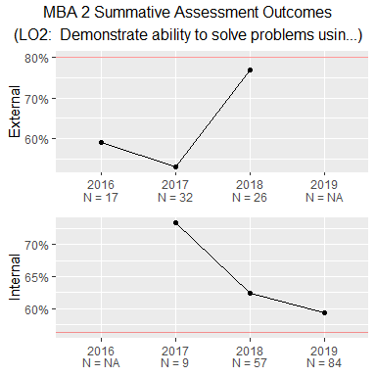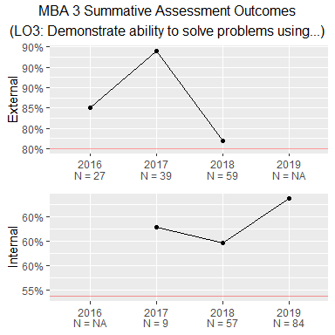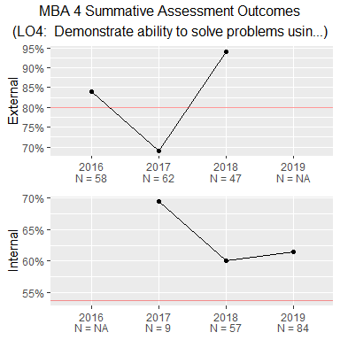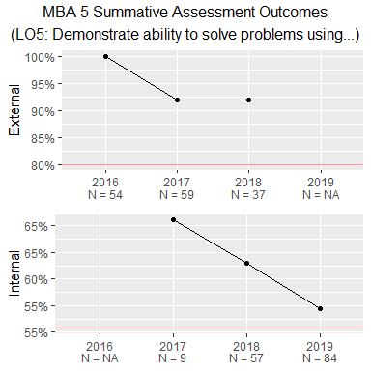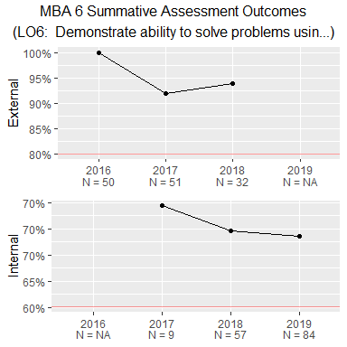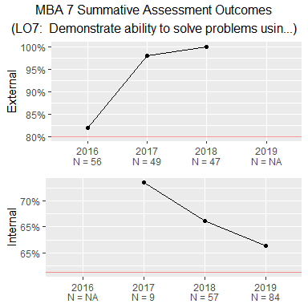
plo | description | internal_tool_description | external_tool_description
MBA 1 | LO1: Demonstrate ability to solve problems using the tools of accounting | Score on Final Exam | NA
MBA 1 | LO1: Demonstrate ability to solve problems using the tools of accounting | Accounting Question on Comp Exam | CPC Exam - Accounting
MBA 2 | LO2: Demonstrate ability to solve problems using the tools of economics | Score on Final Exam | NA
MBA 2 | LO2: Demonstrate ability to solve problems using the tools of economics | Economics Question on Comp Exam | CPC Exam - Economics
MBA 3 | LO3: Demonstrate ability to solve problems using the tools of finance | Score on Final Exam | NA
MBA 3 | LO3: Demonstrate ability to solve problems using the tools of finance | Finance Question on Comp Exam | CPC Exam - Business Finance
MBA 4 | LO4: Demonstrate ability to solve problems using the tools of human resource management | Score on Final Exam | NA
MBA 4 | LO4: Demonstrate ability to solve problems using the tools of human resource management | HR Mgt Question on Comp Exam | CPC Exam - Management: Human Resource Management
MBA 5 | LO5: Demonstrate ability to solve problems using the tools of international business | Score on Final Exam | NA
MBA 5 | LO5: Demonstrate ability to solve problems using the tools of international business | Int’l Business Question on Comp Exam | CPC Exam - Global Dimensions of Business
MBA 6 | LO6: Demonstrate ability to solve problems using the tools of marketing | Score on Final Exam | NA
MBA 6 | LO6: Demonstrate ability to solve problems using the tools of marketing | Marketing Question on Comp Exam | CPC Exam - Marketing
MBA 7 | LO7: Demonstrate ability to solve problems using the tools of strategic management | Score on Final Exam | NA
MBA 7 | LO7: Demonstrate ability to solve problems using the tools of strategic management | Strategic Management Question on Comp Exam | CPC Exam - Business Integration and Strategic Management
MBA 8 | LO8: Employ mathematical and statistical techniques in business decision-making | Score on Final Exam | NA
MBA 8 | LO8: Employ mathematical and statistical techniques in business decision-making | NA | CPC Exam - Quantitative Research Techniques and Statistics
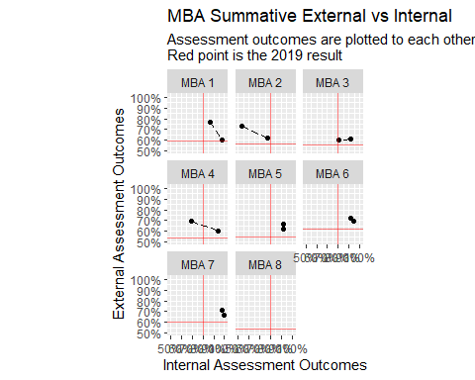
- Formative assessments only consist of internal assessments.
- Summative internal assessment outcomes for 2019 (comp exam) need to be provided.
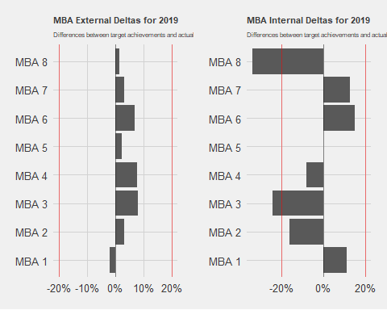

Next

