**Block Diagram**

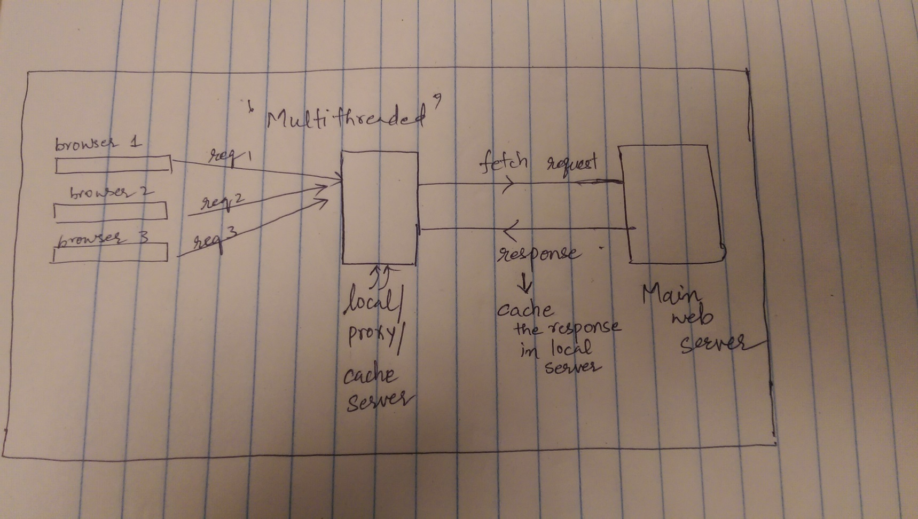

**Example Inpur/Output:** This is how your output should look like!

1. Multithreaded Server (compile-> gcc -pthread serverThreads.c, run -> ./a.out)

This is an example of connections (you need to fetch and display the actual websites on your web browser)

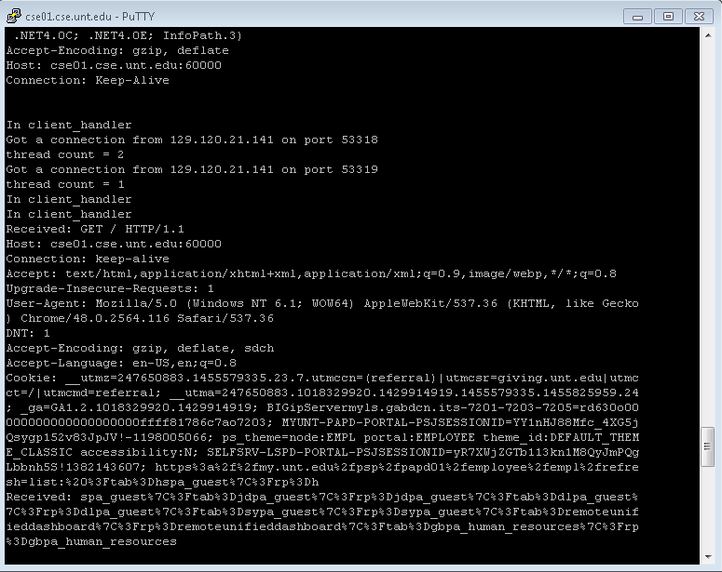

**2. Blocked website example:**

HTTP Response when a website in blacklist is requested

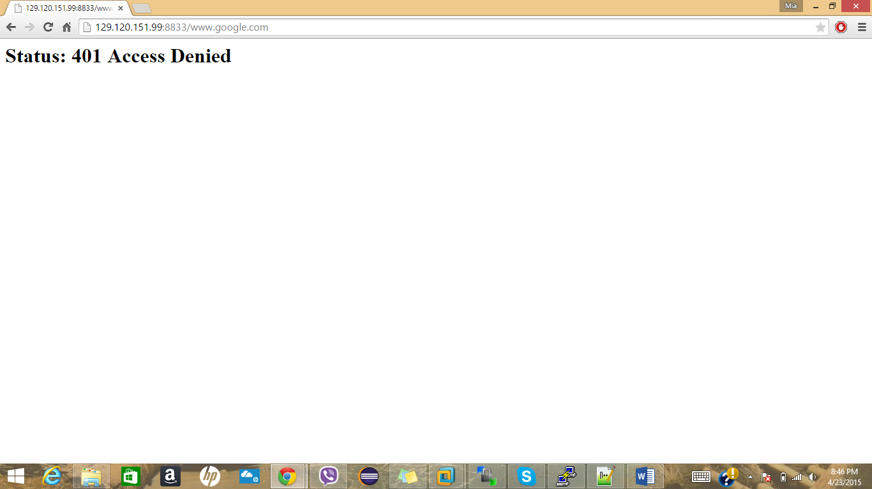

**3. Include caching in local server snapshot**

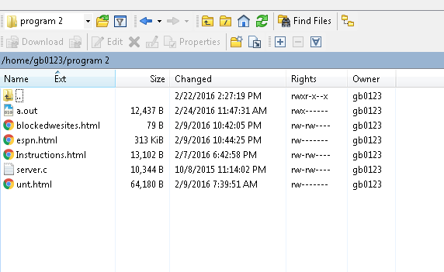

**4. Filtering language in the website:** [**http://www.hyperhero.com/en/insults.htm**](http://www.hyperhero.com/en/insults.htm) **(You can replace the words with blank space or any other word)**

