|  |  |  |  |
| --- | --- | --- | --- |
|  | |  | | --- | | **CSL-220: Database Management System** | | **Semester: BSIT-4A**  **BISMAH SIDDIQUI Fall 2021**  **02-235211-016** | |

**Lab 06: DDL Queries**

# Exercises

1. Create a replica of **Teacher** table with all the records in it.

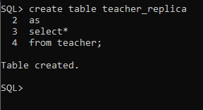

1. Create a replica of **Std** table with all the students that belong to BSCS program

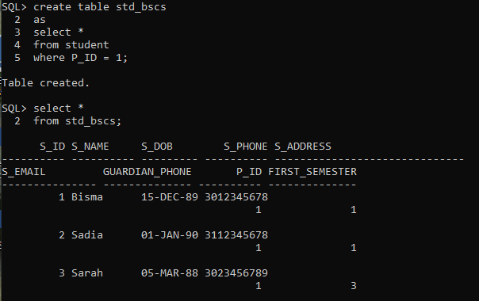

1. Add a column ‘Address’ in replicated **Teacher** Table.

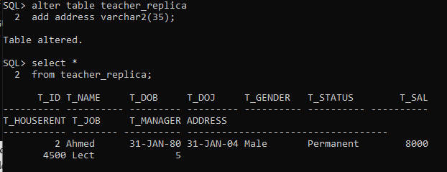

1. Drop column ‘Address’ from replicated table.

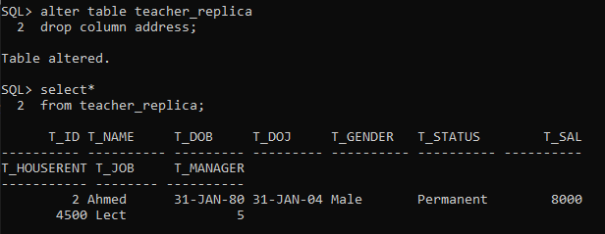

1. Add columns ‘House No’ character ,’Street No’ numeric, ’Area’ character ,’City’ character in replicated **Teacher** Table with the respective data types.

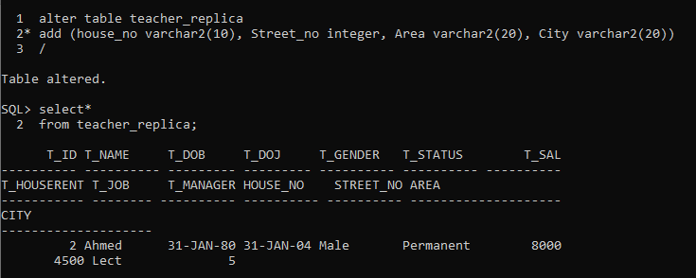

1. Change the data type of ‘House No’ from character to numeric.

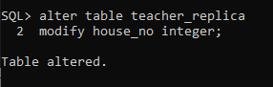

1. Create the Data Definitions for each of the relations shown below, using SQL DDL. Assume the following attributes and data types:

**FACULTY table:**

FacultyID (integer, primary key)

FacultyName (25 characters)

**COURSE table:**

CourseID (8 characters, primary key)

CourseName (15 characters)

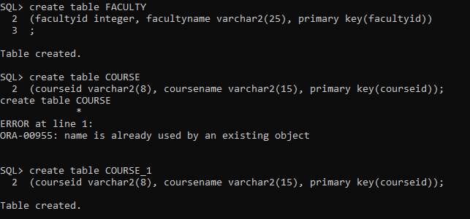

|  |  |  |
| --- | --- | --- |
| **Department of Computer Sciences** | **31/67** | **Fall 2021** |
| **CSL-220: Database Management System** |  | **Lab 06: DDL Queries** |

**CLASS table:**

ClassID (integer primary key)

CourseID (8 characters foreign key)

SectionNo (integer)

Semester (10 characters)



**STUDENT table:**

StudentID (integer, primary key)

StudentName (25 characters)

FacultyID (integer foreign key)

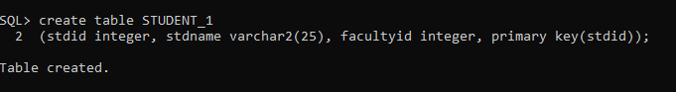

1. Add an attribute, **Class** and **Phone** to the **STUDENT** table.

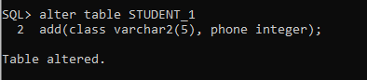

1. Change StudentName size from 25 characters to 20 characters

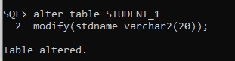

1. Remove all records from student table

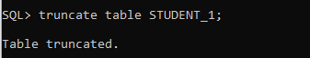

1. Remove newly created Faculty and Course tables

