Topics | Session
Chapter 1: An Introduction to Python  Basics of interpreter and compiler based languages pro’s and con’s | 45 min
Chapter 2: Beginning Python Basics  Datatypes with Example | 45 min
Tea Break | 10 min
Demo -1 With Raspberry Pi 3 | 10 min
Chapter 3: Python Program Flow  Control Statements and Special cases related to Python | 45 min
Chapter 4: Functions & Modules  Anonymous functions  List Comprehension  Basics of *args and **kwargs | 45 min
Lunch Break | 45 min
Chapter 5: Exceptions and Classes  Need for Handling run time anomalies  Introduction to OOP’s Concept | 45 min
Assignment and Demo-2 with RPi3 and ESP8266 | 10 min
Workshop on Python Programming
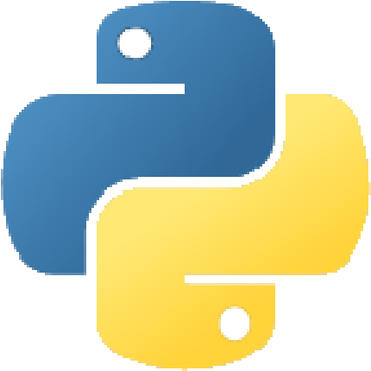

"Life's better without braces and Semicolons"
Day -1
Topics | Session
Chapter 6: Accessing API -1  Introduction to IoT  MQTT and HTTP Protocol  With Exposure Thingsboard IoT Platform | 45 min
Chapter 7: Accessing the API-2  Introduction to and Adafruit IoT Platform  Accessing Weather API’s in Python  Exposure REST API’s in Python | 45 min
Tea Break | 10 min
Demo-3 RPi-3 with Image Processing | 30 min
Lunch | 45 min
Chapter 8: Flask in Python  Running Headless Server in local machine  Decorators in Python  Basics of HTML and CSS for building Web Applications | 45 min
Chapter 9: Deep learning and Introduction to Tensor Flow  Introduction to Open CV  Accessing Google’s Tensor Flow API’s for object recognition  Face Detection and Recognition API’s in Python  Haar Cascade Classifiers in Python | 60 min

Day -2

Speaker’s
- K M Vinayaka Swamy (Module Lead, Hewlett Packard Enterprise, Bangalore)
- S G Ravi Prakash (Lead IoT Consultant, Preva Systems Pvt, Bangalore)

