Hands on Workshop on Python

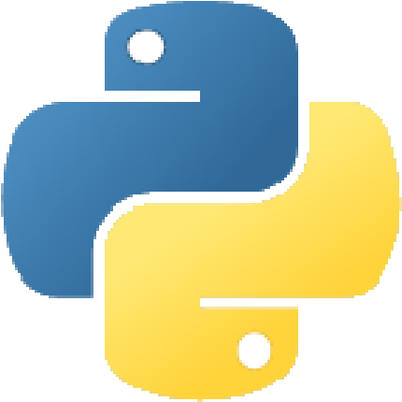

"Life's better without braces and Semicolons"
(Bruce Eckel)

Python is among the top five programming languages worldwide. More and more programmers are migrating to Python because of its combination of simple syntax and power. The language is easy to learn and remember. You can get more things done in fewer lines of code. Moreover, you can make use of hundreds of useful libraries to solve problems quickly.

This hands-on workshop is structured around carefully planned exercises. Concepts will be introduced and then exercises will be handed out to participants. Code that is written will be immediately reviewed by the trainer and discussed with the class. The best way to learn is by doing, by making mistakes. This workshop enables participants to start coding from the outset. Slides and presentations are kept to a minimum.

Skills Imparted

Python overview. Language syntax. Writing pythonic code. Hands-on learning and problem solving. Using Jupyter,IDLE or PyCharm editor. Looking up the help on core libraries.

Day -1

Chaper 1: An Introduction to Python
1.1 What can Python do?
1.2 Why Python?
1.3 Good to know
1.4 Python Syntax compared to other programming languages
1.5 Python Install

Chapter 2: Beginning Python Basics
2.1. The print statement
2.2. Comments
2.3. Python Data Structures & Data Types
2.4. String Operations in Python
2.5. Simple Input & Output
2.6. Simple Output Formatting

Chapter 3: Python Program Flow
3.1. Indentation
3.2. The If statement and its' related statement
3.3. An example with if and it's related statement
3.4. The while loop
3.5. The for loop

Chapter 4: Functions & Modules
4.1. Create your own functions
4.2. Functions Parameters
4.3. Variable Arguments
4.4. Scope of a Function
4.5. Function Documentations
4.6. Lambda Functions & map

Chapter 5: Exceptions and Classess
5.1. Exception handling with try and Handling Multiple Exceptions
5.2. try , except ,finally and default python handlers
5.4. Concepts of OOP’s in detail

Day-2

Chapter 6: Accessing API -1
6.1 Gmail(send,receive and much more things in gmail)
6.2 Youtube(upload,download and finding trending videos in Youtube)
6.3 Openweather ( Extracting weather condition and forecast based on lat and lon based on API key)

Chapter 7: Accessing the API-2
Introduction to IoT and protocols MQTT and HTTP in python API’s
7.1 Protocols MQTT and HTTP in python
7.2 Thingsboard API to push sensor data
7.3 Adafruit API to publish and subscribe sensor

Chapter 8: Flask in Python
8.1 Running Python server in Local machine
8.2 Accessing HTML and CSS files in flask (/)
8.3 Flask with SQL data base

Chapter 9: Deep learning and Introduction to TensorFlow
9.1 Face detection and Face recognition using Haar cascade Algorithm
9.2 Object detection using Tensor Flow API
9.3 People count in Python
9.4 Text detection in Images
9.5 Text to Speech conversion in Python
9.6 More examples in Python
Training Duration: Two days.
Target Audience:
• Students of ECE/CSE/EEE/ME/IP/Civil/MCA/Diploma Engineering

