Sureify-Coke Studio Front-end Challenge

# Requirements:

1. Design an app that lists and play popular songs from Coke Studio.
   1. Design a visually interactive list of songs.
   2. Implement a music player to stream songs.
   3. Implement a feature to favourite a song.
   4. Add search feature to search for song in the list.
   5. Implement song download functionality to device.
   6. Add user activity feature to track activities on a song.

# Implementation:

1. Custom design of music player – tracks each song, progress of song.
2. Download a song while playing.
3. Add to favourites list a song, you like.

# Screenshots

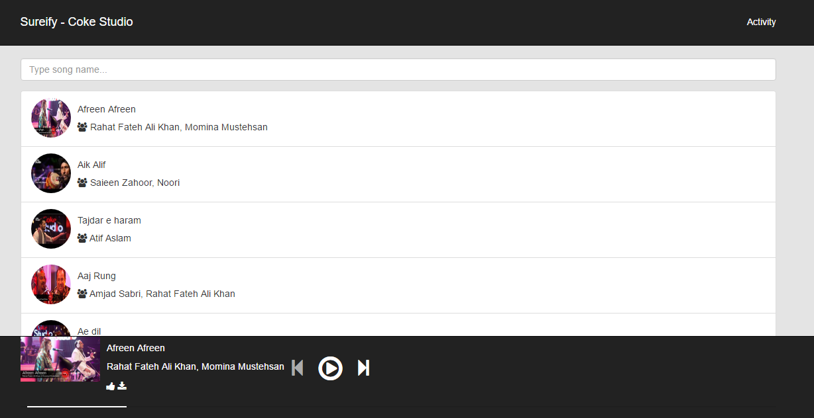

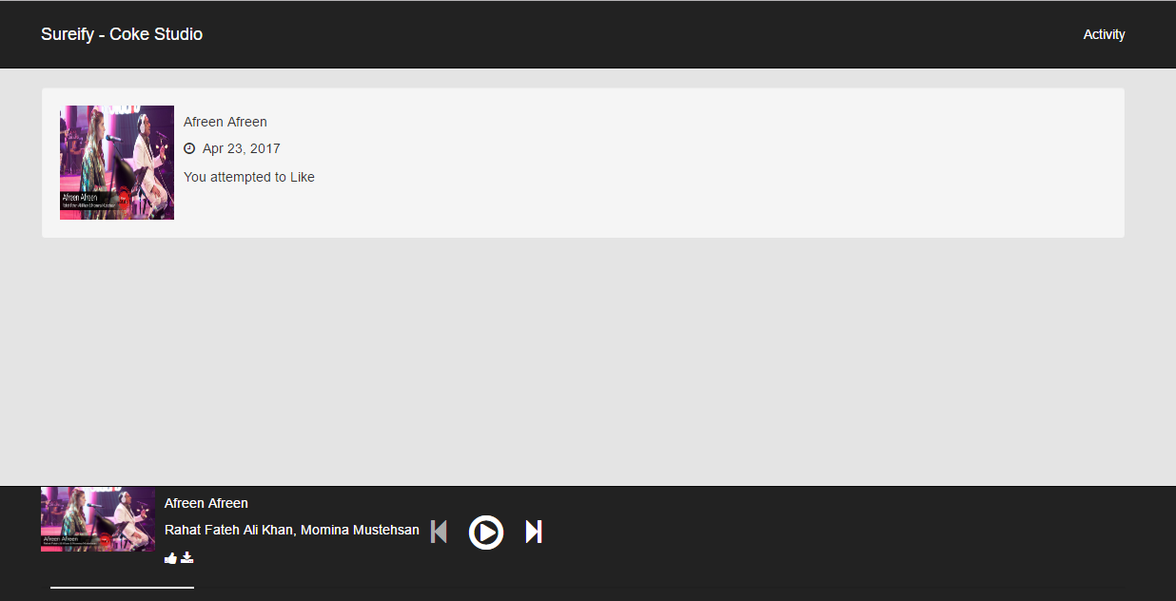

Fig 2: Activity of user, when (s)he likes/dislikes or downloads a song.

# Code Implementation:

Music player is built in AngularJS using AngularJS directives.

The Music Player component gives controls to control the music –

1. Previous – Move to previous song.
2. Next – Move to next song.
3. Play/Pause – Control the playback of the current song.
4. Liking/ Disliking a song
5. Download song.
6. Progress of the duration of current track.

# Deployment Instructions:

Copy the source code and unzip it.

Navigate into the extracted folder.

Open command window (Win + R for windows, or Terminal in Linux/Mac), and start a simple server in the current directory.

1. For NodeJS, type:
   1. npm install -g http-server
   2. http-server
   3. Navigate to <http://localhost:8080>