NEXUSCYBER
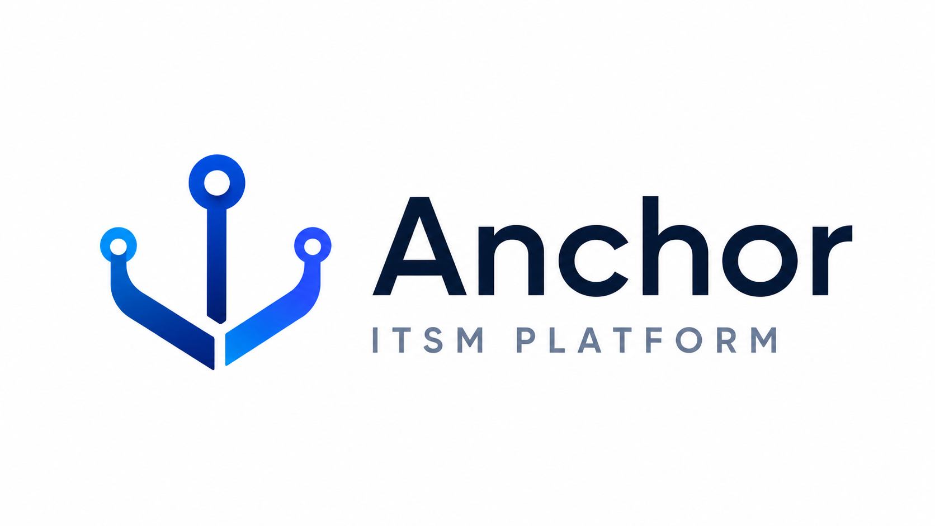
Administrator Guide
How to operate the Anchor ITSM platform — for service-desk agents and administrators

DOCUMENT TYPE | Administrator Guide
PRODUCT | Anchor ITSM Platform
VERSION | 1.0
AUDIENCE | Service-desk agents & administrators
PORTAL | https://anchor.azurewebsites.us

Table of Contents
1. Purpose & Audience
2. Signing In
3. The Control Plane at a Glance
4. Working Tickets
5. Service Catalog & Approvals
6. On-call & Escalation
7. Continuous Monitoring (ConMon) & Security Posture
8. Notifications & SLAs
9. Dashboards & Analytics
10. Customers & Tenancy
11. Knowledge Base
12. Quick Reference

1. Purpose & Audience
This guide explains how to operate the Anchor ITSM platform day to day. It is written for service-desk agents, team leads, and administrators who work tickets, run on-call and continuous monitoring, and manage customer tenants.
Anchor is a multi-tenant control plane: every customer organization is isolated, and what you can see or do is governed by your assigned role.

2. Signing In
Open https://anchor.azurewebsites.us and choose Sign in. Agents and administrators sign in with their organization account (Entra single sign-on) via the “Sign in as Admin” option.
- Agent / admin plane: the full operational control plane (tickets, on-call, posture, dashboards).
- Customer plane: a focused support experience for end users (see the companion User Guide).
Your role determines which navigation items appear. If something is missing, you likely lack the permission for it — ask a platform administrator.

3. The Control Plane at a Glance
The left sidebar groups everything you do into four areas:
Area | What lives here
Work | Dashboard, Tickets, Queues, Incidents, Service catalog, Knowledge base, Changes, Problems
Operations | On-call, Escalation, Alerts, Services, Customers, Channels, Automations
Insights | Dashboards, Analytics, Audit log, Email logs
Security | Posture, Compliance

Use the theme toggle in the top-right header to switch between light and dark mode; your choice is remembered.

4. Working Tickets
Tickets are the unit of work. Open Tickets or Queues to find work assigned to you or your team.
- Pick up a ticket by assigning it to yourself (this also stops the response-SLA clock).
- Use a public reply to talk to the requester; use an internal note for agent-only context.
- Move the ticket through its status as you work it (triage → in progress → resolved).
- Resolve when fixed; the customer is notified and invited to rate the experience. A customer reply reopens it.
Response vs. resolution SLA
Each ticket has a response target and a resolution target. The response clock is met on first response — a public reply, an assignment, or moving out of the intake state. Targets come from the ticket’s priority (or the catalog item for requests).

5. Service Catalog & Approvals
Customers raise structured requests from the Service catalog (e.g., new account, license, group change). Some items require approval before fulfillment.
- Pending-approval requests wait until an approver approves or rejects them; the requester is notified of the outcome.
- Fulfillment steps track the work; the request auto-resolves when all steps are complete.

6. On-call & Escalation
Operations → On-call shows schedules, the current responder, and each rotation’s participants.
- Add or remove responders from a rotation; the system re-sequences positions automatically and will not let you remove the last responder.
- Set a responder’s cell number so paging can reach them after hours.
- Delete a schedule when it is retired (blocked while pages are still open).
Escalation policies define who is paged, in what order, and after how long. A page that is not acknowledged in time escalates to the next step.

7. Continuous Monitoring (ConMon) & Security Posture
Anchor runs scheduled ConMon checks per customer (mapped to NIST 800-53 / CMMC controls). A failing check raises a posture finding.
- Critical/high findings can become remediation tickets (with a remediation SLA) routed to the owning tier — trackable like any other ticket.
- Security → Posture shows findings by severity and overdue remediation; Compliance shows control coverage by family.
See the Posture & Compliance dashboard for ConMon pass/finding results and NIST control coverage at a glance.

8. Notifications & SLAs
Notifications are event-driven and sent from the service mailbox. New tickets notify the covering team; customers receive an acknowledgment, reply, resolution, and CSAT email.
- The Notifications dashboard tab shows delivery health — sent, substituted, skipped, or failed — so silently dropped messages are visible.
- Email sends retry automatically on transient failures.
Default SLA targets (business minutes; response / resolution)
Priority | Response | Resolution
P1 | 15 min | 4 hours
P2 | 30 min | 8 hours
P3 | 60 min | 24 hours
P4 | 120 min | 72 hours

9. Dashboards & Analytics
Insights → Dashboards provides enterprise views with a 7/30/90-day selector and a per-customer filter:
- Executive KPIs — backlog, opened vs closed, MTTR, SLA attainment, CSAT.
- SLA performance — response/resolution attainment, met-vs-breached, within-SLA by category.
- Ticket operations — opened-vs-closed trend, backlog by status/priority/age.
- Team performance, Customer portfolio (MSP), Posture & compliance, On-call & change, and Notifications.

10. Customers & Tenancy
Operations → Customers lists the organizations you serve. Each org is isolated by row-level security; agents only see the customers in their scope.
- Onboard a new customer org and (for SSO) record its Entra tenant ID.
- The Customer portfolio dashboard gives a per-tenant health view: open backlog, P1s, SLA, CSAT.

11. Knowledge Base
Work → Knowledge base holds self-service articles and runbooks. Author and publish articles so customers can resolve common issues themselves (password reset, MFA, mailbox, cloud access).

12. Quick Reference
Task | Where
Find my work | Work → Tickets / Queues
See who’s on call | Operations → On-call
Run / review ConMon | Security → Posture; Compliance
Check notification delivery | Insights → Dashboards → Notifications
KPIs & SLA | Insights → Dashboards
Portal | https://anchor.azurewebsites.us

