NEXUSCYBER
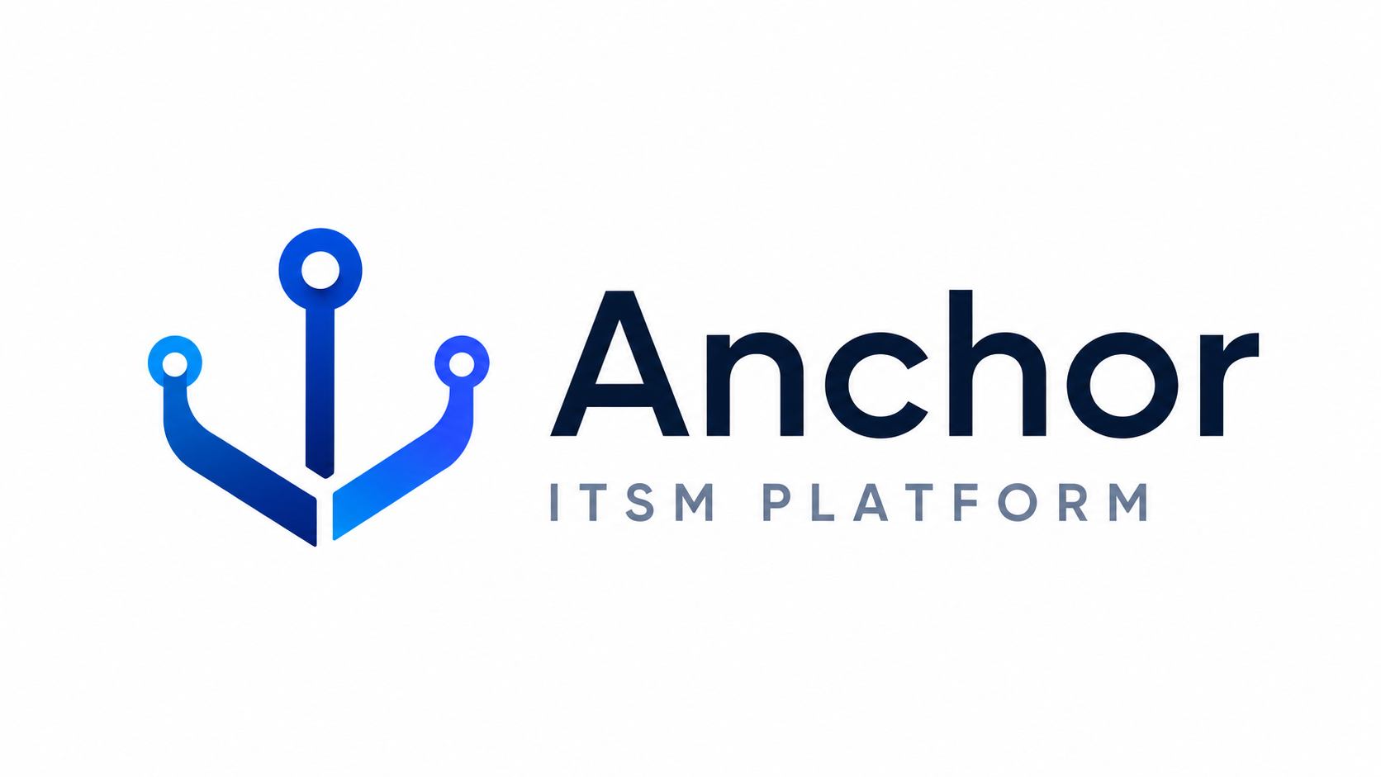
User Guide
How to get IT support through the Anchor portal — for end users

DOCUMENT TYPE | User Guide
PRODUCT | Anchor ITSM Platform
VERSION | 1.0
AUDIENCE | End users & customers
PORTAL | https://anchor.azurewebsites.us

Table of Contents
1. Welcome — What Anchor Is
2. Signing In
3. Getting Help — Submit a Request
4. What You Can Request
5. Tracking Your Tickets
6. Responding & Reopening
7. Rate Your Experience
8. Knowledge Base & Self-Service
9. Notifications You’ll Receive
10. Response Times
11. Reporting an Urgent or Security Issue
12. Quick Reference Card

1. Welcome — What Anchor Is
Anchor is your support portal for IT and Microsoft 365 help. Use it to ask for help, track your requests, and find self-service answers — every request becomes a tracked ticket so nothing is lost.

2. Signing In
Go to https://anchor.azurewebsites.us and choose Sign in. Use your work account (single sign-on). If your organization isn’t set up for SSO yet, contact your administrator.

3. Getting Help — Submit a Request
There are two ways to reach us, and both open a tracked ticket:
- Support portal (preferred): https://anchor.azurewebsites.us — pick the request that fits and fill in the details.
- Email: send your request to the support mailbox and we’ll open a ticket for you.
To help us act quickly, include:
- Who the request is for, and who is authorizing it.
- What you need (e.g., reset password, add to a group, assign a license).
- Any business impact or deadline (e.g., a new-hire start date).

4. What You Can Request
Common requests you can raise from the portal:
Category | Examples
Accounts | Password reset, account unlock, new user, offboarding
Access | Group membership, license assignment, shared mailbox
Microsoft 365 | Teams/SharePoint site, guest access, mailbox recovery
Cloud | Azure / AWS GovCloud access requests
Security | Report phishing, lost/stolen device

5. Tracking Your Tickets
Open Tickets (My requests) to see everything you’ve submitted and its current status. Each ticket shows its number (e.g., ABCD-000123), summary, status, and updates from the team.

6. Responding & Reopening
When our team replies, you’ll get an email. You can reply directly to that email — your response is automatically added to the same ticket (keep the ticket number in the subject).
- Replying to a resolved or closed ticket reopens it, so you don’t have to start over.

7. Rate Your Experience
After a ticket is resolved, you’ll be invited to rate your experience (1–5 stars). You can also rate it on the ticket page. Your feedback helps us improve service.

8. Knowledge Base & Self-Service
Many issues can be solved without waiting for an agent. Open the Knowledge base for step-by-step articles, including:
- Self-service password reset (including GCC High).
- Setting up MFA and recovering a lost authenticator.
- Installing approved software, recovering files, and mailbox tips.

9. Notifications You’ll Receive
From the support mailbox you’ll receive: an acknowledgment when your ticket is created, a note when an agent replies or your ticket is in progress, a resolution notice, and a short satisfaction survey. These are automated — reply to continue the conversation on your ticket.

10. Response Times
We prioritize requests by impact and urgency. Higher-priority issues get a faster first response and resolution target.
Priority | First response | Resolution target
P1 — critical | Minutes | Hours
P2 — high | Same business day | 1 business day
P3 — normal | Within hours | 1–3 business days
P4 — low | Next business day | As scheduled

11. Reporting an Urgent or Security Issue
For a suspected security incident (phishing, lost/stolen device, suspicious sign-in), use the matching request type so it is treated as high priority. Do not click suspicious links — report and delete.

12. Quick Reference Card
Need | Do this
Submit a request | https://anchor.azurewebsites.us → choose a request
Track a request | Tickets / My requests
Add information | Reply to the ticket email
Self-help | Knowledge base
Rate us | Resolved ticket → star rating

