CreditNirvana Product & Research Challenge
Problem Statement 3
An address geocoder that learns from field visits
Solution report: the problem, the data, what we use and why, the results, and how it runs inside the CN platform
At a glance
Result | Median pin error 43.9 m vs 376 m for the commercial geocoder (100 surveyed addresses); 66% of addresses within 100 m vs 9%
Where it learns | Field-visit GPS trails, failed-visit trails, address text structure, landmarks, agent integrity
Confidence | Every pin carries a calibrated 90% radius; 90% radius covers the true location 91% of the time on surveyed truth
Outputs | Pin, radius, tier, landmark directions for 3,117 addresses; offline packs per town; value-ranked verify queue; agent integrity table
Evidence status | Measured on 100 surveyed addresses (15 in test split). The reduction in "not traceable" is modelled, not measured; a randomised pilot is the proof

1. Executive summary
The problem. Field collections depends on finding the borrower. Commercial geocoders place Indian addresses at the pincode or locality centre, so the pin is wrong by hundreds of metres. On the 100 surveyed addresses in our data the commercial pin has a median error of 376 m and a 90th percentile of 839 m. Agents then search, ask neighbours, and sometimes close the account as "address not traceable", including accounts where the borrower lives exactly where the address says.
The opportunity. The answer already exists. Each successful visit records the GPS trail of an agent standing at the borrower's door. Today that sits in visit logs and never flows back into the address record.
What we built. A geocoder that gives every address a pin, a calibrated confidence radius and landmark directions, and that gets better as visits arrive. It combines five kinds of evidence in one probability model: the structure of the address text (locality, street grid, landmarks), the commercial pin as a noisy hint, GPS trails from successful visits, GPS trails from failed visits (as places the house is not), and an integrity layer that stops fake check-ins from teaching it wrong locations.
What it achieves.
- Median error 43.9 m against 376 m (8.6x better); 66% of surveyed addresses within 100 m, against 9%.
- On addresses that already have a field visit: median 9.1 m, 90th percentile 35 m.
- Replaying visits in date order, median error falls from 185 m to 53 m as visits accumulate from 436 to 5,578. The geocoder keeps improving.
- One agent (FA009) accounts for 222 of 610 visits that look fabricated. They are detected without naming the agent, and they carry almost no weight.
- Modelled effect on "address not traceable": per-visit rate falls from about 19% to 8%. This is an estimate to be proven in the pilot, not a measured result.
What we ask the business to do. Run a randomised pilot in one territory, send the 1,477 low-confidence addresses to a cheap verification step before any visit, and start verification with the 20% of that queue that holds 74% of the value.

2. The problem and what success means
The statement asks for a geocoder with five properties, and each one shaped a design decision:
Requirement | What it means in practice | How we meet it
Weak, noisy evidence | A GPS fix on a visit shows where the borrower was met, not necessarily the home. Accuracy varies. | Every visit is weighted by a learned reliability score and combined with an outlier model
Reading Indian addresses | Mixed scripts, transliteration, abbreviations, relative landmarks | Multilingual parser for locality, street-grid numbers and landmark phrases (English, Hindi, Kannada, romanised forms)
Honest confidence | The visit planner decides to visit or verify first; an uncalibrated score is worse than none | 90% radius calibrated against held-out evidence and surveyed truth
Fake visits | Check-ins from home or a tea stall would teach wrong locations; no single agent may push the model | Generic integrity flags, agent-level discount, learned visit reliability
Works offline | Field areas have poor connectivity | Static per-town packs of 150 to 170 KB each

Success metrics from the problem statement: median and 90th-percentile distance error against confirmed locations compared with a commercial geocoder; share of "address not traceable" outcomes; productive visits per agent-day; calibration of the confidence radius. The first and last we measure directly. The second we estimate with a model. The third needs the pilot.

3. The data and what we found

3.1 What we have
Table | Size | Role
addresses | 3,117 (2,880 in towns T1 to T3; 237 village) | Address text, type, source; the thing to locate
baseline_geocodes | 2,880 | Commercial pin and its stated precision (rooftop, street, locality, pincode)
field_visits | 5,578 visits, 9 agents | Outcome, check-in point, dwell, GPS accuracy, photo hash, remark
visit_gps_points | 160,406 fixes | The trail of each visit, about one fix every 30 seconds
surveyed_addresses | 100 (15 in the test split) | The only true locations; used for evaluation only, never for fitting
localities, landmarks_poi, towns | 240 POIs | Published locality centres and a landmark table (incomplete)
accounts, agents, lenders, payments, skip_traces, dial_attempts | shared | Checked for signal; accounts and agents are used (section 6.4); the rest are not (section 8)

3.2 Findings that shaped the design
- Addresses follow a street grid, and the grid is learnable. In town T1, the main-road number moves the location about 107 m per step along x and the cross number about 73 m along y. In T2 the gali number moves y by about 75 m. In T3 the block letter moves y by about 124 m. Published locality centres are off by about 200 m on average. This is why a model trained on visit locations beats the commercial geocoder even before any visit exists for an address.
- A visit's GPS trail is much better than its check-in point. Against the surveyed houses, the single check-in fix has a median error of 25 m and a 90th percentile of 152 m. The weighted average of the last five trail fixes (the agent standing at the door) gives 9.6 m and 61 m.
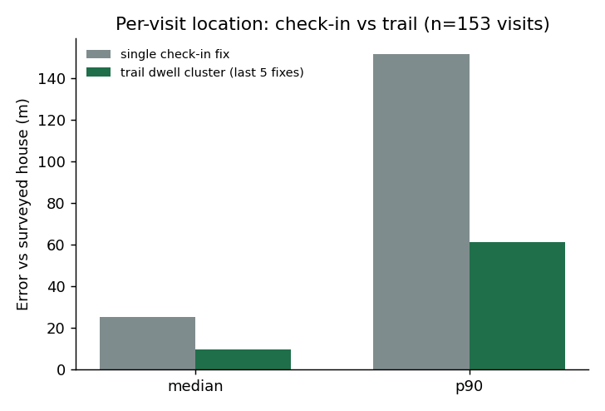
Figure 1. Per-visit location error against the surveyed house
- Every outcome except "not traceable" puts the agent at the house; "not traceable" is useful negative evidence. Found visits sit a median 15 to 35 m from the house. Failed visits cluster near the commercial pin, and only 9% of failed trails ever pass within 100 m of the true house, so a failed trail rules out the ground it covered.
- Pin error drives "address not traceable". At addresses where the commercial pin is within 100 m the not-traceable rate is 0%; at 800 m or more it is 54%. 569 addresses have both a found and a not-traceable visit, so the outcome often reflects an agent's failed search, not a bad address.
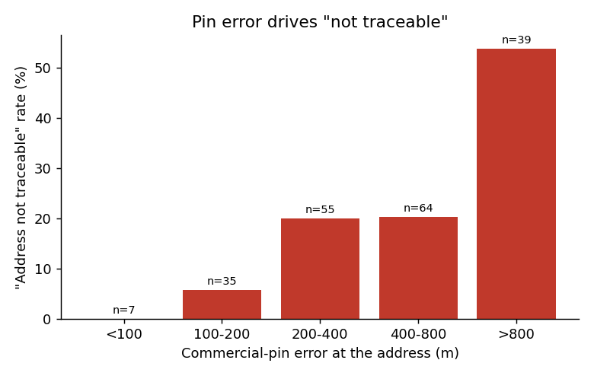
Figure 2. "Address not traceable" rate by commercial-pin error (surveyed addresses, 200 visits)
- One agent's evidence is contaminated. FA009 has 222 of 610 visits flagged: check-ins pile up at two fixed spots (123 and 79 check-ins) across 104 and 65 different addresses in different localities, and 162 visits share just six reused photo hashes. On surveyed addresses all six flagged visits were 2.7 to 7.2 km from the house. The other eight agents have no flags.
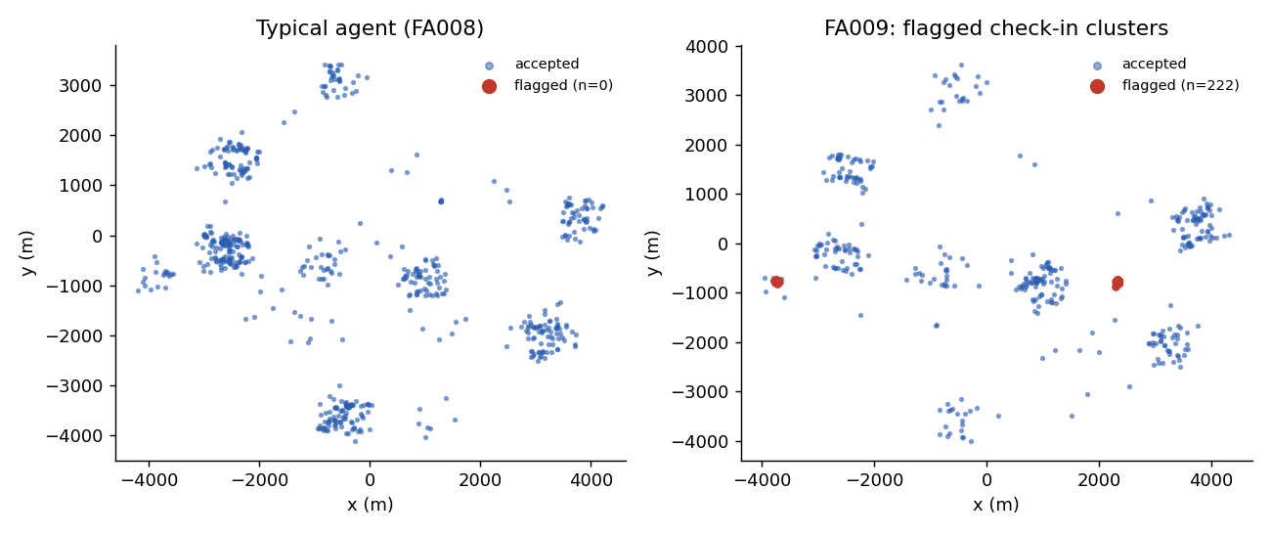
Figure 3. Check-ins in town T3: a typical agent versus FA009, with flagged clusters in red
- Matching "the same building" on text is unsafe. 27 groups of addresses (58 addresses) share locality, grid numbers and house number. Where both members of a pair are located, the median separation is 296 m and none are within 60 m. House numbers collide by chance. We therefore do not pool visits across accounts on a text match.

4. The solution: what we use and why
The geocoder treats each address as an unknown location and builds a probability map over the surrounding ground. Every piece of evidence multiplies the map by a likelihood. The pin is the centre of the final map and the confidence radius is its spread. This is one model, not a pipeline of hand-tuned rules, which is why new evidence can be added without breaking what exists.
Component | What it does | Why we use it (evidence)
1. Address parser | Reads locality (fuzzy match), cross/main/gali/block/road numbers, landmark phrases, pincode (edit-distance 1) | Names are misspelt and mixed-script. 90.2% of town addresses name a locality; for the rest, pincode narrows to 2 to 4 candidates
2. Street-grid prior | Per-town regression from grid numbers to coordinates, with learned locality centres and per-locality slopes; heavy-tailed | Cuts median error from 335 m (published centres) to 232 m with no visit at all; cross-validated on visit-derived labels
3. Landmark factor | Raises the likelihood of locations near a same-type landmark | Takes the prior-only median from 179 m to 136 m. The POI table is incomplete, so it is a soft factor with a 5% "landmark missing" allowance
4. Commercial pin | Used as a noisy observation, sigma by stated precision (rooftop 30 m, pincode 2 km) | Rooftop and street pins are good (26 m and 100 m error); locality and pincode pins are not. It helps, never dominates
5. Trail-dwell location | Weighted mean of the last five fixes of each visit | 3x tighter than the check-in point (9.6 m vs 25 m median)
6. Failed-visit trails | Every trail fix carves out probability mass where the house was not found | Only 9% of failed trails pass within 100 m of the house; the trail is real information
7. Integrity flags | Flags check-in clusters spread over many unrelated localities and photo hashes reused across addresses; discounts the agent | Catches FA009 with no agent id in the code; flagged visits were 2.7 to 7.2 km wrong
8. Learned visit reliability | Gradient-boosted model predicts if a visit is within 50 m of the consensus of the others; sets each visit's outlier probability and spread | Cross-validated AUC 0.92. The steadiness of the last five fixes is the strongest signal. Median error on 362 held-out visits 12.3 m to 8.2 m
9. Calibrated radius and tiers | 90% credible radius, rescaled with held-out evidence; A (visit), B (visit with directions), C (verify first) | The planner needs an honest radius to choose between visiting and verifying

4.1 Why one probabilistic model, not separate rules
- Evidence disagrees. A visit 5 km from the address text is either a fake, a borrower met at work, or a text error. A probability model weighs it against everything else instead of trusting or discarding it outright.
- Uncertainty comes for free. The radius is read off the model, then calibrated.
- It improves by adding evidence. A new visit, a new landmark or a new integrity signal is one more factor.

4.2 Why we trust the visit location but not every visit
Most visits are clean (90% of those we could test sit within 50 m of the consensus of the others). The risk is the minority that are not: fabricated check-ins, borrowers met at work, drifting GPS. We handle this in three layers: hard flags for obvious fabrication, an agent-level discount where flags are common, and a learned per-visit reliability score for everything else.

4.3 How the geocoder keeps improving
- More visits sharpen the street grid. Every located visit adds a training point for the prior, so addresses that were never visited get better too (median 192 m to 146 m in the replay).
- Verification calls and first visits convert low-confidence addresses. A tier C address that gets one clean visit becomes tier A.
- The integrity layer is re-scored weekly. A new fabricated pattern shows up as a new cluster and is down-weighted automatically.
- Landmark table repair. Visit clusters that repeatedly mention the same landmark reveal missing or offset landmarks to add.

5. How we tested it
- Ground truth. The 100 surveyed addresses are used only for scoring, never for fitting. They are all residences.
- Strict protocol. The street-grid prior is fitted on train-split accounts only, with the surveyed addresses excluded. The headline numbers come from this protocol. A second "production" fit uses visits from all splits (still excluding surveyed addresses) and is used for the delivered pins.
- Ablation. Each component is added in turn and re-scored, so every claim above is the measured gain of one step.
- Calibration. The radius multiplier is set on held-out addresses, then checked against surveyed truth, with a leave-one-out conformal check.
- Learning curve. Visits are replayed in date order and the whole model is re-fitted at seven cutoffs, to show improvement over time.
- Rejected ideas are reported (section 8).

6. Results

6.1 Accuracy against surveyed truth
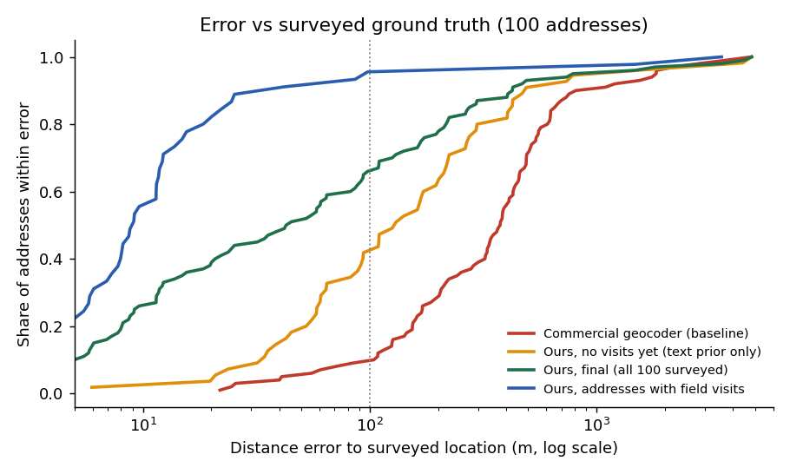
Figure 4. Share of addresses within a given error (log scale)
Step (each adds one upgrade) | All med (m) | All p90 (m) | Visited med | Unvisited med | Test (n=15) med
v0 commercial baseline | 376 | 839 | 384 | 363 | 456
v1 published locality centre | 335 | 837 | 336 | 329 | 464
v2 + street-grid prior | 232 | 647 | 229 | 240 | 160
v3 + commercial pin as observation | 179 | 602 | 185 | 169 | 145
v4 + landmark factor | 136 | 528 | 152 | 131 | 109
v5 + visit evidence (check-in point) | 58 | 426 | 19 | 131 | 82
v6 + trail-dwell location | 44 | 426 | 9.2 | 131 | 82
v7 + outlier model + integrity | 44 | 426 | 10.6 | 131 | 82
v8 + failed-trail evidence | 44 | 426 | 10.6 | 131 | 82
v9 + learned visit reliability (final) | 43.9 | 425.6 | 9.1 | 131 | 82
Visited = 45 surveyed addresses with a clean field visit; unvisited = the other 55.
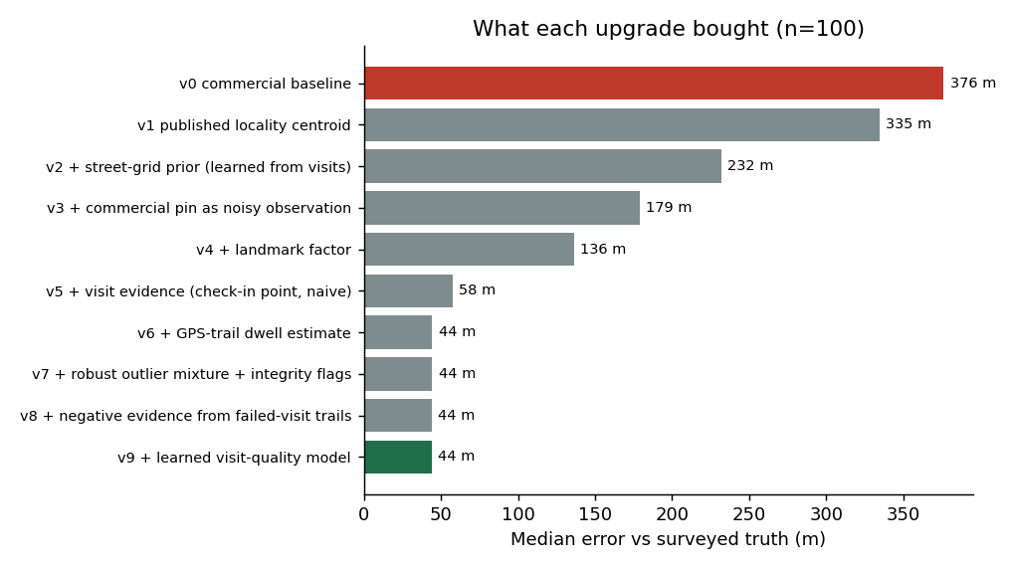
Figure 5. Median error after each upgrade
Read the tails carefully. Mean error is 262 m (baseline 533 m) and the 90th percentile is 426 m. The long tail comes from addresses that name no locality, where the pincode leaves 2 to 4 candidate localities (n=10 on the surveyed set: median 412 m, mean 1,566 m). The calibrated radius marks these as tier C. The test split's 90th percentile is 2.8 km for the same reason, on only 15 addresses.
The last three steps barely move the medians on this surveyed sample: a clean trail-dwell estimate (v6) is already as good (9.2 m vs 9.1 m). Their value is robustness. All six flagged visits on surveyed addresses were 2.7 to 7.2 km wrong, and on 362 held-out visits the learned weighting cut the median error by a third.

6.2 It improves as visits arrive
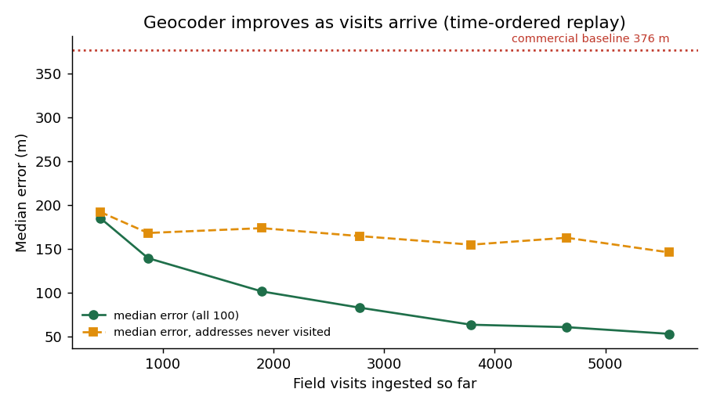
Figure 6. Median error vs visits ingested (time-ordered replay)
Median error falls from 185 m with 436 visits to 101 m with 1,897 and 53 m with 5,578. The share of surveyed addresses within 50 m rises from 17% to 49%. Addresses that were never visited also improve (192 m to 146 m), because the street-grid prior learns from other addresses.

6.3 Confidence radius
- No visit yet: raw radius times 1.10, fitted on 347 held-out addresses. Coverage of the 90% radius on surveyed truth is 0.91 (n=56). Median radius 397 m.
- With visits: raw radius kept. Coverage on surveyed truth 0.91 (n=44). Median radius 30 m. A held-out-visit proxy test gave a lower raw coverage (0.79), but its targets are single noisy visits, so we did not widen further.

6.4 What the geocoder tells the visit planner
Tier | Addresses | Rule | Action
A: visit directly | 1,165 | 90% radius up to 75 m | Visit with the pin
B: visit with directions | 238 | Radius up to 200 m | Visit; use landmark directions
C: verify first | 1,477 | Radius over 200 m | Cheap verification (call or WhatsApp location) before a field visit
Not geocodable | 237 | Village addresses outside the three mapped towns | On-ground verification

For tier C and not-geocodable residences we rank a verify queue of 1,172 addresses by expected value (overdue amount times the dataset's ability-to-pay estimate, used as a stand-in for recovery chance). The top 20% of the queue holds 74% of that value. The suggested field-agent pool for each address matches the account's language and excludes flagged agents.

6.5 Effect on "address not traceable" (modelled)
A logistic fit on 200 visits at surveyed addresses relates pin error to the not-traceable outcome. Applying it to our pins instead of the commercial pins implies the per-visit not-traceable probability falls from 19.3% to 7.6%, about 60% relative. This assumes the outcome depends only on pin error and rests on 49 addresses. We present it as the hypothesis for the pilot, not as a result.

7. How it runs inside the CN platform
CN component | What it receives from the geocoder | Behaviour
Field app | Pin, 90% radius, tier, landmark directions, per town, offline | Static pack of 150 to 170 KB per town; no network call at visit time
Visit planner | Pin and tier for each address | Tier A and B go to visit lists; tier C goes to verification first
Address records | A confirmed pin after a clean visit | Written back to the account. Not shared across accounts on a text match (section 3.2, finding 6)
Right-party contact (PS2) | Location confidence | Addresses that are only hard to find are not marked invalid
Integrity team | Per-visit flags and per-agent flag share | A flagged agent goes to human review; no automatic penalty
Dashboards | "Not traceable" trend and error by territory | Computed from the same tables; refreshed with each visit batch

7.1 Constraints
Constraint | How the design handles it
DPDP: purpose and retention | Location data is used only for collections. GPS trails are needed only long enough to compute the dwell estimate and the failed-trail evidence; after that only the derived pin should be kept. Field-operations data stays in a separate access scope
Employment and monitoring law | Agent GPS is used for evidence weighting and integrity review only. A flag triggers human review, never an automatic penalty
No over-inference | The geocoder returns a pin for an address already on file. It does not infer where a person goes
Explainability | Each pin comes with the evidence behind it: visits used, visits discounted and why, landmark used, radius
Fair Practices Code | Pins are used only to locate a visit. Low confidence routes to verification, never to harsher treatment

7.2 Pilot design
- Where: one territory, starting with T1, where the street grid is cleanest.
- Randomisation: at agent-day level. Arm A uses the new pins and tiers; arm B continues the current process.
- Outcomes: "address not traceable" share, productive visits per agent-day, distance from the planned pin to the confirmed meeting point, and radius coverage.
- Duration: long enough for each tier C address to be verified and visited at least once.
- Stop rules: pause if the 90% radius covers under 80% of confirmed locations.

8. What we tried that did not help
We checked every table in the dataset for signal. These did not earn a place in the model, and we say so rather than pad the story.
Idea | Test | Result
Agent remarks (address corrections) | Parsed 643 correction clauses ("actual house behind the park, 2 lanes ahead") into landmark, relation and lane count; added as a landmark factor under six settings | No change on surveyed addresses. The agent already stood at the house (median 7 m), and the named landmark is within 100 m of the located house only 19% of the time
"Met at shop" remarks | Widened the uncertainty of those visits | Visited-address 90th percentile worsened from 41.5 m to 64.9 m; rejected
Search-effort wording on failed visits | Compared how close failed trails passed to the house | 14% vs 8% within 100 m, on 21 vs 26 visits; too few to use
Lender address format | Prior error by KYC format | 175 to 212 m across formats; no difference in unresolved-locality share
Cash-field payments | Matched cash-collected visits to cash payments | 14 same-account pairs, none within 48 hours
Dial-attempt remarks | Searched for location content | The 267 matches all mean "phone switched off"
Residence and office of one account | Distance between the two | Median 3.75 km; one does not locate the other
Cross-account building matching | Same locality, grid and house number | Median 296 m apart; chance collisions

9. Limitations and risks
- Small ground truth. 100 surveyed addresses, 15 in the test split. Confidence intervals are wide, and the data is synthetic.
- Heavy tail. 1,635 town addresses have no clean visit and rely on the text model alone (median error about 130 to 190 m, 90% radius about 400 m). Addresses with no locality named are the worst.
- Along-street position in towns T2 and T3 is weakly predicted by the text alone.
- Villages (237 addresses) are outside the three mapped towns and are not geocoded.
- Labels are visit consensus for the prior, which carries 10 to 30 m of noise.
- Calibration in the with-visits regime rests on 44 surveyed addresses.
- The not-traceable and productivity effects are unproven until the pilot.
- Gaming. An agent who learns the integrity rules may adapt. The flags are generic and re-scored weekly, and the learned reliability score uses features an agent cannot easily control, such as trail steadiness.

10. Roadmap: the improvement loop
# | Upgrade | Expected gain
1 | Ask the borrower or agent for the locality or a landmark when none is named | Converts tier C to tier A; removes the main source of the tail
2 | Route one visit per day per locality to the highest-uncertainty cluster | Improves many unvisited addresses at once
3 | Weekly integrity re-scoring and per-agent drift monitoring | Keeps fake visits out as behaviour changes
4 | Landmark table repair from visit clusters | Stronger landmark factor
5 | Learned building identity, once verified same-building pairs exist | Safe cross-account pooling
6 | Randomised pilot | Proves the not-traceable and productivity effects

Appendix A. Reproducibility and files
All numbers in this report come from the code supplied with it. Run order: runA.py (pins), runB.py (calibration), runC.py (learning curve), runD.py (outputs), final_ablation.py (ablation table), charts.py (figures). vq.py builds the visit-reliability model and remark.py parses remarks.
File | Contents
geocoded_addresses.csv | Pin, 50% and 90% radius, tier, evidence type, directions, account value fields and suggested agent pool for all 3,117 addresses
verify_queue.csv | 1,172 residence addresses to verify, ranked by expected value
offline_pack_T1/T2/T3.json | Compact per-town packs for the field app
visit_integrity.csv, agent_integrity.csv | Per-visit flags and weights; per-agent flag share and action
ablation.csv, learning_curve.csv | The tables behind sections 6.1 and 6.2

