Administrator User’s Guide

Reference Material Series

Aheeva Contact Center Suite

version 4.3

Copyright © 2006 Aheeva Technologie Inc. All Rights Reserved.

All contents of this document are subject to change without notice and do not represent a commitment on the part of Aheeva. Every effort is made to ensure the accuracy of this information. However, due to ongoing product improvements and revisions, Aheeva cannot guarantee the accuracy of this material, nor can it accept responsibility for errors or omissions. No warranties of any nature are extended by the information contained in these copyrighted materials. Use or implementation of any one of the concepts, applications, or ideas described in this document or on web pages maintained by Aheeva, may infringe one or more patents or other intellectual property rights owned by third parties. Aheeva does not condone or encourage such infringement. Aheeva makes no warranty with respect to such infringement, nor does Aheeva waive any of its own intellectual property rights that may cover systems implementing one or more of the ideas contained herein. Procurement of appropriate intellectual property rights and licenses is solely the responsibility of the system implementers. The software referred to in this document is provided under a Software License Agreement. Refer to the Software License Agreement for complete details governing the use of the software.

Aheeva and the Aheeva logo are registered trade marks.

Published by:
Aheeva Technologie Inc.
1000, St-Antoine Street West, Suite 500
Montreal, Quebec
Canada, H3C 3R7

www.aheeva.com

Document Version history

Date | Version | Author | Description of changes
See Appendix A.

The masculine gender is used in this document with no discrimination and for the sole purpose of readability and clarity.

Table of contents

About Aheeva Technologie 7
Who should read this guide? 7
What’s new in version 2.1? 8
Version 2.1 features 9
System requirements 10
License information 10
Asterisk configuration files 11
Answering machine detector 11
Transfer application 12
External trunk application 13
Working with the CCS application 14
Menus 15
Viewing real-time information 18
Short cut to agent’s and agent group’s information and properties 22
Setting up resource files, work force management and quality control 22
Network management 24
Site setup 24
Defining a site 24
PBX server 25
Recording server 26
Encryption server 27
Modifying the configuration 28
Displaying server statistics 29
Tenant management 31
Setting up tenants 31
User management 32
Creating users 32
Live monitoring of users 34
AheevaPhone settings 37
Service levels and productivity 38
Queues 38
Wrap-up time and Not Ready reasons 38
American call center features 39
Payroll general configuration 40
Call center activities and payroll 42
Resources 43
Not Ready reasons 43
Setting up Not Ready reasons 43
Skills 44
Setting up agent skills 44
Queues 45
Setting up call queues 45
Setting up service & productivity tolerance with queues 46
Using the CCS CTI Command Line Interface 47
Agent groups 47
Setting up groups of agents 47
Modifying agent groups 50
Assigning agent groups to campaigns 51
Agents 51
Setting up your agents 51
Managing your agents’ files 54
Filters 55
Creating filters 55
Modifying filters 56
Treatments 56
Creating Treatments 56
Modifying treatments 57
Example of a filter, a treatment and a calling list 58
Calling lists 59
Step 1 — Creating calling lists 60
Step 2 — Creating calling lists 64
Modifying calling lists 65
Do-Not-Call lists 66
Creating Do-not-call lists 66
Adding numbers to Do-not-call lists 66
Searching for Do-not-call numbers 67
Displaying Do-not-call list contents 67
Campaigns 67
Setting up service campaigns 67
Running your campaign 72
Work force management 74
Teams 74
Setting up teams of agents 74
Work schedules 75
Adding a schedule 75
Viewing and adjusting published schedules 76
Real-time adherence 77
Agent adherence to work schedules 78
Payroll information 80
Setting up commissions 80
Setting up methods of payment 81
Payroll information reports 83
Routing scripts 87
Routing scripts 87
Step 1—CCS Manager scripting tool 87
Step 2—Asterisk’s extensions.conf file 91
Reporting 93
Generating reports 93
Agents 94
Agent Groups 97
Agent summary 98
Outbound calls 99
Inbound calls 100
Agent login 101
Campaigns 101
Calling Lists 101
Queues 102
Quality Monitoring 104
Playing recordings 104
Recording reports 105
Index 107
Appendix A — Document change history 112
Appendix B — Formulas to generate return values in reports 115

List of figures

Figure 1. Aheeva CCS architecture. 14
Figure 2. User interface. 15
Figure 3. Menus. 16
Figure 4. Real-time information and live conversation monitor. 18
Figure 5. Example of a contact center site with its dedicated servers. 25
Figure 6. Live monitoring of users. 35
Figure 7. Calling list performance at a glance. 65
Figure 8. A campaign’s record. 69
Figure 9. Creating work schedules. 75
Figure 10. Adjusting work schedules. 76
Figure 11. Adherence to work schedule in real time. 78
Figure 12. Payroll on login and production time. 84
Figure 13. Creating routing scripts. 88
Figure 14. Selecting recordings to playback 105

About Aheeva Technologie
Aheeva Technologie Inc. develops and commercializes CCS, a multimedia customer contact and relations management platform based on the award-wining open source, standard-based, IP PBX, Asterisk. The platform delivers intelligent call routing and multimedia contact management for outbound and inbound applications, including sales, customer support and market research.

The advantages of an IP Contact Center Suite are multiple:

Easy integration and fast deployment. IP architecture allows you to create the configuration that works best with your infrastructure and meets your needs. Exploiting existing data networks gives you greater control and management capability over your current investments by achieving the full lifecycle value from investments in ACD and PBX.
Reduce call center operating costs. VoIP software technology facilitates implementation of remote call center branches and remote representatives. Cost saving can be realized since the organization will not be charged for carrier or long-distance charges between the gateway connected to the primary contact center switch and the remote switch or user.
Integrate all media in a single platform and single point of administration. Using converged voice and data networks hightens manageability and lowers the cost of expansion.
Improve agent productivity. Numerous monitoring and call management features — real-time monitoring, full audio and video recording, performance reporting and adherence to work schedules, efficient and highly customized calling lists and routing scripts— allow you to follow the activities of agents (local or remote) and make the appropriate adjustments. Information is available to you rapidly so you can make changes even in the middle of a service campaign.

CCS is intended for supervisors, managers and administrators of contact centers. Because it runs in a server–client environment it is accessible at any time with an internet browser.

Who should read this guide?
This manual is intended for the users of the Aheeva’s application: supervisors, managers and administrators of contact centers. It describes the application’s features and contains step-by-step procedures on how to use them.

System administrators will have read the Installation guide as part of the platform installation process.

What’s new in version 2.1?
Network management and view. The entire network and all its sites are now managed from a single location through an easy-to-use diagram. The Aheeva CCS network is made up of the CCS CTI server and as many sites as you wish to define. Sites (local or remote) are made up of PBX servers, recording servers (SSL protocol) and encryption server.

Each site you define is visually confined to a box with a dotted-lined border: you simply insert the various servers you need and position them for easy viewing by clicking and dragging the object.

Recording servers are independant from the CCS CTI module. Recordings are performed on local servers and data is sent to the central server (CTI module) at user-defined periods. This feature reduces bandwidth usage at times of heavy traffic as you can have synchronization with the main server occurring at night, for instance.

Database connection notification. Automatic notification when one of the database connections fails and connection cannot be reestablished. Only a simple modification of the serverCfg.xml file is required and system administrator will receive a status update or failure notification.

Slave and clustering technology. Reports can be generated with either one of these MySQL technology for users who make the request. Slave server capabilities can be used for large database requests whereas clustering offers high availability.

CTI command line interface. To get right into the heart of the CCS CTI module, a new command line interface. It’s purpose is to monitor the calls that are in queues and to remove calls from queues if need be.

New queue, agent and agent group reports with new table for the dbCruncher tool. These tables have been redesigned to extract specifically information on performance. Data is presented according to service levels as calls are answered, not answered or abandoned. Reports are displayed more quickly. A pie-chart diagram has been added so you can evaluate the data at a glance. A range is given, in second increments, between the moment at which calls are placed in queues and the time at which they are answered

Direct on-line live monitoring. Clicking any of the agents’ names on the CCS real-time monitoring window frame brings up an audio player to listen to the agent’s and customer’s conversation without the need to dial an access code.

Do-not-call list support. Users can draw lists of customers who do not wish to be contacted, either for a specific service campaign, or ever at all. Available options include a global Do-not-call list. Also user-defined, it will contain those numbers that should never be called, such as the emergency services’ or the police station’s number.

Version 2.1 features
New and improved features in version 2.1.

New graphical user interface. A crisp look for the graphical interface to make features and tools neatly accessible.

Service level and productivity control. Up-front controls for user-defined service factor and service levels monitoring through queue timing parameters and wrap up time settings.

Payroll module. Redesigned to incorporate global payroll configuration feature that ties in tolerance values to user-defined work periods and call center activities and duration for Not Ready reasons.

Login and production report. A tool to override payroll data to reflect changes in agents’ activities and apply specific terms of payment.

American call center features. Dial function on AheevaPhone can be disabled. Data that is collected behind the scene and stored in the database from where users can retrieve it: includes DNIS, call ID and switch ID as well as disconnect reason.

System requirements

Operating system
Windows XP or Linux for agents’ station.
Windows XP for supervisors’ station.
Linux for server computer.
Browser: Internet Explorer.
Headset: Plantronics (DA55 with H51/H51N) or DSP-100.
Line: Either T1, E1, PRI, analog lines or IP connections.
Server
The Web server and the Aheeva application server can be located on the same computer. The database server can also be installed on the same computer or, depending on your needs, on another machine.
Database: MySQL

License information
The license that you have acquired will determine which modules of the application are available to you. For that reason, the screen captures that are shown in this document may not reflect exactly what you see in the window of the CCS Manager. This is especially true of the menu frame as it lists the available features and is used for navigation.

Asterisk configuration files
Three of Asterisk’s configuration files must be configured before your start running the CCS Manager. You must enable Asterisk’s answering machine detector, transfer and trunk applications: TFER, TRUNK and AMD.

 | Related topics. Several other features of the CCS Manager require that you modify some of Asterisk’s files. See the topics, this document, Live monitoring of users, Setting up call queues, Setting up your agents and Routing scripts.

Answering machine detector
Use a command shell, to set amd.conf file as follows:
Asterisk | # initial_silence: Maximum silence duration before the greeting. If exceeded then MACHINE.  # greeting: Maximum length of a greeting. If exceeded then MACHINE.  # after_greeting_silence: Silence after detecting a greeting. If exceeded then HUMAN  # total_analysis_time: Maximum time allowed for the algorithm to decide on a HUMAN or PERSON  # min_word_length: Minimum duration of Voice to considered as a word  # between_words_silence: Minimum duration of silence after a word to considere the audio what follows as a new word  # maximum_number_of_words: Maximum number of words in the greeting. If exceeded then MACHINE  [AnsweringMachineDetector]  initial_silence = 2500  greeting = 1500  after_greeting_silence = 300  total_analysis_time = 5000  min_word_length = 120  between_words_silence = 50  maximum_number_of_words = 2  silence_threshold = 256

Transfer application
Transfers are defined as internal or external applications. Both types of transferts, internal or external, need to be set in Aheeva’s dialplan (aheeva_dialplan.conf).

When external, the default, the TFER application is sent to the trunk. When internal, the TFER application is sent to SIP extensions of type 22XX.

Define the transfer application in the aheeva_dialplan.conf file as follows:
Asterisk | [aheeva_ccs_transfer]  exten => _TFER.,1,AHEventsProxy(MSG_TYPE_TERMINATE_CALL:${UNIQUEID}:${AH_PHONE_NUMBER}:${AH_RECORDID}:${EPOCH})  exten => _TFER.,n,Dial(${TRUNK}/${EXTEN:5})  exten => _TFER.,n,Hangup  exten => h,1,Hangup  exten => t,1,Hangup
 | About the TFER application. By default, all transfers are sent to the external TRUNK, as shown above in this example.  If you wish to perform internal transfers, you must modify the configuration example given above as follows.
Example of a transfer to extensions of type 22XX, SIP call:

[aheeva_ccs_transfer]

exten => _TFER22XX,1,AHEventsProxy(MSG_TYPE_TERMINATE_CALL:${UNIQUEID}:${AH_PHONE_NUMBER}:${AH_RECORDID}:${EPOCH})
exten => _TFER22XX,n,Dial(SIP/${EXTEN:4})
exten => _TFER22XX.,n,Hangup

exten => _TFER.,1,AHEventsProxy(MSG_TYPE_TERMINATE_CALL:${UNIQUEID}:${AH_PHONE_NUMBER}:${AH_RECORDID}:${EPOCH})
exten => _TFER.,n,Dial(${TRUNK}/${EXTEN:5})
exten => _TFER.,n,Hangup

exten => h,1,Hangup
exten => t,1,Hangup

External trunk application
Configuration of the TRUNK application (external) in extension.conf in order to dial through the group of ZAP numbers of type 1.

Asterisk | [globals]  CONSOLE=Console/dsp ; Console interface for demo  ;CONSOLE=Zap/1  ;CONSOLE=Phone/phone0  IAXINFO=guest ; IAXtel username/password  ;IAXINFO=myuser:mypass  TRUNK=ZAP/g1 ; Trunk interface  AH_BARGE_EXTEN=8481 ; Aheeva Agent Barge extension (cf aheeva_dialplan.conf)

Working with the CCS application
The Aheeva Contact Center Solution is a sophisticated representative of the current developments in the field of integrated computer and telephony technologies. It makes use of Voice-over-IP (VoIP) in three protocols (IAX2, SIP and H.323). Includes features such as Interactive Voice Response (IVR), digital recording of voice and data, comprehensive software dialer and software phone, live information and a carefully designed user interface.
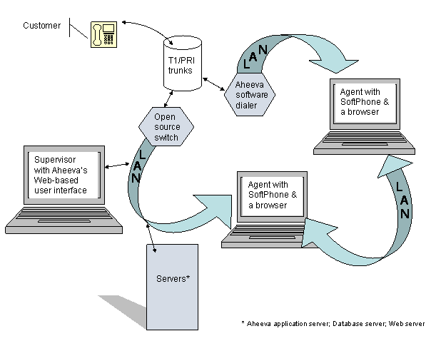
Figure 1 Aheeva CCS architecture.

Not at the office?
Tasks that can be accomplished from a remote location according to access rights include:

- Tenant and user management.
- Reporting. Reports can be produced from any PC or laptop and real-time information can be observed from anywhere. All you need is an Internet connection.
- Setting up and managing agent groups, calling lists, filters and treatments.
- Define and manage routing scripts.
- Set up your work force. Monitor and report on your agents and teams, view real-time adherence to work schedules.
- Monitoring. Evaluate calls or e-mails by playing back stored recordings of agents’ interactions with customers. Live monitoring of supervisors’ interactions with customers.

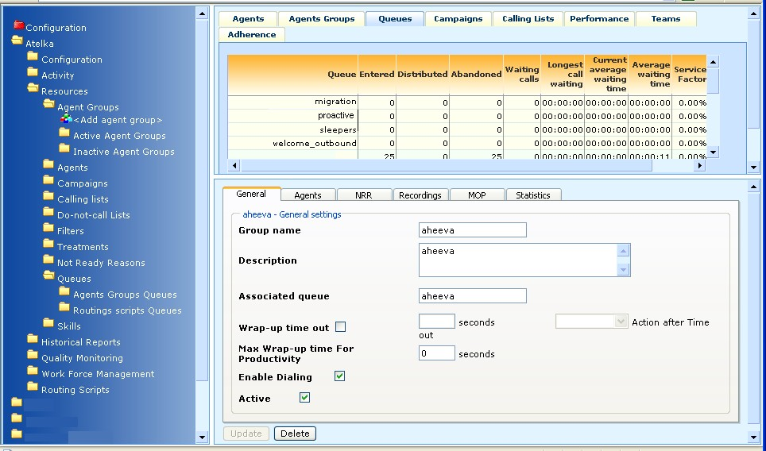
Menu of resources
and managing tools
Live data
& live audio
Resources’ files, reporting and quality management
Figure 2 User interface.

The CCS Manager window is divided into three frames. The left-hand frame gives access to the menus and constitutes your navigation panel. (The license that you have acquired will determine the menu items that will appear on your application.) The top right-hand side of the window displays live information; while the bottom right-hand side displays the means to define parameters, enter data, select options and initiate actions.

Menus
Navigation through the application is done with the menus. You can access each of the functions that are performed by the menu items simply by clicking their name in the menu.

Configuration
The menu items under Configuration are the tools with which administrators create the tenants of your contact center (or clients hiring your services) and the system users that are to be given various access levels to the Aheeva application.
The configuration folder is red-colored to reflect the sensitive nature of this folder’s contents and their impact.
Network configuration
PBX servers, recording servers and encryption servers are linked to make up a contact center site. Users can set up as many sites (real or virtual) as are needed.
Tenant management
Tenants are added to the database and are given an ID number automatically. They are modified and deleted from this menu.
User management
Users of the application are associated to specific tenants, are given a user name and password as well as a role which determines their access rights to the various part of the system.
Note that in Aheeva CCS, the term “user” excludes agents. The application is used for managerial and administrative purposes.

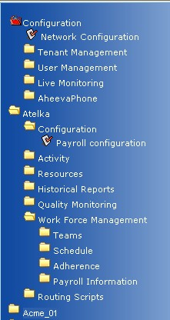  Figure 3 Menus. | Live monitoring
 | As agents’ interactions with customers are monitored live so are the interactions between users of this application and customers. This feature applies generally to supervisors since they are the most likely type of users of this application to be talking to the customers. Within the context of the CCS Manager, the tasks of a supervisor are assembled under the prerogatives tied to the user role termed “Quality Monitoring”.
 | Softphone settings
 | AheevaPhone will update itself automatically, from the location indicated here.
 | Atelka (tenant #1)
 | Payroll configuration
 | Holds. overall payroll rules. Specific applications are to be found in the Work force management menu item.
 | Activity
 | These are the payable or billable activities. undertaken by agents in the call center and which are going to help establish payroll practices.
 | Resources
 |  | Agent groups. The menu lists as many groups as you create. Clicking the group’s name displays its properties in the right-hand frame of the application’s window.
 |  | Agents. List of all the agents assigned to the given tenant.
 |  | Campaigns. List of the campaigns that are under way for the given tenant.
 |  | Calling lists. They are listed in two separate groups: those that are active and those that are inactive.
 |  | Do-Not-Call lists. . List of telephone numbers that must not be called, because the customer does not wish to be contacted.
 |  | Filters. List filters as you create them.
 |  | Treatments. List of treatments that you created.
 |  | Not ready reasons. . User-defined list of reasons for agents not to be ready.
 |  | Skills. . List of skills that can be associated to agents and that are instrumental in call routing.
 |  | Queues. . Timing of calls in queues as they relate to agent groups and routing scripts and used to measure service level. User-defined waiting lapses to answer calls or abandon them.
Historical reports
Access to the settings to generate reports for:
Agents details, agent groups, agent summary, agent login, inbound calls, outbound calls, campaigns, calling lists and queues.
These reports will present similar information as that seen live except that reports are requested from the database and can cover any time span you want.
 | Quality monitoring
 | This function encompasses the playing of agent–customer recording.
 | Work force management
Work schedules and work teams are organized here and the agents’ diligence regarding their schedule can be viewed live or reported on.
How the system displays and reports on agents’ adherence to work schedules is defined here.
Managing a work force involves payroll information. You can define methods to pay the agents and tie the methods to an accounting system.
 | Routing scripts
You can associate multiple parameters and have inbound calls and broadcast campaigns routed according to tailored requirements.
User-defined routing scripts can be put together with a graphical tool. Select the building blocks and simply click-and-drag them into position.

Viewing real-time information
The window frame that displays real-time information contains eight panels: each one provides information live on a particular topic. You can monitor, for example, agents’ status, work, queues or calling lists in real-time and see changes as they happen.

All the information that is displayed in this group of panels is being recorded simultaneously.
Related topics. See the topic, in this document, Generating reports.

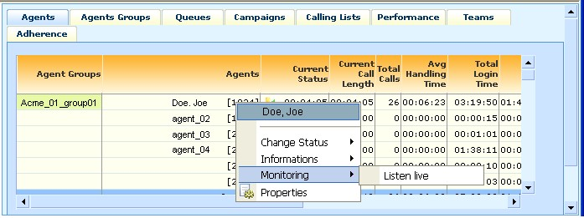
Figure 4 Real-time information and live conversation monitor.

Each panel displays as many individual elements as the number of resources that you have defined in your call center. Individual panels in the group are accessed by clicking their tab.

For instance, if you have ten groups of agents working on seven campaigns you will be able to monitor in real-time all the ten groups, with all of their teams of agents, and all of the seven campaigns.

Use the menu (left-hand frame of the application’s window) to navigate from one campaign to the other.
Time. Whether measured as a duration or given as the expression of a precise moment, time is always displayed in the “hour: minutes: seconds” format.

Agents
Shows to which group the individual agent has been assigned. The agent’s name and login.
Current status includes the system’s defaults (waiting, wrapping up, in outbound call, in inbound call, in logout, not ready, ready, conference, dialing, on hold) plus whatever other reasons you choose to set up for your agents to select when they are not ready, as well as status duration (how long has the agent being waiting, for instance).
Total number of calls that are handled, duration of current call, average handling time, total login time, total talk time, productivity ratio (wrap-up-time added to not-ready-time divided by login time), total wait time, total not ready time, total wrap up time, total on-hold time, total conference time and total dialing time.
Color flag. In this example, yellow highlight of agents that are wrapping up a call or who have put a client on hold indicates that more than one minute has elapsed.
A red highlight indicates that agents have been “Not ready” for over one minute.
You can, however, define the situations that you want flagged.
Pop-up contextual menu. A shortcut to information is available for agents. See below, the topic Shortcut to agent and agent group information & properties.
Return values formulas. See Appendix B—Formulas to generate return values in reports.

Agent groups
Displays the number of agents in the group that are in session, the number of agents that are not ready, that are ready and those that are waiting.
Total number of calls that are currently being handled by the group, the number of agents that are taking an inbound call, those that are taking an outbound call, the number of agents that are not ready, waiting, dialing, on hold, wrapping up a call, the time spent in conference by the group’s agents and the busy factor for the group (sum of the individual agents’ busy factor divided by the number of agents in the group).

Pop-up contextual menu. A shortcut to information is available for agent groups. See below, the topic Shortcut to agent and agent group information & properties.

Queues
Inbound calls are automatically placed in queues when no agent is available. You create these queues, a regular function of routing algorithms, beforehand for a group of agents.
The queue you create for a group of agents, in the Agent Group creation panel, is automatically passed on to the “queue” column in the panel group that shows real-time information.
The Queue panel displays, for each queue, the number of calls entered, distributed and abandoned, the number of calls waiting, and the longest time that a call was waiting in the queue, the current average waiting time and the average waiting time. Also displays the service factor percentile (number of calls that were effectively distributed to agents and answered and abandon level).
Dark, blue-gray rows are routing scripts. Some scripts have been associated to specific, and often similarly named queues, while other scripts have not.
Notice that, sometimes, the real-time information panel shows the same number of calls that are being entered, distributed or abandonned for the queue as there are for the corresponding routing script. This is simply because the queue and the routing script, in such instances, have the same purpose: to pick-up and queue the calls from a given origin.
Related topics. See, in this document, the topics Setting up groups of agents, Routing scripts and Using the CCS CTI command line interface.

Campaigns
Displays the time the campaign started (date and time), its status (running, paused, unknown or not loaded), the dialing algorithm being used and the percentile of the target that has been reached.
The number of dials, the number of calls that have been answered, not answered and abandoned. The number of calls that were picked up by an answering machine, a fax as well as the number of calls that responded by a SIT or a busy line.

Calling lists
Displays the remaining customers’ records to be processed in the calling list: total number and current time zone (hour difference between the city where calls are being placed and the city where the Aheeva software dialer is located). As well as the customers’ records that are currently being processed (the total number being processed and the number to be processed over the next hour).
The percentile of calls that have been complete, the hit rate, the number of dials that were performed for the given calling list, the number of calls that were answered, not answered and abandoned.
As well as the number of calls that were picked up by an answering machine, those that responded by a SIT, those that were busy and those that were picked up by a fax.

Performance
The program displays the performance of those agents that are in session, working at a specific campaign.
Displays the agent’s ID number, last name and first name.
The number of contacts with the customers, the number of refusals, callbacks, sales, sales per hour and the percentile of net conversion rate to sales.

Teams
Displays the team’s name (generally, the team leader’s name), and sorts all the agents in teams. Shows the same information as the agents’ panel.
The live information is displayed for the individual agents as well as for the team as a whole.

Adherence
Color-coded diagram displays the agent’s work schedule, breaks and gaps between breaks and the following work period.
The red bar indicates non-adherence to the schedule (logged out while the agent should be connected to the application). The green bar indicates adherence to the schedule.
Provides a global adherence value expressed as a percentile.
To load the daily work schedule, click the start button in the Real-time Adherence View (Work Force Management > Adherence). Schedules are stored in the database.

Short cut to agent’s and agent group’s information and properties
The live information panel provides a pop-up menu related to agents and agent groups.
Users whose role has been defined in the system as “super admin” or “admin” are the only users of the application that have access to this shortcut.

In the live information panel, right-click the agent’s or the group’s name. The following pop-up menu is displayed:

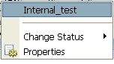  Group pop-up menu |  |  | 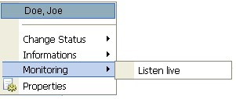  Agent pop-up menu
Change status |  | Select log out to disconnect the agent or the entire group at once.
Informations |  | This option is available only for agents.  IP address of his/her machine,  Host name of the machine,  Name of the switch,  Aheeva Phone version number.
Monitoring |  | This option is available only for agents.  Listen live. Gives access to the agent spying feature.
Properties |  | Displays the file of the agent or of the group of agents.

Setting up resource files, work force management and quality control
The bottom right-hand frame of the Aheeva’s application window displays contextual tools. This frame of the user interface displays the form or, depending on the context, the set of options that need selecting before the system produces what you want it to produce.

This is were you create your agents’ files, that you set up your campaigns and their associated calling lists, filters or dialing algorithms and routing scripts.

Quality monitoring and work force management are also carried out through this area of the user interface.

Network management
A CCS network is made up of the CTI server and as many sites as you wish to define. Sites, local or remote, are made up of PBX servers, recording servers and encryption server. Your network and all its sites are managed with the graphical tool of the CCS Manager.

Site setup
Within the context of the CCS Manager the concept of site management includes managing the routing of voice and data as well as managing agents and their files, since agents are associated to a given site (and its server) whether the site is real or virtual. You can use multiple IP addresses to perform routing functions both for inbound and outbound calls.
Related topics. See the topics, in this document, Setting up your agents.

Defining a site
You must start the setup by defining at least one site since several of the application’s elements — such as agents, encryption servers, recording servers and IP switches — are linked to any one of your sites.
For example, your office is in Toronto, Canada, and you have agents working from Miami, USA. The agents in Miami will be connected through the CCS Manager to a given server located in Miami and its associated site; you thereby avoid the long distance fees that would be incurred where those same agents to be connected to the servers at your office in Canada.
Sites must be named and exist in the database before you can provide them with one or several IP switches, recording and cryption servers.

- In the Menu frame, click the Network configuration folder (Configuration > Network configuration).
The system displays the configuration in the bottom right-hand frame of the window.
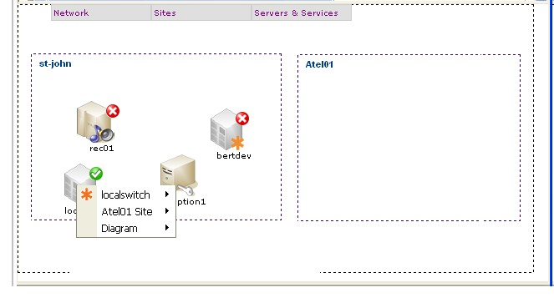
site 2—
not yet serviced
Menu bar
site 1 with
its servers
Information
pop-up
Figure 5 Example of a contact center site with its dedicated servers.

Each site you define is visually confined to a box with a dotted-lined border: you simply insert the various servers you need, by using the menu bar, and position them for easy viewing by clicking and dragging the object.

- From the Menu bar, click the Sites menu and select the Add site menu item. Name the site and click Submit.

Saving or resetting your site layout
Save your site layout from time to time as you add servers to the site. From the Menu bar, click the Network menu and select the Save layout menu item. To reset the site quickly, click the Reset layout menu item.

PBX server

To add a switch
- In the Menu frame, click the Network configuration folder (Configuration > Network configuration).
The system displays a graphical configuration of your sites in the bottom right-hand frame of the window.
- In the menu bar, click the Servers and Services menu. Select Add PBX server.
- Provide the following information.
 | PBX server
Site |  | Select a site from the list.
Name |  | Virtual name for the PBX server. This name will be displayed on the network diagram.
Password |  | Alphanumeric password.
IAX internal host |  | IP address for internal IAX2 communications.
IAX internal port |  | Port number for internal IAX2 communications.
IAX external host |  | IP address for external IAX2 communications.
IAX external port |  | Port number for external IAX2 communications.
Load balance for agent |  | Percentage of the communication load to be used by inbound calls to agents within a given defined site.
Outbound load balance |  | Percentage of the communication load to be used for outbound calls from a given defined site.
You can verify the server’s status at any time by displaying the contextual pop-up statistics box.
See, below, Displaying server statistics.

- Click the Save button.

Recording server
Recording servers are independant from the CTI module. Recordings are performed on local servers and data is sent to the central server (CTI module) at user-defined periods. This feature can reduce bandwidth usage at times of heavy traffic as users can have the recordings transfered to the main server at night, for instance.

To add a recording server
- In the Menu frame, click the Network configuration (Configuration > Network configuration).
The system displays a graphical configuration of your sites in the bottom right-hand frame of the window.
- In the menu bar, click the Servers and Services menu. Select Add Recording server.
- Provide the following information.
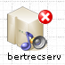 | Recording server
Site |  | Select a site from the list.
Name |  | Virtual name for the recording server. This name will be displayed on the network diagram.
Password |  | Alphanumeric password.
Internal host |  | IP address for internal communications.
Internal port |  | Port number for internal communications.
Internal secure port |  | Port number for internal SSL communications.
External host |  | IP address for external communications.
External port |  | Port number for external communications.
External secure port |  | Port number for external SSL communications.
Recording sales directory |  | Assign a URL (relative pathname) where recordings of “Sales” transactions are to be stored.
 |  | Example of a relative path:  /recordings/sales/
Recording NoSales directory |  | Assign a URL (relative pathname) where recordings of “No sales” transactions are to be stored.
Daily Synchronization |  | Click to activate. Activates the next two fields in the server’s file and allows you to define the time when the recordings will be sent to another recording server.
Send recordings to |  | Select the server to which recordings are to be sent to another recording server.
Synchronization time |  | Select the time of the day at which recordings are to be sent to another recording server.  Day starts at midnight, local.
Agents load balance |  | Indicate the percentage of the communication load to be used by the agents within the given site.
Max. disk to use |  | Indicate the maximum disk space to be used by the given recording server.  When the maximum disk usage has been reached, the system switches to another server.
You can verify disk usage and other server’s statistics at any time by displaying the contextual pop-up statistics box.
See, below, Displaying server statistics.
- Click the Save button.

Encryption server
You can use an encryption server to further secure the voice and data recordings of customer relations. Within the context of the CCS Manager you can specify the encryption server and parameters so all the recordings of the agents within a site can be encrypted while on transit.
Related topics. See the topic, in this document, Setting up groups of agents.

To add an encryption server
- In the Menu frame, click the Network configuration folder (Configuration > Network configuration).
The system displays a graphical configuration of your sites in the bottom right-hand frame of the window.
- In the menu bar, click the Servers and Services menu. Select Add Encryption server.
- Provide the following information.
 | Encryption server
Site |  | Select a site from the list.
Name |  | Virtual name for the encryption server. This name will be displayed on the network diagram.
Protocol |  | Select “https” to use the SSL protocole.
Internal host |  | IP address for internal communications.
Internal port |  | Port number for internal communications.
External host |  | IP address for external communications.
External port |  | Port number for external communications.
URL |  | Assign a URL (relative pathname) for the encryption.
Example of a relative path:
/encryptor/encryptor/
You can verify the server’s status at any time by displaying the contextual pop-up statistics box.
See, below, Displaying server statistics.
- Click the Save button.

Modifying the configuration
Run the cursor over any of the server icons to display a contextual menu from wich you can access the server’s file as well as the site’s. All the contextual menus contain the three following menu items:

the server’s (its configuration and statistics)
the site’s (its name and statistics)
the network configuration’s diagram (save layout and hide/show grid)

To change the site’s name
- Right-click a server and, from the contextual menu, select the site’s name, then the menu item Configuration.
- Change the name in the dialog box and click the Submit button.

To delete the site
- Right-click a server and, from the contextual menu, select the site’s name, then the menu item Configuration.
- Click the Delete button.

To change a server’s configuration
- Right-click a server and, from the contextual menu, select the server’s name, then the menu item Configuration.
The server’s file is displayed in the bottom right-hand frame of the window.
- Make the appropriate changes and click the Submit button.

To delete a server
- Right-click a server and, from the contextual menu, select the server’s name, then the menu item Configuration.
The server’s file is displayed in the bottom right-hand frame of the window.
- Click the Delete button.

Displaying server statistics
Run the cursor over any of the servers to display a contextual menu from with you can connect or disconnect the servers as well as display contextual information. A red “X” icon indicates that the server is not active whereas a green ckeckmark indicates that the server is active.

To display site and server statistics
Right-click a server and from the contextual menu, select the site’s name or, if you want server statistics, select the server’s name, then the menu item Statistics.
Recording server
Server name |  | Name of server (as displayed on the network diagram).
Status |  | Disconnected or connected.
Since |  | Date and time when current status was initiated.
Total recordings |  | Total number of recordings on the server.
Daily total recordings |  | Total number of recordings on the server for the given day.
Disk usage |  | Number of GB of used space and remaining number of GB of unused space. A status bar gives the information visually.
PBX server
Switch |  | Server’s name and site. Format “name@site”.
Status |  | Disconnected or connected.
Since |  | Date and time when current status was initiated.
Agents |  | Number of agents connected to the server.
Inbound calls |  | Number of inbound calls routed by the server.
Outbound calls |  | Number of outbound calls routed by the server.

Tenant management
Creating a tenant in the CCS Manager means simply to create a named folder that will appear in the application’s menu and, thereby, allow you to attach the resources that are to work for that tenant.

Setting up tenants

To add a tenant
- In the Menu frame, click the Tenant Management folder (go to Configuration > Tenant Management) and select Add Tenant.
The system displays the entry form in the bottom right-hand frame of the window.
- Enter a name and click the Submit button. The system assigns and ID number automatically when you create a tenant.

To modify tenants
- In the Menu frame, click the Tenant Management folder (go to Configuration > Tenant Management) and select the relevanttenant.
The tenant’s file is displayed in the bottom right-hand frame of the window.
- Change its name and click the Update button.

To delete tenants
 | Caution. Deleting a tenant erases from the database all the resources linked to that tenant. We suggest that you deactivate the tenant instead, until you feel safe that you will not need the data any longer.
- In the Menu frame, click the Tenant Management folder (go to Configuration > Tenant Management) and select the relevant tenant.
The tenant’s file is displayed in the bottom right-hand frame of the window.
- Click the Delete button.
- Confirm your choice

User management

Creating users
- In the Menu frame, click the User Management folder (go to Configuration > User Management) and select Add User.
The system displays the entry form in the bottom right-hand frame of the window.
- Enter the following information:
Tenant |  | Select a tenant from the list. The user that you are creating will be limited to viewing or processing information for this tenant only. This is to ensure privacy of tenant data when several users, for instance, are running several campaigns for several tenants.
 |  | Notice that the field becomes inactive when the user is to have Super Admin access privileges. A super administrator of the application has access to any tenant’s information.
User name |  | Assign a user name. You can use the person’s real name.
Password |  | Assign a password. A second field is provided for you to confirm the password (Retype).
Role |  | Select a role from the list. Each has specific access privileges.  Super Admin. Provides the highest access level. Will be able to see and change any information.  Admin. Will not be able to access the Configuration features, therefore will not be able to create tenants or users. Will be assigned one tenant and will be able to view and change all the information related to that one tenant; the resources, historical reports and quality monitoring tools that are associated with the tenant.  Historical report. Will not be able to access the Configuration features, therefore will not be able to create tenants or users. Will be assigned one tenant and will be able to view and produce reports related to that one tenant and can be limited to specific groups.  Quality monitoring. Will not be able to view tenants’ information other than that pertaining to the one to whom he or she is associated. Will be able to manage resources and perform quality monitoring duties only for certain tenants and specific groups of agents. Sometimes known as the “supervisor”.  Viewer. Will see only the real-time information related to one tenant and and specific groups. No access to reports.
Groups |  | Assign one or several groups to this user by selecting them from the list of available groups. The assigning of groups to users is a function designed to ensure additional privacy protection by restricting access to group information even within the administration of services to a single tenant.
 |  | Notice that this feature is not available for users of type Admin and Super Admin since they can access information from any available group (albeit the user of type Admin is limited to groups belonging to one tenant).
Active |  | This option is active by default. Click to remove the check mark if you want to prevent the user from accessing the application.
- Click the Add user button.

To modify users
- In the Menu frame, click the User Management folder (go to Configuration > User Management) and select the user.
The user’s file is displayed in the bottom right-hand frame of the window.
- Make the appropriate changes and click the Modify user button.

To delete users
- In the Menu frame, click the User Management folder (go to Configuration > User Management) and select the user.
The user’s file is displayed in the bottom right-hand frame of the window.
- Click the Delete user button.

Live monitoring of users
Within the context of Aheeva’s application, the concept of live monitoring has been provisioned as a completely separate feature from quality monitoring.
Related topics. See, in this document, the topics Viewing real-time information and Quality monitoring.
See also, the topic Asterisk configuration files.

Users’ conversations with customers can be monitored simply by picking the telephone, dialing a number or an extension and listening in. Whereas agent’s conversation with customers can be monitored simply by clicking the agent’s name on the application’s real-time information panel.

The live monitoring feature is not to be confused with the CCS Manager’s menu item known as “quality monitoring” in which recordings of agents’ interactions are played back. Live monitoring in the present case consists in listening to conversations of the agents and the clients. Several supervisors can listen to a same agent without it interfering with the simultaneous recording of data.

Setting up this feature involves two steps:
- With the graphical interface of the CCS Manager you indicate the users whose conversations you wish to access.

- Using a command shell and the appropriate Asterisk configuration file, the open-source IP-PBX used by the Aheeva application, you enter the extension numbers. These are the extension numbers that the person performing the live monitoring will dial on a telephone pad to be able to listen to someone else’s conversation.
Asterisk | Set the live monitoring extension in the following /etc/asterisk/extensions.conf file:  AH_BARGE_EXTEN=8481  Include the agentbarge context in every context that you want to be able to monitor live.  For example, to do agent barge from the AheevaPhone, you would set up the file as follows:  [agents]  include => agentbarge  ; Requests coming from the AheevaPhone  exten => _AH.,1,Set(AH_UNIQUEID=DUMMYID)  exten => _AH.,2,AgentLogin(${EXTEN:2},s)  ; Requests coming from the AheevaPhone (backward compatibility)  exten => _AK.,1,Set(AH_UNIQUEID=DUMMYID)  exten => _AK.,2,AgentLogin(${EXTEN:2},s)  Where “8481” is the extension number to be dialed before the application asks for the numeric login and the numeric password of the user to whom you wish to listen.

- In the Menu frame, click the Live Monitoring folder (Configuration > Live Monitoring) and select Add User.
The system displays the entry form in the bottom right-hand frame of the window.
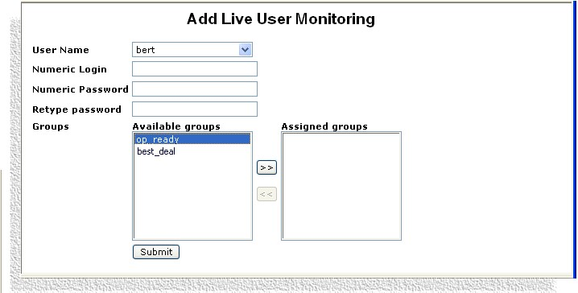
Figure 6 Live monitoring of users.

- Enter the following information:
User name |  | Select the user from the list.
Numeric login |  | Assign a numeric login. Login performed with the telephone keypad to listen to the user’s conversations. .
Numeric password |  | Assign a numeric password. As with the numeric login, the password is entered with the telephone keypad. You must confirm the password (Retype).
Groups |  | Select the group of agents, from the list of available groups, that you wish to assign to this particular user. Click the >> button to confirm the assignment.  Assigning agent groups to users is an additional mean to restrict access to your tenants’ information. Agent groups are linked to specific campaigns, for specific tenants and a user that is assigned a group is able to display only the tenant data that is allowed for that group.  To delete user–group associations, select the group you want to remove from the Assigned groups list and click the << button or her groups of agents.
The assigning of groups to determined users is a feature of the live user monitoring function designed to ensure privacy protection by restricting access to groups and to the information that they hold. The feature is to be used in conjunction with the user role definition.

See, in this document, the topic User Management.
- Click the Submit button.

To update or delete a monitoring instance
Once the monitoring feature has been set up for a user, you can update and delete the information.
- In the Menu frame, click the Live Monitoring folder (Configuration > Live Monitoring) and select the appropriate user of the monitoring instance.
- Make the required changes and click the Update or Delete button.

AheevaPhone settings
Aheeva’s softphone can be updated automatically. Simply indicate the location of the software. Every time that a user starts the softphone, the application checks the server at the indicated location for the latest version.

- In the Menu frame, click AheevaPhone Configuration (Configuration > AheevaPhone) and enter the following information on the Auto-Update panel in the bottom right-hand frame of the window.
Enable AutoUpdate |  | Click to activate the function.
Internal URL |  | URL address of the server on which the softphone application is to be located and server used for internal connections.
Internal Port |  | Port number for internal use.
External URL |  | URL address of the server used for external connections.
External Port |  | Port number for external use.
Path (relative to Web root) |  | Enter the relative path to the software telephone.
Example of a relative path:
/aheevaccs/aheevaphone/
Site |  | Select the name of the physical location of the site.  The choices in the drop-down list are fed from the Network configuration panel. It is the name given to that specific site in the Network configuration panel.

Service levels and productivity
Aheeva’s application gathers information and stores it in the database in order to provide you with controls over service levels and productivity.

The following elements in the system all concurr to measure levels of customer service and agent productivity.

Queues
The duration that calls are kept waiting before they are answered or abandoned are part of a call center service level policies for its groups of agents.

Within the context of the CCS Manager, the following descriptions and calculations apply:

Service factor |  | Number of calls that were distributed to agents and answered plus abandon level.  ( Number of calls answered within 20 seconds / (Number of distributed calls + Number of abandoned calls – Number of calls which are abandoned within 5 seconds) ) *100
Service level |  | Variance between calls that were distributed and calls that were handled.

Live data |  | What happens to calls while they are queued is sent to the live Queues information panel of the CCS Manager in the form of a service factor percentile.
Reporting |  | Queues report displays service factor and service level.
How-to |  | See, in this document, the topic Setting up call queues.

Wrap-up time and Not Ready reasons
Values given to the Max wrap-up time for productivity option in the agent group’s file, the Wrap-up time out and the duration you indicate for the Not Ready time in the payroll general configuration group of panels will affect calculations for the agent’s productivity ratio.

Within the context of the CCS Manager, the following descriptions and calculations apply:

Productivity ratio |  | Wrap-up time plus not-ready time divided by login time.  100* (1- (Wrap-up-time exceeded + not-ready-time that affected productivity) / login time)  (#) Wrap-up-time exceeded = Average wrap-up time for the period specified – Maximum wrap-up time for the campaign.

Live data |  | Wrap up time and Not Ready time are displayed on the live Agent information panel and the live Agent group panel. Colour-coded flags on the live information panel for agents indicate that agents have gone over the user-defined duration of Not Ready time.
Reporting |  | Not Ready time shows up in the Agent report (includes Not Ready time, Not Ready count and Not Ready time compared to login time), the Agent Group report and Agent Summary report.  Wrap up time and count show up in the Agent report, Agent Group report, Agent Summary report and Inbound Calls report.
How-to |  | See, in this document, the topics
Setting up Not Ready reasons
Setting up groups of agents
Payroll general configuration

American call center features
These fonctions are invisible to the user. They are database fields which content is extracted to either feed the live information panel of the CCS Manager or to be provided in report form.

Dial disabled |  | You can disable the dialing function of the AheevaPhone so agents cannot dial out. This feature is activated in the agent group’s file.
Disconnect reason stored |  | When the agent hangs up, the reason is stored in the database, in the agent group’s file. Call center managers can extract the information from the database.
Ready on login |  | As soon as agents log into the AheevaPhone they are in “Ready” mode, they must take incoming calls.
Security |  | The agent station’s ID (hostname) and IP address (IP_Address) are stored in the database in the agent’s login file.
DNIS |  | Dialed Number Identification Service. Identifies, at all times, both parties in every call: the agent and the caller.
Call ID and switch’s IP |  | Saves the tracknum in the table that records agents’ conversations (qms_agent_conversation). It identifies the call-specific IP as well as the IP address of the switch.

Payroll general configuration
Global payroll information for all the agents working in the call center is defined here.
To achieve this configuration, not ready reasons must be set and added to agent groups.
Related topic. To define commissions and methods of payment see, in this document, the topics Payroll information and Call center activities and payroll.

General payroll configuration means that you will indicate by how many minutes agents are allowed to go over the allocated tolerance for the duration of a given connection time (or work period).

To set up payroll configuration
- In the Menu frame, find the relevant tenant and click Payroll configuration (go to the tenant’s menu > Configuration).
The system displays the three-panel entry form in the bottom right-hand frame of the window. Click the tabs to access the corresponding panels.
- Enter the following information.
General setup
Work periods |  | Duration. Select the duration of the work period. This is the length of time that agents are connected to the application in one work period.  Tolerance. Indicate the number of minutes by which agents can go over the value you indicated for the corresponding work period.  Click the Add a new work period button to add as many work periods as you need.  Click the Save work periods button to save the information.
Duration for Not Ready Reasons |  | Click the Define durations for NRR button.  Login time. Displays the work periods you have defined.  Tolerance. Displays the tolerance values for the associated work periods.  The system lists the Not Ready Reasons that you have previously defined which may include bathroom, break and lunch.  Indicate the number of minutes that you allow for the activity. Of course, it is consequent to the length of time agents must work. For example, in a 4-hour work period, you may set a 15-minute break, whereas for a 8-hour period, you would set a 30-minute break.  Click the Save durations for NRR button.
 |  | Example: You define a work period (login time) with a duration of 4 hours. During that 4 hours, you allow a 15-minute break. You also set the work period tolerance to be equal to 20 minutes. This means that during work periods of 4 hours, agents can go over the anticipated 15-minute break by 20 minutes. If they go over that value, colour-coded flags are triggered on the live information panel for agents.

Paid NRR
Agent group |  | Select the group of agents from the drop-down list.
Not Ready Reasons |  | The system displays the reasons you have defined.  To define the Not Ready reasons, see, in this document, the topic Setting up Not Ready reasons.
Paid time |  | Click if the associated Not Ready reason is to be paid time (paid to agents).
Billable time |  | Click if the associated Not Ready reason is to be billable to customer.  Click the Save payable NRR for this agent group button.

Summary
Lists the groups of agents with the paid time and billable time formulae you have defined for each of them including which of the Not Ready reasons are to be paid to the agents or billed to the customer.

Call center activities and payroll
The activities in which the agents can be engaged are defined here. The list will be made available in the panels where you set up the information for the agents to get paid according to these activities and other remuneration factors.

Related topics. See, in this document, the topics Payroll general configuration and Payroll information.

To create agent activities
- In the Menu frame, find the relevant tenant and click Add an activity (go to the tenant’s menu > Activity).
The system displays the entry form in the bottom right-hand frame of the window.
- Enter the following information.
Name |  | Name the activity. Example of names include: integration, training, coaching and production.
- Click the Save button.

The activities are listed in the Current Activities folder as you create them.

To modify agent activities
- In the Menu frame, find the relevant tenant and click the activity’s name (go to the tenant’s menu > Activity > Current Activities).
The system displays the entry form in the bottom right-hand frame of the window.
- Make the appropriate change, which is to change the name of the activity and click the Update button.

Resources
Each one of your tenants is allocated a set of resources, of reporting tools as well as a set of quality monitoring and scheduling tools.

Not Ready reasons
These settings are user-defined and they allow you to retrieve the type of information about the work habits of your agents and their behavior that is relevant to your business.

The Not Ready reasons that you define here are listed and used in several panels throughout the application namely the Payroll configuration group of panels and the agent group configuration panels.

Setting up Not Ready reasons

To create a user-defined list of reasons
- In the Menu frame, find the relevant tenant and click the Not Ready Reasons folder (go to the tenant’s menu > Resources > Not Ready Reasons) and select Add Not Ready Reason.
The system displays the entry form in the bottom right-hand frame of the window.
- Enter the following information.
Not Ready Reason name |  | Name the reason. Example of names include: break, lunch, technical problem, coaching and bathroom.
Active |  | Click to activate the reason. If you leave unchecked, the item will be listed in the Inactive Not Ready Reasons folder.
Global |  | Click to activate.
Use this NRR in productivity |  | Click to activate the feature and have the associated “not ready reason” taken into account when generating reports and statistics on productivity.  Will be made available in the payroll information panel and used in the agent’s report, agent group’s report and agent summary report.
- Click the Save button.

To modify Not Ready reasons
- In the Menu frame, find the relevant tenant and, depending on the situation, click the Active Not Ready Reasons folder or the Inactive Not Ready Reasons folder (go to the tenant’s menu > Resources > Not Ready Reasons). Click the relevant reason.
The system displays the entry form in the bottom right-hand frame of the window.
- Modify the information and click Update.

To delete Not Ready reasons
- In the Menu frame, find the relevant tenant and, depending on the situation, click the Inactive Not Ready Reasons folder (go to the tenant’s menu > Resources > Not Ready Reasons). Reasons that are actively in use by agent groups cannot be deleted. Click the relevant reason.
The system displays the entry form in the bottom right-hand frame of the window.
- Click the Delete button.

Skills
You can associate any number of skills to the agents. Indicate a level of mastery and the system will take the information into consideration when routing incoming calls and IVR. Skills can be constituted of any type of knowledge or ability.

Setting up agent skills

To define skills for agents
- In the Menu frame, find the relevant tenant, click the Skills folder (go to the tenant’s menu > Resources > Skills) and select Add a skill.
The system displays the entry form in the bottom right-hand frame of the window.
- Enter a name for the skill (for example, a language or a computer skill).
- Click the Submit button. The new skill is now listed in the Menu frame.

To modify skills
- In the Menu frame, find the relevant tenant, click the skills folder (go to the tenant’s menu > Resources > Skills) and select the skill that is to be modified.
- Change the name of the skill and click the Update button.
Matching callers’ needs with agents’ skills. Skills are associated to agents through the agent’s file. A scripting element in the routing script feature of the CCS Manager (the Agent pickup method) can be used to match callers’ requirements (such as the need for a Spanish-speaking agent) with agents’ skills.

Related topic. See also, in this document, the topic Setting up your agents.

To delete skills
- In the Menu frame, find the relevant tenant, click the skills folder (go to the tenant’s menu > Resources > Skills) and select the skill that is to be modified.
- Click the Delete button.

Queues

Related topics. See , in this document, the topic Service level and productivity.
You can monitor, through on-line information and the reporting feature, the efficiency of queues. See, in this document, Viewing real-time information (queues) and the topic Generating reports, queues.

You can define the maximum number of seconds by which incoming calls are to be kept in queues (regular queues as well as routing scripts’).

This will have an incidence on the service factor and service level of your call center. The information is recorded and made available to you.

Setting up call queues
Setting up the queue feature involves three steps:
- With the graphical interface of the CCS Manager you name the queue where calls are to be directed for the designated group of agents. This is done through the group’s file.

- With the graphical interface of the CCS manager you indicate the time that calls can be kept waiting before they are answered or removed from the queue. This is done through the queues’ file and the settings will be made available through the agent group’s file.

- With a command shell, you enter the queue in the appropriate configuration file of Asterisk, the open-source IP-PBX used by the Aheeva application.

Asterisk | - Add the appropriate contexts in the configuration file /etc/asterisk/queues.conf. For example:  [op_ready]  music = default  timeout = 2  Where [op_ready] is the name of the queue. The name is case sensitive and will be reflected throughout the application. And where “music” indicates the music-on-hold class that is to be played when a call is placed in the queue. And where “timeout” indicates the maximum amount of time (in seconds) that the system is allowed to keep calls in the queue before it finds an agent that is available.  If music is equal to “none”, no music will be played to callers who are on hold.  - You must specify the music-on-hold class in the configuration file /etc/asterisk/musiconhold.conf.

Setting up service & productivity tolerance with queues
Notice that queues for routing scripts are defined and reported on in the same manner as queues that are not part of a routing script.

The CCS Manager menu will list as many group queues as they are groups. And as many routing script queues as are routing scriprts.

To set up a regular group queue
- In the Menu frame, find the relevant tenant and click the relevant Agent group queue (go to the tenant’s menu > Resources > Queues > Agent group queues).
The system displays the entry form that contains two panels in the bottom right-hand frame of the window.
Complete each panel to indicate how long you want calls to be kept in queues. Individual panels are accessed by clicking their tab.

Service factor
Longuest time waiting |  | Indicate, in seconds, the longest time a call can be kept waiting before it receives an answer.
Abandoned |  | Indicate, in seconds, the shortest time a call can be kept in a queue before it is abandoned.
 |  | This information is used in the calculation of the Service factor which appears in the live information Queue panel of the CCS Manager and the queue report.
Service level
Answer times |  | Select 10 values from the left-hand box the parameters, in seconds, that you will be using to measure the time that calls are kept in queues before they are answered.
 |  | This information is used in the calculation of the Service level which appears in the queue report
Abandon times |  | Select 10 values from the left-hand box the parameters, in seconds, that you will be using to measure the time that calls are kept in queues before they are abandoned.
 |  | This information is used in the calculation of the Service level which appears in the Queues report and Inbound calls report.

To set up queues in a routing script
Refer to the instructions above in To set up a regular group queue.

Using the CCS CTI Command Line Interface
The CCS CTI Command Line Interface (CLI) has been created to give you access to the heart of the CTI. You can display status variables, queues and to remove calls from the queues.

- With the use of a command shell, enter the following:
ahcli
- The following four commands are available to you in the CTI CLI:

*show version* |  | Displays the current Aheeva CCS version.
*show queue details* |  | Shows the active calls in all the queues or in a specific queue.
/Usage/ |  | Show queue details.  Show queue details <queue_name>
*show status* |  | Show the current CTI status variables.
*remove queue call* |  | Remove one or more calls from all the queues.
/Usage/ |  | Remove queue call <tracknum1> <tracknum2>”},
*help* |  | Displays this message.

Agent groups

Setting up groups of agents
\You can assemble your groups of agents according to the skills of the agents. This is the method you will employ to match skills and abilities to the requirements of specific campaigns.

Agent groups must be defined before the individual agents that will constitute the groups. You need only to open a file for the group by providing some general settings. Adding the agents to the group or defining methods for paying them can be done at a second stage.

Naming convention for outbound campaigns only. We suggest that you keep the name of agent groups, the name of the campaigns to which they are assigned, the name of the calling queues and the name of any other resource that is attached to a particular campaign very similar (or identical) to the name given to the campaign.
For example: You name a service campaign for your client Acme “Acme_Best_Deal”. You could name the group of agents assigned to this campaign “acme_best_deal”. You can also name the routing script for this group of agents “acme_best_deal_broadcast”.

Name formats: No spaces, no comma and no special characters
(ex.: ~, / or ^). Use alphabetical letters, numbers 0–9 and the underscore.

To add an agent group
- In the Menu frame, find the relevant tenant and click the Agent Groups folder (go to the tenant’s menu > Resources > Agent Groups) and select Add agent group.
The system displays the entry form that contains four panels in the bottom right-hand frame of the window.
Each panel must be completed to put the agent group into effective use. However, the General settings must be provided, then saved before you use the edit mode to continue filling out the remaining panels. Individual panels in the group are accessed by clicking their tab.

- Enter the following information.
General settings
Group name |  | Name of the group.
Description |  | Describe the purpose of the group, its tasks or anything else that will help you identify it.
Associated queue |  | Name of the queue where calls are to be parked specifically for this group.  The queue must also be setup in the corresponding configuration file of Asterisk, the open-source IP-PBX used by the Aheeva application. See the instructions below: Setting up call queues and Using the CCS CTI command line interface.
Wrap-up  Time out |  | Click to activate the feature. Indicate the number of seconds allowed before time-out.  Select an Action after the time has elapsed: Not ready, Ready, Logout.
Max wrap-up time for productivity |  | Indicate the number of seconds allowed for wrapping up calls.  This will be used in calculating productivity for the agent and will show up in the agent summary’s report.
Enable dialing |  | Click to enable agents to use their softphone to dial out.
Active |  | Click to activate the agent group.
- Click the Save button.
- Continue creating the group by selecting it from the list of active agent groups (Menu frame > tenant’s menu > Resources > Agent Groups > Active Agent Groups) and completing the remaining panels.

Agent configuration
Show agent by ID |  | Click to display agents according to their ID number (login number) rather than in alphabetical order.
Non-configured agents |  | List of the agents that are available to work in this group. The system feeds this information automatically from the agents’ files. Select from this list only those agents that are to be actively engaged in the campaign.
Assigned agents |  | To add agents to the group: select the agents you need from the Non-configured agents list and click the >> button.  To remove agents from the group: select the agents from the Assigned agents list and click the << button.  You can modify the list of assigned agents as need be.

NRR — Not Ready Reasons configuration
Add a new reason |  | Select from the list the reasons you wish to make available to the agents; so they can indicate the reason why they are not ready.
 |  | See, in this document, the topic Not Ready reasons as you must make up a list of reasons if you want them to be displayed in this panel.

Recording options
Enable recording |  | Click to activate recording of agent–customer relations for the given group.
Recordings stay local |  | If activated, recordings will remain on the agent’s station instead of being sent automatically to the server. This measure helps to minimize the use of bandwidth if needed.
Encode recordings to MP3 |  | If left inactive, recordings will be done in WAV format. Scripts can also convert .wav files to MP3 to reduce storage space.
Minimum recording time |  | This option and its complement —maximum recording time— refer to a single call. Select the minimum length of time during which a call is to be recorded.  Selecting “0 sec” will record the entire call.
Maximum recording time |  | Select the maximum number of minutes during which a call is to be recorded.
Low quality MP3 |  | (Smaller files). Activated by default if you choose to record in MP3.
High quality MP3 |  | (Larger files). Click to activate
Enable encryption |  | Click to activate the encryption of voice and data for the given group.
Encryption server |  | Select the name of the encryption server.
 |  | See, in this document, the topic Encryption server.
Encryption method |  | Select the name of the encryption method (AES, MyAES or DES3) to be used for the recordings of the group.

MOP — Methods of payment
Select MOP |  | Select the method of payment of the group. For this field to list methods, you must define them first.
 |  | See, in this document, the topic Setting up methods of payment.
 |  | Override salary. Click to activate override salary for the given group.
 |  | Amount. Add the new amount of the salary.

Statistics
Displays a pie chart, color-coded, to the most prevalent status amongst the agents in the group.

- Click the Update button.

Modifying agent groups

To modify agent groups
- In the Menu frame, find the relevant tenant and click the Agent Groups folder (go to the tenant’s menu > Resources > Agent Groups).
The menu displays the list of groups you have defined.
- Click the appropriate group.
- In the group’s file, make the required changes and click the Update button.
- For a description of the various fields in the agent’s file, refer to the topic “To add an agent group”.

To delete agent groups
- In the Menu frame, find the relevant tenant and click the Agent Groups folder (go to the tenant’s menu > Resources > Agent Groups).
The menu displays the list of groups you have defined.
- Click the appropriate group.
- The system displays the group’s file. Click the Delete button.

Assigning agent groups to campaigns
Assigning a group of agents to a campaign is considered to be a characteristic belonging to the campaign. Therefore it is in the campaign’s file that the reference to the group attached to the campaign is to be found and handled.

Related topics. See, in this document, Viewing real-time information (agent groups) and the topic Setting up service campaigns.
See also the topic Asterisk configuration files.

Agents

Setting up your agents
Setting up this feature involves two steps:
- With the graphical interface of the CCS Manager you create the agents’ files which, among other information, include a login identification, generally a numeric code, that agents use to connect to the application.

- Using a command shell, you enter, in the appropriate configuration file of Asterisk (the open-source IP-PBX used by the Aheeva application), the login that each agent will use to make a call manually. The rest of the data in the agents’ files is managed automatically and stored in the database.

Asterisk | Identifying agents  For each agent, you must include an entry in the configuration file /etc/asterisk/agents.conf. For example:  agent => 800,Agent  Where “800” is the login number that is assigned to the agent through the CCS Manager when the agent’s file is created. It is not necessary to replace “Agent” by the agent’s name as it is the CTI server and the database that handle that information.  Linking agents’ softphone to a protocol file  - The AheevaPhone that agents may use is based on the IAX2 protocol and the corresponding configuration file must include the agents’ login. In the /etc/asterisk/iax.conf file enter the following:  [800]  type=friend  host=dynamic  context=agents  permit=0.0.0.0/0.0.0.0  Where, in this example, “[800]” is a given agent’s login.  - The context “agents” shown above is created in the /etc/asterisk/extensions.conf file as follows:  [agents]  include => local  include => longdistance  ; Requests coming from the SoftPhone  exten => _AK.,1,SetVar(AK_UNIQUEID=DUMMYID)  exten => _AK.,2,AgentLogin(${EXTEN:2},s)  The dialer is not involved in this configuration: it relates to calls made manually by the agents. The above example shows a context in which agents can log into Asterisk and perform local as well as long-distance calls.

To add an agent
- In the Menu frame, find the relevant tenant and click the Agents folder (go to the tenant’s menu > Resources > Agents) and select Add agent.
The system displays the entry form that contains three panels in the bottom right-hand frame of the window.
Each panel needs to be completed to create the agent . Individual panels for the agent are accessed by clicking their tab.

- Enter the following information.
General information
Group ID |  | Select a group from the drop-down list to which the new agent is to be associated.
Agent groups must be defined before the individual agents that will constitute the groups. Otherwise, this list will be empty.
You need only to open a file for the group by providing some general settings. Adding the agents to the group, as will be the case in this procedure, can be done at a second stage.
Last name |  | Agent’s last name. Not mandatory.
First name |  | Agent’s first name. Not mandatory.
Comments |  | Enter skills, knowledge or other characteristic that the agent may possess and that will help you to associate him or her to a particular requirement of a given campaign. Not mandatory.
Login |  | Login assigned to the agent. Mandatory information.
Password |  | Password assigned to the agent. Mandatory information.
Start date |  | Click to select a date. Not mandatory.
End date |  | Click to select a date. Not mandatory.
Active |  | Click to activate the option. Rendering the agent “active” only makes him or her available to be included in the group that you have selected for him or her.  You need to perform an additional step to have the agent actively working in a group and, consequently, a service campaign. Open the group’s record and instruct the system of the agents you need.  You can leave the option unchecked if you do not want to make the agent available yet to any particular group.  Deactivating an agent removes him or her from the list of agents already assigned to a group, even if the group is assigned to a campaign (that is not loaded, however).

Personal information
Birth  date |  | Agent’s date of birth. Optional information.
Address |  | Agent’s street address. Optional information.
City |  | Agent’s address. Optional information.
Salary |  | Enter a figure.

Site details
Site |  | This is the physical location of the agent. Select a site from the drop-down list to which the new agent is to be associated.
 |  | Sites must be defined before the individual agents that will belong to the site. See, in this document, the topic Network management.
Preferred  sites |  | Preferred login site for the Asterisk telephony. Select the sites (real or virtual) —or IP switch— through which the given agent is to log on to the system. The sites will be listed by order of priority. Use the up or down arrow to change the selected site’s priority. This feature is used to balance loads during call routing.

- Click the Save button.
Set agent skills
The skills panel becomes available once the agent’s general information and site information has been completed and saved.
Once skills have been defined they will be listed here.
A scripting element in the routing script feature of the CCS Manager (the Agent pickup method) can be used to match callers’ requirements (such as the need for a Spanish-speaking agent) with agents’ skills.
See, in this document, the topics Skills and Routing scripts.
Enter a numeric value: integer numbers between “0” and “100”. Or click-and-drag the cursor to the right, to increase the weight, or to the left to decrease the weight of the particular skill.
- Click the Set Skills button.

Managing your agents’ files

Related topics. See also, in this document Viewing real-time information (agents), Reporting and Quality monitoring.

To modify agent files
- In the Menu frame, find the relevant tenant and click the Agents’ folder (go to the tenant’s menu > Resources > Agents).
The menu displays two sets of agents: those that are active and those that are inactive.
- Select the relevant set and click the name of the agent.
- In the agent’s file, make the appropriate changes and click the Update button.
For a description of the various fields in the agent’s file, refer to the topic “To add an agent”.

To delete agent files
Caution. Deleting an agent’s file may alter the statistics and reports that you may wish to generate at a latter time. To keep the data about agents that are no longer active, we suggest that you deactivate the agents instead of deleting them.
- In the Menu frame, find the relevant tenant and click the Agents folder (go to the tenant’s menu > Resources > Agents).
The menu displays two sets of agents: those that are active and those that are inactive.
- Select the relevant set and click the name of the agent.
- In the agent’s file, make the appropriate changes and click the Delete button.

Filters
Filters are user-defined criteria that are applied to calling lists according to a given processing order.

You can create an unlimited number of filters and they can be made available or sit dormant. However, only one filter can be actively associated to a calling list at any one time, but you can easily switch filters.
Related topic. For an example on how filters fonction with treatments in a calling list, see at the end of the topic, Treatments, the topic titled Example of a filter, a treatment and a calling list.
See also, in this document, the topics Treatments and Calling lists.

Creating filters
- In the Menu frame, find the relevant tenant and click the Filters folder (go to the tenant’s menu > Resources > Filters) and select Add filter.
The system displays the entry form in the bottom right-hand frame of the window.
- Enter the following information.
Filter name |  | Name the filter.
Description |  | Provide a description of the filter’s purpose.
Criteria |  | Enter the SQL statement (WHERE).
 |  | Remember that statements of mixed case will not work. For example, in the above SQL statement, the word “WHERE”, must be written all in lower cases, “where”, or all in upper cases, “WHERE”, but not a mixture of both cases.
Order by |  | Enter the resulting action. SQL statement.
Active |  | Click to make the filter available to calling lists.
 |  | The enforcement of the filter is done though the calling list’s file.
- Click the Save button.

Modifying filters

To modify a filter
- In the Menu frame, find the relevant tenant and click the Filters folder (go to the tenant’s menu > Resources > Filters).
The menu displays the list of filters that you have created.
- Click the filter that needs changing. The system displays the filter’s settings.
- Make the appropriate modifications and click the Update button.

To delete a filter
Deleting a filter that is linked to a calling list removes the filter from the calling list’s file.

- In the Menu frame, find the relevant tenant and click the Filters folder (go to the tenant’s menu > Resources > Filters).
The menu displays the list of filters that you have created.
- Click the appropriate filter. The system displays the filter’s settings.
- Click the Delete button.

Treatments
Treatments are a set of actions that are performed by the program when the software dialer encounters certain events, or conditions. You can grade each of the program actions in the treatment. The ability to be activated or deactivated at will, is a behavior that treatments share with filters; this characteristic makes then available, or not, to be applied to a calling list.

Creating Treatments
Naming convention for outbound campaigns only. We suggest that you keep the name of agent groups, the name of the campaigns to which they are assigned, the name of the calling queues and the name of any other resource that is attached to a particular campaign very similar (or identical) to the name given to the campaign.
For example: You name a service campaign for your client Acme “Acme_Best_Deal”. You could name the group of agents assigned to this campaign “acme_best_deal”. You can also name the routing script for this group of agents “acme_best_deal_broadcast”.

Name formats: No spaces, no comma and no special characters
(ex.: ~, / or ^). Use alphabetical letters, numbers 0–9 and the underscore.

- In the Menu frame, find the relevant tenant and click the Treatments folder (go to the tenant’s menu > Resources > Treatments) and select Add treatment.
The system displays the entry form in the bottom right-hand frame of the window.
- Enter the following information.
Name |  | Name of the treatment
Description |  | Description of the treatment’s purpose.
Call result |  | Select the event that is to trigger the treatment: a busy line, no answer, an abandoned call, an answering machine, no more trunk, an agent SIT or an agent unavailable (personal call back).
Order |  | Select the order in which this treatment is to be processed by the dialer.
Interval |  | Time, in minutes, that the software dialer must wait between dials.
Increment |  | Number of minutes by which the software dialer must increase the time elapsed between dials.
Attempts |  | Number of attempts in one cycle. For example, after dialing 10 times the dialer abandons and closes the cycle.
Active |  | Activate or deactivate the treatment. Activating a treatment makes it available to the calling lists.
 |  | However, treatments are selected and enforced from within a calling list. Deleting a calling list breaks the link between the treatment and the calling list.
- Click the Save button.

Modifying treatments

To modify a treatment
- In the Menu frame, find the relevant tenant and click the Treatments folder (go to the tenant’s menu > Resources > Treatments).
The menu displays the list of treatments that you have created.
- Click the treatment you wish to change. The system displays the treatment’s settings.
- Make the appropriate modifications and click the Update button.

To delete a treatment
Deleting a treatment breaks the link with the calling list and the treatment is erased from the calling list’s file.

- In the Menu frame, find the relevant tenant and click the Treatments folder (go to the tenant’s menu > Resources > Treatments).
The menu displays the list of treatments that you have created.
- Click the appropriate treatment. The system displays the treatment’s settings.
- Click the Delete button.

Related topics. See also, in this document, the topics Filters and Calling lists.

Example of a filter, a treatment and a calling list
Let’s assume that you want to broadcast a pre-recorded message to all the members of a club to let them know that the following week’s meeting has been moved to another day. Some members are English-speaking and others are French-speaking. That information is in their file.

The filter
You decide to set up a filter that would detect the English language and a second filter to detect the French language and allow the broadcasting of the corresponding message.

Example, Filter 1: WHERE language=’1’
Example, Filter 2: WHERE language=’0’

The treatment
The purpose of treatments is to tell the CTI module how to process the “what if” situations. In the example presented here, once the appropriate language has been found the system broadcasts the message and, if the recipient answers, he or she will hear the pre-recorded message. The CTI will detect if an answering machine or a voice messaging system picks up the broadcast, and in which case it will simply broadcast the message.

If, however, the recipient is already using the line and doesn’t have a secondary mean of picking up the message (such as an automatic voice messaging application), you can use a treatment to have the CTI redial a given number of times, within such and such a range of time, until it can successfully broadcast its message.

Example, treatment:
Select “Busy” as the call result (the “busy” state will trigger the application to run this treatment).
Select “5” as an Attemps value.
Select “60” minutes as the Interval value.
Select “5” minutes as the Increment value.
Select “1” as the priority Order value.

When the CTI detects a busy line, it will try 5 times, every hour, to redial that number and leave your pre-recorded message. The dialer will also increase by 5 minutes the lapse of time it allows between every dialing. This particular treatment must be processed before other treatments in the calling list (priority order=1).

The calling list
We have given only one example of two filters (English and French) and one example of a treatment (redial when line is busy). But there are numerous “what if” situations and you will have to define filters and treatment to cover any event you need covered.

In the calling list file, you would load as many filters as you need (to keep them at hand, but you can apply only one at the time) and as many treatments as you need (these you sort by order of priority).

The calling list in our example (with its 2 filters—detect English and detect French—and its 1 treatment—redial when line is busy) will join other calling lists in the service of a campaign. Furthermore, each of the calling lists in the campaign will be given a weight to add, in the CTI module, an additional processing priority order.

Calling lists
Large arrays of filter and treatment permutations can be associated to as many calling lists. It is by using and combining filters and treatments that you will determine how telephone numbers are to be processed and how they are to be retrieved from the database and sent to the software dialer.

Several calling lists can be associated to the same campaign. You decide of their individual priority.

Related topic. For an example on how filters function with treatments in a calling list, see the topic titled Example of a filter, a treatment and a calling list.

Naming convention for outbound campaigns only. We suggest that you keep the name of agent groups, the name of the campaigns to which they are assigned, the name of the calling queues and the name of any other resource that is attached to a particular campaign very similar (or identical) to the name given to the campaign.
For example: You name a service campaign for your client Acme “Acme_Best_Deal”. You could name the group of agents assigned to this campaign “acme_best_deal”. You can also name the routing script for this group of agents “acme_best_deal_broadcast”.

Name formats: No spaces, no comma and no special characters
(ex.: ~, / or ^). Use alphabetical letters, numbers 0–9 and the underscore.

Step 1 — Creating calling lists
- In the Menu frame, find the relevant tenant and click the Calling lists folder (go to the tenant’s menu > Resources > Calling lists) and select Add calling list.
The system displays an entry form in the bottom right-hand frame of the window.
- Enter the following information.
New Calling list wizard
 | List name |  | Name of the calling list.
 | Description |  | Description of the purpose of the calling list.
Name the database table | Associated table name |  | Name of the database table where the calling list will be stored. Defaults to the same name that you have just used to name the new calling list. You can modify the name.
 | Max attempts |  | Select the number of times the numbers on the calling list will be attempted before dialling is abandoned.
 | Active |  | The option is active by default. Click to deactivate the calling list. It does not delete the list; it just makes it unavailable to outbound service campaigns.
- Click the Next>> button.
New calling list wizard (cont’d)
 | Quote  Source file name  Load format |  | Click to indicate the format of the source file. This is the file that will feed the table in the database will information about your customers, such as phone number, address or call result.
 | xls |  | Excel file format
Get source file to feed database table | csv |  | Coma-separated value/variable file format.
 | txt |  | Text file.
 | Delimiter |  | Select between coma, semi-colon, tab or space.
 | Quote |  | Double or single quotation mark.
 | Source file name |  | Enter the path name or use the Browse button to locate the data file to be used in creating the calling list.
 | Load format |  | Select a format template from a previous operation.  The template will match the headings on the source file with the fields int the database table. If no template is selected, you will match he headings at the next step in this procedure.
- Click the Next>> button or the Finished>> button.
New calling list wizard (cont’d)
 |  |  | The window frame displays, on the left, the database table fields. On the right, the source file that will feed the calling list table.
Match data from source file with data in new table | Table columns |  | The fields you’ll be defining. If you want to match the table fields to the source file fields yourself, by hand, click a field on the table column list and then click the corresponding field on the source file list.  If the matching data in the source file sits, for example, on the 3rd row, the system will assign a “3” to the left of the matching table column heading.
 | Skip |  | Enter an integer. These are the rows (from the top) in the source file that do not contain data that is significant to the calling list. Examples are headings, notes or comments.
 | Auto fill action |  | Fills automatically the database table with those fields that are present in the source file but not in the database table. The system also tags the matches
 | Clear all action |  | Clears the matches.
 | Create new fields |  | Inserts fields.
- Click the Next>> button or the Finished>> button.

Loading statistics—New calling list
 | Status |  | Status of the loading process of the table fields. Completed or not.
 | Processed |  | Number of records processed.
Loading status | Inserted |  | Number of records that have been inserted in new the table.
 | Errors |  | Number of errors or of records that contained errors.
 | Time |  | Time it has taken to tranfer data from source file into the CCS Manager database.  Percentage of records processed.
- Click the Next>> button.
Dialing hours
From  To |  | Select the start and end times from the drop-down menus.
All records |  | Apply the dialing hours to all the records in the calling list
Empty hours records |  | Apply the dialing hours to those records that did not have hours in the source file.
None |  | Do not apply the dialing hours to any of the records.
Screen pop
URL |  | IP address where the screen pop file is located.
Defined URLs |  | List of IP addresses.
All records |  | Apply the screen pop on all the records in the calling list.
Records with no extra data |  | Apply the screen pop only to those records on the source file that do not have a screen pop.
None |  | No records will display the customer’s or other file.
 |  | To create the screen pop PHP file, see the document titled Creating PHP-enabled screen pop-ups.
Phone number purification
 |  | This feature is used to pair down telephone numbers, to strip them of area codes and other prefixes in order for the application to apply processing rules based on the isolated numeric prefixes or other caracters.
No action |  | No action is to be taken on non-numeric caracters (such as letters) the telephone number in the database table stays as is.
Remove record |  | If a non-numeric caracter is found in the telephone number in the database table, the record is removed.
Prefix rules |  | Select a prefix rule file. The list will contain the files you have created. You can edit the given rule file by clicking Edit rules.  Prefixes are digits that are appended to telephone numbers to indicate the location of the called party such as using “1” before an area code will signal a long distance call. In Canada. If your business is located in another country, the digit, or digits, to signal a long distance call may vary.  This is a table file, for example: cfg_calling_list_prefix.
Time zones setup
Edit rules |  | Click to edit any of the rule files. Because time zones are linked to the geographical location of your business, you will define yourself the rules that are to be applied to time zone processing.  This is a table file, for example: cfg_timezone_rules.
Select the required rules in the Available rules list. Click the right arrow to confirm the selection.
To remove time zone rules from the Selected rules list, highlight the rule and click the left arrow.
To change the processing priority order of the rules you have selected, highlight the rule and click the up or down arrow.
All records |  | Apply the rules to all the records in the table.
Empty time zone records |  | Apply the rule to those records in the source file that did not have time zone information.
None |  | Do not apply the rules to any record.
- Click the Next>> button or the Finished>> button.
The system will display the status of the request as follows:

Queries status
Daily hours |  | Status: completed, in progress or waiting.  Provides the number of rows affected by the default hours values.  Provides the number of rows affected by a general update.
Extra data |  | Status: completed, in progress or waiting.  Provides the number of rows affected by the update of extra data.
Non-numeric phone numbers |  | Status: completed, in progress or waiting.  Provides the number of rows that have undesired caracters in the phone number.
Prefix rules |  | Status: completed, in progress or waiting.  Provides the number of rows to which the prefix rule has been applied.
Time zones |  | Status: completed, in progress or waiting.
- Click the Next>> button.
The system asks if you want to save the parameters. Saving the data means saving the format of the calling list. Next time you create a calling list, these parameters will be applied automatically and you will simply be required to click the Next button at every panel.
The calling list is now on the Active Lists folder or the Inactive Lists folder (depending on your decision).

Step 2 — Creating calling lists
In the previous step, you have created the calling list format, you must now attach filters and treatments to the list.

- Click the calling list’s name on the Menu frame (go to the tenant’s menu > Resources > Calling lists)
General information
This panel has been populated by the system from the previous steps.

Treatments
Current filter |  | Displays the current filter for this calling list. To remove the filter from the calling list, click the – button. The filter is put back in the list of available filters.
Available filters |  | List the filters that are available to be applied to the calling list. Select one filter and click the Apply Filter button.
 |  | You must create the filters before they can be listed and made available.
Treatments |  | Available. Displays the treatments that are available to the list. Click the treatment and the –> button to apply the treatment.  Selected. Lists the treatments that are to be applied to the list.  To remove a treatment from the Selected list, click the treatment’s name and the <– button.

Statistics
Click the panel’s name tab to access four graphs illustrating the per record status, per call result, per record type and answers per day for a given calling list.
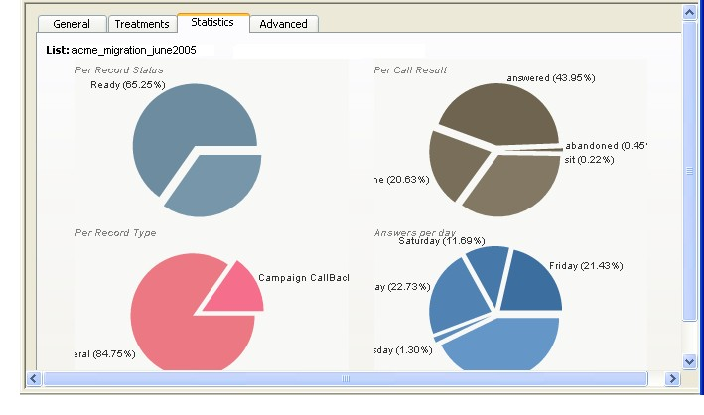
Figure 7 Calling list performance at a glance.

Modifying calling lists

To modify a calling list
- In the Menu frame, find the relevant tenant and click the Calling lists folder (go to the tenant’s menu > Resources > Calling lists).
The menu displays two sets of calling lists: those that are active and those that are inactive.
- Select the set you need and click the name of the appropriate calling list.
- In the calling list’s file, make the changes and click the Update button.
Related topics. For a description of the various settings, refer to the topic Creating calling lists.

To delete a calling list
The name of the calling list is removed from the CCS Manager’s window, but the list is not deleted from the database.

- In the Menu frame, find the relevant tenant and click the Calling lists folder (go to the tenant’s menu > Resources > Calling lists).
The menu displays two sets of calling lists: those that are active and those that are inactive.
- Select the set you need and click the name of the appropriate calling list.
- In the calling list’s file, click the Delete button.

Related topics. See also, in this document, the topics Treatments, Filters and Viewing real-time information (calling lists).

Do-Not-Call lists
In Aheeva CCS, Do-not-call lists contain the telephone numbers that should not be called, either for specific campaigns or never called at all. You can add numbers that should not be called to a campaign that is already active. You can also remove numbers from active Do-not-call lists.

Related topics. See also, in this document, the topic Campaigns (Do-not-call lists information panel).

Creating Do-not-call lists
- In the Menu frame, find the relevant tenant and click the Do-not-call lists folder (go to the tenant’s menu > Resources > Do-not-call lists) and select Create a Do-not-call list group.
The system displays the entry panel group in the bottom right-hand frame of the window.
- Enter a name for the Do-not-call list and click the Submit button.

Adding numbers to Do-not-call lists
- In the Menu frame, find the relevant tenant and click the Do-not-call lists folder (go to the tenant’s menu > Resources > Do-not-call lists) and select Add numbers to Do-not-call list.
The system displays the entry panel group in the bottom right-hand frame of the window.
- Provide the following information:
Do not call numbers when |  | Select an operand: equal to, not equal to, start with, end with, contain or don’t contain.  Enter a digit string in the text field to correspond to the operand you have selected.
Available groups |  | Displays all the Do-not-call lists that you have created. In order to add numbers to any lists, you must select the list from this box and click the >> buton to transfer the list onto the Selected groups box.
Selected groups |  | Numbers on “do-not-call’s” can be added only to the lists that are displayed in this box.  To remove a list, select it and click the << button.
 |  | About the Global list. This list is to be reserved for holding those numbers that should never be dialled, on any campaign. Numbers such as those for the emergency services (911) or of people who have expressed their wish to be removed from all of your calling lists.

- Click the Submit button.

Searching for Do-not-call numbers
The search for numbers is enforced in relation to service campaigns and not amongst lists of Do-not-call numbers. Looking in campaign rather than Do-not-call lists, makes the searching of telephone numbers, either for deletion or addition purposes, easier to manage on the long run as Do-not-call lists may be associated to several campaigns. You may not want to stop the dialling of the given number from occuring on every single campaign.

- In the Menu frame, find the relevant tenant and click the Do-not-call lists folder (go to the tenant’s menu > Resources > Do-not-call lists) and select Search campaign for Do-not-call numbers.
The system displays the entry panel group in the bottom right-hand frame of the window.
- Enter the number to be found. The system displays every campaign in which it has found the number.
A checkmark next to a campaign’s name indicates that the number is on an active Do-not-call list. You may click the option button to remove the checkmark.
An empty option button indicates that the requested number has not been placed on a Do-not-call list (or if it ever was, it is now removed from the campaign’s Do-not-call list of numbers. You may click the option button to add a checkmark.
- Click the Submit button.

Displaying Do-not-call list contents
In the Menu frame, find the relevant tenant and click the Do-not-call lists folder (go to tenant’s menu > Resources > Do-not-call lists). Select a Do-not-call list and click the View Contents button.

Campaigns

Setting up service campaigns
Service campaigns are highly customizable. They are built with permutable components (filters, treatments and calling lists) that, furthermore, can be themselves adjusted to produce numerous combinations.

Many factors, both internal and external, will influence the outcome of a campaign. Internal factors include: the skills of the agents, supervisors, coaches and the training that they received; the skills of those who build calling lists, the filter and treatments that are being applied to the calling list as well as the relative weight given to each of the calling lists that come into play in the course of the campaign.

External factors include: sudden and marked changes that can occur (in the rate of answered, not answered calls or talk time) to which the dialer must adjust and either slow down the dialing rate or increase the dialing rate. A slowdown means that agents must spend more time waiting whereas an increase of the dialing rate carries a risk of a rise in abandoned calls. Limits set on the percentage of abandoned calls that is acceptable will also influence results as calls will be sent to queues if no agent is available or to a standby pool.

Technically, you can manage an unlimited number of campaigns for several tenants at the same time.

The Aheeva CCS Manager works closely with your database. All the elements needed to run a campaign must be present in the database beforehand. When you instruct the system to start a service campaign, all the elements to run the campaign—namely, the groups of agents and calling lists as well as the tenant for whom they will be working—must already be found in your database.

Most campaign components are linked together; one exercising an action upon the next component. Deleting an element in a chain disconnects the links. For example, you define a treatment and make it available to be applied to a calling list. Later, you open the calling list’s file and enforce that treatment. If you were to delete the treatment you wouldn’t be deleting only the information about the treatment you would also be removing any connection the treatment may have with calling lists.
Related topic. For an example on how filters fonction with treatments in a calling list, see at the end of the topic, Treatments, the topic titled Example of a filter, a treatment and a calling list.

Naming convention for outbound campaigns only. We suggest that you keep the name of agent groups, the name of the campaigns to which they are assigned, the name of the calling queues and the name of any other resource that is attached to a particular campaign very similar (or identical) to the name given to the campaign.
For example: You name a service campaign for your client Acme “Acme_Best_Deal”. You could name the group of agents assigned to this campaign “acme_best_deal”. You can also name the routing script for this group of agents “acme_best_deal_broadcast”.

Name formats: No spaces, no comma and no special characters
(ex.: ~, / or ^). Use alphabetical letters, numbers 0–9 and the underscore.

To create a campaign
- In the Menu frame, find the relevant tenant and click the Campaigns folder (go to the tenant’s menu > Resources > Campaigns) and select Add campaign.
The system displays the entry panel group in the bottom right-hand frame of the window.
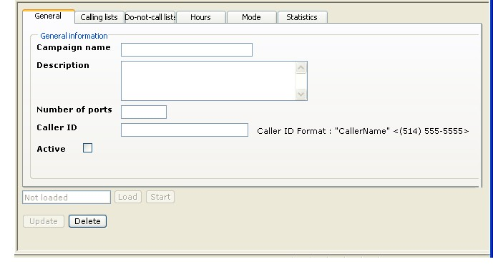
Figure 8 A campaign’s record.

- Enter the following information.

General information
Campaign name |  | Name of the campaign.
Description |  | Describe the purpose of the campaign.
Number of ports |  | Select as many ports as you have agents assigned to a campaign. Current practice is to assign 2 ports (or lines) per agent.
Caller ID |  | Enter an identification for the telephone number under which the campaign will be run.  For example: “ABCD” <(514) 457-5555> or  “Hello” <(514) 457-3333>
Active |  | Click to activate. If you leave unchecked the campaign will be listed in the Inactive Campaigns folder.
- Click the Save button.

Associated calling lists
Available calling lists |  | These are the calling lists that you made available, or activated, to this particular campaign.  - Active: Click the option to make the calling list active. You can deactivate the particular list by removing the check mark.  - Weight: Indicate, with a number, the relative preferential processing that the software dialer is to give the calling list. This grading forces the application to give preferential treatment to one list (the one with the higher weight) over the other. Maximum value is “100”.  For example: You give a weight of “2” to calling list A, and a weight of “9” to calling list B. The dialer will use first the settings that you indicated in the file of calling list A and then switch to calling list B’s settings if it needs them to reach the objectives of the campaign.
 |  | Adjusting the settings of factors that a computer program is meant to integrate into a preferential processing is almost an art. You will need to experiment a little, observe the results and judge of the effects that your adjustments produce on the software dialer.

Do-not-call lists
Available groups |  | Select from the Available groups the Do-not-call lists that are to be applied to the service campaign.
Selected groups |  | Click the >> button to place the selected item on the Selected group box. All the telephone numbers that appear on the selected lists will not be dialed during the campaign.
 |  | See, in this document, the topic Do-Not-Call lists.

Campaign daily hours
Indicate the hours during which the campaign is to be active. This is the time at the client’s location (matches the time zone in your calling list).
Click the From and To fields, for each day of the week, and select from the list the start and end time.

Dialing mode
Agent group |  | Specific agents and their associated queue. They must be already defined in the database for them to be listed here.
Dialing mode |  | Select one of Aheeva’s dialing algorithms.  - Predictive. The dialer can adjust automaticaly to information as it is collecting it and change its response rate by increasing or decreasing the frequency of numbers dialed in relation to the availability of agents, that of the customers and the length of time spent on line.  - Progressive. The dialer waits for the agent to be free before dialing out.  - Preview. Agents get to preview the customer’s file and must confirm that they want the call before the dialer initiates the communication. This is useful when agents need time to become acquainted with a file before they talk to the customer.  - Broadcast. Pre-recorded voice messages. The dialer detects faxes, voice-mail and answering machines. It also detects the tone that indicates the answering machine or voice-mail is ready to record the message. If the call is picked up by a human, it simply delivers the message.
Optimization parameter |  | Use only with the “predictive” dialing mode.  Two types of parameters: Agent busy factor and Overdial rate. Users can define either as a percentage.  The agent busy factor is calculated as the total-talk-outbound-time plus the total-talk-inbound-time plus the total-wrap-up-time divided by the total login-time.  Overdial. Dialer takes into account the percentage of “no answer” and “answering machine” and adjusts the amount of telephone numbers it should dial. Must also take into account the incidence of abandoned calls.
Target |  | Percentage to be reached.
Abandon rate |  | Calls abandoned by customers because no connection was achieved. When the percentage of calls that are dropped by the customers has reached 0.5% below the value indicated here, the system will start to slow down. The minimum acceptable value that you can enter is “0.5%”.
Answering machine detection |  | Click to activate.
 |  | To view the parameters that have been defined, see the amd.conf file.
Load |  | This feature is not available as long as the information about the campaign and the way you want to run it has not been saved in the database.  To the left of this button a dedicated field shows the status of the campaign: running, paused, not loaded.
The real-time information panel about the campaign will also show the campaign’s status.
Notice that the “not loaded” status in the campaign’s file is translated in the real-time information panel by the term “unknown”. Simply because the information about the campaign not having been passed (or loaded into) to the software dialer, the later does not “know” the status of the campaign nor the dialing mode it would be instructed to use.
Start |  | For this feature to be available, the campaign must be loaded.

Statistics
Displays overall campaign data.

- Click the Update button.

Running your campaign

To load the campaign
- In the Menu frame, find the relevant tenant and click the Campaigns folder (go to the tenant’s menu > Resources > Campaigns). The menu lists all the campaigns that are available in your database.
- Click the name of the campaign in the list. In the campaign’s file (bottom right-hand frame of the application’s window) verify that all the settings are correct and click the Load button. This simply means that values have been read from the database and the parameters for the campaign have been loaded into the application.

To start the campaign
- When your agents are ready to start work, click the Start button.
Notice that the Start button will be replaced by a Stop button.

Unloading the campaign
Unlike the stopping or pausing of the campaign —that keeps the parameters suspended, intact and waiting to be reloaded to run their course— unloading a campaign will reset all the treatments that you have applied to the campaign.
Example: You define a treatment that will force the dialer to try dialling a busy, and unsanswered, number 10 times. When the dialer has reached the 9th attempt, you unload the campaign.
When you load the campaign again, the dialer will not execute the 10th, and last, dialling attempt, thereby finishing the treatment cycle: it will start again at the beginning, as if the treatment had been freshly reapplied to the campaign.

To stop or pause a campaign
- In the Menu frame, find the relevant tenant and click the Campaigns folder (go to the tenant’s menu > Resources > Campaigns). The menu lists all the campaigns that are available in your database.
- Click the name of the campaign in the list. In the campaign’s file (bottom right-hand frame of the application’s window), click the Stop button.
Notice that the campaign’s parameters have not been unloaded from the system. Everything is still ready to run.

To delete a campaign
- In the Menu frame, find the relevant tenant and click the Campaigns folder (go to the tenant’s menu > Resources > Campaigns). The menu lists all the campaigns that are available in your database.
- Click the name of the campaign in the list. In the campaign’s file (bottom right-hand frame of the application’s window) click the Delete button.

Work force management

Teams
Besides organizing agents into groups so they can be assigned to a given task, you can further separate the agents into teams. A team is a great motivational aid that incites agents to increase productivity.
Related topic. See also, in this document, the topics Viewing real-time information and Reporting.

Setting up teams of agents

To create a team
- In the Menu frame, find the relevant tenant, click the Teams folder (go to the tenant’s menu > Work force management > Teams) and select Add a team.
The system displays the entry form in the bottom right-hand frame of the window.
- Enter a team name and the name of the leader (usually an agent from the team).
- In the Non-configured agents list, click the name of the agents you wish to include in the team and click the >> button. The agents that are listed in the Assigned box belong to the team.
- To remove agents from the team, select their name in the Assigned list and click the << button.
- Click the Add new team button.

To modify a team
- In the Menu frame, find the relevant tenant, click the Teams folder (go to the tenant’s menu > Work force management > Teams) and select the relevant team.
The system displays the entry form in the bottom right-hand frame of the window.
- Make the appropriate changes and click the Update team button or, to delete the team, click the Delete team button.

To delete a team
- In the Menu frame, find the relevant tenant, click the Teams folder (go to the tenant’s menu > Work force management > Teams) and select the relevant team.
The system displays the entry form in the bottom right-hand frame of the window.
- Click the Delete team button.

Work schedules
The Aheeva CCS Manager allows you to create and manage the work schedules of your agents. They, in turn, can view the schedules on the intranet.

Adding a schedule
- In the Menu frame, find the relevant tenant, click the Add schedule item (go to the tenant’s menu > Work force management > Schedule).
The system displays the period entry form in the bottom right-hand frame of the window.
- Select the group of agents whose schedules you want to add.
- Select a start and end dates and click the Submit button.
The system displays the results in a three-panel secondary window.
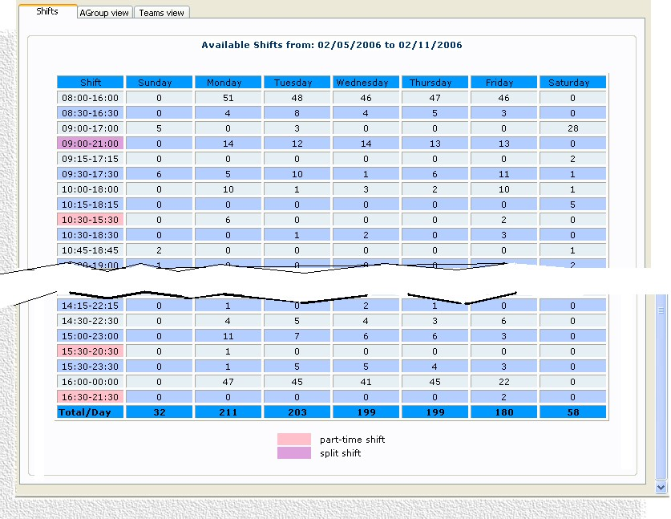
Figure 9 Creating work schedules.

Shifts tab
Part time |  | Shows the part time shifts for the selected period.
Split |  | Shows the split shifts for the selected period.  Displays also the total number of shifts per day.
Group view tab
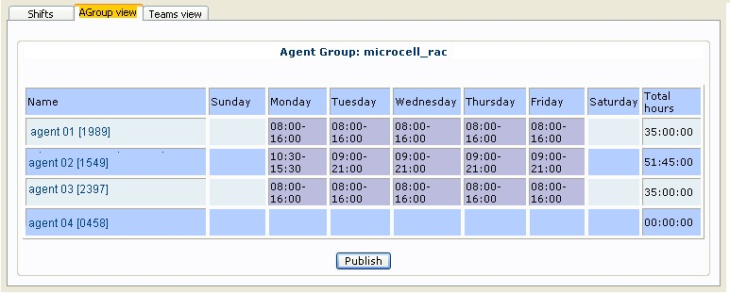
 |  | Lists the names of the agents in the given groups and their daily schedule.
Team view tab
 |  | Lists the names of the agents in the given teams and their daily schedule.
- Click the Publish button to send the data to the corresponding table in the database. The agents will view their schedules in the Intranet.

Viewing and adjusting published schedules
- In the Menu frame, find the relevant tenant, click the View schedule item (go to the tenant’s menu > Work force management > Schedule).
The system displays the period entry form in the bottom right-hand frame of the window.
- Select the group of agents whose schedules you want to view.
- Select a start and end dates and click the Submit button.
The system displays the results in a three-panel secondary window.
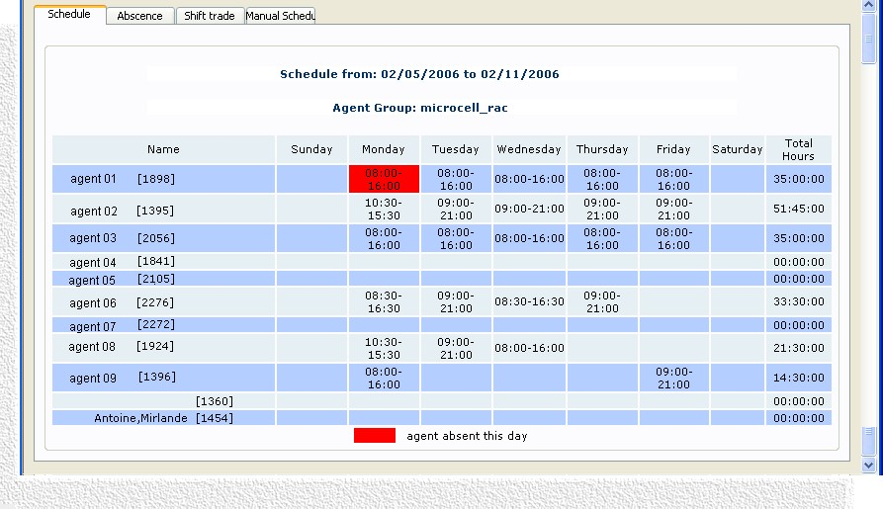
Figure 10 Adjusting work schedules.

Schedule
 |  | Displays the daily schedule for the selected group and period. Total number of hours and whether the agent was absent.
Abscence
 |  | This panel is used to set the absences of the agents.
Choose agent |  | Select an agent from the list.
Schedule |  | Display the agent’s schedule for the selected period.
Choose day |  | Click and select from the calendar. Click the Set absent button.  The absence will be marked in red in the agent’s schedule (click the Schedule tab to display the schedule).
Shift trade
 |  | This panel is used to exchange shifts between agents.
Agent 1 & 2 |  | Select the agents from the lists. Chose the days to be traded.  Click the Trade button.
Manual schedule
 |  | The manual schedule panel is used to add work shifts to schedules that are already published.
Select agent |  | Select the agent. The agent’s schedule for the current week is displayed on the right-hand side.
Select day |  | Select the day to which you want to add a work shift.
Start and end times |  | Indicate a start and end times.
Lunch/break |  | Click the “Add a new break” button to add a lunch period or a break period.
Start and end times |  | Select the break start and end times.
- Click the Save button

Real-time adherence
This feature is used to define the display settings on the diagram that shows, in real time, whether or not agents are diligent by adhering to their work schedule. The feature will also report on past adherence.

Agent adherence to work schedules

To set real-time viewing
This function shows information for every agent in a group that is connected to the application on a given day.
- In the Menu frame, find the relevant tenant, click the Adherence folder (go to the tenant’s menu > Work force management > Adherence) and select Real time adherence.
The system displays the entry form in the bottom right-hand frame of the window.
- Select the groups of agents (to clear the selection use the Select None button).
- Select the Start and End time in which to view information live for the current date.
- In the Spacing drop-down list, select the time measurement units, in minutes, that are to be used in the diagram.
- Click the Start button, the Update button, if you’ve made changes, or the Stop button to make changes. The requested information is displayed in the top right-hand frame of the window.
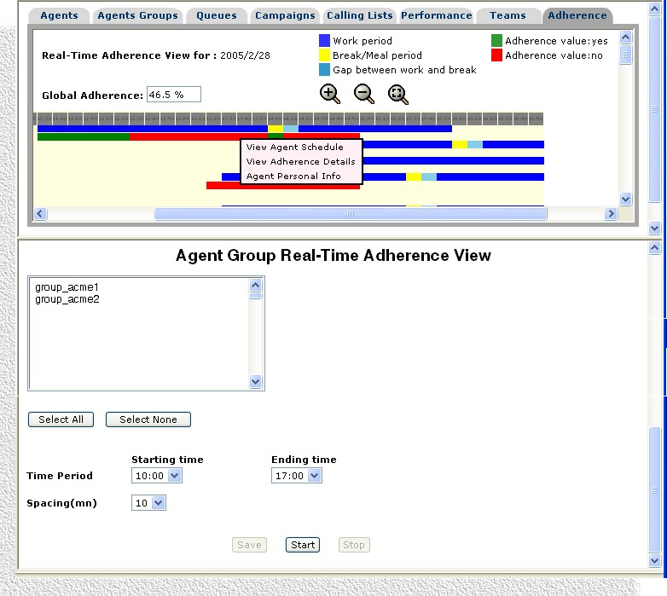
Figure 11 Adherence to work schedule in real time.

Reading the live information panel
You can run your cursor over the diagram to display information about the color-coded bar such as “agent X is logged out, should be logged in.”

Right-click anywhere in the agent’s adherence bar to display a pop-up menu that presents you with three informational options about the agent: you can view the agent’s work schedule, adherence details as well as organizational information which covers the equipment through which the agent is connected (IP address, host, group and team to which the agent belongs and login).

Use the magnifying glass icons to zoom in and out.

To view agent adherence by date
This function will display in a separate window the real-time information for a selected date. Will also provide an adherence value expressed as a percentage.

- In the Menu frame, find the relevant tenant, click the Adherence folder (go to the tenant’s menu > Work force management > Adherence) and select View adherence graph.
The system displays the entry form in the bottom right-hand frame of the window.
- Select individual agents by clicking their name (Ctrl + click for multiple selection)
click Show all agents to display the agent’s name in alphabetical order in the selection drop-down list —or—
click Show agent by ID to display the agents in the selection drop-down list by their ID number (login).
- In the Time period, select a Start time and End time.
- In the Spacing drop-down list select the time measurement units, in minutes, that are displayed horizontally across the diagram.
- Select a start and an end date and indicate whether you want to view daily figures or cover a month.
- Click the Submit button.

To report on agent adherence
This function will display in the bottom right-hand frame of the application window real-time information for a selected date.

- In the Menu frame, find the relevant tenant, click the Adherence folder (go to the tenant’s menu > Work force management > Adherence) and select Adherence report.
The system displays the entry form in the bottom right-hand frame of the window.
- Select individual agents by clicking their name (Ctrl + click for multiple selection),
- Click Show all agents to display the agent’s name in alphabetical order in the selection drop-down list —or—
click Show agent by ID to display the agents in the selection drop-down list by their ID number (login).
- In the Report type, activate one of the options: yearly, monthly or daily report.
- Select a start and an end date according to the report type.
- Select a sorting order: descending value, ascending value, agents’ login or name.
- Click the Submit button.

Payroll information
This feature is used to connect the hours worked by your agents, together with their salary, with your enterprise’s accounting application. Terms of payment are entered here, actual hours are logged, pays and commissions are calculated and the information is stored in the database. The data can then be exported to the company’s payroll system.

Setting up commissions

To create a payment commission
- In the Menu frame, find the relevant tenant, click the Commissions folder (go to the tenant’s menu menu > Work force management > Payroll Information) and select Add Commission.
The system displays the panel group entry form in the bottom right-hand frame of the window.
- Enter the following information:
General settings
Commission |  | Name of the commission. For example: comis01_acme_best_deal.
Description |  | Enter a description for the commission.
Max commission value |  | Absolute value expressed as dollars/hour that cannot be exceeded.
Active |  | Click to activate. If left unchecked, the commission will be displayed in the Inactive commissions folder.
- Click the Save button. The system now displays the second panel in the group.
Commission settings
 |  | Select the criterion on which to base the commission.
Fixed |  | Click to activate. The commission will be set to the value defined in the previous panel, General settings.
Sales based |  | Click to activate. Select the range: sales per hour, sales per week or sales per unit.
Group average based |  | Click to activate. Select the range: by default, the option sales per week is displayed. Click to activate.  Add a new range. Click to define the weekly commission range.  For example, if the option Sales per week is selected, and the following is specified  From 10.01 To 20.00 Use 1.50  From 20.01 To 30.00 Use 2.00  This means that the agent whose sales are 10.01% to 20.00% higher than the group’s average will receive an extra $1.50 per hour. The agent whose sales are 20.01% to 30.00% higher than the group’s average will receive an extra $2.00 per hour.
Performance based |  | Click to activate. Indicate if the commission is to be calculated on the conversion rate or on sales per week.
- Click the Save button.

To modify or delete a commission
- In the Menu frame, find the relevant tenant, click the Commissions folder (go to the tenant’s menu > Work force management > Payroll information) and select the relevant item in the active commissions folder or the inactive commissions folder.
The system displays the panel group entry form in the bottom right-hand frame of the window.
- Make the appropriate changes and click the Update button or, to delete the commission, the Delete button.
Related topic. For a description of the panel contents, see, above, the topic To create a payment commission.

Setting up methods of payment

To add a method of payment
- In the Menu frame, find the relevant tenant, click the Methods of payment folder (go to the tenant’s menu > Work force management > Payroll information) and select Add Method of payment.
The system displays the panel group entry form in the bottom right-hand frame of the window.
- Enter the following information:
General settings
Method of payment |  | Enter a name. For example: mop_acme_best_deal
Description |  | Enter a description.
Active |  | Click to activate. If you leave unchecked, the method of payment will be listed in the Inactive item folder.

Method of payment codes
 |  | The Method of Payment codes that you enter in the Aheeva CCS application must be the same codes that can be found in your company’s payroll system. Otherwise, errors will occur as your accounting system will not be able to match the information.
Training code |  | Enter a code that is to indicate agents on training and indicate whether agents on training activities are to be paid an hourly rate or a fixed dollars value.
Integration code |  | Enter a code that is to indicate agents on integration and indicate whether agents on integration activities are to be paid an hourly rate or a fixed dollars value.
Production code |  | Enter a code that is to indicate agents on production and indicate whether agents on production activities are to be paid an hourly rate or a fixed dollars value.
Commission code |  | Enter a code that is to indicate that the agent is to be paid on commission.  Depending on the type of commission, the system displays the hourly option or the dollars option.
Continuing training code |  | Enter a code that is to indicate agents on continuing training and indicate whether agents on continuing training activities are to be paid an hourly rate or a fixed dollars value.

Commissions
The list on the left contains all the commissions that you have defined. Select one and click the >> button to display the selected items in the list on the right.
See, above, the topic Setting up treatments of payment.

Overtime
Number of weekly hours |  | Number of hours worked in a normal work week. Example: 40.00.  This will affect the calculation of overtime for hours worked above the number indicated here.

Methods of payments can be applied to an entire group of agents thus saving time when you create the file of a new agent since the agent will invariably be assigned to a group.

Related topic. See, in this document, the topics Setting up groups of agents and Setting up your agents.

To modify a method of payment
- In the Menu frame, find the relevant tenant, click the Methods of payment folder (go to the tenant’s menu > Work force management > Payroll information) and select the relevant method of payment.
The system displays the panel group entry form in the bottom right-hand frame of the window.
- Make the appropriate modifications and click the Update button.
Related topic. For a description of the panel contents, see, above, the topic To add a method of payment.

To Delete a MOP
- In the Menu frame, find the relevant tenant, click the Methods of payment folder (go to the tenant’s menu > Work force management > Payroll information) and select the relevant method of payment.
The system displays the panel group entry form in the bottom right-hand frame of the window.
- Make the appropriate modifications and click the Delete button. For a description of the panel contents, see the previous step To add a method of payment.

Payroll information reports
This is where you associate and override the activites in which specific agents are engaged and the specific terms of payment for those activities.

Related topics. See also, in this document, the topics Call centers activities and payroll, Payroll configuration and Setting up methods of payment.

Login and production time
Methods of payment are applied to paid time, but information on login time is essential in calculating production time and pay.

- In the Menu frame, find the relevant tenant, click the Reports folder (go to the tenant’s menu > Work force management > Payroll information) and select Login and production.

The system displays the entry form in the bottom right-hand frame of the window.

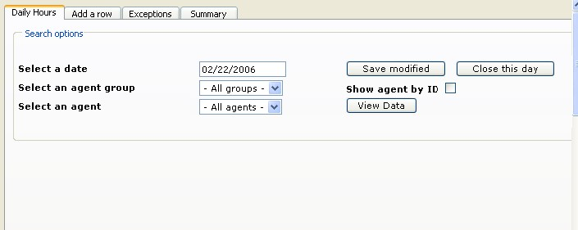
Figure 12 Payroll on login and production time.

- Enter the following information.
Daily hours
Date |  | Select a date.
Agent group |  | Select a group of agents.
Agent |  | Select the agent.
Show by ID |  | Activate to sort the display of data according to agent’s ID.
View data |  | Click to view the login and production data for the selected group or the selected agent.  The system displays the agent ID, first and last name, the associated agent group, the total login time and total paid time.  Override. Click to override the information for the associated agent.  Correction. Enter the number of minutes or hours to be corrected. A correction means, for example, that you want to change the type of activity in which the agent has been involved. This will change payroll information for the selected agent according to the settings you have defined in the Methods of payment group of panels.  Override time. Will display the corrected Paid time. For example: if the Paid time field shows 7:10, the agent is to be paid for 7 hours and 10 minutes. If you entered 30 minutes in the Correction field, the Override time is now 7:40. Therefore, the selected agent is now going to be paid for 7 hours and 40 minutes of work.  Override cause. Select the activity in which the agent has been engaged and for which you are making this correction to payroll information.  Custom cause. Enter a description if the activity you have selected in Override cause is “other”.
Save modified |  | Click to save the changes.
Close day |  | Use to close the day at midnight.
 |  | Warning: Once you close a day, you will not be able to modify the payroll information for that day.

Add a row
 |  | Warning: Adding rows of activities to agents’ files so that they can be paid for those activities can only be done before you close the day at midnight using the Close this day button on the Daily hours panel.
Agent group |  | Select a group of agents.
Agent |  | Select an agent.
Date |  | Select a date.
Add row |  | Click the Add a row button to add a paid activity for the selected agent or group of agents.  The system displays the agent ID, first and last name and the agent group.  Activity. Select the activity.  Paid time. Indicate the number of minutes or hours for which the agent is to be paid.  Comment. Enter a comment.
Save rows |  | Click to save the information you have added to the agent’s or agent group’s payroll information.

Exceptions
Start date |  | Select a start date.
End date |  | Select an end date.
View Exceptions |  | Click to view the exceptions to payroll information that have been created by users over the specified period before the respective days were closed.  Override by. The system displays the information that can be found on the Daily hours panel and the name of the user who made the modifications.

Summary
The panel displays the summary of hours that have been recorded as login time, paid time and billable time for every group of agents. Also displays the associated queue.

Extract payroll data
The payroll data (methods of payment and hours worked) collected by Aheeva CCS can be exported to your accounting system.

- In the Menu frame, find the relevant tenant, click the Extract payroll data report (go to the tenant’s menu > Work force management > Payroll information > Reports) and select Login and production.

The system displays the entry form in the bottom right-hand frame of the window.
- Enter the following information.
From and To |  | Select the start and end dates.  The period range is limited to one week. The week must start on a Sunday and end on a Saturday.
Export to |  | Select the application to which data is to be exported. Generally, this is your accounting or payroll program.
Mail to |  | Enter the e-mail address where the data is to be sent.

Routing scripts

Routing scripts
You can use routing scripts both for inbound and outbound applications. Scripting, in the CCS Manager, is a two-fold process: a graphical layout of the script and a customization of Asterisk’s configuration file extensions.conf.

To create a script
Setting up routing scripts involves two steps:
1) With the graphical interface of the CCS Manager you assemble the various elements of the scripts on the drawing board. The instructions to the CCS Manager on how the application is to exchange data with Asterisk are as follows.

2) With a command shell, you enter the telephone extensions in the extensions.conf configuration file of Asterisk, the open-source IP-PBX used by the Aheeva application.

Step 1—CCS Manager scripting tool
Use the CCS Manager graphical tool to connect the script’s building blocks on a drawing board and to represent the various paths that different call instances will be following. To open the pop-up box to specify any of the building blocks, simply click the box.

- In the Menu frame, find the relevant tenant, click the Routing Scripts folder (go to the tenant’s menu > Routing Scripts) and select Add routing script.
The system displays the selection form in the bottom right-hand frame of the window.

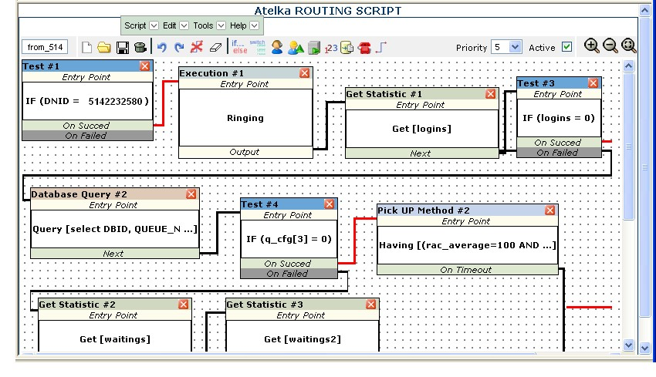
Menu bar
Tool bar
Figure 13 Creating routing scripts.

You are provided with a menu bar and a tool bar for shortcuts. Below is a list of the options that are available for script building.
Scripts must start with en entry point and end with a termination point.

- Enter the script’s name in the field to the left of the tool bar (example, from_514: routing path for calls that originate from the “514” area code).
 |  | Menu bar — Script
 |  | Besides the familiar menu items, such as “save”, this menu includes the following feature.
Script statistics |  | Displays the overall number of calls that have been routed by the given script on a given day (day starts at midnight, local time).
 |  | Menu bar — Edit
 |  | Besides the familiar editing capabilities, such as “undo”, contains the following.
Clear diagram |  | Erases the diagram. It is the equivalent to a reset action.
Validate diagram |  | Checks for construction errors, but will not detect errors of logic.
Call properties |  | Lists the local variables that are created by the user from database queries (SQL queries). Use to add new properties.
 |  | Menu bar — Tools
Statements  If… else… |  | Use to define call conditions that are to trigger the particular routing of a call. Select a call property, a logical operator and the value to be sought in the database in order to start the script.
Switch… case… |  | Switches can have several exit points which means that you can connect the switch element by using the link tool to several other building blocks.  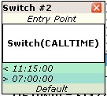  Exit points
Switch statements are listed in the container box as you define them. There are as many exit points to the given call condition.
In the statement definition pop-up box, the “+” icon adds the statement to the list; the “x” icon removes it; and the arrow icons increase or decrease the order in which a given statement is to be processed.
Select a call property, a logical operator, enter a parameter value and click the + icon.
Actions  Agent pickup method |  | Calls can be picked up by agents according to agent properties such as the group to which an agent belongs, the agent’s ID or agent’s skills.  The agent pickup method uses the same logic as the one that is applied to Asterisk’s Queue application.  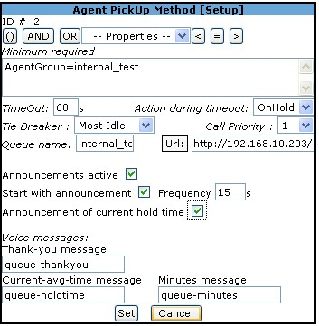  Build a logical expression in the Minimum required text field by clicking the mathematical operands.  Enter a timeout value, in seconds, and the action that is to occur until the caller reaches the timeout threshold.  Tie breaker can be the call is going to the agent that is the most idle, or that is the least busy.  Select a priority for processing the given call. Indicate a queue to hold the call and a URL.  Click the option to activate or deactivate the playing of announcements.  Start with announcement will play the announcement as soon as the call enters the queue.  Specify a frequency: the delay, in seconds, between announcements.  You can let callers know of the estimated current waiting time in the queue by activating the option Announcement of current hold time.  You can use any of the three available messages to callers:  Indicate the file name of the thank-you message. Example: “Thank you for your patience.”  Indicate the file name of the current-avg-time message. Example: “The current hold time is X.”  Indicate the file name of the queue minutes messages. Example: “X minutes.”
 |  | In the above example of how to set up the call pickup method, we used the messages provided by Asterisk for queue.conf, but you can use any recorded messages that you want. Simply put the files in /var/lib/asterisk/sounds.
Call priority increment |  | Increases the priority order.
Application execute |  | Select one or several Asterisk functions (IP-PBX telephony application) and define its parameters.  Notice the description of the selected Asterisk application appears to the left of the parameters text box. For instructions on setting this feature, see above the “Switch” statement.
Get string |  | Digits are used in control messages. The system plays a message (a WAV file) to the agent requiring that he or she takes a given action.  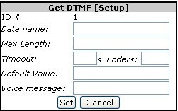  Indicate a data name (the data that the agent will hear), the maximum length of the message and a timeout in seconds.  Enders and a default value are optional. Indicate the location of the voice message file.
Database query |  | Used to run a SQL query to extract any value that is in the database. The result of the search is stored in a table (local variable) that you name in the “Result Name” field.  For example, with a credit card number, the system can retrieve a customer’s name, type of telephone equipment, and much more.
Custom server |  | User-defined C++ application. Use to integrate in the overall script your own application. The system assigns automatically an ID number to the server.  From the drop-down lists, select the library, the function and define your parameters.
End call |  | Select an action that will terminate the call, and end the given routing script.  In the Parameters field, enter a value. For example, if the call is to be transferred, enter the extension number of the device where the call is to be sent.
Link boxes |  | To link script’s elements: select the Link boxes menu item (or the shortcut on the tool bar); click the exit point in the first script’s element, click the entry point in the second element in the script’s sequence.  To remove links, double-click the link and click the Delete arrow icon on the tool bar.
Menu bar — Statistics
Statistics  Counter |  | Will count the calls that are processed through the given script or the number of calls at a specific call condition (“If” statement) depending on where, in the graph, you place the counter box.  Activate the “Show statistics” to display the count value on the building block.
Get statistics |  | Script element used to collect information on queues and on agents based on call properties or on skills.  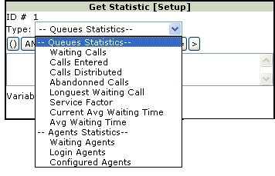
- Select the path element (building block) from the menu bar or the tool bar. An empty building block appears on the drawing board. Click the building block to set the parameters in the pop-up box.

- Use the link tool to connect the path elements and to denote action–reaction.
- Assign a priority to the script (right-hand corner of tool bar).
- Activate or deactivate the script by checking the option (right-hand corner of tool bar).
- Save the script diagram.

Step 2—Asterisk’s extensions.conf file
Use a command shell to set the extensions.conf file.
Asterisk | Add the appropriate telephone extensions in the default context of the /etc/asterisk/extensions.conf configuration file. For example:  [default]  exten => 5145551234,1,Goto(aheeva_sbr,s,1)  Where “5145551234” is the telephone number for incoming call connections (inbound). Each time a telephone number (a building block) is added to a script with the CCS Manager scripting tool, a corresponding entry must be inserted in the default context of the extensions configuration file.

To modify scripts
- In the Menu frame, find the relevant tenant, click the Scripts folder (go to the tenant’s menu > Routing Scripts) and select the relevant routing script.
The system displays the diagram in the bottom right-hand frame of the window.
- Make the appropriate changes and click on either the save or delete icons.

Reporting

Related topic. See also, in this document, the topic Viewing real-time information and Appendix B—Formulas to generate return values.

Generating reports
Aheeva Contact Center Solution reports not only on standard items in the field of telephony but also on items that are specific to the application.

The depth of the information that the CCS application can record and generate is one of its much appreciated features, but on certain occasions you may want to display information quickly. The application allows you to do both.

MySQL slave and clustering technology are available on request. Slave server capabilities can be used for large database requests whereas clustering offers high availability.

Because the measure of performance has been deemed to be an important factor in businesses that run contact centers. Quantifying the efficiency of agents and queues is now a streamlined reporting feature characterized by its expediency. For example, you can now find out quickly the number of calls that a given queue is distributing within a range of given numbers of seconds, so you can adjust the appropriate settings accordingly. These settings involve not only queues, but agents as well, since agents are the ones to pick up and process the calls. You will see, at a glance, why agents may experience delays in processing current calls and thereby, in pickup up the following calls.

To generate reports
All reports are generated through the same procedure.

- In the Menu frame, find the relevant tenant, click the Historical reports folder (go to the tenant’s menu > Historical reports) and select the report from the list.
The system displays the selection form in the bottom right-hand frame of the window.
- Select the agent, the campaign or whatever other object you wish to report on (Ctrl+click for multiple selections).
To select several objects, hold the Ctrl key and click.
- Select the type of report: daily, monthly, yearly.
- Indicate the range of the period you wish to cover by selecting a Start date and an End date.
- Click the Submit button.

Agents
Agent and queue reports are extracted from tables specially designed in order for the dbCruncher tool to display data on performance. The agent report separates information on calls that have been answered from calls that have not been answered because the agents were not ready or involved in a service process, such as transfering or holding calls. It prints the following information.

Answered calls
Telephony data
Time period |  | In daily reports, time is presented in hourly slices; in monthly reports, in daily slices; and in yearly reports, in montly slices.
Login time |  | Total time the agent is connected to the application.
Login count |  | Number of times the agent opened a work session (connected to the application).
Inbound time |  | Total amount of time spent handling inbound calls.
Inbound count |  | Number of inbound calls that the agent received.
Ountbound time |  | Total amount of time spent handling outbound calls.
Outbound count |  | Number of outbound calls that the agent made.
Wrap up time |  | Total amount of time spent wrapping up.
Wrap-up count |  | Number of wrap-ups that the agent performed.
Hold time |  | Total amount of time spent by the agent handling calls on hold.
Hold count |  | Number of calls placed on hold that the agent received.
Average
Time period |  | In daily reports, time is presented in hourly slices; in monthly reports, in daily slices; and in yearly reports, in montly slices.
Inbound calls |  | Average time spent handling inbound calls.
Outbound calls |  | Average time spent handling outbound calls.
Wrap-up calls |  | Average amount of time spent wrapping calls up.
Hold calls |  | Average amount of time that calls were on hold.
Handling |  | Average amount of time handling calls.

Percentage vs login time
Time period |  | In daily reports, time is presented in hourly slices; in monthly reports, in daily slices; and in yearly reports, in montly slices.
Inbound calls |  | Time (expressed as a percentage) with inbound calls compared to total amount of time the agent was connected to the application (in session).
Outbound calls |  | Time (expressed as a percentage) with outbound calls compared to total amount of time the agent was connected to the application (in session).
Wrap-up calls |  | Time (expressed as a percentage) wrapping calls up compared to total amount of time the agent was connected to the application (in session).
Hold calls |  | Time (expressed as a percentage) handling calls on hold compared to total amount of time the agent was connected to the application (in session).
Handling |  | Time (expressed as a percentage) handling calls compared to total amount of time the agent was connected to the application (in session).
Busy |  | Total-talk-outbound-time plus total-talk-inbound-time plus total-wrap-up-time divided by the total-login-time. Expressed as a percentage.

Unanswered calls
Telephony data
Time period |  | In daily reports, time is presented in hourly slices; in monthly reports, in daily slices; and in yearly reports, in montly slices.
Login time |  | Total time the agent is connected to the application.
Login count |  | Number of times the agent opened a work session (connected to the application).
Wait time |  | Total amount of time the agent was waiting.
Wait count |  | Number of times the agent was waiting.
Single transfer time |  | Time spent performing a single transfer.
Single transfer count |  | Number of single transfers that the agent performed.
Two-step transfer time |  | Time spent performing a two-step transfer.
Two-step transfer count |  | Number of two-step transfers (three-party) that the agent performed.
Not ready time |  | Total amount of time that the agent was “Not ready”
Not ready count |  | Number of times that the agent used the “Not ready” mode.
Not ready reasons
Time period |  | In daily reports, time is presented in hourly slices; in monthly reports, in daily slices; and in yearly reports, in montly slices.
 |  | Time spent in Not ready reasons.
Average
Time period |  | In daily reports, time is presented in hourly slices; in monthly reports, in daily slices; and in yearly reports, in montly slices.
Wait calls |  | Average amount of time waiting for calls.
Single transfer calls |  | Average amount of time performing single transfers.
Two-step transfer calls |  | Average amount of time performing two-step transfers.
Not ready calls |  | Average amount of time being “Not ready”.
Percentage vs login time
Time period |  | In daily reports, time is presented in hourly slices; in monthly reports, in daily slices; and in yearly reports, in montly slices.
Wait calls |  | Time (expressed as a percentage) spent waiting for calls compared to total amount of time the agent was connected to the application (in session).
Single transfer calls |  | Time (expressed as a percentage) spent performing single transfers compared to total amount of time the agent was connected to the application (in session).
two-step transfer calls |  | Time (expressed as a percentage) spent performing two-step transfers compared to total amount of time the agent was connected to the application (in session).
Not ready calls |  | Time (expressed as a percentage) in “Not ready” mode compared to total amount of time the agent was connected to the application (in session).

Statistics
 |  | Pie-chart diagram, color-coded to indicate inbound calls, outbound, calls, wrap-up time, hold time, waiting time, Not ready time, single transfers and two-step transfers.
Other |  | Also includes the total amount of time that the agent was scheduled to work; the total amount of time that the agent was connected to the application (login); the total productivity time (total-wrap-up-time plus total-not-ready-time divided by the total amount of time that the agent was in session (login))and the adherence to the work schedule (expressed as a percentage).

Agent Groups
Agent group, agent and queue reports are extracted from tables specially designed in order for the dbCruncher tool to display data on performance. The agent group report separates information on calls that have been answered from calls that have not been answered because the agents were not ready, waiting or involved in a service process, such as transfering or holding calls. It prints the following information.

Answered calls
Login details
Login time |  | Total amount of time that the groupe of agents have been connected to the application.
Login count |  | Number of times the agents in the group opened a work session (connected to the application).
Inbound calls
Inbound time |  | Total amount of time spent handling inbound calls.
Inbound count |  | Number of inbound calls that the agents received.
Inbound average |  | Average amount of time time spent handling inbound calls.
Outbound calls
Outbound count |  | Number of outbound calls that the agents in the group made.
Outbound time |  | Total amount of time spent handling outbound calls.
Outbound average |  | Average amount of time spent handling outbound calls.
Wrap up calls
Wrap-up count |  | Number of wrap-ups that the agent performed.
Wrap-up time |  | Total amount of time spent wrapping calls up.
Wrap-up average |  | Average amount of time spent wrapping up calls.
Hold calls
Hold count |  | Number of calls that were placed on hold.
Hold time |  | Total amount of time that calls were placed on hold.
Hold average |  | Average amount of time that calls were on hold.

Unanswered calls
Waiting calls
Waiting count |  | Number of times the group of agents was waiting.
Waiting time |  | Total amount of time that the group of agents was waiting.
Waiting average |  | Average amount of time that the group was waiting.
Transfer calls
Transfert count |  | Number of calls that the group of agents transferred.
Transfert time |  | Total amount of time spent in transferring calls.
Transfert average |  | Average amount of time spent in transferring calls.
Not ready calls
Not ready count |  | Number of times that the group was “Not ready”.
Not ready time |  | Total amount of time spent in the “Not ready” mode.
Not ready average |  | Average amount of time that the agents were not ready.

Statistics
Pie-chart diagram, color-coded to indicate inbound calls, outbound, calls, wrap-up time, hold time, waiting time, Not ready time, single transfers and two-step transfers.

Agent summary
A summary report is extracted for every agent in a given group where the information is presented as item counts (such as number of calls, number of transfers), time count (such as time spent in inbound call, outbound calls), average counts and percentages.

Data
Agent name |  | Lists the name of all the agents in the group.
Scheduled |  | Total time scheduled to work.
Actual |  | Actual hours in session (login).
Inbound calls |  | Number of calls and time spent in inbound calls.
Outbound calls |  | Number of calls and time spent in outbound calls.
Wrap up calls |  | Number of wrap ups and time spent wrapping up.
Hold calls |  | Number of calls that were on hold and time spent on hold.
Waiting calls |  | Number of calls that have been waiting and time spent waiting.
Transfer calls |  | Number of calls that were transferred and time spent in transfers.
Not ready |  | Number of calls that were met by a “Not ready” reason and time that calls were held by a “Not ready” reason.

Average
Agent name |  | Lists the name of all the agents in the group.
Inbound calls |  | Average time spent in inbound calls.
Outbound calls |  | Average time spent in outbound calls.
Wrap up calls |  | Average time spent wrapping up.
Hold calls |  | Average time spent hold calls.
Waiting calls |  | Average time that the agent spent waiting.
Transfer calls |  | Average time spent in transfers.
Not ready |  | Average time that the agent was “Not ready”.

Percentage
Agent name |  | Lists the name of all the agents in the group.
Scheduled |  | Total time scheduled to work.
Actual |  | Actual time in session (login).
Adherence |  | Degree of variance between scheduled and actual time. Expressed as a percentage.
GAP |  | Gap between actual time worked and scheduled time.
Productivity |  | Sum of (wrap-up time in excess of the average wrap-up time for the selected period and Not ready time that affected the productivity) divided by time that the agent was connected to the application.
Calls per hour |  | Number of calls per hour.
Calls out/in |  | Percentage of calls that were outbound.
Transfers |  | Percentage of time spent in transfers
Not ready |  | Percentage in “Not ready” mode.

Outbound calls
Reports telephony data regarding agent groups in specific outbound campaigns. Amounts are calculated by adding the time spent by every agent in the group while engaged in the corresponding activity.

Data
Agent ID and name |  | Agent ID and name.
Total login time |  | Total time the agent was connected to the application.
Contacts |  | Number of outbound calls.
Success |  | Number of sales.
Refusals |  | Number of refusals.
Call backs |  | Number of call back.

Statistics
Agent ID and name |  | Agent ID and name.
Calls per hour |  | Number of calls handled per hour.
Sales per hour |  | Number of sales per hour.
Refusals per hour |  | Number of refusals per hour.
Net conv. rate |  | Total sales divided by total contacts (expressed as a percentage).

Inbound calls
Reports telephony data regarding agent groups. Amounts are calculated by adding the time spent by every agent in the group while engaged in the corresponding activity.

Call date |  | Date of the specific call (telephone number as search criteria).  Date for the result.
Time period |  | Start and end dates.
Calls offered |  | Calls that were distributed.
Call handled |  | Actual calls that were handled.
% SVL |  | Degree of service level, variance between calls offered and calls handled.
Talk time |  | Time spent talking with customer.
Wrap up time |  | Time spent in wrapping up call.
Hold time |  | Time spent on hold.
Average handling time |  | Average time spent handling the call.

Agent login
Excerpted from the agent report.

Agent ID |  | Unique ID value of agent’s.
Agent name |  | The name of the agent.
First login |  | First time that the agent opens a work session.
Last logout |  | Last time that the agent closes the work session.
Total login time |  | Total time spent in session (connected to the application).

Campaigns
See also, in this document, the topic Real-time information.

Time |  | The period of time to calculate.
Hit rate |  | The hit rate for the entire campaign.
Dials |  | The number of dialing attempts.
Answered |  | The number of calls that were answered by the customers.
No answer |  | The number of times that calls produced no answer from the customers.
Abandoned |  | The number of times that the software dialer had to abandon a call due to agents not been able to take the call.
Answering machine |  | The number of times that calls to customers were picked up by an answering machine.
SIT |  | The number of times that calls to customers produced SITs (Special Information Tones).
Busy |  | The number of times that calls to customers generated a busy signal.
Fax |  | The number of times that calls to customers were picked up by a fax.

Calling Lists
Time |  | The period of time to calculate.
Hit rate |  | The hit rate generated by this calling list.
Dials |  | The number of dialing attempts generated by this calling list.
Answered |  | The number of calls that were answered in this calling list.
No answer |  | The number of calls that were not answered.
Abandoned |  | The number of times that the software dialer had to abandon a call due to agents not been able to take the call.
Answering machine |  | The number of calls that were picked up by an answering machine.
SIT |  | The number of times that calls to customers produced SITs (Special Information Tones).
Busy |  | The number of times that calls to customers generated a busy signal.
Fax |  | The number of times that calls were picked up by a fax.

Queues
Queues and agent reports are extracted from tables specially designed in order for the dbCruncher tool to display data on performance. The queue report provides general information on the number and types of calls that have handled as well as information on the service level offered by the given queue. It prints the following information.

Related topics. You can also monitor the queues on-line. See, in this document, Viewing real-time information (queues) and the topic Setting up call queues.

General data
Telephony data
Time period |  | In daily reports, time is presented in hourly slices; in monthly reports, in daily slices; and in yearly reports, in montly slices.
Entered |  | Total number of calls that were lined up on the given queue.
Answered |  | Total number of calls that were answered.
Abandoned |  | Total number of calls that were abandoned.

Percentages
Percentages
Time period |  | In daily reports, time is presented in hourly slices; in monthly reports, in daily slices; and in yearly reports, in montly slices.
Answered |  | Percentage of calls in the given queue that were answered.
Abandoned |  | Percentage of calls in the given queue that were abandoned.
Service factor |  | Number of calls that were effectively answered by agents.
Service level
Answered calls |  | Number of calls that were answered within a given time (range from within 10 to 180 seconds). Also the corresponding percentage values.
Abandoned calls |  | Number of calls that were abandoned within a given time (range from within 10 to 180 seconds). Also the corresponding percentage values.

Statistics
 |  | Pie-chart diagram, color-coded to indicate answered calls and unanswered call.
Time period |  | Throughout the report, time is given as a total amount of time (hours: minutes: seconds).
Entered |  | The number of calls that were lined up in this queue.
Distributed |  | The number of calls that were distributed to agents.
Abandoned |  | The number of calls that were abandoned because agents were not available.
Service factor |  | Number of calls that were effectively answered and distributed to agents.

Quality Monitoring
Agents work with Aheeva’s softphone, AheevaPhone, a state-of-the-art phone based on the IAX2 protocol for use in Voice-over-IP (VoIP). The open source IP PBX serves as telephony switch and call control. The software phone is a thin client that can be installed to run remotely.
Related topic. For information on monitoring the users of the CCS Manager, see, in this document, the topics Live monitoring of users.

Playing recordings
Recording of voice and data is performed on the agent’s station, integrated and stored on your server. All the information is tracked so you can retrieve and display what you need.
How is recording done?
When active, recording can be conducted on sampling, as spot-checks, on pre-determined periods, or recording can be performed non-stop while agents are on the telephone and the information is stored on the server or kept locally, on the agents’ work station.

- All the calls are recorded on the agent’s computer in WAV or MP3 format by Aheeva’s IP softphone. Scripts convert .wav files to MP3 to reduce storage space.
- The file is sent by a socket to a designated server. No recording equipment or sound card required.

- In the Menu frame, find the relevant tenant, click the Quality Monitoring folder and select Agent’s conversation.
The system displays the entry form in the bottom right-hand frame of the window.

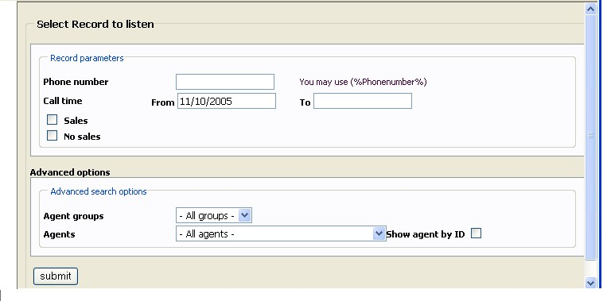
Figure 14 Selecting recordings to playback

The elements in the entry form are, in fact, search criteria since the recordings are going to be retrieved from the database according to what you specify in this form.
- Enter the following information.
Phone number |  | Enter a number to view the recordings associated to a specific location.
Call time |  | Select a start date and an end date from the pop-up calendars.
Sales |  | Use to play only those agent–customer interactions were sales were recorded.
No sales |  | Use to play only those agent–customer interactions were no sales were recorded.
Advanced search options
Agent group |  | Select the group of agents.
Agents |  | Select a particular agent.
Show agent by ID |  | Activate to sort the results by ID number.
- Click the Submit button.

Recording reports
Use this option to report on the recordings made of the CCS Manager’s users.

- In the Menu frame, find the relevant tenant, click the Quality Monitoring folder and select Listening report.
The system displays the entry form in the bottom right-hand frame of the window.
- Enter the following information.
IP |  | Machine’s IP address.
Listen time |  | Select a start date and an end date from the pop-up calendars.
User |  | Select a user. Will list all the users you have defined in Configuration > User management.
- Click the Submit button.

Index

Abandon rate
calling list reporting, 100
campaign reporting, 99
setting, 70
Access rights
See. Role, user, Monitoring, user management
Active
agent option, 52
calling list option, 68
calling list setting, 59
campaign option, 68
filter option, 55
treatment status, 56
Activities
menu item, 16
Activities and payroll, 41
Adherence
real-time information, 21
See. Real-time adherence
Admin
See. Role, user
Agent
activate, 52
add to group, 48
associate to group, 52
file, delete, 54
file, modify, 53
login, 52
menu item, 16
password, 52
real-time information, 19
remove from to group, 48
reports, 92
setup, 51
Agent group
add agents to, 48
assign to campaign, 50
assign to user, 34
create, 47
delete, 50
menu item, 16
modify, 49
real-time information, 19
reports, 95
setup, 46
AheevaPhone
link to protocole file, 50
quality monitoring, 102
setup, 36
AMD
See. Answering machine detection
amd.conf file, 11
Answered calls
agent group reporting, 95
agent reporting, 92
calling list reporting, 99
queue reporting, 101
Answering machine detection
calling list reporting, 100
campaign reporting, 99
dialing mode, 70
Answering machine detector, 11
Asterisk, 24, 33, 44, 50, 89
Attempts, dial-up
treatment setting, 56
Available filter
calling list setting, 63
Available treatments
calling list setting, 63
Broadcast
dialing mode, 69
Busy factor
agent’s, 70
group’s, 19
Busy signal
calling list reporting, 100
campaign reporting, 99
Call property
in routing script, 86
Call result
treatment setting, 56
Calling list
activate, 59, 68
create, 59
delete, 64
example, 58
in campaign, available, 68
Max attemps, 59
menu item, 16
modify, 64
real-time information, 20
See. Do-Not-Call lists
Calls
abandoned, 99
answered, 92, 95, 99, 101
not answered, 116
Not answered, 99, 114
Campaign
activate, 68
create, 68
delete, 72
load, 70, 71
menu item, 16
real-time information, 20
run, 71
setup, 66
start, 71
status, display real-time, 70
stop. See Pause
Command Line Interface
CCS CTI, 46
Commissions
create, 79
Configuration
dialplan, 12
extensions, 13
menu item, 15
network, 23
See. AheevaPhone, setup, Monitoring, User management, Tenants
switches, IP, 23
Database
calling list source file, 59
reporting, 91
Dialer
dialing algorithms, 69
Dialing mode
campaign's settings, 68
Dialplan configuration, 12
Dials, number of
calling list reporting, 99
campaign reporting, 99
Do-not-call lists, 69
Do-Not-Call lists, 65
menu item, 17
Encryption server, 26, 27, 49
Extension configuration, 13
Fax detection
calling list reporting, 100
campaign reporting, 99
File
agent group's, 49
agent's, 53
Filter
activate, 55
availabe, 63
create, 54
delete, 55
example, 57
in calling list, display, 63
menu item, 17
modify, 55
Format
audio & graphic files, 102
See. Naming convention, Time, expression of
Group
See. Agent group, Live monitoring
Historical report
menu item, 17
See. Role, user
Hit rate
calling list reporting, 99
campaign reporting, 99
Inbound calls
See. Queues, real-time
Increment
treatment setting, 56
Interval
treatment setting, 56
Live monitoring of users, 33, 103
Live recording, agent’s
See. Real-time information, Quality monitoring, Recording agents
Live recording, user’s
See. Live monitoring
Load
campaign setting, 70
IP switches, 25
sites and communication routing, 53
Login
agent's, 52, 99
numeric, 34
See. Reports, agent, Reports, agent
user's, 32
Login and production. See Payroll information report
Logout
agent's, 99
Menus, 15
Methods of payment
create, 80
delete, 82
for agent group, 49
modify, 82
Monitoring
See. Quality monitoring, Real-time information, Live monitoring of users
user management, 33
MOP. See Methods of payment
MP3, file format, 102
Naming convention, 47
Navigation. See Menus
Network management, 23
Not answered
calling list reporting, 100
Not answered calls
agent group reporting, 116
agent reporting, 114
Not loaded
campaign status, 70
Not Ready reason, 42, 48
Not-ready reason
menu item, 17
Optimization parameter
campaign setting, 70
Outbound calls
See. Queues, real-time
Outbound service campaign
See. Campaign
Password
agent's, 52
live monitoring, 34
user's, 31
Pause
campaign status, 70
Payment commissions
create, 80
Payroll configuration, 39
menu item, 16
Payroll information, 79
Payroll information report, 82
Performance
campaign factors, 67
real-time information, 20
Ports
number of, 68
Predictive
dialing mode, 69
Preview
dialing mode, 69
Privacy
See. Live monitoring, Role, user, User management
Productivity ratio
agent’s, 19
Progressive
dialing mode, 69
Quality monitoring
description, 102
menu item, 17
See. Role, user
Queues, 44
associate to group, 47
calls abandoned, 101
calls distributed, 101
calls entered, 101
menu item, 17
real-time information, 19
reports, 100, 101
Real-time adherence
live display setting, 77
reporting, 78
view by date, 78
Real-time information, 18
Record. See File
Recording
agents
See. Real-time information
agents–playback, 102
agents–playback options, 103
server, 25
understanding, 102
users
See. Live monitoring of users
Remote access, 14
Reports
agent group, 95
agent summary, 96
agents, 92
generate, 91
inbound calls, 98
outbound calls, 97
queue, 100
Resources
menu item, 16
Role, user, 31
Routing script
and agents’ skills, 43
live information about queues, 20
menu item, 17
setup, 85
Running
campaign status, 70
Schedule. See Work schedules
Screen pops, 61
Scripting
See. Routing script
Security
group assignment, 31
See. Role, user, User management, Encryption server, Recording server
tenant’s information, 31
Selected filter
calling list setting, 63
Selected treatments
calling list setting, 63
Server
and recordings, 102
CTI, 28
encryption, 26
PBX, 24, 29
recording, 25
site’s, 23
statistics, 29
user-defined application, 88
with AheevaPhone, 36
Service factor percentile
queues’, 19
Service levels and productivity, 37
SIT
calling list reporting, 100
campaign reporting, 99
Site
See. Configuration, switches, Agent, setup, Switches, IP, Configuration, switches
Skills
agent option, 53
Create, 43
menu item, 17
Softphone
See. AheevaPhone
SSL
See. Recording server
Start
campaign setting, 70
Statistics
agents in group, 49
calling list, 63
routing scripts, 86
servers, 28
Super Admin
See. Role, user
Switches, IP, 23, 26
Table name
calling list database, 59
Team
create, 73
real-time information, 21
Tenants, 30, 31
TFER application, 12
Time
expression of, 18
Treatment
activate, 56
available, 63
create, 56
delete, 57
example, 57
in calling list, display, 63
menu item, 17
modify, 56
Unanswered calls. See Not answered, 114
Unknown
campaign status (Not loaded), 70
User management, 31
User name
user's, 31
Viewer
See. Role, user
WAV, file format, 102
Weight
calling list option, 68
Work force management
menu item, 17
setup, 73
Work schedule
create, 74
view, 78
Wrap up
and agent’s productivity, 97
in agent group’s, 95
in agent’s reporting, 92
Wrap-up time, 37

Appendix A — Document change history

Date | Doc. Ver. | Author | Description of changes
Sept. 2004 | 1.0 | Justa Gonzalez, for Aheeva Technology | Initial version
March 2005 | 2.0 | Justa Gonzalez, for Aheeva Technology | —Addition of Work force management, Skill-based routing, Switch management features and Asterisk configuration files.  —Modification of Quality monitoring, Reporting and Configuration topics.
June 2005 | 2.1 | Justa Gonzalez, for Aheeva Technology | —Addition of Site setup, SoftPhone setting and Recording options.  —Modification of Work force management (removal of item method of payment), of Routing scripts and Live monitoring.
November 2005 | 3.0 | Justa Gonzalez, for Aheeva Technology | —Addition of Encryption server; Methods of payment; custom application in routing scripts; Work schedules; user-defined “Not ready” reason; color-coded pie charts of current status statistics for groups of agents, calling lists and campaigns; routing script element (“get statistics”) to collect information on queues and on agents based on call properties or on skills; inbound calls reporting.  —Modification of the routing scripts nomenclature: expanded the scope of the routing script by removing the emphasis on the notion of “skill-based” scripting.  Gathered files on resources (agents, groups, campaigns) into panel groups in a single frame.  Calling list tables: choice of file formats and delimiters. Format templates are provided.
December 2005 | 4.0 | Justa Gonzalez, for Aheeva Technology | Version 2.0 of Aheeva CCS platform.  —Addition of sections Who should read this guide, About Aheeva Technologies and What’s new in version 2.0.  Network management: site management with PBX server, encryption server and new recording server with their respective settings.  Database connections and user notification.  Availability of MySQL slave and clustering technology.  CTI Command Line Interface.  Direct on-line live monitoring. Rigth-click agent’s name on real-time information window frame.  Introductory sub-section (Generating reports) to the Reporting section: explanation of new agent, agent group and queue reports, example of usage and tie to monitoring performance.  User-defined black lists for “Do not call”.  Example of how treatments and filters work.  —Modification of agent and queue reports: new database tables for faster generation, accent on extracting performance data, new pie-chart diagram.
January 2006 | 4.1 | Justa Gonzalez, for Aheeva Technology | —Addition of license information related to available modules.  Agent summary and outbound calls reports.  Broadcast campaigns in routing script’s usage.  Appendix B, formulas for return values in tables.  Short-cut to agent’s and agent group’s information and properties in real-time viewing.  Notes of type “Caution”.  Steps to creation of a calling list.  Loading and viewing work schedules.  —Modification of agent pickup method in routing scripts.  Changed extensions.conf file in relation to the live monitoring feature.  Changed operating system for supervisors.  Specified that the PBX server is used for IAX2 communications (internal and external)  Changed server destination for recordings done on local servers. No longer sent to CTI server.  Moved the document section “Database connections” to the Installation guide.  —Deletion of Detailed agent performance and detailed agent performance by leader reports.  Removed FireFox browser.  Removed image and video recording capability.
February 2006 | 4.2 | Justa Gonzalez, for Aheeva Technology | Version 2.1 of Aheeva CCS platform.  —Addition of section titlted “Service levels and productivity” includes overview of queue control, wrap up time control and American call center features.  Payroll general configuration panels.  Agent activities to be used in payroll practices.  Queue timing for incoming calls and routing scripts as part of service level and productivity monitoring.  —Modification of call queues section to include new queue resource to define waiting time for calls to be answered or abandoned.  Methods of payment information: treatments of payment are termed “commissions”.  Payroll reports merged into new “login and production report”.  Changed “black list” to “do-not-call list”.  Changed screen captures to match new GUI.  —Removed loading work schedules step. Now done outside the CCS Manager.
April 2006 | 4.3 | Justa Gonzalez, for Aheeva Technology | —Addition of agent spying in: short cut to agent information.  Payroll data extraction.  —Modified section Setting up service & productivity tolerance with queues.  —Removed CTI server statistics display.

Appendix B — Formulas to generate return values in reports

This section lists the fields whose values are calculated according to the reporting structure of the CCS application. The reporting tool structure is pre-defined in the database schemas that are supplied in the Aheeva CD-ROM.

The left-hand column indicates the field name and the right-hand column provides the formulas or functions that are being used.

Besides the fixed value keys, numerous fields are set up with the standard arithmetic functions as well as the date and time functions found in MySQL. They are described simply with terms such as “call count” or “wait count”.

Agent report
Answered calls |  |  | Telephony data
Time period |  | For a daily report, time period is presented in hourly slices; for a monthly report, in daily slices; for a yearly report, in monthly slices
Login time |  | Total time the agent is connected to the application
Login count |  | Agent connection count to the application
Inbound time |  | Total time the agent spent in inbound calls
Inbound count |  | Inbound call count for specific agent
Outbound time |  | Total time the agent spent in outbound calls
Outbound count |  | Outbound call count for specific agent
Wrap up time |  | Total time the agent spent in wrapping up calls
Wrap-up count |  | Wrap-up operation count for specific agent
Hold time |  | Total time the agent spent handling calls that were on hold
Hold count |  | Hold call count that the agent received
Average
Time period |  | For a daily report, time period is presented in hourly slices; for a monthly report, in daily slices; for a yearly report, in monthly slices
Inbound calls |  | Inbound Time / Inbound count
Outbound calls |  | Outbound Time / Outbound count
Wrap-up calls |  | Wrap-up Time / Wrap-up count
Hold calls |  | Hold Time / Hold count
Handling, overall |  | (Inbound Time + Outbound Time+ Wrap-up Time+ Hold Time) / ( Inbound count + Outbound count)
Percentage vs login time
Time period |  | For a daily report, time period is presented in hourly slices; for a monthly report, in daily slices; for a yearly report, in monthly slices
Inbound calls |  | (Inbound Time / Login Time) *100
Outbound calls |  | (Outbound Time / Login Time) *100
Wrap-up calls |  | (Wrap-up Time / Login Time) *100
Hold calls |  | (Hold Time / Login Time) *100
Handling, overall |  | ( (Inbound Time + Outbound Time+ Wrap-up Time+ Hold Time) / Login Time) *100
Busy |  | ( (Inbound Time + Outbound Time+ Wrap-up Time) / Login Time) *100

Unanswered calls |  | Telephony data
Time period |  | For a daily report, time period is presented in hourly slices; for a monthly report, in daily slices; for a yearly report, in monthly slices
Login time |  | Total time the agent is connected to the application
Login count |  | Agent connection count to the application
Wait time |  | Total time the agent spent waiting
Wait count |  | Wait count for specific agent
Single transfer time |  | Total time the agent spent in transferring calls to another person
Single transfer count |  | Call count that are directly transferred by the agent to another person
Two-step transfer time |  | Total time the agent spent in three-party calls
Two-step transfer count |  | Three-party call count performed by specific agent
Not ready time |  | Total time the agent was in “Not ready” mode
Not ready count |  | Number of times the agent indicates that he/she was not ready
Not ready reasons
Time period |  | For a daily report, time period is presented in hourly slices; for a monthly report, in daily slices; for a yearly report, in monthly slices
Average
Time period |  | For a daily report, time period is by hour for each day; for a monthly report by day for each month; for yearly report by month for each year
Wait calls |  | Wait time / Wait count
Single transfer calls |  | Single transfer time / Single transfer count
Two-step transfer calls |  | Two-step transfer time / Two-step transfer count
Not ready calls |  | Not ready time / Not ready count
Percentage vs login time
Time period |  | For a daily report, time period is presented in hourly slices; for a monthly report, in daily slices; for a yearly report, in monthly slices
Wait calls |  | (Wait time / Login time) *100
Single transfer calls |  | (Single transfer time / Login time) *100
two-step transfer calls |  | (Two-step transfer time / Login time) *100
Not ready calls |  | (Not ready time / Login time) *100

Statistics
 |  | Pie-chart diagram, color-coded.
Other |  | Same calculations as above, except for  Total productivity time (total-wrap-up-time plus total-not-ready-time divided by the total amount of time that the agent was in session [login]) and the adherence to the work schedule (expressed as a percentage).

Agent group
Reports generated for groups of agents are built by adding the values returned for every agent in the group. For that reason, calculations are not listed below (please refer to the agent’s values, above).

However, the presentation of data is different for transfert tracking: whereas the agent report separates data between single transfers and two-step transfers, the group report combines both type of information into a single output as follows:

Unanswered calls |  |  | Transfer calls
Transfert count |  | Addition of values returned for every agent in the group, for single and two-step transfers.
Transfert time |  | Addition of values returned for every agent in the group, for single and two-step transfers.
Transfert average |  | (Single transfer time+ two-step transfer time) / (Single transfer count + two-step transfer count)

Agent summary
This reports generates data for agents belonging to given groups. The information provides a summary of the agent group report.
Data
Scheduled |  | Sum of time scheduled to work
Actual |  | Sum of actual time in session (TOTAL_LOGIN)
Inbound calls |  | Inbound call count  Inbound time
Outbound calls |  | Outbound call count  Outbound time
Wrap up calls |  | Wrap up count  Wrapping up time
Hold calls |  | Call hold count  Hold time
Waiting calls |  | Call waiting count  Wait time
Transfer calls |  | Transfer count  Transfer time
Not ready |  | “Not ready” count  “Not ready” time

Average
Inbound calls |  | Inbound time / inbound count
Outbound calls |  | Outbound time / outbound count
Wrap up calls |  | Wrap up time / wrap up count
Hold calls |  | Hold time / hold count
Waiting calls |  | Wait time / wait count
Transfer calls |  | Transfer time / transfer count
Not ready |  | Not ready time / not ready count

Percentage
Scheduled |  | Sum of time scheduled to work
Actual |  | Sum of actual time in session (TOTAL_LOGIN)
Adherence |  | Degree of variance between scheduled and actual time (in %)
GAP |  | (Actual / Scheduled time) * 100
Productivity |  | 100* (1- (Wrap-up-time exceeded + not-ready-time that affected productivity) / login time)  (#) Wrap-up-time exceeded = Average wrap-up time for the period specified – Maximum wrap-up time for the campaign.
Calls per hour |  | 3600 * sum (CALLS) / sum (TOTAL_LOGIN)
Calls out/in |  | 100* (Outbound count + inbound count)
Transfers |  | 100* (Single transfer time + two-step transfer time) / Actual time
Not ready |  | (Not ready time / login time) * 100

Outbound calls

Data
Total login time |  | Login time
Contacts |  | sum ( n_in_call_outbound)
Success |  | Number of sales
Refusals |  | Number of calls with a result code = 2
Call backs |  | Number of calls with a result code = -1

Statistics
Sales per hour |  | 3600*sum(SALES) / sum(TOTAL_LOGIN)
Refusals per hour |  | 3600*sum (refusals) / sum(TOTAL_LOGIN)
Net conv. rate |  | (100*sum(SALES) / sum (RCONTACTS))

Inbound calls
Call date |  | Date for the result. Date of specific call (telephone number as search criterion)
Time period |  | The period of time to calculate
Calls offered |  | Call (queued - abandoned) count
Call handled |  | Call (distributed- abandoned) count
% SVL |  | [1 – ((offered - handled) /offered)]*100]
Talk time |  | Talk time with customer
Wrap up time |  | Time to complete request after a call
Hold time |  | Hold time
Average handling time |  | (totalTalkTime + totalWrapUpTime + totalHoldTime) / handled

Agent login
Agent ID |  | Fixed value. Unique ID of the agent
Agent name |  | Fixed value
First login |  | First time the agent opens a work session
Last logout |  | Last time the agent closes a work session
Total login time |  | Total time the agent is connected to the application

Campaign
Time |  | The period of time to calculate
Hit rate |  | Calls [(NbAnswered /NbDials) * 100]
Dials |  | Calls [NbNoAnswer + NbAnswered +NbAnswerMachine + NbSit + NbBusy +NbAbandoned]
Answered |  | Answered call count
No answer |  | Not answered call count
Abandoned |  | Abandoned call count
Answering machine |  | Call answered by answering machine count
SIT |  | Call with SIT answer count
Busy |  | Call with busy answer count
Fax |  | Call with fax answer count

Calling list
Time |  | The period of time to calculate
Hit rate |  | Calls [(NbAnswered /NbDials) * 100]
Dials |  | Calls [NbNoAnswer + NbAnswered +NbAnswerMachine + NbSit + NbBusy +NbAbandoned]
Answered |  | Number of answered calls
No answer |  | Number of no answered calls
Abandoned |  | Number of abandoned calls
Answering machine |  | Number of calls with Answering machine answer
SIT |  | Number of calls with sit answer
Busy |  | Number of calls with busy answer
Fax |  | Number of calls with fax answer

Queues
General data |  |  | Telephony data
Time period |  | For a daily report, time period is presented in hourly slices; for a monthly report, in daily slices; for a yearly report, in monthly slices
Entered |  | Call count that are lined up in the queue
Answered |  | Call count that are answered by a agent
Abandoned |  | Call count that are abandoned (because any agent is available)

Percentages |  |  | Percentages
Time period |  | For a daily report, time period is by hour for each day; for a monthly report by day for each month; for yearly report by month for each year
Answered |  | Number of answered calls / Number of entered calls
Abandoned |  | Number of abandoned calls / Number of entered calls
Service factor |  | ( Number of calls answered within 20 seconds / (Number of distributed calls + Number of abandoned calls – Number of calls which are abandoned within 5 seconds) ) *100
Service level
Answered calls |  | Answered calls within a given number of seconds. Range of 10 to 180 seconds.
Abandoned calls |  | Abandoned calls within a given number of seconds.

Statistics
Pie-chart diagram. Color-coded.
Same calculation formula as above.

