User manual to view the database:

Step 1: click on the link below to go download the latest version of Db browser for SQLite. Follow the instructions for installing the program. When finish move to step 2.

<https://sqlitebrowser.org/dl/>

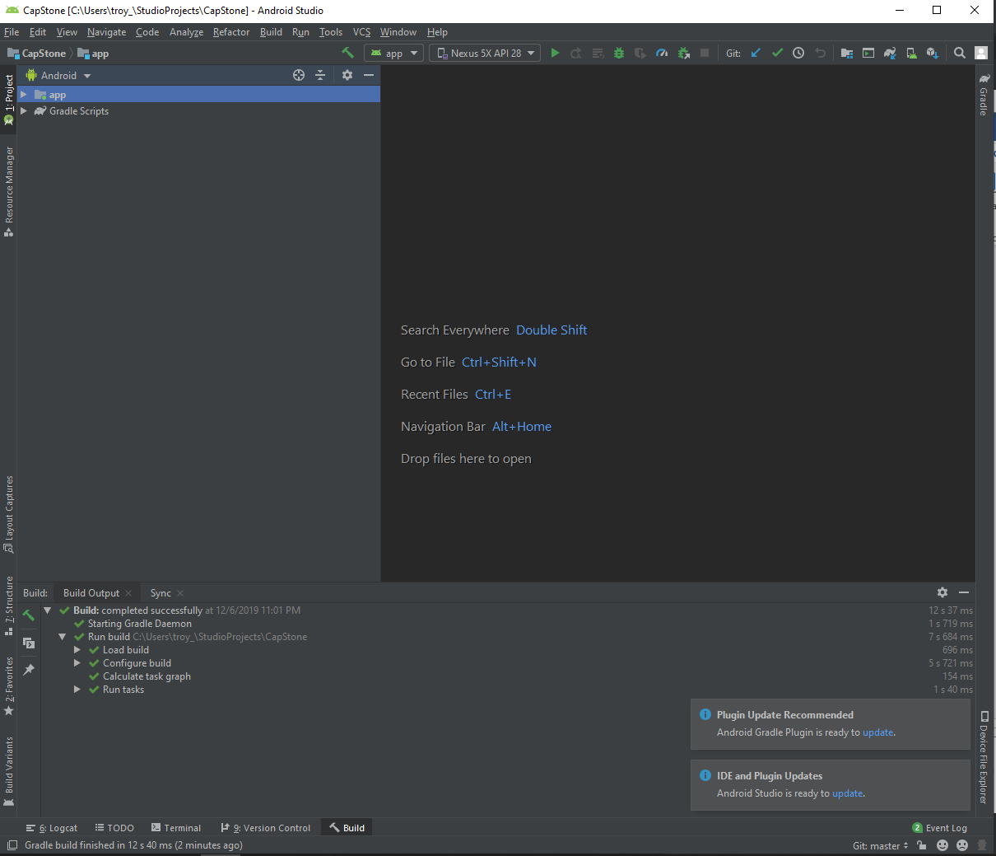step 2: open android studio and load our group’s project and find a tap called device file explore.

step 3: follows the file path

/data/data/com.example.smartcalendar/databases/Events.db

Right click on the database and save it to desktop to be use later.

Step 4: open Db browser application and click on Open database. Find where the Events.db was save and load it into Db browser. Once the database is loaded in Db browser, you are now able to see the events that you’ve added into the app.

