Antimalware Scan Interface (AMSI)

The Windows Antimalware Scan Interface (AMSI) is a versatile interface standard that allows your applications and services to integrate with any antimalware product that's present on a machine.
It supports a calling structure allowing for file and memory or stream scanning, content source URL/IP reputation checks, and other techniques.
Windows components that integrate with AMSI
The AMSI feature is integrated into these components of Windows 10.
- User Account Control, or UAC (elevation of EXE, COM, MSI, or ActiveX installation)
- PowerShell (scripts, interactive use, and dynamic code evaluation)
- Windows Script Host (wscript.exe and cscript.exe)
- JavaScript and VBScript
- Office VBA macros

The Windows AMSI interface is open. Which means that any application can call it; and any registered anti-malware engine can process the content submitted to it.
Windows Defender is the application that's calling AMSI APIs. But you can call the same APIs from within your own application.
Here's a sample of a script that uses the XOR-encoding technique to hide its intent (whether that intent is benign or not). For this illustration, we can imagine that this script was downloaded from the Internet.
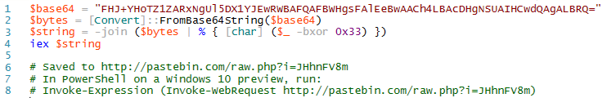
To make things more interesting, we can enter this script manually at the command line so that there is no actual file to monitor. This mirrors what's known as a "fileless threat". It's not as simple as scanning files on disk. The threat might be a backdoor that lives only in the memory of a machine.
To make things more interesting, we can enter this script manually at the command line so that there is no actual file to monitor. This mirrors what's known as a "fileless threat". It's not as simple as scanning files on disk. The threat might be a backdoor that lives only in the memory of a machine.
Below, we see the result of running the script in Windows PowerShell. You'll see that Windows Defender is able to detect the AMSI test sample in this complicated scenario, merely by using the standard AMSI test sample signature.
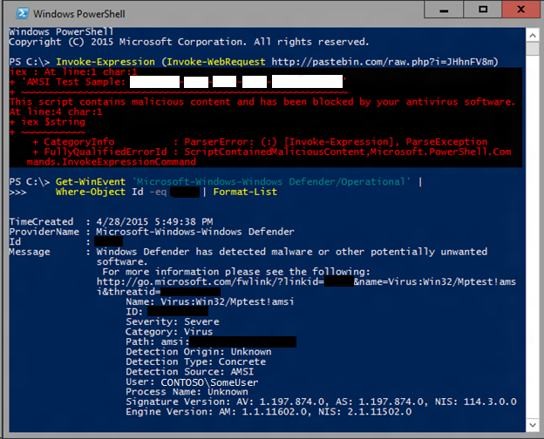
For Windows users, any malicious software that uses obfuscation and evasion techniques on Windows' built-in scripting hosts is automatically inspected at a much deeper level than ever before, providing additional levels of protection.
In response, anti-malware software starts to do basic language emulation. For example, if we see two strings being concatenated, then we emulate the concatenation of those two strings, and then run our signatures on the result. Unfortunately, this is a fairly fragile approach, because languages tend to have a lot of ways to represent and concatenate strings.
But what if the obfuscator is so trivial that it looks like many well-behaved scripts? A signature for it would generate an unacceptable number of false positives. Here's a sample stager script that's too benign to detect on its own.
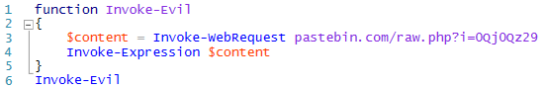
Fileless Threats
The term "fileless" suggests that a threat doesn't come in a file, such as a backdoor that lives only in the memory of a machine. However, there's no one definition for fileless malware. The term is used broadly, and sometimes to describe malware families that do rely on files to operate.
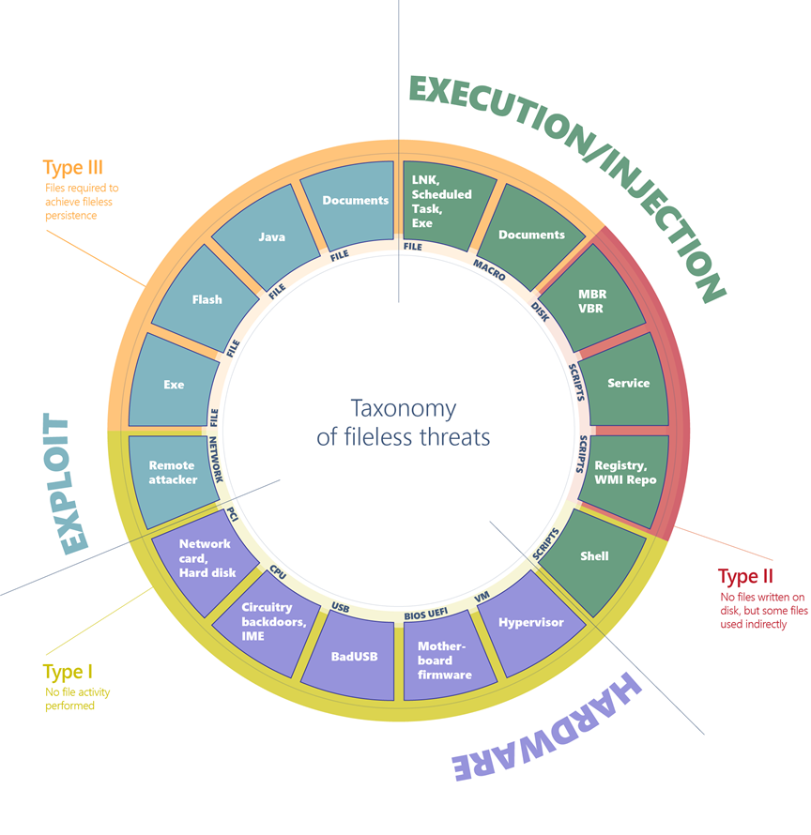
Comprehensive diagram of fileless malware

Fileless threats can be classified by their entry point, which indicates how fileless malware can arrive on a machine. They can arrive via an exploit, through compromised hardware, or via regular execution of applications and scripts.

Type I: No file activity performed
A fully fileless malware can be considered one that never requires writing a file on the disk. One example is where a target machine receives malicious network packets that exploit the EternalBlue vulnerability. The vulnerability allows the installation of the DoublePulsar backdoor, which ends up residing only in the kernel memory. A compromised device may also have malicious code hiding in device firmware (such as a BIOS), a USB peripheral (like the BadUSB attack), or in the firmware of a network card. All these examples don't require a file on the disk to run, and can theoretically live only in memory. The malicious code would survive reboots, disk reformats, and OS reinstalls.
Type II: Indirect file activity
There are other ways that malware can achieve fileless presence on a machine without requiring significant engineering effort. Fileless malware of this type doesn't directly write files on the file system, but they can end up using files indirectly. For example, with the Poshspy backdoor attackers installed a malicious PowerShell command within the WMI repository and configured a WMI filter to run the command periodically.
Type III: Files required to operate
Some malware can have a sort of fileless persistence, but not without using files to operate. An example for this scenario is Kovter, which creates a shell open verb handler in the registry for a random file extension. Opening a file with such extension will lead to the execution of a script through the legitimate tool mshta.exe.
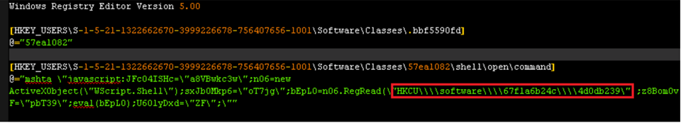
Kovter's registry key

Defeating fileless malware
Through AntiMalware Scan Interface (AMSI), behavior monitoring, memory scanning, and boot sector protection, Microsoft Defender for Endpoint can inspect fileless threats even with heavy obfuscation. Machine learning technologies in the cloud allow us to scale these protections against new and emerging threats.
Reference: https://learn.microsoft.com/en-us/defender-endpoint/

HOW AMSI WORKS
When a user executes a script or initiates PowerShell, the AMSI.dll is injected into the process memory space. Prior to execution the following two API’s are used by the antivirus to scan the buffer and strings for signs of malware.
- AmsiScanBuffer()
- AmsiScanString()
If a known signature is identified execution doesn’t initiate and a message appears that the script has been blocked by the antivirus software. The following diagram illustrates the process of AMSI scanning.

AMSI Evasions
1. PowerShell Downgrade
Even though that Windows PowerShell 2.0 has been deprecated by Microsoft it hasn’t been removed from the operating system. Older versions of PowerShell doesn’t contain security controls such as AMSI protection and could be utilized as a form of evasion. Downgrading the PowerShell version to an older version is trivial and requires execution of the following command:
1 | powershell -version 2

2. Base64 Encoding
Fabian Mosch used an old AMSI bypass of Matt Graeber to prove that if base64 encoding is used on strings (AmsiUtils & amsiInitFailed) that trigger AMSI and decoded at runtime could be used as an evasion defeating the signatures of Microsoft. This technique prevents AMSI scanning capability for the current process by setting the “amsiInitFailed” flag.
Original AMSI Bypass: [Ref].Assembly.GetType('System.Management.Automation.AmsiUtils').GetField('amsiInitFailed','NonPublic,Static').SetValue($null,$true)
Base 64 Encoded AMSI Bypass:
[Ref].Assembly.GetType('System.Management.Automation.'+$([Text.Encoding]::Unicode.GetString([Convert]::FromBase64String('QQBtAHMAaQBVAHQAaQBsAHMA')))).GetField($([Text.Encoding]::Unicode.GetString([Convert]::FromBase64String('YQBtAHMAaQBJAG4AaQB0AEYAYQBpAGwAZQBkAA=='))),'NonPublic,Static').SetValue($null,$true)
3. Hooking
Tom Carver created a proof of concept in the form of a DLL file which evades AMSI by hooking into the “AmsiScanBuffer” function. The “AmsiScanBuffer” will then be executed with dummy parameters. The DLL needs to be injected into the PowerShell process which the AMSI bypass will performed.
.\SimpleInjector.exe powershell.exe .\AmsiHook.dll

4. Memory Patching
Daniel Duggan released an AMSI bypass which patches the AmsiScanBuffer() function in order to return always AMSI_RESULT_CLEAN which indicates that no detection has been found. The patch is displayed in the following line:
static byte[] x64 = new byte[] { 0xB8, 0x57, 0x00, 0x07, 0x80, 0xC3 };

The bypass has been released in C# and PowerShell. The DLL can be loaded and executed with the use of the following commands:

[System.Reflection.Assembly]::LoadFile("C:\Users\pentestlab\ASBBypass.dll")
[Amsi]::Bypass()

5. Registry Key Modification
AMSI Providers are responsible for the scanning process by the antivirus product and are registered in a location in the registry. The GUID for Windows Defender is displayed below:
HKLM:\SOFTWARE\Microsoft\AMSI\Providers\{2781761E-28E0-4109-99FE-B9D127C57AFE}

Removing the registry key of the AMSI provider will disable the ability of windows defender to perform AMSI inspection and evade the control. However, deleting a registry key is not considered a stealthy approach (if there is sufficient monitoring in place) and also requires elevated rights.

6. DLL Hijacking
DLL Hijacking can be also used to evade AMSI from userland as it has been described by SensePost. The only requirement is to create a non-legitimate amsi.dll file and plant it on the same folder as PowerShell 64 bit which could be copied to a user writable directory. The proof of concept code has been released by SensePost and is also demonstrated below.

