Viridis Demo

The code below demonstrates two color palettes in the [viridis](https://github.com/sjmgarnier/viridis) package. Each plot displays a contour map of the Maunga Whau volcano in Auckland, New Zealand.

## Viridis colors

image(volcano, col = viridis(200))

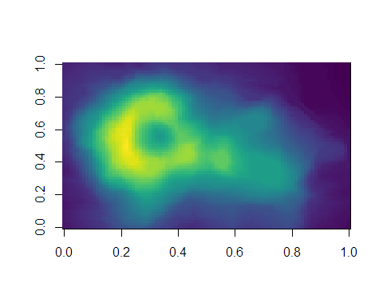

## Magma colors

image(volcano, col = viridis(200, option = "A"))

