TERRA-AUDIT

AI-ASSISTED DIGITAL MRV PLATFORM FOR AWD RICE IRRIGATION CARBON CREDITS

SOFTWARE REQUIREMENTS SPECIFICATION & ANALYSIS

Submitted By:
Kazi Nahid | BSSE-1437
Md. Jariful Rahman | BSSE-1419

Submitted To:
Dr. Mohammed Shafiul Alam Khan
Professor
Institute of Information Technology
University of Dhaka

Supervisor’s Signature: ________________________

IIT — University of Dhaka

Table of Contents
- 1. Introduction
  - 1.1 Purpose
  - 1.2 Intended Audience
  - 1.3 Usage Scenarios
  - 1.4 Conclusion
- 2. Inception
  - 2.1 Understanding the Problem
  - 2.2 Icebreaking
  - 2.3 Identifying the Stakeholders
  - 2.4 Stakeholder Viewpoints
  - 2.5 Working Towards Collaboration
  - 2.6 Elicitation of Terra-Audit
- 3. Quality Function Deployment
  - 3.1 Normal Requirements
  - 3.2 Exciting Requirements
- 4. User Story
- 5. Scenario Based Modeling
  - 5.1 Use Case Diagram (Level 0, 1, 1.1, 1.1.1, 1.1.2, 1.2 – 1.6)
  - 5.2 Activity Diagram (Level 1, 1.1, 1.1.1, 1.2 – 1.6)
- 6. Data Based Modeling
  - 6.1 Noun Identification
  - 6.2 Final Data Objects
  - 6.3 Relations
  - 6.4 ER Diagram
  - 6.5 Schema Diagram
- 7. Class Based Diagram
  - 7.1 Identified Nouns
  - 7.2 Identified Verbs
  - 7.3 General Classification
  - 7.4 Selection Criteria
  - 7.5 Class Card
  - 7.8 CRC Diagram
- 8. Behavioral Diagram
  - 8.1 Event Table
  - 8.2 State Transition Diagram
  - 8.3 Sequence Diagram
- 9. Data Flow Diagram
  - 9.1 Level 0: Terra-Audit
  - 9.2 Level 1: Terra-Audit
- 10. References

1. Introduction
Terra-Audit is envisioned as a low-cost, satellite-only digital MRV (Measurement, Reporting and Verification) platform for rice-cultivation carbon projects. Alternate Wetting and Drying (AWD) irrigation reduces methane emissions from rice paddies, but proving that a farmer actually practiced AWD has traditionally required manual logs or expensive water-level sensors. Terra-Audit replaces those with Sentinel-1 SAR satellite observations pulled from Google Earth Engine, detects AWD drydown events in the radar signal, converts the observed behavior into carbon credit estimates under the Verra VM0051 Tier 2 (QA3) methodology, and packages the entire calculation into auditor-ready evidence files.

1.1 Purpose
Terra-Audit aims to provide carbon project developers, researchers and auditors with an intuitive and verifiable environment for turning satellite radar signals into carbon credit evidence. The platform combines field boundary management, Sentinel-1 time-series analytics, rule-based and AI-assisted AWD event detection, VM0051-aligned carbon accounting, and one-click export of a complete evidence package (PDF, JSON, CSV). By integrating exciting features like machine-learning AWD detection with per-prediction confidence and automatic phenology-derived season detection, Terra-Audit makes smallholder rice carbon projects in Bangladesh and South Asia measurable without any on-the-ground hardware.

1.2 Intended Audience
The primary audience for this SRS document includes:
- Developers: To understand the functional requirements, module boundaries and calculation logic for implementing the platform.
- Project Managers: To plan and allocate resources efficiently.
- Stakeholders: To review and provide feedback on the project’s goals and requirements.
- Quality Assurance Team: To ensure all features are delivered as specified, especially the traceability of every carbon number.
- End Users: Carbon project developers, agronomy researchers and third-party auditors who will use the platform to generate and verify AWD carbon credit evidence.

1.3 Usage Scenarios
Scenario 1: Registering a Field and Running Signal Analytics
- A carbon project developer opens Terra-Audit and draws a rice paddy boundary on the interactive map (or uploads a GeoJSON/KML file, or pastes GPS coordinates).
- The system computes the field area automatically and the developer saves the field with an ID, name and district.
- The developer selects a monitoring season (e.g., “Boro 2026”) and runs the analytics engine.
- Terra-Audit checks its local cache, fetches any missing Sentinel-1 observations from Google Earth Engine, smooths the signal, and marks flooded states and AWD drydown events on an interactive chart.
- Sowing and harvest dates are derived from the VH phenology signal and the season length is auto-populated for the carbon calculation.
Scenario 2: Generating a Carbon Credit Estimate and Evidence Package
- The developer opens the Carbon Asset Ledger tab, which is pre-filled with the detected AWD event count, season length and field area.
- The VM0051 QA3 engine computes baseline vs. project CH₄ emissions, applies the IPCC water scaling factor, deducts the 15% uncertainty buffer and the N₂O irrigation penalty, and reports the final issuable tCO₂e with a step-by-step audit trail.
- The developer downloads the evidence package — a PDF report, a machine-readable JSON audit record, and the raw time-series CSV — and hands it to a third-party auditor, who can reconstruct every number.
Scenario 3: Training and Validating AI Detection Models
- A researcher builds a labeled dataset from previously analyzed fields and trains Random Forest and XGBoost baseline classifiers.
- In the AI Validation tab, the researcher compares both models’ precision, recall, F1, confusion matrices, feature importance and ROC curves against the rule-based threshold gate.
- On the Signal Analytics tab, the researcher selects a trained model as the active detector; predictions arrive with per-observation confidence, and the app automatically falls back to the threshold gate if the selected model has not been trained yet.

1.4 Conclusion
This document serves as a comprehensive reference for the requirements of Terra-Audit. It ensures all stakeholders have a shared understanding of the project’s objectives and scope, paving the way for successful development and deployment.

2. Inception

2.1 Understanding the Problem
Rice paddies are a major source of anthropogenic methane, and AWD irrigation is a proven mitigation practice — but existing carbon-credit workflows fail to verify it credibly. Terra-Audit is designed to address the following challenges:
- Self-reported irrigation logs from farmers are unverifiable and easily disputed by auditors.
- On-the-ground water-level loggers are too expensive to deploy across thousands of smallholder paddies.
- Carbon credit calculations are usually opaque spreadsheets; auditors cannot trace how an issued tonne was derived.
- Evidence is fragmented — field boundaries, satellite data, event detection and emission math live in disconnected tools.

2.2 Icebreaking
Terra-Audit bridges the gap between field reality and registry-grade evidence by fostering a unified platform that:
- Uses freely available Sentinel-1 radar data, which sees through clouds and works day and night — ideal for monsoon-season Bangladesh.
- Detects flooded and dry paddy states directly from VV backscatter, removing the need for self-reporting.
- Applies the Verra VM0051 methodology transparently, exposing every intermediate value of the calculation.
- Produces a self-contained, downloadable evidence package that a third-party auditor can independently re-verify.

2.3 Identifying the Stakeholders
The key stakeholders for Terra-Audit are:
- Carbon Project Developer: As primary users, they register fields, run analytics, and generate credit estimates and evidence packages.
- Researcher / Data Scientist: They build datasets, train and validate AI detection models, and study detector agreement.
- Auditor: They receive the exported evidence package and verify that every reported number can be reconstructed from the inputs.
- Program Operator (farmer cooperative / NGO): They enroll farmers’ fields into the program and rely on the platform’s outputs to claim credits on the farmers’ behalf.

2.4 Stakeholder Viewpoints
After talking with the stakeholders, we collected the following viewpoints of requirements from them.
Carbon Project Developer Developers are looking for a platform where a field can be registered in minutes — by drawing on a map, uploading a boundary file, or pasting GPS points — with the area computed automatically. They want a one-click analytics run per season that clearly shows flooded periods, drydown events, and sowing/harvest dates, and a carbon ledger that pre-fills itself from the analytics so credits can be estimated without manual re-entry. Every calculation step must be visible so the estimate survives auditor scrutiny.
Researcher / Data Scientist Researchers seek reproducible pipelines: a labeled dataset built from consistent rules, standard classifiers (Random Forest, XGBoost) trained with cross-validation, and honest metrics — clearly framed as agreement with the rule-based gate, since no independent ground truth exists. They also want to swap the active detector at analysis time and see per-prediction confidence.
Auditor Auditors need a self-contained evidence package: field identity and geometry, the exact monitoring window, the raw satellite observations, the detected events, the methodology constants used, and the arithmetic from baseline emissions to final issuance — in both human-readable (PDF) and machine-readable (JSON/CSV) forms.
Program Operator Operators want low cost above all: no field hardware, free satellite data, and a tool simple enough that one technician can process an entire district’s fields season by season.

2.5 Working Towards Collaboration
Collaborative efforts are focused on:
- Aligning the platform’s features with stakeholder needs, prioritizing verifiability of the carbon math.
- Establishing open channels for feedback throughout the development lifecycle.
- Encouraging active involvement of key stakeholders during testing phases to refine the platform’s usability and the completeness of the evidence package.

2.6 Elicitation of Terra-Audit
The following Terra-Audit capability areas were identified during requirements gathering:
- Field Management: Draw, upload or paste field boundaries; automatic area computation; persistent field registry.
- Satellite Data Engine: Sentinel-1 SAR retrieval from Google Earth Engine with local caching for repeat analysis.
- MRV Signal Analytics: Rule-based and AI-assisted detection of flooded states, AWD drydown events, and crop phenology.
- Carbon Estimation: Transparent VM0051 QA3 credit calculation with IPCC default factors.
- Evidence Reporting: Exportable PDF / JSON / CSV audit package.
- AI Validation: Dataset building, model training and evaluation dashboards.
- Visualization: Interactive map, signal charts and carbon ledger in a tabbed dashboard.

3. Quality Function Deployment
Quality Function Deployment (QFD) is a systematic approach to translate the needs of users into measurable technical requirements. By employing QFD, the platform ensures that stakeholder expectations — above all, auditability of the carbon numbers — are transformed into design specifications that align with the goals of Terra-Audit. This methodology helps maximize user satisfaction by bridging subjective user needs with objective, quantifiable criteria. The requirements listed below were identified and refined using QFD to meet the MRV and technical demands of the platform.
Collaborative Requirements Gathering Requirements for Terra-Audit were gathered through collaborative workshops involving representatives from all stakeholder groups. This approach ensured:
- A holistic understanding of user needs.
- Prioritization of features based on stakeholder input.
- Early identification of potential challenges and mitigation strategies.

3.1 Normal Requirements
Field Management:
- Draw on Map: Users can draw a polygon or rectangle field boundary on an interactive Leaflet map.
- Upload Boundary File: Users can upload GeoJSON or KML files; malformed input returns a friendly error instead of crashing.
- Paste GPS Coordinates: Users can paste newline-separated lat, lon pairs (minimum 3 points) to form a polygon.
- Automatic Area Calculation: Field area in hectares is computed via the Shoelace formula with spherical latitude correction.
- Field Registry: Fields (ID, name, district, geometry, area) are persisted in a local SQLite database and selectable from the sidebar.
Satellite Data Engine:
- Google Earth Engine Connection: Authenticated GEE session initialized once per app run.
- Sentinel-1 Retrieval: VV and VH backscatter over the field geometry, DESCENDING orbital pass only, for a chosen date window.
- Derived Indices: Cross Ratio (VH − VV) and Radar Vegetation Index computed per observation.
- Time-Series Caching: Observations cached in SQLite keyed by field and monitoring window; cache is checked before every live GEE query.
- Signal Smoothing: Savitzky-Golay filter (window 5, polyorder 2) reduces SAR speckle noise, falling back to raw values below 5 observations.
MRV Signal Analytics:
- Flood Detection: Z-score anomaly detection on smoothed VV; observations with z-score below −0.8 are flagged as flooded.
- Drydown Detection: A sharp positive VV jump (above 1.2σ) immediately following a flooded state counts as one AWD drydown event.
- Phenology Detection: Sowing date = global VH minimum; harvest = sharpest post-peak VH drop; requires at least 3 post-sowing observations.
- Season Fallback: When phenology cannot be derived, a 120-day default season is used with a visible warning.
Carbon Estimation (Verra VM0051 v1.0, QA3 pathway):
- Water Scaling Factor: SF_w = 1.00 (0 drydowns), 0.71 (1 drydown), 0.52 (2 or more drydowns), per IPCC 2019 Refinement Table 5.12.
- Methane Accounting: Baseline CH₄ (continuous flooding, SF_w = 1.0) vs. project CH₄, using EF_c = 1.4 kg CH₄/ha/day (South Asia default).
- CO₂e Conversion: IPCC AR5 GWP₁₀₀ = 28 for CH₄.
- Uncertainty Deduction: Flat 15% QA3 deduction for projects under 60,000 tCO₂e/yr.
- N₂O Penalty: Irrigation-regime-change penalty (Eq. 25, CF_N2O = 0.00314, GWP_N2O = 265), applied only when drydowns occurred.
- Leakage Screen: N₂O penalty as a percentage of gross CH₄ reduction, flagged de minimis below 5%.
- Final Issuance: CH₄ after uncertainty deduction minus N₂O penalty, floored at zero, with a full step-by-step audit trail in the UI.
Evidence Reporting:
- PDF Report: 8-section A4 report (field info, monitoring period, satellite data, AWD events, carbon estimation, methodology, assumptions, limitations).
- JSON Audit Record: Machine-readable record embedding all inputs, intermediate values and the full time-series.
- CSV Export: Raw time-series for independent reanalysis.
Visualization Dashboard:
- Tabbed UI: Spatial Asset Inspection (map), Statistical Signal Analytics (charts), Carbon Asset Ledger (calculator + export), AI Validation (model metrics).
- Progress Checklist: Sidebar tracker — field registered → analytics complete → credits calculated.

3.2 Exciting Requirements
- AI-Based AWD Detection: Users can select Random Forest or XGBoost as the active detector; the model overrides the rule-based flags and attaches a per-observation predicted label and confidence score. If the selected model has not been trained, the app automatically falls back to the threshold gate with an explanatory message.
- AI Validation Dashboard: Cross-validated precision / recall / F1 per class, confusion-matrix heatmap, feature importance and ROC curves — explicitly framed as agreement with the threshold gate, since no independent ground truth exists.
- Phenology-Driven Automation: Sowing/harvest dates detected from the VH signal auto-populate the season length in the carbon ledger, removing manual data entry between tabs.

4. User Story
Field Management
- Field Registration: Any user can register a rice paddy by drawing its boundary on the map, uploading a GeoJSON or KML file, or pasting GPS coordinates as lat, lon lines. The system validates the geometry, computes the area in hectares automatically, and suggests the next available field ID. The user completes the registration with a name and district, after which the field appears in the sidebar selector. Invalid uploads never crash the app — a readable error message explains what went wrong.
- Field Selection & Deletion: Users pick the active field from a sidebar radio list showing name, district and area. A field can be deleted with a confirmation step, which also removes its cached satellite data and clears any analysis state derived from it.
Satellite Data Acquisition & Caching
The user selects a monitoring window — a named season preset (Boro, Aman, Pre-Kharif) or custom dates — and runs the analytics engine. The system first checks the local SQLite cache for that exact field and window; only on a miss does it query Google Earth Engine for Sentinel-1 VV/VH backscatter (DESCENDING passes only, to avoid orbit-mixing artifacts). Fresh observations are cached so repeat runs are instant. The UI reports whether data came from cache or a live fetch.
Signal Analytics (Threshold Gate)
The rule-based detector standardizes the smoothed VV signal into z-scores, flags observations below −0.8 as flooded, and counts an AWD drydown event whenever the VV signal jumps by more than 1.2σ right after a flooded state. Detected floods and drydowns are marked on an interactive time-series chart, alongside an audit-trail table of every observation and derived value.
Phenology Detection
From the smoothed VH signal, the system infers the sowing date (global VH minimum) and harvest date (sharpest post-peak VH drop), and derives the season length from them. When the window has too few observations for reliable phenology, the system falls back to a 120-day season and tells the user it did so.
Carbon Asset Ledger
The carbon tab arrives pre-filled with the detected AWD event count, season length and field area. On calculation, the VM0051 QA3 engine shows each step: water scaling factor selection, baseline vs. project CH₄, CO₂e conversion at GWP 28, the 15% uncertainty deduction, the N₂O irrigation penalty, the leakage de-minimis screen, and the final issuable tCO₂e (floored at zero). Nothing is hidden — the ledger is designed to be re-computed by hand.
Evidence Package Export
After a successful run, the user downloads three files: a PDF report for human review, a JSON audit record embedding every input and intermediate value plus the full time-series, and the raw CSV. Together they form a self-contained package an external auditor can verify without access to the running system.
AI Engine (Exciting)
A labeled dataset is built by replaying the threshold gate over all cached field-window time-series and recording each observation as dry, flooded or drydown. Random Forest and XGBoost classifiers are trained on leakage-safe features (raw and smoothed backscatter, indices, and days-since-sowing — never the gate’s own flags). Trained models are persisted to disk and can be chosen as the active detector on the analytics tab, where their predictions replace the gate’s flags and add a confidence column.
AI Validation Dashboard
The researcher runs cross-validated training for both models in one click and compares them side by side: threshold-agreement score, macro precision/recall/F1, per-class metrics, confusion-matrix heatmaps, feature importance and one-vs-rest ROC curves. The dashboard states plainly that all metrics measure agreement with the threshold gate, not accuracy against independently verified irrigation events.

5. Scenario Based Modeling

5.1 Use Case Diagram
A Use Case describes the system behavior under various conditions as the system responds to a request from one of its stakeholders. In fact, a use case diagram is a kind of visualization of the system where an end-user has an idea of a specific feature. It simply describes a story using corresponding actors who perform important roles in the story and makes the story understandable for the users.
The first step in writing a Use Case is to define the set of “actors” that will be involved in the story. Actors are the different people or systems that use the system or product within the context of the function and behavior that is to be described. Every user has one or more goals when using the system.
Primary Actor: Primary actors interact directly to achieve the required system function and derive the intended benefit from the system. They work directly with the software. In Terra-Audit these are the Carbon Project Developer, the Researcher and the Auditor.
Secondary Actor: Secondary actors support the system so that primary actors can do their work. In Terra-Audit these are Google Earth Engine (satellite data source), the SQLite Project Store (field registry and time-series cache) and the Model Artifact Store (persisted AI models). Here is given the use case diagram to observe the non-technical view of the system.

Level: 0
USE CASE ID: 0
Name: Terra-Audit
Primary Actor: Carbon Project Developer, Researcher, Auditor
Secondary Actor: Google Earth Engine, SQLite Project Store, Model Artifact Store
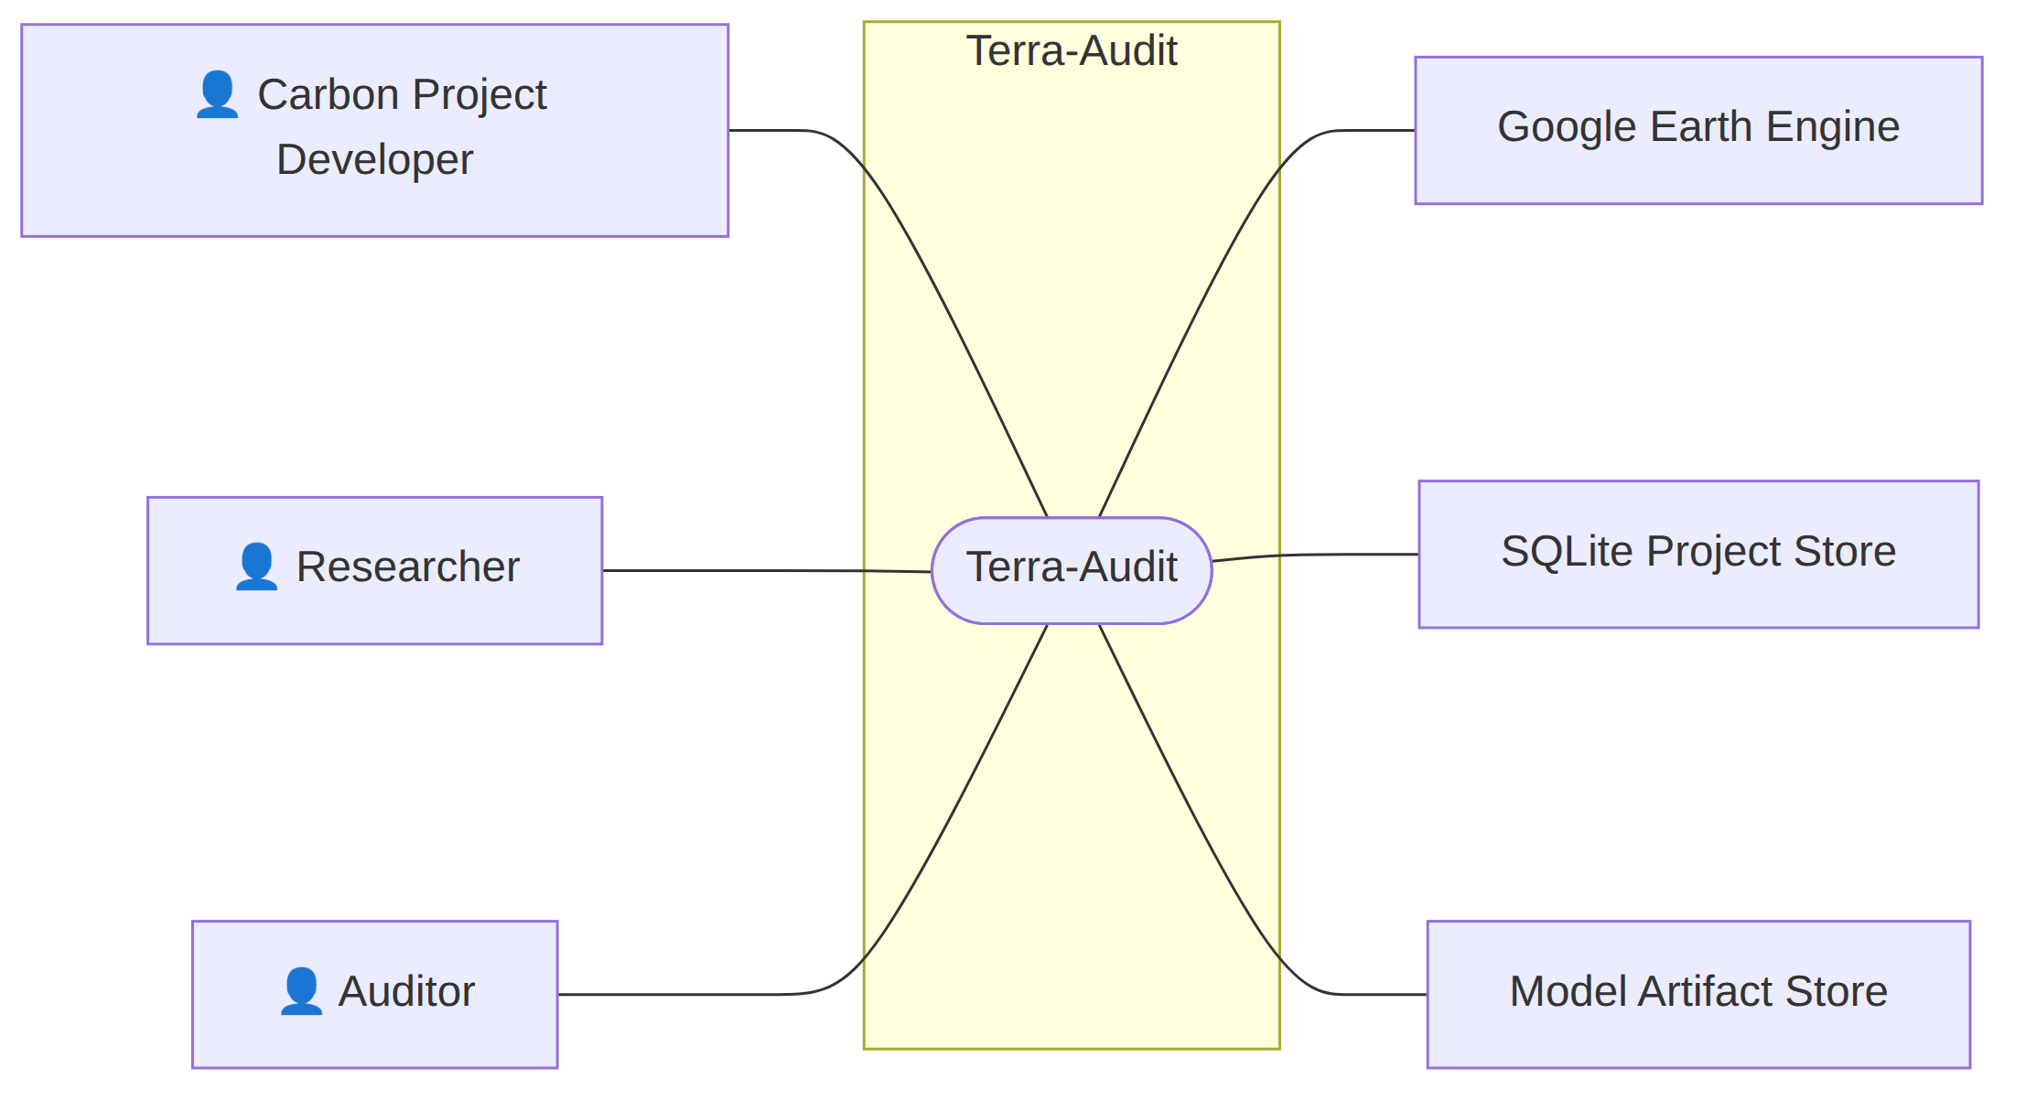
Fig 1: Terra-Audit — AI-Assisted Digital MRV Platform

Level: 1
USE CASE ID: 1
Name: Terra-Audit
Primary Actor: Carbon Project Developer, Researcher, Auditor
Secondary Actor: Google Earth Engine, SQLite Project Store, Model Artifact Store
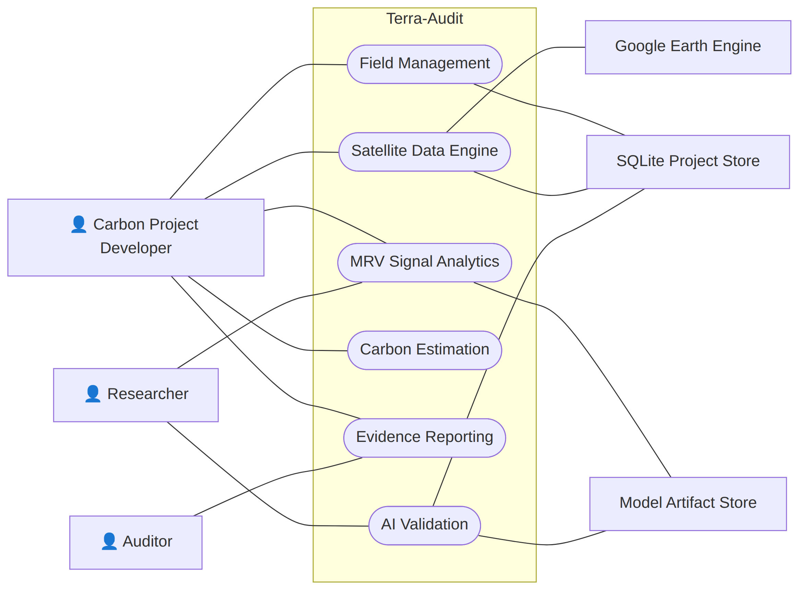
Fig 2: Level 1 of Terra-Audit

Level: 1.1
USE CASE ID: 1.1
Name: Field Management
Primary Actor: Carbon Project Developer
Secondary Actor: SQLite Project Store
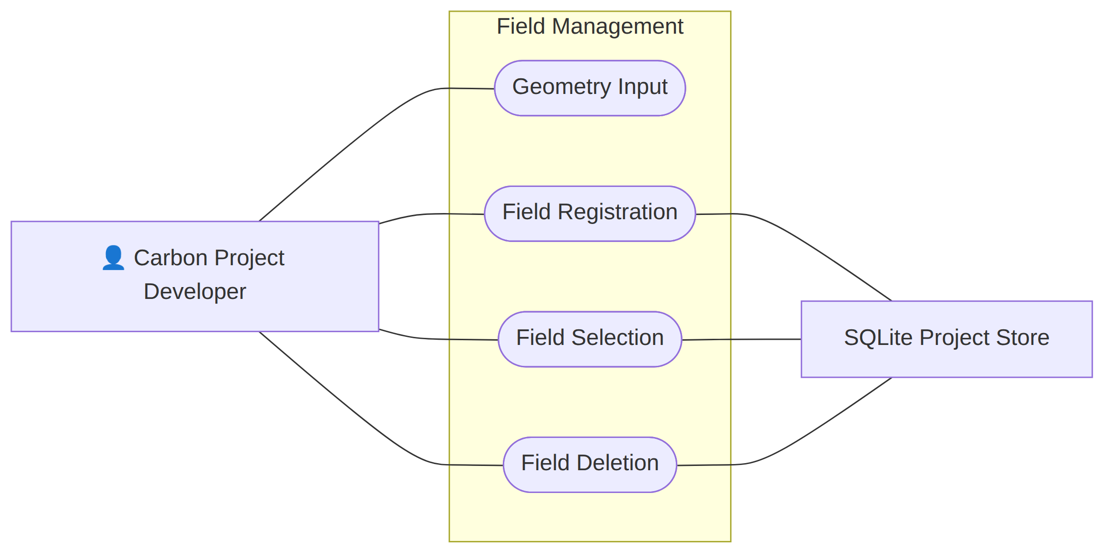
Fig 3: Field Management

Level: 1.1.1
USE CASE ID: 1.1.1
Name: Geometry Input
Primary Actor: Carbon Project Developer
Secondary Actor: None
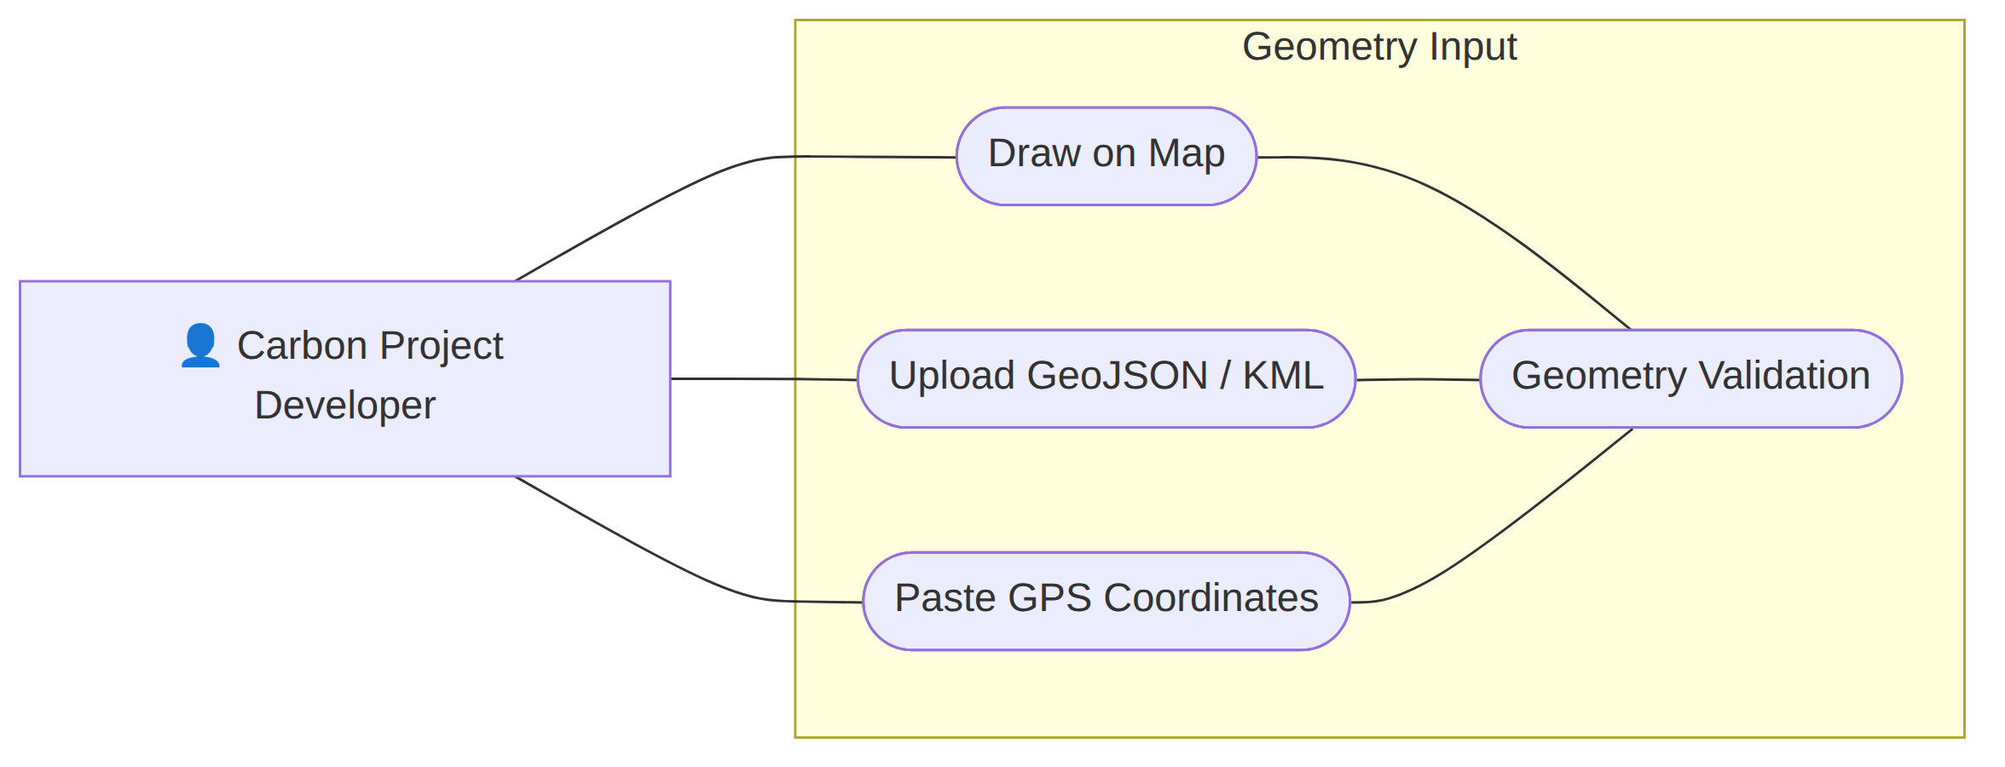
Fig 4: Geometry Input

Level: 1.1.2
USE CASE ID: 1.1.2
Name: Field Registration
Primary Actor: Carbon Project Developer
Secondary Actor: SQLite Project Store
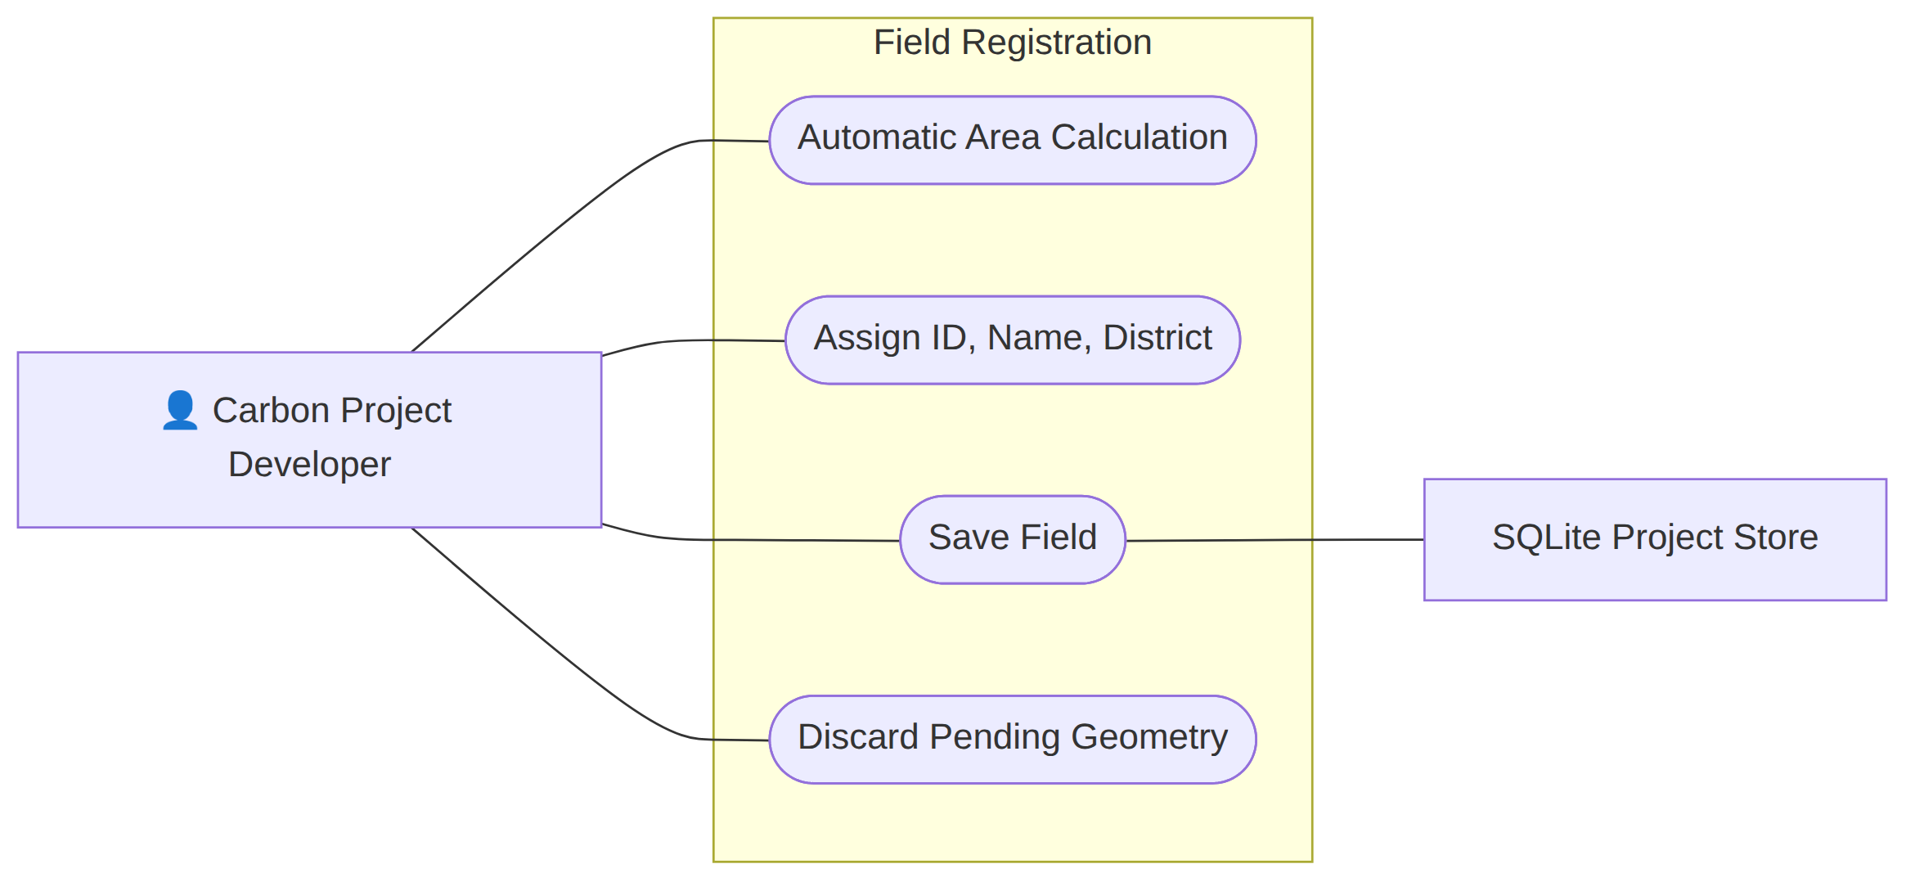
Fig 5: Field Registration

Level: 1.2
USE CASE ID: 1.2
Name: Satellite Data Engine
Primary Actor: Carbon Project Developer
Secondary Actor: Google Earth Engine, SQLite Project Store
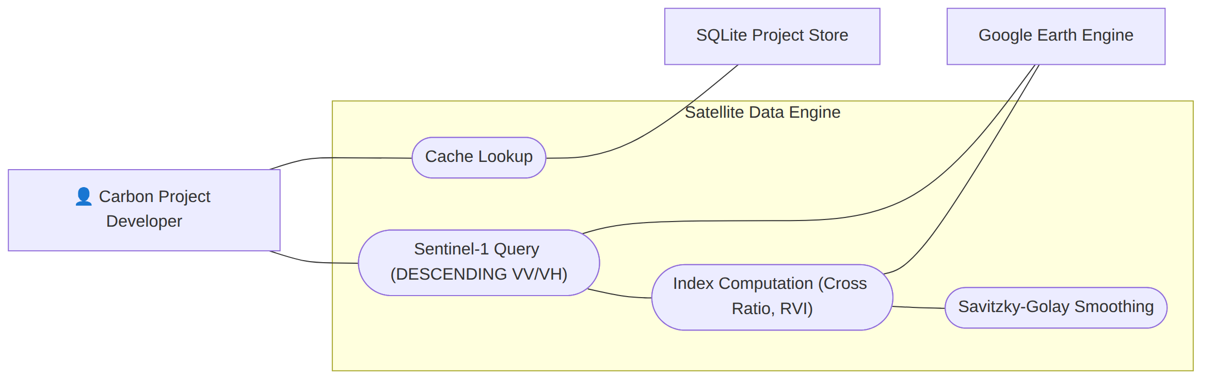
Fig 6: Satellite Data Engine

Level: 1.3
USE CASE ID: 1.3
Name: MRV Signal Analytics
Primary Actor: Carbon Project Developer, Researcher
Secondary Actor: Model Artifact Store
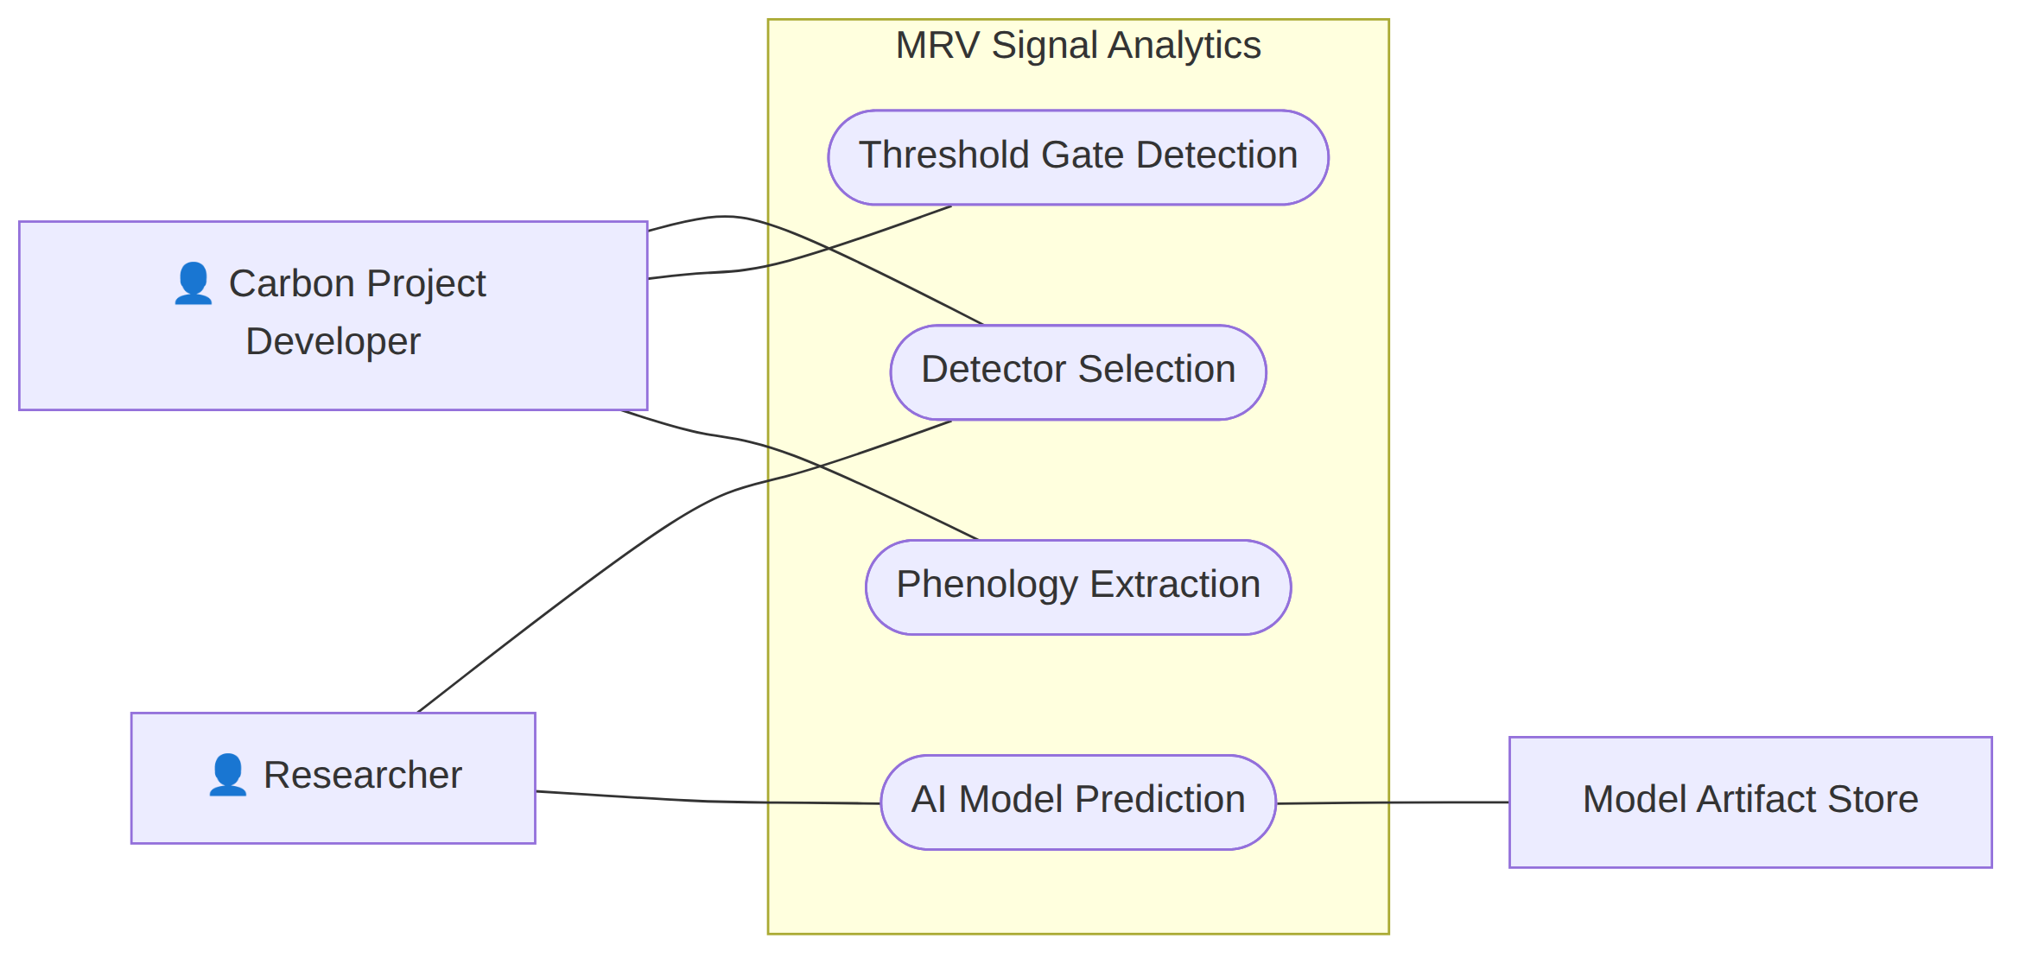
Fig 7: MRV Signal Analytics

Level: 1.4
USE CASE ID: 1.4
Name: Carbon Estimation
Primary Actor: Carbon Project Developer
Secondary Actor: None
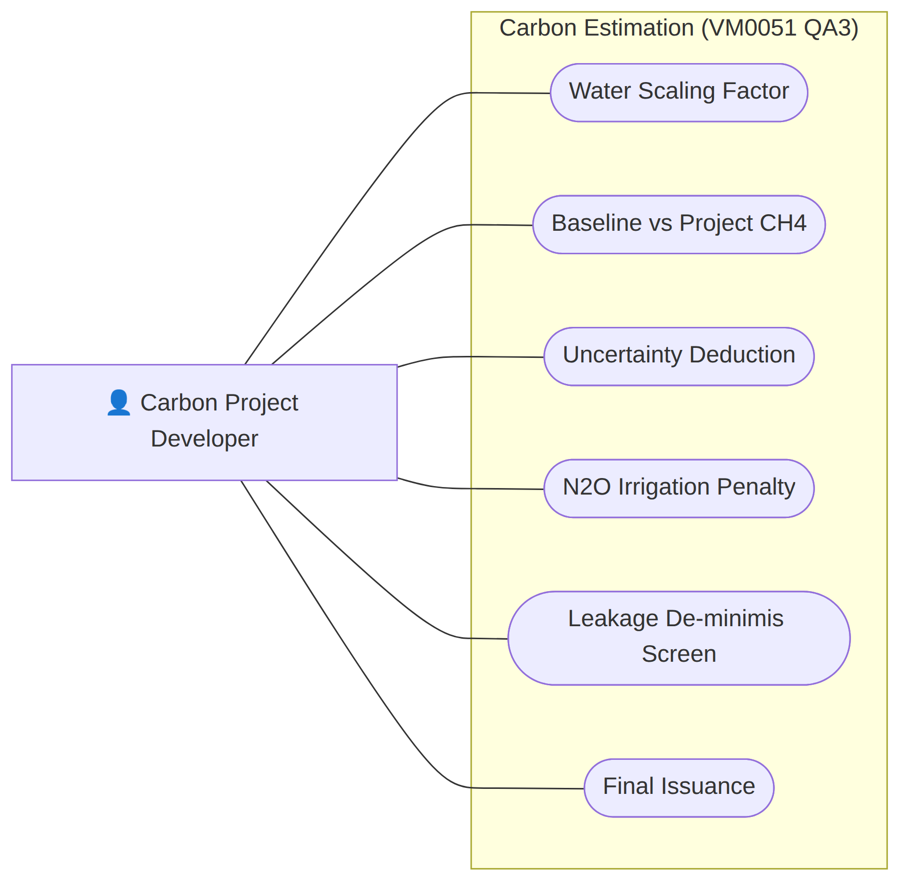
Fig 8: Carbon Estimation

Level: 1.5
USE CASE ID: 1.5
Name: Evidence Reporting
Primary Actor: Carbon Project Developer, Auditor
Secondary Actor: None
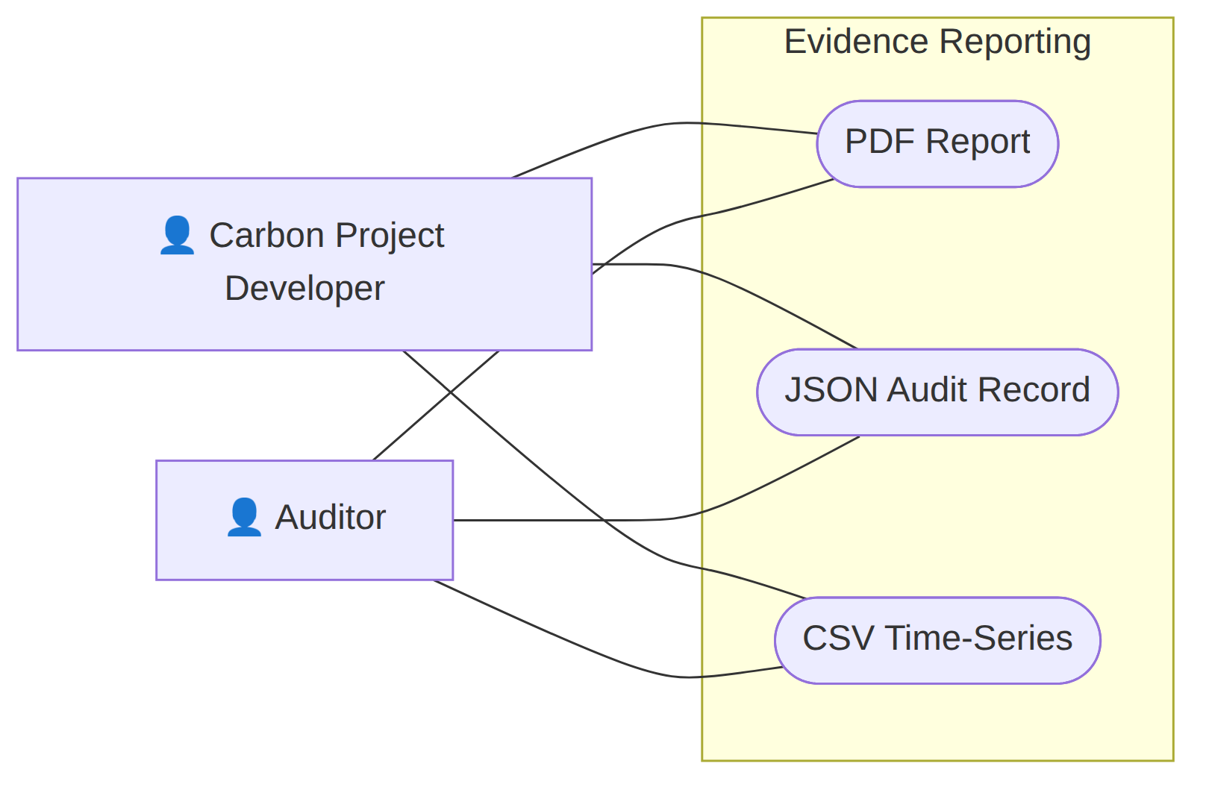
Fig 9: Evidence Reporting

Level: 1.6
USE CASE ID: 1.6
Name: AI Validation
Primary Actor: Researcher
Secondary Actor: SQLite Project Store, Model Artifact Store
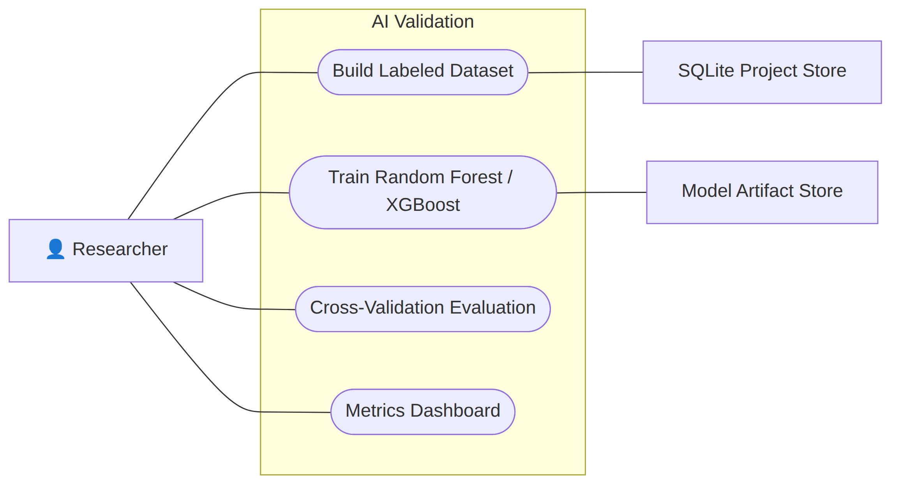
Fig 10: AI Validation

5.2 Activity Diagram

Level: 1
Name: Terra-Audit
Reference: Use case Diagram level-1
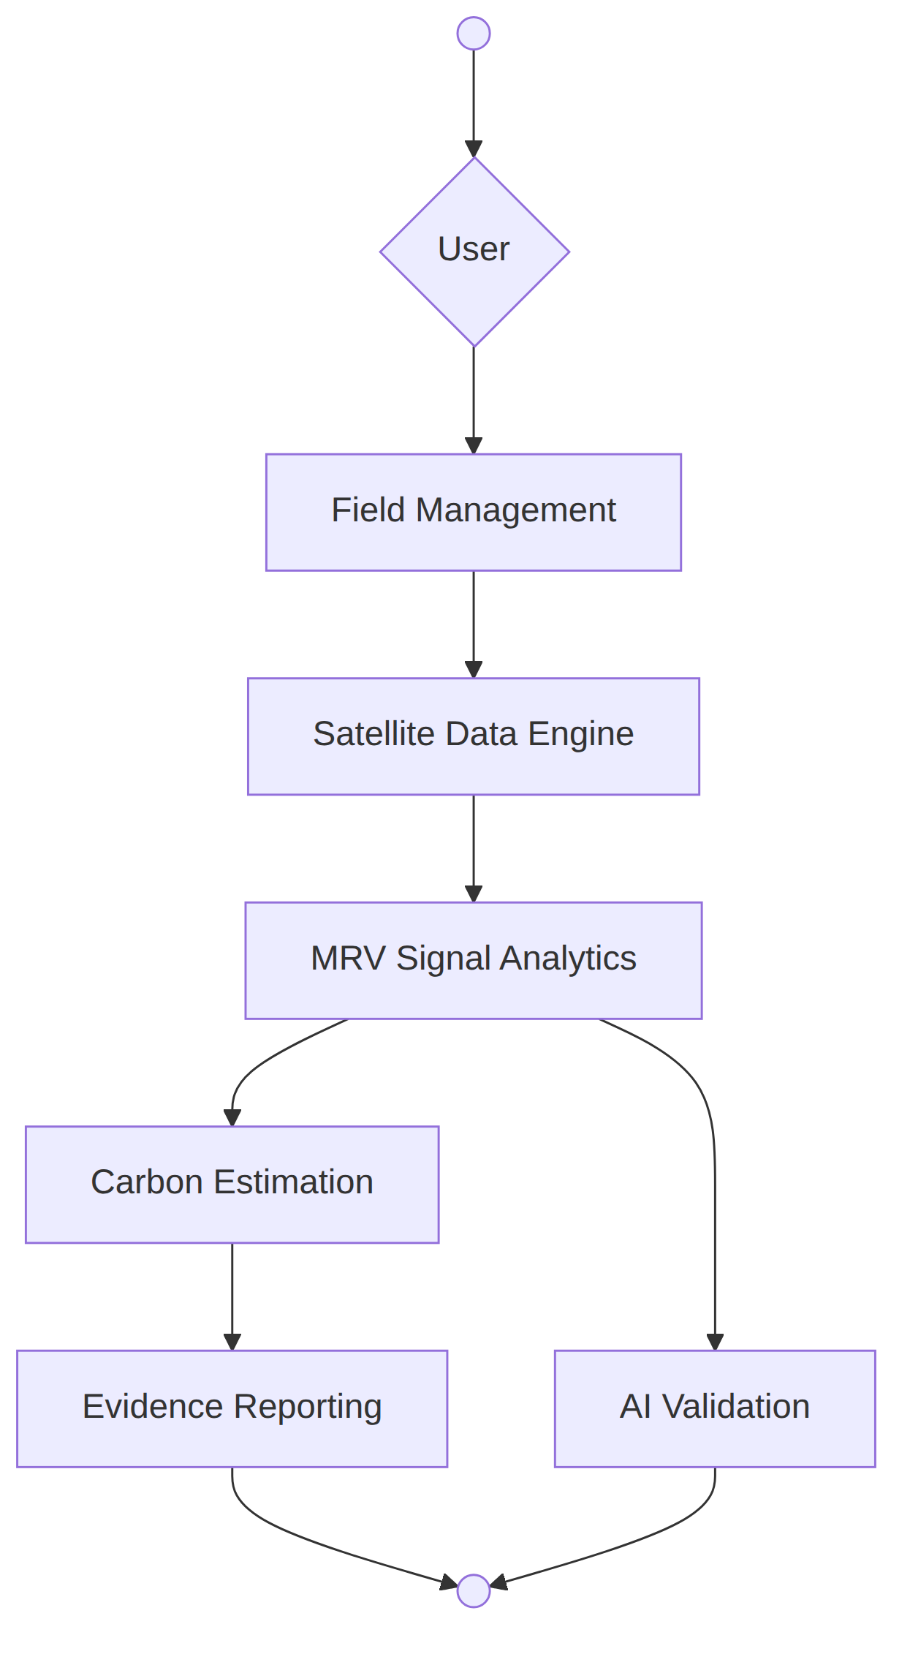
Fig 11: Terra-Audit (Use Case - 1)

Level: 1.1
Name: Field Management
Reference: Use case Diagram level-1.1
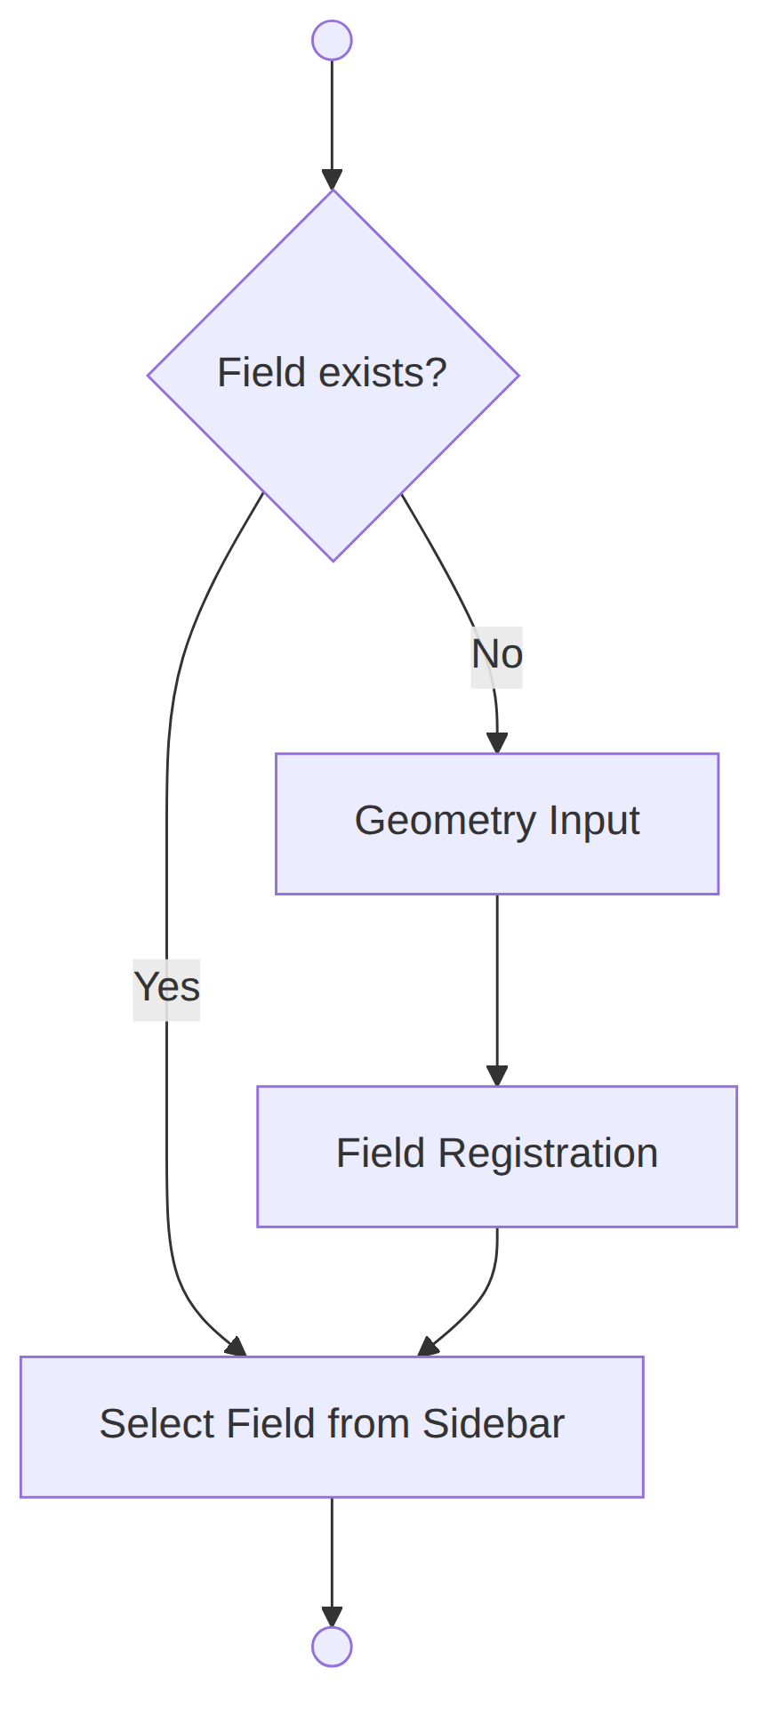
Fig 12: Field Management (Use Case - 1.1)

Level: 1.1.1
Name: Geometry Input & Registration
Reference: Use case Diagram level-1.1.1, 1.1.2
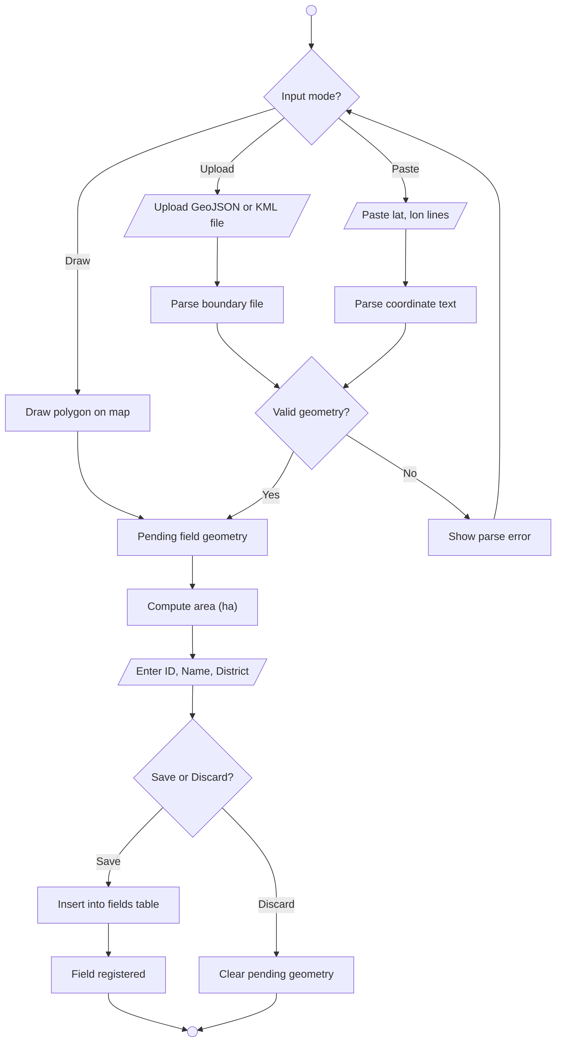
Fig 13: Geometry Input & Registration (Use Case - 1.1.1)

Level: 1.2
Name: Satellite Data Engine
Reference: Use case Diagram level-1.2
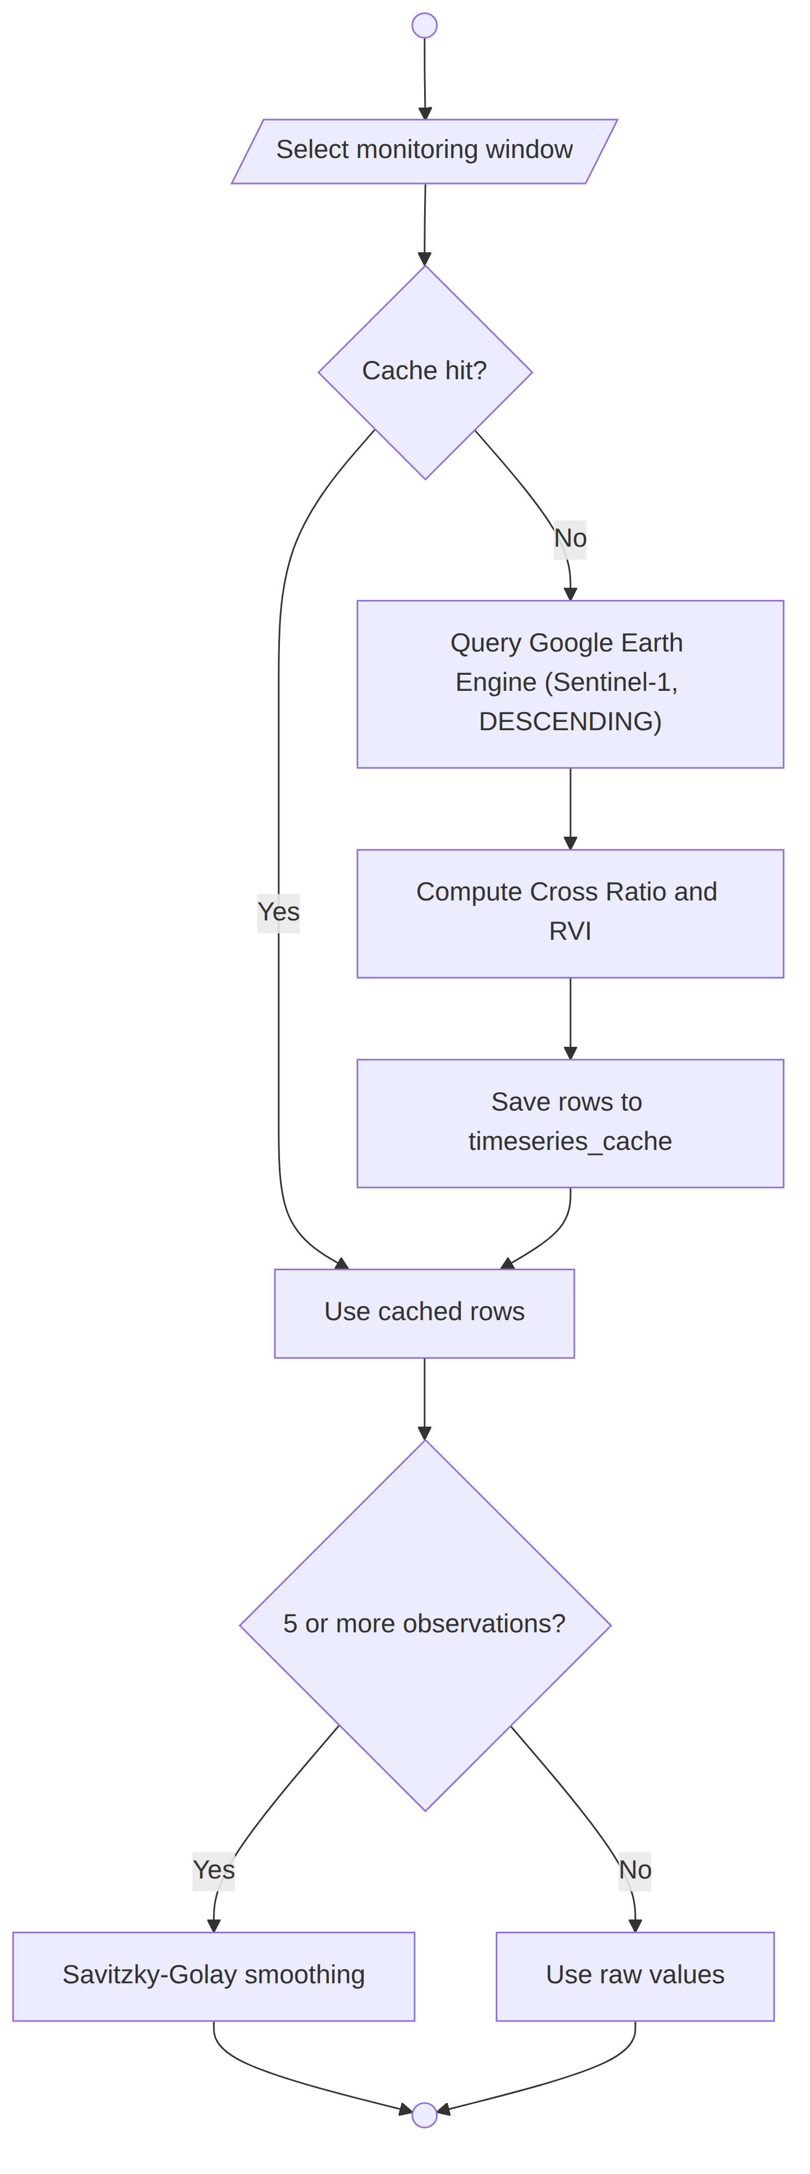
Fig 14: Satellite Data Engine (Use Case - 1.2)

Level: 1.3
Name: MRV Signal Analytics
Reference: Use case Diagram level-1.3
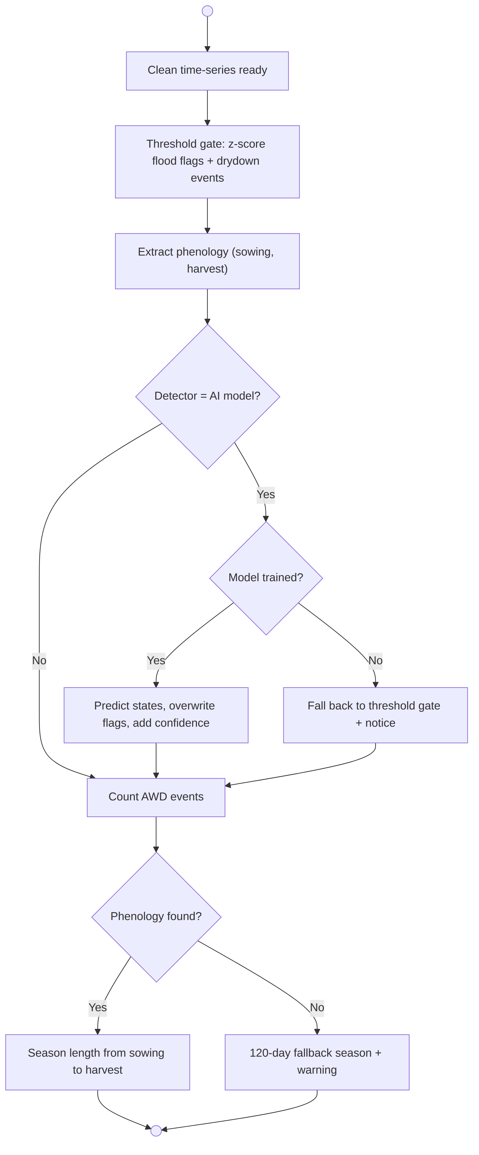
Fig 15: MRV Signal Analytics (Use Case - 1.3)

Level: 1.4
Name: Carbon Estimation
Reference: Use case Diagram level-1.4
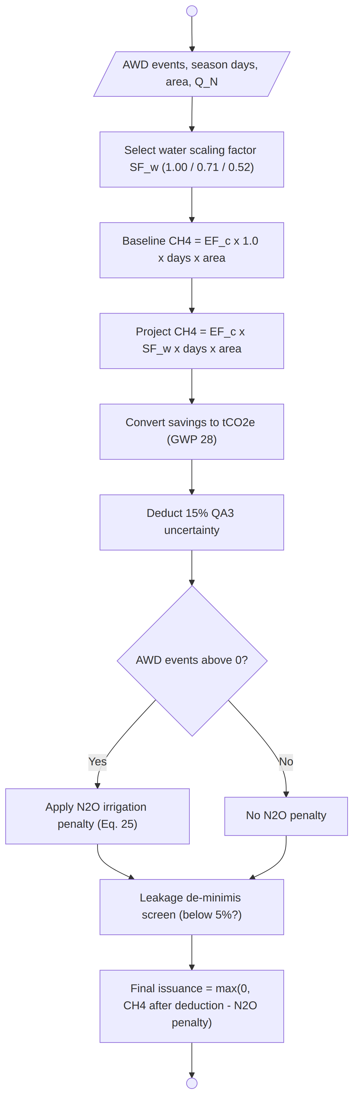
Fig 16: Carbon Estimation (Use Case - 1.4)

Level: 1.5
Name: Evidence Reporting
Reference: Use case Diagram level-1.5
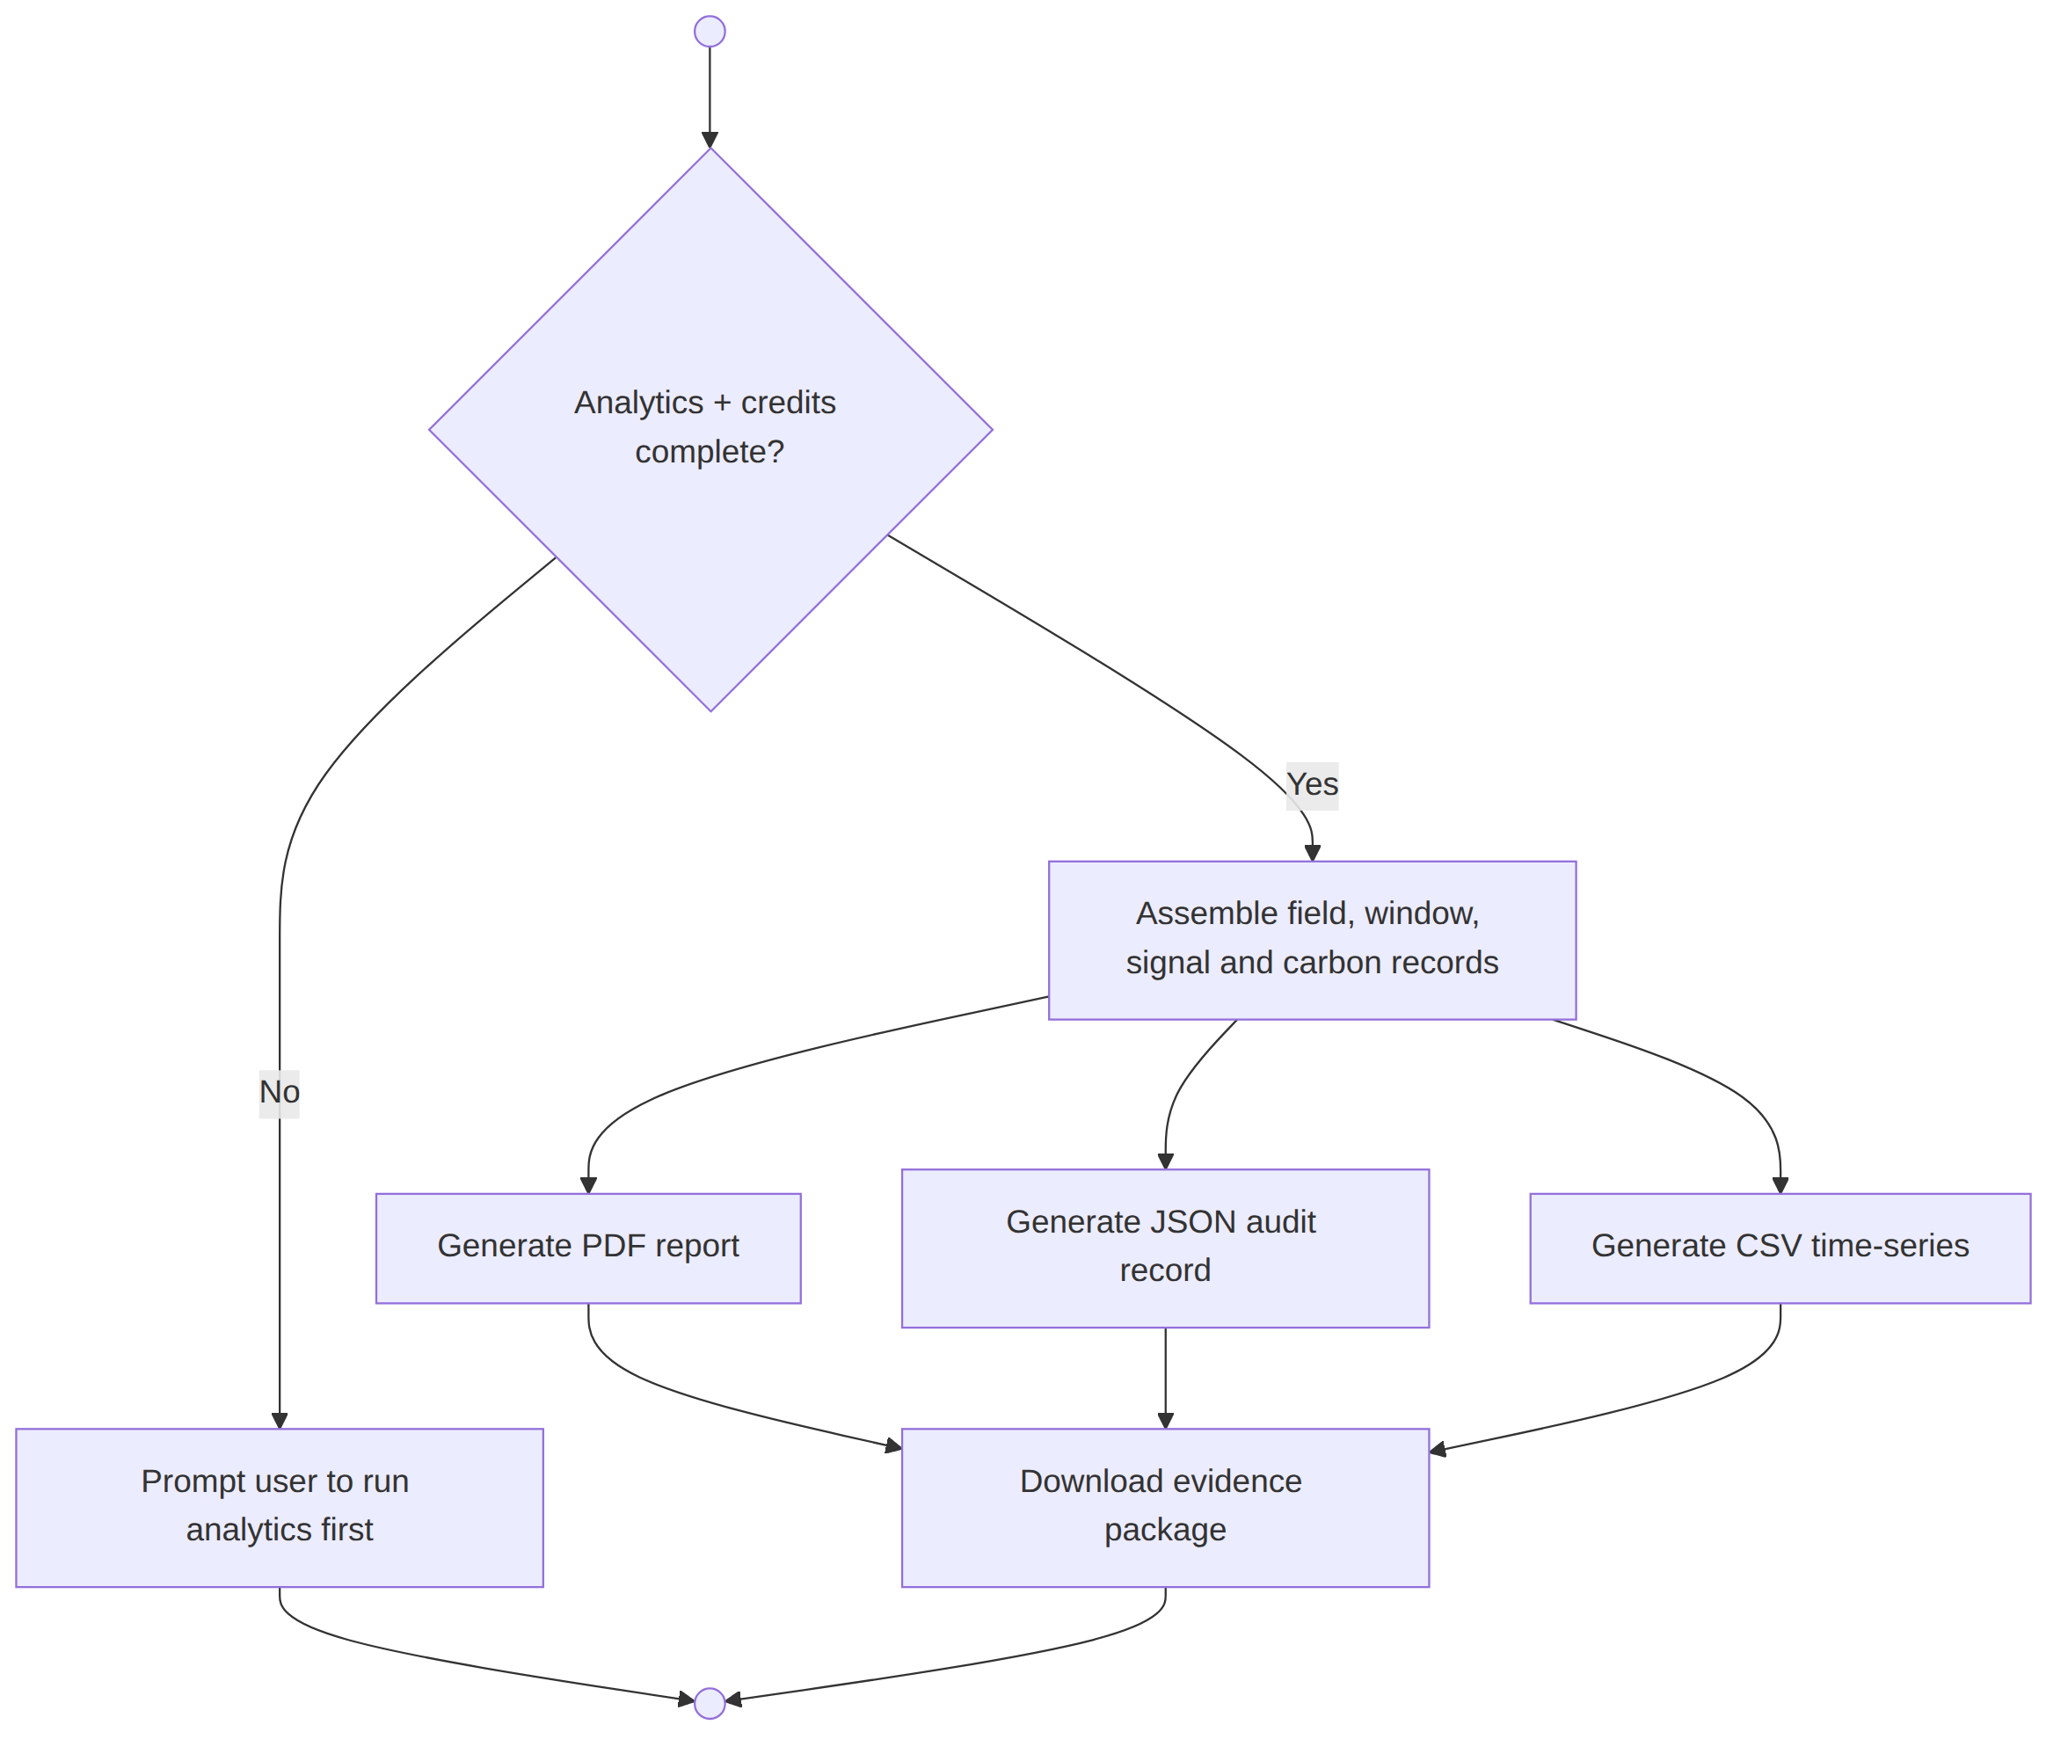
Fig 17: Evidence Reporting (Use Case - 1.5)

Level: 1.6
Name: AI Validation
Reference: Use case Diagram level-1.6
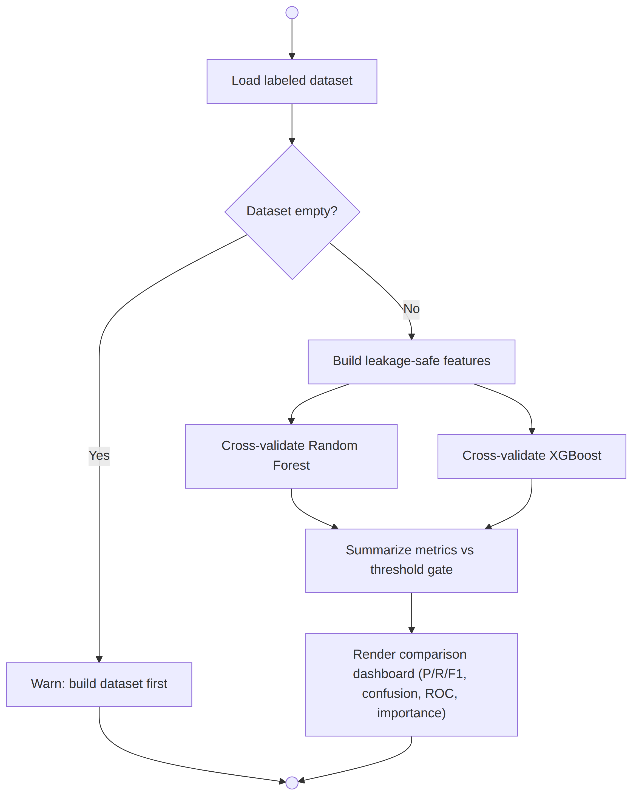
Fig 18: AI Validation (Use Case - 1.6)

6. Data Based Modeling
DATA MODELING CONCEPT: If software requirements include the necessity to create, extend or interact with a database or complex data structures need to be constructed and manipulated, then the software team chooses to create data models as part of overall requirements modeling. The entity relationship diagram (ERD) defines all data objects that are processed within the system, the relationships between the data objects and the information about how the data objects are entered, stored, transformed and produced within the system.
DATA OBJECTS: A data object is a representation of composite information that must be understood by the software. A data object can be an external entity, a thing, an occurrence, a role, an organizational unit, a place or a structure.

6.1 Noun Identification:
Serial | Nouns | Problem/Solution space | Attributes
1 | Field | S | 2, 3, 4, 5, 6
2 | Field ID | S
3 | Field name | S
4 | District | S
5 | Boundary geometry | S
6 | Area (hectares) | S
7 | Interactive map | P
8 | Rice paddy | P
9 | Farmer | P
10 | Monitoring window | S | 11, 12, 13
11 | Season preset | S
12 | Start date | S
13 | End date | S
14 | Satellite observation | S | 15, 16, 17, 18, 19
15 | Observation date | S
16 | VV backscatter | S
17 | VH backscatter | S
18 | Cross ratio | S
19 | Radar Vegetation Index (RVI) | S
20 | Time-series cache | S | 1, 10, 14
21 | Smoothing filter | S
22 | Z-score | S
23 | Flooded state | S
24 | Drydown event | S
25 | AWD event count | S
26 | Phenology | S | 27, 28, 29
27 | Sowing date | S
28 | Harvest date | S
29 | Season length | S
30 | Detector | S
31 | Threshold gate | S | 22, 23, 24
32 | AI model | S | 33, 34, 41
33 | Prediction (predicted label) | S
34 | Confidence | S
35 | Carbon estimate | S | 25, 29, 36, 37, 38, 39, 50
36 | Water scaling factor (SF_w) | S
37 | Emission factor (EF_c) | S
38 | Uncertainty deduction | S
39 | N₂O irrigation penalty | S
40 | Model artifact | S
41 | Dataset row | S | 14, 42
42 | Label (dry / flooded / drydown) | S
43 | Evidence package | S | 44, 45, 46
44 | PDF report | S
45 | JSON audit record | S
46 | CSV export | S
47 | Auditor | P
48 | Carbon registry (Verra) | P
49 | Leakage screen | S
50 | Final issuance | S

6.2 Final Data Objects:
- Field
- MonitoringWindow
- TimeseriesObservation
- AWDAnalysisResult
- PhenologyResult
- CarbonEstimate
- AIDatasetRow
- AIModelArtifact
- EvidencePackage

6.3 Relations:
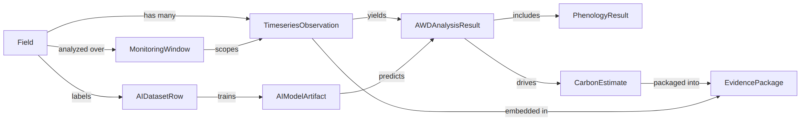
Fig 19: Entity Relation

6.4 ER DIAGRAM:
The persisted entities live in SQLite (data/project_store.db); model artifacts are persisted as joblib files under data/ai_models/. Analysis results, carbon estimates and evidence packages are derived on demand and are not stored as tables.
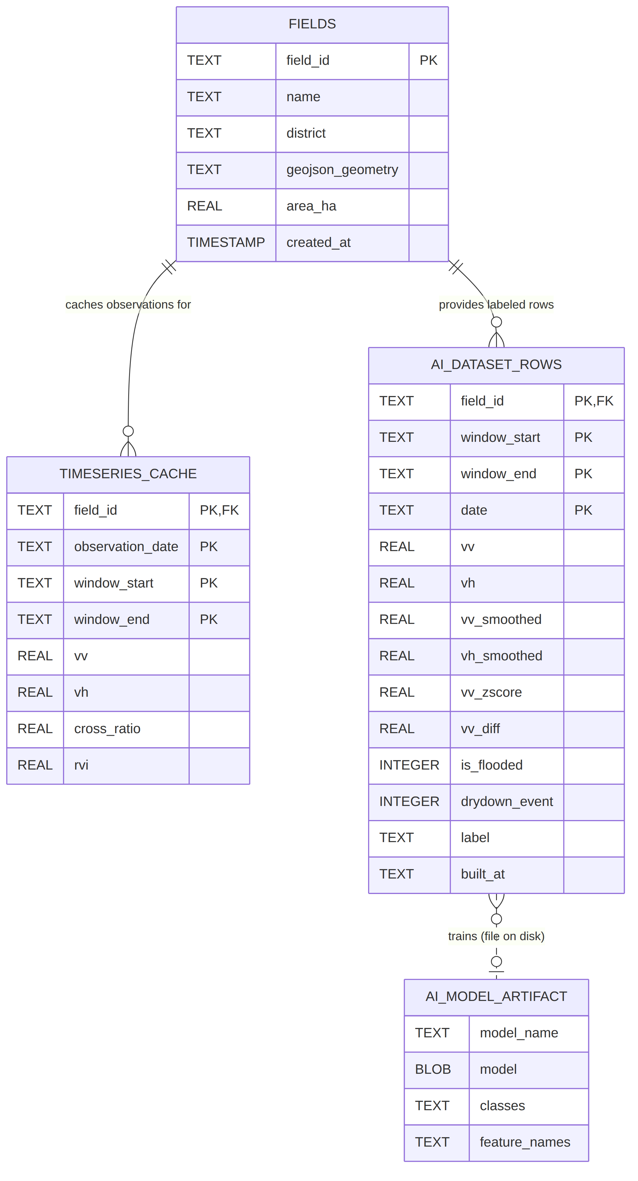
Fig 20: ER Diagram

6.5 Schema Diagram:
Data Object | Attribute | Type
Field | field_id (PK) | string
 | name | string
 | district | string
 | geojson_geometry | string (GeoJSON FeatureCollection)
 | area_ha | number (hectares)
 | created_at | timestamp
MonitoringWindow | season_label | string (e.g. “Boro 2026”)
 | window_start | date (ISO)
 | window_end | date (ISO)
TimeseriesObservation | field_id (PK, FK) | string
 | observation_date (PK) | date
 | window_start (PK) | date
 | window_end (PK) | date
 | vv | number (dB)
 | vh | number (dB)
 | cross_ratio | number (VH − VV)
 | rvi | number
AWDAnalysisResult | vv_smoothed | number
 | vh_smoothed | number
 | vv_zscore | number
 | vv_diff | number
 | is_flooded | 0 / 1
 | drydown_event | 0 / 1
 | predicted_label (AI path) | string
 | confidence (AI path) | number (0–1)
 | total_awd_events | integer
 | detector_used | string
PhenologyResult | is_sowing | 0 / 1
 | is_harvest | 0 / 1
 | sowing_date | date
 | harvest_date | date
 | season_length_days | integer (120-day fallback)
 | from_phenology | boolean
CarbonEstimate | sf_w_project | number (1.00 / 0.71 / 0.52)
 | e_baseline | number (kg CH₄)
 | e_project | number (kg CH₄)
 | delta_e_ch4 | number (kg CH₄)
 | delta_e_co2e | number (tCO₂e)
 | unc_deduction_pct | number (0.15)
 | unc_tco2e | number (tCO₂e)
 | ch4_after_unc | number (tCO₂e)
 | pe_n2o_tco2e | number (tCO₂e)
 | q_n_kg_per_ha | number
 | leakage_pct | number (%)
 | leakage_de_minimis | boolean
 | final_issuance | number (tCO₂e, floored at 0)
AIDatasetRow | field_id, window_start, window_end, date (PK) | composite key
 | district | string
 | area_ha | number
 | vv | number
 | vh | number
 | cross_ratio | number
 | rvi | number
 | vv_smoothed | number
 | vh_smoothed | number
 | vv_zscore | number
 | vv_diff | number
 | vh_diff | number
 | is_flooded | 0 / 1
 | drydown_event | 0 / 1
 | is_sowing | 0 / 1
 | is_harvest | 0 / 1
 | label | string (“dry” / “flooded” / “drydown”)
 | built_at | timestamp
AIModelArtifact | model_name | string (“random_forest” / “xgboost”)
 | model | fitted classifier (joblib)
 | classes | list of strings
 | feature_names | list of strings
EvidencePackage | pdf_report | bytes (A4, 8 sections)
 | json_audit_record | string (all inputs + intermediates + full time-series)
 | csv_timeseries | string

7. Class Based Diagram
Class-Based Modeling Concepts:
Class-based modeling represents the objects that the system will manipulate, the operations that will be applied to the objects, relationships between the objects and the collaborations that occur between the classes that are defined.

7.1 Identified Nouns:
Serial | Noun
1 | Field
2 | Field ID
3 | Field name
4 | District
5 | Boundary geometry
6 | Area (hectares)
7 | Interactive map
8 | Monitoring window
9 | Season preset
10 | Start date
11 | End date
12 | Satellite observation
13 | VV backscatter
14 | VH backscatter
15 | Cross ratio
16 | Radar Vegetation Index (RVI)
17 | Time-series cache
18 | Smoothing filter
19 | Z-score
20 | Flooded state
21 | Drydown event
22 | AWD event count
23 | Phenology
24 | Sowing date
25 | Harvest date
26 | Season length
27 | Detector
28 | Threshold gate
29 | AI model
30 | Prediction (predicted label)
31 | Confidence
32 | Carbon estimate
33 | Water scaling factor (SF_w)
34 | Emission factor (EF_c)
35 | Uncertainty deduction
36 | N₂O irrigation penalty
37 | Leakage screen
38 | Final issuance
39 | Model artifact
40 | Dataset row
41 | Label
42 | Evidence package
43 | PDF report
44 | JSON audit record
45 | CSV export

7.2 Identified Verbs:
Serial | Verbs
1 | register
2 | draw
3 | upload
4 | paste
5 | parse
6 | validate
7 | compute
8 | save
9 | select
10 | delete
11 | query
12 | filter
13 | cache
14 | smooth
15 | standardize
16 | detect
17 | flag
18 | count
19 | extract
20 | derive
21 | fall back
22 | calculate
23 | scale
24 | convert
25 | deduct
26 | penalize
27 | screen
28 | floor
29 | issue
30 | generate
31 | export
32 | download
33 | build
34 | label
35 | train
36 | cross-validate
37 | persist
38 | load
39 | predict
40 | overwrite
41 | evaluate
42 | summarize
43 | visualize

7.3 General Classification:
Candidate classes are categorized based on the seven general classification. The analysis classes manifest themselves in one of the following ways:
- External entities
- Things
- Events
- Roles
- Organizational units
- Places
- Structures
A candidate class is selected for special classification if it fulfills two or more characteristics.
Serial | Solution Space Nouns | General Classifications
1 | Field | 2, 6, 7 (selected)
2 | Boundary geometry | 2
3 | Area (hectares) | 2
4 | Monitoring window | 2, 7 (selected)
5 | Satellite observation | 2, 3, 7 (selected)
6 | VV backscatter | 2
7 | VH backscatter | 2
8 | Cross ratio | 2
9 | RVI | 2
10 | Time-series cache | 2, 7 (selected)
11 | Smoothing filter | 2
12 | Z-score | 2
13 | Flooded state | 3
14 | Drydown event | 3
15 | AWD event count | 2
16 | Phenology | 2, 3 (selected)
17 | Sowing date | 3
18 | Harvest date | 3
19 | Detector | 4
20 | Threshold gate | 2, 7 (selected)
21 | AI model | 2, 7 (selected)
22 | Prediction | 3
23 | Confidence | 2
24 | Carbon estimate | 2, 7 (selected)
25 | Water scaling factor | 2
26 | Uncertainty deduction | 2, 3
27 | N₂O irrigation penalty | 2, 3
28 | Final issuance | 2, 3
29 | Model artifact | 2, 7 (selected)
30 | Dataset row | 2, 7 (selected)
31 | Label | 2
32 | Evidence package | 2, 7 (selected)
33 | PDF report | 2
34 | JSON audit record | 2
35 | CSV export | 2
36 | Google Earth Engine | 1
37 | SQLite project store | 1, 6
38 | Interactive map | 2, 6

7.4 Selection Criteria:
The candidate classes are then selected as classes by six Selection Criteria. A candidate class generally becomes a class when it fulfills around three characteristics.
- Retain information
- Needed services
- Multiple attributes
- Common attributes
- Common operations
- Essential requirements
Potential general classified nouns to become a class after selection criteria:
Serial | Solution Space Nouns | Selection Criteria
1 | Field | 1–5 (selected)
2 | TimeseriesObservation | 1–5 (selected)
3 | MonitoringWindow | 1, 3, 4 (selected)
4 | CarbonEstimate | 1–5 (selected)
5 | AIDatasetRow | 1–5 (selected)
6 | AIModelArtifact | 1–5 (selected)
7 | EvidencePackage | 1, 2, 3 (selected)
Additional classes required:
Serial | Additional classes
1 | SpatialDataEngine
2 | AdaptiveAWDGate
3 | CarbonAssetEngine
4 | GeoUtils
5 | ProjectStore
6 | ReportGenerator
7 | DatasetBuilder
8 | FeatureEngineer
9 | ModelRegistry
10 | AWDPredictor
11 | ModelEvaluator

7.5 Class Card:

SpatialDataEngine
Attribute | Method
(reads EE_PROJECT from environment) | +extract_clean_timeseries(geojson_geometry, start_date, end_date)

Responsibilities | Collaborator
Initialize the Earth Engine session; Fetch Sentinel-1 VV/VH backscatter (DESCENDING pass only); Compute Cross Ratio and RVI per observation; Apply Savitzky-Golay smoothing (window 5, polyorder 2) | Google Earth Engine

AdaptiveAWDGate
Attribute | Method
−z_flood_threshold = −0.8; −dynamic_delta_sigma = 1.2 | +analyze_irrigation_behavior(df); +extract_phenology(df)

Responsibilities | Collaborator
Standardize VV into z-scores and flag flooded states; Detect AWD drydown events (sharp VV jump after flooding); Derive sowing (VH minimum) and harvest (sharpest post-peak VH drop) | SpatialDataEngine (input), DatasetBuilder, Streamlit UI

CarbonAssetEngine
Attribute | Method
−ef_c = 1.4; −gwp_ch4 = 28; SF_CONTINUOUS_FLOODING = 1.00; SF_SINGLE_AERATION = 0.71; SF_TRUE_AWD = 0.52; UNC_QA3_DEFAULT = 0.15; CF_N2O = 0.00314; GWP_N2O = 265 | +calculate_credits(awd_events, season_length_days, area_ha, q_n_kg_per_ha); −_water_scaling_factor(awd_events); −_n2o_irrigation_penalty(q_n_kg_per_ha, area_ha)

Responsibilities | Collaborator
Implement the VM0051 v1.0 QA3 credit calculation; Baseline vs project CH₄, CO₂e conversion, uncertainty deduction; N₂O penalty, leakage screen, final issuance floored at 0 | Streamlit UI, ReportGenerator (output shape)

GeoUtils
Attribute | Method
— | +compute_area_ha(geojson_feature); +parse_geojson_upload(content); +parse_kml_upload(content); +parse_coordinate_text(text)

Responsibilities | Collaborator
Parse user-supplied boundaries (GeoJSON / KML / coordinate text); Return (feature, error) instead of raising on bad input; Compute area via Shoelace formula with spherical correction | Streamlit UI

ProjectStore
Attribute | Method
−DB_PATH = data/project_store.db | +get_db_connection(); +initialize_database(); +check_cache(field_id, window_start, window_end); +save_cache(field_id, df, window_start, window_end)

Responsibilities | Collaborator
Own the SQLite schema (fields, timeseries_cache) and migrations; Serve cached time-series before any live GEE query; Persist newly fetched observations | Streamlit UI, DatasetBuilder

ReportGenerator
Attribute | Method
−_PDF (A4 template with header/footer) | +generate_pdf(field_info, window, signal, carbon); +generate_audit_json(field_info, window, signal, carbon, df); +generate_timeseries_csv(df)

Responsibilities | Collaborator
Produce the 8-section auditor-facing PDF report; Emit the machine-readable JSON audit record with full time-series; Emit the raw CSV export | CarbonAssetEngine (input shape), Streamlit UI

DatasetBuilder
Attribute | Method
−DATASET_TABLE = “ai_dataset_rows” | +build_dataset(gate); +save_dataset(df); +load_dataset()

Responsibilities | Collaborator
Replay the threshold gate over every cached field-window series; Label each observation dry / flooded / drydown; Persist and reload the labeled dataset | AdaptiveAWDGate, ProjectStore

FeatureEngineer
Attribute | Method
−LABEL_CLASSES = [dry, flooded, drydown]; −base features: vv, vh, cross_ratio, rvi, vv_smoothed, vh_smoothed, vv_diff | +build_features(df, include_area_ha); +encode_labels(y)

Responsibilities | Collaborator
Build leakage-safe feature matrix (excludes the gate’s own flags); Add days-since-window-start / days-since-sowing and district one-hots; Encode labels in a fixed class order | ModelRegistry, AWDPredictor

ModelRegistry
Attribute | Method
−MODEL_DIR = data/ai_models; −MODEL_REGISTRY: random_forest (200 trees, balanced), xgboost (200 rounds, depth 4) | +train_and_evaluate(model_name, X, y, k); +save_model(result); +load_model(model_name)

Responsibilities | Collaborator
Train classifiers with stratified k-fold cross-validation (plain k-fold fallback for tiny classes); Persist and reload model bundles via joblib | FeatureEngineer, AWDPredictor, ModelEvaluator

AWDPredictor
Attribute | Method
— | +predict_awd_states(df, model_name, field_id, district, area_ha, window_start, window_end)

Responsibilities | Collaborator
Load the selected model and align features to its training columns; Overwrite is_flooded / drydown_event with model output; Attach predicted_label and confidence; raise FileNotFoundError if untrained (UI falls back to the gate) | ModelRegistry, FeatureEngineer, Streamlit UI

ModelEvaluator
Attribute | Method
— | +summarize_fold_predictions(result); +feature_importance(result); +roc_curve_data(result); +summarize(result)

Responsibilities | Collaborator
Compute per-class precision / recall / F1 and confusion matrix from out-of-fold predictions; Report threshold-agreement score (explicitly not ground-truth accuracy); Provide feature importance and one-vs-rest ROC data | ModelRegistry, Streamlit UI

7.8 CRC Diagram:
Diagram Id: 1
Name: Carbon Project Developer
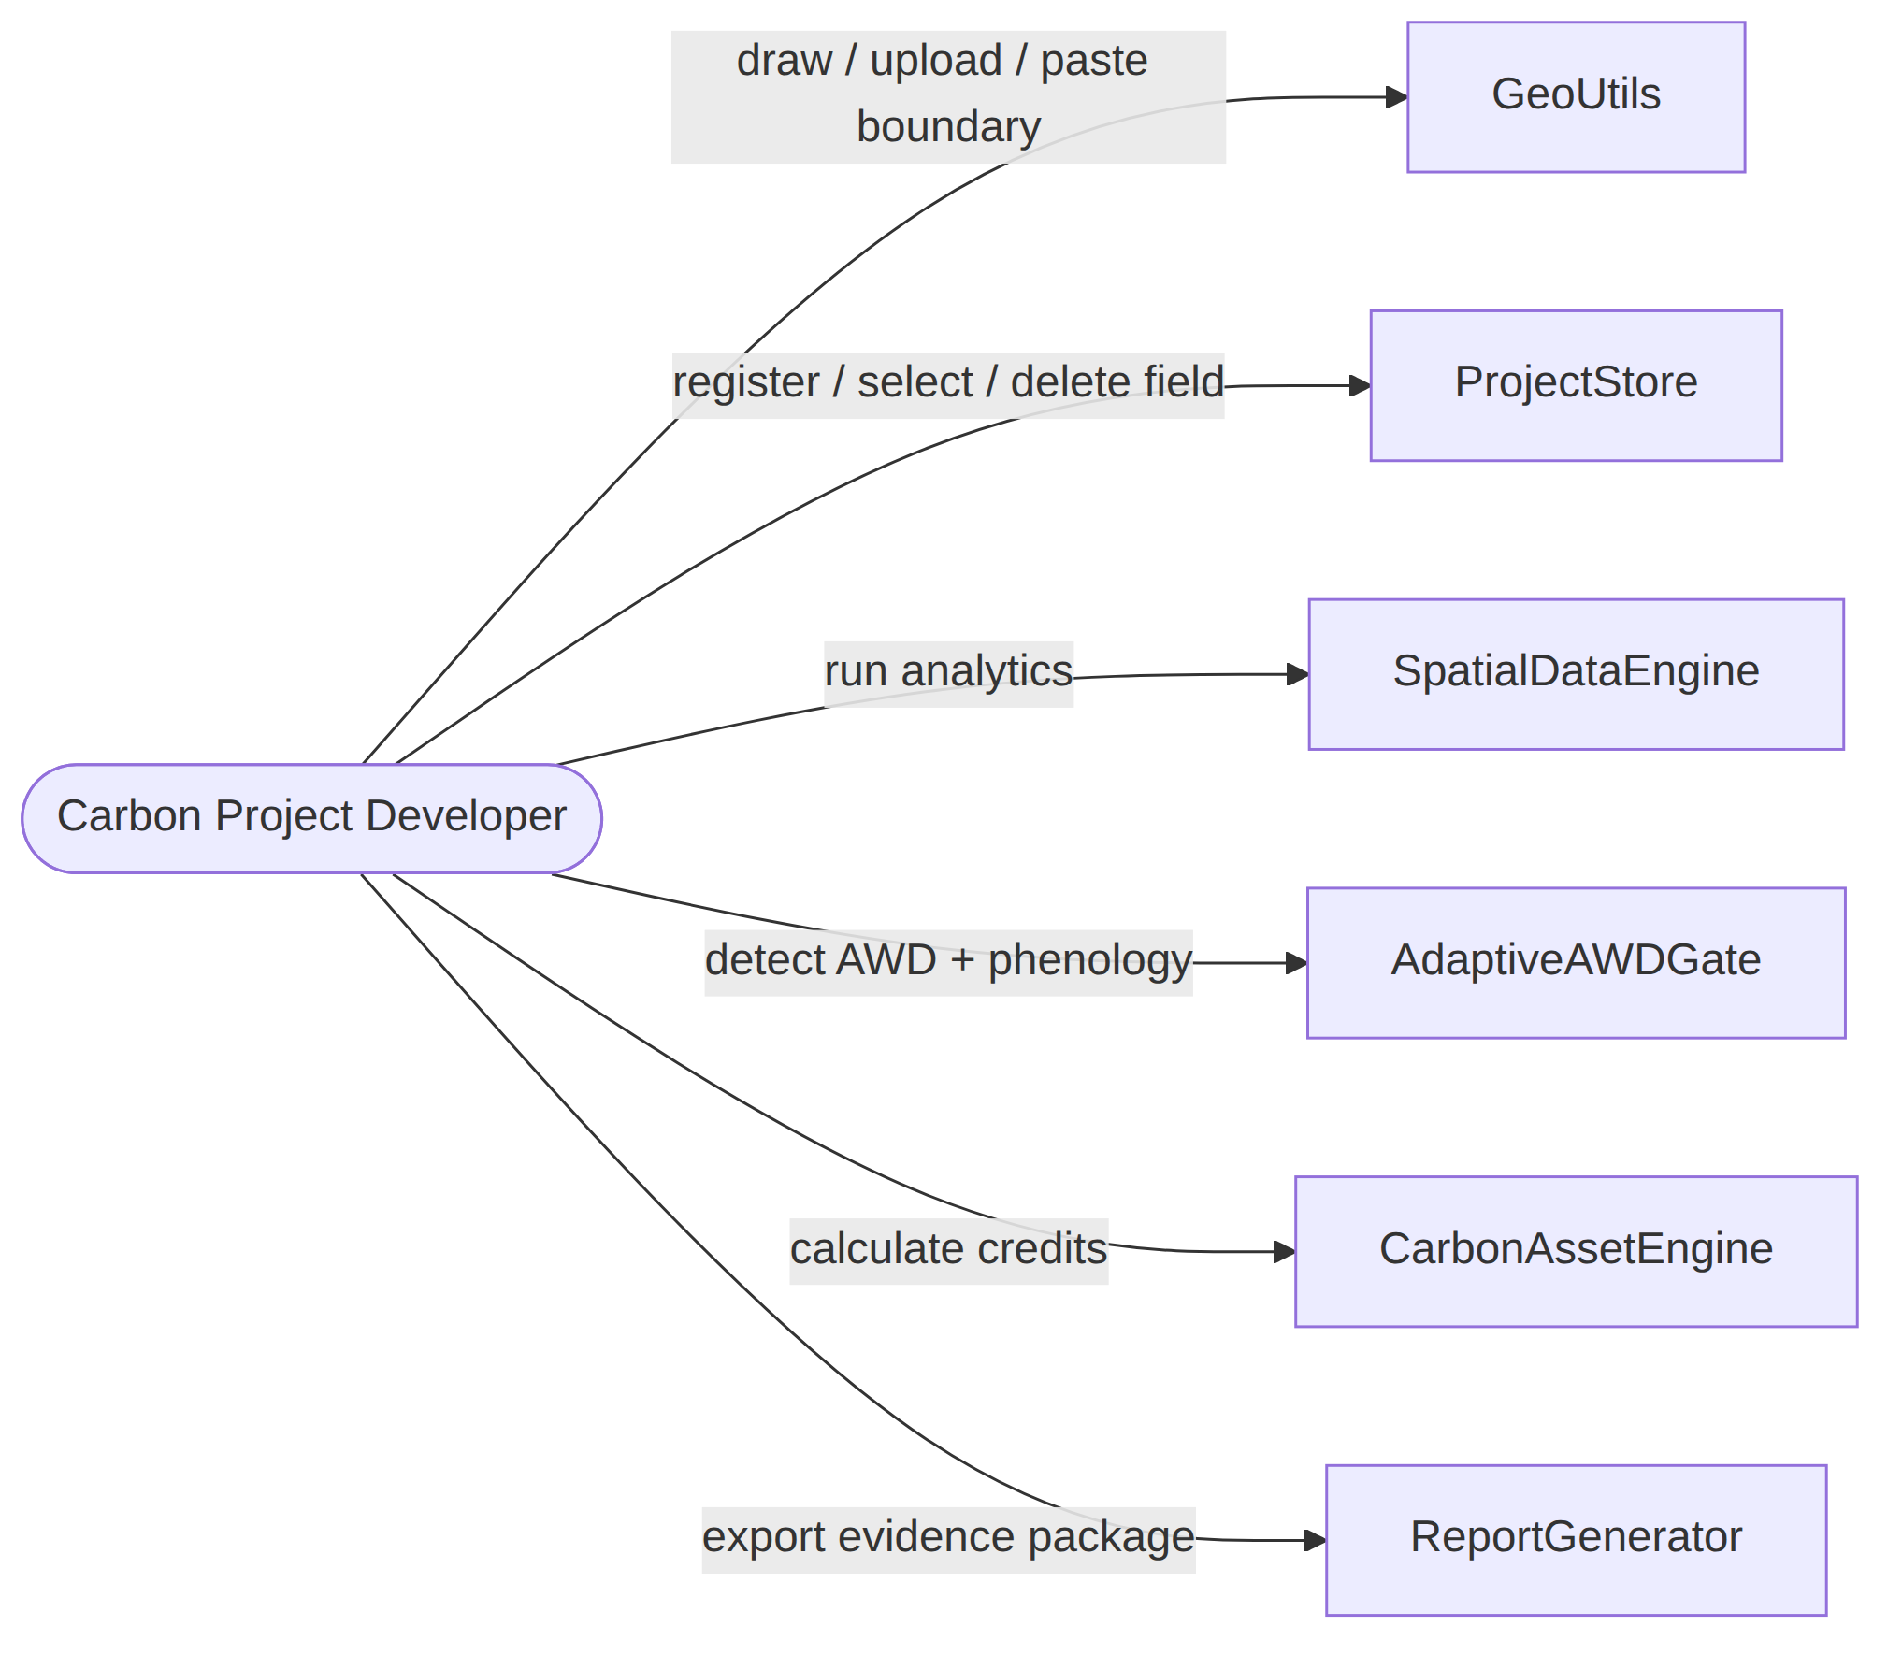
Fig 21: CRC (Carbon Project Developer)
Diagram Id: 2
Name: Researcher
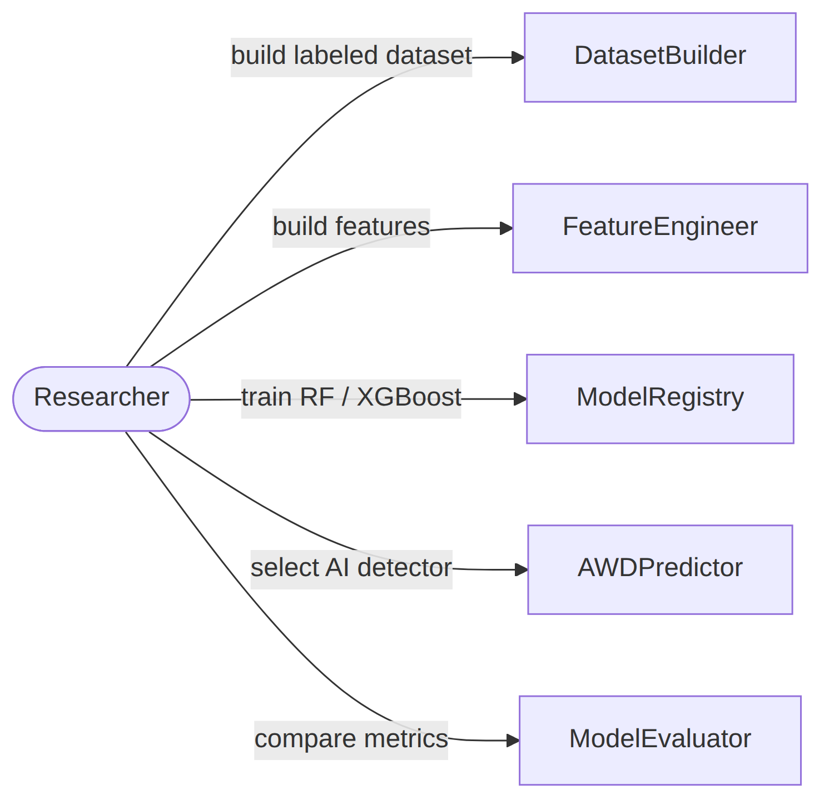
Fig 22: CRC (Researcher)

8. Behavioral Diagram

8.1 Event Table:
Serial | Event | Initiator | Associated Methods
1 | Draw field boundary | Carbon Project Developer | (Leaflet Draw → pending geometry)
2 | Upload boundary file | Carbon Project Developer | +parse_geojson_upload(); +parse_kml_upload()
3 | Paste GPS coordinates | Carbon Project Developer | +parse_coordinate_text()
4 | Register field | Carbon Project Developer | +compute_area_ha(); INSERT INTO fields
5 | Delete field | Carbon Project Developer | DELETE FROM fields, timeseries_cache
6 | Run analytics | Carbon Project Developer | +check_cache(); +extract_clean_timeseries(); +save_cache()
7 | Detect AWD events | System | +analyze_irrigation_behavior()
8 | Extract phenology | System | +extract_phenology()
9 | AI prediction | Researcher / Developer | +predict_awd_states(); +load_model()
10 | Model fallback (untrained) | System | FileNotFoundError → threshold gate
11 | Calculate carbon credits | Carbon Project Developer | +calculate_credits()
12 | Export evidence package | Carbon Project Developer / Auditor | +generate_pdf(); +generate_audit_json(); +generate_timeseries_csv()
13 | Build labeled dataset | Researcher | +build_dataset(); +save_dataset()
14 | Train AI models | Researcher | +build_features(); +train_and_evaluate(); +save_model()
15 | Evaluate AI models | Researcher | +summarize_fold_predictions(); +feature_importance(); +roc_curve_data()

8.2 State Transition Diagram
A UML state diagram, which depicts the active states for each class and the occasions (triggers) that induce changes between these active states, is part of a behavioral model. Here we’ve listed the most important events that trigger the change of states.
Diagram ID: 1
Class Name: Field
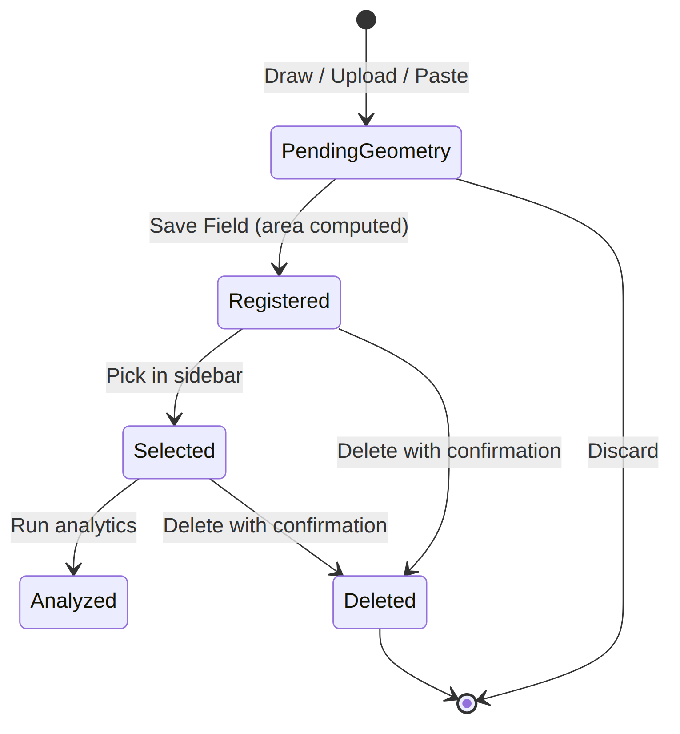
Fig 23: Field State Transition
Diagram ID: 2
Class Name: ProjectStore (Time-series Cache)
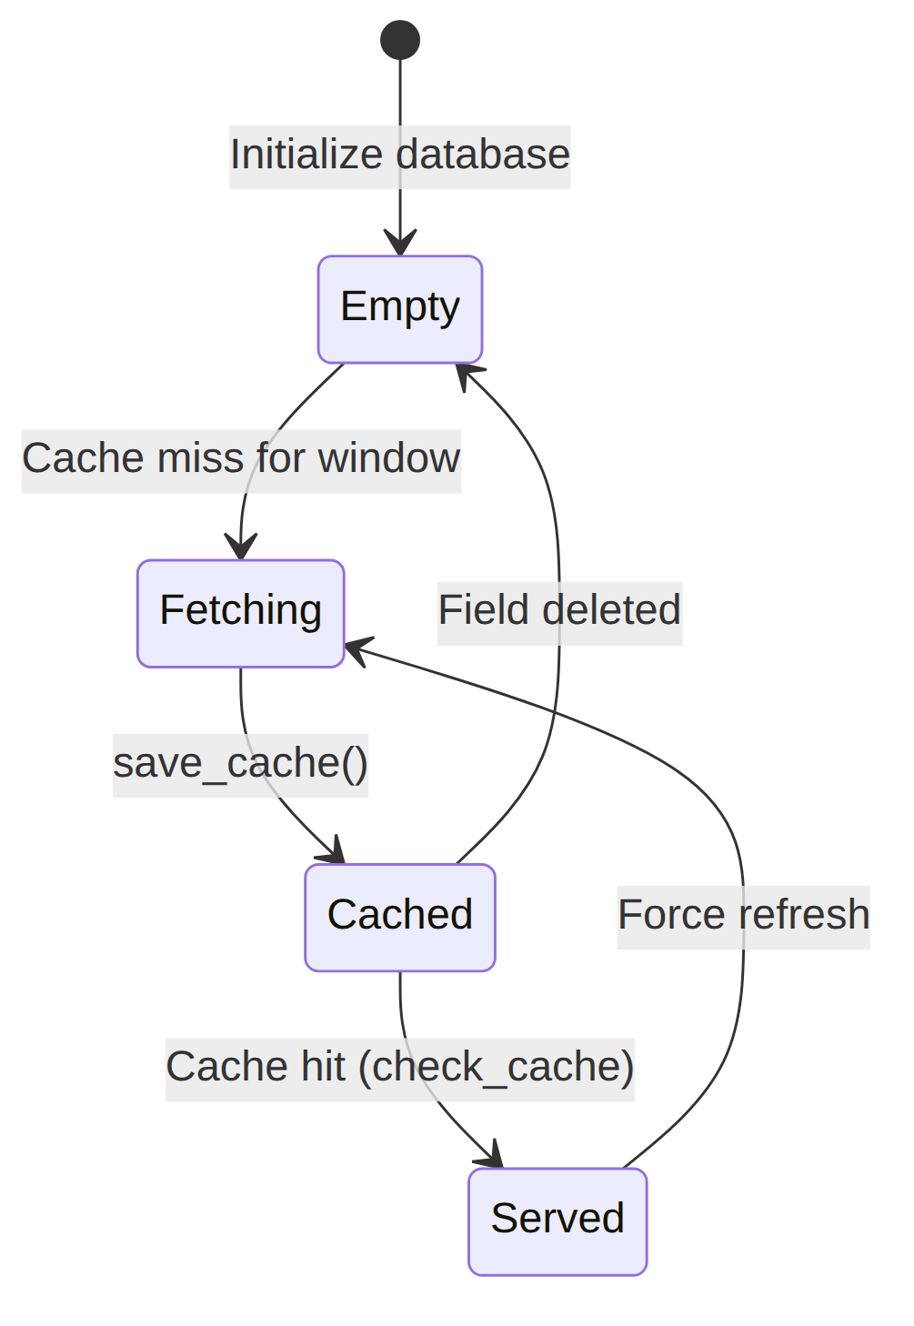
Fig 24: ProjectStore State Transition
Diagram ID: 3
Class Name: AdaptiveAWDGate (per observation)
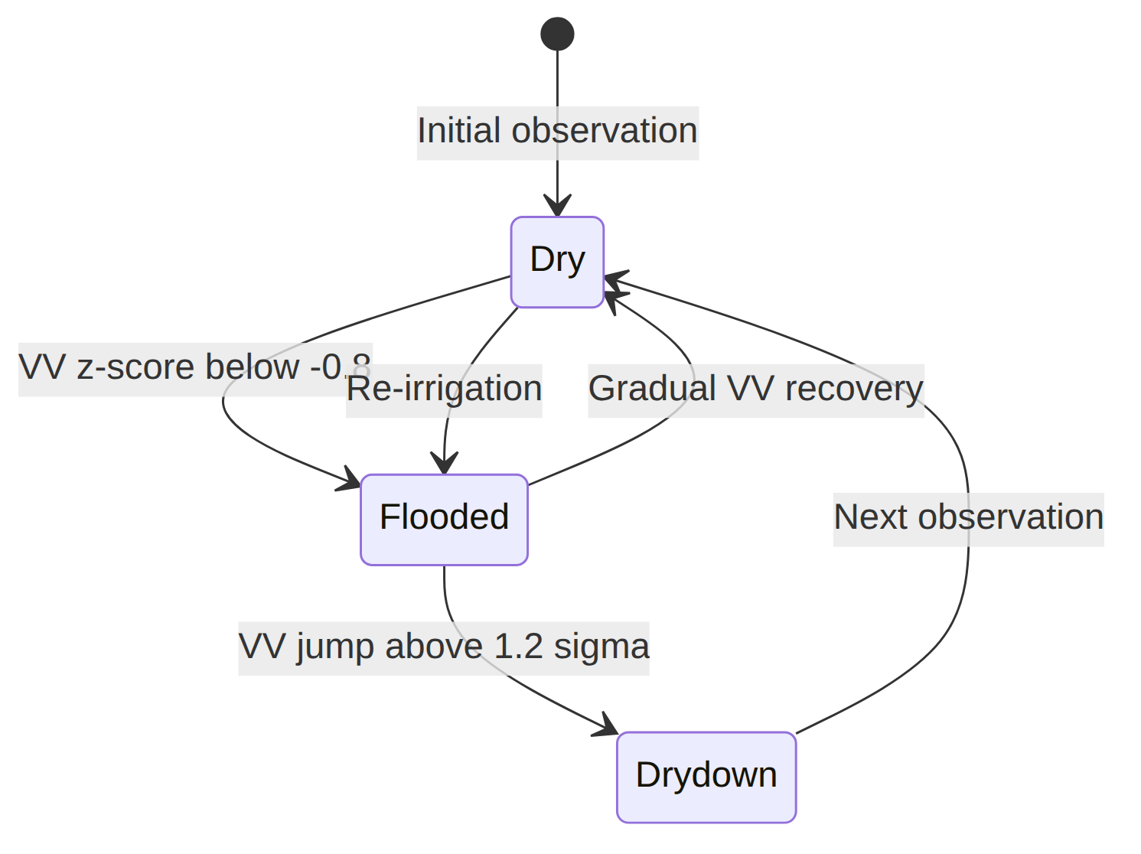
Fig 25: AdaptiveAWDGate State Transition
Diagram ID: 4
Class Name: AIModelArtifact
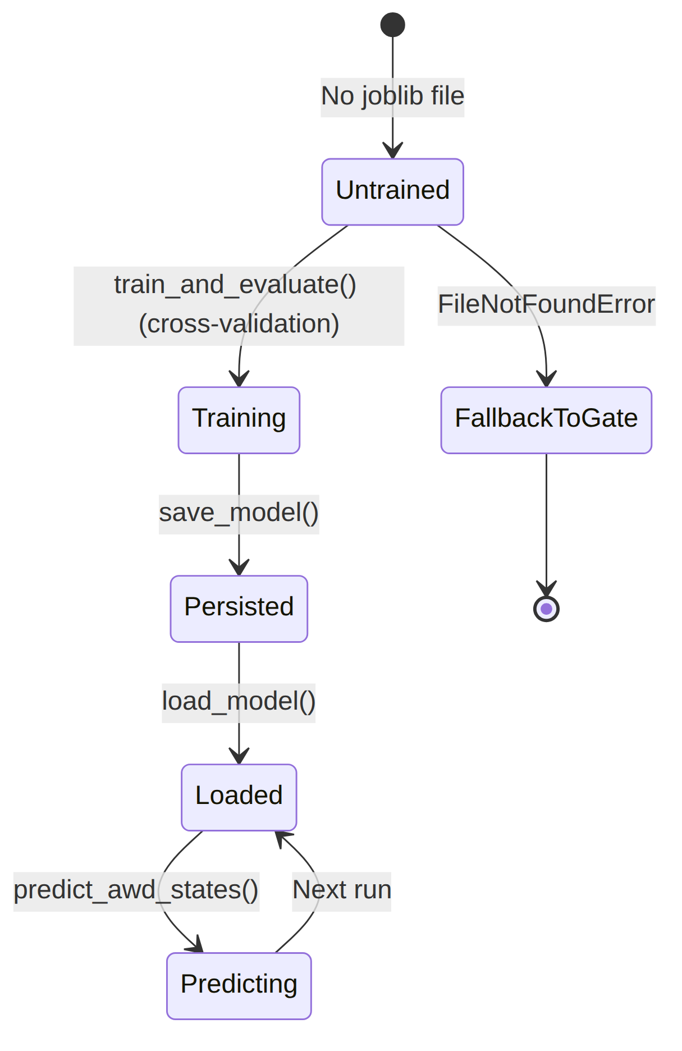
Fig 26: AIModelArtifact State Transition
Diagram ID: 5
Class Name: CarbonEstimate
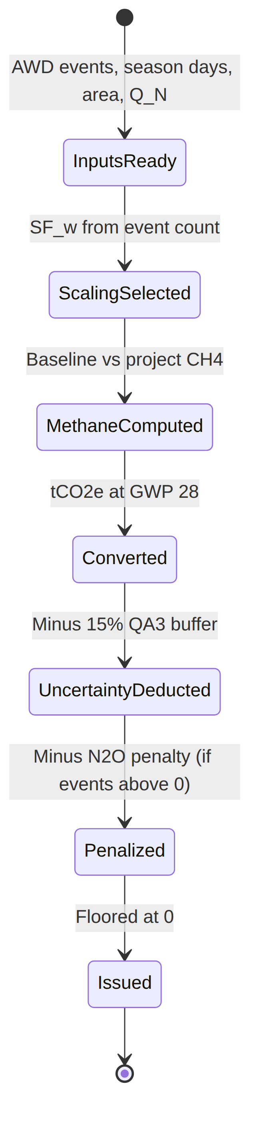
Fig 27: CarbonEstimate State Transition
Diagram ID: 6
Class Name: EvidencePackage
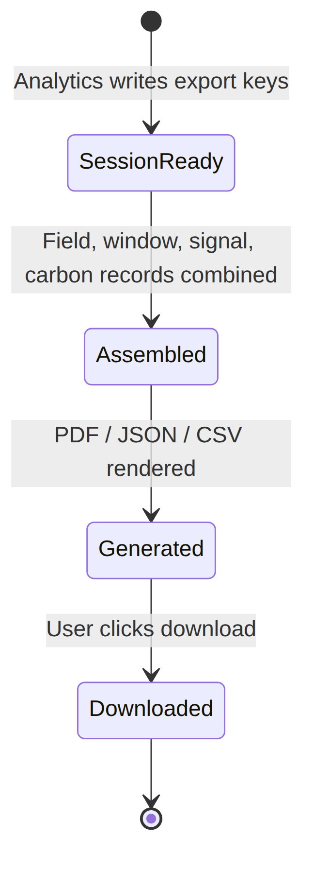
Fig 28: EvidencePackage State Transition

8.3 Sequence Diagram
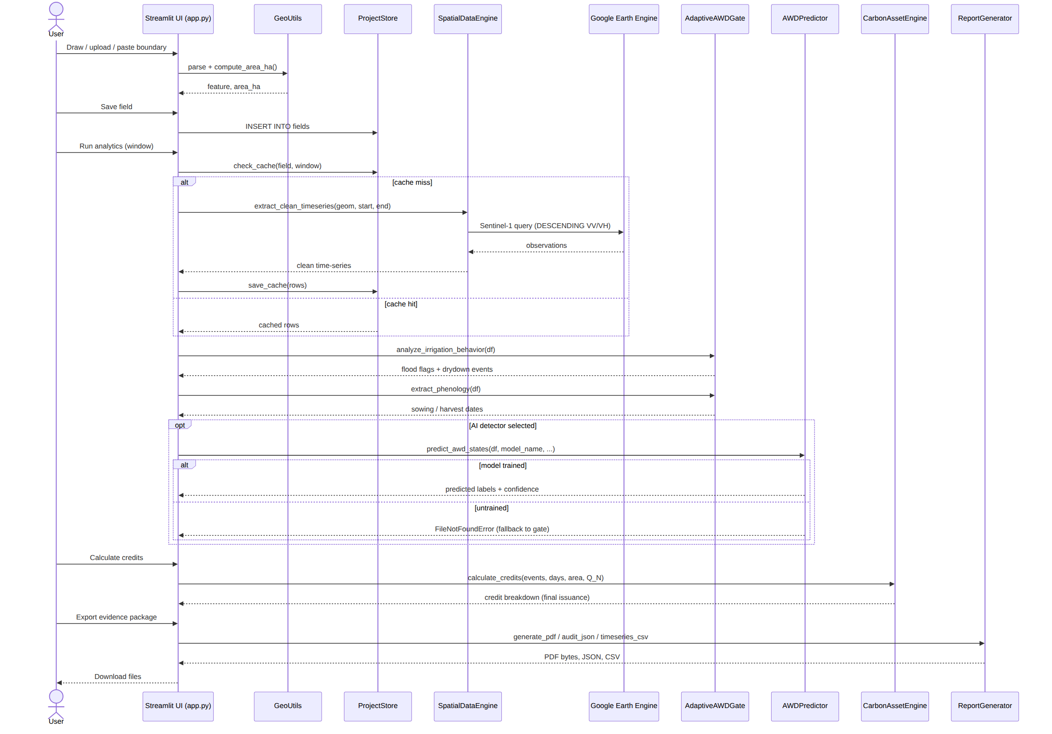
Fig 29: Sequence Diagram

9. Data Flow Diagram
A data-flow diagram is a visual representation of how data moves through a system or a process. A data flow diagram (DFD) shows how information moves through any system or process. It displays data inputs, outputs, storage locations, and routes between each destination using predefined symbols such as rectangles, circles, and arrows as well as brief text labels.

9.1 Level 0: Terra-Audit
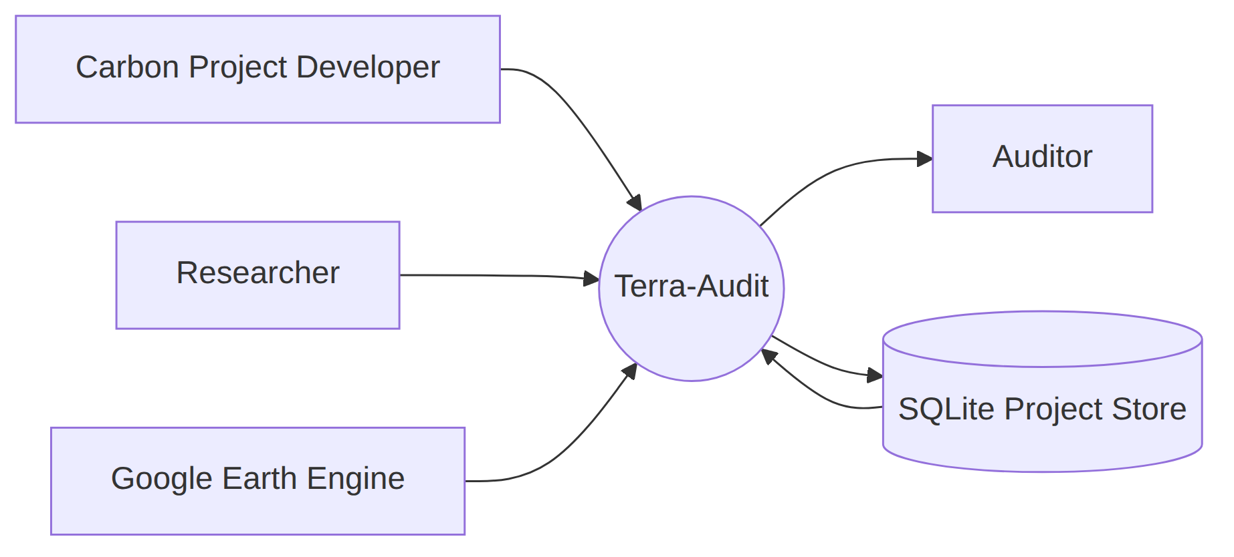
Fig 30: Data Flow Diagram (Level 0)

9.2 Level 1: Terra-Audit
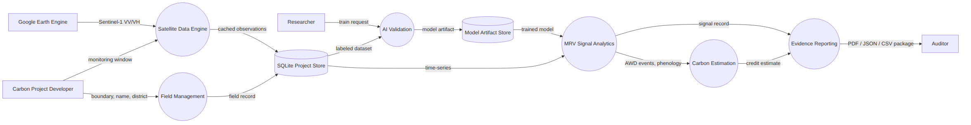
Fig 31: Data Flow Diagram (Level 1)

10. References
- Verra, VM0051 v1.0 — Methodology for Improved Management in Rice Production Systems, 27 February 2025. Available at: https://verra.org/methodologies/ — a copy is included in this repository at docs/VM0051v1_27Feb25.pdf.
- IPCC, 2019 Refinement to the 2006 IPCC Guidelines for National Greenhouse Gas Inventories, Volume 4 (Agriculture, Forestry and Other Land Use), Chapter 5, Table 5.12 (water regime scaling factors) and Chapter 11, Table 11.1 (N₂O emission factors). https://www.ipcc-nggip.iges.or.jp/public/2019rf/
- IPCC, Fifth Assessment Report (AR5), Climate Change 2013: The Physical Science Basis — 100-year Global Warming Potential values (CH₄ = 28, N₂O = 265) used in the carbon estimation engine.
- European Space Agency / Copernicus Programme, Sentinel-1 SAR User Guide. https://sentinels.copernicus.eu/web/sentinel/user-guides/sentinel-1-sar
- Google, Google Earth Engine API Documentation (earthengine-api, dataset COPERNICUS/S1_GRD). https://developers.google.com/earth-engine
- R. Lampayan et al., “Adoption and economics of alternate wetting and drying water management for irrigated lowland rice,” Field Crops Research, vol. 170, pp. 95–108, 2015 (background on AWD practice).
- A. Savitzky and M. J. E. Golay, “Smoothing and Differentiation of Data by Simplified Least Squares Procedures,” Analytical Chemistry, vol. 36, no. 8, pp. 1627–1639, 1964 (signal smoothing filter used in the data engine).
- L. Breiman, “Random Forests,” Machine Learning, vol. 45, no. 1, pp. 5–32, 2001.
- T. Chen and C. Guestrin, “XGBoost: A Scalable Tree Boosting System,” Proceedings of the 22nd ACM SIGKDD, pp. 785–794, 2016.
- F. Pedregosa et al., “Scikit-learn: Machine Learning in Python,” Journal of Machine Learning Research, vol. 12, pp. 2825–2830, 2011.
- Streamlit Inc., Streamlit Documentation. https://docs.streamlit.io
- R. S. Pressman and B. R. Maxim, Software Engineering: A Practitioner’s Approach, 8th ed., McGraw-Hill, 2015 (requirements modeling: scenario-based, data-based, class-based and behavioral modeling used throughout this document).

