 | INSTITUTE OF INFORMATION TECHNOLOGY  UNIVERSITY OF DHAKA | 

TERRA-AUDIT
– AI-Assisted Digital MRV Platform for AWD Rice Irrigation and Agricultural Land Management Carbon Credits
Submitted As
Technical Report
SE801 Project Midterm Report

Submitted By
Kazi Nahid
BSSE Roll: 1437

Supervised By
Dr. Emon Kumar Dey
Professor
Institute of Information Technology
University of Dhaka

Date of Submission
2 August 2026
Table of Contents
1. Project Overview 1
1.1 Project Title 1
1.2 Problem Statement 1
1.3 Objectives 1
1.4 Scope 2
1.5 Deliverables 3
2. Requirements Analysis 3
2.1 Functional Requirements (List) 3
2.2 Non-functional Requirements 4
2.3 Stakeholders 6
3. System Modeling 6
3.1 Use Case Diagram and Descriptions 6
3.1.1 Use Case Descriptions 11
3.2 Activity Diagram 12
3.2.1 Updated Cropland ALM Activity Flow 20
4. Data & Information Modeling 21
4.1 Entity-Relationship Diagram 21
4.2 Database Schema 21
4.3 Dataset Description (AI-Assisted Detection) 22
5. Software Design 23
5.1 Component Diagram 23
6. AI Engineering Design 25
6.1 AI Pipeline 25
6.2 Model Selection 25
6.3 Prompt Design 26
7. Preliminary Test Plan 26
7.1 Testing Objectives 26
7.2 Features to be Tested 26
7.3 Traceability Matrix 29
8. Implementation Progress 30
8.1 Implementation Progress 30
8.2 Challenges and Planned Responses 31
9. Timeline 32
9.1 Gantt Chart 32
References 34

1. Project Overview

1.1 Project Title
Terra-Audit — AI-Assisted Digital MRV Platform for AWD Rice Irrigation and Agricultural Land Management Carbon Credits.
Document identity: the course outline for this deliverable calls it a “Project Midterm Technical Report,” and the cover page title is kept aligned with that outline. Where this document or its predecessor drafts refer to an “SRS,” that label means this report functions as a concise SRS/design/progress extract for the midterm checkpoint — it is not a claim that this is the authoritative, final full SRS for the project. A more complete SRS-style document is expected to accompany final submission.

1.2 Problem Statement
Rice paddies are a major source of anthropogenic methane, and Alternate Wetting and Drying (AWD) irrigation is a proven mitigation practice, but existing carbon-credit workflows fail to verify it credibly. Self-reported irrigation logs are unverifiable, on-the-ground water-level loggers are too expensive to deploy across thousands of smallholder paddies, and carbon calculations are usually opaque spreadsheets that an auditor cannot trace back to raw evidence. A parallel problem exists for non-wetland cropland enrolled under improved agricultural land management: baseline versus project practice changes (fertilizer, tillage, residue, crop planting) and soil organic carbon (SOC) stock change must be quantified from lab measurements and disclosed with full uncertainty accounting, which existing smallholder-scale tooling does not support end to end.
Terra-Audit addresses both gaps with a single low-cost, evidence-first platform: Sentinel-1 SAR observations pulled from Google Earth Engine detect AWD drydown events for rice fields, while manually entered practice schedules and SOC lab samples drive a parallel accounting path for cropland fields, and both paths are converted into auditor-ready evidence packages under Verra methodologies.

1.3 Objectives
- Replace unverifiable farmer self-reporting with satellite-derived AWD event detection for rice paddies, using freely available Sentinel-1 SAR data that works day and night through cloud cover.
- Provide a parallel, methodology-compliant accounting path for cropland fields enrolled under improved agricultural land management, driven by manually entered practice and SOC data rather than satellite signal.
- Implement carbon credit calculation transparently against Verra VM0051 (rice AWD, QA3 default-factor pathway) and Verra VM0042 (cropland ALM) so every intermediate value is inspectable and reproducible by hand.
- Extend the VM0042 path to cover integrated crop-livestock accounting for supported grazing livestock, including enteric-fermentation CH₄ and pasture/range/paddock manure CH₄ and N₂O, for fields that report livestock alongside crop practices.
- Screen for production-decline leakage using baseline and project yields: the screen is left explicitly unresolved when yield data is missing, and issuance is blocked when a real yield decline is detected rather than silently ignored.
- Persist every carbon-calculation run to a credit history and summarize it in a cross-field portfolio view, so a developer can track a field's calculation history and compare fields methodology-by-methodology.
- Offer an optional AI-assisted detector (Random Forest / XGBoost) that can replace the rule-based AWD gate, with automatic fallback when no model has been trained.
- Package every credit calculation into a downloadable evidence bundle — complete PDF and JSON exports, plus a supplementary CSV currently limited to practice/SOC data — that a third-party auditor can verify without access to the running system.

1.4 Scope
In scope:
- Field boundary registration by drawing, file upload (GeoJSON/KML), or pasted GPS coordinates, with automatic area computation.
- A field-type selector that routes each registered field down one of two independent methodology paths — rice_awd (Sentinel-1 driven) or cropland_alm_vm0042 (manual practice/SOC driven).
- Sentinel-1 retrieval, caching, signal smoothing, threshold-gate AWD detection, and phenology extraction for rice fields.
- Manual practice-schedule and SOC-measurement entry, validation, and VM0042 credit calculation for cropland fields (SOC stock change, N₂O, biomass burning, fossil-fuel CO₂, uncertainty and buffer deduction).
- Manual baseline/project livestock schedules for supported integrated crop-livestock systems.
- Enteric-fermentation and pasture-manure emissions for cattle, buffalo, sheep, and goats.
- Yield-based production-decline leakage screening using baseline and project crop yields.
- Persistent calculation history per field and a portfolio-level summary covering both methodology paths.
- Editing a field's name and district after registration, while keeping its geometry and field type immutable.
- VM0051 QA3 credit calculation for rice fields (CH₄ water-scaling accounting, uncertainty deduction, N₂O irrigation penalty).
- AI-assisted AWD detection and a model validation dashboard, scoped to the rice path only.
- Evidence package export (PDF, JSON, CSV) for both methodology paths.
- Primary geographic focus is Bangladesh and South Asia for the rice path; the cropland ALM path is not geography-locked but uses the same IPCC/AR5 default emission factors.
Out of scope (this phase):
- On-the-ground hardware sensors of any kind.
- Verra methodologies other than VM0051 and VM0042.
- Full VM0042/VMD0054 leakage quantification is outside this phase. The current engine implements a conservative production-decline screen using baseline/project yield data, but it does not quantify every displacement, imported-organic-amendment, livestock-displacement, or land-conversion leakage category. Unresolved categories are disclosed explicitly and are never silently treated as zero.
- Multi-node deployment, authentication/authorization, or hosted persistence beyond the local SQLite store.

1.5 Deliverables
- A working Streamlit dashboard (app.py) covering field management, signal analytics, both carbon ledgers, AI validation, and a cross-field portfolio view.
- A local SQLite-backed field registry, time-series cache, ALM practice/SOC data store, livestock schedule table, and credit-history table (src/database.py).
- Two independent, unit-tested carbon accounting engines: CarbonAssetEngine (VM0051 QA3) and AlmCarbonEngine (VM0042), the latter extended with integrated-livestock emission terms and yield-based production-decline leakage screening.
- An AI detection pipeline (dataset builder, feature engineer, model registry, predictor, evaluator) for the rice path.
- Exportable evidence packages: complete PDF/JSON exports for both methodology paths, plus a CSV export currently limited to practice/SOC data (see FR11/FR18).
- A portfolio dashboard and persisted calculation history that let a developer inspect prior runs for a field and compare fields across both methodology paths.
- This technical documentation and an automated pytest regression suite. The automated suite concentrates on the two accounting engines; several UI, database, reporting, geometry, caching, and AI flows remain manual or untested (see Section 7).

2. Requirements Analysis

2.1 Functional Requirements (List)
ID | Requirement | Priority
FR1 | Register a field by drawing a polygon, uploading a GeoJSON/KML file, or pasting lat, lon coordinates; compute area automatically via the Shoelace formula with spherical correction. | Must
FR2 | Select a field type (rice_awd or cropland_alm_vm0042) at registration; the FieldTypeRegistry dispatches the correct detector, methodology engine, and UI tabs for that field thereafter. | Must
FR3 | For rice fields, retrieve Sentinel-1 VV/VH backscatter (DESCENDING pass only) over the field geometry and cache it in SQLite keyed by field and monitoring window. | Must
FR4 | Apply Savitzky-Golay smoothing, z-score flood detection (z < −0.8), and drydown-event detection (>1.2σ jump after a flooded state) to the rice time-series. | Must
FR5 | Derive sowing and harvest dates from the VH phenology signal, falling back to a 120-day season with a visible warning when signal quality is insufficient. | Must
FR6 | For cropland fields, accept manually entered baseline/project practice schedules (crop type, tillage, residue handling, fertilizer rates, fuel use, yield) and lab-measured SOC samples, validating completeness before calculation. | Must
FR7 | Calculate rice carbon credits under VM0051 QA3: baseline vs. project CH₄, IPCC water-scaling factor, 15% uncertainty deduction, N₂O irrigation penalty, final issuance floored at zero. Note: the calculation engine correctly implements QA3 (a Tier 1 regional-default pathway), but the UI and generated evidence reports currently mislabel this as “VM0051 Tier 2” — a known labeling defect tracked in Section 8.2. | Must
FR8 | Calculate cropland carbon credits under VM0042: SOC stock change (Quantification Approach 2), default-factor N₂O (fertilizer + N-fixing residue), biomass burning, fossil-fuel CO₂, probability-of-exceedance uncertainty deduction, cumulative non-permanence buffer, integrated-livestock emission differences (FR13), and production-decline leakage screening (FR14). | Must
FR9 | Offer an AI-assisted AWD detector (Random Forest or XGBoost) as an optional override for the rice path, with automatic fallback to the rule-based gate if the selected model is untrained. | Should
FR10 | Provide an AI validation dashboard comparing detector agreement, precision/recall/F1, confusion matrices, feature importance, and ROC curves. | Should
FR11 | Export an evidence package — PDF report and JSON audit record — for whichever methodology path a field uses, including every input that materially affects the calculation. The CSV export currently covers practice and SOC data only; it is described as a practice-and-SOC export rather than a complete calculation package, since generate_alm_data_csv() does not yet receive the livestock schedule. | Must
FR12 | Allow field selection and deletion from a sidebar registry, cascading deletion to cached time-series and stored practice/SOC data. | Should
FR13 | For a cropland ALM field, accept baseline and project livestock schedules for supported livestock types, population, and productivity system, and calculate enteric-fermentation and pasture-manure emissions. | Must
FR14 | Accept baseline and project crop yields, screen for production decline, disclose missing leakage data, and block issuance when the project causes a material yield decline that has not been fully quantified and mitigated. | Must
FR15 | Persist every carbon-calculation run with its timestamp, inputs, intermediate results, and final issuance, and allow the user to inspect previous calculations for a field. | Should
FR16 | Present a portfolio summary containing every registered field, methodology path, area, latest calculation date, latest issuance, and totals by methodology. | Should
FR17 | Allow the user to edit a registered field's name and district without changing its geometry or methodology type. | Should
FR18 | Include every input that materially affects a calculation in the audit JSON and PDF. If the CSV is advertised as a complete evidence export, it must also include livestock data; otherwise describe the CSV accurately as a practice-and-SOC data export. | Must

2.2 Non-functional Requirements
ID | Category | Requirement | Verification
NFR1 | Reliability | Boundary parsers never raise on malformed input; they return (data, error) so the UI can surface a readable message. | Unit tests feed malformed GeoJSON/KML/coordinate input and assert a readable error, not an exception.
NFR2 | Reliability | Database migrations are designed to be idempotent for duplicate-column additions. Broad exception handling around migration steps is a known hardening gap for a future phase: it should be narrowed so a genuine migration failure is surfaced rather than silently swallowed. | Manual re-run of initialize_database() against an already-migrated database; code review of the exception scope.
NFR3 | Accuracy & Traceability | Every reported carbon figure must be reconstructable by hand from disclosed intermediate values; no hidden constants or silent defaults. Every result exposes its input values, factor values and sources, intermediate results, and deductions. | Golden-value regression tests plus manual recomputation from the exported audit JSON.
NFR4 | Performance | A repeat analytics run for an already-fetched field/window is served from the local SQLite cache without a live Earth Engine call. No response-time target has been benchmarked yet; this is a preliminary, cache-hit-vs-cache-miss qualitative target pending measurement. | Manual UI walkthrough comparing a cache-hit run against a cache-miss run; a quantitative benchmark is planned but not yet recorded.
NFR5 | Usability | Single-page tabbed dashboard; values computed in one tab (AWD events, season length, area) auto-populate the corresponding carbon ledger tab. A “readable” validation error names the offending field and the expected format. | Manual UI walkthrough.
NFR6 | Portability | Runs on a single machine via streamlit run app.py; requires one-time Earth Engine authentication per machine, no other external services. | Manual setup on a clean machine.
NFR7 | Maintainability | Each field type’s detector and methodology engine are isolated behind a register_field_type() plugin registry. Adding a third field type still requires corresponding UI rendering and reporting integration in app.py; the registry does not eliminate that work. | Code review of registry usage versus app.py methodology-specific renderers.
NFR8 | Data Integrity | SAR retrieval restricted to DESCENDING passes only to avoid orbit-mixing artifacts; known methodology gaps (e.g., ALM leakage categories beyond the production-decline screen) are surfaced as explicit flags rather than defaulted to zero. | Code review; leakage-disclosure regression tests.
NFR9 | Security & Privacy | This is a local, single-user prototype: no authentication is provided, local database access control depends entirely on host-machine permissions, and exported evidence packages can contain sensitive field-location and ownership data. | Code review; documented as a deployment caveat in Section 6.4 style hardening notes.
NFR10 | Backup & Recovery | The SQLite database and joblib model artifacts are local files with no automated backup. Loss of the host machine's disk loses all registered fields, cached signal, practice/livestock/SOC data, and credit history unless the user manually copies the files. | Manual file-copy verification; no automated backup job exists yet.
NFR11 | Accessibility | Form labels, color contrast, and keyboard interaction should meet a basic accessibility bar, and status indicators (e.g., AWD flood/dry state) should not rely on color alone. | Manual review; no automated accessibility audit has been run yet.
NFR12 | External-Service Resilience | Earth Engine authentication failure, network failure, an empty image collection, or an API error must degrade gracefully (readable message, no crash) rather than surface a raw stack trace. | Manual fault-injection walkthrough (revoke credentials, disconnect network) is planned but not yet recorded as a passed test.
NFR13 | Reproducibility | Currently, each saved joblib artifact records only the trained model, class labels, and feature names — not training timestamp, label provenance, or evaluation method. Recording that fuller metadata alongside the artifact is a target for a future phase and is not implemented now. | Code review of the current ModelRegistry save function confirms only model/classes/features are persisted; the fuller-metadata target is not yet implemented or audited.
NFR14 | Testability | The two accounting engines are covered by an automated pytest regression suite, including golden-value and fallback-path scenarios. Coverage for UI, database, reporting, geometry, caching, and AI flows is currently manual (see Section 7). | python3 -m pytest -q against the accounting-engine test modules; see Section 7 for the recorded run status.

2.3 Stakeholders
Stakeholder | Interest
Carbon Project Developer | Registers fields, runs analytics or enters practice/livestock/SOC data, and generates credit estimates and evidence packages.
Researcher / Data Scientist | Builds AI training datasets, trains and validates AWD detection models, studies detector agreement with the rule-based gate.
Auditor | Receives the exported evidence package and independently reconstructs every reported number from its disclosed inputs.
Program Operator (farmer cooperative / NGO) | Enrolls farmers’ fields into the program and relies on the platform’s outputs to claim credits on the farmers’ behalf.
Farmer / Landholder | Owns or manages the enrolled field and provides the practice, livestock, yield, and SOC evidence the calculations depend on.
System Operator / Administrator | Maintains Earth Engine credentials, Python dependencies, the SQLite store, model artifacts, and backups on the host machine.
Validation & Verification Body / Verra Auditor | Independently checks methodology applicability, evidence completeness, equations, uncertainty treatment, leakage disclosure, and issuance eligibility. A carbon-credit estimate produced by this prototype is not itself a Verra registration or issuance decision — it is evidence submitted for that external process.
Google Earth Engine / Copernicus | External data-service stakeholders whose availability, authentication requirements, and data characteristics constrain the rice workflow.

3. System Modeling

3.1 Use Case Diagram and Descriptions
A use case describes the system’s behavior under a given condition as it responds to a request from one of its actors. Primary actors interact directly with Terra-Audit to achieve a goal: the Carbon Project Developer, the Researcher, and the Auditor. Secondary actors support the system so primary actors can do their work: Google Earth Engine (satellite data source), the SQLite Project Store (field registry, time-series cache, and ALM practice/SOC data), and the Model Artifact Store (persisted AI models).
Level | Use Case | Primary Actor | Secondary Actor | Figure
0 | Terra-Audit | Developer, Researcher, Auditor | GEE, SQLite, Model Store | Fig 1
1 | Terra-Audit | Developer, Researcher, Auditor | GEE, SQLite, Model Store | Fig 2
1.1 | Field Management | Developer | SQLite Project Store | Fig 3
1.1.1 | Geometry Input | Developer | None | Fig 4
1.1.2 | Field Registration | Developer | SQLite Project Store | Fig 5
1.2 | Satellite Data Engine | Developer | GEE, SQLite Project Store | Fig 6
1.3 | MRV Signal Analytics | Developer, Researcher | Model Artifact Store | Fig 7
1.4 | Carbon Estimation | Developer | None | Fig 8
1.5 | Evidence Reporting | Developer, Auditor | None | Fig 9
1.6 | AI Validation | Researcher | SQLite, Model Artifact Store | Fig 10
1.7 | Cropland ALM Practice & Credit Entry | Developer | SQLite Project Store | Fig 11
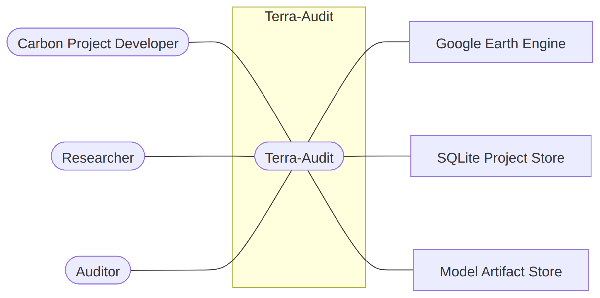
Fig 1: Terra-Audit — AI-Assisted Digital MRV Platform (Level 0). The root use case: all three primary actors interact with Terra-Audit, which depends on the three secondary actors to do its work.
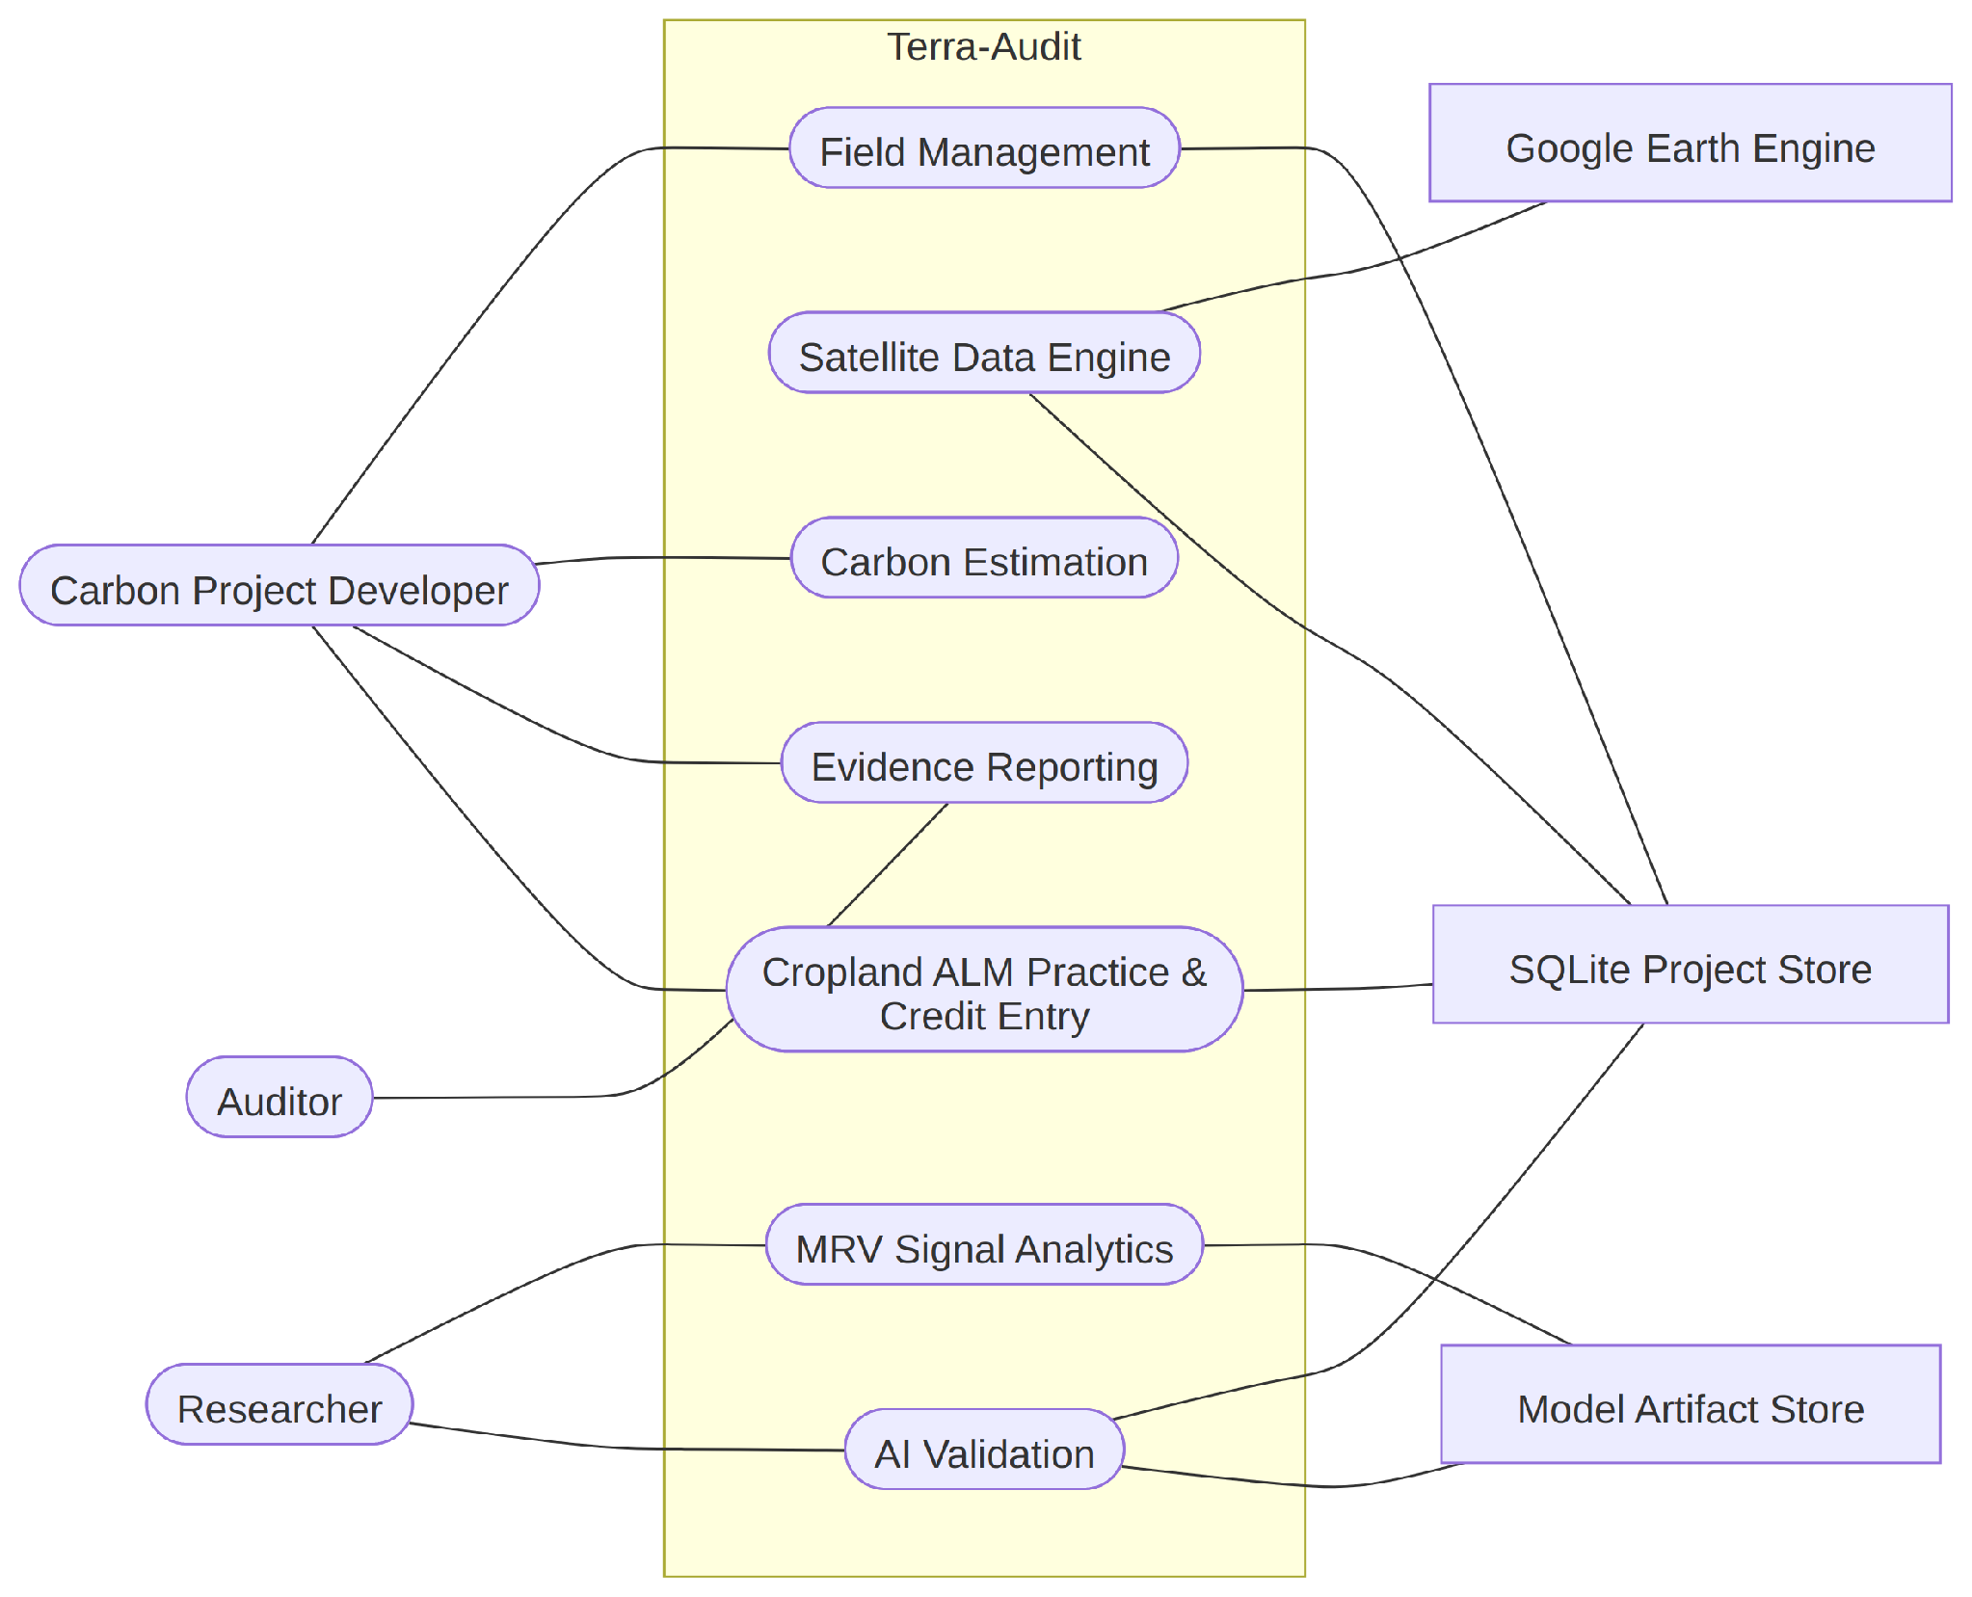
Fig 2: Level 1 of Terra-Audit. The root use case decomposes into seven first-level capability areas — Field Management, Satellite Data Engine, MRV Signal Analytics, Carbon Estimation, Evidence Reporting, AI Validation, and Cropland ALM Practice & Credit Entry — each expanded further below.
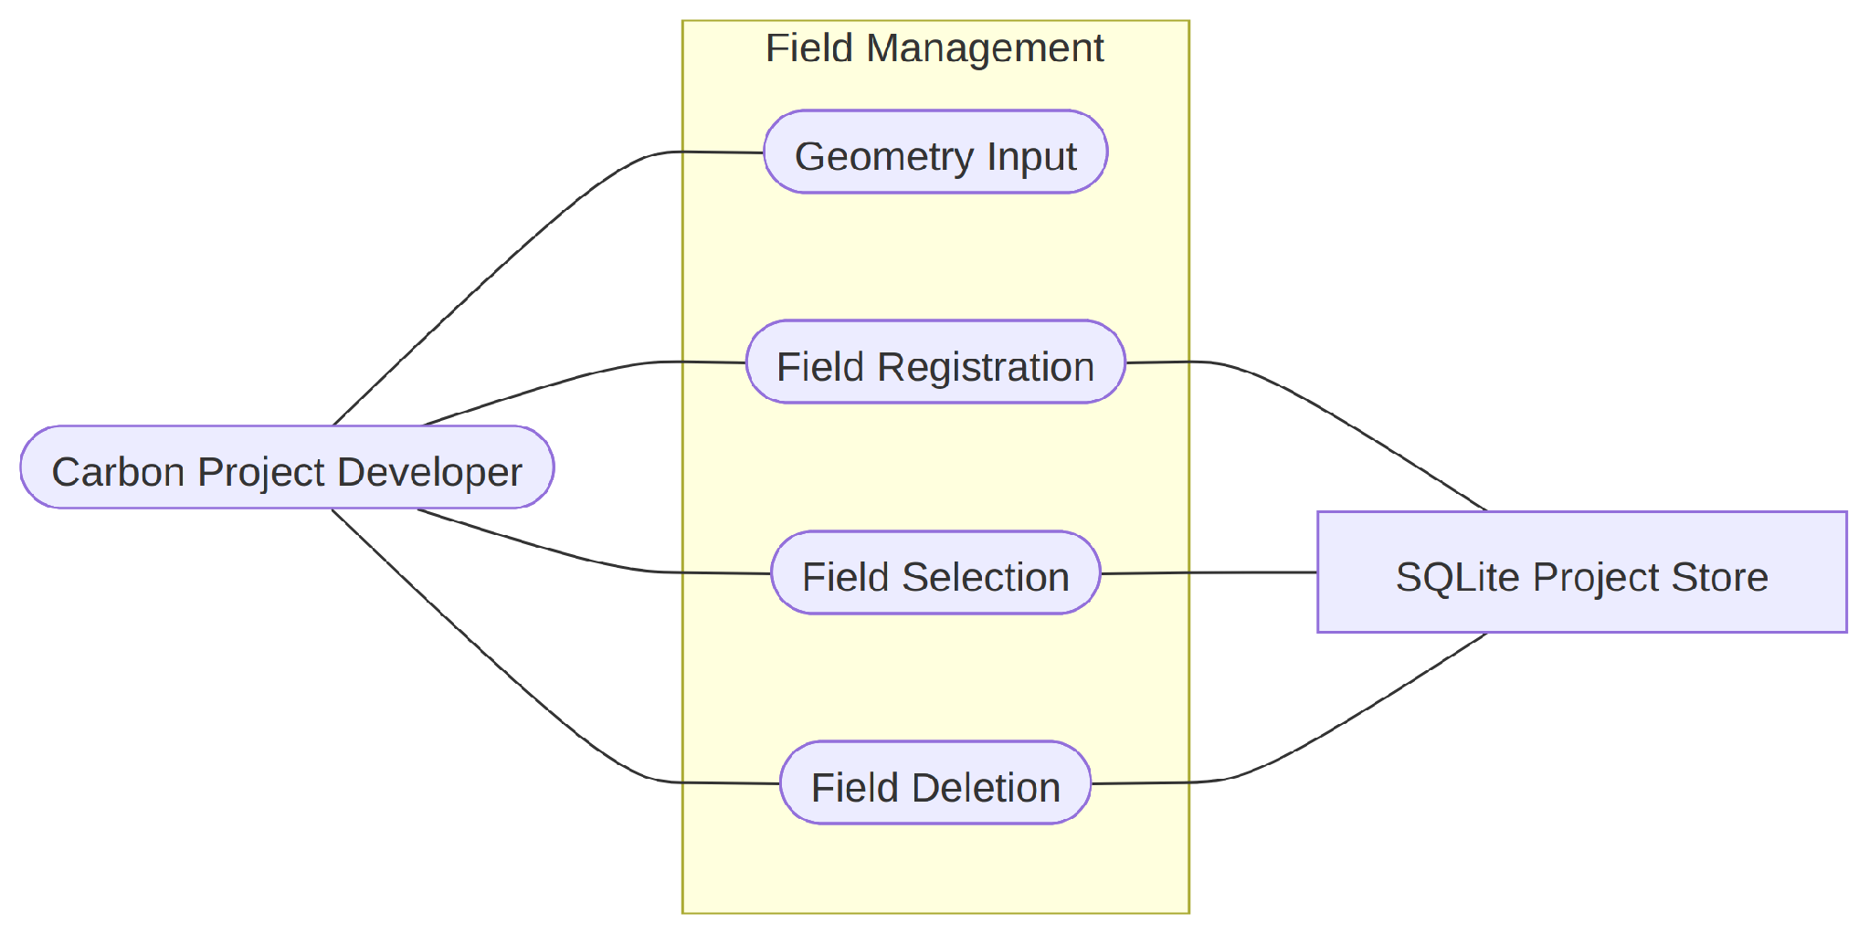
Fig 3: Field Management (Use Case 1.1). The developer registers, selects, and deletes fields; this level decomposes into Geometry Input (1.1.1) and Field Registration (1.1.2).
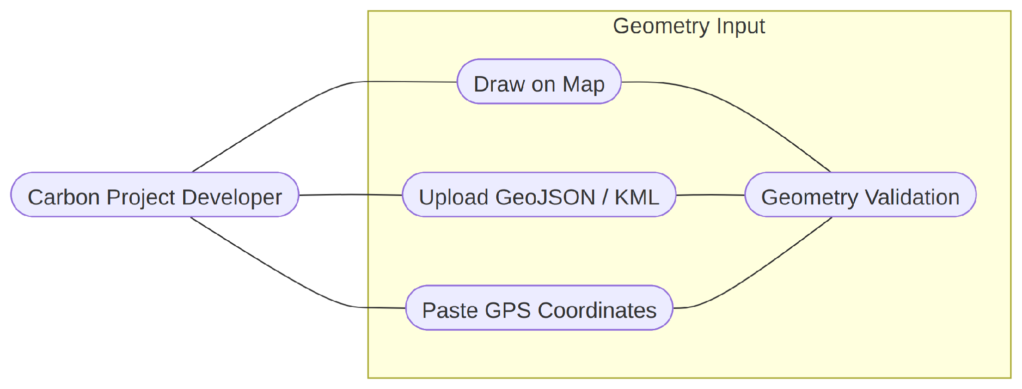
Fig 4: Geometry Input (Use Case 1.1.1). The developer supplies a field boundary by drawing on the map, uploading a GeoJSON/KML file, or pasting GPS coordinates; malformed input returns a readable error instead of crashing the app.
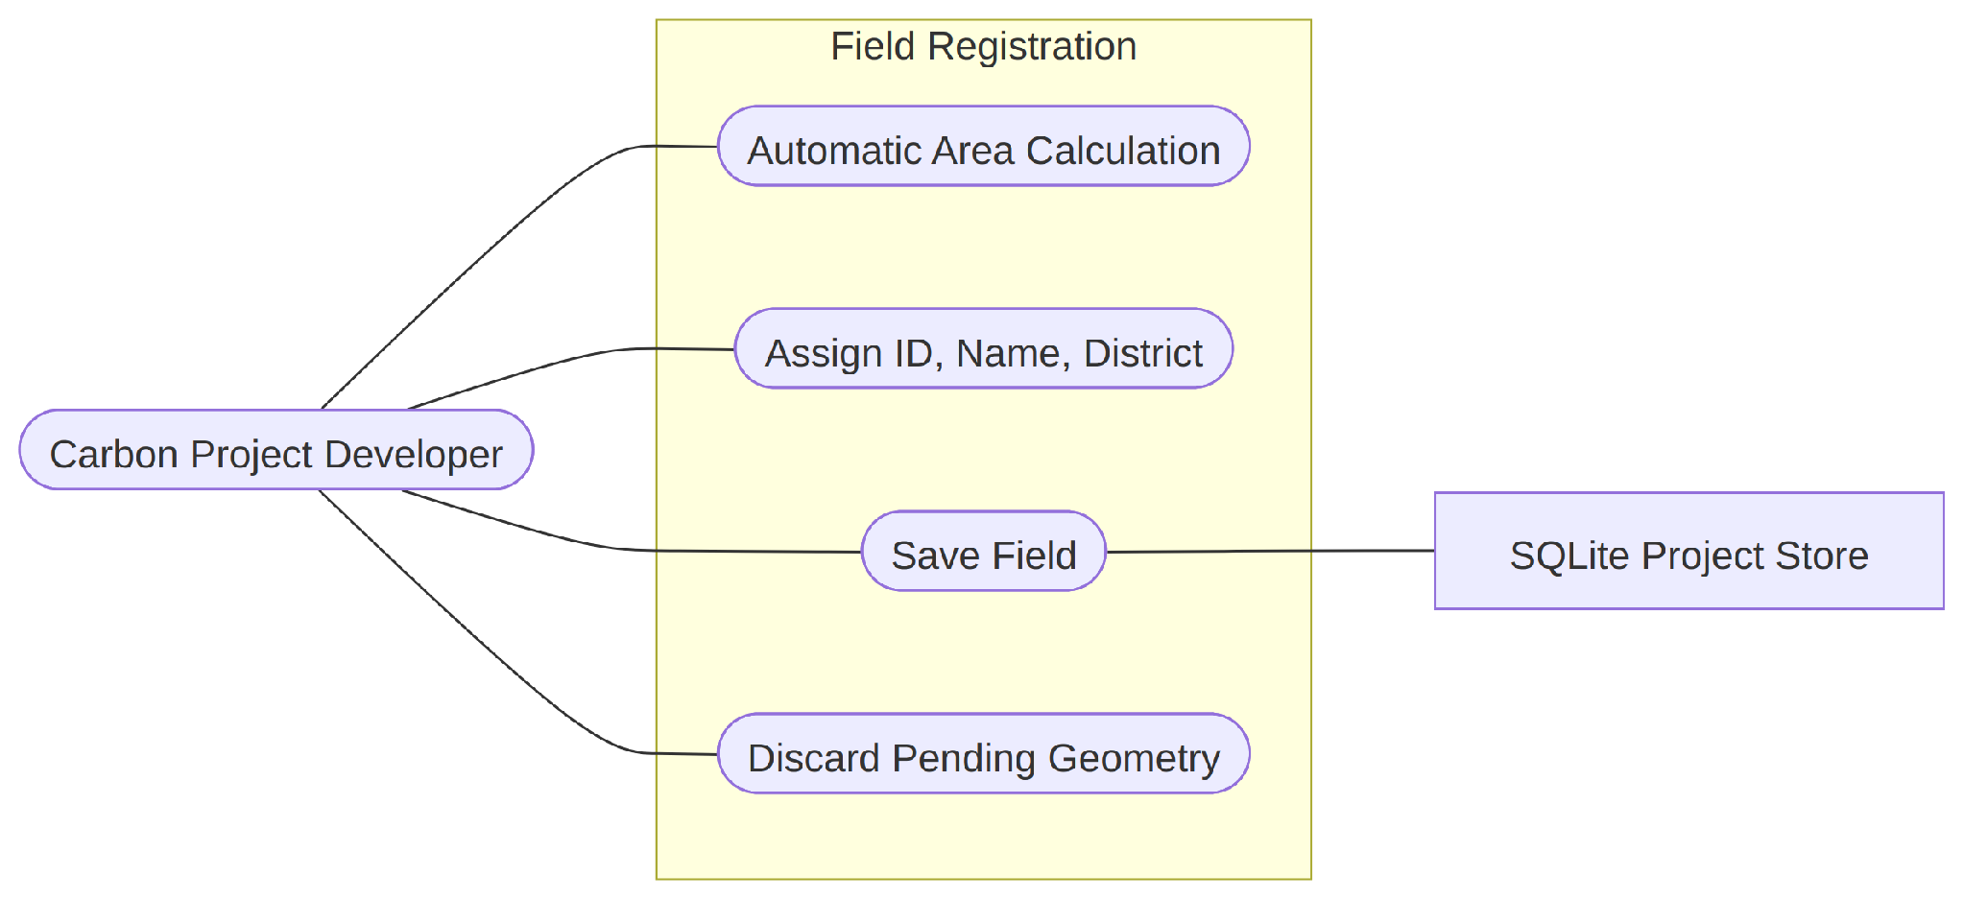
Fig 5: Field Registration (Use Case 1.1.2). Once a geometry is validated, the system computes area via the Shoelace formula with spherical correction and persists the field — ID, name, district, geometry, area, and field type — to the SQLite registry.
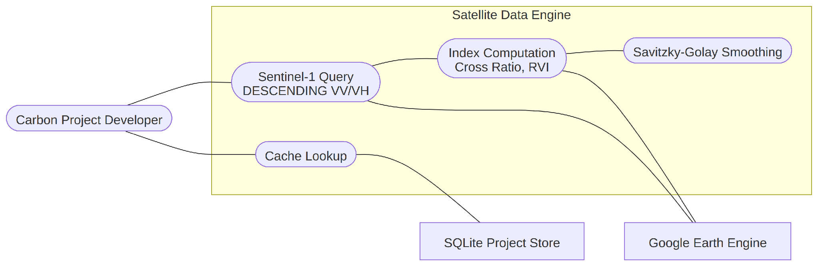
Fig 6: Satellite Data Engine (Use Case 1.2). For rice_awd fields, retrieves Sentinel-1 VV/VH backscatter over the field geometry (DESCENDING pass only) from Google Earth Engine, checking the local cache first and persisting any newly fetched observations for instant reuse.
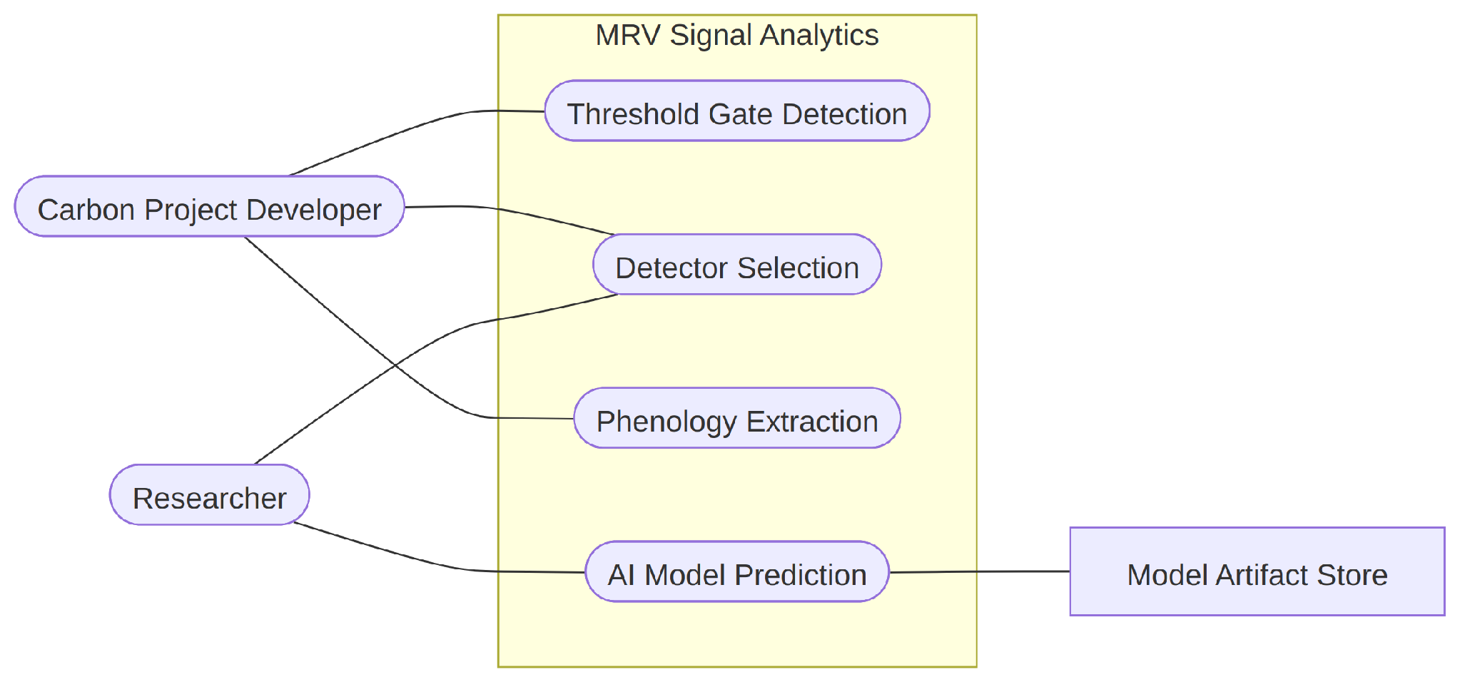
Fig 7: MRV Signal Analytics (Use Case 1.3). Applies Savitzky-Golay smoothing, z-score flood detection, drydown-event detection, and VH-based phenology extraction to the cached time-series; the researcher may substitute an AI-assisted detector for the rule-based gate.
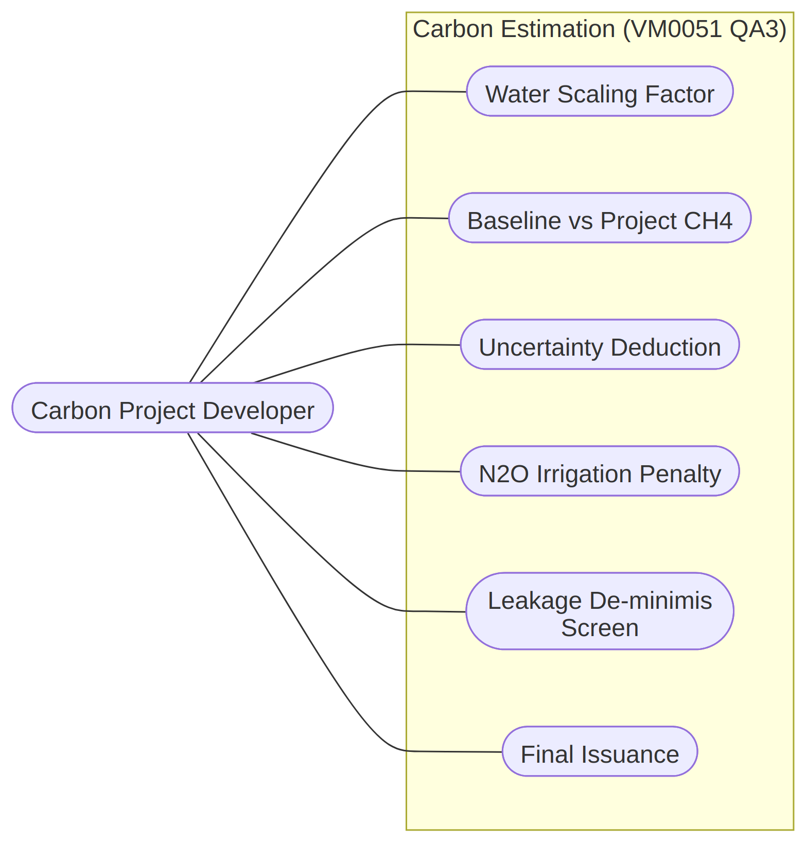
Fig 8: Carbon Estimation (Use Case 1.4). Computes VM0051 QA3 rice credits or VM0042 cropland ALM credits depending on the field’s type, exposing every intermediate value in the ledger for hand verification.
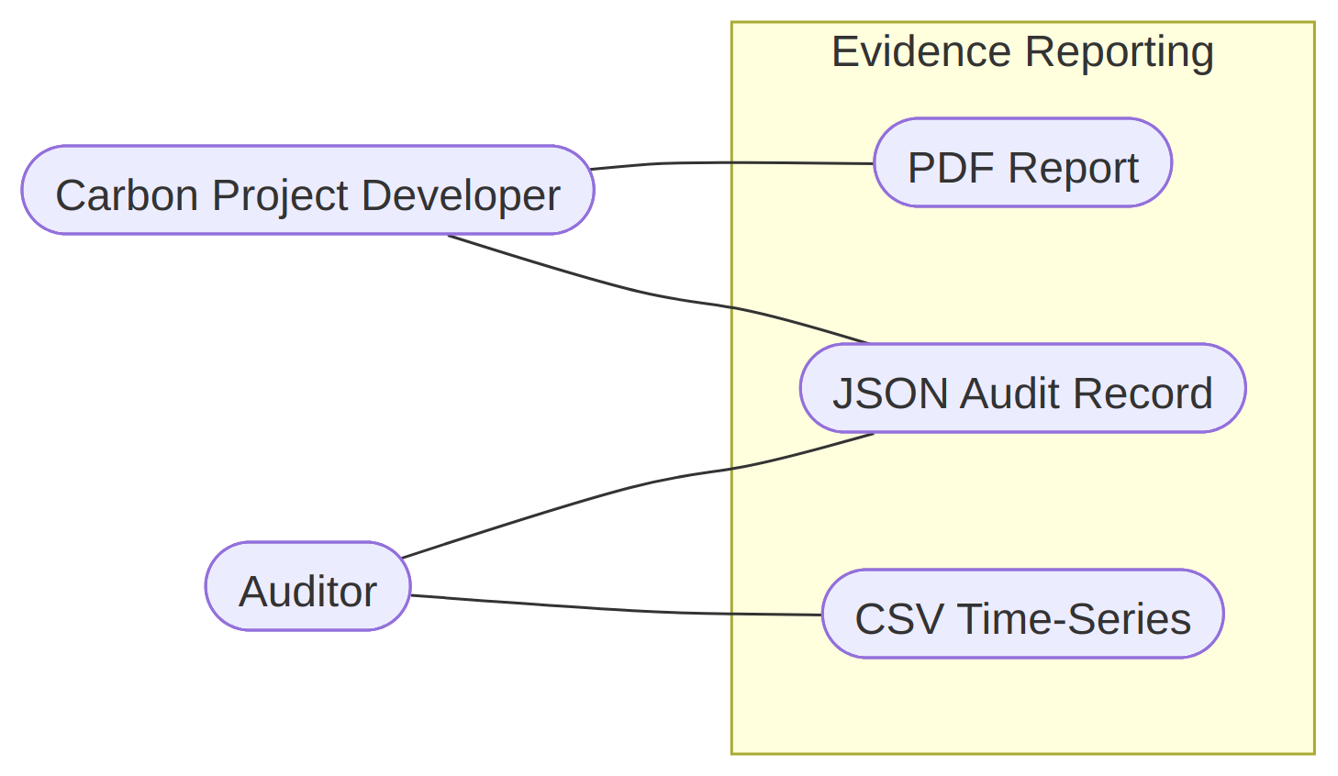
Fig 9: Evidence Reporting (Use Case 1.5). Packages the field record, monitoring window, satellite or practice data, and carbon calculation into a downloadable PDF report, JSON audit record, and CSV.
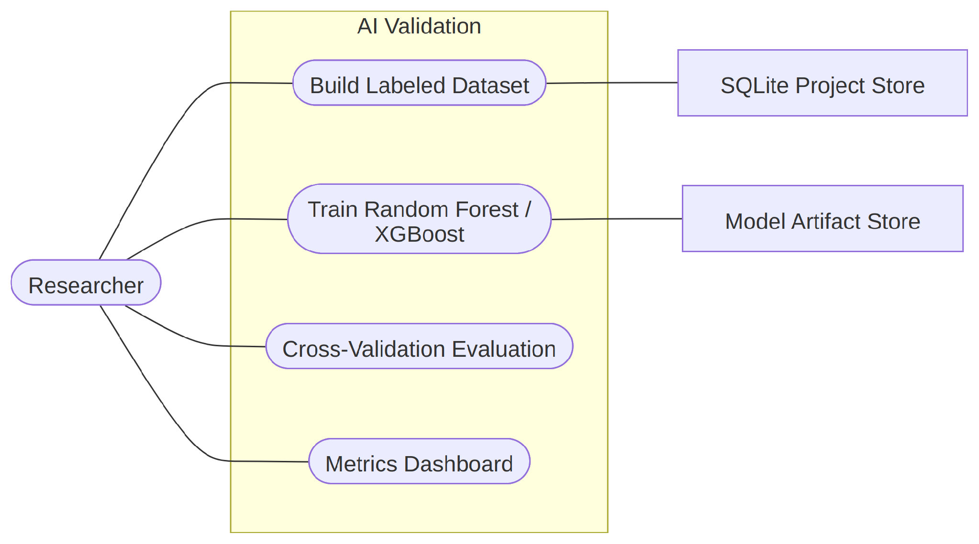
Fig 10: AI Validation (Use Case 1.6). The researcher builds a labeled dataset, trains Random Forest and XGBoost classifiers, and compares their agreement with the rule-based gate via precision/recall/F1, confusion matrices, feature importance, and ROC curves.
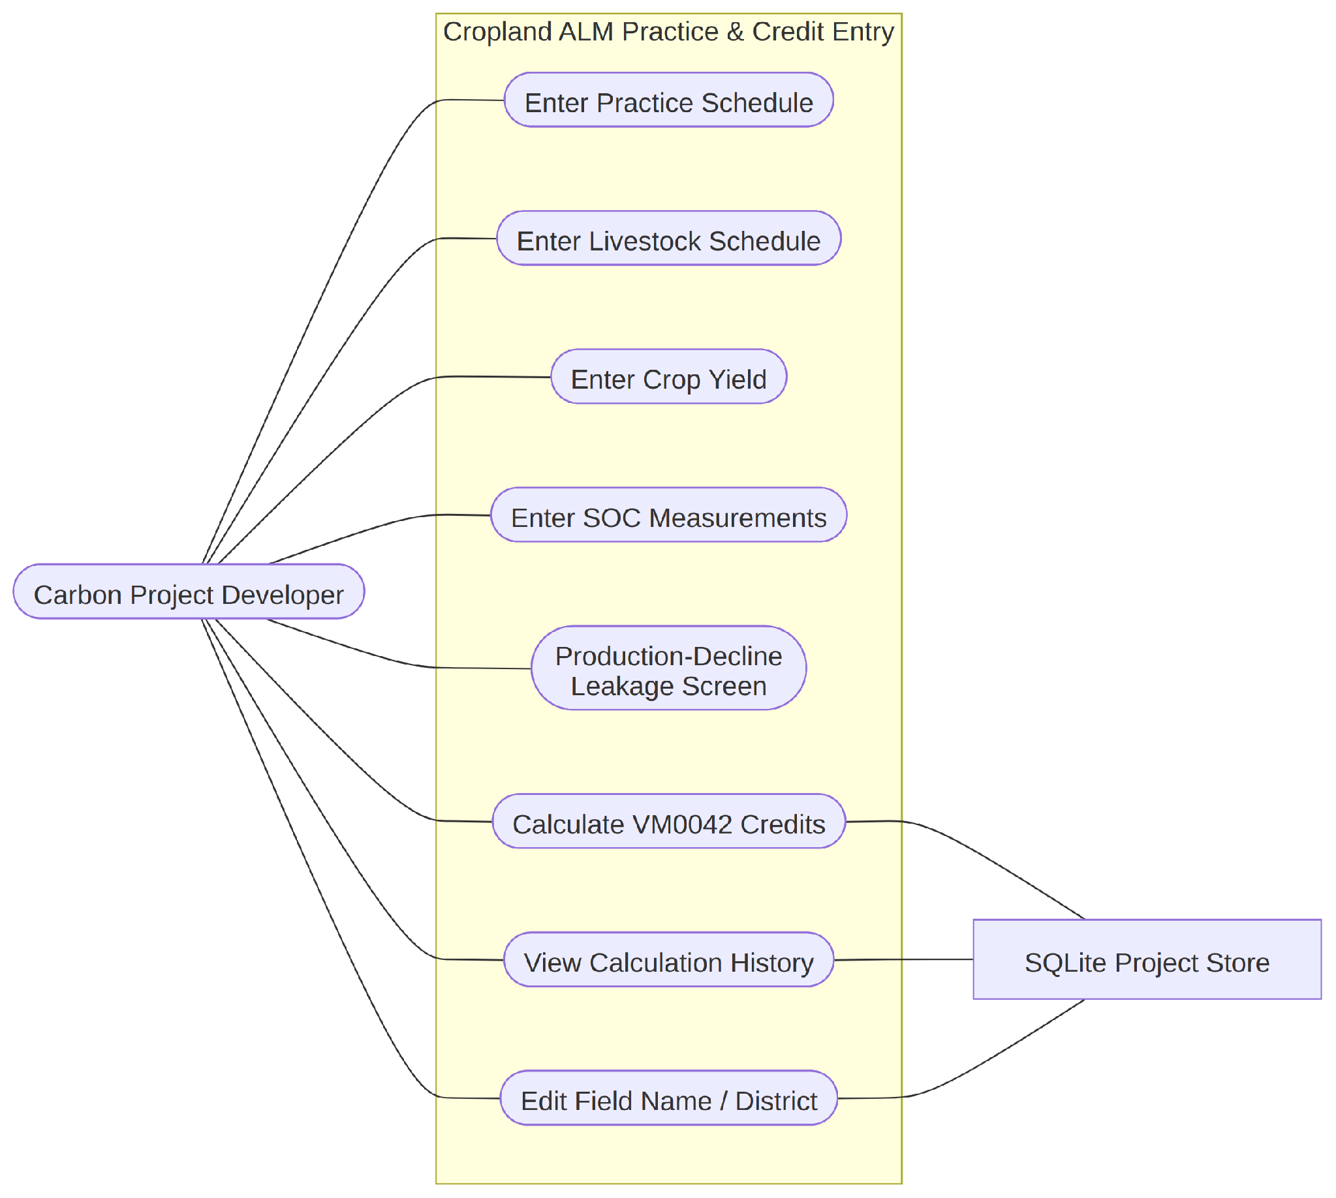
Fig 11: Cropland ALM Practice & Credit Entry (Use Case 1.7). The developer enters the practice schedule, livestock schedule, and crop yield; runs the production-decline leakage screen; calculates VM0042 credits; and can separately view calculation history or edit the field's name/district.
Use Case 1.7 — Cropland ALM Practice & Credit Entry: Primary Actor: Carbon Project Developer. Secondary Actor: SQLite Project Store. The developer enters baseline and project practice schedules, an optional baseline/project livestock schedule, crop yields, and lab-measured SOC samples for a cropland_alm_vm0042 field; the system validates completeness (falling back to zero credits with full uncertainty if SOC data is incomplete rather than over-crediting), runs the production-decline leakage screen, then calculates and exports VM0042 credits. The developer can also inspect the field's calculation history and edit its name/district from this use case area.

3.1.1 Use Case Descriptions
The captions above summarize each diagram; this table gives the minimum specification — actor, precondition, trigger, normal flow, alternative/error flow, and postcondition — for each of the seven first-level capability areas.
Use Case | Actor(s) | Precondition / Trigger | Normal Flow | Alt. / Error Flow | Postcondition
Field Management | Developer | None; triggered from sidebar. | Input geometry → validate → compute area → assign ID/name/district/type → save. | Invalid geometry → readable error, no field created. | Field persisted; appears in selector.
Satellite Data Engine | Developer | Rice field registered; open Signal Analytics tab. | Check cache → miss: query Sentinel-1 → compute indices → smooth → cache. | Earth Engine/network error → readable message, no crash. | Time-series available for analytics.
MRV Signal Analytics | Developer, Researcher | Time-series cached; run gate or AI model. | Standardize → flag flood/drydown → phenology → optional AI override. | AI model untrained → fallback to rule-based gate. | AWD count & season length available.
Carbon Estimation | Developer | Rice: analytics done. Cropland: practice/livestock/yield/SOC saved. | Rice: VM0051 steps. Cropland: SOC + livestock + leakage steps. Floor at zero. | Missing SOC → zero credits, full uncertainty. Missing yield → leakage unresolved. | Ledger computed; saved to credit history.
Evidence Reporting | Developer, Auditor | Calculation run exists; export triggered. | Assemble data → generate PDF/JSON (CSV for practice/SOC) → download. | No calculation yet → export disabled. | Evidence downloaded, matching credit history.
AI Validation | Researcher | Cached rice time-series exists. | Build dataset → features → cross-validate RF/XGBoost → dashboard. | Empty dataset → warning, no training. | Metrics rendered; models optionally saved.
Cropland ALM Practice & Credit Entry | Developer | Cropland field registered; open Practice tab. | Practice → livestock (optional) → yields → SOC → save → leakage screen → calculate. | Incomplete SOC/cadence → validation error. Missing yield → disclosed, not zeroed. | Data saved; credits calculated & persisted.

3.2 Activity Diagram
The activity diagrams below trace the control flow behind each use case level. The rice AWD workflow (Figs 12–14, 16, 18–19) is carried forward from the full SRS since it has not materially changed this phase; the cropland ALM flow (Fig 20 caption text below, superseding the earlier version) has changed materially with the addition of livestock accounting and leakage screening and is described in full below rather than diagrammed as unchanged.
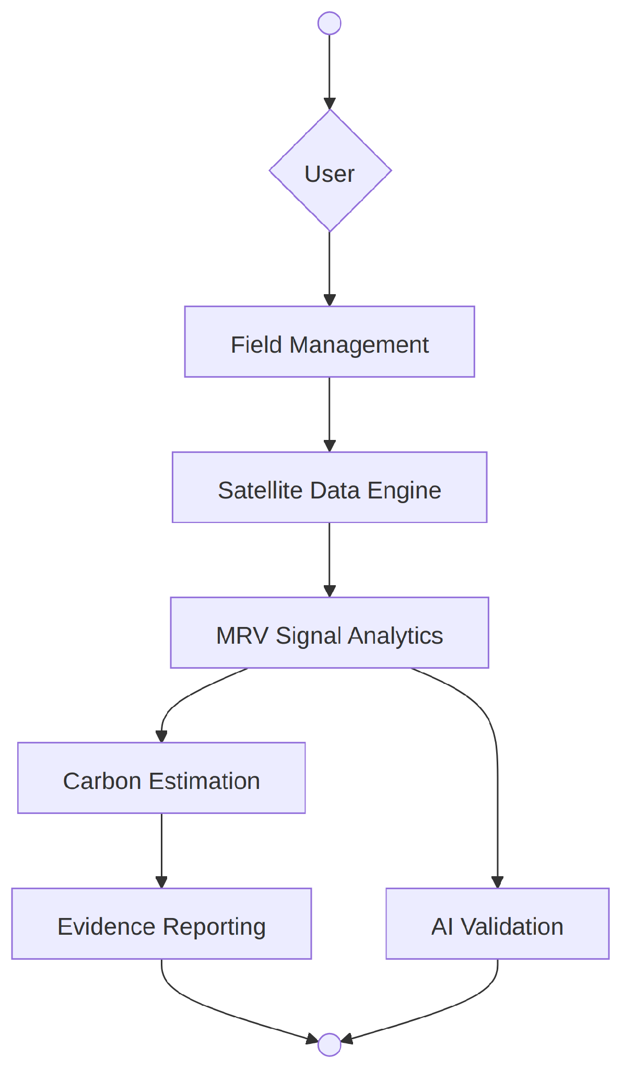
Fig 12: Terra-Audit (Activity — Use Case 1). The top-level flow: a field is registered, analytics are run, credits are calculated according to the field’s methodology path, and evidence is exported.
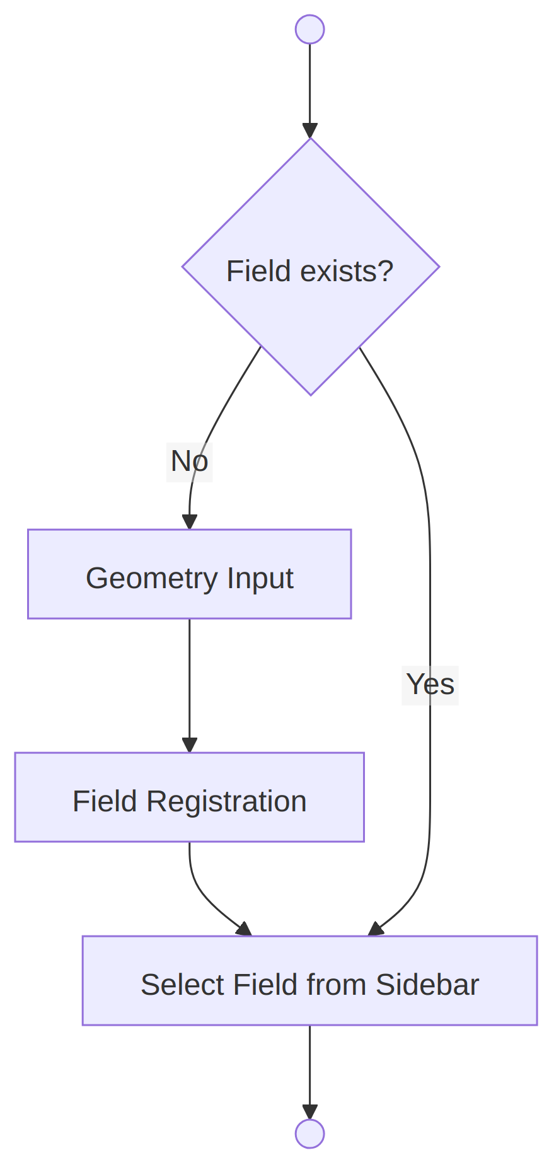
Fig 13: Field Management (Activity — Use Case 1.1). Draw, upload, or paste a boundary; validate; compute area; persist the field record.
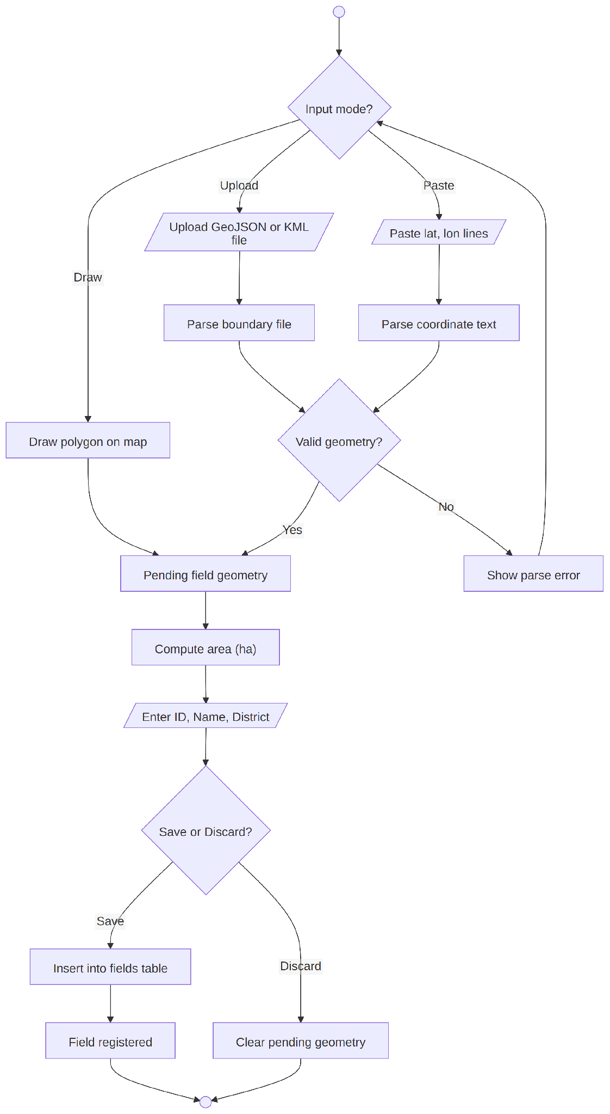
Fig 14: Geometry Input & Registration (Activity — Use Case 1.1.1). The three input methods converge on a single validation and registration path, so any input source produces an identical stored field record.
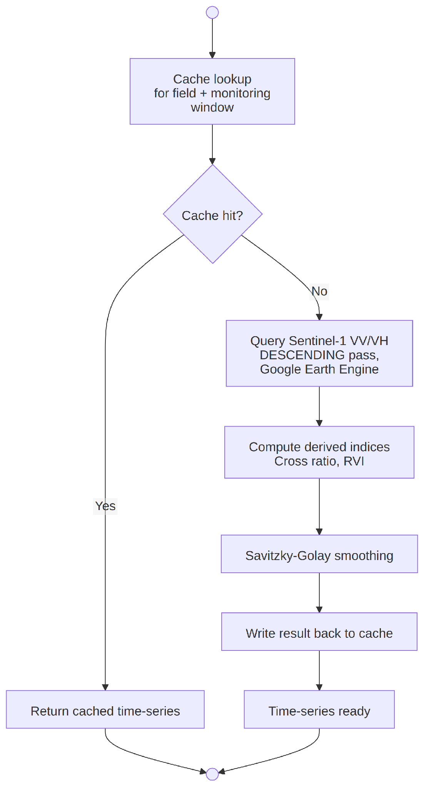
Fig 15: Satellite Data Engine (Activity — Use Case 1.2). Check the cache; on a miss, query Earth Engine, compute derived indices, smooth the signal, and write the result back to the cache.
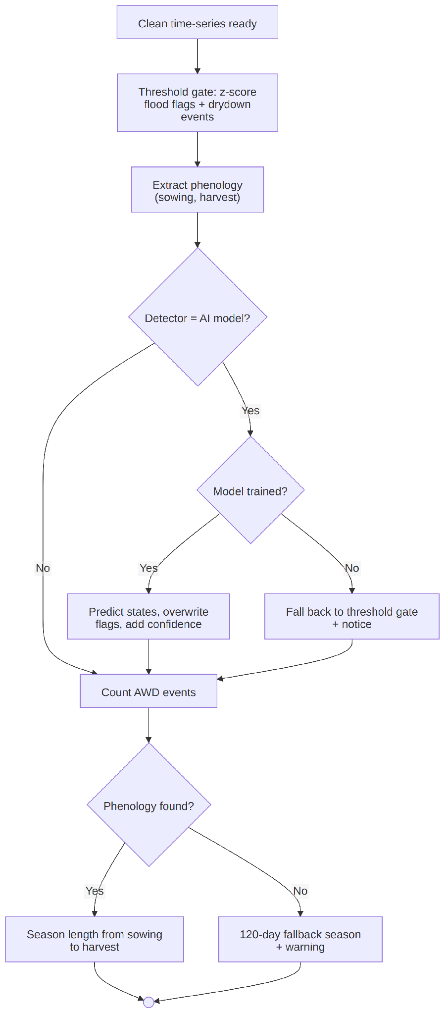
Fig 16: MRV Signal Analytics (Activity — Use Case 1.3). Standardize VV into z-scores, flag flooded states, detect drydown events, extract phenology, and — if an AI model is selected and trained — overwrite the rule-based flags with model predictions plus a confidence score.
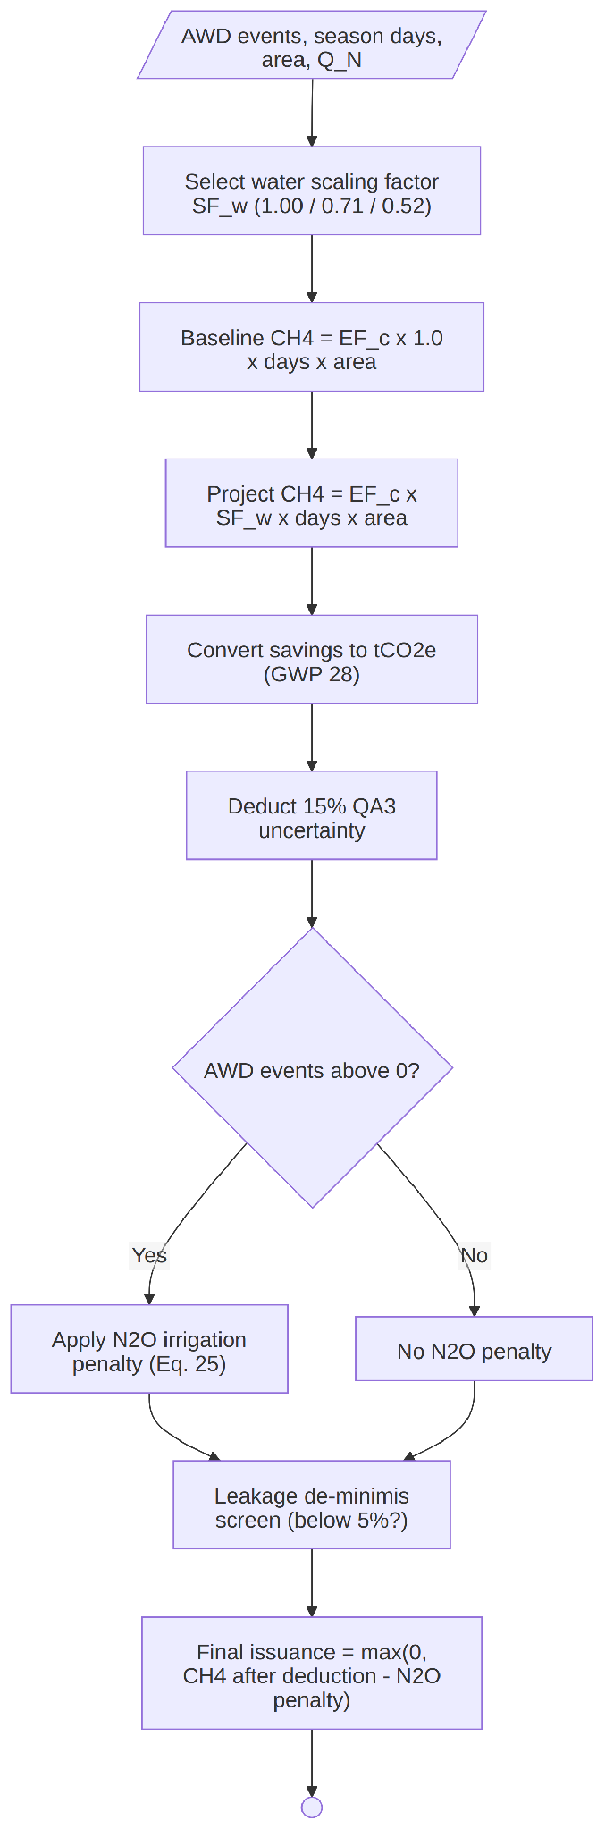
Fig 17: Carbon Estimation (Activity — Use Case 1.4). Branches on field type: the VM0051 QA3 steps (water scaling, uncertainty deduction, N₂O penalty) for rice fields, or the extended VM0042 steps (SOC stock change, livestock emissions, leakage screen, uncertainty and buffer deduction) for cropland fields; both paths floor final issuance at zero and persist the result to credit history.
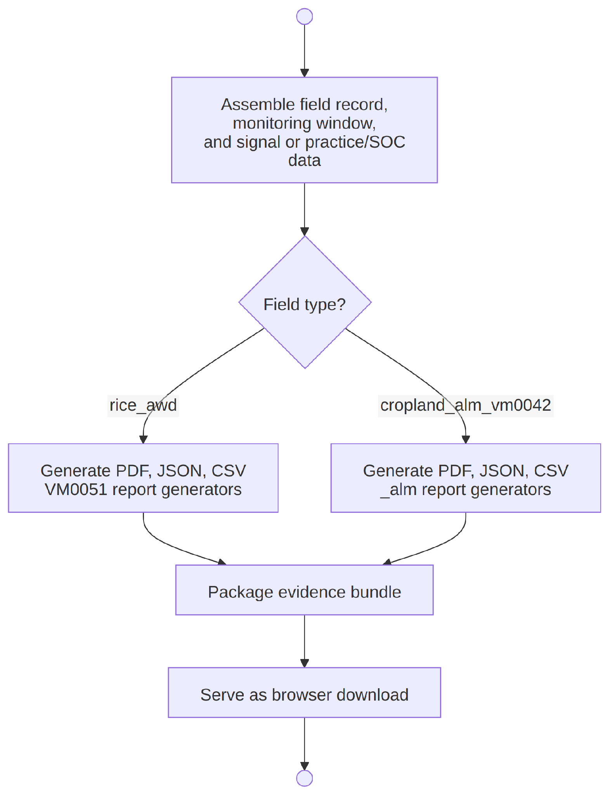
Fig 18: Evidence Reporting (Activity — Use Case 1.5). Assemble the field, window, signal/practice, and carbon data into the PDF and JSON generators (and the CSV generator for practice/SOC data), then serve each as a browser download.
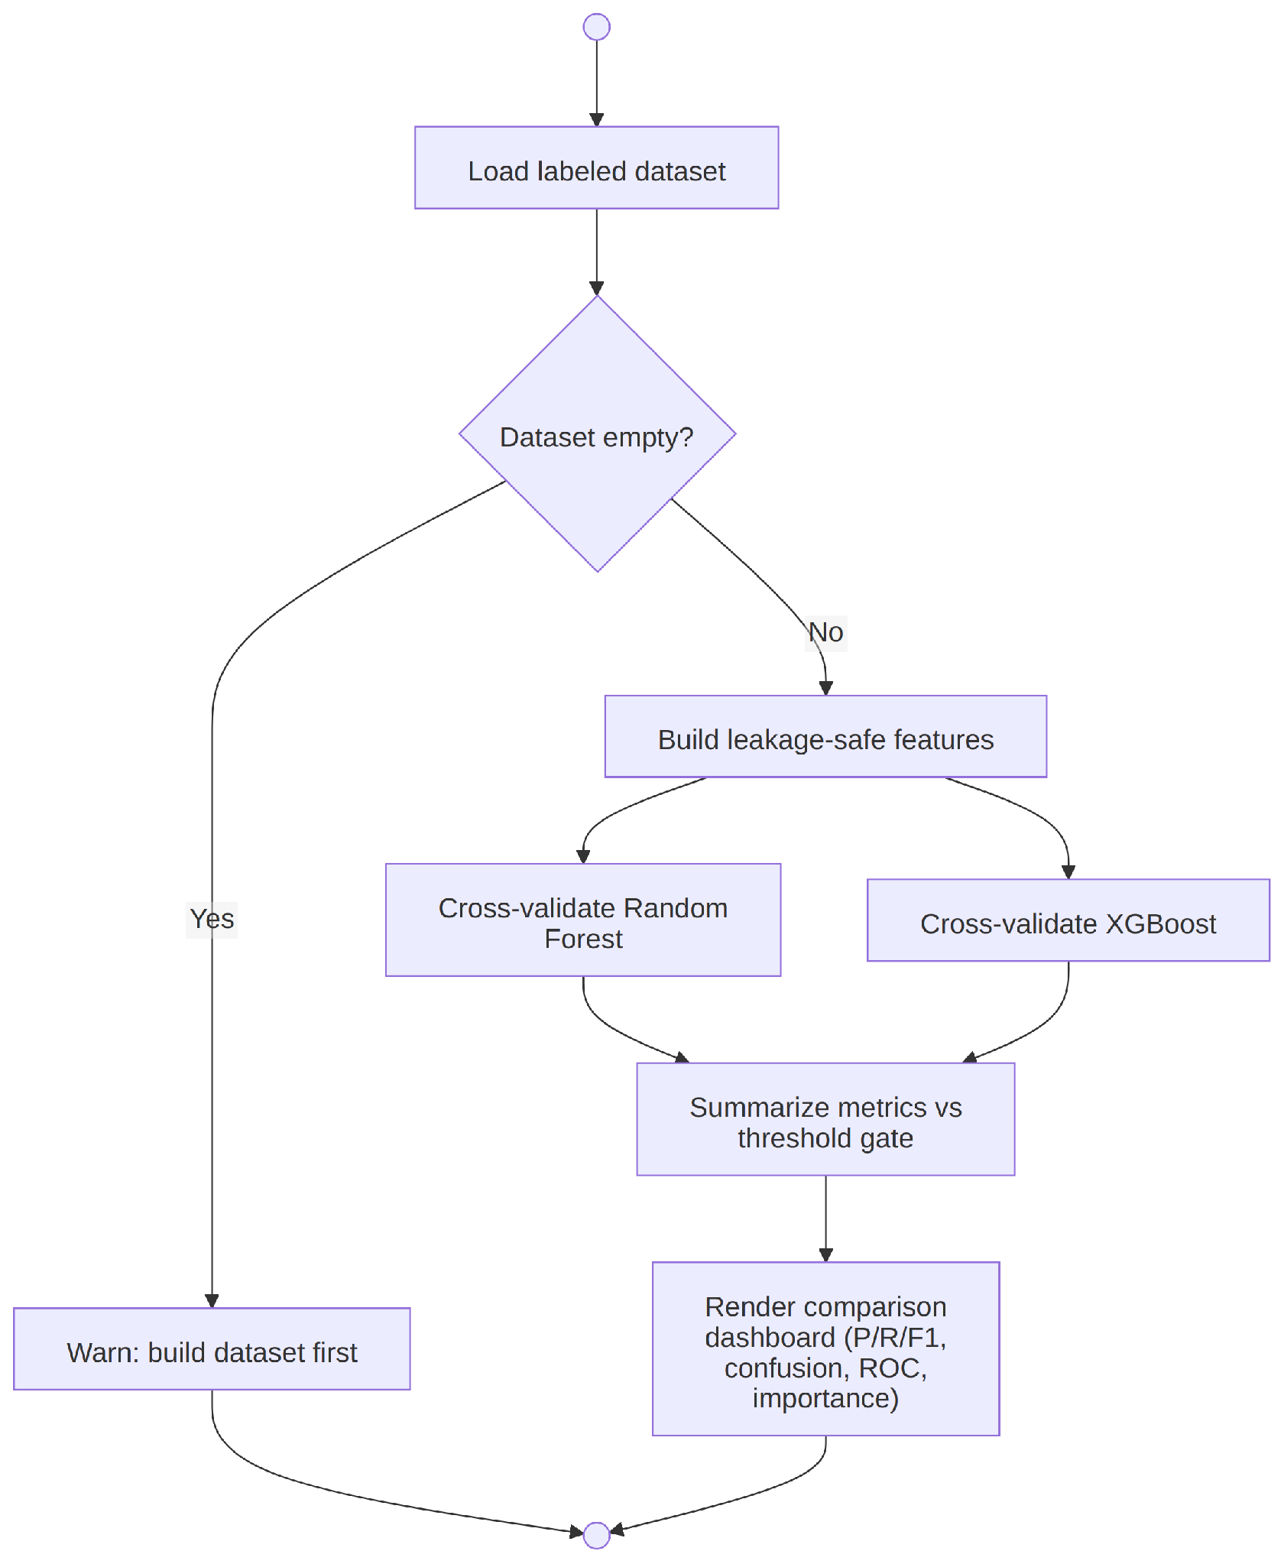
Fig 19: AI Validation (Activity — Use Case 1.6). Build the labeled dataset, engineer leakage-safe features, train both classifiers with cross-validation, then evaluate and compare them.

3.2.1 Updated Cropland ALM Activity Flow
The cropland ALM activity flow has changed materially this phase with the addition of livestock accounting, yield-based leakage screening, and calculation history, and is described here rather than shown as an unchanged diagram: enter baseline/project crop practices → enter baseline/project livestock schedule (optional) → enter baseline/project yield → enter paired SOC measurements → validate completeness and remeasurement cadence → calculate SOC and non-SOC emission terms, including integrated-livestock terms when present → run the production-decline leakage screen against baseline/project yield → apply the uncertainty deduction and update the cumulative non-permanence buffer → block issuance or explicitly disclose any unresolved leakage/uncertainty condition rather than defaulting it to zero → save the calculation to credit history → export evidence (PDF, JSON; CSV for practice/SOC data) → update the cross-field portfolio summary.

4. Data & Information Modeling

4.1 Entity-Relationship Diagram
Fields, cached time-series, cropland ALM inputs, livestock schedules, and calculation history are persisted in SQLite at data/project_store.db; trained AI model artifacts are persisted separately as joblib files under data/ai_models/. The diagram below reflects the six core tables created by initialize_database(), including the alm_livestock_schedule and credit_history tables added this phase alongside the previously documented alm_practice_schedule and soc_measurements tables. A seventh table, ai_dataset_rows, is created separately by the AI dataset pipeline once it has been run and is not shown in the diagram (see Section 4.2).
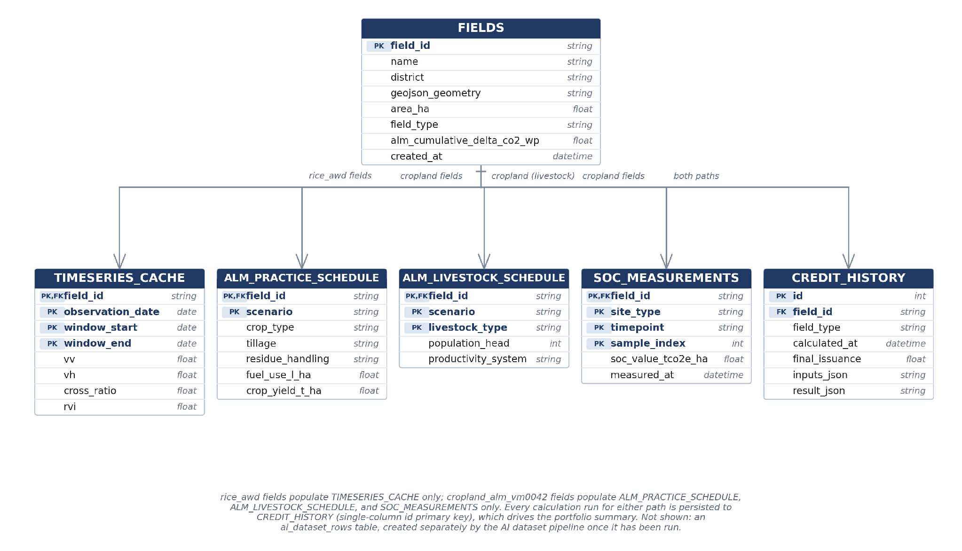
Fig 20: Entity-Relationship Diagram (six core tables from initialize_database()). fields is the shared parent entity; rice_awd fields populate timeseries_cache only, cropland_alm_vm0042 fields populate alm_practice_schedule, alm_livestock_schedule, and soc_measurements, and every field's calculation runs — on either methodology path — are persisted to credit_history via a single-column id primary key.

4.2 Database Schema
Table | Key Columns | Purpose
fields | field_id (PK), name, district, geojson_geometry, area_ha, field_type, alm_cumulative_delta_co2_wp | Field registry; field_type drives routing, alm_cumulative_delta_co2_wp tracks the cumulative SOC indicator across verification periods. name and district are editable post-registration (FR17); geometry and field_type are immutable.
timeseries_cache | field_id, observation_date, window_start, window_end (composite PK), vv, vh, cross_ratio, rvi | Cached Sentinel-1 observations, keyed to the exact monitoring window to prevent cross-window collisions.
alm_practice_schedule | field_id, scenario (baseline/project, composite PK) | Crop type, rotation/cover-crop/intercropping flags, tillage, residue handling, synthetic/organic N rates, N-fixing residue, fuel use, and yield per scenario.
alm_livestock_schedule | field_id, scenario, livestock_type (composite PK), population_head, productivity_system, timestamps | Baseline/project livestock population and productivity system for supported livestock types (cattle, buffalo, sheep, goats), feeding the enteric-fermentation and pasture-manure emission terms. There is no grazing-days column; grazing duration is not a current input to the livestock calculator.
soc_measurements | field_id, site_type (project/control), timepoint (t_start/t_final), sample_index (composite PK), soc_value_tco2e_ha | Paired lab SOC samples feeding the VM0042 stock-change and uncertainty equations.
credit_history | id (PK, single column), field_id (FK), field_type, calculated_at, final_issuance, inputs_json, result_json | One row per calculation run for either methodology path, storing inputs and the full result (result_json) so a developer can inspect prior runs and the portfolio view can aggregate totals. Not a composite key — id alone is the primary key.
ai_dataset_rows | Not independently verified for this revision | Created separately by the AI dataset pipeline (DatasetBuilder) once it has been run, outside initialize_database(). Its exact column layout is not confirmed here and should not be assumed from the six-table description above.
Schema migrations (initialize_database() in src/database.py) are designed to be idempotent for duplicate-column additions — each ALTER TABLE is wrapped in a try/except so re-running the migration against an already-current database is a no-op. This does not prove migrations are unconditionally safe: the current exception handling is broad enough that it would also mask a genuine migration failure, which is a hardening item for a later phase rather than a resolved guarantee.

4.3 Dataset Description (AI-Assisted Detection)
The optional AI detector is trained on a dataset built by replaying the rule-based threshold gate over every cached rice field/window time-series, not on externally labeled ground truth. Each row records: raw and smoothed VV/VH, cross ratio, RVI, z-score and diff features, days-since-window-start, district (one-hot), and a label of dry, flooded, or drydown assigned by the gate. Feature construction explicitly excludes the gate’s own decision flags to avoid label leakage. Because labels originate from the gate itself, all reported model metrics are framed as agreement with the rule-based gate, not accuracy against independently verified irrigation events. This disclosure is unchanged from the full SRS and remains one of the report’s clearest statements of a real methodological limitation.
Dataset size and model results: as of this technical report (2 August 2026), empirical dataset counts (rows, per-class counts, number of fields/districts/monitoring windows represented) and trained-model metrics are not being reported here, because a clean, reviewer-verifiable dataset build and training run had not been captured at report-writing time. The pipeline (DatasetBuilder, FeatureEngineer, ModelRegistry, AWDPredictor, ModelEvaluator) is implemented, but automated tests for this pipeline have not yet been written (Section 7.2 correctly lists AI test coverage as planned, not existing); empirical results are pending a recorded run and will be added once available rather than estimated here.
Known validation risk: the current cross-validation is observation-level, not grouped. Because consecutive observations from the same field/monitoring window are highly correlated, an observation-level fold can place near-duplicate observations from the same field/window in both the training and validation folds, which would inflate agreement metrics relative to a true held-out evaluation. Minority classes (drydown events are rare relative to flooded/dry states) are especially sensitive to this.
Planned validation: future work should (1) switch to grouped cross-validation split by field or by monitoring window so no field/window appears in both training and validation, and (2) validate a sample of predictions against independent irrigation logs or field observations rather than only against the rule-based gate that generated the labels.

5. Software Design

5.1 Component Diagram
app.py reads a field’s stored field_type and dispatches through FieldTypeRegistry to one of two independent module stacks — the Sentinel-1-driven rice AWD stack, or the manual-entry cropland ALM stack — sharing only the geometry, persistence, and reporting utilities. This is a Registry / Strategy design: register_field_type() maps a field_type key to a detector factory, a methodology factory, and a uses_sar flag. The registry dispatches detector/methodology metadata only; app.py still contains separate, methodology-specific UI renderers for the two paths, so adding a third field type would require new UI rendering and reporting integration in app.py in addition to a new registry entry — the registry does not make a third path a zero-touch addition.
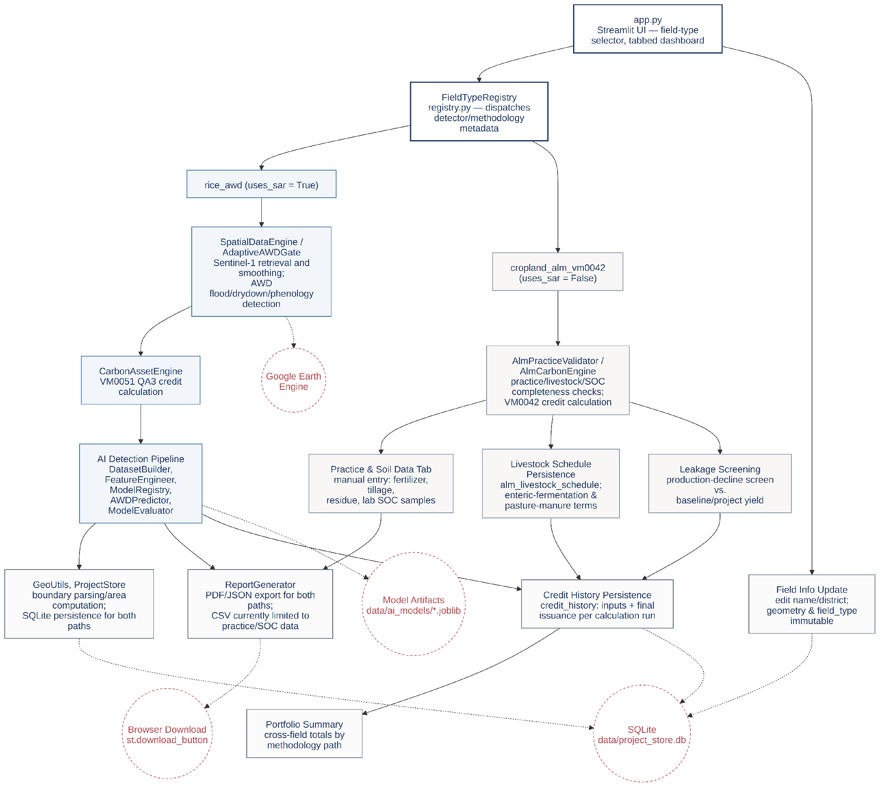
Fig 21: Component Diagram.
Component | Responsibility
FieldTypeRegistry | Maps a field_type key to its detector factory, methodology factory, and uses_sar flag; the single dispatch point for both paths, but not a complete abstraction of UI/reporting differences (see above).
SpatialDataEngine / AdaptiveAWDGate | Rice path: Sentinel-1 retrieval and smoothing; AWD flood/drydown/phenology detection.
CarbonAssetEngine | Rice path: VM0051 QA3 credit calculation.
AlmPracticeValidator / AlmCarbonEngine | Cropland path: practice/livestock/SOC completeness checks; VM0042 credit calculation including integrated-livestock emissions and production-decline leakage screening.
Livestock Schedule Persistence | Cropland path: stores baseline/project livestock population (population_head), productivity system, and livestock type in alm_livestock_schedule; feeds AlmCarbonEngine's enteric-fermentation and pasture-manure terms. There is no grazing-days input in the current schema.
Leakage Screening | Cropland path: compares baseline vs. project yield, blocks issuance on a material decline, and explicitly flags the screen as unresolved when yield data is missing.
Credit History Persistence | Shared: writes one row per calculation run (either path) to credit_history with its inputs and final issuance; backs the per-field history view and the portfolio aggregation.
Portfolio Summary | Shared: queries credit_history and fields to render a cross-field summary — area, latest calculation date, latest issuance, and totals by methodology.
Field Info Update | Shared: lets the developer edit a field's name/district in place while leaving geometry and field_type immutable.
GeoUtils, ProjectStore | Shared: boundary parsing/area computation; SQLite persistence for both paths.
ReportGenerator | Shared: PDF/JSON evidence export for both paths, plus a CSV export currently limited to practice/SOC data (see FR11/FR18).
AI Detection Pipeline | Rice path only: DatasetBuilder, FeatureEngineer, ModelRegistry, AWDPredictor, ModelEvaluator.

6. AI Engineering Design

6.1 AI Pipeline
The AI pipeline applies only to the rice AWD path and augments, rather than replaces, the rule-based gate:
- DatasetBuilder replays the threshold gate over every cached field/window time-series and labels each observation.
- FeatureEngineer builds a leakage-safe feature matrix (raw/smoothed backscatter, indices, days-since-sowing, district one-hots).
- ModelRegistry trains Random Forest (200 trees, class-balanced) and XGBoost (200 rounds, max depth 4) classifiers with stratified k-fold cross-validation (falling back to plain k-fold for very small classes) and persists trained bundles via joblib.
- AWDPredictor loads the selected model at analysis time, aligns features to its training columns, and overwrites the gate’s flags with model predictions plus a per-observation confidence score; it raises FileNotFoundError for an untrained model, which the UI catches to fall back to the rule-based gate automatically.
- ModelEvaluator reports precision/recall/F1, confusion matrices, feature importance, and one-vs-rest ROC curves — all computed from out-of-fold cross-validation predictions and explicitly framed as agreement with the gate, not ground-truth accuracy.

6.2 Model Selection
Random Forest and XGBoost were chosen over deep-learning approaches because the input is a small, structured, tabular feature set (not imagery), where tree-ensemble methods are well-suited, computationally cheap to retrain per district, and expose interpretable feature importance — a property directly useful for auditor-facing explanations. Both models are trained side by side with the same stratified k-fold split so the AI Validation dashboard can compare them fairly and let the researcher pick the active detector per analysis run.
When a class (typically the drydown class) has too few samples for stratified k-fold, ModelRegistry falls back to plain KFold. Results for that minority class should be treated as provisional rather than as a stable estimate, since plain KFold does not guarantee class balance across folds. The pipeline code being implemented and unit-tested is not the same claim as the AI validation work being empirically complete: actual dataset counts and trained-model metrics are reported in Section 4.3 only if and when a clean run has been captured, and grouped, field-level validation against independent ground truth (rather than the rule-based gate's own labels) remains final project work rather than completed validation.

6.3 Prompt Design
Not applicable. Terra-Audit’s AI component is a classical supervised tabular classifier (Random Forest / XGBoost), not a large language model, so there is no prompt template or generative pipeline to design.

7. Preliminary Test Plan

7.1 Testing Objectives
- Verify that hard-coded emission factors and scaling constants in both accounting engines match their cited methodology source (IPCC 2019 Refinement tables, VM0051/VM0042 equations, AR5 GWP values).
- Verify edge-case handling: zero AWD events, zero area, the QA3 project-size gate, insufficient SOC data (must zero out with full uncertainty rather than over-credit), and the leakage-disclosure flag.
- Verify that the ALM cumulative SOC indicator is computed across all verification periods since project start, since it can flip a positive current-period result to “no removals” if a prior deficit dominates.
- Verify a full golden-value scenario end to end for each engine against hand-computed expected output.
- Extend automated coverage toward geometry parsing (GeoJSON, KML, coordinates, malformed input, MultiPolygon, known-reference area), database behavior (initialization, migration, CRUD, cache-window keys, cascade deletion, livestock persistence, credit history), field-type registry dispatch (including invalid types), evidence completeness (PDF/JSON/CSV for both paths, including livestock), AI pipeline integrity (feature leakage, feature-column alignment, missing-model fallback, grouped cross-validation, metrics, artifact metadata), and portfolio aggregation.
- Validate, through manual UI walkthroughs, the parts of the system not yet covered by automated tests: geometry upload/paste parsing, map drawing, caching behavior, and the AI validation dashboard, until the corresponding automated tests above are implemented.

7.2 Features to be Tested
Feature Area | Test File | Test Case (function) | Expected Result | Status
Water scaling factor selection | test_carbon_calculator.py | test_zero_awd_events_yields_no_reduction, test_single_drydown_uses_single_aeration_factor, test_true_awd_uses_corrected_scaling_factor | SF_w = 1.00 / 0.71 / 0.55 for 0 / 1 / ≥2 drydowns respectively. | Automated
Pre-season & organic-amendment factors | test_carbon_calculator.py | test_default_organic_amendment_scaling_matches_footnote_16, test_preseason_category_short_vs_long, test_custom_amendments_applied_per_scenario | Defaults match VM0051 §8.2.3 footnote 16 and Table 5.13; user overrides apply per scenario. | Automated
QA3 size gate & N₂O penalty | test_carbon_calculator.py | test_qa3_project_size_gate_blocks_oversized_projects, test_qa3_gate_allows_typical_smallholder_field, test_zero_n_input_yields_zero_n2o_penalty, test_n2o_penalty_uses_gwp_n2o_and_cf_n2o_constants | Issuance blocked above the 60,000 tCO₂e/yr gate; N₂O penalty uses CF_N2O = 0.00314, GWP_N2O = 265. | Automated
Rice final issuance edge cases | test_carbon_calculator.py | test_zero_area_does_not_raise, test_final_issuance_uses_symbolic_ch4_gwp | No exception on zero-area input; issuance uses AR5 GWP₁₀₀ = 28 for CH₄, floored at zero. | Automated
VM0042 default-factor constants | test_carbon_calculator_alm.py | test_diesel_ef_matches_vm0042_parameter_table, test_conservative_ef_direction | Fossil-fuel CO₂ factor matches the VM0042 parameter table; rounding is conservative (never over-credits). | Automated
SOC readiness & golden scenario | test_carbon_calculator_alm.py | test_soc_not_ready_falls_back_to_zero_with_full_uncertainty, test_full_scenario_golden_values, test_buffer_vcu_arithmetic_holds | Incomplete SOC data yields zero credits at full uncertainty rather than an inflated estimate; a full scenario matches hand-computed values; buffer/VCU arithmetic is internally consistent. | Automated
Leakage disclosure | test_carbon_calculator_alm.py | test_other_leakage_gap_is_disclosed_not_silently_zero, test_production_decline_leakage_unscreened_when_no_yield_data, test_production_decline_leakage_screens_clean_when_yield_maintained, test_production_decline_leakage_blocks_issuance_when_yield_declines | leakage_screened is always an explicit flag, never silently assumed zero; a yield decline against baseline correctly blocks issuance. | Automated
Cumulative non-permanence indicator | test_carbon_calculator_alm.py | test_cumulative_indicator_persists_across_verification_periods, test_cumulative_indicator_can_flip_classification, test_remeasurement_cadence_validation | The indicator accumulates across periods (not reset each run) and can flip an ER/CR classification; remeasurement cadence beyond MAX_VERIFICATION_YEARS = 5 is flagged. | Automated
Integrated-livestock emission terms | test_carbon_calculator_alm.py | Enteric fermentation, invalid livestock inputs, buffalo manure, sheep pasture N₂O, empty-livestock fallback, and livestock reduction increasing issuance (multiple test functions; see file) | Enteric-fermentation and pasture-manure CH₄/N₂O terms match IPCC 2019 Refinement Ch.10/Ch.11 defaults for the declared livestock type and population. | Automated
End-to-end fixture (ALM, livestock) | test_carbon_calculator_alm.py | test_alm_livestock_ui_walkthrough_fixture | A regression fixture captured from a real livestock-inclusive UI walkthrough reproduces the same output on every run. | Automated
End-to-end fixture (rice) | test_carbon_calculator.py (planned) | Not yet implemented | A regression fixture captured from a real rice-field UI walkthrough reproduces the same output on every run. | Not started
Geometry parsing & area | Manual UI walkthrough | — | GeoJSON/KML upload with malformed input returns a readable error; pasted coordinates below 3 points are rejected; Shoelace area matches a known reference polygon. The parser accepts MultiPolygon input, but compute_area_ha() assumes ordinary Polygon coordinate nesting — end-to-end MultiPolygon area correctness is not confirmed and should not be assumed until tested. | Manual
Database CRUD, migration & cascade | test_database.py (planned) | Not yet implemented | initialize_database() is idempotent on re-run; field CRUD, cache-window keys, and cascade deletion behave correctly; livestock and credit-history rows persist and cascade with their parent field. | Not started
Field-type registry dispatch | test_registry.py (planned) | Not yet implemented | register_field_type() dispatches the correct detector/methodology for rice_awd and cropland_alm_vm0042; an unregistered field type raises a clear error. | Not started
Evidence completeness (incl. livestock) | test_report_generator.py (planned) | Not yet implemented | PDF/JSON exports for both paths include every input that materially affects the calculation, including livestock data when present; the CSV export is verified against its documented practice/SOC-only scope. | Not started
AI feature leakage & grouped CV | test_feature_engineer.py, test_model_registry.py (planned) | Not yet implemented | Feature matrix excludes the gate's own decision flags; a grouped-by-field/window cross-validation split is available and produces different (typically lower) agreement than observation-level splits. | Not started
Portfolio aggregation | test_portfolio.py (planned) | Not yet implemented | Portfolio view totals match a hand-computed sum across a small fixture set of fields spanning both methodology paths. | Not started
Caching layer | Manual UI walkthrough | — | A repeat analytics run on an already-cached field/window returns instantly without a live Earth Engine call. | Manual
AI detection fallback | Manual UI walkthrough | — | Selecting an untrained model triggers the documented fallback to the rule-based gate with a visible message. | Manual
Recorded test-run status: at report-writing time, python3 -m pytest -q could not be executed in the review environment because the installed Python environment did not contain pytest, even though requirements.txt declares pytest>=8.0.0. This report therefore does not claim a pass count for the automated suite. The accompanying checklist item (installing dependencies in the intended environment and running the suite) remains outstanding, and its actual result should be recorded here — accurately, including any failures — once it has been run, rather than assumed.

7.3 Traceability Matrix
Compact mapping from functional requirement to the use case it supports, the component/module that implements it, its test(s), and current status. Status reflects only what is independently evidenced elsewhere in this report; “Automated” means an existing test file covers it, not that the full suite has been run clean this phase (Section 7.2).
Req. | Use Case | Component | Test(s) | Status
FR1 | Field Mgmt / Geometry Input | GeoUtils | Manual walkthrough | Implemented, manually verified
FR2 | Field Management | FieldTypeRegistry | Planned (test_registry.py) | Implemented; test not started
FR3 | Satellite Data Engine | SpatialDataEngine | Manual walkthrough | Implemented, manually verified
FR4 | MRV Signal Analytics | AdaptiveAWDGate | Manual walkthrough | Implemented, manually verified
FR5 | MRV Signal Analytics | AdaptiveAWDGate (phenology) | Manual walkthrough | Implemented, manually verified
FR6 | Cropland ALM Entry | AlmPracticeValidator | test_soc_not_ready_falls_back... | Automated
FR7 | Carbon Estimation (rice) | CarbonAssetEngine | test_carbon_calculator.py | Automated
FR8 | Carbon Estimation (cropland) | AlmCarbonEngine | test_carbon_calculator_alm.py | Automated (SOC/leakage); livestock not yet covered
FR9 | AI Validation | AWDPredictor | Manual walkthrough | Implemented, manually verified
FR10 | AI Validation | ModelEvaluator | Manual walkthrough | Implemented, manually verified
FR11 | Evidence Reporting | ReportGenerator | Planned (test_report_generator.py) | Implemented (PDF/JSON); CSV limited
FR12 | Field Management | ProjectStore | Planned (test_database.py) | Implemented; test not started
FR13 | Cropland ALM Entry | Livestock Persistence, AlmCarbonEngine | test_carbon_calculator_alm.py (enteric fermentation, buffalo manure, sheep pasture N₂O, etc.) | Automated
FR14 | Cropland ALM Entry | Leakage Screening | test_production_decline_leakage_* | Automated
FR15 | Calculation History | Credit History Persistence | Planned (test_database.py) | Implemented; test not started
FR16 | Portfolio Summary | Portfolio Summary | Planned (test_portfolio.py) | Implemented; test not started
FR17 | Field Info Update | Field Info Update | Manual walkthrough | Implemented, manually verified
FR18 | Evidence Reporting | ReportGenerator | Planned (test_report_generator.py) | Partial — CSV excludes livestock

8. Implementation Progress
This section responds to the separate implementation-progress brief (Working Prototype / Implementation Progress / Challenges). Screenshots of the running prototype are omitted from this revision by request; the status table and narrative below stand on their own.

8.1 Implementation Progress
Status is reported conservatively: a row is marked Complete only where this report has independent evidence (an automated test, a golden-value scenario, or an explicit prior manual-verification note) rather than because the corresponding code exists.
Module / Feature | Status | Evidence | Remaining Work
Field registration & geometry parsing | Complete | Manual UI walkthrough; Shoelace area computation reviewed. | Add automated tests (Section 7.2).
SQLite field registry & SAR cache | Complete | Manual UI walkthrough; schema documented in Section 4.2. | Add automated CRUD/migration tests.
Sentinel-1 retrieval | Complete | Manual UI walkthrough against live Earth Engine. | Automated fault-injection tests for auth/network/empty-collection errors.
Threshold-gate analytics & phenology | Complete | Manual UI walkthrough. | Automated tests for phenology fallback path.
VM0051 calculator | Complete | Automated golden-value and edge-case tests (Section 7.2). | None identified for this phase.
VM0042 practice/SOC calculator | Complete | Automated golden-value and leakage-disclosure tests (Section 7.2). | None identified for this phase.
Integrated livestock calculations | Complete | Automated tests in test_carbon_calculator_alm.py cover enteric fermentation, invalid livestock inputs, buffalo manure, sheep pasture N₂O, empty-livestock fallback, livestock reduction increasing issuance, and a livestock UI-walkthrough regression fixture (test_alm_livestock_ui_walkthrough_fixture). | Document the IPCC Ch.10/Ch.11 constants used and cross-check against the parameter tables cited in References.
Production-decline leakage screening | Complete | Automated tests for unresolved/clean/blocking scenarios (Section 7.2). | Extend to remaining VM0042/VMD0054 leakage categories (Section 1.4).
Evidence PDF/JSON/CSV | In Progress | PDF/JSON implemented and used in golden-value fixtures; CSV scope confirmed limited to practice/SOC data. | Extend CSV (or its documentation) to livestock data per FR18.
Credit history & portfolio | In Progress | UI entry points observed (portfolio tab, calculation display); persistence and aggregation not yet independently tested in this report. | Add automated persistence and aggregation tests.
AI dataset/model pipeline | In Progress | Pipeline code implemented; see Section 4.3 for the honest state of empirical results. | Capture a clean dataset build and training run; report real counts and metrics.
Automated calculator tests | Complete | test_carbon_calculator.py and test_carbon_calculator_alm.py pass locally per prior development notes; a fresh pytest run for this report was not executed (Section 7.2). | Run and record python3 -m pytest -q in the intended environment.
Database/report/AI/UI automated tests | Not Started | No test files for these areas were identified. | Implement test_database.py, test_report_generator.py, test_registry.py, AI grouped-CV tests, and UI smoke tests.
Independent ground-truth validation | Not Started | No independent irrigation-log or field-observation validation has been performed. | Design and execute a grouped, field-level validation study.
Full leakage quantification | Not Started | Only the production-decline screen is implemented; other VM0042/VMD0054 leakage categories are undisclosed-as-zero by omission and must remain explicitly flagged, not assumed complete. | Complete the applicability/data review and implement or formally bound each remaining category.
Deployment, authentication, backup, hardening | Not Started | Runs locally via streamlit run app.py with no authentication layer. | Design and implement for any multi-user or hosted deployment phase.

8.2 Challenges and Planned Responses
Challenge | Planned Response
No independent AWD ground truth — all AI labels come from the rule-based gate itself. | Collect field/irrigation observations (farmer logs, site visits, or partner-verified records) to build an independent validation set.
Very small drydown class relative to flooded/dry states. | Gather more seasons and fields to grow the minority class, and use grouped (field/window-level) validation rather than observation-level splits so results are not inflated by near-duplicate rows.
Earth Engine authentication/API dependency. | Graceful error handling for auth/network/empty-collection/API failures, cache-first operation to reduce live-call frequency, and documented one-time setup steps.
Incomplete leakage quantification beyond the production-decline screen. | Finish the applicability/data review for the remaining VM0042/VMD0054 leakage categories and either implement them or explicitly block issuance for cases they would cover, rather than leaving them silently unaddressed.
SOC sampling cost and cadence. | Formalize validation rules and a documented sampling protocol so paired baseline/project samples meet the methodology's minimum count and remeasurement cadence.
Local SQLite store with no authentication. | Document the current single-user/local-only posture explicitly (Section 2.2, NFR9–NFR10) and design backups/access controls/authentication as part of any later hosted-deployment phase.
User-facing VM0051 labeling defect: the UI (app.py) and generated evidence reports (report_generator.py) currently display “VM0051 Tier 2,” but the implemented water-scaling factor is a Tier 1 regional default per the code's own comments — the calculation engine and this report correctly say VM0051 QA3, but the on-screen and PDF label does not match. | Correct the UI/report label to accurately reflect the implemented QA3 / Tier 1 regional-default pathway rather than “Tier 2,” and add a regression check so the label and the calculation engine cannot silently drift apart again.

9. Timeline

9.1 Gantt Chart
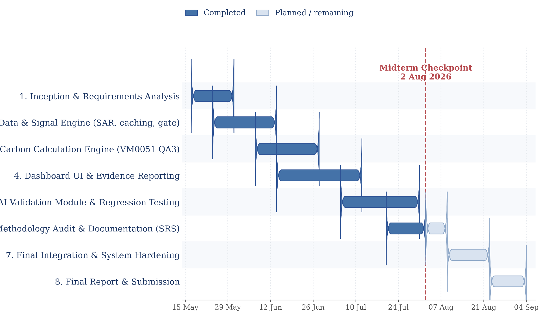
Fig 22: Project Timeline (Gantt Chart).
Phase | Window | Status at Midterm (2 Aug 2026)
1. Inception & Requirements Analysis | 17 May – 31 May | Complete
2. Data & Signal Engine (SAR, caching, threshold gate) | 24 May – 14 Jun | Complete
3. Carbon Calculation Engine (VM0051 QA3) | 07 Jun – 28 Jun | Complete
4. Dashboard UI & Evidence Reporting | 14 Jun – 12 Jul | Complete
5. AI Validation Module & Regression Testing | 05 Jul – 31 Jul | Code implemented; independent validation not complete (Section 6.2, Section 4.3)
6. Methodology Audit & Documentation (this report) | 20 Jul – 09 Aug | In progress
7. Final Integration & System Hardening | 09 Aug – 23 Aug | Planned
8. Final Report & Submission | 23 Aug – 04 Sep | Planned
At the 2 August 2026 midterm checkpoint, the rice AWD path (VM0051) and the cropland ALM path (VM0042) are both implemented and unit-tested at the accounting-engine level — this is a narrower claim than “validated complete.” The AI pipeline is implemented, but independent validation is not complete without ground truth and recorded model results (Section 4.3, Section 6.2). The regression suite covers the two accounting engines well, but system-wide regression testing is not complete while geometry, database, reporting, caching, AI integration, and UI flows remain manual or untested (Section 7).
Remaining work:
- Correct report diagrams and schema to match the implemented six-table data model (this revision).
- Complete export coverage for livestock data (FR18).
- Add system-level automated tests (database, reporting, registry, AI pipeline, portfolio — Section 7.2, 7.3).
- Record an actual clean python3 -m pytest -q run and report its real result.
- Perform grouped and independent AI validation (Section 4.3, Section 6.2).
- Complete or formally bound the remaining leakage-quantification categories (Section 1.4).
- Run a final end-to-end demonstration and evidence-package audit for both methodology paths.

References
- Verra, VM0051 v1.0 — Methodology for Improved Management in Rice Production Systems, 27 February 2025. A copy is included in this repository at methodologies/verra/vm0051/VM0051v1_27Feb25.pdf.
- Verra, VM0042 v2.2 — Methodology for Improved Agricultural Land Management, including its June 2026 corrections where applicable to the equations and default factors cited in Sections 1, 2, and 4. A copy is included in this repository at methodologies/verra/vm0042/VM0042v2.2.pdf.
- Verra, VMD0054 — Methodology for Estimating Leakage from Displacement of Agricultural Activities (production-decline leakage screening cited in Sections 1.4, 2.1 FR14, and 8.1).
- IPCC, 2019 Refinement to the 2006 IPCC Guidelines for National Greenhouse Gas Inventories, Volume 4 (Agriculture, Forestry and Other Land Use), Chapter 5, Table 5.12 (water regime scaling factors) and Table 5.13/5.14 (pre-season and organic-amendment factors); Chapter 10 (livestock enteric fermentation and manure management, cited for the integrated crop-livestock terms in Sections 1.3, 2.1 FR13, and 4.2); Chapter 11, Table 11.1 (N₂O emission factors, including pasture/range/paddock-deposited manure N₂O).
- IPCC, Fifth Assessment Report (AR5), Climate Change 2013: The Physical Science Basis — 100-year Global Warming Potential values (CH₄ = 28, N₂O = 265) used in both carbon estimation engines.
- Verra, Verra Registry Program Guide and Standard — general registration, issuance, and non-permanence risk tool (buffer) process referenced wherever this report discusses issuance eligibility or the non-permanence buffer (Sections 1.4, 2.3, 4.1).
- European Space Agency / Copernicus Programme, Sentinel-1 SAR User Guide. https://sentinels.copernicus.eu/web/sentinel/user-guides/sentinel-1-sar
- Google, Google Earth Engine API Documentation (earthengine-api, dataset COPERNICUS/S1_GRD). https://developers.google.com/earth-engine
- R. Lampayan et al., “Adoption and economics of alternate wetting and drying water management for irrigated lowland rice,” Field Crops Research, vol. 170, pp. 95–108, 2015 (background on AWD practice).
- A. Savitzky and M. J. E. Golay, “Smoothing and Differentiation of Data by Simplified Least Squares Procedures,” Analytical Chemistry, vol. 36, no. 8, pp. 1627–1639, 1964 (signal smoothing filter used in the data engine).
- L. Breiman, “Random Forests,” Machine Learning, vol. 45, no. 1, pp. 5–32, 2001.
- T. Chen and C. Guestrin, “XGBoost: A Scalable Tree Boosting System,” Proceedings of the 22nd ACM SIGKDD, pp. 785–794, 2016.

