 | INSTITUTE OF INFORMATION TECHNOLOGY  UNIVERSITY OF DHAKA | 

TERRA-AUDIT
– AI-Assisted Digital MRV Platform for AWD Rice Irrigation and Agricultural Land Management Carbon Credits
Submitted As
Technical Report
SE801 Project Final Technical Report

Submitted By
Kazi Nahid
BSSE Roll: 1437

Supervised By
Dr. Emon Kumar Dey
Professor
Institute of Information Technology
University of Dhaka

Submission Date
Oct 8, 2026
Letter of Transmittal

October 8, 2026
BSSE 4th Year Exam Committee
Institute of Information Technology
University of Dhaka

Subject: Final Report Submission — Terra-Audit: AI-Assisted Digital MRV Platform for AWD Rice Irrigation and Agricultural Land Management Carbon Credits

Dear Sir,

I am submitting the technical report for my Software Project Lab 3 project, Terra-Audit: AI-Assisted Digital MRV Platform for AWD Rice Irrigation and Agricultural Land Management Carbon Credits. This report covers the project’s requirements, software design, implementation, interface design, testing, user guidance, and the limitations of the current system. I welcome your feedback and suggestions for further improvement.

Thank you for your consideration.

Sincerely,
Kazi Nahid
BSSE-1437
Institute of Information Technology
University of Dhaka

October 8, 2026
______________________________
Supervisor’s Signature

Acknowledgement

I would like to express my sincere gratitude to the Institute of Information Technology, University of Dhaka, for the opportunity to carry out Terra-Audit as my Software Project Lab 3 project. I am deeply thankful to my supervisor, Dr. Emon Kumar Dey, Professor, Institute of Information Technology, University of Dhaka, for his guidance, critical feedback and encouragement throughout the requirements analysis, design, implementation and evaluation of this work. I also thank my classmates for their helpful discussions and feedback during the project reviews.

Abstract

Alternate Wetting and Drying (AWD) irrigation and improved agricultural land management (ALM) can reduce greenhouse-gas emissions, but the monitoring, reporting and verification (MRV) evidence behind carbon claims is usually scattered across field logs, spreadsheets and disconnected calculations. Terra-Audit is an evidence-centred digital MRV platform that prepares agricultural carbon projects for audit. It implements two scoped accounting pathways—Verra VM0051 v1.1 for AWD rice and VM0042 v2.2 for cropland ALM with a restricted VMD0054 v1.1 leakage adapter—on a Next.js frontend, a FastAPI backend and a durable database-backed worker. The platform provides organization and project access control, structured evidence records, Sentinel-1 SAR analytics through Google Earth Engine, methodology bundles with deterministic readiness checks, immutable versioned calculation snapshots, version-pinned internal review and audit-oriented exports. Random Forest/XGBoost detectors, managed crop models and bounded generative-AI explanations are assistive; deterministic server code remains the only authority for accounting values and readiness states.

On 7 October 2026 the complete backend suite passed (177 tests, 0 failures), together with the frontend tests, production build, TypeScript check and lint (0 errors). Independent AWD field validation, complete methodology coverage and external VVB/Verra verification remain outside the delivered scope and are discussed as limitations.

Keywords: digital MRV, AWD rice, VM0051, VM0042, carbon accounting, evidence provenance, satellite monitoring, readiness, internal review.

Table of Contents
1. Introduction 1
1.1 Project Title 1
1.2 Problem Statement and Motivation 1
1.3 Objectives 1
1.4 Scope 2
1.5 Deliverables 3
1.6 Project Timeline 3
1.7 Organization of the Report 4
2. Background and Related Work 5
2.1 AWD Irrigation and Rice Methane 5
2.2 Satellite Monitoring of Rice Fields 5
2.3 Carbon Methodologies and Digital MRV 5
2.4 Gap Addressed by Terra-Audit 5
3. Requirements Analysis 5
3.1 Requirements Inception 5
3.2 Functional Requirements 6
3.3 Non-functional Requirements 7
3.4 Stakeholders and Viewpoints 8
3.5 Quality Function Deployment 9
3.6 Usage Scenarios and User Stories 9
4. Scenario-Based Modeling 10
4.1 Use Case Diagrams 10
4.2 Activity Diagrams 15
5. Data-Based Modeling 18
5.1 Entity-Relationship Diagram 18
5.2 Database Schema 20
5.3 Dataset Description (AI-Assisted Detection) 21
6. Class-Based Modeling 21
6.1 Analysis Classes 21
6.2 Class Cards (CRC Model) 22
6.3 Design Class Diagram 23
7. Architectural Design 25
7.1 Architectural Context Diagram 25
7.2 Defining Archetypes 25
7.3 Top-Level Components 26
7.4 Mapping Requirements to Software Architecture 28
7.5 Technology Stack 28
7.6 Design Evolution and Alternatives 29
8. Component-Level Design 29
8.1 Persistent Data Sources and Interfaces 29
8.2 API Design 31
8.3 Behavioral Design 32
8.4 Deployment Design 38
9. AI Engineering Design 39
9.1 Classical AWD ML Pipeline 39
9.2 Model Selection and Evaluation 40
9.3 Managed Crop Models 40
9.4 Generative AI Explanation Architecture 40
9.5 Prompt and Context Design 40
9.6 AI Authority Boundary and Evaluation Limitations 41
10. Interface Design 41
10.1 Interface Objects and Actions 42
10.2 Primary User Workflows 42
10.3 UI Events and State Transitions 42
10.4 Responsive, Validation and Accessibility Design 43
10.5 Interface States as Seen by the User 43
11. Implementation 47
11.1 Final Feature Status 47
11.2 Worked Calculation Checks 49
11.3 Remaining Engineering and Validation Gaps 49
12. Testing 49
12.1 Testing Objectives 49
12.2 Testing Approach, Strategy and Pass/Fail Criteria 50
12.3 Detailed Test Cases 51
12.4 Verification Results 52
12.5 Risks and Contingencies 52
12.6 Requirements Traceability Matrix 53
13. User Manual, Deployment and Repository 54
13.1 Sign In and Select Project Context 54
13.2 Register a Field and Build Evidence Context 55
13.3 Rice Signal Analytics and Calculation 55
13.4 ALM Evidence and VM0042 Calculation 55
13.5 Methodology Readiness and Internal Review 55
13.6 AI Explanation 56
13.7 Export and Troubleshooting 56
13.8 Local Installation and Development Setup 56
13.9 Deployment and Public Repository 57
14. Evaluation, Limitations and Conclusion 57
14.1 Final Evaluation 57
14.2 Methodology and Accounting Limitations 58
14.3 Scientific Validation Limitations 58
14.4 Provenance and Reproducibility Limitations 58
14.5 Security and Operational Limitations 58
14.6 Generative-AI Limitations 59
14.7 Prioritized Future Work 59
14.8 Conclusion 59
Appendix A — Calculation and Internal-Review Persistence 59
References 60

List of Figures and Tables
Figures
Fig 1 Project timeline (Gantt chart) — p. 4
Fig 2 Use Case Level 0 — Terra-Audit as a single system with its actors and external systems — p. 11
Fig 3 Use Case Level 1 — the ten user-goal modules and their actors — p. 12
Fig 4 Use Case Level 2 — Carbon Calculation (1.4) with «include» and «extend» relationships — p. 13
Fig 5 Overall activity diagram with swimlanes for the project user, the Terra-Audit server and the durable worker — p. 15
Fig 6 Activity diagram — versioned carbon calculation commit — p. 16
Fig 7 Activity diagram — methodology readiness and internal review with swimlanes — p. 17
Fig 8 Entity-relationship diagram (crow's-foot notation) of the core persistent entities — p. 19
Fig 9 CRC cards for the nine core design classes — p. 23
Fig 10 Design class diagram: principal classes and modules, key operations and dependencies — p. 24
Fig 11 Architectural context diagram (ACD) of Terra-Audit — p. 25
Fig 12 Layered architecture archetype instantiated for Terra-Audit — p. 26
Fig 13 Pipe-and-filter archetype: the Sentinel-1 signal-processing pipeline of the rice AWD pathway — p. 26
Fig 14 Top-level component diagram of Terra-Audit — p. 27
Fig 15 Level-0 data-flow diagram — p. 30
Fig 16 Level-1 data-flow diagram: processes, data stores and external flows — p. 31
Fig 17 State diagram — durable background job lifecycle (src/jobs/queue.py) — p. 33
Fig 18 State diagrams — (a) calculation version lifecycle and (b) data-quality issue lifecycle — p. 33
Fig 19 State diagram — internal review submission lifecycle (src/projects/reviews.py) — p. 34
Fig 20 Sequence diagram — calculation commit from authenticated request to immutable version — p. 35
Fig 21 Sequence diagram — internal review from submission to guarded decision — p. 36
Fig 22 Sequence diagram — Sentinel-1 signal run through the durable job queue — p. 37
Fig 23 Sequence diagram — bounded AI explanation with server-side validation — p. 38
Fig 24 UML deployment diagram of Terra-Audit — p. 39
Fig 25 AI authority and data flow — p. 41
Fig 26 Application shell and project navigation — p. 43
Fig 27 Monitoring batch state: one running batch with two pending child jobs; no data-quality issues — p. 44
Fig 28 Rice calculation readiness and inputs — p. 45
Fig 29 Review-related states — p. 46
Fig 30 AI workspace — crop-model controls — p. 47
Fig 31 Calculation and internal-review persistence tables — p. 60
Tables
Table 1 Project phases: planned and actual windows — p. 4
Table 2 Functional requirements and priorities — p. 6
Table 3 Non-functional requirements and verification targets — p. 7
Table 4 Stakeholders and viewpoints — p. 8
Table 5 Use-case inventory and actor mapping — p. 12
Table 6 Detailed use-case specifications — p. 13
Table 7 Persistent database schema by domain — p. 20
Table 8 Analysis-class identification from scenario nouns — p. 22
Table 9 Design classes and their implementing modules — p. 24
Table 10 Component responsibilities — p. 27
Table 11 Mapping functional requirements to architectural elements — p. 28
Table 12 Technology stack — p. 28
Table 13 REST API summary by router group — p. 31
Table 14 Behavioral event table — p. 32
Table 15 User-interface objects and actions — p. 42
Table 16 UI events and resulting state changes — p. 42
Table 17 Final implementation status by subsystem — p. 47
Table 18 Remaining engineering and validation gaps — p. 49
Table 19 Direct API endpoint verification — p. 50
Table 20 Detailed test cases with outcomes — p. 51
Table 21 Verification results (7 October 2026, commit bc402f2) — p. 52
Table 22 Functional requirements traceability matrix — p. 53

1. Introduction

1.1 Project Title
Terra-Audit — AI-Assisted Digital MRV Platform for AWD Rice Irrigation and Agricultural Land Management Carbon Credits.
This report consolidates the requirements analysis (SRS), the midterm design and the final design, implementation, testing and user documentation of Terra-Audit. All descriptions refer to the final Next.js/FastAPI system; the Streamlit prototype used before the midterm has been retired.

1.2 Problem Statement and Motivation
Rice paddies are a major source of anthropogenic methane, and Alternate Wetting and Drying (AWD) irrigation is a recognized mitigation practice, but evidence collection and carbon accounting remain difficult to scale and audit. Farmer irrigation logs can be incomplete or difficult to verify, continuous field instrumentation can be costly across many smallholder fields, and spreadsheet-based accounting often separates the reported result from the evidence, assumptions, methodology version, and calculation history that produced it. A parallel problem exists for improved agricultural land management (ALM), where practice changes, production data, soil organic carbon (SOC) measurements, leakage considerations, and uncertainty must be assembled from different evidence sources and retained consistently across verification periods.
Terra-Audit addresses these problems as an evidence-first digital MRV platform with two scoped accounting pathways. For rice fields, Sentinel-1 SAR observations from Google Earth Engine support analysis of flooding and drydown behavior; for cropland ALM fields, structured practice, soil, laboratory, production, livestock, and leakage evidence supports the accounting workflow. The platform combines deterministic carbon calculations, methodology-bundle and readiness checks, versioned calculation snapshots, internal review, durable background processing, and exportable evidence records. Satellite and AI outputs are treated as supporting analytical evidence rather than as substitutes for independent field validation or external VVB/Verra verification.

1.3 Objectives
- Use freely available Sentinel-1 SAR observations to provide scalable supporting evidence of rice-field flooding and drydown behavior while clearly separating satellite-derived analytics from independently validated AWD ground truth.
- Provide a parallel evidence-driven cropland ALM pathway based on the project’s scoped implementation of Verra VM0042 v2.2, using structured practice, production, livestock, soil-sampling, laboratory, custody, and reviewed SOC evidence rather than rice satellite signals.
- Implement transparent deterministic carbon accounting for the supported subsets of Verra VM0051 v1.1 (rice AWD, QA3/default-factor pathway) and VM0042 v2.2 (cropland ALM), exposing important intermediate values and methodology assumptions for review.
- Represent the evidence lifecycle explicitly, including crop seasons and corrections, observations, practice events, attachments, production records, soil sampling, laboratory results, chain-of-custody records, reviewed SOC inputs, and supported integrated crop-livestock evidence.
- Integrate methodology bundles, corrections, applicability, readiness checks, and restricted VMD0054 v1.1 leakage logic so unsupported, incomplete, or reviewer-dependent requirements are disclosed instead of being silently treated as satisfied or zero.
- Preserve calculation history through versioned calculation records and frozen evidence/input/result snapshots, and support internal review of eligible calculation versions without presenting that workflow as external VVB validation or registry verification.
- Support AI-assisted analysis while keeping deterministic accounting authoritative: classical Random Forest/XGBoost models and managed crop models remain experimental, while generative AI is limited to bundle-scoped draft explanations that are validated by server-side rules and require human review.
- Provide an authenticated multi-user web workflow with organization/project access control, durable background jobs, calculation history, review and export facilities, and sufficient traceability for audit preparation while clearly disclosing current security, provenance, and methodology limitations.

1.4 Scope
In scope:
- Authenticated account, organization, project, farm, and field workflows, including field registration from supported geometry inputs and server-side organization scoping.
- Two registered accounting pathways — rice_awd and cropland_alm_vm0042 — with field type treated as an immutable routing attribute after registration.
- Rice signal analytics using Sentinel-1 VV/VH observations, compatible caching, durable signal jobs, smoothing, threshold-based AWD/phenology logic, and optional experimental ML detectors.
- Structured cropland evidence for VM0042, including crop seasons, practice schedules, production records, soil sampling plans/strata/samples, laboratory results, custody history, reviewed SOC mapping, and supported non-SOC emission inputs.
- Baseline/project livestock schedules for the supported integrated crop-livestock scope.
- Supported livestock emission terms, including selected enteric-fermentation and pasture/range/paddock manure sources within the scoped ALM engine.
- Project-, field-, bundle-, and reporting-period-scoped leakage assessment using the implemented restricted VMD0054 v1.1 adapter and structured production evidence.
- Versioned calculation history with frozen inputs, results, readiness state, methodology-bundle context, and supersession metadata; eligible versions can enter the internal review workflow.
- Methodology document/bundle management, corrections, project applicability, deterministic readiness evaluation, findings, and reviewer workflow.
- Deterministic scoped accounting for VM0051 v1.1 rice and VM0042 v2.2 ALM, including the implemented uncertainty, leakage, SOC, and selected non-SOC terms.
- Classical AWD ML, managed crop-model experimentation, and generative draft explanations, all explicitly separated from authoritative accounting and external verification decisions.
- Supported export paths include legacy verification PDF/JSON/CSV, versioned calculation JSON, and snapshot-backed ALM calculation PDF; the application also provides private evidence attachments, calculation history, and operational/admin views for jobs, methodology sources, providers, and worker state.
- Primary research focus remains Bangladesh/South Asia for the rice pathway. The application supports SQLite for local/test use and PostgreSQL plus local or private S3-compatible storage configurations for hosted operation.
Out of scope (this phase):
- Independent field-level AWD ground-truth validation and continuous on-field sensor integration are not completed in the current project; the satellite detector remains an experimental/supporting evidence source.
- Carbon-accounting pathways other than the implemented VM0051 and VM0042 scopes, and complete implementation of every requirement, tool, safeguard, and procedure associated with those methodologies and the VCS program.
- External validation/verification by a VVB, Verra registry integration, VCU creation/issuance, and any claim that an internally calculated quantity is an issued carbon credit.
- Complete production-security certification and operational assurance, including comprehensive project-level authorization coverage, database foreign-key/row-level-security enforcement, independent penetration testing, verified backup/restore drills, and fully sealed end-to-end provenance for every legacy export path.

1.5 Deliverables
- A Next.js web frontend and FastAPI backend providing authenticated project, field, evidence, monitoring, calculation, review, AI, export, and administration workflows; the legacy Streamlit runtime has been retired.
- A domain-oriented persistence layer supporting SQLite and PostgreSQL, with structured records for accounts, projects, fields, evidence, soil, production, calculations, reviews, methodologies, jobs, AI records, and private attachment/model storage.
- Deterministic scoped accounting engines for VM0051 v1.1 rice and VM0042 v2.2 ALM, including restricted VMD0054 v1.1 leakage integration, methodology/readiness gates, and versioned calculation persistence.
- A durable worker/job system for signal analytics and AI work, together with the Sentinel-1 threshold pipeline, experimental RF/XGBoost and managed crop models, and provider-backed generative explanation infrastructure.
- Structured evidence management, private attachments, calculation snapshots/history, internal review/findings, and workflow-specific export paths: legacy verification PDF/JSON/CSV, versioned calculation JSON, and snapshot-backed ALM calculation PDF, with legacy-provenance limitations disclosed.
- Methodology source/bundle management, project applicability and readiness checks, calculation history/portfolio views, operational monitoring, and server-validated draft AI explanations.
- Final technical documentation, this user manual, the public GitHub repository and a verified test baseline: on 7 October 2026 (commit bc402f2) the backend suite reported 177 passed and 0 failed, the frontend tests passed (4/4), and the production build, TypeScript check and ESLint (0 errors, 5 warnings) completed successfully.

1.6 Project Timeline
Fig 1 compares the planned schedule from the SRS and midterm report with the actual windows reconstructed from the repository history, and Table 1 summarizes the outcome of each phase.
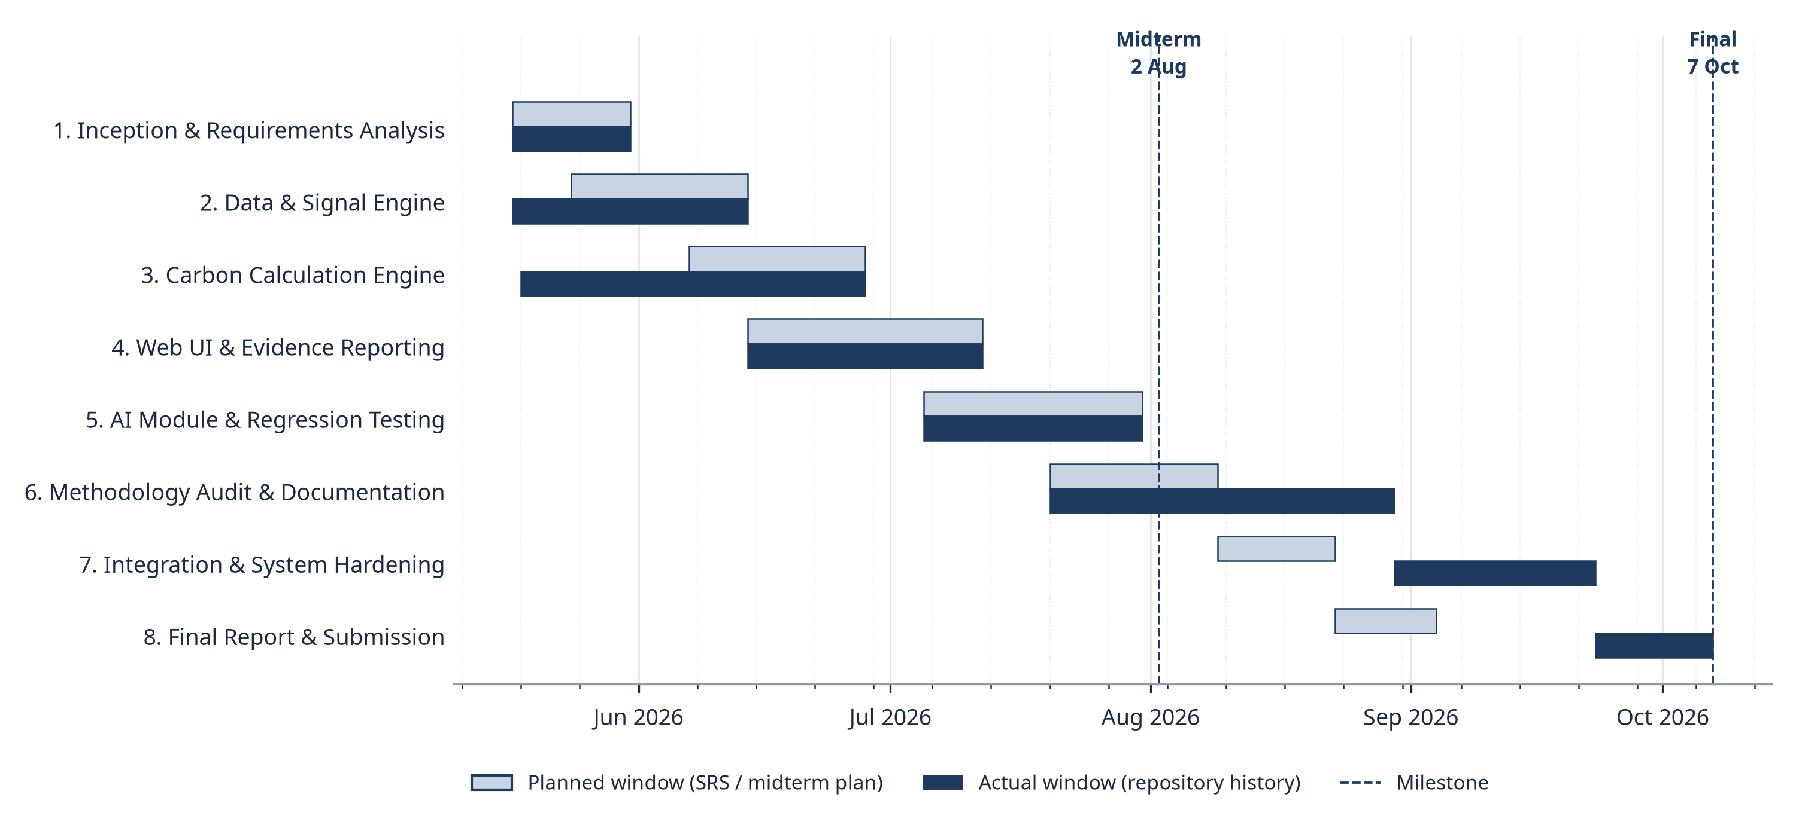Fig 1: Project timeline (Gantt chart): planned windows versus actual windows, with the midterm (2 Aug 2026) and final verification (7 Oct 2026) milestones.
Table 1: Project phases: planned and actual windows
Phase | Planned window | Actual window | Outcome
1. Inception & Requirements Analysis | 17 May – 31 May | 17 May – 31 May | Complete; scope grew from a single-user prototype to a multi-user MRV platform.
2. Data & Signal Engine | 24 May – 14 Jun | 17 May – 14 Jun | Complete; durable signal jobs, cache versioning and smoothing.
3. Carbon Calculation Engine (VM0051 QA3) | 07 Jun – 28 Jun | 18 May – 28 Jun | Complete for the scoped VM0051 v1.1 QA3 pathway.
4. Web UI & Evidence Reporting | 14 Jun – 12 Jul | 14 Jun – 12 Jul | Streamlit replaced by Next.js + FastAPI; review and export workflows.
5. AI Module & Regression Testing | 05 Jul – 31 Jul | 05 Jul – 31 Jul | RF/XGBoost with field-grouped evaluation; managed crop models.
6. Methodology Audit & Documentation | 20 Jul – 09 Aug | 20 Jul – 30 Aug | Bundles, corrections, readiness and the VM0042/VMD0054 ALM pathway.
7. Integration & System Hardening | 09 Aug – 23 Aug | 30 Aug – 23 Sep | Organizations/roles, durable jobs, snapshots, internal review.
8. Final Report & Submission | 23 Aug – 04 Sep | 23 Sep – 07 Oct | Final report; full verification re-run on 7 Oct 2026.
Phases 1–5 finished close to plan and were reported at the 2 August midterm. Methodology work (phase 6) expanded substantially after the midterm—methodology bundles, corrections, readiness and the VM0042/VMD0054 ALM pathway—so integration, hardening and the final report moved to September and early October. The extension produced the multi-user system, durable jobs, versioned snapshots and internal review described in this report.

1.7 Organization of the Report
Chapter 2 reviews background on AWD, SAR-based rice monitoring and the Verra methodologies. Chapters 3–5 present the requirements, scenario-based models and data-based models. Chapters 6–8 cover class-based modeling, architectural design and component-level design, including the behavioral and deployment models. Chapter 9 describes the AI engineering design, Chapter 10 the interface design, Chapter 11 the final implementation and Chapter 12 testing. Chapter 13 is the user manual with deployment and repository details, and Chapter 14 evaluates the system and concludes the report.

2. Background and Related Work

2.1 AWD Irrigation and Rice Methane
Flooded rice fields emit methane because waterlogged soil creates anaerobic conditions that favour methanogenic microbes. Alternate Wetting and Drying (AWD) lets the field water level fall below the soil surface before re-irrigation, interrupting these conditions and reducing methane emissions while maintaining yield when practised correctly [9]. Verra VM0051 v1.1 quantifies emission reductions from improved rice management using IPCC water-regime, pre-season and organic-amendment scaling factors [1], [4]; its QA3 default-factor approach is applicable only to projects below 60,000 tCO2e per year.

2.2 Satellite Monitoring of Rice Fields
Synthetic aperture radar (SAR) suits rice monitoring because C-band backscatter responds to standing water and canopy structure and is unaffected by cloud cover. Flooded fields show low VV backscatter because of specular reflection, and backscatter rises as the canopy develops [13], [14]. Sentinel-1 provides free dual-polarized (VV/VH) C-band observations with a 6–12 day revisit [7], [15], and Google Earth Engine offers planetary-scale access to the Sentinel-1 GRD archive [8], [16]. Terra-Audit uses these properties to detect flooding and drydown events, but treats them as supporting evidence because revisit gaps cannot observe every drainage event.

2.3 Carbon Methodologies and Digital MRV
VM0042 v2.2 credits improved agricultural land management through soil organic carbon (SOC) change, non-SOC emission sources and uncertainty deductions, while VMD0054 v1.1 estimates leakage from displaced agricultural production [2], [3]. Conventional MRV for such projects relies on spreadsheets and manually collected documents, which separate the reported number from its evidence, methodology version and calculation history. Digital MRV aims to keep evidence, calculations and review decisions connected and reproducible. Validation and verification remain the responsibility of an accredited VVB under the Verra VCS Program [6].

2.4 Gap Addressed by Terra-Audit
Remote-sensing workflows and carbon-accounting spreadsheets are usually separate tools, so reviewers must reconcile satellite outputs, field evidence and calculations by hand. Terra-Audit combines (i) satellite-derived AWD evidence, (ii) structured ALM evidence, (iii) deterministic methodology engines, (iv) methodology readiness that never treats unsupported requirements as satisfied and (v) immutable, versioned calculation snapshots with internal review in a single multi-user web application.

3. Requirements Analysis

3.1 Requirements Inception
The original SRS established Terra-Audit around the need to make agricultural MRV evidence more traceable and less dependent on disconnected manual records. During implementation, that problem expanded from a single-user rice prototype into a multi-user platform covering project/field management, structured evidence, two scoped carbon-accounting pathways, methodology readiness, durable processing, internal review, and AI-assisted analysis. The final requirements therefore retain the original evidence-first motivation while reflecting the capabilities and constraints of the final implementation.
Requirement elicitation combines the earlier SRS and midterm analysis with implementation evidence from the final system. Carbon-project users need transparent calculations and evidence history; researchers need reproducible satellite/ML workflows; reviewers need explicit readiness and provenance; administrators need secure, observable operations; and external VVB/Verra processes remain outside the application authority boundary. Requirements that cannot be fully automated are represented as partial, unsupported, blocking, or human-review dependent rather than being treated as silently complete.

3.2 Functional Requirements
Table 2: Functional requirements and priorities
ID | Requirement | Priority
FR1 | Provide authenticated account access and account-recovery flows; derive the active organization from the authenticated user rather than from a client-selected tenant identifier. | Must
FR2 | Create and manage projects, farms, and fields; register each field with a supported geometry and an immutable accounting pathway (rice_awd or cropland_alm_vm0042), and maintain dated project/farm memberships. | Must
FR3 | For rice fields, request Sentinel-1 VV/VH observations for a monitoring window, reuse compatible cached or active work where possible, and otherwise execute acquisition/processing through the durable signal-job workflow. | Must
FR4 | Process rice time-series with the implemented smoothing, flood/drydown and phenology logic, and retain threshold-based detection as the deterministic reference path for experimental AWD ML models. | Must
FR5 | Record crop seasons with correction/version history and associate field observations, practice events, monitoring runs, reviews, data-quality issues, and evidence attachments with the appropriate field/season context. | Must
FR6 | For cropland ALM fields, record baseline/project practices, production records, livestock schedules, soil sampling plans, strata, samples, laboratory results, custody events, and reviewed SOC evidence required by the supported calculation scope. | Must
FR7 | Calculate the implemented VM0051 v1.1 QA3/default-factor rice result deterministically, including supported CH₄ scaling, uncertainty and irrigation-change N₂O terms, while exposing unsupported methodology elements separately from the numerical calculation. | Must
FR8 | Calculate the implemented VM0042 v2.2 ALM subset from frozen evidence, including supported SOC, uncertainty, selected non-SOC emission terms, integrated livestock terms, and restricted VMD0054 v1.1 displacement-leakage logic. | Must
FR9 | Support experimental Random Forest/XGBoost AWD detectors and managed crop models without treating model predictions or model-versus-threshold agreement as independent scientific validation. | Should
FR10 | Provide bundle-scoped generative AI draft explanations through configured providers, using deterministic server-built context packets and server-side validation; AI output must not control accounting values, readiness, or verification decisions. | Should
FR11 | Export the formats implemented for each workflow: legacy verification PDF/JSON/CSV, versioned calculation JSON, and snapshot-backed ALM calculation PDF, while clearly distinguishing snapshot-backed outputs from legacy paths whose historical provenance is not fully frozen. | Must
FR12 | Provide field/project history and portfolio views that let authorized users inspect registered fields, current methodology path, calculation versions, latest results, and relevant project context. | Should
FR13 | Manage versioned methodology documents, bundles, corrections, project applicability, and deterministic readiness requirements for the supported accounting pathways. | Must
FR14 | Persist each new calculation as a versioned record with frozen evidence/input/result/readiness context and supersession metadata so later evidence or calculation changes do not silently rewrite historical numerical payloads. | Must
FR15 | Allow eligible calculation versions to enter an internal review workflow with submissions, reviewer assignments, review events, findings, comments, and notifications. | Should
FR16 | Provide portfolio and operational views for project/calculation summaries, methodology/source coverage, configured AI providers, background jobs, and worker status. | Should
FR17 | Enforce organization scoping and project-role permissions for supported workflows while allowing permitted updates to editable project/field metadata without changing immutable accounting-pathway identity. | Must
FR18 | Execute long-running signal and AI work through the durable database-backed queue with worker heartbeat, retry, cancellation, and failure states rather than relying on in-request synchronous execution. | Must

3.3 Non-functional Requirements
Table 3: Non-functional requirements and verification targets
ID | Category | Requirement | Verification
NFR1 | Security & Identity | Authentication secrets and credentials must be protected; production configuration must reject weak/default JWT secrets, and account tokens must be validated against the current active user and token-version state. | Authentication/account-access tests plus configuration and security-code review.
NFR2 | Authorization & Tenant Isolation | Tenant identity must come from authenticated server state, and project/role authorization must be enforced for protected operations; any endpoint that remains organization-scoped rather than uniformly project-member-scoped must be documented as a limitation. | Tenant/auth regression tests and endpoint-level authorization review.
NFR3 | Auditability & History | Saved calculations must retain frozen evidence/input/result/readiness context and a version chain sufficient to review historical results without silently recomputing them from current evidence. | Calculation/snapshot/export regression tests and historical-version comparisons.
NFR4 | Reproducibility | Deterministic accounting and scoped fingerprints must be reproducible from stored values and stable canonical serialization; software/model versions and provenance limitations must be disclosed where complete executable provenance is not yet captured. | Golden-value tests, fingerprint tests, snapshot/version tests, and code review of version/provenance fields.
NFR5 | Methodology Integrity | Unsupported, incomplete, or reviewer-dependent methodology requirements must remain explicit and must not be silently interpreted as satisfied, zero, or externally verified. | Methodology/readiness tests and review of blocking/unsupported requirement behavior.
NFR6 | External-Service Resilience | External-service failures (Earth Engine, email, storage, AI provider, worker availability) must degrade through actionable application/job states rather than exposing raw failures as successful results. | Job/API tests, fault-path review, and operational/manual service checks.
NFR7 | Availability & Job Durability | Long-running analytics and AI work must be decoupled from request lifetimes through the durable queue, with persisted pending/running/completed/failed/cancelled state, retries where supported, and worker heartbeat visibility. | Durable-job tests, worker CLI checks, and job-state UI/API verification.
NFR8 | Maintainability | Domain packages must remain separated by capability (accounts, projects, evidence, methodology, carbon, signals, jobs, AI, persistence, reporting) so API/frontend changes do not become calculation authority. | Architecture/code review plus full regression suite.
NFR9 | Portability & Migration Transparency | The system must support local/test SQLite and hosted PostgreSQL configurations without changing domain behavior; deployment-specific limitations and unverified migration paths must be stated explicitly. | Fresh/repeated SQLite initialization tests, representative legacy-upgrade test, and deployment/migration review.
NFR10 | Privacy & Storage | Private evidence/model artifacts must be accessed through authenticated application paths, use sanitized storage keys/checksums, and avoid exposing tenant files as public static assets; shared-storage/backup limitations must be disclosed. | Attachment/storage tests, authenticated-download review, and backup/restore script review.
NFR11 | Usability & Accessibility | Important UI states—loading, queued, running, blocked, permission denied, validation failure, completed, failed and retry—must be visible and understandable without relying on color alone. | Frontend tests, ESLint, responsive/UI review, and final-state screenshot inspection.
NFR12 | Scientific Validity | Satellite/ML outputs must be represented as experimental/supporting evidence unless independently validated; software tests or model-versus-threshold metrics must not be described as proof of real-world AWD accuracy. | Review of detector-label provenance plus explicit scientific-validation status in the report.
NFR13 | Deployment & Operations | Supported deployment topology, external dependencies, storage/database configuration, and backup/recovery assumptions must be documented separately from what has actually been verified live. | Deployment checks, configuration review, worker/CLI checks, and explicit verified-vs-supported reporting.
NFR14 | Testability | The final verification process must pass the current backend/core regression suite and frontend test/build/type checks, while any unexecuted scientific, browser-E2E, PostgreSQL, provider, or external-service validation remains explicitly separate. | Re-run on 7 October 2026: backend 177 passed, 0 failed, 0 skipped; frontend tests, build and TypeScript pass; ESLint 0 errors, 5 warnings.

3.4 Stakeholders and Viewpoints
Table 4: Stakeholders and viewpoints
Stakeholder | Interest
Carbon Project Developer / Project Lead | Creates and manages project context, registers fields, coordinates evidence, runs scoped calculations, reviews readiness/history, and prepares exports; project contributors/viewers receive narrower role-based access.
Researcher / Data Scientist | Builds/evaluates experimental AWD and crop models, studies satellite/threshold behavior, and distinguishes model agreement from independently validated agronomic accuracy.
Internal Reviewer | Reviews eligible calculation versions inside Terra-Audit, records findings/comments/events, and checks evidence/readiness context; this role is internal and is not a substitute for a VVB.
Program Operator (farmer cooperative / NGO) | Coordinates enrollment and field/evidence collection across participating farms and uses the platform to prepare project records for downstream review.
Farmer / Landholder | Owns or manages enrolled land and provides or confirms agronomic, production, livestock, soil, irrigation, and other field evidence used by project staff.
System Operator / Administrator | Maintains application configuration, methodology sources, provider permissions, worker/queue operations, database/storage settings, and operational/backup tooling.
External Validation/Verification Body (VVB) / Verra Process | Independently evaluates methodology applicability, evidence, monitoring, calculations, safeguards and verification requirements outside the application. Terra-Audit internal review and estimated quantities do not constitute VVB verification or Verra-issued VCUs.
External Data and AI Services | Google Earth Engine/Copernicus provide satellite observations, while configured AI/email/storage services support optional platform functions; their availability and credentials constrain runtime behavior.

3.5 Quality Function Deployment
The final QFD groups the functional requirements in Table 2 by user value without duplicating their full specification. Normal requirements are the essential access, evidence, accounting, readiness, versioning, export and durable-job capabilities (FR1, FR2, FR5-FR8, FR11, FR13, FR14, FR17, FR18). Expected requirements cover traceable signal processing, history/portfolio, internal review and operational visibility (FR3, FR4, FR12, FR15, FR16). Exciting requirements are the experimental ML and bounded generative-AI capabilities (FR9, FR10), which remain outside deterministic accounting and external verification authority.

Traceability runs from stakeholder need → QFD category → FR ID and priority → implementing component (Chapter 7) → verification evidence (Chapter 12).

3.6 Usage Scenarios and User Stories
US1 — Project lead: create/select project context, register fields, assign members, organize evidence and save versioned calculations so every result remains tied to an authorized project and field.

US2 — Rice/ALM project user: collect the pathway-specific signal or structured practice/SOC/production/leakage evidence needed for the scoped VM0051 or VM0042 calculation, while retaining source context and blocking incomplete requirements.

US3 — Reviewer: inspect methodology readiness, frozen calculation versions, evidence context, findings and history so unresolved requirements remain visible and later evidence does not silently rewrite historical numerical results.

US4 — Researcher or authorized AI user: compare experimental threshold/ML outputs or request grounded draft explanations while keeping model agreement and AI text distinct from scientific validation, accounting authority and external verification.

US5 — Administrator: monitor methodology sources, provider permissions, jobs and worker state so background/external-service failures can be diagnosed without being presented as successful work.

4. Scenario-Based Modeling

4.1 Use Case Diagrams
Use-case modeling describes the externally visible goals that Terra-Audit actors achieve. Primary actors are project users (lead, contributor, viewer), researchers, internal reviewers and administrators. Google Earth Engine, the AI provider and the email service are external systems; the database and storage are internal and are not modeled as actors. VVB and Verra processes lie outside the system boundary.

4.1.1 Use Case Level 0: System Context
At Level 0 the whole platform is a single use case (Fig 2). Every human actor interacts with Terra-Audit, which in turn depends on three external systems.
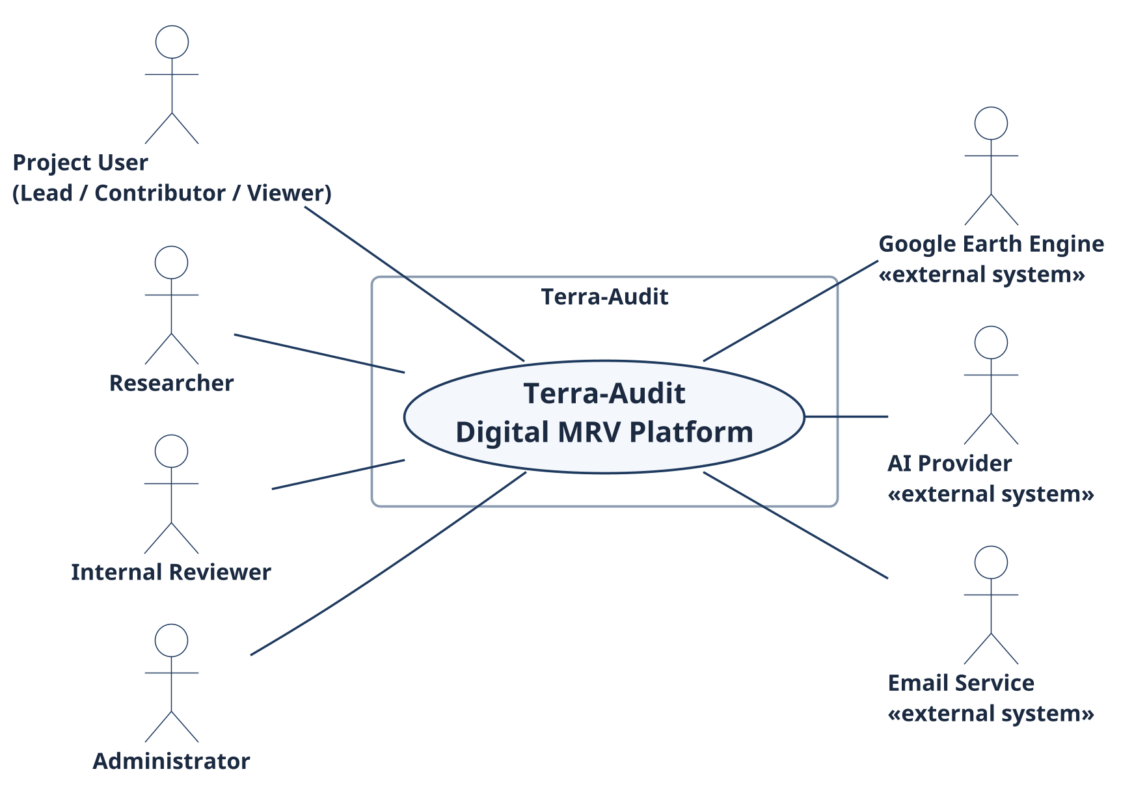
Fig 2: Use Case Level 0 — Terra-Audit as a single system with its actors and external systems.

4.1.2 Use Case Level 1: Modules of Terra-Audit
Level 1 decomposes the platform into ten user-goal modules (Fig 3); Table 5 maps each module to its actors.
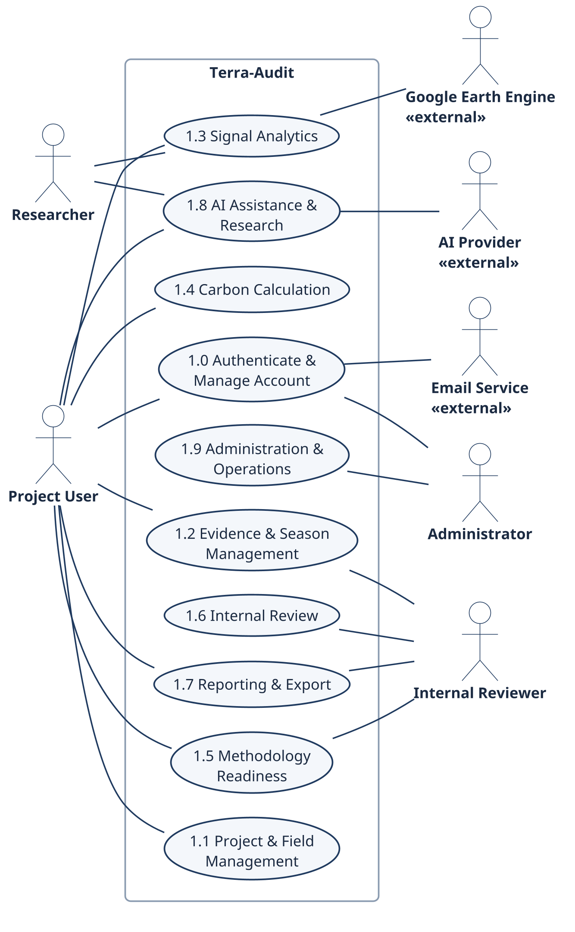
Fig 3: Use Case Level 1 — the ten user-goal modules and their actors.
Table 5: Use-case inventory and actor mapping
ID | Use Case | Primary Actor | Secondary Actor / System | Figure
L0 | Terra-Audit Digital MRV Platform | All human actors | Earth Engine, AI provider, email | Fig 2
1.0 | Authenticate & Manage Account | Project User, Administrator | Email service (Brevo) | Fig 3
1.1 | Project & Field Management | Project Lead / Contributor | — | Fig 3
1.2 | Evidence & Season Management | Project User, Internal Reviewer | — | Fig 3
1.3 | Signal Analytics | Project User, Researcher | Google Earth Engine | Fig 3
1.4 | Carbon Calculation | Project User | — | Fig 3, Fig 4
1.5 | Methodology Readiness | Project User, Internal Reviewer | — | Fig 3
1.6 | Internal Review | Internal Reviewer, Project Lead | — | Fig 3
1.7 | Reporting & Export | Project User, Internal Reviewer | — | Fig 3
1.8 | AI Assistance & Research | Project User, Researcher | AI provider | Fig 3
1.9 | Administration & Operations | Administrator | Durable job queue / worker | Fig 3

4.1.3 Use Case Level 2: Carbon Calculation
Fig 4 refines module 1.4. Preview and commit both include input selection; a commit additionally builds a frozen evidence snapshot, runs the pathway engine (VM0051 for rice_awd, VM0042 with VMD0054 leakage for cropland ALM) and evaluates readiness. Reusing saved signal evidence and superseding a prior version are optional extensions.
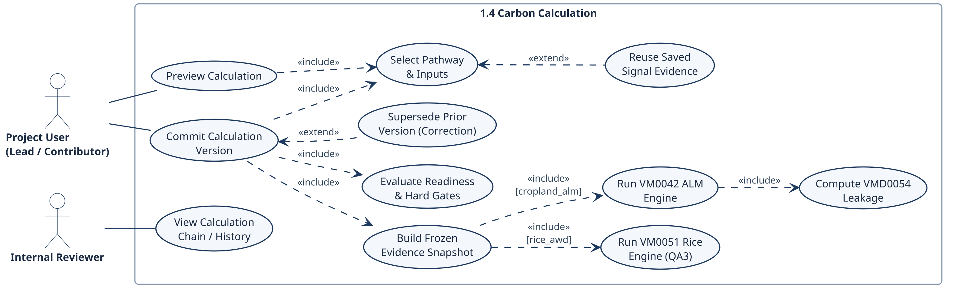
Fig 4: Use Case Level 2 — Carbon Calculation (1.4) with «include» and «extend» relationships.

4.1.4 Use Case Descriptions
Table 6 specifies the actor, precondition, normal flow, alternative/error flow and postcondition of each Level-1 use case.
Table 6: Detailed use-case specifications
Use Case | Actor(s) | Precondition / Trigger | Normal Flow | Alt. / Error Flow | Postcondition
Authenticate & Manage Account | Any user; Administrator | Registered or invited email address | Request OTP or sign in → bcrypt check → JWT stored in httpOnly session → organization and role loaded | Wrong credentials → 401; revoked token version → sign in again; email not configured → OTP unavailable | Authenticated session bound to the user's organization
Project & Field Management | Project Lead / Contributor | Authenticated organization/project context. | Create/select project → manage members → register field/geometry → assign project/farm membership → update permitted metadata. | Invalid geometry, duplicate/invalid input, or insufficient permission → no write and actionable error. | Authorized project/field context persisted.
Evidence & Season Management | Project User / Internal Reviewer | Field exists; authorized evidence context. | Create/correct season → observations/practice events → attachments → soil/lab/custody → production/livestock evidence. | Validation, permission, storage, or missing-required-data errors remain visible; corrections append history rather than silently replacing prior versions. | Versioned evidence state available to readiness/calculation workflows.
Signal Analytics | Project User / Researcher | rice_awd field and monitoring window selected. | Reuse compatible active/cache result where possible → otherwise enqueue signal_run → worker queries Earth Engine → process threshold/ML detector → store result. | Earth Engine, worker, empty-data, detector, or authorization failure → job/error state; no successful result is fabricated. | Completed signal result or explicit failed/cancelled state is available.
Carbon Calculation | Project User | Registered field plus pathway-specific inputs/evidence. | Select pathway and inputs → optionally use saved signal → build snapshot → run VM0051 or VM0042/leakage → evaluate gates/readiness → save version. | Invalid inputs, unsupported/applicability conditions, leakage/SOC hard blocks, or unresolved readiness prevent a ready-for-review state. | Versioned draft or ready-for-review calculation is persisted.
Methodology Readiness | Project User / Internal Reviewer | Active methodology bundle and project/field context. | Resolve bundle/applicability → evaluate registered requirements/corrections → calculate fingerprint/readiness → expose blockers and reviewable items. | Unsupported or automated-only requirements cannot be silently overridden; stale evidence changes the fingerprint/state. | Current readiness and blocking evidence context is displayed/stored.
Internal Review | Project Lead / Internal Reviewer | Specific calculation version is ready_for_review. | Submit calculation → assign reviewer → record review events/findings/comments → resolve or track findings. | Blocked/draft calculation cannot enter normal review; authorization failures are rejected. | Version-pinned internal review trail is retained.
Reporting & Export | Project User / Internal Reviewer | Calculation/history context exists and user is authorized. | Select the relevant verification or calculation record → choose an export format actually available for that record → inspect history/portfolio context → download. | Unsupported export, missing context, or legacy provenance limitation is disclosed rather than silently substituted. | Supported evidence/report artifact is downloaded with stated provenance limits.
AI Assistance & Research | Researcher / Authorized User | Authorized project context plus evidence/methodology context or a research dataset. | Build/evaluate AWD or crop models, or request AI explanation → build deterministic packet → provider/job → validate citations/numbers → retain draft. | Missing provider/permission/data, oversized packet, or failed validation → warning/failed job; no authoritative decision is written. | Research metrics or a validated human-review draft is available.
Administration & Operations | Administrator | Administrative authorization. | Manage methodology sources/provider permissions → inspect jobs/workers → retry/cancel supported jobs → use operational/backup tooling. | Permission, stale worker, external-service, or configuration failure remains visible and does not masquerade as success. | Operational configuration and monitoring state are updated or an explicit failure remains.

4.2 Activity Diagrams
The activity diagrams describe the implemented control flow. Swimlanes separate the user, the server and the durable worker; blocked states are shown explicitly so that failed services or incomplete methodology requirements never appear as successful MRV outcomes.
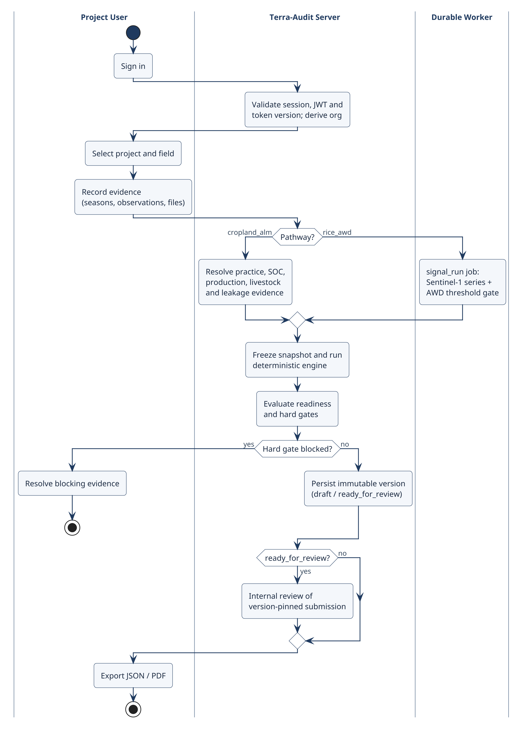
Fig 5: Overall activity diagram with swimlanes for the project user, the Terra-Audit server and the durable worker.
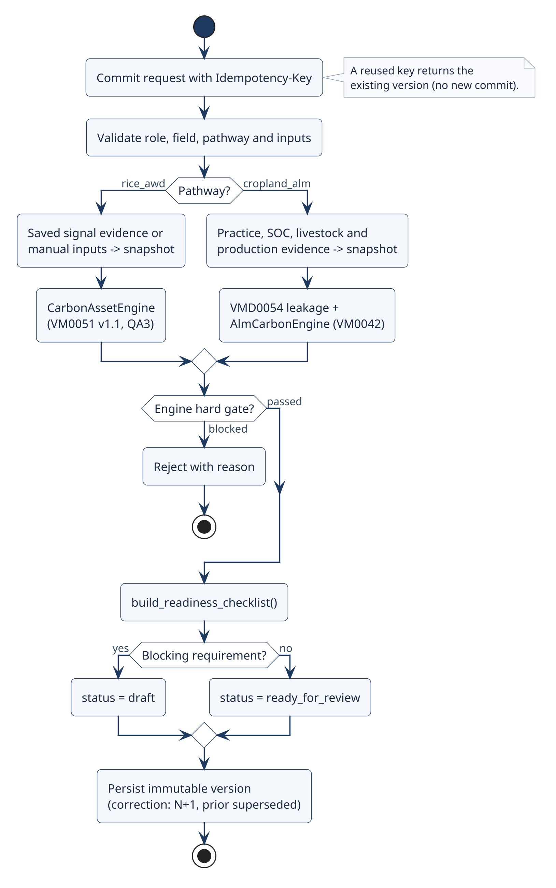
Fig 6: Activity diagram — versioned carbon calculation commit.
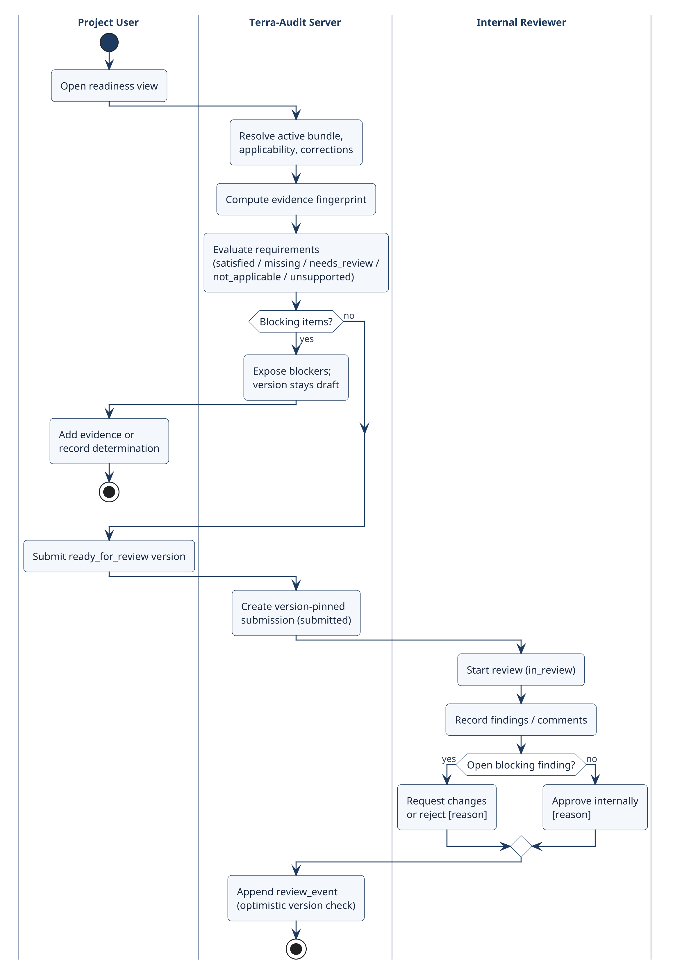
Fig 7: Activity diagram — methodology readiness and internal review with swimlanes.

4.2.1 Cropland ALM Detailed Activity Flow
The final ALM flow begins with an organization/project-scoped cropland_alm_vm0042 field and dated project membership. Users record baseline/project crop seasons and practice schedules, optional supported livestock schedules, production records, soil sampling plans/strata/samples, laboratory results, custody events, and reviewed SOC mappings (or explicitly identified legacy aggregate SOC evidence). A project/bundle/reporting-period leakage assessment is then saved. The calculation workflow builds a frozen snapshot containing the relevant practice, production, leakage and SOC evidence; the restricted VMD0054 v1.1 adapter computes the supported displacement-leakage term; and the scoped VM0042 v2.2 engine evaluates SOC/non-SOC terms, uncertainty, allocation and buffer logic. Readiness and engine hard gates are evaluated before a versioned calculation is persisted. Only a ready_for_review version can enter internal review. Snapshot-based ALM PDF and calculation JSON exports can then be generated. Current restrictions—including single-field leakage scope, unsupported mitigation Step 2, nonannual SOC blocking where unresolved annualization applies, and incomplete sequential-period cumulative-state reconciliation—must remain visible rather than being represented as complete methodology coverage.

5. Data-Based Modeling

5.1 Entity-Relationship Diagram
Terra-Audit uses a domain-oriented relational schema. Fig 8 shows the core entities in crow's-foot notation with their primary keys and principal reference attributes; Appendix A details the calculation and internal-review tables. Most tables are tenant-scoped through a composite (org_id, id) primary key. Relationships are logical: the SQLite schema does not declare FOREIGN KEY constraints, so scoped identifiers, application queries and authorization checks enforce referential integrity.
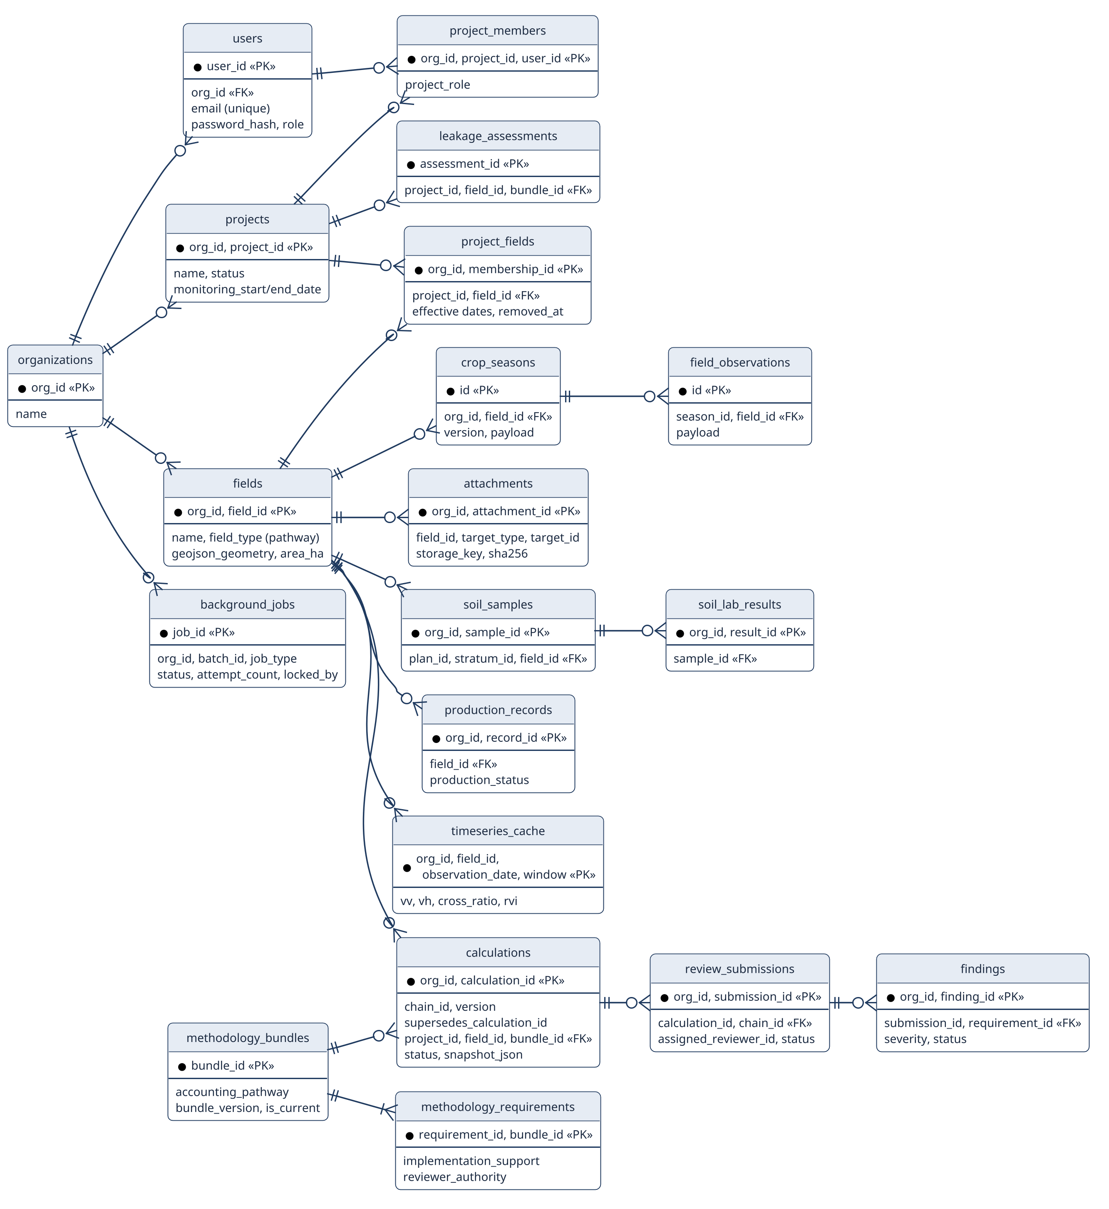
Fig 8: Entity-relationship diagram (crow's-foot notation) of the core persistent entities.

5.1.1 Relationship Summary
Identity and project context — User-to-project access is represented through ProjectMember with explicit roles. Project-to-field membership is represented through effective-dated ProjectField records, so a field is not reduced to a single project_id and assignment history can be retained.
Evidence and sampling — CropSeason, FieldObservation, ObservationReview and PracticeEvent use append-oriented field/season records. Attachments remain field-scoped and reference supported targets. The ALM soil path links sampling plans, optional strata, samples, laboratory results, custody events and reviewed SOC mappings; production records and leakage assessments provide additional field/project evidence.
Calculation provenance — Calculation records are versioned and immutable at the application level: chain_id and supersedes_calculation_id preserve correction history, while snapshot_json, inputs_json, result_json and readiness_json freeze the committed context. CalculationAttachmentRef retains protected attachment links; legacy credit history remains distinguishable from snapshot-backed calculations.
Methodology reference data — MethodologyDocument, MethodologyBundle, bundle-document membership and MethodologyRequirement form the shared registry. Tenant-specific ProjectMethodologyApplicability records bind a project/pathway to a bundle and effective period; correction/confirmation records remain separate from global source data.
Internal review — ReviewSubmission pins one immutable calculation version. Reviewer assignments, lifecycle ReviewEvents, Findings and finding comments/resolution activity belong to the internal workflow and never represent external VVB verification, Verra registration or registry issuance.

5.2 Database Schema
Table 7: Persistent database schema by domain
Domain | Important Entities / Tables | Purpose
Accounts & Identity | organizations, users, pending_registrations, account_links, account_token_versions, account_rate_limits | Tenant identity, account access/recovery, token revocation/versioning, and account-level throttling.
Projects & Land | projects, project_members, project_membership_events, farms, fields, project_fields, farm_fields, quantification_units | Project roles and dated land/field memberships; field records carry the registered accounting pathway and geometry context.
Monitoring & Evidence | crop_seasons, field_observations, observation_reviews, practice_events, monitoring_runs, data_quality_issues, attachments | Versioned crop-season history and structured monitoring/evidence records, including private evidence-file metadata.
Soil / Production / ALM | soil_sampling_plans, soil_strata, soil_samples, soil_lab_results, soil_custody_events, soc_evidence_reviews, alm_practice_schedule, alm_livestock_schedule, production_records, leakage_assessments | Structured ALM evidence for reviewed SOC, practices, production, supported livestock inputs, and restricted leakage assessment.
Calculations & Review | calculations, calculation_idempotency_keys, calculation_attachment_refs, readiness_determinations, review_submissions, reviewer_assignments, review_events, findings, finding_comments | Versioned calculation snapshots/results/readiness plus version-pinned internal review and findings history.
Methodology | methodology_documents, methodology_bundles, bundle-document mappings, methodology_requirements, project_methodology_applicability, methodology_chunks/FTS, correction links/confirmations | Methodology/version/correction registry, retrieval index, applicability context, and requirement definitions used by readiness and AI context.
Jobs / AI / Satellite | background_jobs, job_batches, workers, ai_records, ai_deployments, ai_provider_permissions, timeseries_cache, timeseries_cache_versions; lazy ai_dataset_rows / ai_dataset_versions | Durable asynchronous work, worker state, satellite cache/versioning, provider/model records, and lazily created research-dataset tables.
The SQLAlchemy connection layer supports SQLite and PostgreSQL. SQLite startup initialization contains historical additive ALTER TABLE operations and selected rebuild/copy migrations; the PostgreSQL path uses final-shape DDL plus module-specific additive changes. There is no Alembic-style versioned migration ledger. In the final software checks, fresh SQLite initialization, repeated initialization/restart, a representative legacy SQLite upgrade, and SQLite integrity checking passed. Remote PostgreSQL migration/runtime verification was not completed, and the existing SQLite-to-PostgreSQL transfer script covers only a legacy subset of the current schema.

5.3 Dataset Description (AI-Assisted Detection)
The classical AWD dataset is built from cached rice time-series and labels generated by the rule-based threshold detector rather than by independent field observations. Feature engineering uses satellite/time-series values while excluding the gate’s own decision flags as direct predictor features. Random Forest and XGBoost therefore measure model-versus-threshold agreement; their metrics cannot be interpreted as accuracy against independently observed irrigation events.
The implemented evaluation harness now requires field identifiers and uses leakage-safe GroupKFold splits so the same field is not placed in both training and validation folds. Pooled out-of-fold precision, recall, F1, confusion-matrix and ROC-style outputs are still explicitly labeled as threshold-gate agreement. Persisted model bundles also record the satellite processing version and field-grouped split strategy so stale feature versions are rejected during loading.
The principal validation risk is no longer observation-level fold leakage; the current implementation uses field-grouped evaluation. The larger limitation is label provenance: the target labels still come from the same threshold detector that the models are intended to imitate. Sparse drydown events, Sentinel revisit gaps, phenology effects, and the absence of independently observed water-level/irrigation events limit how strongly the resulting metrics can be interpreted.
Future scientific validation should compare detected flood/drydown events against independent ground truth such as water-level-tube observations, irrigation logs, or partner-verified field observations and report event-level precision/recall, timing error, false drydown rate, and performance across seasons/locations. Managed crop models are a separate exploratory feature using reviewed crop-identity labels; neither that work nor the AWD classifiers establish methodology-authoritative AWD compliance.

6. Class-Based Modeling

6.1 Analysis Classes
Candidate classes were identified with the grammatical-parse technique [17]: nouns in the usage scenarios (Section 3.6) and the SRS were listed and then filtered by whether they retain information, provide needed services, have multiple attributes and share common operations. Table 8 summarizes the decisions.
Table 8: Analysis-class identification from scenario nouns
Candidate noun(s) | Decision | Resulting design element
User, organization, project member | Accepted | accounts / projects modules; users, project_members
Project, farm, field | Accepted | projects repository; fields, project_fields
Crop season, observation, practice event | Accepted | evidence modules (append-only records)
Soil sample, lab result, production record | Accepted | soil and production evidence modules
Satellite image, backscatter time series | Accepted | SpatialDataEngine; timeseries_cache
Flooding / drydown event, phenology | Accepted | AdaptiveAWDGate
Emission reduction, carbon credit, leakage | Accepted | CarbonAssetEngine, AlmCarbonEngine, VMD0054
Calculation, snapshot, version | Accepted | snapshot / calculations module
Methodology, bundle, requirement | Accepted | methodology registry and readiness
Review, finding, comment | Accepted | reviews module
Job, worker; explanation, provider | Accepted | jobs queue + worker; AI packets / validator
Date, area, location, district | Rejected (attribute) | attributes of field / season
Dashboard, page, button | Rejected (interface) | frontend components only
VVB, Verra registry | Rejected (external) | outside the system boundary

6.2 Class Cards (CRC Model)
CRC cards record each design class's responsibilities and collaborators (Fig 9). Only implementation-backed classes and modules are shown; method-level operations appear in the design class diagram (Fig 10).
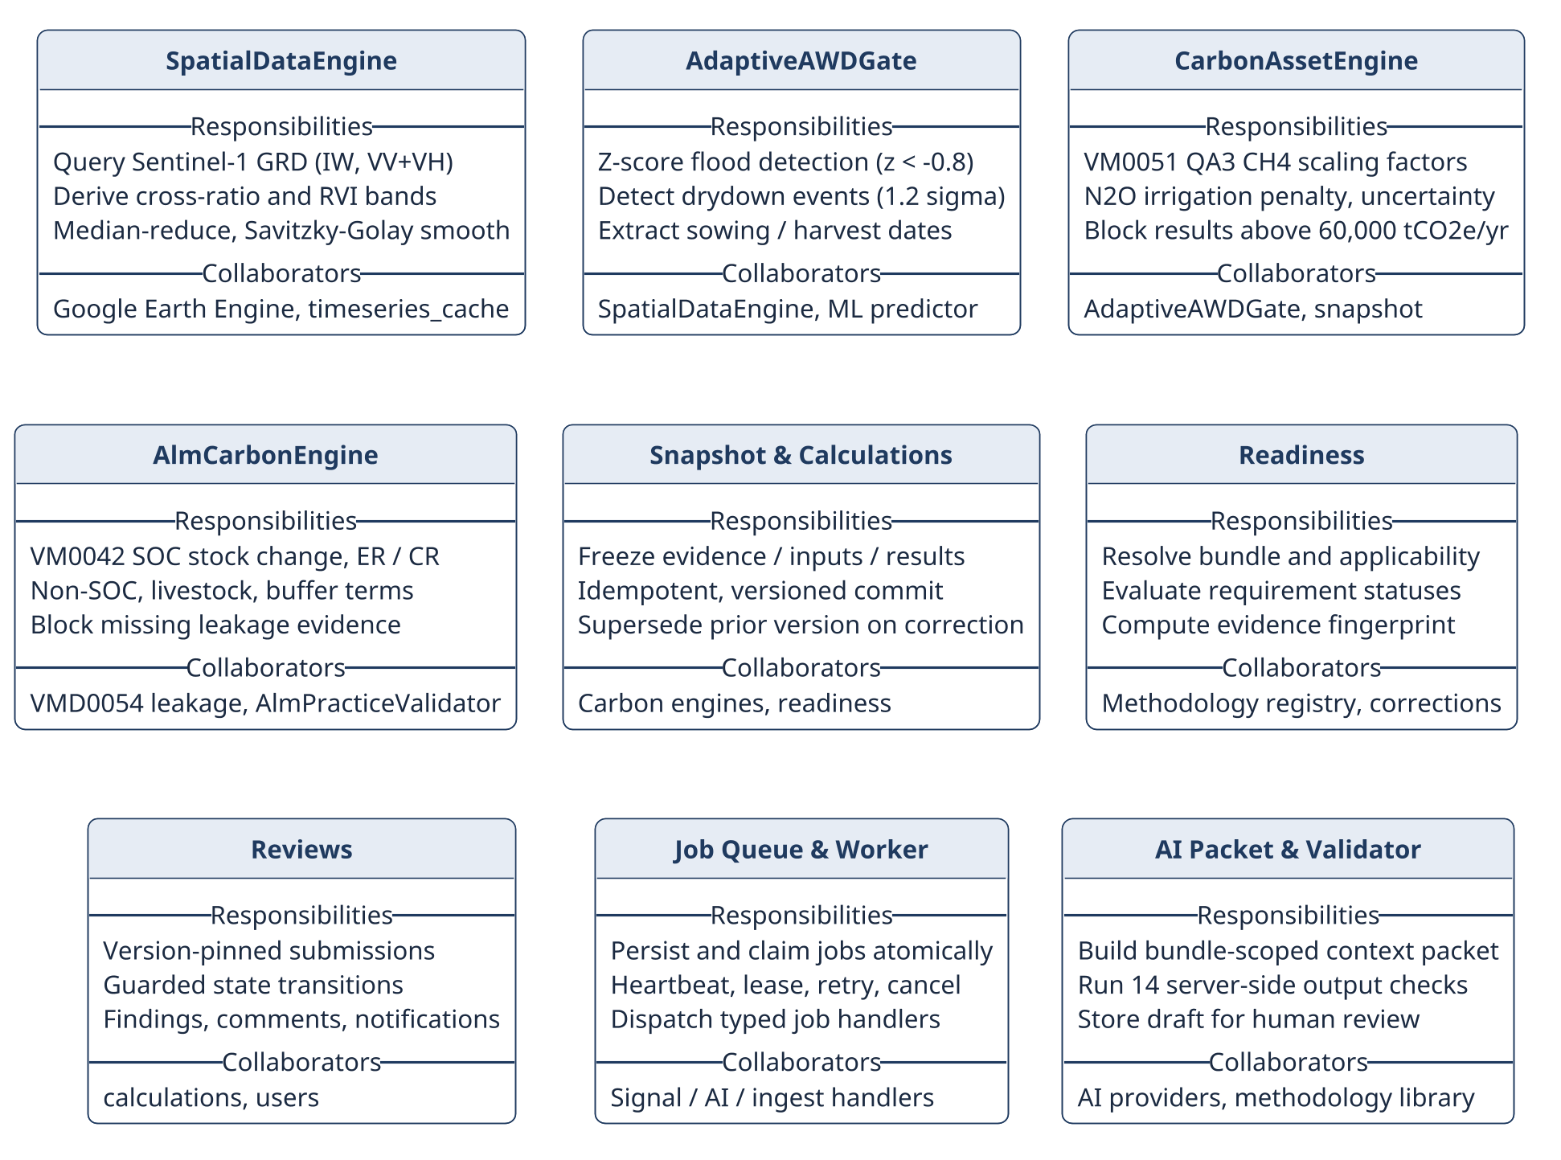
Fig 9: CRC cards for the nine core design classes.

6.3 Design Class Diagram
The implementation is modular but is not a uniform class/service/repository hierarchy. Design responsibilities are distributed across domain packages and a smaller number of classes/helpers. Important software-design units include account/authentication primitives in src/accounts and backend/security.py; project and internal-review repositories in src/projects; evidence modules for seasons, monitoring, soil and production; methodology registry/library/readiness modules; deterministic rice and ALM carbon engines; the leakage adapter; snapshot/calculation-version persistence; signal acquisition/processing; the durable job queue and worker handlers; AI packets/providers/validators and ML models; reporting; and persistence/storage.
The main authority boundary is deliberate: UI, jobs, satellite models and language models may provide inputs, analytics or explanations, but accounting values, readiness states and validation rules remain server-owned deterministic behavior. This separation reduces the risk that a probabilistic component silently changes methodology logic.
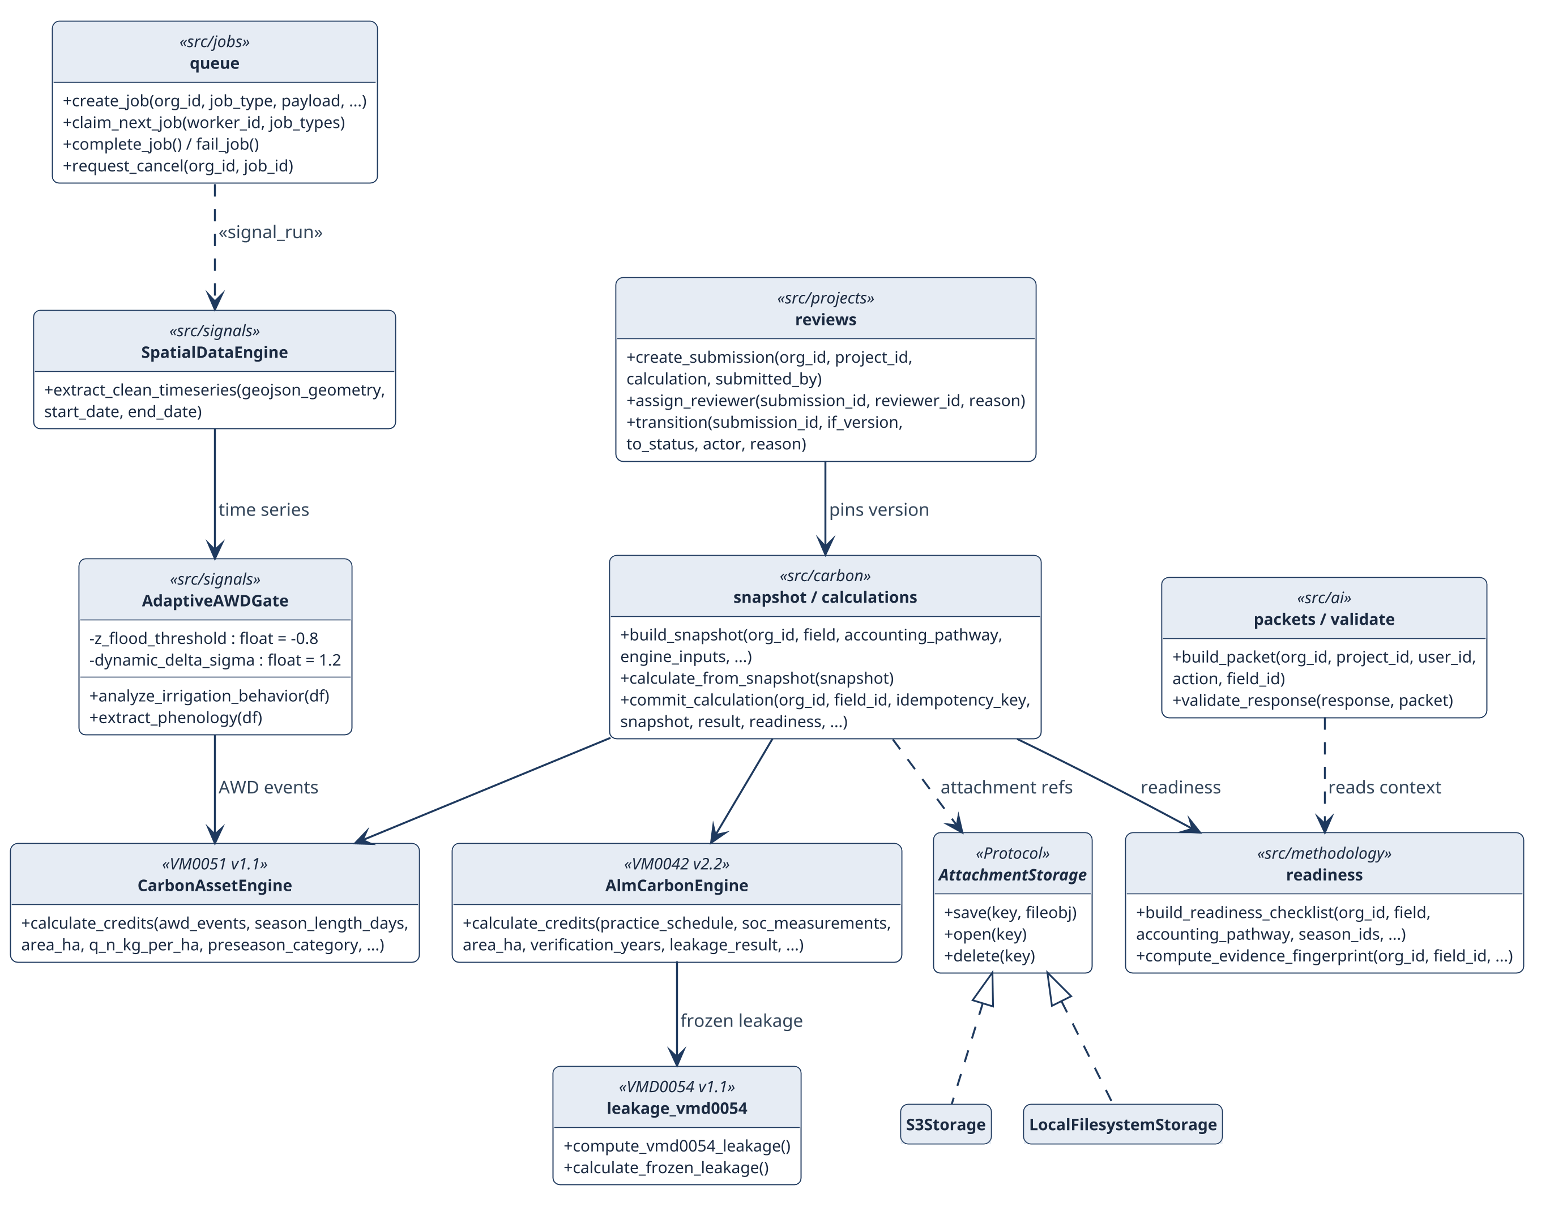
Fig 10: Design class diagram: principal classes and modules, key operations and dependencies.

6.3.1 Design Class to Implementation Mapping
The implementation is capability-oriented rather than a uniform object hierarchy, so Table 9 names the real classes and module-level operations that own each design responsibility.
Table 9: Design classes and their implementing modules
Design class | Module | Key operations | Responsibility
CarbonAssetEngine | src/carbon/rice.py | calculate_credits() | Scoped VM0051 v1.1 QA3 rice result, intermediates, hard gates
AlmCarbonEngine | src/carbon/alm.py | calculate_credits() | Scoped VM0042 v2.2 SOC/non-SOC terms, uncertainty, buffer, blocking flags
SpatialDataEngine | src/signals/earth_engine.py | extract_clean_timeseries() | Sentinel-1 VV/VH, cross-ratio and RVI series
AdaptiveAWDGate | src/signals/threshold_gate.py | analyze_irrigation_behavior(), extract_phenology() | Flood/drydown and sowing/harvest indicators
Snapshot & versioning | src/carbon/snapshot.py, calculations.py | build_snapshot(), commit_calculation() | Frozen context; idempotent immutable versions
Readiness | src/methodology/readiness.py | build_readiness_checklist() | Requirement statuses and bundle context
Internal review | src/projects/reviews.py | create_submission(), transition() | Version-pinned, guarded review transitions
Durable jobs | src/jobs/queue.py | create_job(), claim_next_job(), fail_job() | Persisted job lifecycle, lease, retry, cancel
AttachmentStorage | src/persistence/storage.py | save(), open(), delete() | Private local or S3-compatible artifacts
AI packet & validator | src/ai/packets.py, validate.py | build_packet(), validate_response() | Bounded context; server-side output checks
Reporting | src/reporting/reports.py | report generators | Legacy and snapshot-backed exports
The browser request boundary is separate: frontend/lib/api.ts sends actions through the Next.js catch-all API proxy, which reads the httpOnly session server-side and forwards an authenticated request to FastAPI. This keeps browser UI state outside the accounting and authorization authority boundary.

7. Architectural Design

7.1 Architectural Context Diagram
The architectural context diagram (ACD) [17] places Terra-Audit among the systems it interacts with (Fig 11). Superordinate systems use Terra-Audit's output: VVB validation/verification and the Verra registry consume exported evidence packages but are outside the system. Subordinate systems are used by Terra-Audit to function: Google Earth Engine, AI providers, the Brevo email API, the relational database and object storage. Peers exchange information at the same level: farm production spreadsheets imported as CSV and Verra methodology documents ingested into the methodology library. Actors are the human users.
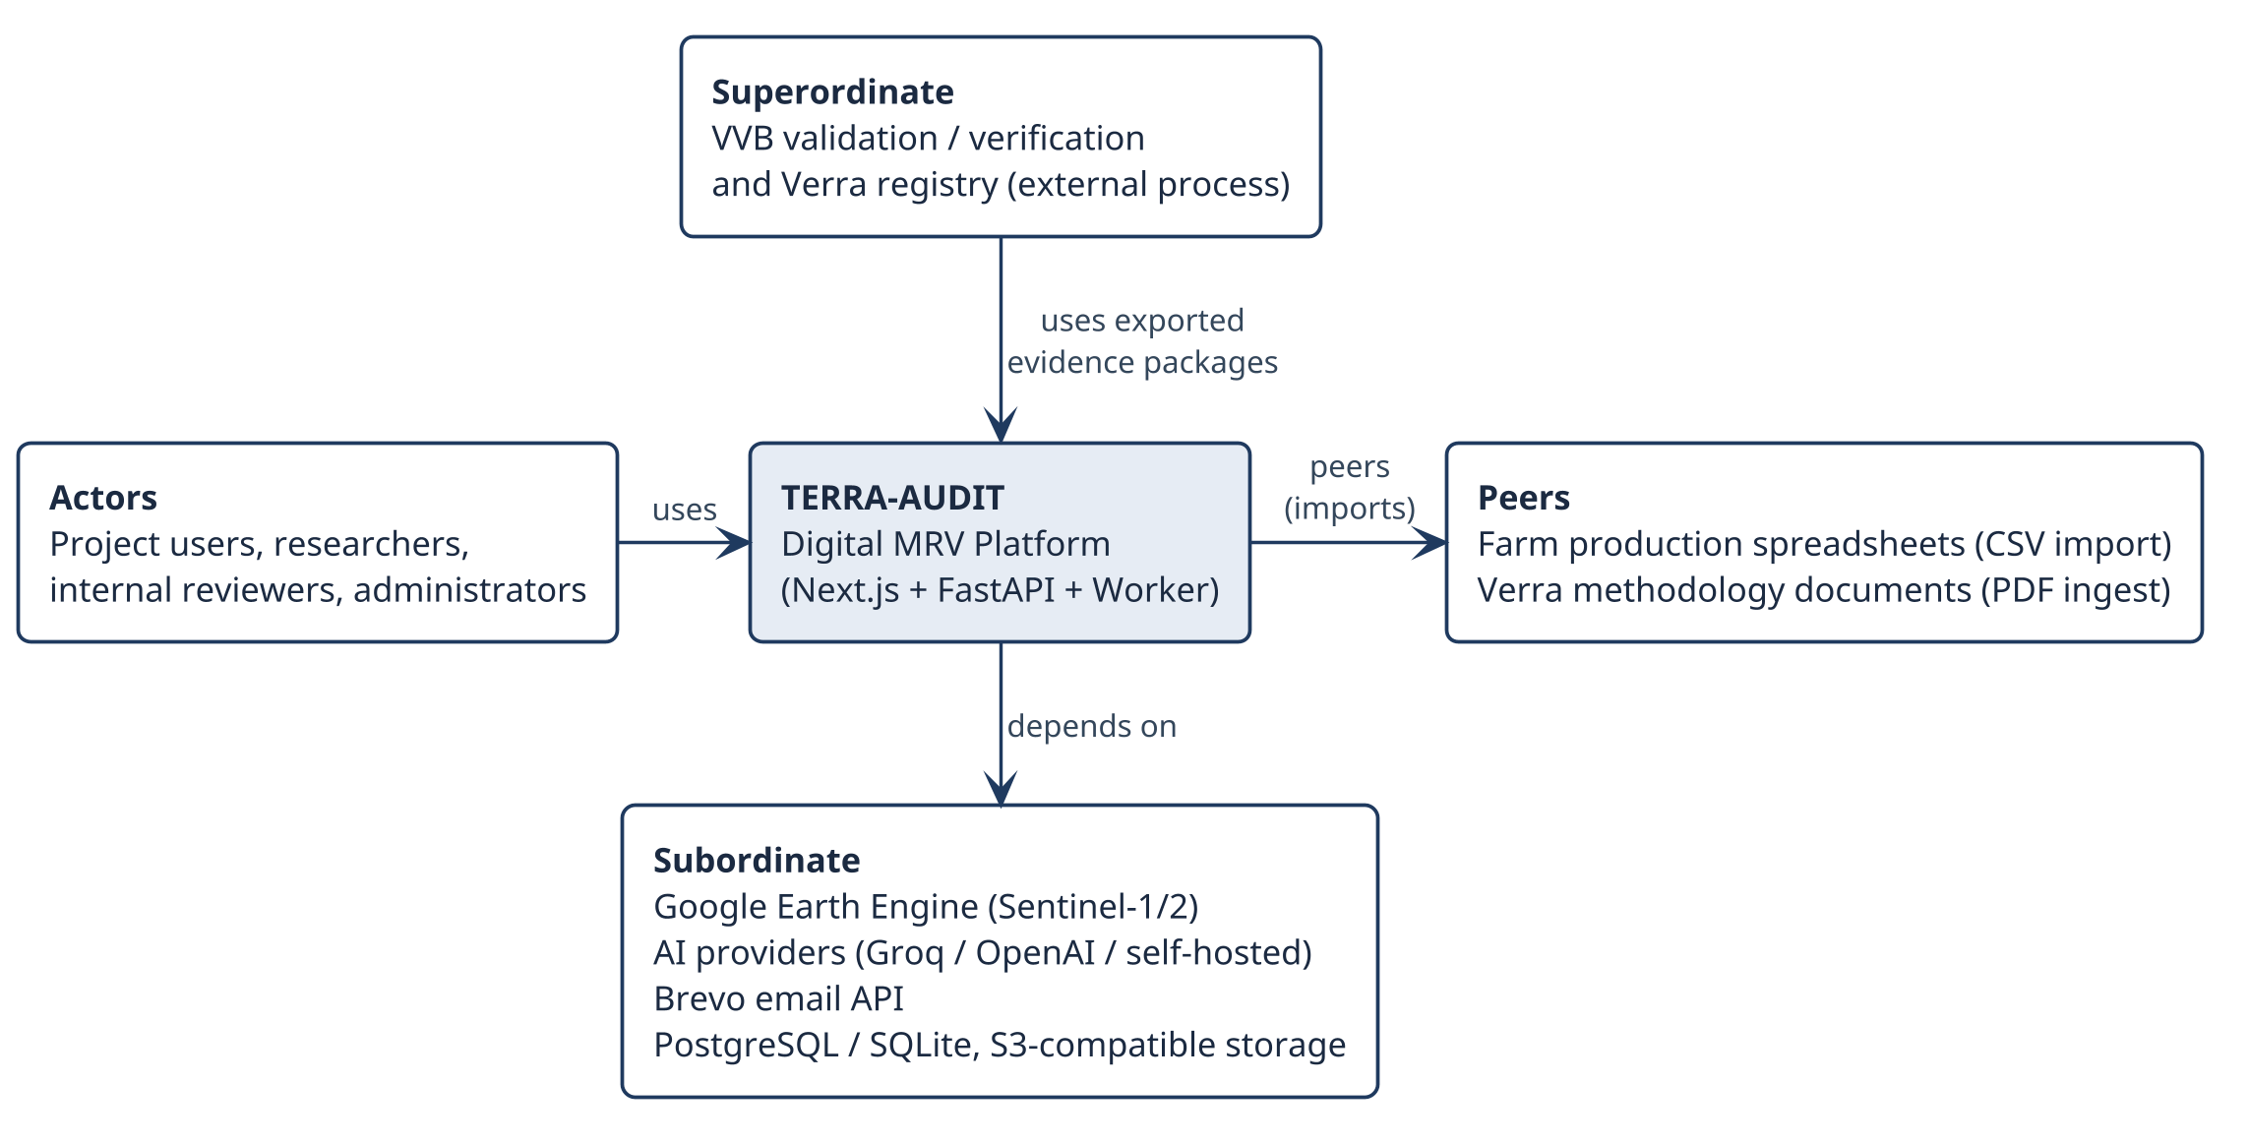
Fig 11: Architectural context diagram (ACD) of Terra-Audit.

7.2 Defining Archetypes
Two archetypes structure the system. The application as a whole follows a layered architecture (Fig 12): presentation, application/API, domain and infrastructure layers, where each layer calls only the layer below and accounting authority stays in the domain layer. The rice signal path follows the pipe-and-filter archetype (Fig 13): each filter transforms the Sentinel-1 series and passes it on, so each stage is testable on its own and a cache hit skips acquisition entirely.
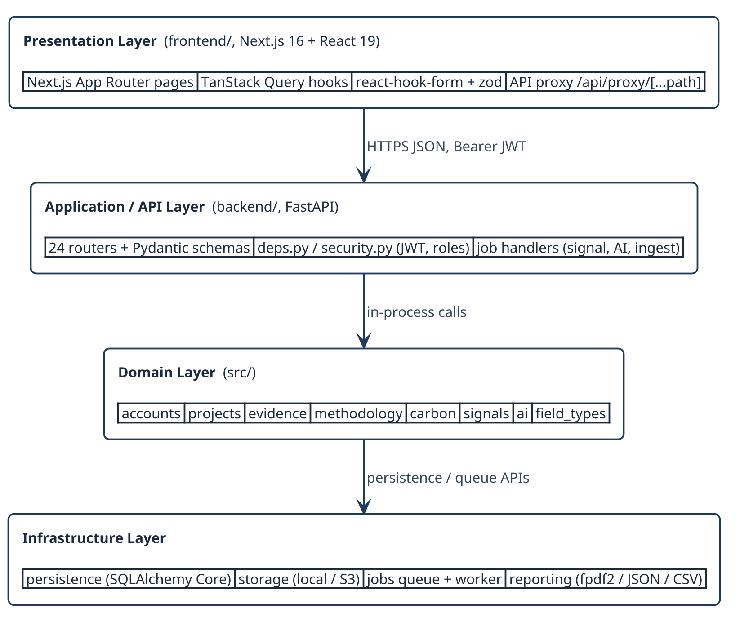
Fig 12: Layered architecture archetype instantiated for Terra-Audit.
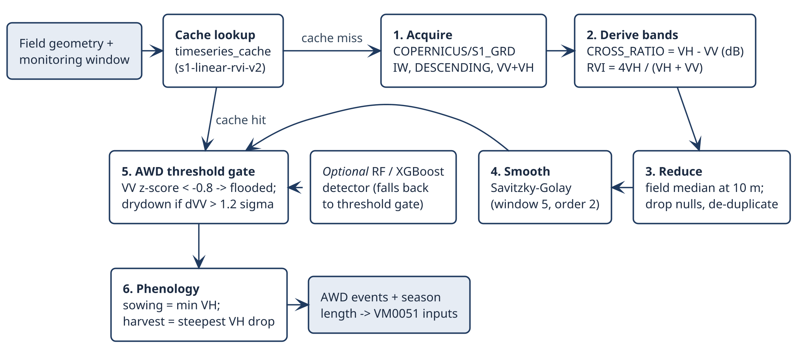
Fig 13: Pipe-and-filter archetype: the Sentinel-1 signal-processing pipeline of the rice AWD pathway.

7.3 Top-Level Components
Refining the archetypes gives the top-level components in Fig 14. A Next.js frontend calls FastAPI through an authenticated server-side proxy; FastAPI routers orchestrate shared Python domain components; long-running signal and AI work is persisted in a database-backed queue and executed by a separate worker. Deterministic accounting, readiness and server validation remain authoritative; ML and generative AI are assistive. Table 10 lists each component's responsibility.
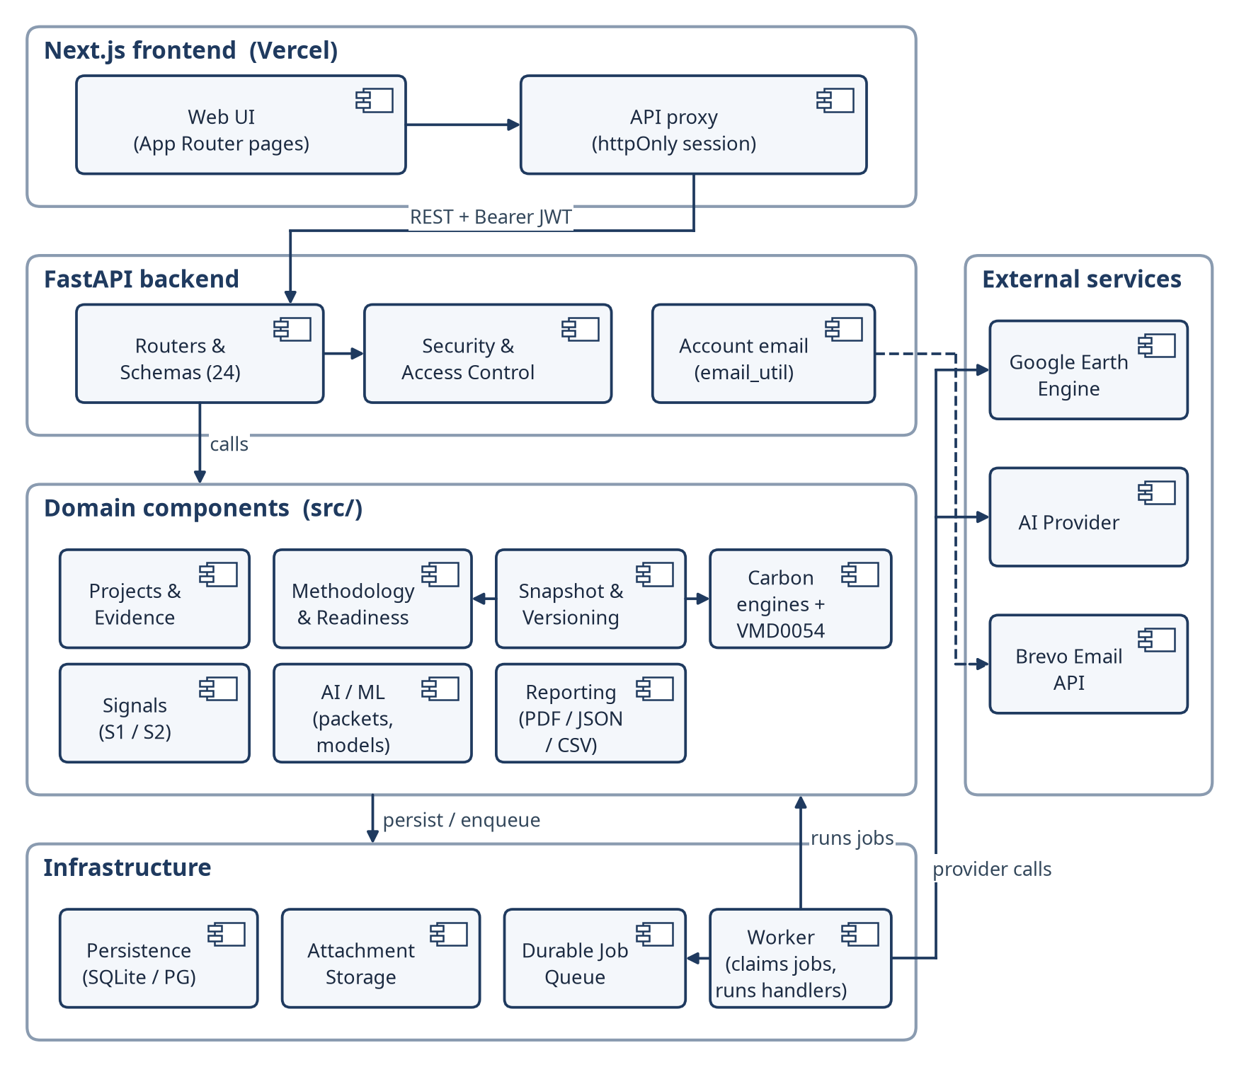
Fig 14: Top-level component diagram of Terra-Audit.
Table 10: Component responsibilities
Component | Responsibility
Next.js Frontend & API Proxy | Renders authenticated pages/components, manages client state/queries, and forwards browser requests through the server-side authenticated API proxy rather than exposing bearer tokens directly to client code.
FastAPI Routers & Schemas | Own HTTP orchestration, request/response validation, route composition, and handoff to shared domain packages.
Accounts / Security / Authorization | Implements identity, password/account-recovery flows, JWT validation, token-version checks, organization scoping, and project/admin access gates.
Projects & Evidence | Manages projects, farms, fields, memberships, crop seasons/corrections, observations, attachments, soil/SOC, production, and internal-review domain records.
Methodology & Readiness | Maintains methodology documents/bundles/corrections, project applicability, requirement definitions, retrieval chunks, evidence fingerprints, and deterministic readiness states.
Carbon Accounting & Leakage | Runs scoped VM0051 v1.1 rice and VM0042 v2.2 ALM calculations plus the restricted VMD0054 v1.1 leakage adapter; AI does not own accounting values.
Snapshots & Calculation Versioning | Builds frozen calculation context, stores inputs/results/readiness, manages idempotency and supersession/version chains, and preserves historical numerical payloads under normal application updates.
Signals / Earth Engine | Queries and processes Sentinel-1 observations, maintains compatible cache versions, applies threshold/phenology logic, and supports selected experimental ML detectors.
Durable Jobs & Worker | Persists long-running work in the database-backed queue; separate worker processes execute signal, AI, methodology-ingestion and related jobs with heartbeat/retry/cancellation state.
AI / ML / Providers / Validation | Supports classical AWD ML, managed crop models, deterministic AI context packets, provider adapters, structured-response validation, and human-review draft explanations.
Reporting & Export | Generates legacy verification PDF/JSON/CSV artifacts, versioned calculation JSON, snapshot-backed ALM calculation PDF, and history/portfolio outputs, with different provenance guarantees for snapshot-backed and legacy paths.
Persistence & Storage | Provides SQLAlchemy-backed SQLite/PostgreSQL access plus local/private S3-compatible artifact storage; application logic enforces relationships because the verified SQLite schema declares no foreign keys.

7.4 Mapping Requirements to Software Architecture
Table 11: Mapping functional requirements to architectural elements
Requirement(s) | Architectural element | Layer
FR1, FR17 | Accounts; Security & Access Control (backend/security.py, deps.py) | Application / Domain
FR2, FR5, FR6 | Projects & Evidence (src/projects, src/evidence) | Domain
FR3, FR4 | Signals pipeline + Durable Job Queue + Worker | Domain / Infrastructure
FR7, FR8 | Carbon Engines + VMD0054 leakage adapter | Domain
FR9, FR10 | AI / ML (src/ai) executed through ai_explain / ai_train jobs | Domain / Infrastructure
FR11, FR12 | Reporting; calculation history and portfolio views | Domain / Presentation
FR13 | Methodology & Readiness | Domain
FR14 | Snapshot & Versioning | Domain
FR15 | Internal review (src/projects/reviews.py) | Domain
FR16 | Operations views (queue status, product readiness) | Presentation / Application
FR18 | Durable Job Queue + Worker | Infrastructure

7.5 Technology Stack
Table 12: Technology stack
Layer | Technology | Purpose
Frontend | Next.js 16.3, React 19.2, TypeScript 5 | App Router pages and server-side API proxy
Frontend | TanStack Query 5, react-hook-form 7 + zod 4, Tailwind CSS 4 | Server state, validated forms, styling
Frontend | Leaflet 1.9 / react-leaflet 5, Recharts 3, KaTeX | Field maps and drawing, charts, equations
Backend | Python 3.12, FastAPI, Uvicorn, Pydantic | REST API and request validation
Backend | SQLAlchemy 2 (Core), SQLite / PostgreSQL (psycopg2) | Persistence
Backend | PyJWT (HS256), bcrypt | Authentication and password hashing
Analytics | earthengine-api, pandas, NumPy, SciPy, Shapely | Sentinel-1/2 acquisition, smoothing, geometry
ML / AI | scikit-learn, XGBoost, joblib; httpx to Groq / OpenAI / self-hosted LLMs | AWD and crop models; explanations
Reporting / storage | fpdf2, pypdf, boto3 | PDF export, methodology ingest, S3 storage
DevOps | Docker, docker-compose, GitHub Actions, pytest, node --test, ESLint | Build, CI and testing

7.6 Design Evolution and Alternatives
The final architecture reflects several deliberate refactorings from the midterm prototype. The Streamlit monolith was replaced by Next.js plus FastAPI so authentication, multi-user authorization, API contracts and responsive interface states could be separated from domain logic. Long-running signal and AI work moved from request-coupled execution to a durable database-backed queue with a separate worker. The old scalar/current-state calculation model evolved into versioned snapshots and readiness-aware calculation records to improve historical auditability. Methodology rules and carbon equations remain deterministic rather than being delegated to a language model; generative AI is constrained to draft explanation. SQLite remains useful for local/test work, while PostgreSQL and private object storage are supported for hosted operation. These choices increase implementation complexity but better match an evidence-centered MRV workflow than the original single-user prototype.

8. Component-Level Design

8.1 Persistent Data Sources and Interfaces
The primary transactional store is accessed through SQLAlchemy and supports SQLite for local/test use and PostgreSQL for hosted use. Private evidence attachments and managed-model artifacts can use local filesystem storage or a private S3-compatible backend. Satellite observations are retained in versioned time-series cache tables; methodology source documents are indexed into document/chunk records; background jobs and worker heartbeat state are persisted in the same database-backed queue. These sources are accessed through application modules rather than by the frontend directly.

8.1.1 Context-Level Data Flow (DFD Level 0)
At Level 0, Terra-Audit is treated as one process. The diagram shows the external actors/services and major information exchanges only; internal data stores and module-level processes are deferred to Level 1.
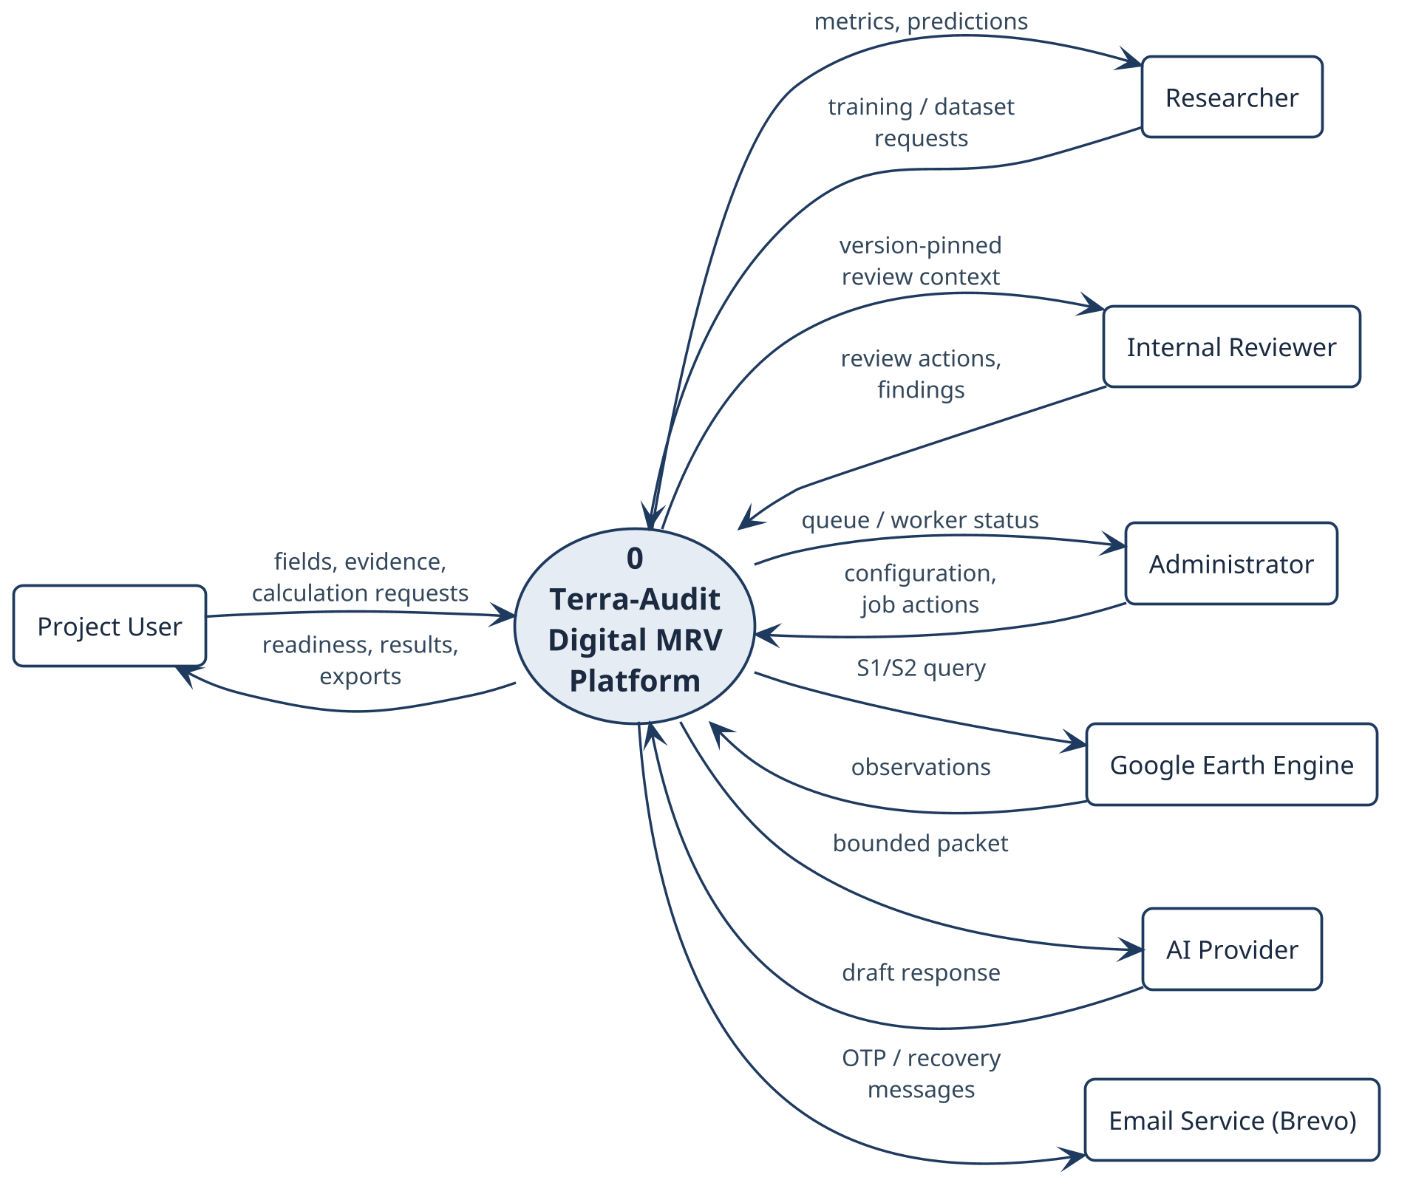
Fig 15: Level-0 data-flow diagram: external entities and the information they exchange with Terra-Audit.

8.1.2 Level-1 Data Flow (DFD Level 1)
Level 1 decomposes the context process into five implementation-backed processes and five logical data stores while preserving the external flows of Fig 15.
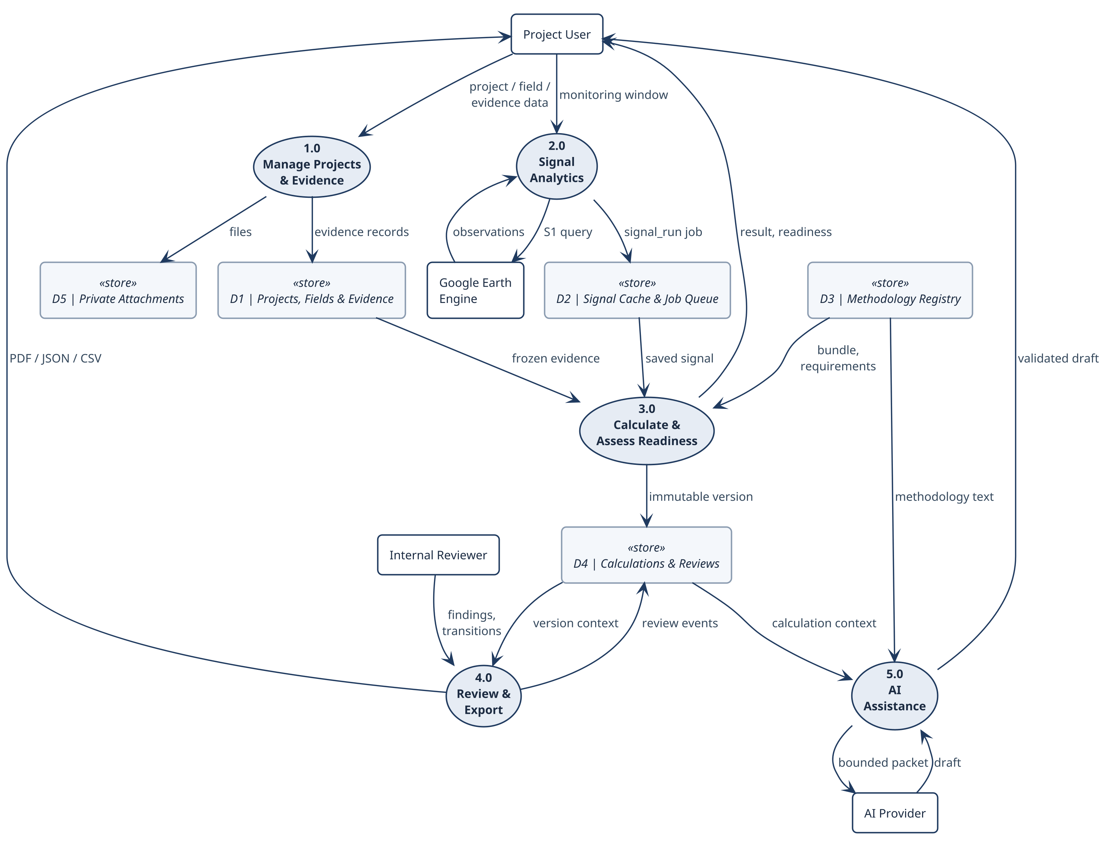
Fig 16: Level-1 data-flow diagram: processes, data stores and external flows.

8.2 API Design
The backend exposes 24 FastAPI routers. All routes except authentication require a bearer JWT; the organization is derived from the token, never from the request. Table 13 groups the representative endpoints.
Table 13: REST API summary by router group
Router group | Representative endpoints | Purpose
Auth & accounts | POST /auth/login, GET /auth/me, POST /auth/register/request-otp, /auth/recovery/* | Sign-in, OTP registration, recovery
Team | GET/POST /team/users, POST /team/invitations | Organization users and invitations
Fields & farms | GET/POST /fields, PATCH /fields/{id}, POST /fields/parse/{geojson|kml|upload|coordinates} | Field registration and geometry
Projects | /projects, /projects/{id}/members, /projects/{id}/fields | Projects, roles, dated memberships
Evidence | /fields/{id}/crop-seasons/..., /attachments, /fields/{id}/soil-*, /production-records | Seasons, observations, files, soil and production
Signals & monitoring | POST /fields/{id}/signal-runs, GET /signal-runs/{job_id}, /projects/{id}/monitoring/bulk-run | Sentinel analytics and batches
Calculations | POST .../calculations/preview, POST /fields/{id}/calculations, GET /calculations/{id}/chain | Preview, commit, history
Methodology | /methodology/bundles, /projects/{id}/methodology-applicability, /methodology/corrections | Registry, applicability, corrections
Reviews | /projects/{id}/submissions, /submissions/{id}/transition, /submissions/{id}/findings | Internal review workflow
AI | POST /projects/{id}/ai/explain, POST /ai/train, POST /ai/dataset/build | Explanations and ML
Export | GET /calculations/{id}/evidence/pdf, /fields/{id}/verifications/{vid}/evidence/{pdf|json|csv} | Evidence packages
Operations | GET /admin/queue-status, /admin/product-readiness, /portfolio/summary, /health | Monitoring and health

8.3 Behavioral Design
Behavioral design combines an event table (Table 14), the persisted state machines (Fig 17–Fig 19) and sequence diagrams of the four highest-risk workflows (Fig 20–Fig 23).

8.3.1 Behavioral Event Table
Table 14: Behavioral event table
Event | Trigger / precondition | System response | Resulting state
Signal run requested | Project user; rice_awd field and window | Return compatible cache or enqueue a deduplicated signal_run; worker fetches Sentinel-1 and stores the result | pending → running → done / error / cancelled
Calculation committed | Writer role; valid inputs; new Idempotency-Key | Freeze snapshot, run engine, evaluate readiness, persist version | draft or ready_for_review; prior version superseded on correction
Review submitted | Calculation is ready_for_review | Create version-pinned submission and review event | submitted
Review action | Assigned reviewer; current if_version | Record finding/comment or allowed transition; open blocking finding prevents approval | in_review / changes_requested / internally_approved / rejected / withdrawn
Data-quality issue | Monitoring run detects a problem | Upsert open issue; acknowledge or resolve with actor and reason | open → acknowledged → resolved
AI explanation requested | Provider permission; allowed action | Return cached validated draft or enqueue ai_explain | pending → running → done / error

8.3.2 State Diagrams
Fig 17 shows the durable job lifecycle including lease-based reclaim and bounded retry. Fig 18 shows that calculation versions are never edited in place—a correction creates version N+1 and supersedes the prior version—and the data-quality issue lifecycle. Fig 19 shows the server-enforced internal review transition table.
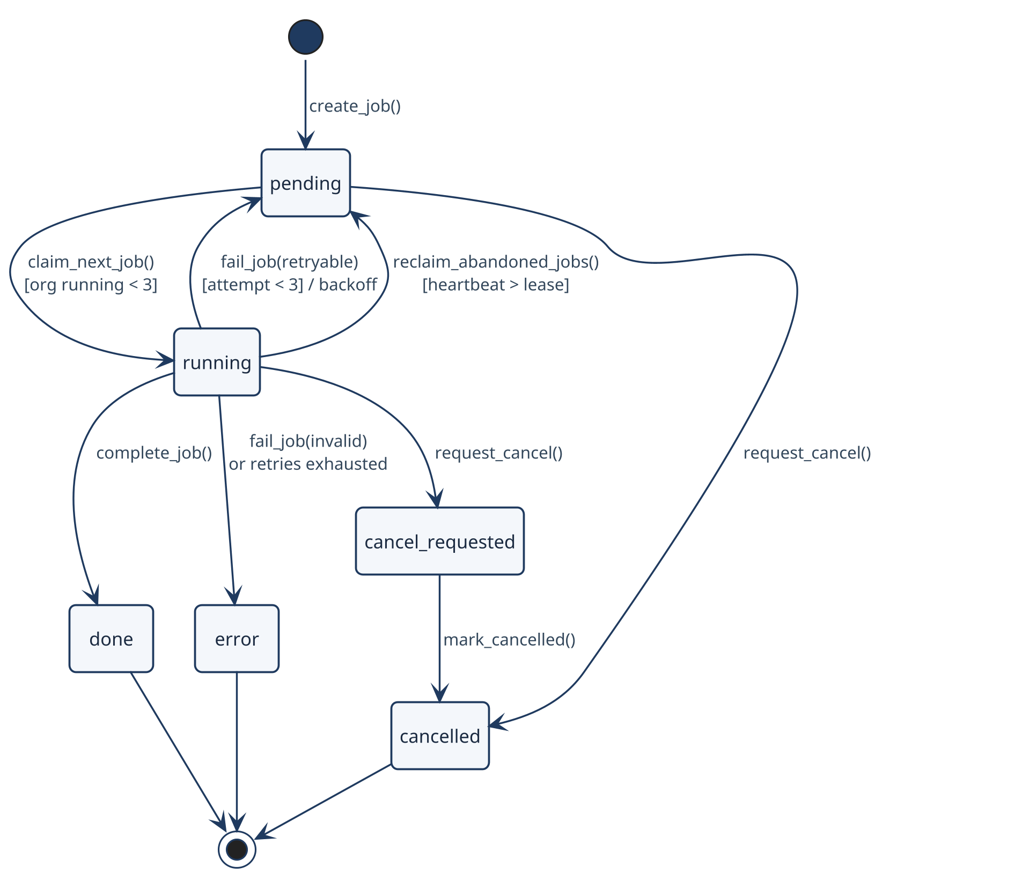
Fig 17: State diagram — durable background job lifecycle (src/jobs/queue.py).
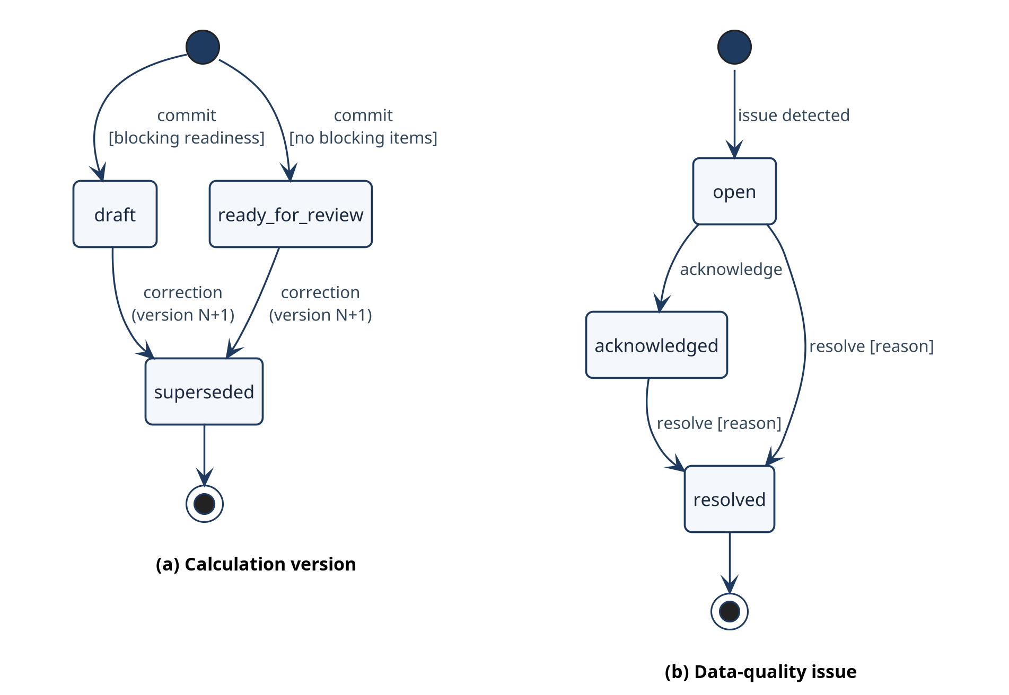
Fig 18: State diagrams — (a) calculation version lifecycle and (b) data-quality issue lifecycle.
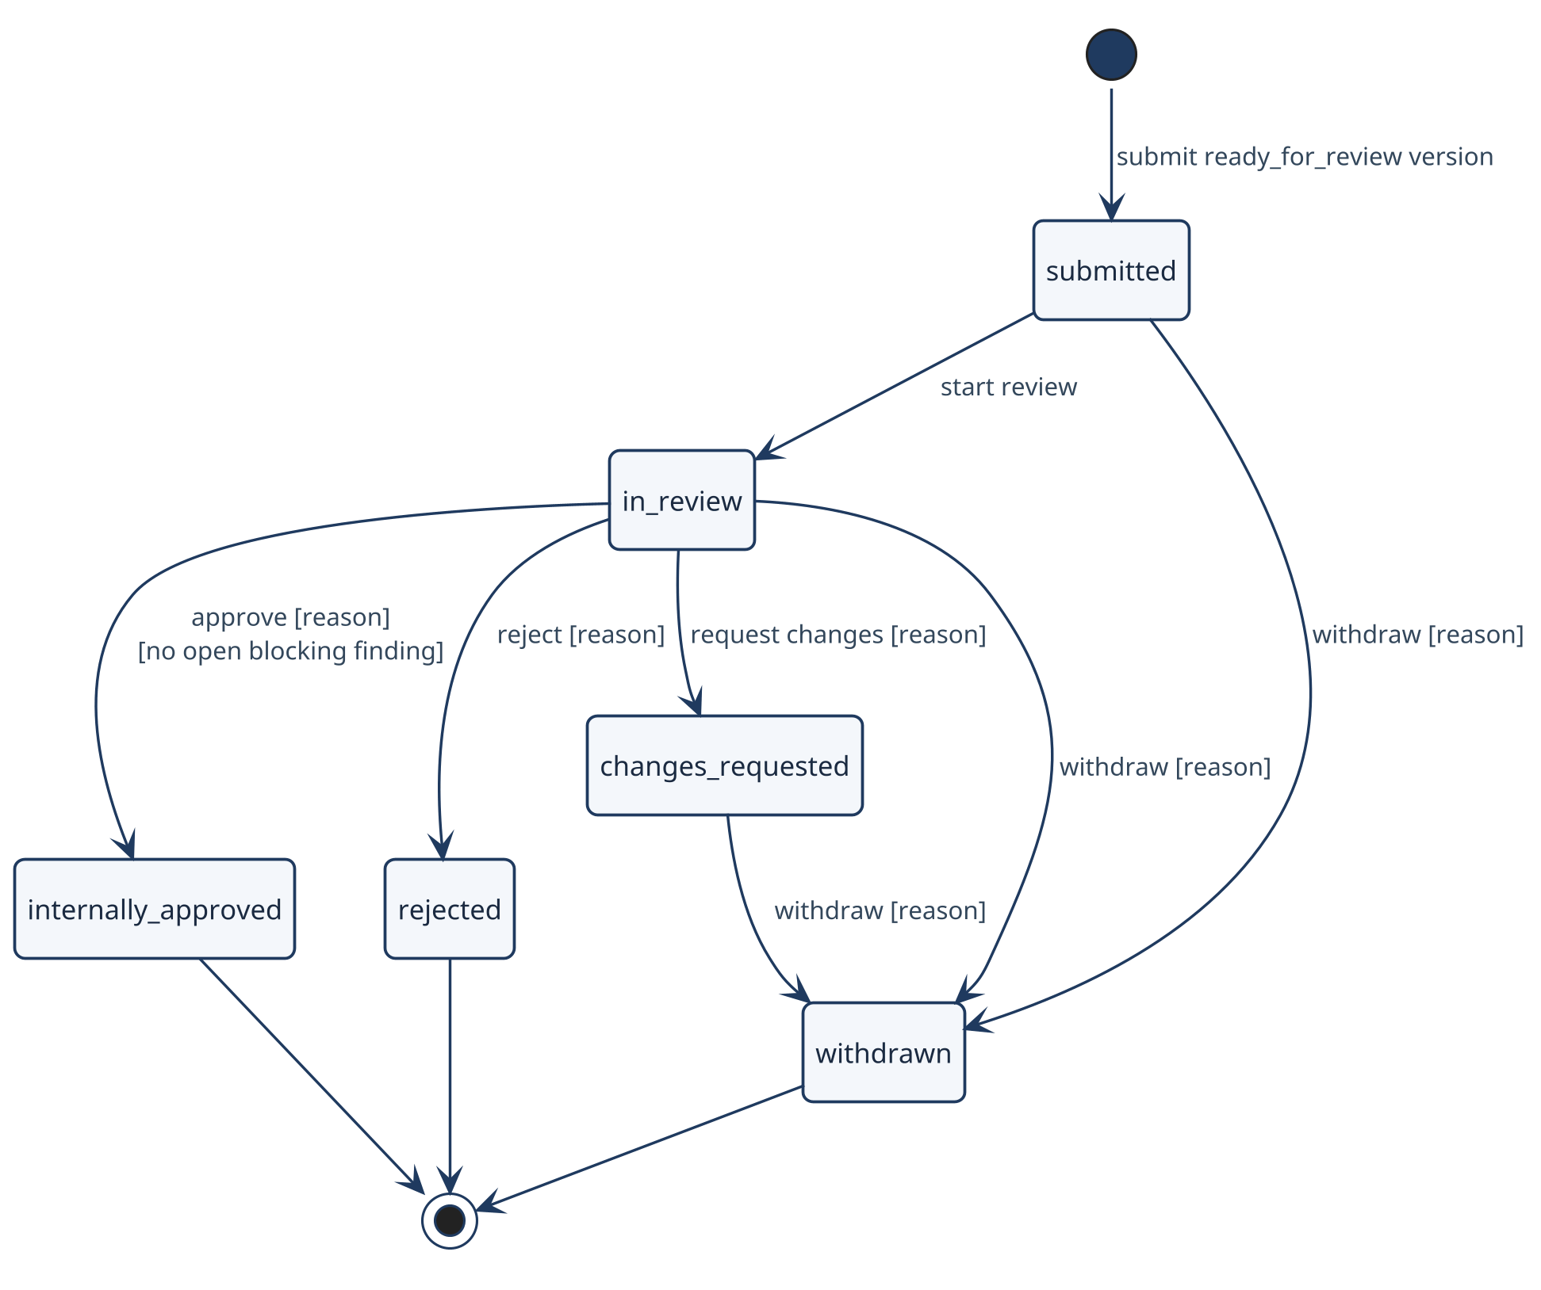
Fig 19: State diagram — internal review submission lifecycle (src/projects/reviews.py).

8.3.3 Sequence Diagrams
The sequences cover immutable calculation commit, version-pinned internal review, the durable signal run and the AI explanation job. Participants are the implemented Next.js, FastAPI, domain and worker boundaries.
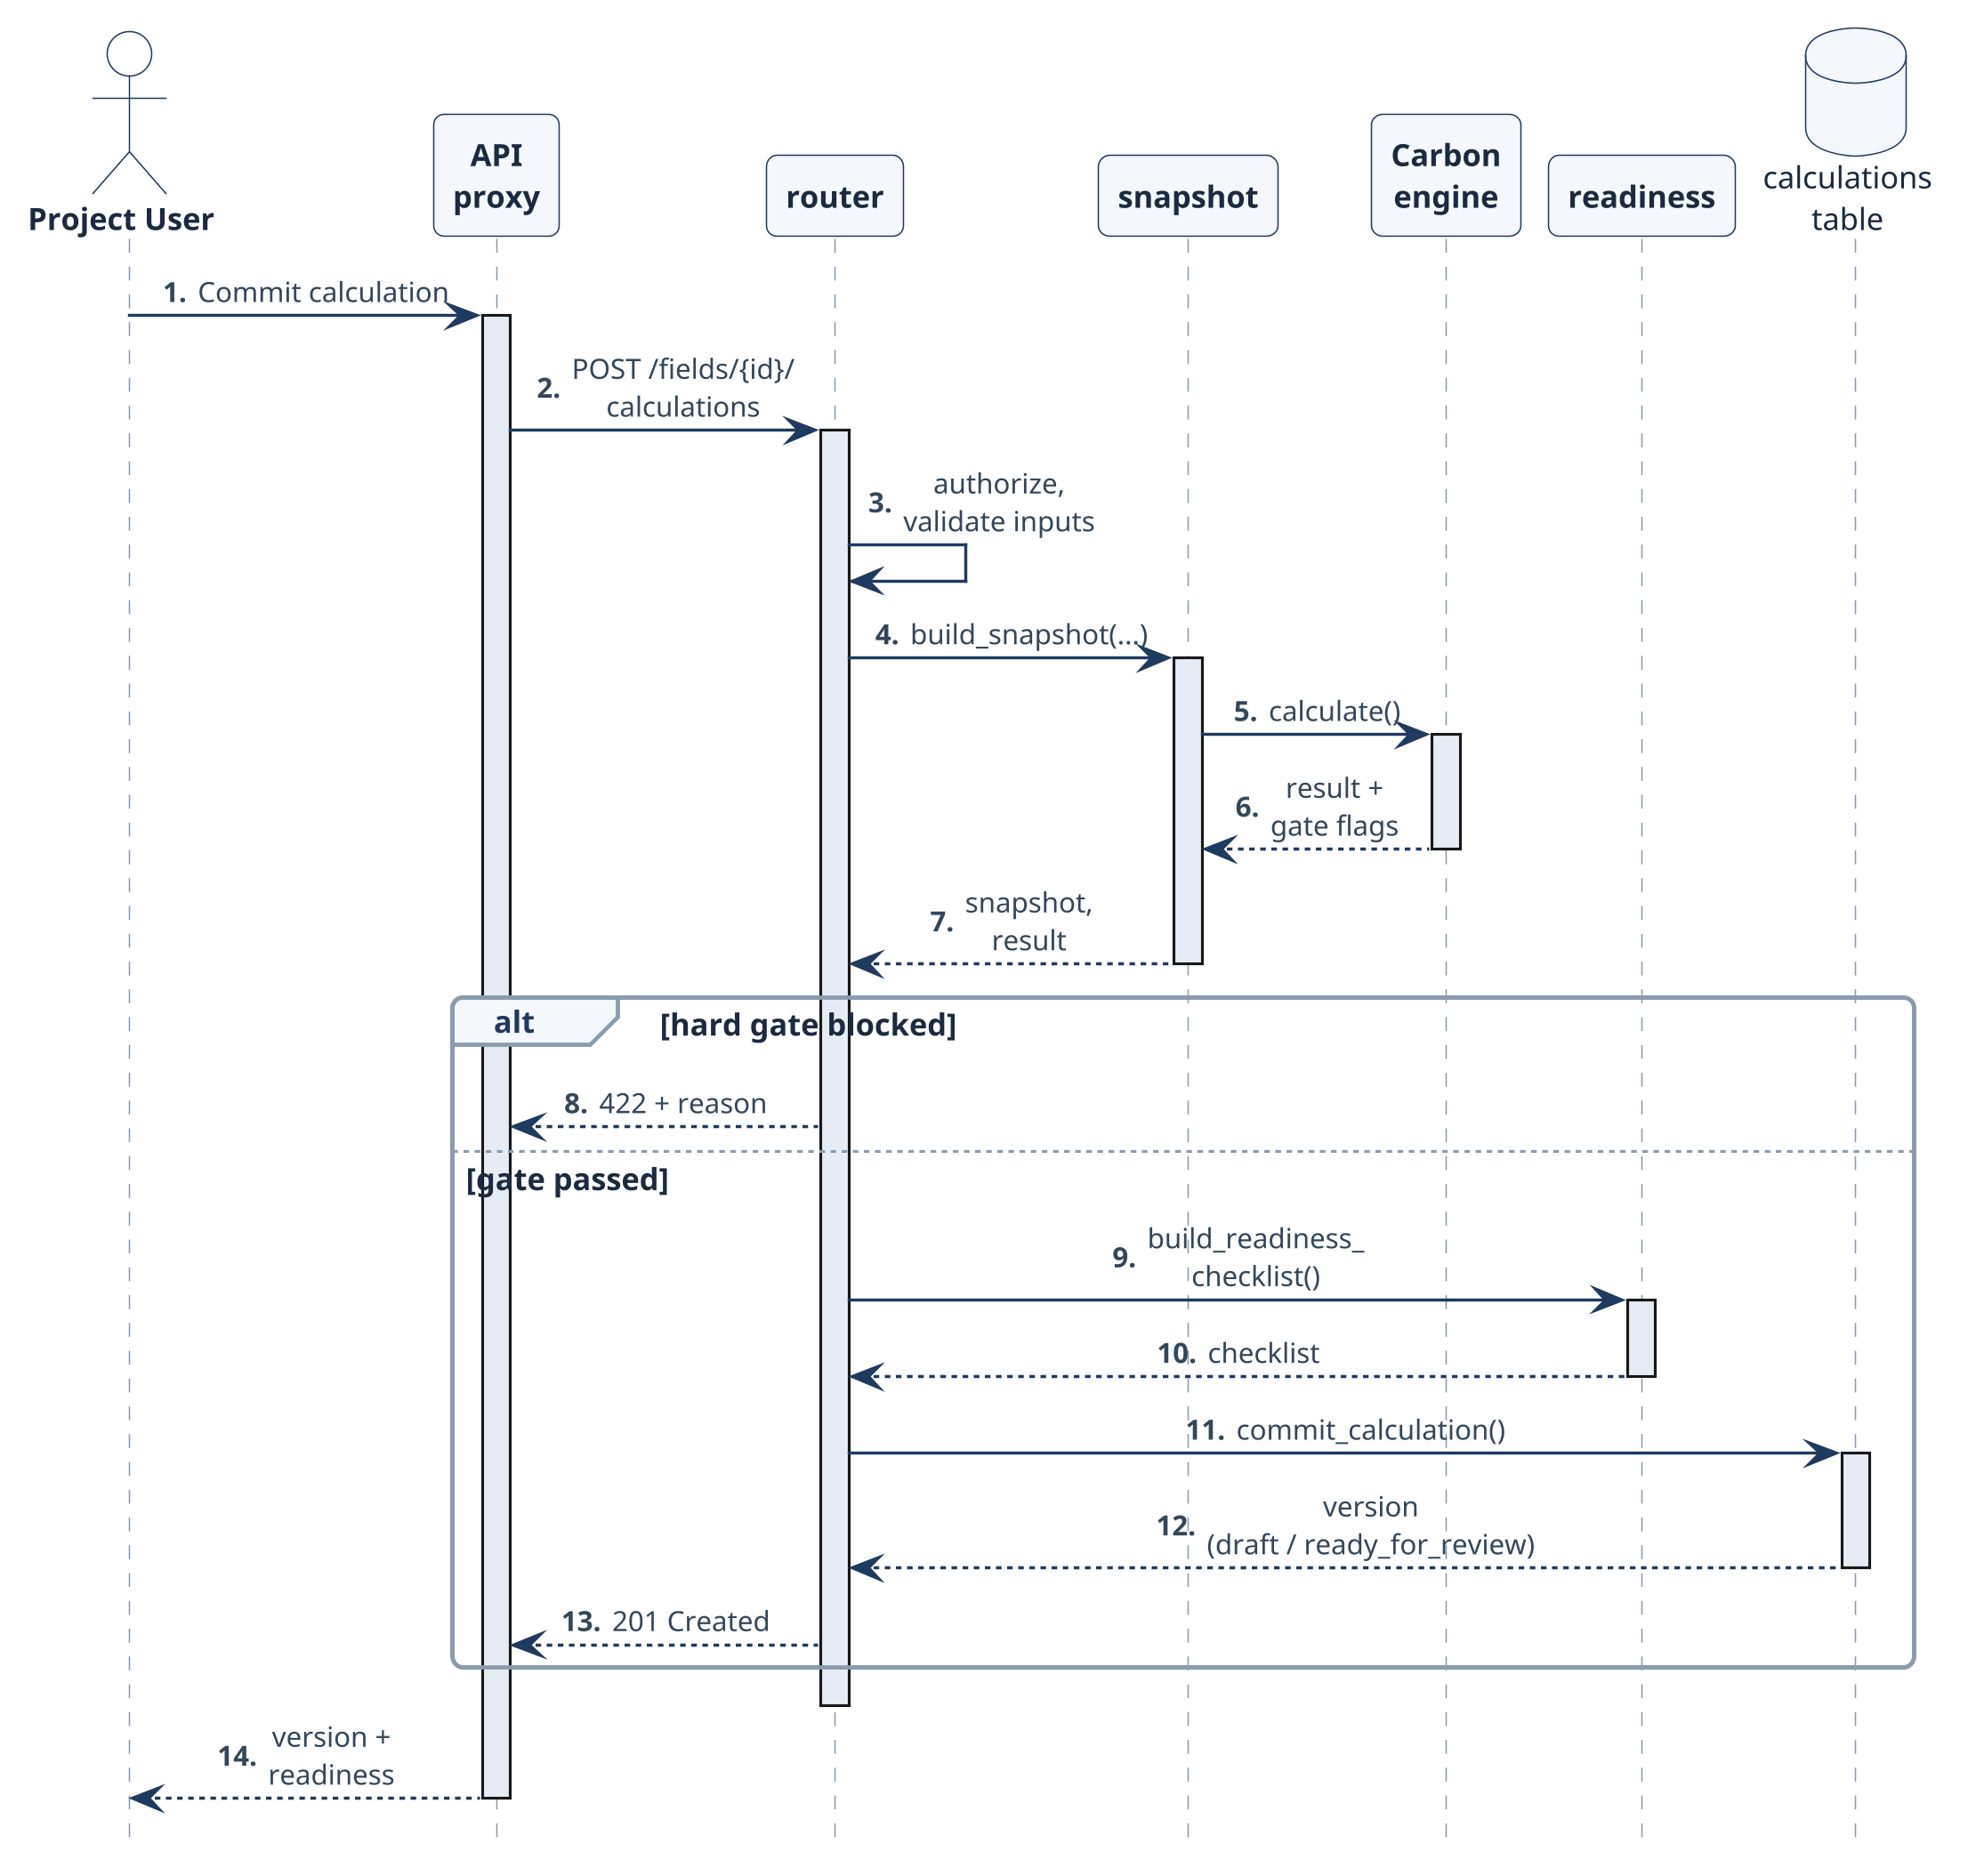
Fig 20: Sequence diagram — calculation commit from authenticated request to immutable version.
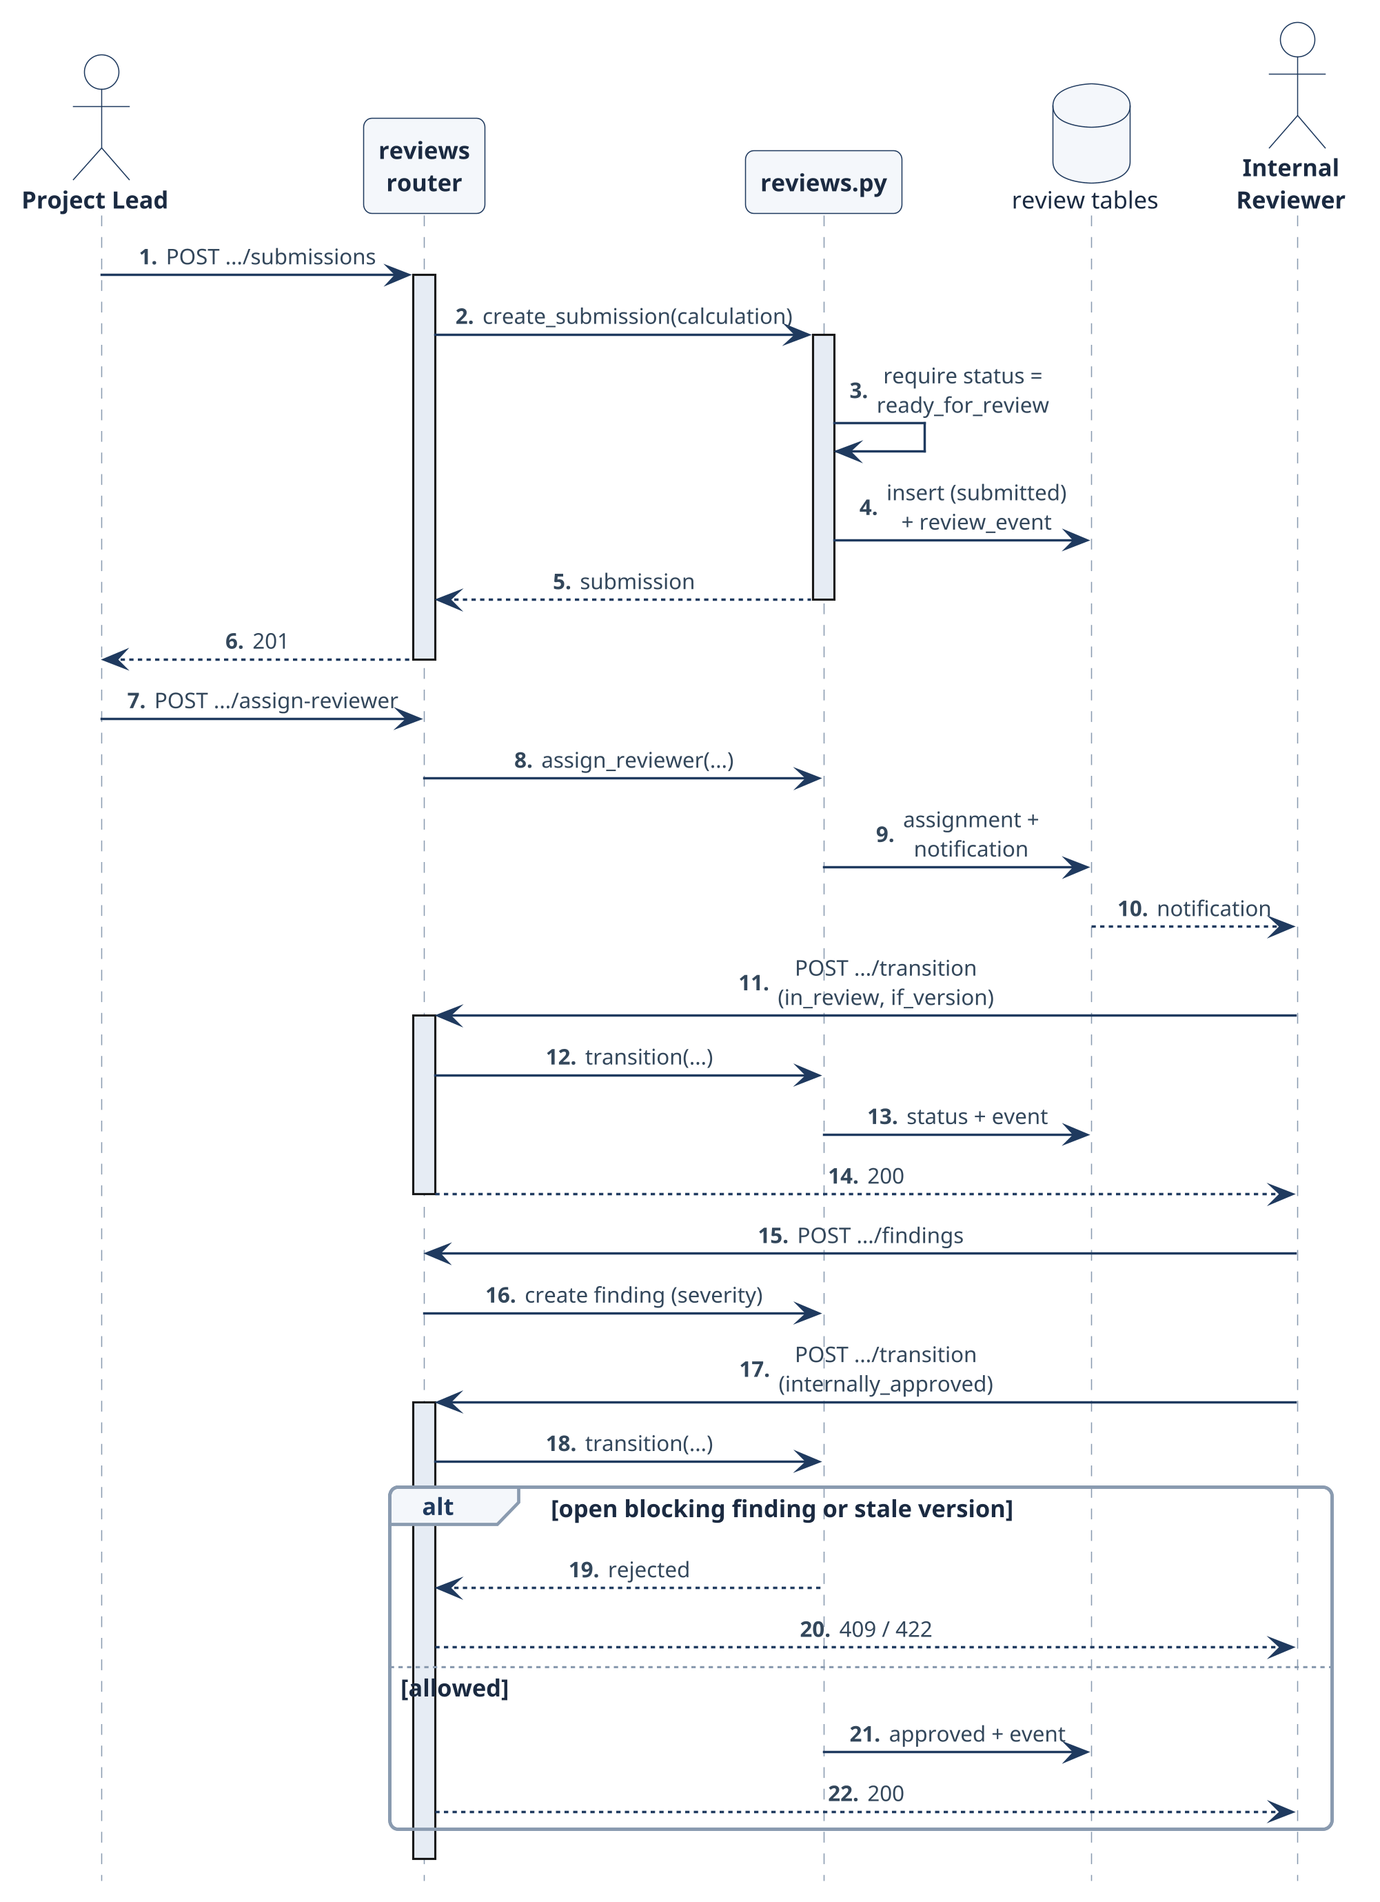
Fig 21: Sequence diagram — internal review from submission to guarded decision.
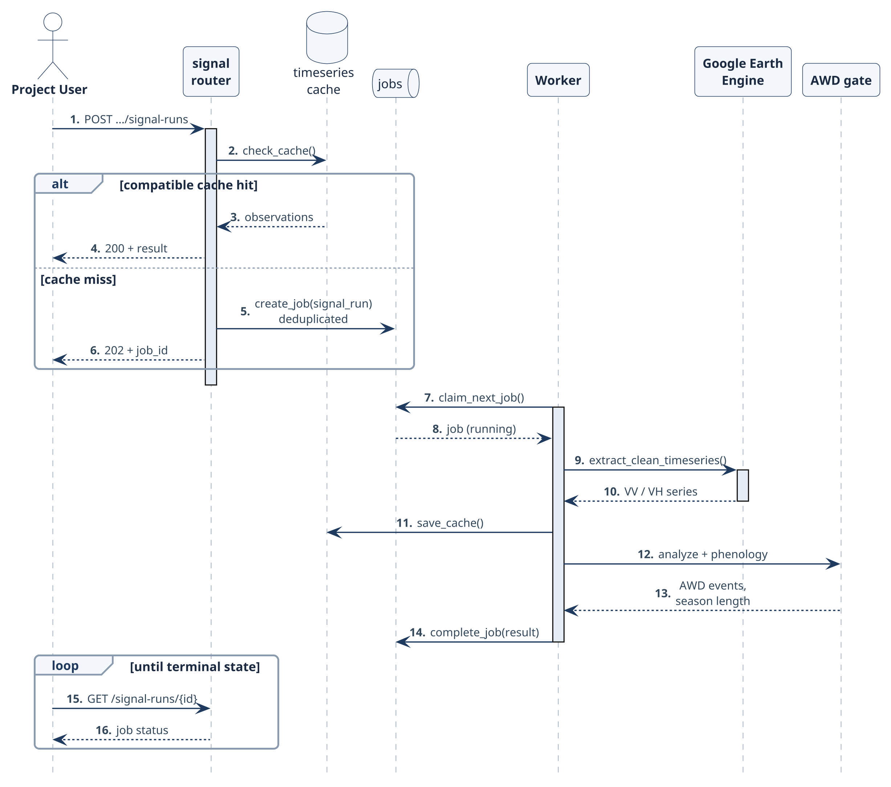
Fig 22: Sequence diagram — Sentinel-1 signal run through the durable job queue.
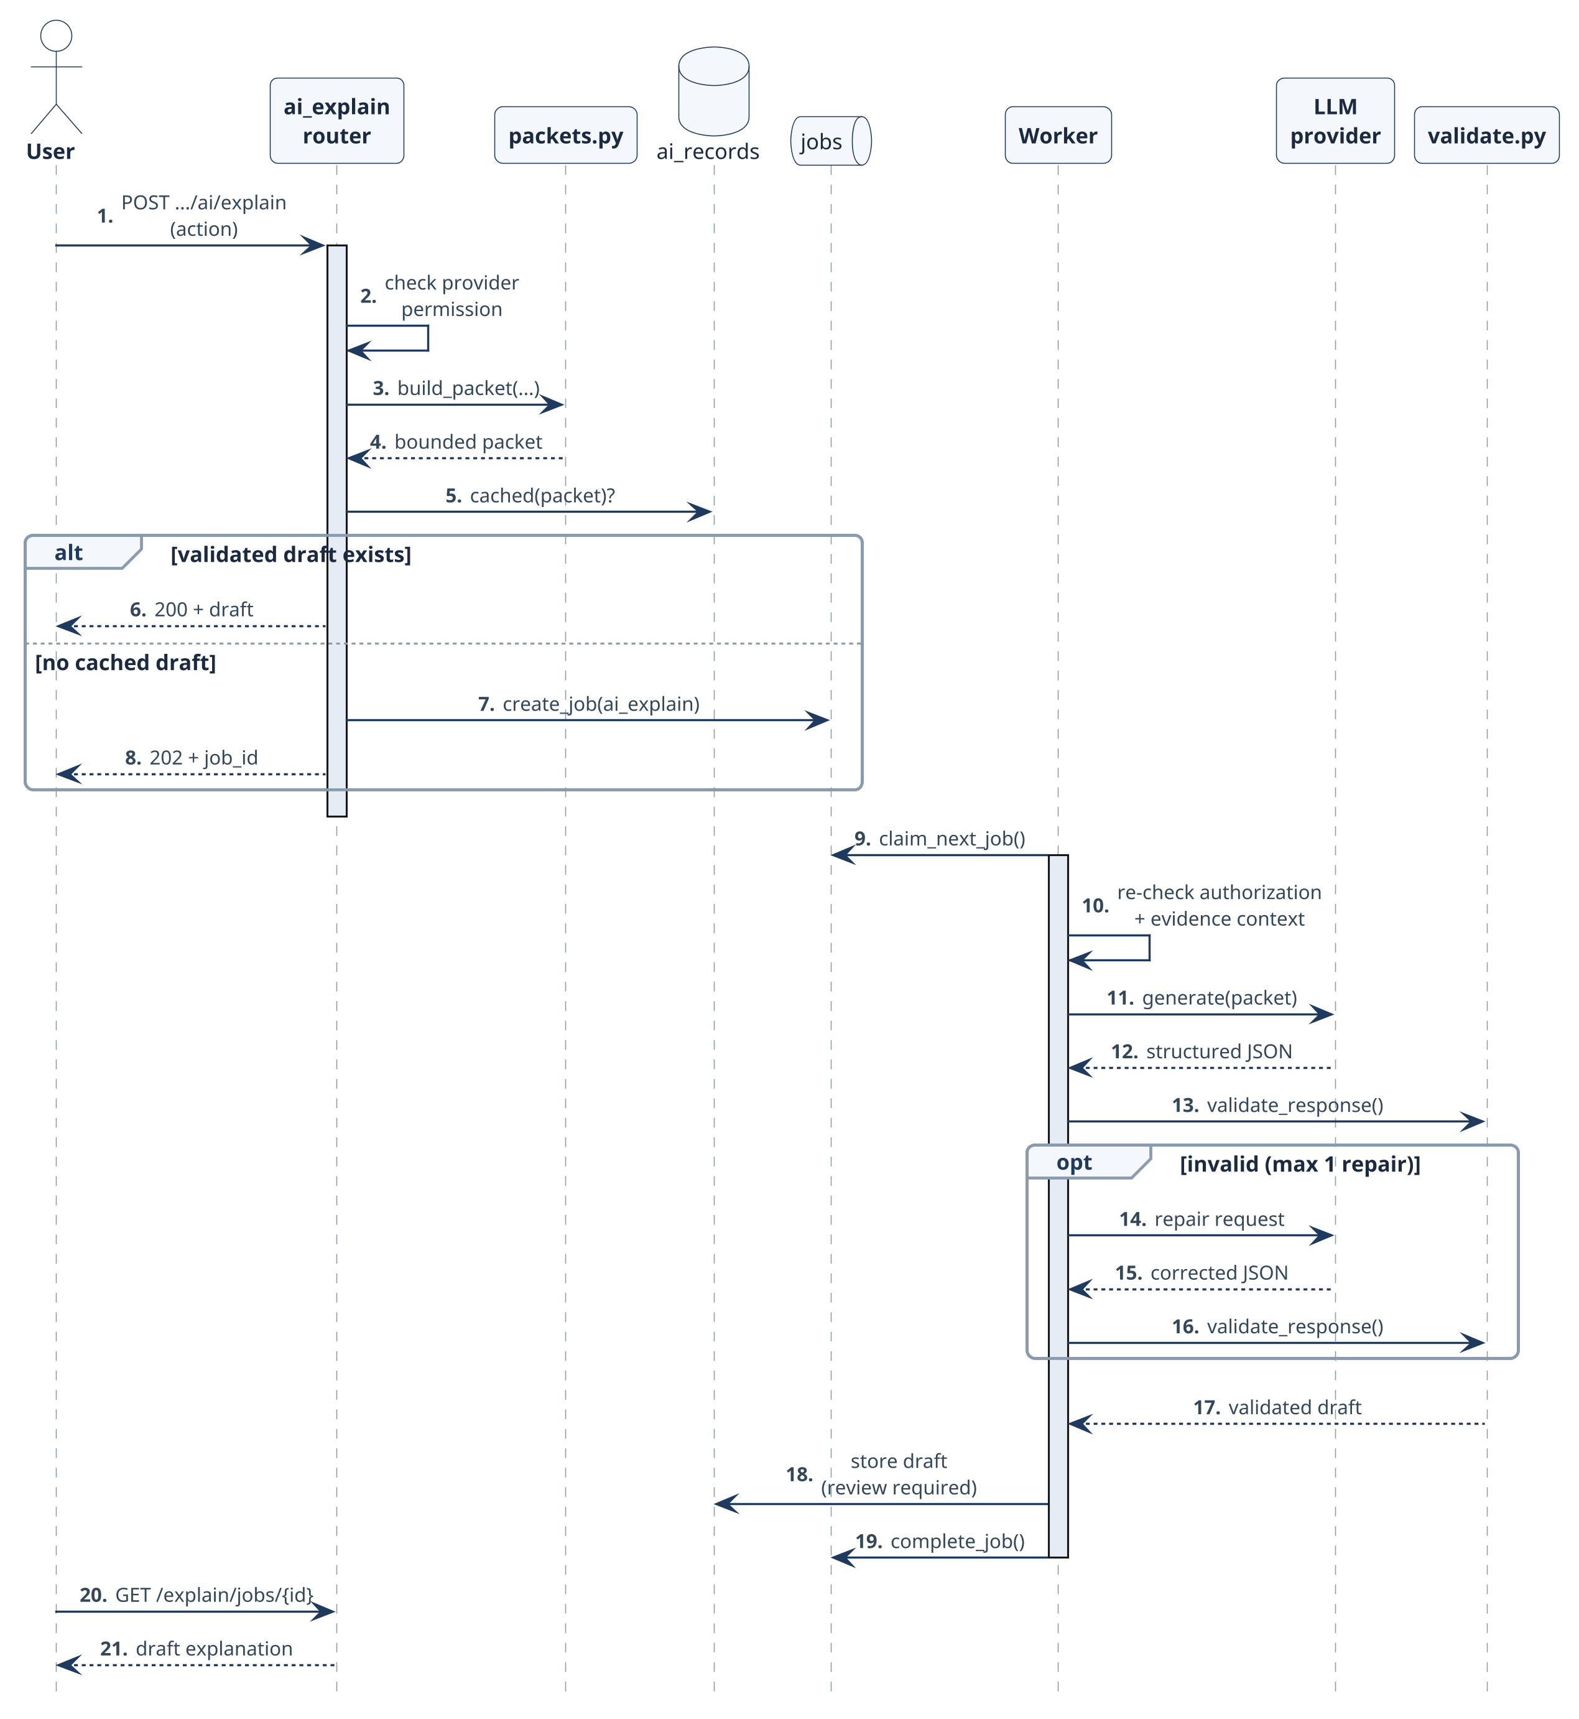
Fig 23: Sequence diagram — bounded AI explanation with server-side validation.

8.4 Deployment Design
Fig 24 shows the deployment architecture. The Next.js frontend is deployed on Vercel and calls the FastAPI backend over HTTPS; the documented production backend runs on Render, and the repository also provides docker-compose (backend, worker and frontend services) and a Railway configuration. Backend and worker run from the same Python 3.12 image: uvicorn serves backend.main:app with a /health endpoint, while python -m backend.worker claims durable jobs from the shared database and calls Earth Engine and AI providers. PostgreSQL is used when DATABASE_URL is set and SQLite otherwise; attachments and model artifacts use local storage or an S3-compatible bucket.
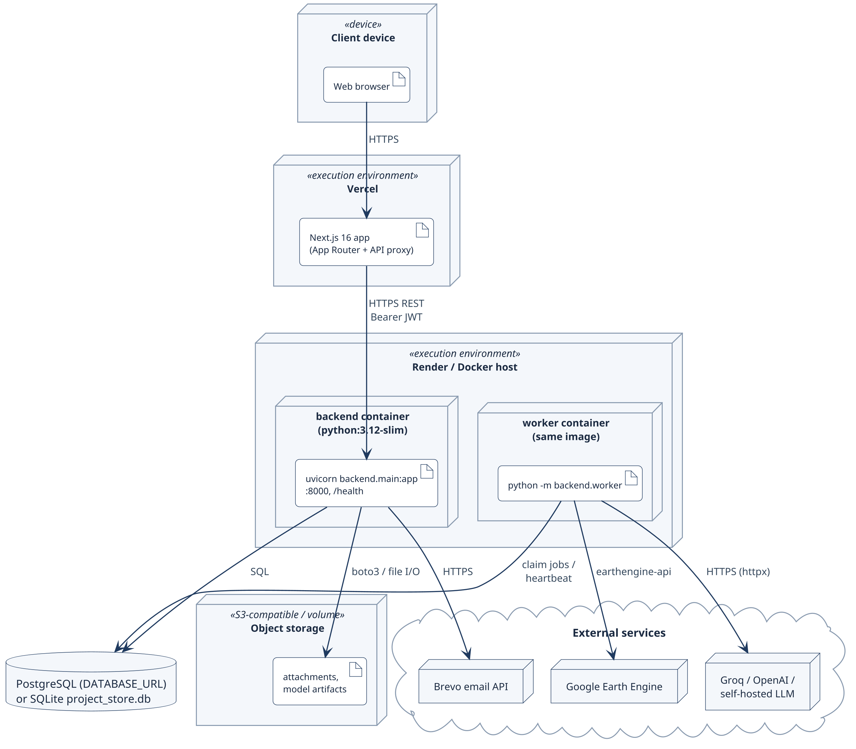
Fig 24: UML deployment diagram of Terra-Audit.

9. AI Engineering Design

9.1 Classical AWD ML Pipeline
The classical AWD ML pipeline applies to the rice signal path and remains experimental/supporting analytics rather than methodology-authoritative evidence:
- DatasetBuilder constructs training rows from cached rice time-series and uses threshold-gate labels; the label source is therefore not independent ground truth.
- Feature engineering builds a tabular matrix from satellite/time-series attributes while excluding the gate’s own decision flags as direct predictor features.
- The shared training harness trains Random Forest (200 trees, class-balanced) and XGBoost (200 estimators, max depth 4) using field-grouped GroupKFold evaluation; at least two independent fields are required and each training fold must contain all label classes.
- Persisted model bundles store the model, classes, feature names, satellite processing version, and the field-grouped split strategy. Loading rejects stale processing versions so models are not silently applied to incompatible satellite features.
- Evaluation reports pooled out-of-fold threshold-agreement metrics such as precision/recall/F1, confusion matrices, feature importance, and one-vs-rest ROC data. The reporting code deliberately avoids presenting these values as independently verified irrigation accuracy.

9.2 Model Selection and Evaluation
Random Forest and XGBoost remain appropriate baselines because the current AWD features are a comparatively small structured tabular set rather than raw imagery. Both can model nonlinear feature interactions, are inexpensive to retrain, and expose feature importance. The final implementation evaluates them with the same field-grouped split strategy so model comparison is not inflated by placing observations from the same field in both training and validation folds.
Field grouping fixes an important evaluation-leakage problem from the earlier design, but it does not fix label provenance. Because the target labels are still generated by the threshold detector, model metrics measure how closely the models reproduce that detector. Independent water-level or irrigation observations are still required before the ML results can support a claim of real-world AWD event accuracy.

9.3 Managed Crop Models
The final system also contains managed crop-model workflows for exploratory crop classification/benchmarking. These models use reviewed crop-identity labels and held-out grouping, but they remain research features rather than carbon-accounting authority. Their presence broadens the AI workspace beyond AWD classification without changing the deterministic VM0051/VM0042 calculation boundary.

9.4 Generative AI Explanation Architecture
Generative AI is implemented as a bounded explanation workflow rather than as an accounting engine. An authenticated project request selects an allowed explanation action, after which the server builds a deterministic action-specific context packet from current project/evidence state and bundle-scoped methodology text. The request is served from cache when an equivalent validated explanation exists; otherwise a durable ai_explain job is queued and processed by the worker. Supported provider adapters include fake, self-hosted, Groq, and OpenAI.
The worker rechecks authorization, provider configuration, and evidence context before calling the provider. The structured response is then validated by server code and may receive at most one repair attempt. A final authorization/evidence check is performed before the explanation is persisted and shown as a draft requiring human review.

9.5 Prompt and Context Design
Prompting is therefore applicable in the final system, but the design is intentionally constrained by server-owned context. Packets contain the requested action, active methodology bundle, selected methodology chunks and linked corrections, evidence/calculation context, sentence identifiers, allowed requirement/record identifiers, hashes, and server-owned limitations/next actions. The model is not permitted to invent its own authoritative requirement identifiers or alter official calculation values. Retrieval is bundle-scoped so explanations are grounded in the methodology version/corrections selected by the application rather than in unrestricted general knowledge.
The output contract is structured rather than free-form only. Validation checks schema compliance, supplied sentence/requirement/record membership, citation presence, numeric/reference support, correction handling, prohibited claims, and server-owned actions/limitations. These checks improve structural reliability but do not prove that every cited sentence semantically entails the generated claim.

9.6 AI Authority Boundary and Evaluation Limitations
AI features are deliberately outside the accounting authority boundary. Random Forest/XGBoost and managed crop models are experimental analytics; generative providers produce draft explanations only. Deterministic code owns methodology readiness, carbon equations, persistence gates, and official numeric outputs. No AI component can turn a blocked requirement into compliant status, perform external VVB verification, or create registry-issued credits.
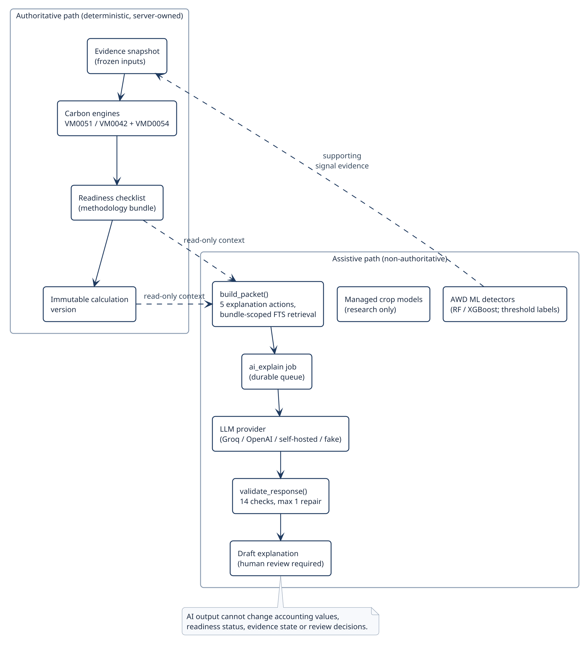Fig 25: AI authority and data flow: deterministic, server-owned accounting path versus the non-authoritative assistive path.
The software regression suite covers the AI code paths, but the dedicated 20-case generative-AI evaluation corpus remains incomplete because the canonical packet fixtures are missing. Likewise, no independent AWD ground-truth dataset has been completed. These gaps are reported as evaluation limitations rather than hidden behind software-test success.

10. Interface Design
The final interface is a responsive Next.js web application centered on authenticated project context, explicit permissions/readiness, durable-job status, versioned calculation history and internal review. Queued, running, blocked, failed, review-required and completed states remain visibly distinct rather than being collapsed into a generic success/failure message.

10.1 Interface Objects and Actions
Interface objects and their actions were derived from the user and task analysis of the SRS. Table 15 lists each object, its operations and the route that hosts it. Actions are role-aware, but server-side authorization remains authoritative.
Table 15: User-interface objects and actions
Interface object | Actions (operations) | Route
Session / account | Sign in, register with OTP, recover access, sign out | /login, /register, /account-access
Project | Create, edit, add members, assign fields, view dashboard | /projects/[projectId]
Field | Register geometry (draw, GeoJSON, KML, coordinates), edit metadata | /fields/new, /fields/[fieldId]/edit
Crop season & evidence | Create season, correct version, add observation / practice event, upload file | /fields/[id]/crop-seasons, /evidence-files
Soil & production evidence | Add sampling plan, sample, lab result, custody event; import production | /fields/[id]/soil-evidence, /production-records
Signal analytics | Choose window and detector, start run, cancel, inspect series | /fields/[id]/signal-analytics
Calculation | Preview, commit (freeze evidence), view version chain, export | /fields/[id]/calculations, /ledger
Methodology readiness | View bundle, applicability and requirement status; record determination | /projects/[id]/methodology
Internal review | Submit, assign reviewer, transition, add finding / comment | /reviews, /reviews/[submissionId]
AI workspace | Request explanation, train / evaluate model, predict | /projects/[id]/ai, /ai-validation
Operations | View queue and worker status, retry / cancel batch, setup | /admin/queue, /admin/setup

10.2 Primary User Workflows
The core user journey is: select project/field → build or review evidence → run rice signal analytics when applicable → preview and save a versioned calculation → inspect readiness → submit an eligible version to internal review → export an available artifact. Researchers use signal/ML/AI workspaces; administrators manage methodology sources, provider permissions and worker/job state.

10.3 UI Events and State Transitions
Table 16 maps the most important user events to the visible interface state and the server-owned state behind it (see the state diagrams in Chapter 8).
Table 16: UI events and resulting state changes
User event | UI state before | UI state after | Server-owned state
Start signal analysis | Idle form | Queued → running progress → result chart or error banner | signal_run job pending / running / done / error
Cancel running job | Running | Cancelling → cancelled | cancel_requested → cancelled
Preview calculation | Input form | Preview result with readiness badges | None (no persistence)
Commit (freeze evidence) | Preview shown | Committed version (draft / ready for review) or blocking message | New calculation version
Submit for review | ready_for_review version | Submission listed as submitted | review_submissions = submitted
Reviewer transition / finding | In review | Status chip and finding list update; approval refused while a blocking finding is open | review_events appended
Request AI explanation | Idle | Pending → validated draft labelled for human review | ai_explain job; ai_records draft
Acknowledge / resolve issue | Open issue | Acknowledged / resolved with actor and reason | data_quality_issues status
Forbidden or invalid action | Any | Inline error message; entered values kept | 403 / 422; no state change

10.4 Responsive, Validation and Accessibility Design
The frontend uses shared labeled controls, reusable validation messages, narrow-screen scrolling/containment, text-plus-color state cues, standardized date/number formatting and keyboard-aware shared controls. These improve usability across desktop/tablet/mobile layouts, but no dedicated final browser-E2E or formal accessibility suite was independently executed.

10.5 Interface States as Seen by the User
Fig 26–Fig 30 show representative states of the web interface using clearly labelled synthetic demonstration records: project navigation, monitoring, calculation readiness and inputs, review views and the AI workspace. Captions describe only what is visible.
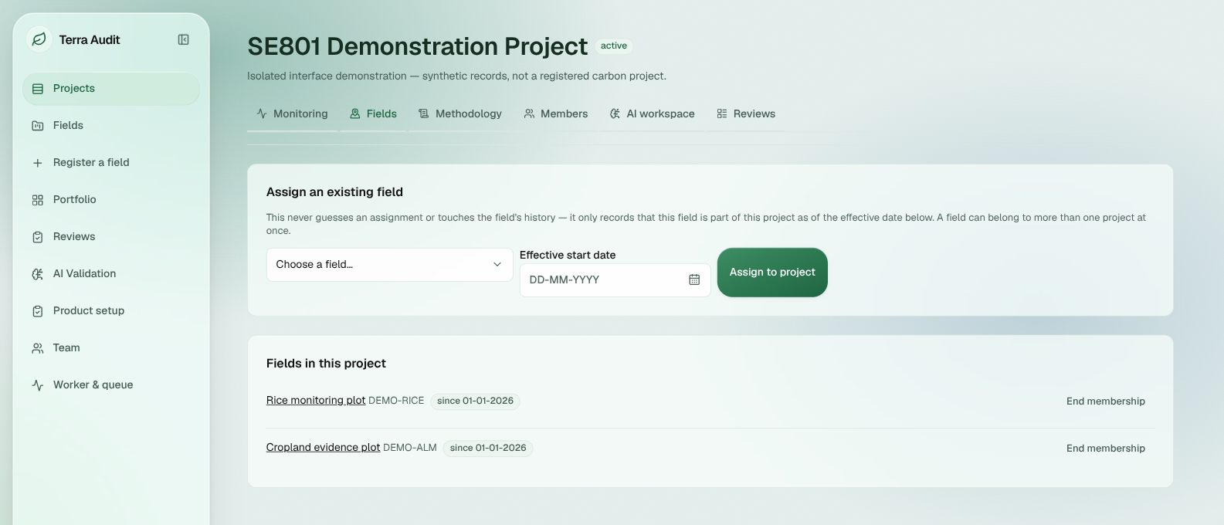Fig 26: Application shell and project navigation: sidebar, project tabs, field-assignment controls and two demonstration fields.
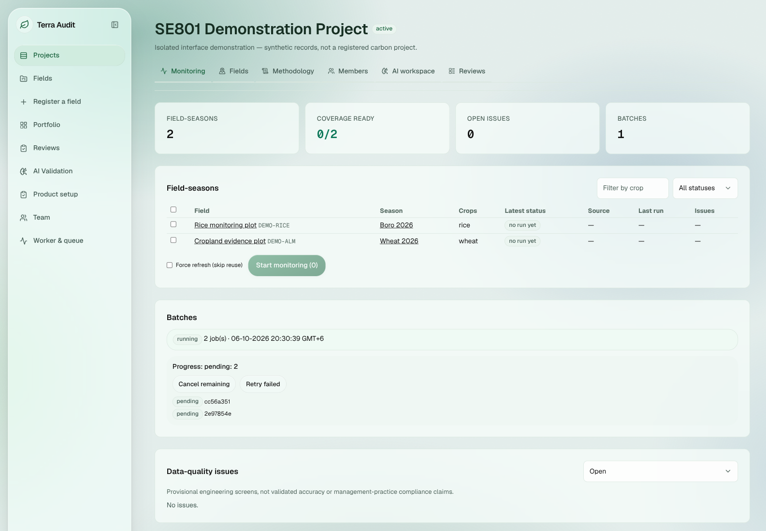Fig 27: Monitoring batch state: one running batch with two pending child jobs; no data-quality issues.
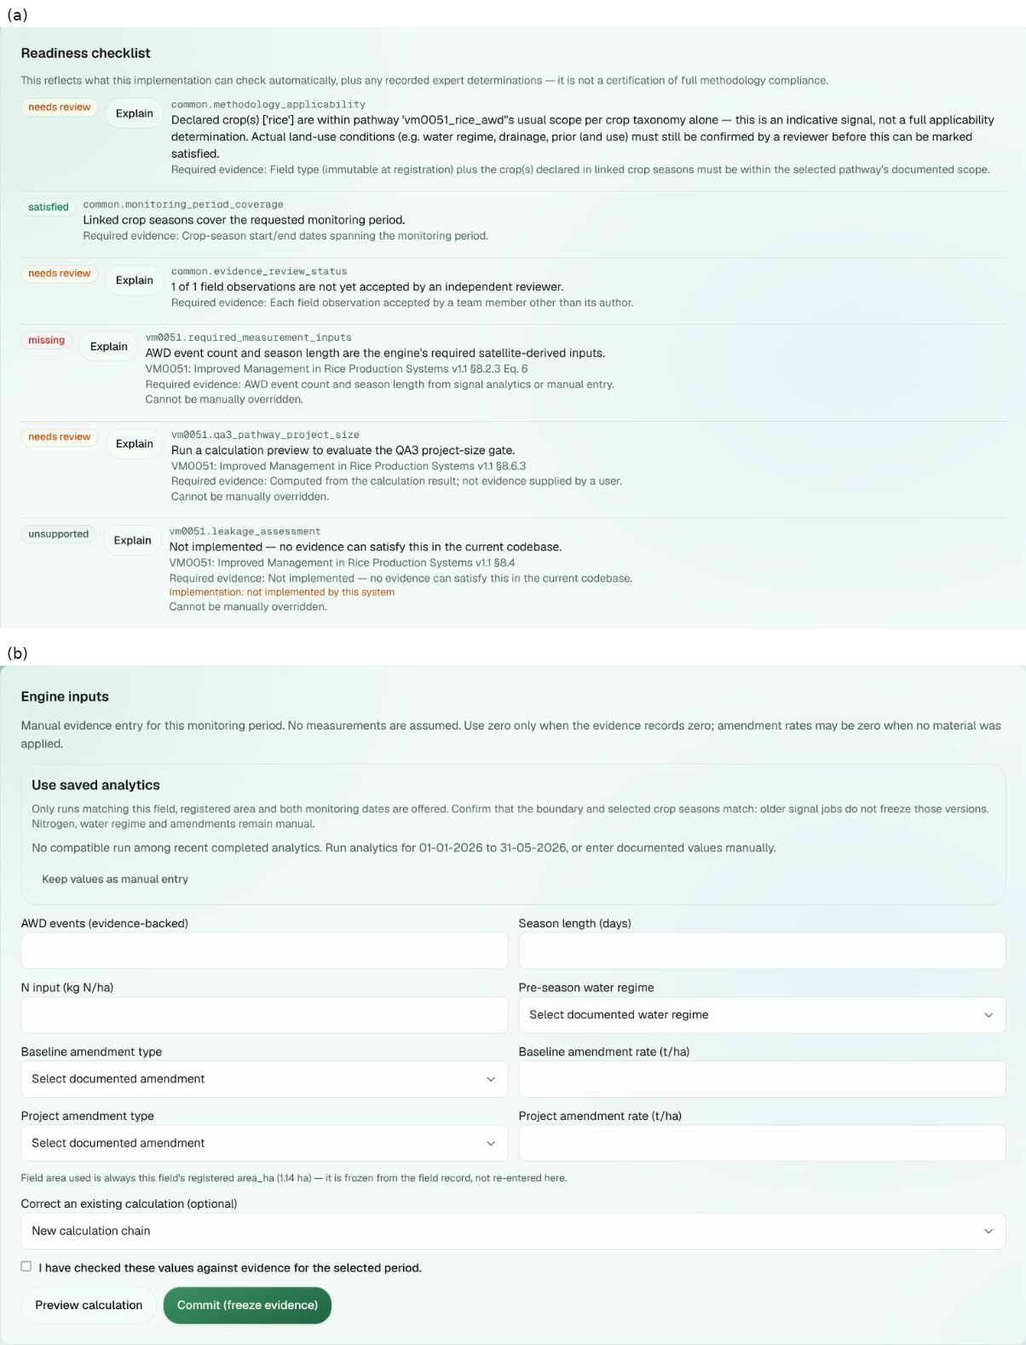Fig 28: Rice calculation readiness and inputs: (a) readiness items marked needs review, satisfied, missing or unsupported; (b) the evidence-backed input form with Preview and Commit (freeze evidence).
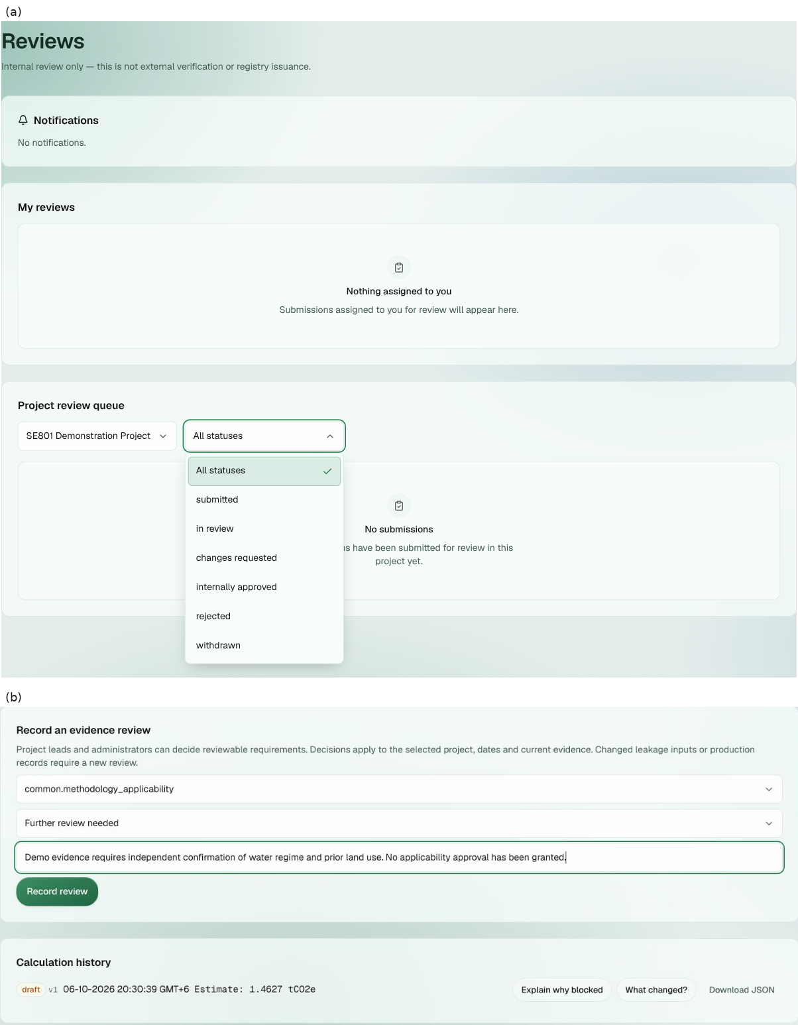Fig 29: Review-related states: (a) the internal Reviews page with its status filter; (b) an evidence-review form and a draft calculation estimate.
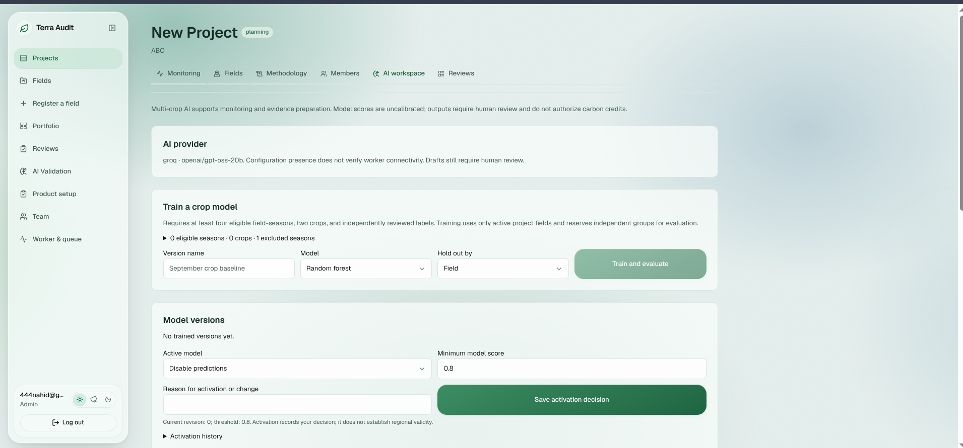Fig 30: AI workspace — crop-model controls: provider label, eligibility count and training/evaluation controls.

11. Implementation
This chapter summarizes the final implemented software rather than reporting midterm progress. Status labels distinguish implemented capability from partial methodology coverage, experimental research features, and validation/operational gaps. A green software test suite does not by itself convert a partial or experimental feature into a fully validated MRV method.

11.1 Final Feature Status
Status is reported conservatively. “Implemented” means the software capability exists and is covered by the current architecture; “Partial” means important scope, provenance, methodology, authorization, or operational limits remain; “Experimental” identifies research features that must not be presented as validated accounting evidence.
Table 17: Final implementation status by subsystem
Module / Feature | Status | Current Evidence | Remaining Work / Boundary
Next.js frontend | Implemented | Authenticated pages/components, responsive routes, API proxy; frontend tests/build/typecheck pass. | Formal browser-E2E/accessibility suite and final-state screenshot capture remain.
FastAPI backend/API | Implemented | Domain routers/schemas, auth dependencies, project/evidence/calculation/job/AI/export APIs; backend suite green. | Continue endpoint-level authorization hardening and API/deployment observability.
Authentication & organizations | Implemented | bcrypt/JWT/token-version/account-recovery flows and server-derived organization scoping. | Login throttling and some production account-policy hardening remain.
Project roles & memberships | Partial | Project lead/contributor/viewer roles, membership events, project/farm-field relationships and access helpers exist. | Project-membership enforcement is not uniform across every field/calculation endpoint.
Evidence / seasons / attachments | Implemented | Crop-season corrections/history, observations, practice events, reviews, monitoring, QA issues and private evidence attachments. | Broader browser acceptance and retention/deletion edge cases remain.
Soil / SOC / lab / custody | Partial | Sampling plans, strata, samples, lab results, custody events and reviewed SOC mapping are implemented. | Full sampling/statistical methodology compliance and multi-stratum accounting remain incomplete.
Sentinel-1 signal processing | Implemented | Earth Engine acquisition, cache/versioning, smoothing, threshold/phenology processing and durable signal jobs exist. | Full acquisition provenance, orbit/incidence-angle/rainfall controls and live-service recovery validation remain.
AWD threshold & classical ML | Experimental | Threshold detector plus field-grouped RF/XGBoost evaluation and versioned feature/model metadata are implemented. | No independent water-level/irrigation ground truth; metrics remain model-versus-threshold agreement.
VM0051 rice accounting | Partial | Scoped VM0051 v1.1 QA3/default-factor calculations and gates are deterministic and regression-tested. | Rice leakage, baseline fertilizer-change N2O, burning and several monitoring/safeguard requirements remain unsupported/partial.
VM0042 ALM + leakage | Partial | Scoped VM0042 v2.2 + corrections, supported SOC/non-SOC terms and restricted VMD0054 v1.1 leakage adapter are implemented. | QA1/modeling, full DSM/sampling, multi-field leakage, mitigation and cumulative sequential-period reconciliation remain incomplete.
Methodology registry & readiness | Partial | Documents, bundles, corrections, applicability and deterministic readiness/fingerprints are implemented. | common.additionality remains unsupported, blocking and non-overridable; methodology coverage is not complete.
Calculation snapshots/versioning | Implemented | Frozen calculation inputs/results/readiness context, idempotency and supersession/version chains are implemented. | No DB-level WORM/immutability trigger; some provenance selections are broader in backend than current UI.
Durable jobs & worker | Implemented | Database-backed queue, worker heartbeat, job handlers, retry/cancel states and operational views exist. | Live production worker/heartbeat and failure-recovery drills remain incompletely verified.
Internal review & exports | Partial | Version-pinned internal review, findings/events, versioned calculation JSON, snapshot-backed ALM PDF, and legacy verification PDF/JSON/CSV paths are implemented. | Rice/legacy export provenance is weaker than ALM snapshot export; internal review is not VVB verification.
AI explanations & managed models | Partial / Experimental | Provider adapters, deterministic packets, validation, durable ai_explain jobs and managed crop-model workflows exist. | 20-case generative-AI evaluation fixtures are incomplete; semantic entailment and scientific accuracy are not proven.
Software verification | Verified | Re-run on 7 October 2026 (commit bc402f2): backend 177 passed / 0 failed; frontend tests, build and TypeScript pass; ESLint 0 errors, 5 warnings. | Scientific field validation, browser E2E, PostgreSQL live migration and external assurance remain separate.

11.2 Worked Calculation Checks
Rice AWD fixture — Inputs: 2 AWD events, 120-day season, 1.0 ha, 100 kg N/ha, short pre-season water regime, and the default 5 t/ha straw amendment in both scenarios. The engine gives SC_o=(1+5)^0.59=2.878122; baseline CH4=293.568470 kg and project CH4=161.462659 kg, so avoided CH4=132.105812 kg=3.698963 tCO2e. The QA3 15% deduction is 0.554844 tCO2e, leaving 3.144118 tCO2e; the irrigation N2O term is 0.083210 tCO2e. Net deterministic estimate=3.060908 tCO2e, below the 60,000 tCO2e/year QA3 gate. This is a code-level worked fixture, not an issued VCU.
Cropland ALM fixture — Inputs follow the fixed 5 ha, one-year regression scenario: baseline synthetic N 120 kg/ha, residue burning 500 kg/ha and diesel 40 L/ha; project synthetic N 80 kg/ha, organic N 20 kg/ha, no residue burning and diesel 25 L/ha; SOC cells are project start [30,32,29], project final [34,35,33], control start [30,31,29], control final [30,31,30]. The mean project-minus-control SOC change is 3.333333 tCO2e/ha; the independently reconstructed uncertainty is 16.115318%. The engine regression fixture gives ER=1.073643 tCO2e and uncertainty-adjusted CR=13.980780 tCO2e; with a 15% non-permanence deduction on the removal term, the deterministic estimate is 12.957306 tCO2e. The fixture still discloses the separate other-leakage limitation and does not imply external verification or issuance.

11.3 Remaining Engineering and Validation Gaps
Table 18: Remaining engineering and validation gaps
Current Gap / Risk | Next Response
No independent AWD ground truth; threshold and RF/XGBoost labels are not field observations. | Design a Bangladesh/South Asia validation campaign using water-level tubes, irrigation logs or partner-verified observations and report event-level precision/recall, timing error and false drydown rate.
Methodology completeness and additionality readiness remain incomplete. | Keep unsupported/blocking requirements explicit; resolve the additionality workflow with a true expert/VVB-style determination path rather than weakening the gate; continue methodology-by-methodology applicability review.
Rice signal/calculation/export provenance is incomplete on legacy paths. | Freeze exact saved signal/evidence context for each committed rice calculation and historical export, including available scene/configuration/boundary/version metadata and software revision.
Authorization and data-integrity enforcement are not uniform at the database/endpoint level. | Extend project-membership checks to remaining field/calculation routes; add stronger login/shared throttling, content inspection, cleanup checks, and consider database FK/RLS controls where appropriate.
Hosted PostgreSQL, shared storage, worker availability, backup/restore and deployed revision are not fully verified end to end. | Run a controlled production/staging operational drill covering current-schema PostgreSQL migration, worker heartbeat/restart, shared object storage, backup restoration, deployed revision identification and external-service recovery.
Generative-AI quality evaluation is incomplete despite structural validation. | Create the 20 frozen canonical context-packet fixtures, run provider acceptance evaluation, and add human semantic review; keep outputs as drafts regardless of provider score.
Scientific and external assurance remain separate from software regression results. | Do not equate 177 passing tests with scientific AWD validation, VVB verification, Verra approval or issued VCUs; keep these claims explicitly separated in UI, exports and the final report.

12. Testing

12.1 Testing Objectives
- Verify the deterministic VM0051 v1.1 and VM0042 v2.2 scoped accounting engines against their implemented factors, equations, golden values, edge cases, and hard numerical gates.
- Verify methodology/readiness behavior so unsupported, incomplete, stale, reviewer-dependent, or hard-blocking conditions remain explicit and cannot silently become satisfied or zero.
- Verify versioned calculation/snapshot behavior: later evidence, corrected seasons, recalculation, or supersession must create new state without silently rewriting the historical numerical inputs/results of an existing calculation version.
- Verify authentication, organization isolation, project-role checks, private evidence access, account recovery, and durable job/worker state transitions across protected backend workflows.
- Verify frontend contracts through automated tests, linting, TypeScript checking and a production build, and verify that backend changes do not break request/response schemas relied on by the Next.js application.
- Keep software verification distinct from scientific and external assurance: passing tests do not establish independent AWD field accuracy, production security certification, PostgreSQL migration correctness, live provider reliability, or VVB/Verra validation and issuance.

12.2 Testing Approach, Strategy and Pass/Fail Criteria
Testing is layered so that a green arithmetic engine alone cannot hide a failure in authorization, evidence persistence, background processing, or frontend contracts. Unit and regression tests cover deterministic calculation logic and helpers; API/integration tests exercise authentication, tenant scoping, evidence, methodology, calculation, export, and job workflows against isolated databases; frontend tests, lint, TypeScript, and production build checks validate the web layer; and manual/operational checks cover deployment and external-service concerns that are not reproduced by the isolated suite.
A software verification item passes when the expected behavior completes without an unexpected failure in the final verification. For the regression suite this means zero failed backend tests, zero failed frontend tests, a successful production build and TypeScript check, and no ESLint errors. A methodology or scientific claim has a higher bar: an automated test can prove that code follows a specified equation or gate, but it cannot prove methodology completeness, independent AWD event accuracy, production security certification, or external VVB/Verra acceptance.
Test environment: Ubuntu Linux with Python (backend virtual environment, pytest 8) and Node.js 22 for the frontend. Backend tests run against isolated temporary SQLite databases with FastAPI's TestClient, fixed fixtures and stubbed external providers, so results do not depend on Earth Engine, AI or email availability.

12.2.1 API Endpoint Verification
The backend suite contains direct FastAPI TestClient coverage for the endpoints in Table 19. Only endpoints with HTTP-level tests are listed; lower-level domain tests are not relabelled as API tests.
Table 19: Direct API endpoint verification
ID | Endpoint | Verified behavior | Test evidence
API-01 | POST /auth/login | 200 + token for valid credentials; 401 for wrong/unknown credentials. | test_auth_endpoints.py
API-02 | GET /auth/me | 200 with authenticated organization/role/email; 401 without a token. | test_auth_endpoints.py,  test_registration.py
API-03 | POST /fields | 201 for authorized admin; 403 viewer; 409 duplicate ID; 422 invalid field type. | test_fields_endpoints.py,  test_field_type_guards.py
API-04 | GET /fields/{field_id} | 200 for owning tenant; 404 for another organization. | test_fields_endpoints.py,  test_field_type_guards.py
API-05 | POST crop-season / GET evidence | 201 authorized create; 403 viewer; 422 invalid payload; 404 cross-tenant evidence access. | test_multicrop.py
API-06 | POST monitoring-run / GET job | 202 durable job, pending before worker dispatch, done after execution, 404 cross-tenant. | test_multicrop.py
API-07 | POST /fields/{field_id}/signal-runs | 200 on compatible local cache hit; 202 durable job on cache miss. | test_signal_run_cache_path.py
API-08 | POST /fields/{field_id}/calculations | 201 with Idempotency-Key and valid ALM context; persists immutable calculation/snapshot state. | test_evidence_verification.py
API-09 | GET /calculations/{calculation_id}/evidence/pdf | 200 application/pdf for owner, 404 cross-tenant, 403 unauthorized viewer; PDF remains snapshot-backed after live evidence changes. | test_evidence_verification.py
API-10 | GET/POST methodology corrections | readable list; 403 viewer confirm; 200 admin confirm; 404 missing resource. | test_methodology_corrections.py
API-11 | GET/POST /team/users | 403 non-admin; 200 admin list; 201 invite; 409 duplicate email; 422 invalid role. | test_team_router.py
Review, batch, AI-provider and other behavior is also covered in the wider regression/integration suite, but it is not presented here as direct endpoint evidence unless a TestClient case was located. Overall regression status is given in Table 21.

12.3 Detailed Test Cases
Table 20 expands representative automated tests into the test-case format with detailed outcomes. All six cases are part of the backend suite re-run on 7 October 2026.
Table 20: Detailed test cases with outcomes
ID | Test case / precondition | Steps / input | Expected result | Actual result | Status
TC-01 | VM0051 QA3 size gate. 2 AWD events, 120-day season, 500,000 ha, 0 kg N | CarbonAssetEngine.calculate_credits() | Reject results above 60,000 tCO2e/yr; no final quantity | qa3_pathway_valid=False; final_issuance=None; reason cites the 60,000 threshold | PASS  test_carbon_calculator.py
TC-02 | VM0042 without leakage evidence. Valid 5 ha ALM fixture, no frozen leakage_result | AlmCarbonEngine.calculate_credits() | Block instead of assuming zero leakage | production_decline_leakage_blocked=True; final_issuance=None; not issuable | PASS  test_carbon_calculator_alm.py
TC-03 | Cross-organization isolation. Field in testorg; admin of otherorg | GET /fields; GET /fields/{id} | Other organization cannot list or read the field | Empty list; HTTP 404 | PASS  test_fields_endpoints.py
TC-04 | Snapshot-backed ALM PDF. Committed ALM calculation | Change live field/practice data; GET /calculations/{id}/evidence/pdf as other org, viewer, owner | Unauthorized rejected; PDF reflects the frozen snapshot | 404 / 403 / 200 application/pdf; content matches the snapshot | PASS  test_evidence_verification.py
TC-05 | Durable monitoring job. Authorized crop season | POST monitoring run; worker claims; query from other org | 202 pending → running → done; other org denied | Lifecycle asserted; cross-org 404; stored evidence unchanged | PASS  test_multicrop.py
TC-06 | AI output validation. Packet allowing one sentence and one requirement | Validate invented values/records and prohibited claims; one-retry path | Invalid output rejected; one repair may succeed | ExplanationValidationError; retry_count=1 succeeds; two failures raise | PASS  test_ai_validate.py

12.4 Verification Results
Table 21: Verification results (7 October 2026, commit bc402f2)
Verification area | Command / evidence | Scope | Pass criterion | Result
Backend regression | python -m pytest -q | Full backend/core suite | 0 failed | PASS — 177 passed, 0 failed, 0 skipped; 20 warnings; 117 s
Frontend tests | npm test | node --test suite | 0 failed | PASS — 4 passed
Production build | npm run build | Next.js production build | Exit 0 | PASS
TypeScript | npm run typecheck | tsc --noEmit | Exit 0 | PASS
ESLint | npm run lint | Frontend lint rules | 0 errors | PASS — 0 errors, 5 warnings
Accounting engines | Backend suite | VM0051, VM0042, VMD0054 gates and golden values | No regression | PASS (in suite)
Methodology / readiness | Backend suite | Bundles, corrections, blocking states | Unsupported stays explicit | PASS (in suite)
Snapshots, auth, jobs, AI validator | Backend suite | Idempotency, tenant guards, queue states, output checks | Covered behavior holds | PASS (in suite)
Generative-AI canonical evaluation | Evaluation runner | 20 frozen packet cases | All fixtures run | NOT EXECUTED — fixtures incomplete
Browser E2E / accessibility | — | Full user journeys | No critical defect | NOT EXECUTED
PostgreSQL and live services | — | Schema upgrade; Earth Engine / AI / email; worker recovery | Graceful recovery | NOT VERIFIED
Independent AWD ground truth | — | Detections vs field observations | Event-level accuracy | NOT EXECUTED — no field dataset
All five automated checks were re-run on 7 October 2026 against commit bc402f2 of the development branch. The backend suite reported 177 passed, 0 failed and 0 skipped (20 deprecation warnings, 116.98 s); the frontend tests passed 4/4; the Next.js production build and TypeScript check completed; and ESLint reported 0 errors and 5 warnings. The CI workflow should generate Next.js types before its standalone type check; this ordering issue remains open. Browser E2E, PostgreSQL migration, live external services and independent AWD validation were not executed and are reported as limitations.

12.5 Risks and Contingencies
Earth Engine or Sentinel availability — Signal requests must surface empty-data, authentication, network, or API failures as explicit job/error states. Cached compatible observations may reduce repeat dependency but do not replace provenance or live-service testing.
Worker unavailable or stale — Durable jobs remain persisted rather than disappearing with the API request. Operations views and heartbeat state are used to detect stale workers; supported retry/cancel paths are preferred over pretending completion.
AI provider unavailable or invalid output — Explanation requests remain optional. Cached validated explanations may be reused; otherwise provider/configuration errors, packet-size failures, or structured-validation failures remain visible and no authoritative readiness/calculation state is written.
Database/storage failure — SQLite is suitable for local/test operation and PostgreSQL is supported for hosted operation, but current PostgreSQL migration/restore behavior is not fully verified. Private evidence/model artifacts require authenticated storage access and a backup/restore strategy.
Insufficient satellite observations or weak ground truth — The system can fall back to explicit manual calculation inputs where allowed, but the absence of observations cannot be converted into a scientific AWD claim. Independent field validation remains a separate research requirement.
Methodology incompleteness — Unsupported or unresolved methodology/program requirements remain disclosed as partial, unsupported, reviewer-dependent, or blocking. The contingency is not to weaken a gate for convenience; it is to keep the calculation as draft/limited until the missing requirement is addressed by supported evidence or an external expert/VVB process.

12.6 Requirements Traceability Matrix
Table 22 maps each functional requirement to its use case, implementing component, verification evidence and final status. “Pass within final suite” refers to the 177-test backend run; partial statuses mark implementation or assurance boundaries that remain even when tests are green.
Table 22: Functional requirements traceability matrix
Req. | Use Case / Goal | Component | Verification | Status
FR1 | Account access / tenant identity | src/accounts; backend/security.py; auth/account-access routers | Authentication/account-access tests | Automated — pass within final suite
FR2 | Project & Field Management | src/projects; field/project/team routers; persistence | Project/team/field regression tests | Automated — pass within final suite
FR3 | Signal Analytics | src/signals; src/jobs; signal router/worker handler | Signal/cache/job regression tests | Automated — pass within final suite
FR4 | Signal Analytics / AWD research | processing.py; threshold_gate.py; src/ai/ml | Signal and ML regression tests | Implemented; software-tested; scientific validation pending
FR5 | Evidence & Season Management | src/evidence/monitoring.py; attachments/monitoring routers | Evidence/monitoring regression tests | Automated — pass within final suite
FR6 | ALM Evidence | src/evidence/soil.py; production.py; ALM schedules | Evidence/ALM regression tests | Automated — pass within final suite
FR7 | Carbon Calculation — rice | src/carbon/rice.py; calculation/carbon routers | Rice carbon regression tests | Automated — pass within final suite
FR8 | Carbon Calculation — ALM | src/carbon/alm.py; leakage_vmd0054.py; snapshot.py | ALM/leakage regression tests | Automated — pass within final suite
FR9 | AI Assistance & Research | src/ai/ml; managed-model modules | ML/model regression tests and code review | Implemented/experimental; independent accuracy pending
FR10 | AI Explanation | src/ai/packets.py; providers.py; validate.py; AI job handlers | AI packet/validator regression tests | Implemented/partial; canonical 20-case evaluation pending
FR11 | Reporting & Export | src/reporting; backend/routers/export.py | Evidence/snapshot/export regression tests | Implemented/partial; legacy provenance limits remain
FR12 | History & Portfolio | calculations/version chain; project/history/portfolio views | Calculation/history/portfolio regression coverage | Implemented; final suite green
FR13 | Methodology Readiness | src/methodology/registry.py; library/corrections/readiness.py | Methodology/readiness regression tests | Implemented/partial methodology coverage
FR14 | Calculation Versioning | src/carbon/snapshot.py; calculations.py; idempotency | Snapshot/version/idempotency tests | Automated — pass within final suite
FR15 | Internal Review | src/projects/reviews.py; reviews router/UI | Review-route/domain regression tests | Implemented; entry still depends on readiness blockers
FR16 | Portfolio / Operations | portfolio/product-ops/monitoring-ops views and routers | Backend regression suite + operational review | Implemented/partial
FR17 | Authorization & editable metadata | backend/access.py; deps.py; field/project update paths | Tenant/auth/team/field tests | Implemented/partial; project enforcement not uniform everywhere
FR18 | Durable Jobs | src/jobs/queue.py; worker.py; job handlers | Job/multicrop/background-work tests | Automated — pass within final suite

13. User Manual, Deployment and Repository
This chapter is the end-user manual for the web application, followed by installation, deployment and repository details. It assumes the account belongs to the required organization and project, and that Earth Engine or an AI provider is configured only for the features that need them. The screenshots in Chapter 10 (Fig 26–Fig 30) illustrate the screens referred to below.

13.1 Sign In and Select Project Context
- Open the Terra-Audit web application and sign in with an existing account. Use the registration or account-recovery flow when self-service access is enabled.
- After authentication, open Projects and select an existing project or create a new one if the current role permits it.
- Use the project/team controls to confirm lead, contributor or viewer membership. UI visibility is not the authorization boundary; the backend rechecks the authenticated user and current role.
- If a protected action is rejected, confirm the active organization/project context and the user’s role rather than changing organization identifiers in the request.

13.2 Register a Field and Build Evidence Context
- Open the field registration workflow from an authorized project context.
- Enter the field identity and supported geometry, then select the accounting pathway: rice_awd or cropland_alm_vm0042. The pathway is treated as an immutable routing attribute after registration.
- Assign the field to the appropriate project/farm membership when required.
- Open Crop Seasons and create the relevant season. Use the correction workflow for later changes so historical versions remain distinguishable.
- Add observations, practice events, production records, attachments and other pathway-specific evidence. ALM workflows may additionally require soil sampling plans/strata/samples, laboratory results, custody events, reviewed SOC mapping, livestock schedules and leakage assessment.
- Resolve validation or review issues rather than substituting a zero/complete value for missing evidence.

13.3 Rice Signal Analytics and Calculation
- Open Signal Analytics for a rice_awd field and choose the monitoring date window and detector/model option.
- Start the analysis. Terra-Audit may reuse compatible active/cache data or queue a durable signal_run for the separate worker.
- Monitor the request until a completed, failed or cancelled state is visible. Earth Engine/worker failures must not be interpreted as a successful analysis.
- Inspect the resulting flooding/drydown/phenology analytics. These outputs are experimental/supporting evidence; they are not independently validated AWD ground truth.
- Open Calculations. Where a compatible completed signal job exists, select it as a saved signal source; alternatively enter permitted manual calculation inputs.
- Review copied source values and any manual overrides, preview the deterministic VM0051 v1.1 calculation, inspect blocking/readiness state, and save a new calculation version.
- Do not interpret the internal calculated quantity as an issued VCU. External verification/issuance remains outside Terra-Audit.

13.4 ALM Evidence and VM0042 Calculation
- Use a cropland_alm_vm0042 field and record baseline/project crop seasons and practice schedules.
- Add production records and any supported livestock schedules.
- Add the required soil sampling/laboratory/custody evidence and complete the SOC evidence-review/adoption workflow where applicable.
- Save the supported project/bundle/reporting-period leakage assessment. Missing or unsupported applicable leakage must remain explicit.
- Open Calculations. The server builds a frozen snapshot of the supported evidence, executes the restricted VMD0054 v1.1 leakage logic and scoped VM0042 v2.2 engine, and evaluates hard gates/readiness.
- Save the calculation as a new version. A corrected evidence state or later reporting period should create a new calculation rather than rewriting the historical result.
- Use the snapshot-based ALM calculation export where available for historical audit review.

13.5 Methodology Readiness and Internal Review
- Open the methodology/readiness area for the relevant project/calculation context.
- Review the active methodology bundle, corrections, applicability and each requirement status. Blocking, unsupported and reviewer-dependent items are intentionally distinct from the numerical carbon result.
- A calculation can be stored as a draft even when it is not eligible for internal review.
- Only a version that reaches ready_for_review can enter the normal internal review workflow.
- Internal reviewers may inspect the version-pinned calculation/evidence context and record assignments, findings, comments and events.
- Internal review is an application workflow only; it is not external VVB validation or Verra verification.

13.6 AI Explanation
- From an authorized project context, select an available explanation action such as blocked-calculation explanation, missing evidence, applicability, leakage explanation or calculation-difference explanation.
- Submit the request. A matching validated cache entry may be reused; otherwise a durable ai_explain job is queued.
- The worker builds/calls the configured provider only after deterministic server context has been prepared. The response is validated for structure, allowed references/citations, numeric support and server-owned actions.
- Read the resulting explanation as a draft that requires human review. It cannot change readiness, carbon quantities or official evidence state.
- If the provider is unavailable, the packet is too large or validation fails, use the visible failure state rather than treating missing AI text as a completed determination.

13.7 Export and Troubleshooting
Export — For versioned calculation history, JSON download is supported. Snapshot-backed VM0042 ALM calculation versions additionally support PDF evidence export. Legacy committed verification records retain their separate PDF/JSON/CSV evidence-package exports. For historical work, prefer snapshot-backed outputs where available and observe any legacy-provenance warning.
Signal job remains pending — Check Worker & queue status; a stale or absent worker prevents queued jobs from completing.
Earth Engine failure — Check Earth Engine authentication/project configuration and confirm that the field/date window contains supported Sentinel observations.
Calculation blocked — Inspect readiness and pathway-specific hard gates. Unsupported requirements cannot be bypassed merely to obtain a “ready” label.
AI explanation unavailable — Check provider permission/configuration, worker state and the reported validation/packet error.
Evidence upload fails — Check file size/type and target context; private evidence is downloaded through authenticated application paths.

13.8 Local Installation and Development Setup
Prerequisites include Python 3.12-compatible tooling, Node/npm, and Earth Engine authentication when the SAR pipeline will be used. A minimal local setup is:
- Clone the public repository and check out the required revision/branch.
- Create and activate a Python virtual environment.
- Install backend dependencies with pip install -r requirements.txt.
- For signal analytics, run earthengine authenticate and earthengine set_project <GCP_PROJECT_ID>.
- Create a project-root .env with at least the required JWT secret, frontend public URL and any external-service configuration. DATABASE_URL is optional; when omitted, local SQLite is used.
- Install frontend dependencies with cd frontend && npm install.
- Start the API with uvicorn backend.main:app --reload.
- Start the durable worker separately with python -m backend.worker.
- Start the frontend with cd frontend && npm run dev.
- Run the verification commands in Chapter 12 before treating a modified revision as release-ready.

13.9 Deployment and Public Repository
Public source repository: https://github.com/knah1d/terra-audit
The development branch contains the code described in this report (commit bc402f2, verified on 7 October 2026). The root README documents the architecture, setup, run and test commands, and configuration examples avoid embedding secrets.
Production uses Vercel for the Next.js frontend and Render for the FastAPI backend; docker-compose and Railway configurations are also provided. PostgreSQL (Neon-compatible) and S3-compatible storage are supported. Hosting is optional for evaluation: the complete application runs locally with the steps in Section 13.8.
A traditional desktop installer is not applicable because Terra-Audit is a browser-based web application. Deployment consists of the web frontend, API, database/storage, and separate worker rather than a downloadable executable installer.

14. Evaluation, Limitations and Conclusion
Terra-Audit has progressed from a local single-user prototype into a multi-domain web application for evidence-centered agricultural MRV preparation. The strongest final outcome is the separation of deterministic accounting/readiness logic from assistive satellite, ML and generative-AI components while adding multi-user access, structured evidence, durable jobs, methodology bundles, calculation versioning and internal review. The software regression results are green, but the project still has clear methodology, scientific, provenance and operational boundaries.

14.1 Final Evaluation
Software architecture — The Next.js/FastAPI/domain/worker structure is materially stronger than the original Streamlit design for multi-user authorization, asynchronous jobs and audit history. Capability-oriented packages keep accounts, projects, evidence, methodology, carbon, signals, jobs, AI, persistence and reporting separate enough that frontend or AI changes do not become calculation authority.
Accounting — The rice and ALM engines are deterministic and regression-tested, with explicit intermediate logic and hard gates. However, both are scoped implementations rather than complete automated implementations of every methodology/program requirement.
Evidence and auditability — Versioned calculation records, evidence snapshots, methodology context, readiness fingerprints and version-pinned internal review provide a substantially stronger audit trail than a mutable spreadsheet/current-state ledger. The remaining weaknesses are primarily incomplete provenance coverage on rice/legacy export paths and application-level rather than database-level immutability.
AI — Classical AWD ML now uses field-grouped evaluation, managed crop models are clearly exploratory, and the generative-AI workflow is constrained by deterministic server packets and validation. These are useful assistive features because they remain outside the authoritative accounting boundary.
Verification — On 7 October 2026 the backend suite passed 177 tests with no failures or skips, and the frontend tests, production build, TypeScript check and lint (0 errors) all passed. This supports confidence in software behavior but does not establish scientific, methodology, deployment or external-verification completeness.

14.2 Methodology and Accounting Limitations
VM0051 v1.1 is implemented only for the scoped QA3/default-factor rice pathway; rice leakage, several fertilizer/burning/monitoring/safeguard elements, and independent evidence that remotely detected events satisfy every methodology requirement remain unsupported or partial. VM0042 v2.2 is likewise scoped to supported QA2-style SOC, uncertainty, selected non-SOC/livestock terms and restricted displacement leakage; QA1/process-model quantification, full DSM/sampling, multi-field leakage, mitigation, nonannual reconciliation and complete sequential-period state remain outside the verified scope.
The methodology registry preserves bundles, corrections, applicability and requirement states, but common.additionality is unsupported, blocking and non-overridable in current behavior. Internal fields such as final_issuance or VCU-style values are therefore internal accounting estimates only; Terra-Audit does not implement Verra registry issuance, and internal review is not VVB verification.

14.3 Scientific Validation Limitations
No independent AWD ground-truth dataset has been completed. Sentinel-1 threshold outputs and RF/XGBoost labels therefore measure model-versus-threshold agreement, not field accuracy; orbit/incidence-angle/rainfall effects, revisit gaps and field water-level timing remain unvalidated. Future field work should compare detections with water-level tubes, irrigation logs or partner-verified observations and report event precision/recall, timing error and performance across seasons and locations.

14.4 Provenance and Reproducibility Limitations
Versioned calculation snapshots preserve historical inputs/results and ALM PDF exports use frozen calculation context, but there is no database WORM guarantee, cryptographic full-package signature or single canonical provenance artifact covering every Sentinel scene, geometry revision, detector configuration, attachment hash and executable Git revision. Existing fingerprints are subset-specific change detectors rather than a signed audit manifest; legacy paths may still use current/latest context.

14.5 Security and Operational Limitations
Authentication, server-derived organization scope, roles, token revocation, private artifact access and durable job controls provide a useful foundation, but some project-membership enforcement is inconsistent and the database has no general foreign keys or row-level security. Login throttling, malware/content scanning, deletion cleanup, backup/restore, live worker health, exact deployed revision, production database/storage and PostgreSQL migration were not independently verified. No penetration test or production-security certification is claimed.

14.6 Generative-AI Limitations
Generative outputs are validated for structure, allowlisted references, citation membership, numeric support, corrections and server-owned actions/limitations, but this does not prove semantic entailment or factual truth; output remains a human-review draft. The 20-case evaluation runner exists, yet frozen canonical packet fixtures are incomplete, so no provider-quality benchmark is claimed.

14.7 Prioritized Future Work
P0 — Keep the regression suite green while fixing CI branch/type-generation ordering and endpoint authorization; P0 — resolve the additionality/readiness contradiction without weakening the methodology gate; P1 — make rice provenance calculation-specific and add a tamper-evident evidence manifest; P1 — execute independent AWD ground-truth validation in Bangladesh/South Asia; P1 — verify PostgreSQL/shared-storage/worker/backup/deployment recovery and complete the 20-case AI evaluation; P2 — adopt versioned migrations and continue methodology coverage only where authoritative sources and expert/VVB review support it.

14.8 Conclusion
Terra-Audit demonstrates a credible software architecture for evidence-centered agricultural MRV preparation: it organizes multi-user evidence, executes scoped deterministic VM0051/VM0042 calculations, preserves methodology/readiness and versioned history, supports internal review, and provides audit-oriented analytics/exports. It must not be presented as an autonomous verification or issuance platform; independent AWD validation, complete methodology/program coverage, full provenance sealing, production operational assurance, and external VVB/Verra processes remain separate work.

Appendix A — Calculation and Internal-Review Persistence
This appendix gives the implementation-level view of the calculation and internal-review tables, which are central to calculation and review traceability. The higher-level ERD in Chapter 5 and the schema table summarize the other domains.
As in Chapter 5, connectors are logical/application relationships. The SQLite design does not declare FOREIGN KEY constraints, so the diagram does not claim database-enforced referential integrity.
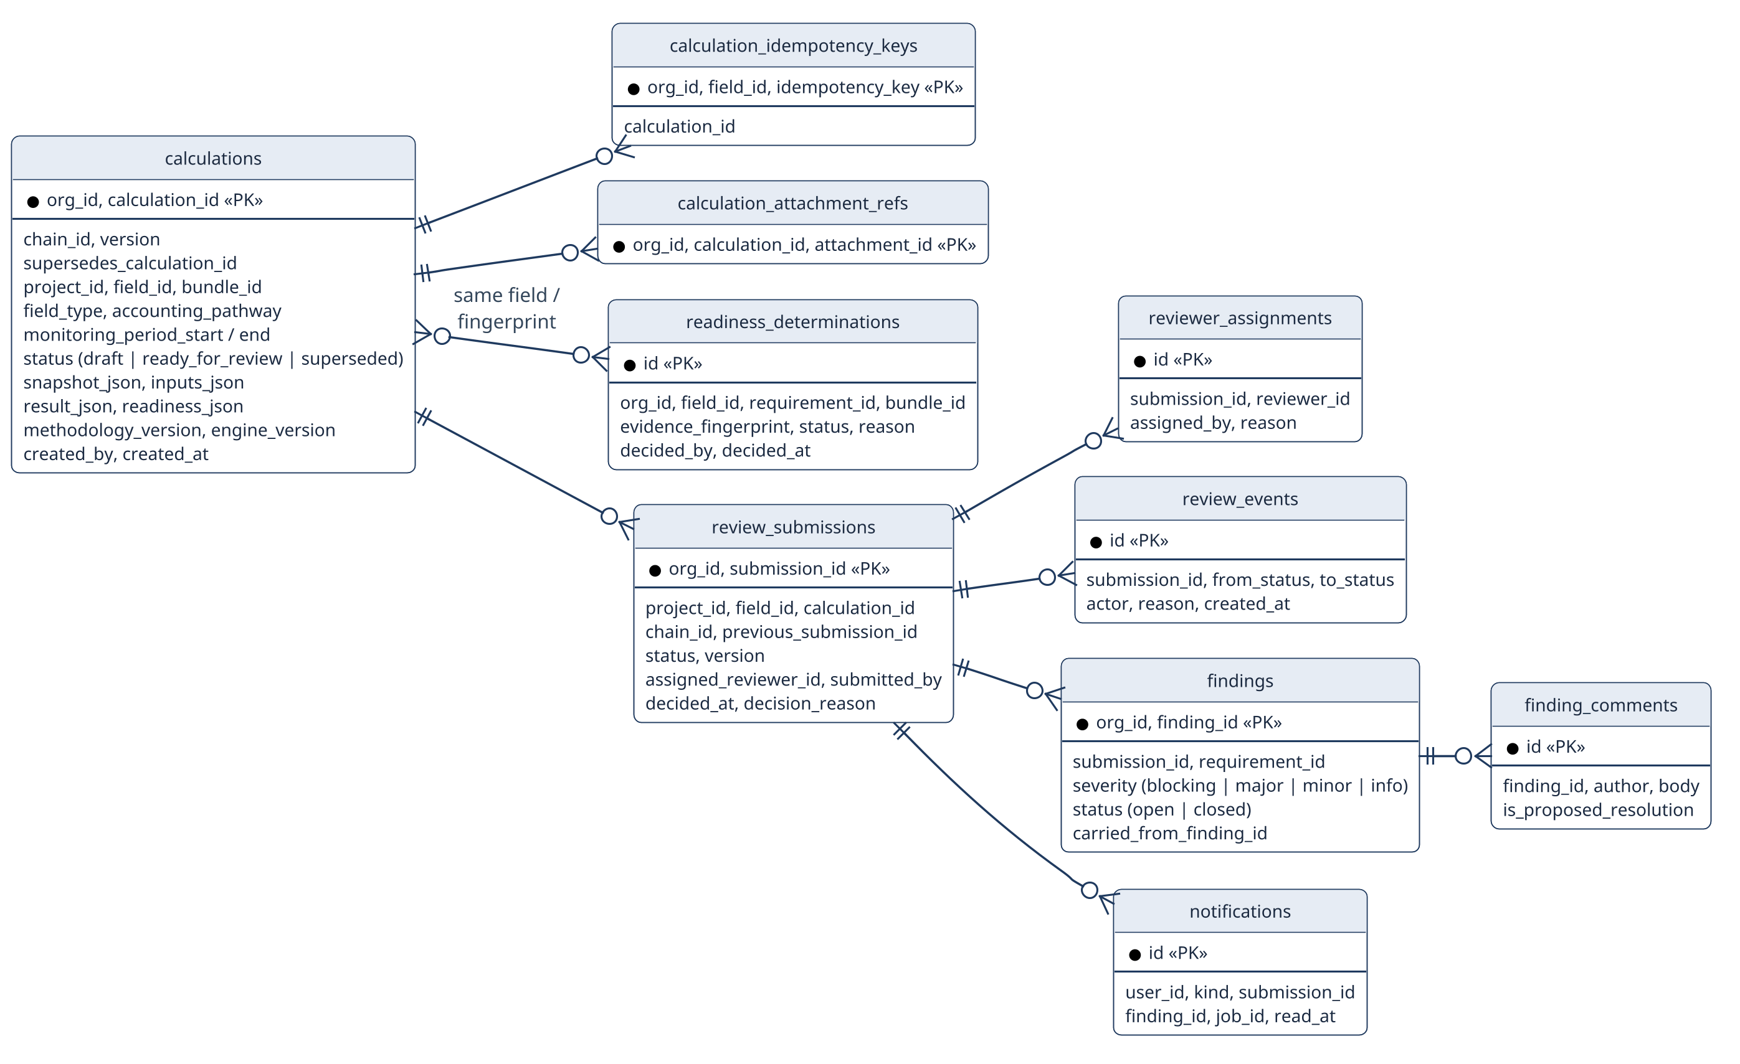
Fig 31: Calculation and internal-review persistence tables.

References
- Verra, VM0051 v1.1 — Methodology for Improved Management in Rice Production Systems. Repository copy: methodologies/verra/vm0051/VM0051-Improved-Management-in-Rice-Production-Systems-v1.1.pdf.
- Verra, VM0042 v2.2 — Methodology for Improved Agricultural Land Management. Repository copy: methodologies/verra/vm0042/VM0042v2.2.pdf. The repository also contains the June 2026 correction/clarification file VM0042v2.2_CC_11JUN2026.pdf and VT0014 v1.0 with its correction notice where relevant to the implemented scope.
- Verra, VMD0054 v1.1 — Methodology for Estimating Leakage from the Displacement of Agricultural Activities. Repository copy: methodologies/verra/vmd0054/VMD0054-v1.1.pdf.
- IPCC, 2019 Refinement to the 2006 IPCC Guidelines for National Greenhouse Gas Inventories, Volume 4 (Agriculture, Forestry and Other Land Use), Chapter 5, Table 5.12 (water regime scaling factors) and Table 5.13/5.14 (pre-season and organic-amendment factors); Chapter 10 (livestock enteric fermentation and manure management, cited for the integrated crop-livestock terms in Sections 1.3, 3.2 and 5.2); Chapter 11, Table 11.1 (N₂O emission factors, including pasture/range/paddock-deposited manure N₂O).
- IPCC, Fifth Assessment Report (AR5), Climate Change 2013: The Physical Science Basis — 100-year Global Warming Potential values (CH₄ = 28, N₂O = 265) used in both carbon estimation engines.
- Verra, VCS Program Guide; VCS Standard v5.0; and Registration and Issuance Process. Repository copies are stored under methodologies/verra/standards/. These documents are cited only for external program/registration/issuance context; Terra-Audit does not perform registry issuance.
- European Space Agency / Copernicus Programme, Sentinel-1 SAR User Guide. https://sentinels.copernicus.eu/web/sentinel/user-guides/sentinel-1-sar
- Google, Google Earth Engine API Documentation (earthengine-api, dataset COPERNICUS/S1_GRD). https://developers.google.com/earth-engine
- R. Lampayan et al., “Adoption and economics of alternate wetting and drying water management for irrigated lowland rice,” Field Crops Research, vol. 170, pp. 95–108, 2015 (background on AWD practice).
- A. Savitzky and M. J. E. Golay, “Smoothing and Differentiation of Data by Simplified Least Squares Procedures,” Analytical Chemistry, vol. 36, no. 8, pp. 1627–1639, 1964 (signal smoothing filter used in the data engine).
- L. Breiman, “Random Forests,” Machine Learning, vol. 45, no. 1, pp. 5–32, 2001.
- T. Chen and C. Guestrin, “XGBoost: A Scalable Tree Boosting System,” Proceedings of the 22nd ACM SIGKDD, pp. 785–794, 2016.
- A. Bouvet and T. Le Toan, “Use of ENVISAT/ASAR wide-swath data for timely rice fields mapping in the Mekong River Delta,” Remote Sensing of Environment, vol. 115, no. 4, pp. 1090–1101, 2011.
- D. B. Nguyen, A. Gruber and W. Wagner, “Mapping rice extent and cropping scheme in the Mekong Delta using Sentinel-1A data,” Remote Sensing Letters, vol. 7, no. 12, pp. 1209–1218, 2016.
- R. Torres et al., “GMES Sentinel-1 mission,” Remote Sensing of Environment, vol. 120, pp. 9–24, 2012.
- N. Gorelick et al., “Google Earth Engine: Planetary-scale geospatial analysis for everyone,” Remote Sensing of Environment, vol. 202, pp. 18–27, 2017.
- R. S. Pressman and B. R. Maxim, Software Engineering: A Practitioner’s Approach, 8th ed. New York: McGraw-Hill Education, 2014.

