Floor plan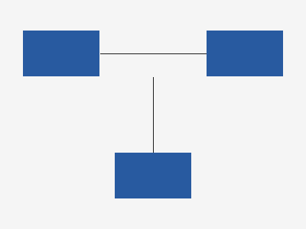
Example Widgets Inc. moved packing next to the loading dock.
Zone | Layout
Packing
Pick rates are reviewed monthly.

