**Notes from hyperparameters tuning**

Performance measure: percentage of correctly classified samples.

Performance value for the default hyperparameter values (A1 = 4, A2 = 4, B = 1): **92.48**

Results for **grid search**, where the values of parameters A1, A2, B were selected from the following set: {0.1, 1.0, 10.0, 100.0, 1000.0}:

the best result (performance = **95.62**) was achieved for **A1 = 1, A2 = 1, B = 0.1**.

For the random search method, where the values of parameters A1, A2, B were randomized from the following ranges (the values were established based on the results for grid search):

- for A1 and A2: <0, 10> with step 1;

- for B: <0, 1> with step 0.1;

the results are as follows:

Results summary

Results in hyperparameters_search_results/QNN

Showing 10 best trials

<keras_tuner.engine.objective.Objective object at 0x7f7a89dc4490>

Trial summary

Hyperparameters:

A_1: 0

A_2: 0

B: 0.0

Score: 0.0

Trial summary

Hyperparameters:

A_1: 4

A_2: 4

B: 0.7000000000000001

Score: 0.0

Trial summary

Hyperparameters:

A_1: 2

A_2: 4

B: 0.1

Score: 0.0

Visualization of hyperparameter tuning results using the grid search method (script visualization.py)[1]:

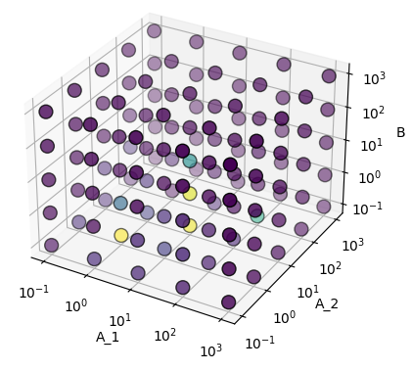

Visualization of hyperparameter tuning results (using the Keras Tuner library) with the Tensor Board tool:

1. Execute the hyperparameters_keras_tuner.py script
2. Run the command:  
   tensorboard --logdir = /tmp/tb_logs  
   (the path to the log directory is defined as a constant in the script).
3. In the web browser go to the address <http://localhost:6006/> (or another, depending on the message received after starting TensorBoard).

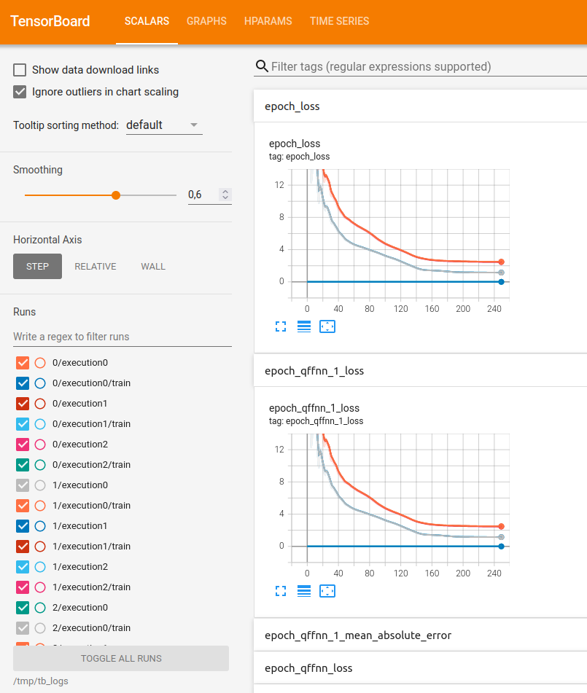

1. The darker the dot, the greater the accuracy of the results.