|  |
| --- |
|  |
| **RTL_EXERCISE_1 BOUND FLASHER** |
|  |
| |  |  | | --- | --- | | Author | Nguyễn Khánh Nam | | Date | 2024/03/06 | | Version | 1.3 | |
|  |
|  |

|  |
| --- |
|  |

Contents

1. Interface 2

2. Functional implementation. 3

3. Internal implementation. 5

3.1. Overall. 5

3.2. State Machine 6

4. History 7

# 1. Interface

|  |
| --- |
| 1  Clock  Rst  1  1  Flick  Lamps  **Bound Flasher System**  16 |
| Figure 1: the figure of Bound Flasher System |

|  |  |  |  |
| --- | --- | --- | --- |
| Signal | Width | In/Out | Description |
| Flick | 1 | In | Flick signal input |
| Clock | 1 | In | Clock signal input |
| Rst | 1 | In | Reset signal input |
| Lamps | 16 | Out | System outputs |

Table 1: Description of signals in Bound Flasher

# 2. Functional implementation.

* Implement a 16-bits LEDs system
* System’s Operation base on three input signal
  + Clock
  + Flick
  + Rst
* The system specification
* Clock signal is provided for system inspire of function status. The function operate state’s transition at positive edge of the clock signal.
* Flick signal: special input for controlling state transfer.
* At the initial state, all lamps are OFF. If flick signal is ACTIVE (set 1), the flasher start operating:
* The lamps are turned ON gradually from lamp[0] to lamp[5].
* The lamps are turned OFF gradually from lamp[5] **(max)** to lamp[5] **(min)**.
* The lamps are turned ON gradually from lamp[0] to lamp[10].
* The lamps are turned OFF gradually from lamp[10] **(max)** to lamp[5] **(min)**..
* The lamps are turned ON gradually from lamp[5] to lamp[15].
* Finally, the lamps are turned ON then OFF simultaneously (blink), return to the initial state.

Additional condition:

* At each kickback point (lamp[5] and lamp[10]), if flick signal is ACTIVE, the lamps will turn OFF gradually again to the **min** lamp of the previous state, then continue operation as above description.

For simplicity, kickback points are considered only when the lamps are turned ON gradually, except the first state.

* Some insulations:
* When flick = 0 at kickback points

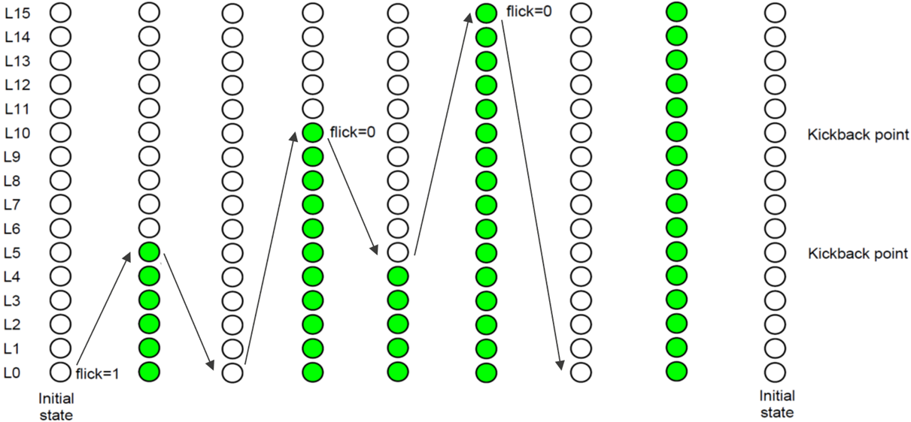

* When flick = 1 at kickback points (lamp[10])

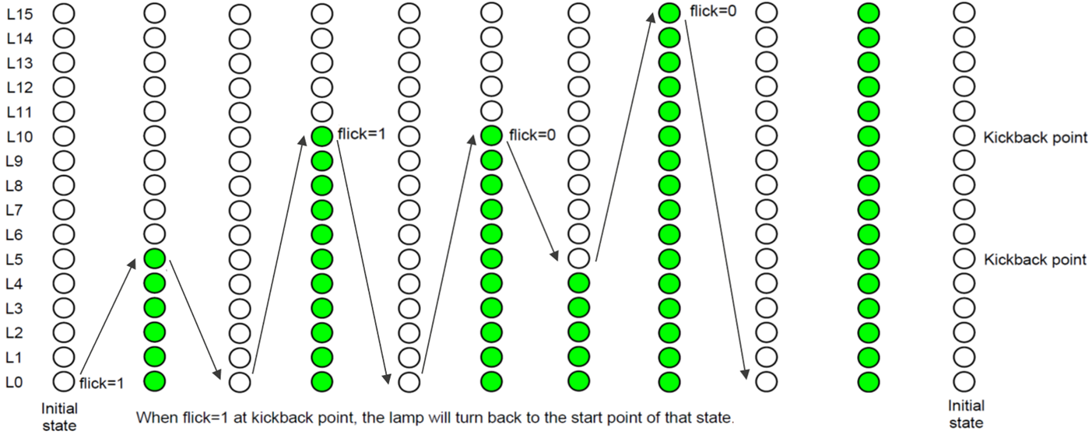

# 3. Internal implementation.

## 3.1. Overall.

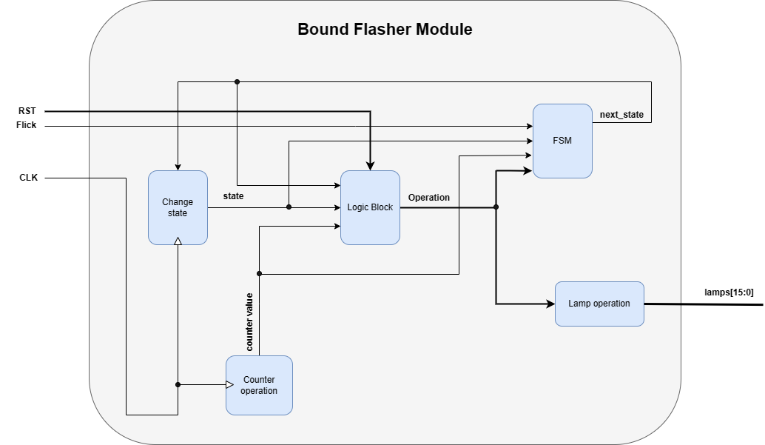

Figure 3.1: Block diagram of Bound Flasher

|  |  |  |  |  |  |  |  |  |  |  |  |  |
| --- | --- | --- | --- | --- | --- | --- | --- | --- | --- | --- | --- | --- |
| |  |  | | --- | --- | | Block | Description | | Change state | The block has two input signal which is CLK and Flick. It is used to define the current state. | | Logic Block | This is where the logic of the module are operated. There are three output that are state, Flick and counter value. The output of this block are the appropriate operations. | | FSM | This block handles the states for the FSM. | | Counter operation | This block is used to process the operations for counter value which will be used for timer delay. It use CLK signal as the input as every clock cycle, the variable will be processed. | | Lamp operation | This block is used to convert the appropriate value for the lamps. | |
|  |

Table 3.1: Block diagram of Bound Flasher Description

## 3.2. State Machine

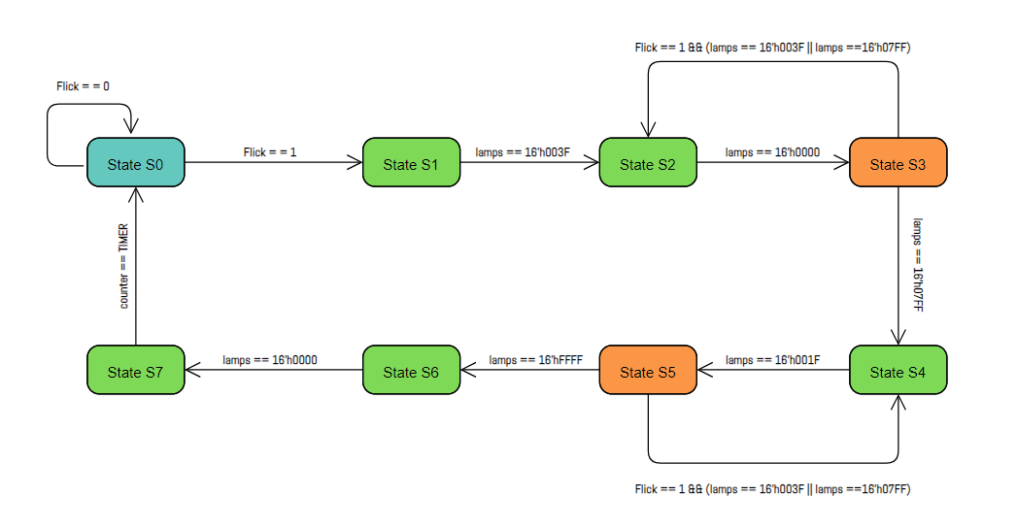

Figure 3.2: State Machine of Bound Flasher

|  |  |
| --- | --- |
| Variable name | Description |
| counter | Using like a timer to make the lamps gradually turn on. |
| TIMER | An integer variable define the number for the counter. |
| Flick | An input signal. |
| lamps | Defines 16-bits output. |

Table 3.2: variable name of State machine

|  |  |
| --- | --- |
| State name | Description |
| State S0 | The initial state. Reset all the bits of the lamps. If there is a HIGH signal of Flick input, it will go to the state S1. Otherwise, it stays at state S0. |
| State S1 | Turn on the lamps gradually from 0 to 5. |
| State S2 | Turn the lamps off gradually from 5 to 0. |
| State S3 | Turn on the lamps gradually from 0 to 10. However, if there is a Flick signal, it will then go back to the previous state (state S2) only when the 6th lamp or the 11th lamp is turned on (kickback point). |
| State S4 | Turn off the lamps from 10 to 5. |
| State S5 | Turn back the lamps on from 5 to 15. If there is a HIGH signal of Flick variable, it will then go back to the state S4 when the 6th lamp or the 11th lamp is turned on (kickback point). |
| State S6 | Turn off the lamps gradually from 15 to 0. |
| State S7 | Turn on back all the lamps at the same time (for blinking). Then go back to initial state when the counter meets TIMER. |

Table 3.3: state name of State machine

# 4. History

|  |  |  |  |
| --- | --- | --- | --- |
| Date | Author | Modified part | Description |
| 2024/02/22 | Nguyễn Khánh Nam | All | New creation |
| 2024/02/24 | Nguyễn Khánh Nam | State machine | Update the state machine picture and explain variables. |
| 2024/02/25 | Nguyễn Khánh Nam | Block diagram | Update block diagram picture and explain. |
| 2024/03/06 | Nguyễn Khánh Nam | Interface, Block diagram | Update reset signal. |