|  |
| --- |
|  |
| **RTL_EXERCISE_1 BOUND FLASHER** |
|  |
| |  |  | | --- | --- | | Author |  | | Date | 2017/03/28 | | Version | 1.1 | |
|  |
|  |

|  |
| --- |
|  |

Contents

1. Interface 2

2. Functional implementation. 3

3. Internal implementation. 5

3.1. Overall. 5

3.2. State Machine 6

4. History 7

# 1. Interface

|  |
| --- |
| **module_name**  aaa  16  ddd  ccc  bbb |
| Figure 1: the figure of Bound Flasher System |

|  |  |  |  |
| --- | --- | --- | --- |
| Signal | Width | In/Out | Description |
| aaa | 1 | In |  |
| bbb | 1 | In |  |
| ccc | 1 | In |  |
| ddd | 16 | Out |  |

Table 1: Description of signals in Bound Flasher

# 2. Functional implementation.

* Implement a 16-bits LEDs system
* System’s Operation base on three input signal
  + Reset
  + Clock
  + Flick
* The system specification
* Clock signal is provided for system inspire of function status. The function operate state’s transition at positive edge of the clock signal.
* Reset signal:
* LOW-ACTIVE Reset = 0: System is restarted to Initial State.
* HIGH-ACTIVE Reset = 1: System is started with initial state.
* Flick signal: special input for controlling state transfer.
* At the initial state, all lamps are OFF. If flick signal is ACTIVE, the flasher start operating:
* The lamps are turned ON gradually from lamp[0] to lamp[5].
* The LEDSs are turned OFF gradually from LEDs [15] to LEDs [5].
* The LEDSs are turned ON gradually from LEDs [5] to LEDs [10].
* The LEDSs are turned OFF gradually from LEDs [10] to LEDs [0].
* The LEDSs are turned ON gradually from LEDs [0] to LEDs [5].
* Finally, the LEDs s are turned OFF gradually from LEDSs [5] to LEDSs [0], return to initial state.
* Additional condition: At each kickback point (LEDs [5] and LEDs [0]), if flick signal is ACTIVE, the LEDs will go back and repeat that STATE. For simple, kickback point is considered only when the LEDs s are turned OFF gradually, except final state.
* Some insulations:
* When flick = 0 at kickback points

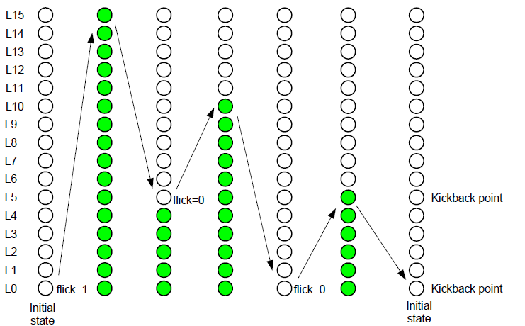

* When flick = 1 at kickback points (lamp[5])

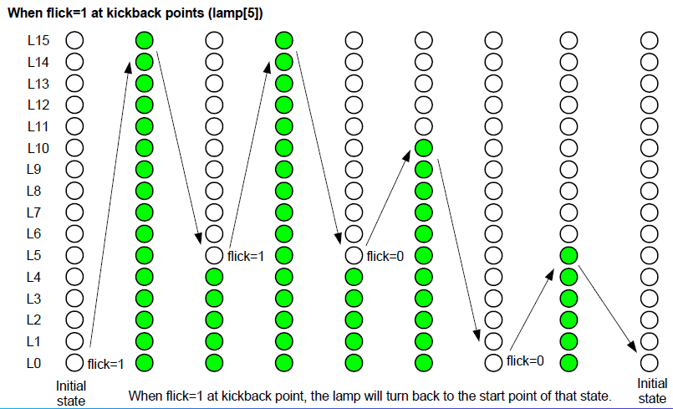

# 3. Internal implementation.

## 3.1. Overall.

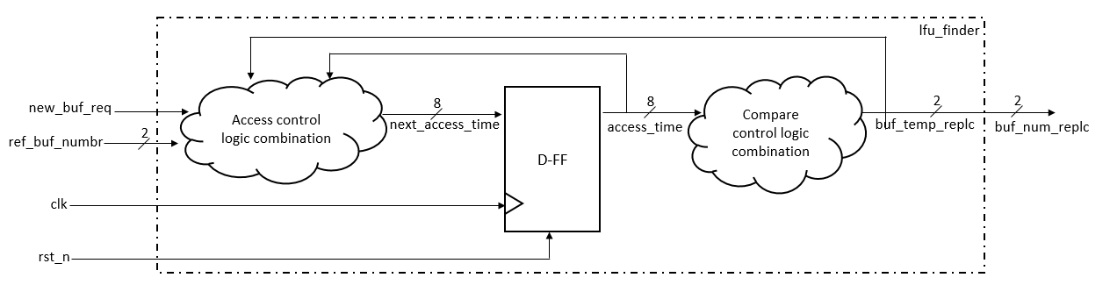

Figure 3.1: Block diagram of Bound Flasher

|  |
| --- |
|  |

Table 3.1: Block diagram of Bound Flasher Description

## 3.2. State Machine

Figure 3.2: State Machine of Bound Flasher

Table 3.2: variable name of State machine

Table 3.3: state name of State machine

# 4. History

|  |  |  |  |
| --- | --- | --- | --- |
| Date | Author | Modified part | Description |
| 2024/02/22 | Nguyễn Khánh Nam | FSM | New creation |
|  |  |  |  |
|  |  |  |  |
|  |  |  |  |