**Below steps is for using the tools:**

**Step 1: (Windows version)** Open any tools that support SSH connections. In this case, we use Mobaxterm as an example. Open Mobaxterm, click on new session, select SSH and choose “**Network settings -> SSH Gateway (jump host)**”. Fill the server Gateway as image below “**hpcc.hcmut.edu.vn**” and port “**3322**”, insert password “bkhpcc”. Access remote host “**10.28.8.71**”, the username below Step 2

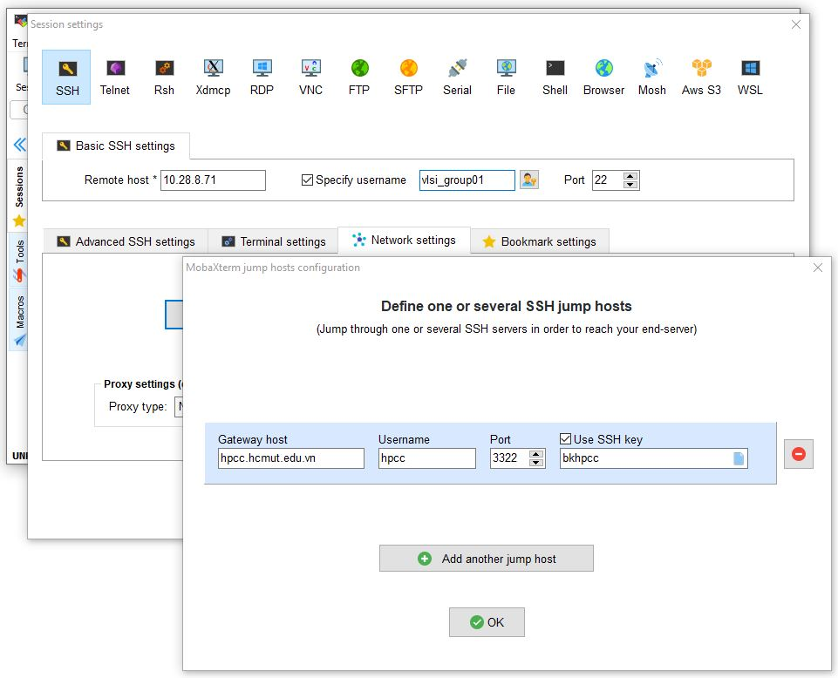

**Step 1: (Linux version)** Open terminal and using ssh gui (insert password “bkhpcc”):

# ssh -X hpcc@hpcc.hcmut.edu.vn -p 3322

Then ssh to server tool:

# ssh -X <username>@10.28.8.71

The username and password below Step 2

**Step 1: (MacOS version)** Install XQuartz and follow Linux version tutorial

Check installed XQuartz (Application -> Utilities), if you have XQuartz app, the software installed successfully.

**Step 2:**

Then use the below login information:

- username "cc<your class group number>group<your group number>". The group number starts from 1. For example, cc01group1, cc01group2, ..., cc01group15.

- password is the same as username. Please do not try to access other accounts. All behaviors are logged.

Moreover, this server currently runs CENTOS 7. This may cause several issues related to the library. Contact us if you meet these problems.

**Step 3:** Open a terminal.

**Step 4:** Add path to use the tool by:

# source /home/share_file/cadence/add_path

**Step 5:** Add path to the license servers:

# source /home/share_file/cadence/add_license

Every time you open a new terminal, please repeat step 4->5 to setup the path.

**Step 6:** Now you are ready to use the tools!