Sample Manuscript using the TampaWorkshop Package

A.M. Poncet, T. Knappenberger, E. Van Santen, and G. Ben-Chanoch.

10/6/2017

# Abstract

This tutorial was written using the following resources.

* Books: (Gandrud 2015; Xie 2015)
* Websites: (*Pandoc User’s Guide* 2017; *R Markdown from R Studio* 2017)

Use minus sign before the *@* to remove the author from the citation. For instance the authors used Gandrud's (2015) book as a reference to write this manuscript.

# Introduction

Leave a blank line to start a new paragraph.

*You can italicize text this way.* **You can bold text this way**

Use \ as escape character. An escape character is placed in front of characters that have a different meaning for the programming language. For instance, \ would be used here in front of \, *, %.

# Material and Methods

This is how you insert a figure.



Sample Figure (This is a Caption)

This is how you include a table into your manuscript.

### Soil Texture by Field (This is a Caption)

|  |  |  |  |
| --- | --- | --- | --- |
| Field | % Clay | % Silt | %Loam |
| F1 | 40 | 35 | 25 |
| F2 | 30 | 40 | 60 |

## Site Description

This is the first subsection within Material and Methods.

## Experimental Design

This is your second subsection within Material and Methods.

## Data Analysis

This is your third subsection within Material and Methods.

# Results and Discussion

Linear model p-value was $2.2016117×{10}^{−20}$.

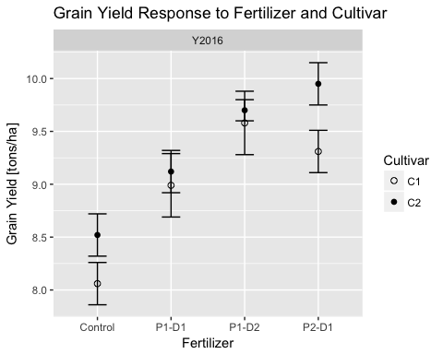

# Conclusions

This is how you create a non-ordered list in markdown.

* first item in first order list.
  + First item in second order list below the first item.
  + Second item in second order list below the first item.
* second item in first order list.

This is how you create an ordered list in markdown.

1. first item in first order list.
   1. First item in second order list below the first item.
   2. Second item in second order list below the first item.
2. second item in first order list.

Make sure that:

* You have an empty line between the text and your list.
* First order lists are idented with 1 tab or 4 spaces.
  + Second order lists are indented with 2 tabs ...
  + ... or 8 spaces.

# References

Gandrud, Christopher. 2015. *Reproducible Research with R and Rstudio.* 2nd ed. CRC Press.

*Pandoc User’s Guide*. 2017. Pandoc. <http://pandoc.org/MANUAL.html#extension-link_attributes>.

*R Markdown from R Studio*. 2017. RStudio. <http://rmarkdown.rstudio.com>.

Xie, Yihui. 2015. *Dynamic Documents with R and Knitr*. 2nd ed. CRC Press.