|  |
| --- |
| Sharepoint deployment Process |

**Introduction:**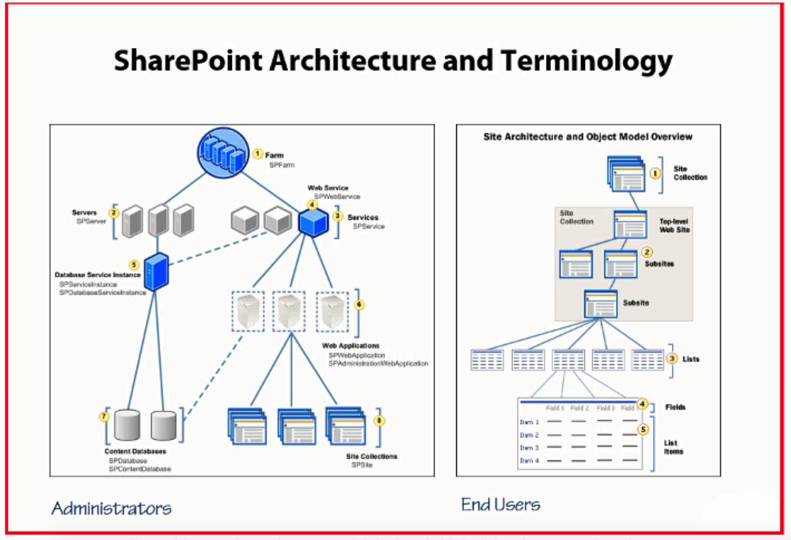

Fig 1

IIS View after install the share point in server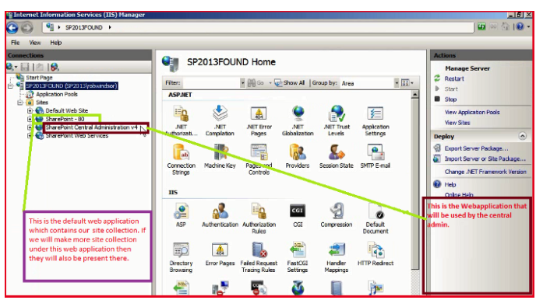

Fig : 2

DataBase Setup View after install the share point in server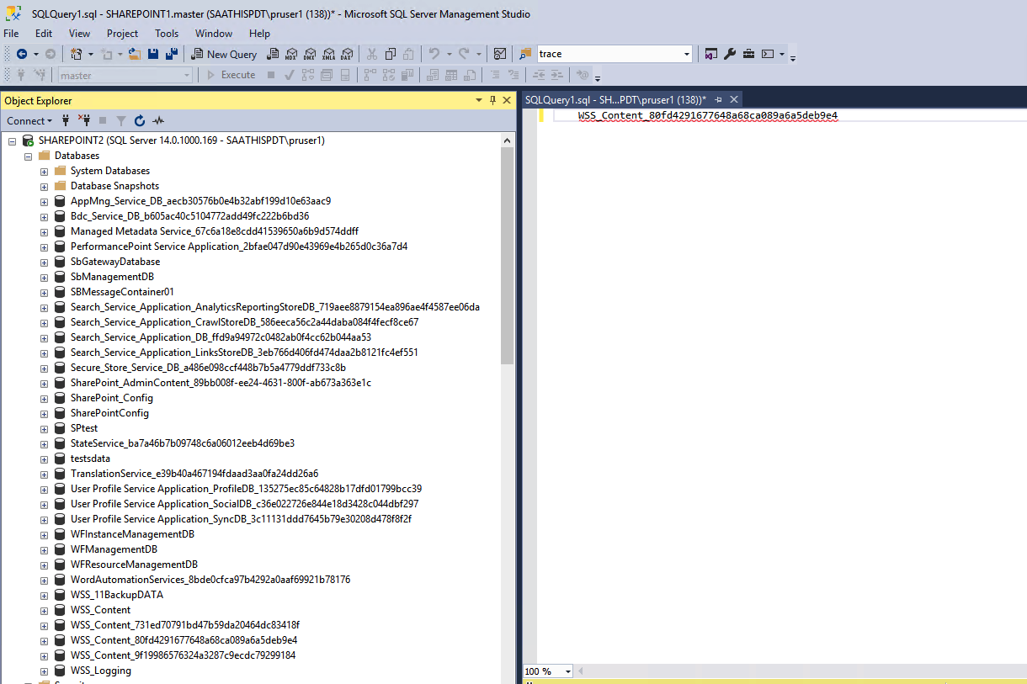

**Fig : 3**

**Applications Configuration**

1. PIP Web Applications for deploy in **Sharepoint IIS server**

**Tab:1**

**Note:** In Above Table APP type is for variate to Web server IIS(sharepoint server) or Web server/client IIS (Any share point accessible server)

|  |  |  |  |  |
| --- | --- | --- | --- | --- |
| SNo | APP Name | APP type | Code type | Details |
| 1 | SPPIPApi | Web server/client IIS | C# CSOM | UI to share point API for Add/update FMR & Tasks |
| 2 | SPPipAPI_SSOM | Web server IIS(sharepoint server) | C# SSOM | UI to share point API for Get FMR & Tasks |
| 3 | ADUVerify | Web server IIS(sharepoint server) | C# Windows Active directory | UI to share point API for Add AD Users |

|  |  |  |  |  |
| --- | --- | --- | --- | --- |
| SNo | APP Name | APP type | Code type | Details |
| 1 | BulkPushConsoleApp_SPBulkupdate | Console | C# CSOM | Bulkpush process for Tasks other server |
| 2 | BulkPushConsoleApp_SPBulkupdate_Ssom | Console | C# SSOM | Bulkpush process for Tasks Sharepoint server |
| 3 | CopyListItemsSsom | Console | C# SSOM | Bulkpush process for Tasks Sharepoint server |
| 4 | BulkpushMultiStatePushConsoleApp | Console | c# windows processer | MultiStates process for Tasks Sharepoint server |
| 5 | BulkpushApiDelete | Console | C# CSOM | Bulkpush process for clear the list items |

2. PIP Console Applications for deploy in **Sharepoint server**

**Tab:2**

PIP Console Applications need to deploy for Bulk FMRS insert/update

**Individual Application level Configuration (web.config & app.config setup)**

Web application & console apps require configuration changes in web.config [for web applications] & app.config[for consoles] plz search key in respective file and change the value as per server.

1. Below app key for use to root the share point site/subsite url

<add key="SITE_URL" value="http://sharepoint1/testlocal" />

2. Below app key for use to root the share point server login name

<add key="SITE_URL_USER" value="pruser1" />

3. Below app key for use to root the share point server login password

<add key="SITE_URL_PWD" value=“%Dalab^!****#” />

4. Below app key for use to root the share point server ADUVerify path

<add key="AD_USER_URL" value="http://localhost:60385/api/ADUVerify" />

5. Below app key for use to root the share point Domain name

<add key="DomainName" value="i:0#.w|saathispdt.com\" />

3. PIP Database installation in **Database server**

Need to install the given PIP content DB name like **WSS_Content_[subsiteGUID]** (.bak file) in share point server and map the same content db from share point admin portal ref below Fig:4

Application manager —> content database refer the below

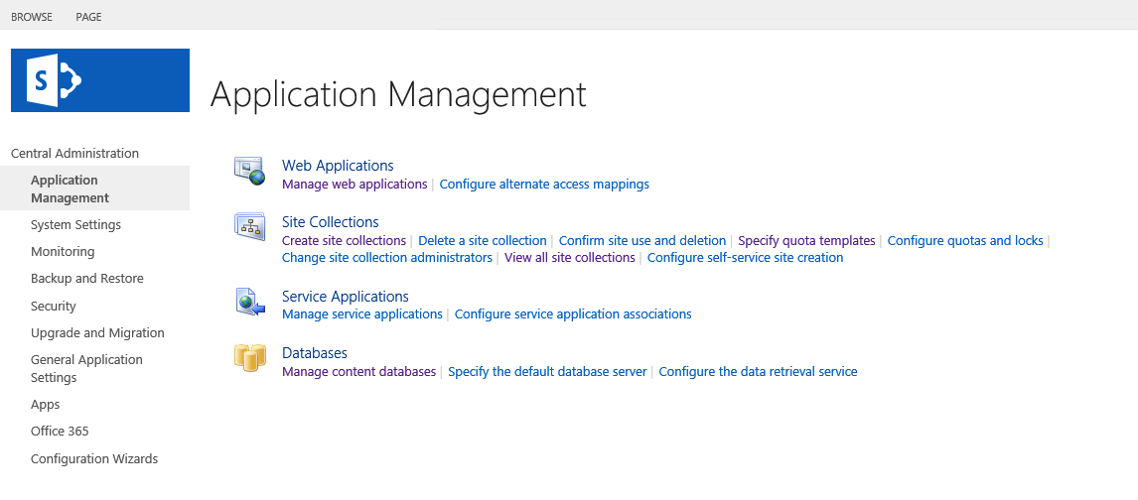

Fig:4

4. Now PIP related all lists added automatically in given share point site URL like 80 or 8080 ports below is the final site list & collection as below Fig:5

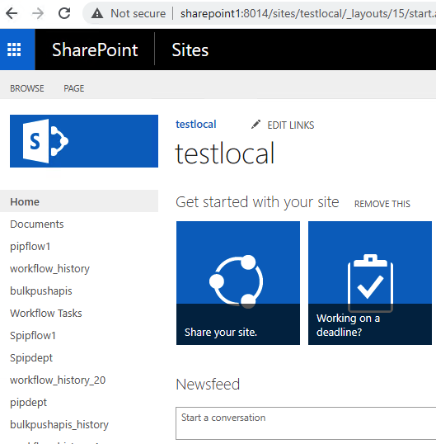

Fig:5

Now the Sharepoint siteURL like below,This Url is used to configure for all share point Applications to connect the lists

sample URL : http://sharepoint1:8014/sites/testlocal