Modern Java 21 – Key Features & Enhancements

Java 21 is a Long-Term Support (LTS) release (2023) and brings many modern, powerful features.

✅ WHAT are Records?
A record is a special short class used only to store data.
record Person(String name, int age) {}

It is automatically:
- immutable
- has getters (name(), age())
- has equals, hashCode, toString

✅ WHY do we use Records?

⭐ 1. To reduce boilerplate
class Person {
private final String name;
private final int age;

// constructor, getters, toString, equals, hashCode...
}

record Person(String name, int age) {}

2. They are immutable
Once created, values cannot change → safer.

WHAT are Sealed Classes?
A sealed class is a class that controls which other classes can extend it.
public sealed class Shape permits Circle, Square {}
This means:
- ONLY Circle and Square are allowed to extend Shape.
- No other class can extend it.

WHY do we need Sealed Classes?
Because before sealed classes, anyone could extend your class:
This causes:
- Security issues
- Harder code maintenance
- Difficult pattern matching
- No control over inheritance

HOW do Sealed Classes work?

1️⃣ You mark a class as sealed
public sealed class Shape permits Circle, Square {
}
public sealed class Shape permits Circle, Square, Rectangle {}

WHAT is Pattern Matching?
Pattern Matching lets Java check a type AND extract (cast) the value automatically
→ no manual casting, no long code, cleaner conditions.

if (obj instanceof String) {
String s = (String) obj; // manual cast
System.out.println(s.toUpperCase());
}

if (obj instanceof String s) {
System.out.println(s.toUpperCase());
}

WHY do we need Pattern Matching?
Because old Java code was:
❌ Verbose
❌ Repetitive
❌ Full of casting
❌ Easy to make mistakes

Pattern Matching in switch (powerful)
You can do type-based switching:

static void display(Object obj) {
switch (obj) {
case String s -> System.out.println("String: " + s.toUpperCase());
case Integer i -> System.out.println("Integer doubled: " + (i * 2));
case null -> System.out.println("NULL value");
default -> System.out.println("Other type");
}
}
Pattern matching is used to check the type of an object and then validate it safely.

What this means in practice
- ❓ Is it the correct type? → Yes / No
- ✅ If Yes → validate fields
- ❌ If No → skip validation

WHAT are Virtual Threads?
Virtual Threads are lightweight threads introduced in Java (Project Loom).
They are not real OS threads — they are managed by the JVM, not the OS.
Think of them like:
🧵 Normal thread = heavy
🪶 Virtual thread = super light

WHY do we need Virtual Threads?
Before virtual threads:
❌ Normal threads were expensive
❌ Java apps used thread pools
❌ You could only have maybe a few thousand thread
❌ Handling many users (like servers) was complicated
After virtual threads:
✔ Create MILLIONS of threads
✔ SIMPLE code (no more complicated async)
✔ Even blocking code becomes cheap
✔ Perfect for servers, APIs, databases
✔ Faster and scalable apps
✔ No need for complex async libraries
public class Main {
public static void main(String[] args) throws Exception {
for (int i = 0; i < 1000; i++) {
Thread.startVirtualThread(() -> {
System.out.println(Thread.currentThread());
});
}
}
}

1. WHAT is Collections Framework?
It is a set of ready-made data structures in Java to store and manage data.
It includes:
- List → ordered, duplicates allowed
- Set → no duplicates
- Map → key-value pairs
- Queue → FIFO structure
Examples:
- ArrayList
- HashSet
- HashMap
- LinkedList
- PriorityQueue
These are all part of the Collections Framework.

2. WHY do we use Collections?
Because arrays are weak, collections are powerful.

Arrays ❌
- Fixed size
- No built-in remove, search, sort
- Hard to manage big data

Collections ✔
- Dynamic size
- Built-in add/remove/update
- Sorting, filtering, grouping
- Many ready-made data structures
- Supports Streams + Lambdas (advanced operations)

3. HOW to use Collections?

✔ List Example (allows duplicates)
List<String> list = new ArrayList<>();
list.add("A");
list.add("B");
list.add("A");

✔ Set Example (no duplicates)
Set<Integer> set = new HashSet<>();
set.add(10);
set.add(20);
set.add(10); // not added

✔ Map Example (key–value)
Map<String, Integer> map = new HashMap<>();
map.put("age", 25);
map.put("height", 180);

Collections Framework and advanced operations

What is a Lambda?
A lambda is just a short way of writing a method.
() -> System.out.println("Hello");

What is a Stream?
A Stream is a pipeline that helps you process collections (List, Set, etc.) in an easy, read
List<Integer> nums = List.of(1,2,3,4);

nums.stream()
.filter(n -> n % 2 == 0)
.forEach(System.out::println);

Step | Meaning | Example
Source | Where data comes from | nums.stream()
Intermediate ops | Transform/filter | filter(), map(), sorted()
Terminal ops | Final output | collect(), forEach(), sum()
filter() — keep only matching
List<Integer> result = nums.stream()
.filter(n -> n > 10)
.toList();

map() — change each item

List<Integer> result = nums.stream()
.map(n -> n * 2)
.toList();

sorted()
nums.stream().sorted().forEach(System.out::println);

distinct() — remove duplicates

nums.stream().distinct().toList();

reduce() — combine to single value

int sum = nums.stream()
.reduce(0, (a, b) -> a + b);

int sum = nums.stream()
.reduce(0, (a, b) -> a + b);

- a = accumulated value
- b = current element

collect() — convert to list/set/map
nums.stream().collect(Collectors.toList());

To Set

nums.stream().collect(Collectors.toSet());

Custom collection

nums.stream()
.collect(Collectors.toCollection(ArrayList::new));

Using Streams with Map
Print keys
map.keySet().forEach(System.out::println);

Print values
map.values().forEach(System.out::println);

Print key + value with streams
map.entrySet().stream()
.forEach(e -> System.out.println(e.getKey() + " = " + e.getValue()));

Parallel Stream
Normal stream → ordered
Parallel stream → faster for large data, but order not guaranteed
nums.parallelStream()
.forEach(System.out::println);

Method References
Shortcut for lambda

Lambda:
names.forEach(n -> System.out.println(n));

Method reference:
names.forEach(System.out::println);

Functional Programming in Java
It means:
✔ No loops
✔ No mutable variables
✔ Use lambdas
✔ Use streams
✔ Use mapping/filtering instead of if/else inside loops

Concept | Use When
Lambda | You want short method implementations
Stream | Processing a list/set/map
filter() | You want to keep only some items
map() | You want to transform items
reduce() | You want a single result (sum, product, max)
collect() | You want to convert stream → list/set/map
groupingBy() | You want category-wise groups
parallelStream() | Large data + performance needed  Exception
An exception is a runtime error that disrupts the normal execution of a program and must be handled to prevent application failure.

WHY do Exceptions happen?
Exceptions happen because:
- Invalid input
- Programmer mistake
- External failure (file, DB, network)

Problem | Exception
Divide by zero | ArithmeticException
Null value | NullPointerException
File missing | FileNotFoundException

HOW does Java handle Exceptions?
Java gives tools:

🔹 try
Code that may fail

🔹 catch
Code to handle failure

🔹 finally
Always runs (cleanup)
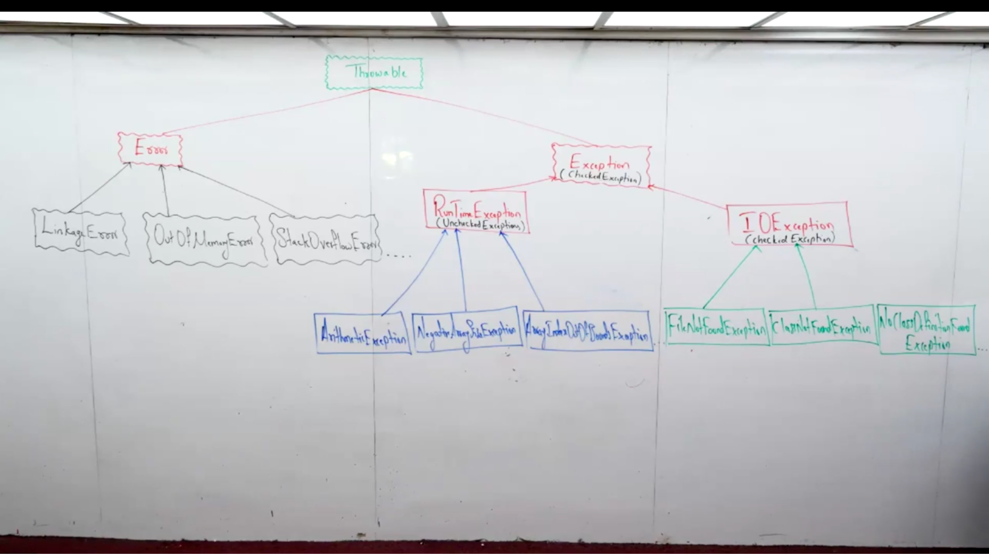

Why LinkageError happens
LinkageError happens when .class files don’t match each other at runtime.

What is OutOfMemoryError?
OutOfMemoryError happens when JVM has NO memory left to create new objects.

What is StackOverflowError?
StackOverflowError happens when the call stack becomes full.

Object
|
└── Throwable
|
├── Error
|
└── Exception
|
├── RuntimeException
|
└── Checked Exceptions

RuntimeException (Unchecked)
- Happens due to programming mistakes
- Compiler does NOT force try-catch

Examples:
- NullPointerException
- ArithmeticException
- ArrayIndexOutOfBoundsException
- ClassCastException

Checked Exceptions
- Compiler forces handling
- Must use try-catch or throws

Examples:
- IOException
- SQLException
- FileNotFoundException
- InterruptedException

What is Exception Propagation?
Exception propagation means an exception moves up the method call stack until it is handled.
Exception occurs in method A
Not handled there
Goes to method B
Continues upward

Until caught

What does “Rethrow the Exception” mean?
Rethrowing an exception means:
catch the exception, do something, then throw it again.

What is Ducking an Exception?
Ducking an exception means:
You are NOT handling the exception where it occurs.
You are passing it to the caller using throws.

