項次 | 標題 | 說明
1. | Download relative Package | -JDK(Current:1.8.0_20)  http://www.oracle.com/technetwork/java/javase/downloads/index.html  -Apache ActiveMQ(Current 5.10.1)  http://activemq.apache.org/download.html  -Apache NMS provider(Current 1.7.0)  http://activemq.apache.org/nms/nms-api-downloads.html  -Apache NMS active client(Current 1.7.0)  http://activemq.apache.org/nms/activemq-downloads.html
2 | 啟動ActiveMQ | -設定環境參數  JAVA_HOME  ACTIVEMQ_HOME  -cmd 起動  %ACTIVEMQ_HOME%\bin\activemq start  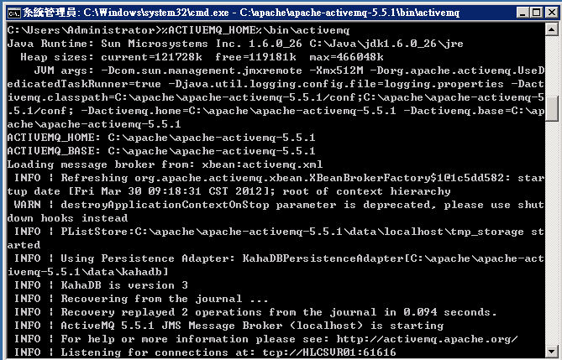
3 | 連上Admin頁 | http://localhost:8161/admin  id: admin  password: admin  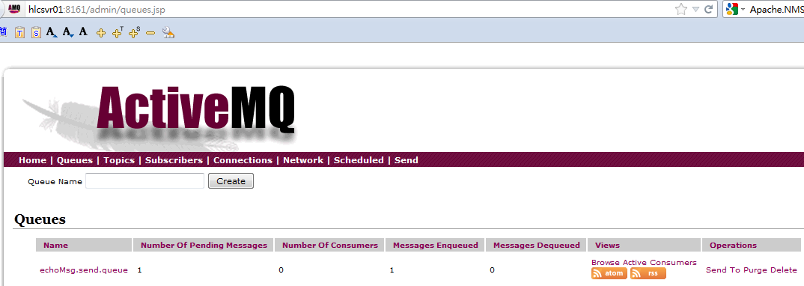
4 | 將active設為Windows (64位元) Service | Ref:  http://stackoverflow.com/questions/4626824/how-do-i-install-activemq-as-a-64-bit-service-on-windows  -環境參數設定  JAVA_HOME  ACTIVEMQ_HOME  -修改 "%ACTIVEMQ_HOME%\bin\win64\InstallService.bat"  :conf  set _WRAPPER_CONF="%ACTIVEMQ_HOME%\bin\win64\wrapper.conf"  set _ACTIVEMQ_HOME="set.ACTIVEMQ_HOME=%ACTIVEMQ_HOME%"  set _ACTIVEMQ_BASE="set.ACTIVEMQ_BASE=%ACTIVEMQ_BASE%"  rem -- Add by Dennis  set _JAVA_HOME="set.JAVA_HOME=%JAVA_HOME%"  rem  rem Install the Wrapper as an NT service.  rem  :startup  rem -- original config  rem "wrapper.exe" -i %_WRAPPER_CONF% %_ACTIVEMQ_HOME% %_ACTIVEMQ_BASE%  rem -- Modify by Dennis  "%ACTIVEMQ_HOME%\bin\win64\wrapper.exe" -i %_WRAPPER_CONF% %_ACTIVEMQ_HOME% %_ACTIVEMQ_BASE% %_JAVA_HOME%  if not errorlevel 1 goto :eof  pause  -修改 "%ACTIVEMQ_HOME%\bin\win64\wrapper.conf"  # Java Application  rem -- Original config  rem wrapper.java.command=java  rem -- Modify by Dennis  wrapper.java.command=%JAVA_HOME%\bin\java.exe  -修改 "%ACTIVEMQ_HOME%\bin\win64\UnInstallService.bat"  :startup  rem -- original config  rem "%_APP_HOME%wrapper.exe" -r %_WRAPPER_CONF%  rem -- modify by dennis  "%ACTIVEMQ_HOME%\bin\win64\wrapper.exe" -r %_WRAPPER_CONF%  -用Administrator權限執行InstallService.bat  # cd %ACTIVEMQ_HOME%\bin\win64  # InstallService.bat  -至服務中啟動active  