 | Frank H. Avery, Jr.
6/20/2008
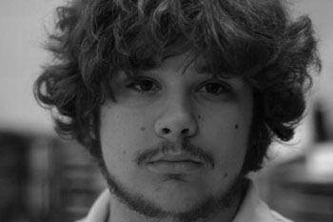 | 704 Howe St. Apt 2 | Radford, VA 24142  804-731-9267  knarfishness@gmail.com  http://www.knarfishness.net

Education
Radford University
May, 2009
Bachelor’s Degree in Web Design, Media Studies Department
experience
Firedog PC Technician | Circuit City Stores, Inc.
May 2007 – August 2007
Operated and supervised the Firedog PC Services desk, including taking in new orders for service, practicing both basic and advanced technical support both in person and over the phone, scheduling installations and running and closing out the cash register.
Digital Photo Editor / Asst. Mgr. Peter Wabbit Photography
May 2005 – August 2005
Responsibilities included receiving, shipping, digital photo order processing and editing, packaging, billing, shipping and customer service via telephone.
General Manager | Media Studies Department, R.U.
August 2005 – Present
Involves both the managing of scheduling and payroll of the other student workers at the Media Studies Equipment Checkout Lab at Radford University. Also involves the day to day duties of the equipment lab, including troubleshooting, website and database maintenance, and general inventory and surplus.
skills
- MCSE / Vista Certified (through Circuit City
- Adobe CSE Suite (Advanced)
- Mac OS X / Linux / Unix based operating systems
- Working knowledge of Java, .net, and C++ (College Level)
- Advanced PC Hardware maintenance, installation and troubleshooting
- 4+ years customer service experience, both in person and over the telephone
- Working knowledge of Apache and IIS web hosting systems

