**Revision History**

|  |  |  |  |
| --- | --- | --- | --- |
| **Version** | **Date** | **Description** | **Author** |
| Inception draft | Jan 28 | First Draft. | Jeremy Knauff |
|  |  |  |  |

**Introduction**

This program is a personal file encryption and decryption app that can has a simple file explorer and can store files into a cloud service.

**Positioning**

***Problem Statement***

File encryption apps are very complex and offer many options with more company ideas in mind. Most users looking for a personal encryption app do not need all of these functions and want something simple that protects their files

***Product Position Statement***

**-**This app is for security-conscious users who are looking for a personal file program and not a fully-fledged business-like file encryption program. It will allow users to use different file explorer options to find files on their system and select them for encryption or decryption. The program is simple and easy to use with no excess functions.

**Stakeholder Descriptions**

***Market Demographics***

Traveling CEO

Small business owner

***User Summary***

Needs to keep important information a secret but, doesn’t know much about security

***Key High-Level Goals and Problems of the Stakeholders***

|  |  |  |  |
| --- | --- | --- | --- |
| **High-Level Goal** | **Priority** | **Problems and Concerns** | **Current Solutions** |
| Simplicity | High | Fast and Easy to use |  |
| Security | High | Potential back doors | Remove old files and replace them with the encrypted files |

***User-Level Goals***

Encrypt and decrypt files

Move, copy and delete files

***User Environment***

Work place, business

**Product Overview**

***Product Perspective***

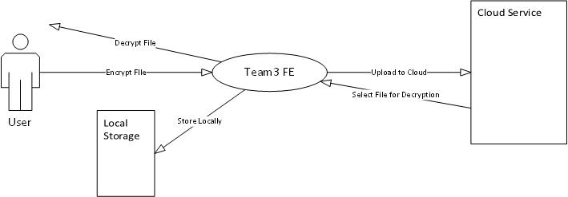

***Summary of Benefits***

|  |  |
| --- | --- |
| **Supporting Feature** | **Stakeholder Benefit** |
| Cloud Storage | Allow users to store files in the cloud in case something happens to the phone |
| File Explorer | Allow users to easily navigate phone to find files |

***Assumptions and Dependencies***

Having a smart phone

Files on a phone

***Cost and Pricing***

Free

***Licensing and Installation***

App store

**Summary of System Features**

* Create passcode for the file
* Change passcode
* Encrypt a file
* Decrypt a file
* Create new file
* Move file
* Search for a file
* Delete a file
* Copy a file
* Store file in the cloud
* Security Question service for forgotten password

**Other Requirements and Constraints**

* Easy to use
* Secure