

Visvesvaraya Technological University, Jnana Sangama, Belagavi – 590 018
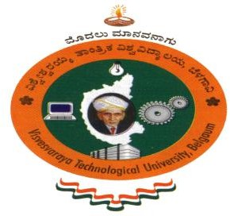
KLS Vishwanathrao Deshpande Institute of Technology,
Haliyal–581329
(Accredited by NAAC with “A” Grade)
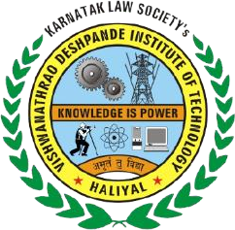
Department of Computer Science and Engineering (AIML)

Internship Report

Artificial Intelligence & Machine Learning

Submitted by
Nauman Khan – 2VD22CI024

VIII–Semester/IV–Year
Under the guidance of

Internal guide: Prof. Bheerappa Sasanoor
External guide: Ms. Maimuneesa Kazi
2025 – 26





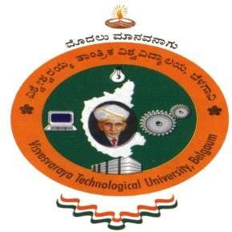
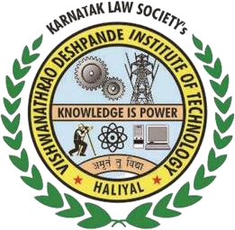
Visvesvaraya Technological University, Jnana Sangama, Belagavi – 590 018

KLS Vishwanathrao Deshpande Institute of Technology,
Haliyal–581329
(Accredited by NAAC with “A” Grade)

Department of Computer Science and Engineering(AIML)

CERTIFICATE
Certified that the Internship Work entitled “Artificial Intelligence & Machine Learning” carried out by Mr. Nauman Khan , USN: 2VD22CI024 a bonafide student of KLS VDIT, Haliyal, in partial fulfillment for the award of Bachelor of Engineering in Computer Science and Engineering(AIML), of the Visvesvaraya Technological University, Belagavi during the year 2025-2026. It is certified that all corrections / suggestions indicated for Internal Assessment have been incorporated in the Report deposited in the Departmental Library. The internship report has been approved as it satisfies the academic requirements in respect of Internship work prescribed for the said Degree.

GUIDE  (Prof. Bheerappa Sasanoor) | HOD  (Dr. Poornima Raikar) | PRINCIPAL  (Dr. V. A. Kulkarni)

Name of the Examiners Signature with Date

1.

2.

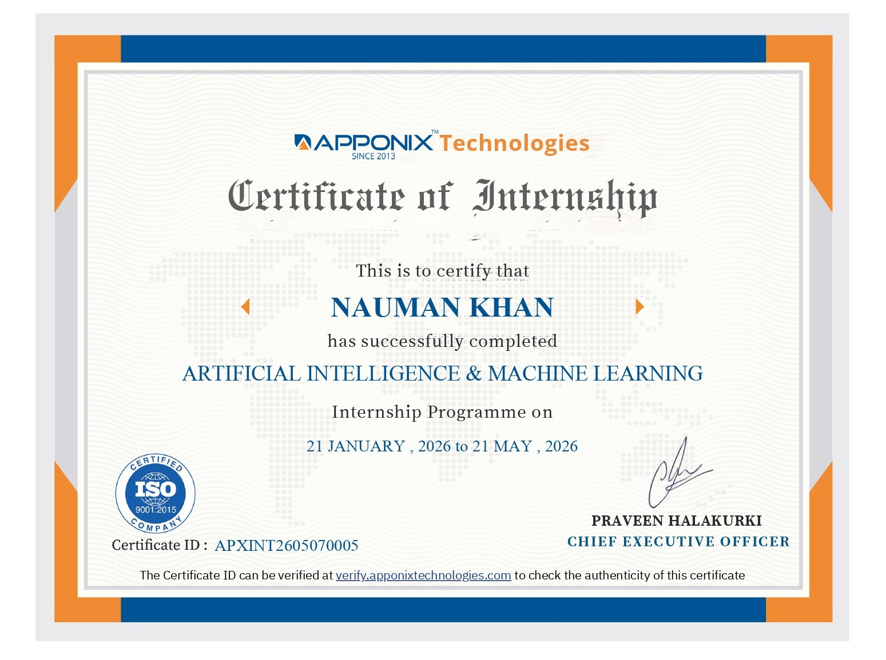

ACKNOWLEDGEMENT

I am indebted to our Principal Dr. V. A. Kulkarni and management of KLS VDIT for providing an environment with all facilities that helped me in completing the internship.
I am extremely grateful to Dr. Poornima Raikar, HOD of the Computer Science and Engineering(AIML), Department for his moral support and encouragement.
I wish to express my sincere gratitude to my internal guide Prof. Bheerappa sasanoor from the Computer Science & Engineering(AIML), and to my external guide Ms. Maimuneesa Kazi, Sr. Trainer at Apponix Technologies Pvt. Ltd., for their guidance and suggestions.
I thank all the teaching and non-teaching staff of the Department of Computer Science and Engineering(AIML) for their kind help.
I also thank the company Apponix Technologies Pvt Ltd for providing me with this golden opportunity to do the internship on the topic Artificial Intelligence & Machine Learning which helped me in learning new things.
Last but not the least, I would like to add some personal notes. If there is a driving force that keeps me going, and what has not changed, it is the constant support and blessing of my parents, family and friends. There is no doubt, in spite of my strenuous efforts; error might remain in the internship report. Naturally, I take full responsibility for any lack of clarity, occasional erratum or inexactness that may occur.

Nauman Khan 2VD22CI024

Table of Contents

Content | Page No.
- Company Profile | 1
- About the Company | 2
- Tasks performed | 3
- Reflection | 10
- Conclusion | 12
- Internship Diary | 13

List OF Figures

Figure No. | Figure Name | Page No.
1 | Requirement analysis | 3
2 | Database | 5
3 | Ai assistant | 7
4 | Login page | 7
5 | Admin control center | 8
6 | Interview scheduling | 8
7 | Dashboard | 9

COMPANY PROFILE

Name: Apponix Technologies Pvt.Ltd.

Address: #306, 10th Main, 46th Cross,4th Block,Rajajinagar,Banglore - 560010

Contact no. : +91 8050580888 / +91 9068980888

Email: info@apponix.com
Website: www.apponix.com
Company logo:

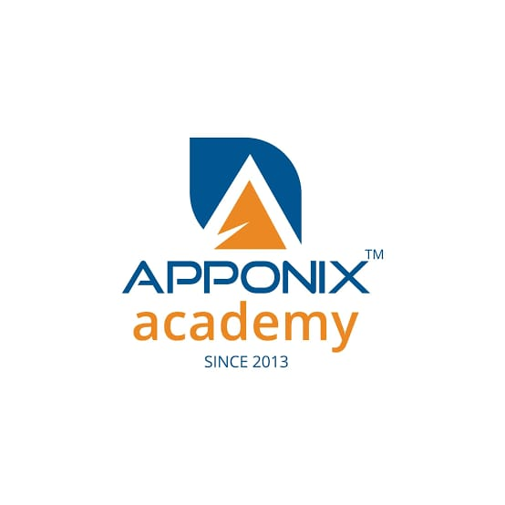
Vision:
To bridge the gap between education and industry by providing high-quality, industry-ready training programs that empower students and professionals with practical skills.
Mission:
To provide dynamic and interactive professional training, preparing students for future job opportunities through hands-on learning, certifications, and placement support.

ABOUT THE COMPANY

- Apponix Technologies is a premier training and internship institute established in 2013, focused on delivering industry-relevant education in domains such as Python Programming, Artificial Intelligence, Data Science, Cloud Computing, Cybersecurity, Digital Marketing, and Web Development. The institute is dedicated to helping students and professionals gain practical knowledge and real-world skills required in today’s competitive job market.

- The organization provides expert trainers from industry backgrounds who offer practical and project-oriented training. Apponix emphasizes hands-on learning through live projects, assignments, workshops, and internships, enabling learners to gain strong technical exposure and confidence.

- Apponix Technologies also offers flexible learning options including classroom, online, and self-paced training. The institute has trained thousands of students and professionals, many of whom are successfully working in reputed companies such as Infosys, Wipro, Amazon, HCL, Adobe, Accenture, and Fujitsu.

- The institute is recognized for its quality training standards and has partnerships and accreditations with organizations such as VMware, ISO, and JainX University. Apponix also provides placement assistance, career guidance, interview preparation, and certification-oriented training to help students build successful careers in the IT industry.

- In addition to technical training, Apponix conducts internship programs in various emerging technologies including Full Stack Development, Artificial Intelligence, Machine Learning, Cloud Computing, Data Analytics, Ethical Hacking, and Android Development. The internship programs are designed to provide practical industry exposure and improve workplace readiness among students

TASKS PERFORMED

As part of my internship at Apponix Technologies, I underwent comprehensive training and hands-on project work in the domain of Artificial Intelligence and Machine Learning. The internship program was designed to provide practical exposure to AI concepts, programming, data analysis, machine learning algorithms, and real-world application development. Throughout the internship, I gained both theoretical understanding and practical implementation skills using modern tools and technologies widely used in the industry.

The training was project-oriented and focused on improving analytical thinking, problem-solving abilities, and technical knowledge in Artificial Intelligence and Machine Learning. The following sections describe the tasks performed and skills acquired during the internship.

1.1 Python Programming and Fundamental Concepts

During the initial phase of the internship, I developed a strong foundation in Python programming, which is one of the most widely used programming languages in Artificial Intelligence and Machine Learning. I learned Python syntax, variables, operators, conditional statements, loops, functions, file handling, exception handling, modules, and object-oriented programming concepts.

I also worked with important Python libraries such as NumPy and Pandas for numerical computation and data manipulation. Practical coding exercises and mini-projects helped me improve logical thinking and problem-solving skills. Additionally, I learned how to write optimized and reusable code for real-world AI applications.

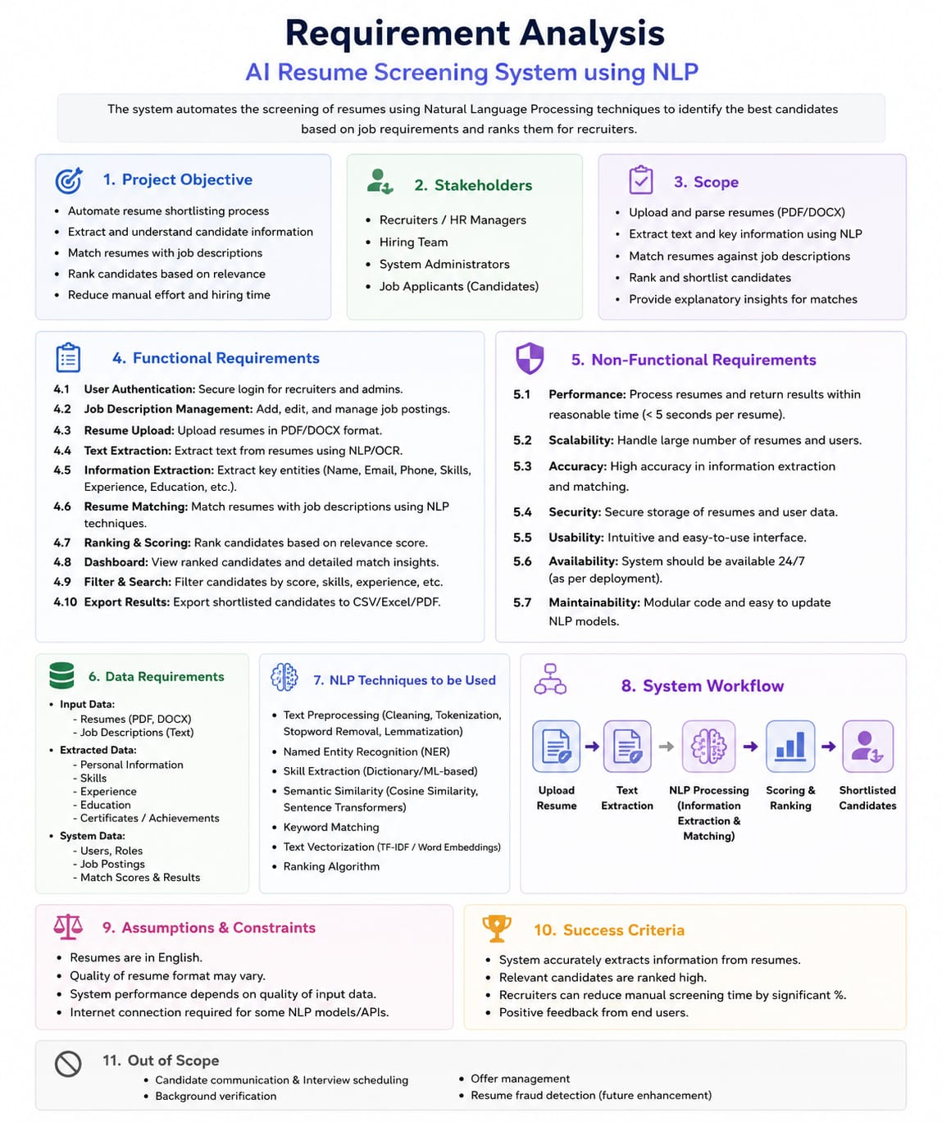
Fig 1 Requirement Analysis

1.2 Data Preprocessing and Data Analysis

Data preprocessing is one of the most critical stages in Machine Learning. During the internship, I worked extensively on cleaning, transforming, and preparing datasets for model training.
The tasks performed included:
- Handling missing and null values
- Removing duplicate records
- Data normalization and standardization
- Feature extraction and feature selection
- Data encoding and transformation
- Outlier detection and removal
I used Pandas, NumPy, and Matplotlib libraries to analyze datasets and generate meaningful insights. I also learned Exploratory Data Analysis (EDA) techniques to understand data distribution, patterns, and correlations using graphs and statistical methods.
1.3 Machine Learning Algorithms and Model Development
As part of the internship training, I studied and implemented various Machine Learning algorithms used for predictive analysis and intelligent decision-making systems.
The algorithms and techniques explored include:
- Supervised Learning
- Linear Regression
- Logistic Regression
- Decision Tree
- Random Forest
- Support Vector Machine (SVM)
- K-Nearest Neighbors (KNN)
- Naive Bayes
- Unsupervised Learning
- K-Means Clustering
- DBSCAN Clustering
- Hierarchical Clustering
I learned how to train machine learning models using datasets, split datasets into training and testing data, evaluate model performance, and improve accuracy using hyperparameter tuning techniques.
The models were evaluated using metrics such as:
- Accuracy
- Precision
- Recall
- F1-Score
- Confusion Matrix
I also gained practical knowledge about overfitting, underfitting, and model optimization techniques.
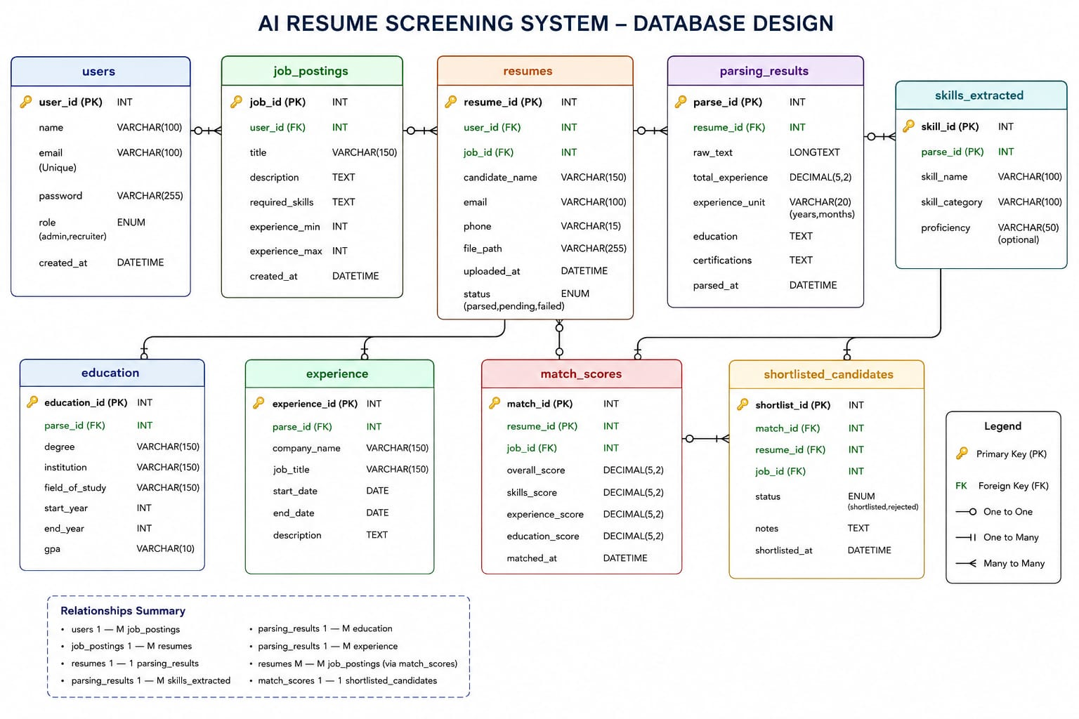
Fig 2 Database

1.4 Artificial Intelligence and Prompt Engineering
During the internship, I was introduced to modern Artificial Intelligence concepts and AI-powered tools. I learned about Generative AI, Natural Language Processing (NLP), and prompt engineering techniques.
The training included:
- Understanding AI models and their applications
- Writing effective prompts for AI systems
- Working with AI-based coding assistants
- Exploring AI automation tools
- Understanding ethical considerations in AI
I practiced using AI platforms and tools to generate code, automate tasks, and improve productivity. This helped me understand how Artificial Intelligence can be integrated into software development and business applications.

1.5 Data Visualization and Reporting
I learned how to visualize data effectively using graphical representations and dashboards. Visualization helped in understanding trends, patterns, and business insights from datasets.
Tools and libraries used:
- Matplotlib
- Seaborn
- Power BI
- The tasks performed included:
- Creating bar charts, pie charts, histograms, and scatter plots
- Building dashboards and reports
- Analyzing trends and patterns
- Presenting model performance visually
This training enhanced my ability to communicate technical findings clearly and effectively.

1.6 Projects and Practical Implementation
During the internship, I worked on several practical assignments and mini-projects related to Artificial Intelligence and Machine Learning. These projects helped me understand real-world implementation of AI concepts.

The activities included:
- Dataset collection and preprocessing
- Training machine learning models
- Prediction and classification tasks
- Data visualization and reporting
- Testing and evaluation of models
The projects improved my hands-on experience in solving real-world problems using AI and Machine Learning techniques.

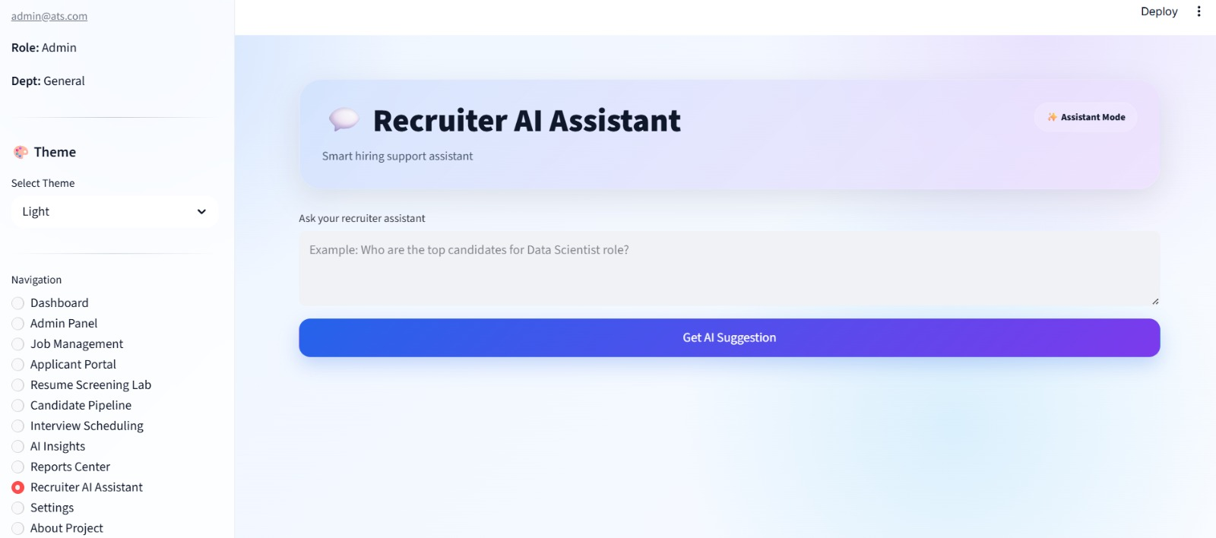
Fig 3 Ai Assistant

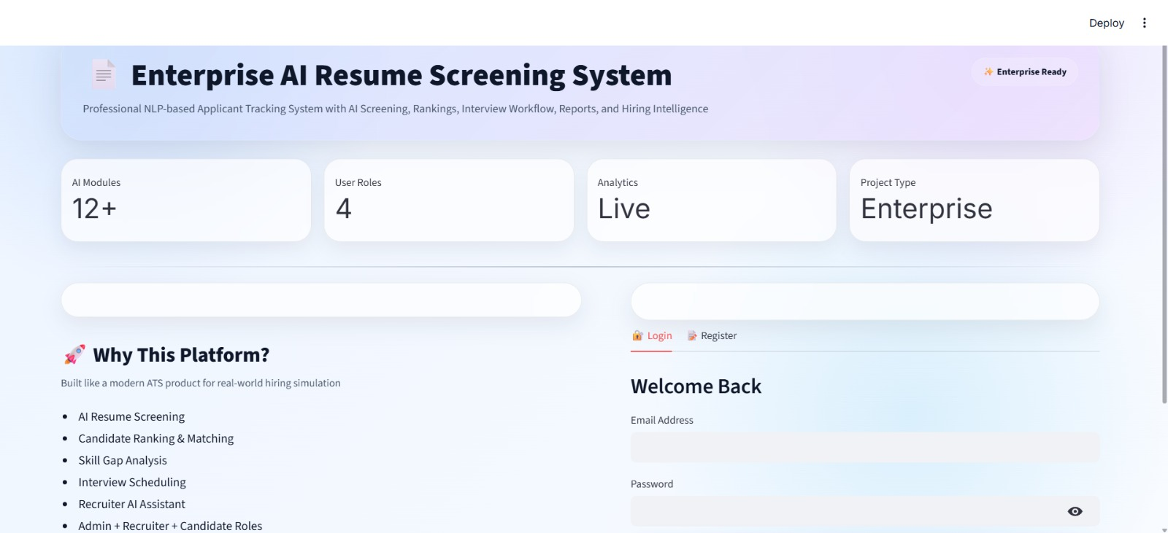
Fig 4 Login Page

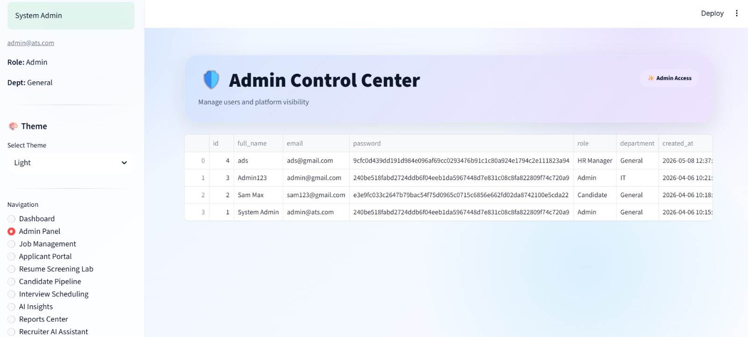
Fig 5 Admin Control Center

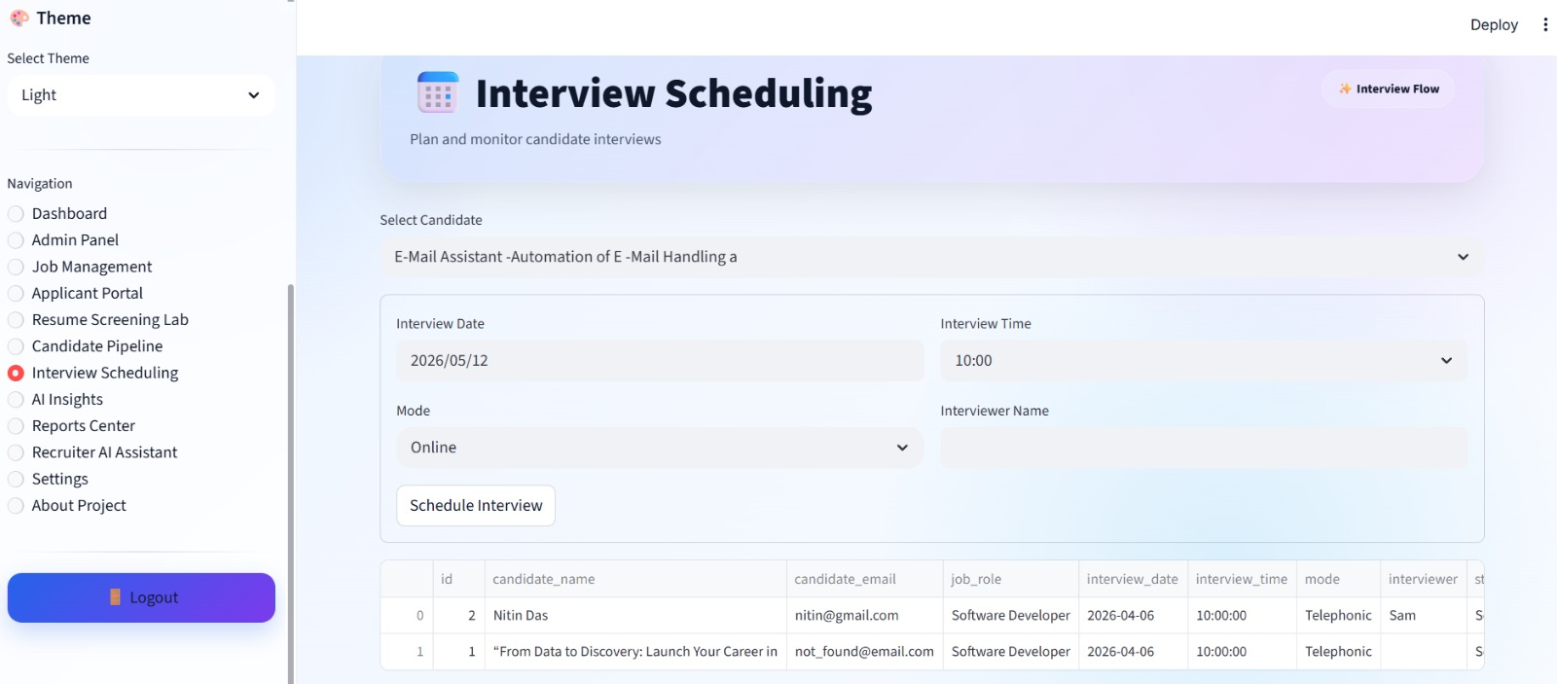

Fig 6 Interview Sceduling

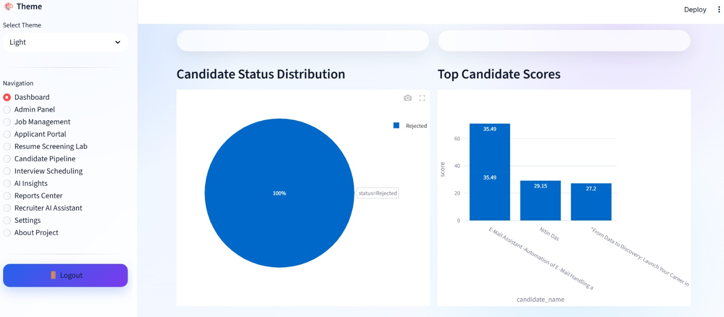
Fig 7 Dashboard

1.7 Soft Skills and Professional Development

Apart from technical training, the internship also focused on improving professional and interpersonal skills required in the corporate environment.

The training included:
- Communication skills
- Team collaboration
- Presentation skills
- Problem-solving techniques
- Time management
- Professional ethics
- These activities improved my confidence, teamwork ability, and workplace readiness.

1.8 Overall Learning Outcome

The internship at Apponix Technologies provided me with valuable industry exposure and practical experience in Artificial Intelligence and Machine Learning. I gained hands-on knowledge in Python programming, data preprocessing, machine learning algorithms, AI tools, and data visualization techniques.
The internship helped me strengthen my technical skills, analytical thinking, and problem-solving capabilities. It also enhanced my understanding of real-world AI applications and prepared me for future opportunities in the fields of Artificial Intelligence, Machine Learning, and Data Science.

REFLECTION

The internship at Apponix Technologies was a highly valuable and enriching learning experience that helped me gain practical exposure in the field of Artificial Intelligence and Machine Learning. This internship provided me with an opportunity to bridge the gap between academic learning and real-world industrial applications. Throughout the internship period, I was able to improve my technical knowledge, analytical thinking, communication skills, and professional confidence.

At the beginning of the internship, I had only basic theoretical knowledge about Artificial Intelligence and Machine Learning. However, through continuous training sessions, practical exercises, and project-based learning, I gained a deeper understanding of how AI and ML technologies are implemented in real-world scenarios. The internship environment encouraged active learning and helped me understand industry expectations and professional work culture.

One of the most important aspects of the internship was learning Python programming and its applications in Machine Learning. I developed a strong understanding of programming concepts such as data structures, functions, object-oriented programming, file handling, and exception handling. Working with Python libraries such as NumPy, Pandas, and Matplotlib enhanced my ability to perform data analysis and visualization efficiently. This practical exposure improved my coding skills and logical thinking abilities significantly.

Another major learning outcome from the internship was understanding the importance of data preprocessing and data analysis in Machine Learning projects. I learned how raw data is cleaned, transformed, and prepared before being used for model training. Through hands-on tasks, I understood the challenges associated with handling missing data, duplicate records, outliers, and feature selection. These activities helped me realize that the quality of data plays a crucial role in the performance and accuracy of Machine Learning models.

The internship also provided me with practical exposure to various Machine Learning algorithms and techniques. I learned the working principles and implementation of algorithms such as Linear Regression, Logistic Regression, Decision Trees, Random Forest, Support Vector Machines, K-Nearest Neighbors, and Clustering algorithms. Implementing these algorithms on datasets helped me understand how predictions and classifications are performed in real-world applications. I also learned about model evaluation techniques, accuracy measurement, and optimization methods, which improved my analytical and problem-solving skills.

One of the most interesting parts of the internship was learning about modern Artificial Intelligence concepts and tools. I explored AI-based systems, prompt engineering techniques, and automation tools that are becoming increasingly important in the technology industry. This exposure helped me understand the growing impact of Artificial Intelligence in various domains such as healthcare, finance, education, transportation, and business automation. It also motivated me to explore advanced AI technologies and pursue further learning in this field.

Apart from technical knowledge, the internship helped me improve my soft skills and professional abilities. Participating in team discussions, presentations, and project activities improved my communication and collaboration skills. I learned how to manage time effectively, work under deadlines, and approach problems systematically. The guidance and support provided by trainers and mentors helped me gain confidence in presenting ideas and solving technical challenges independently.

The internship experience also taught me the importance of continuous learning and adaptability in the rapidly evolving technology industry. Artificial Intelligence and Machine Learning are dynamic fields where new tools, frameworks, and techniques are introduced regularly. This internship motivated me to stay updated with emerging technologies and continuously improve my skills to meet industry requirements.

Working on practical assignments and mini-projects helped me understand how theoretical concepts are transformed into real-world solutions. The internship enhanced my ability to analyze problems, interpret data, and develop efficient solutions using Machine Learning techniques. It also improved my confidence in working with datasets, developing predictive models, and presenting project outcomes effectively.

Overall, my internship at Apponix Technologies was a highly productive and rewarding experience. It provided me with valuable technical exposure, practical implementation skills, and professional development opportunities. The internship strengthened my interest in Artificial Intelligence and Machine Learning and inspired me to pursue a career in this field. The knowledge and experience gained during this internship will be highly beneficial for my future academic projects, research activities, and professional career development

CONCLUSION
The internship at Apponix Technologies provided me with valuable practical exposure in the field of Artificial Intelligence and Machine Learning. During the internship, I gained in-depth knowledge of Python programming, data preprocessing, machine learning algorithms, data visualization, and AI-based tools through both theoretical learning and hands-on implementation.

The internship helped me understand the complete workflow of Machine Learning projects, including data collection, preprocessing, model training, evaluation, and prediction. I also developed practical skills in using libraries such as NumPy, Pandas, Matplotlib, and Scikit-learn for solving real-world problems. Working on mini-projects and assignments improved my analytical thinking, problem-solving ability, and technical confidence.

Apart from technical knowledge, the internship also enhanced my communication skills, teamwork, presentation abilities, and professional ethics. The guidance provided by trainers and the practical learning environment helped me bridge the gap between academic concepts and industry requirements.

Overall, the internship was highly beneficial in strengthening my understanding of Artificial Intelligence and Machine Learning technologies. It provided me with industry-oriented skills and practical experience that will support my future academic projects and career opportunities in the field of AI, Machine Learning,
and DataScience.

INTERNSHIP DIARY

