ACMReport User Manual

Contents

About ACMReports 2

Download 2

ACM Configuration 2

Open database port 2

Add new user 3

Time settings 5

Select the Events and Door 7

ACMReport configuration 8

Configure connection 8

Edit Request 9

Read Data 10

Export to Microsoft Word or Excel 11

Export in PDF 12

Sample PDF file 13

Known issues 14

Credentials 14

License 14

# About ACMReports

ACMReports is open source freeware software distributes on MIT License.

It is an example of integrated 3rd party utility for Avigilon Control Manager (ACM). It generate work time reports from transaction database. This report could be customized in order to implement solution for enter and exit control in the facilities.

ACMReports connect to ACM, select the first entrance and the last exit events for specified door(s). Match them with user and give the report for a day in PDF file.

# Download

Source code: <https://github.com/knave2000/ACMReports/>

# ACM Configuration

ACM should be already installed and configured.

<http://avigilon.com/support-and-downloads/for-software/acm/downloads/>

## Open database port

Some additional configuration is required.

Select “Appliance” from “Setup & Settings” menu.

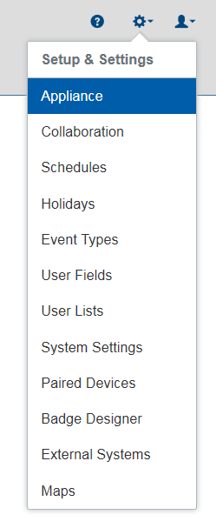

Open access for external connection to Transaction database.

Put port number into the field “Transactions Connect Port”. 5432 – default port for PostgreSQL.

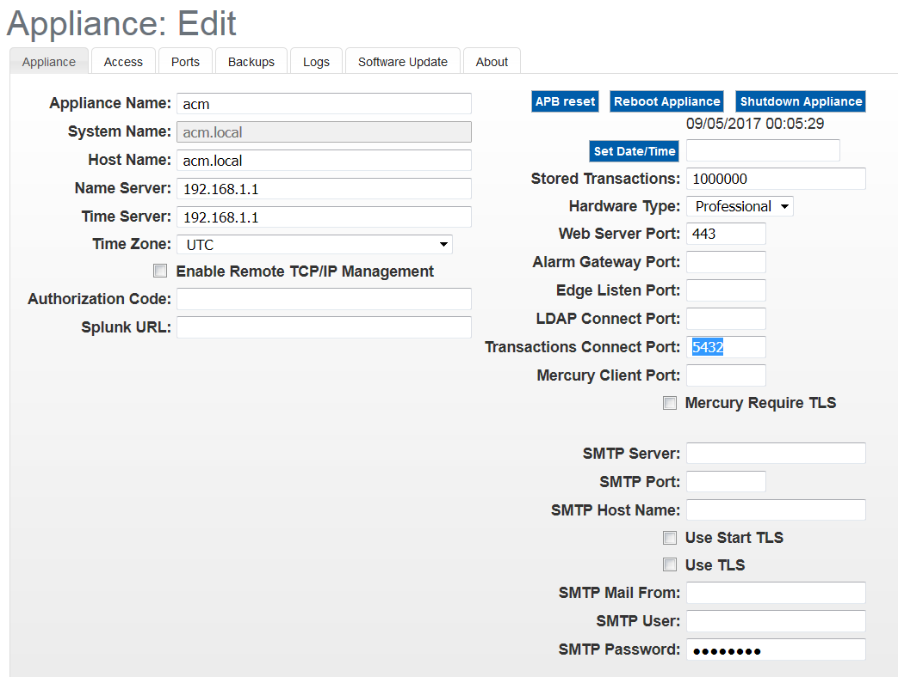

## Add new user

Add new Identity that will be used by ACMReports.

Go to “Identities” menu.

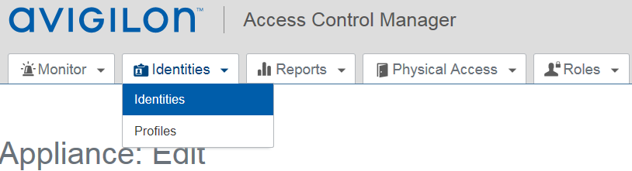

Click “Add Identity” button.

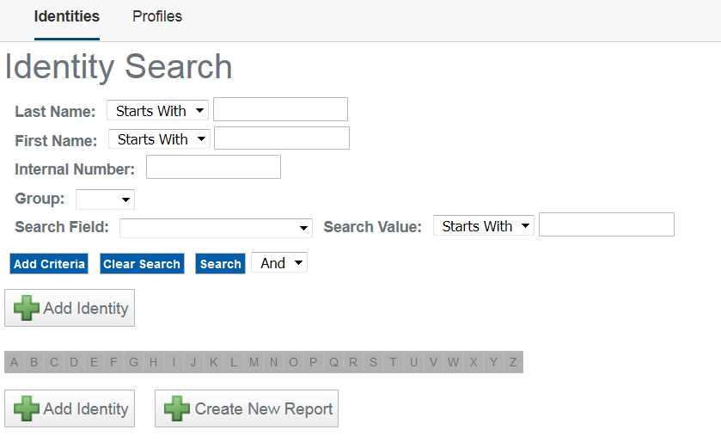

In the bottom of form in “Account Information”:

* Give login name (postgresql – for example)
* Give password for this login
* Confirm the password
* Put the mark in checkbox “Allow Remote Access?”
* Select “Indefinite” in “Inactivity Timer”

This Identity do not require tokens.

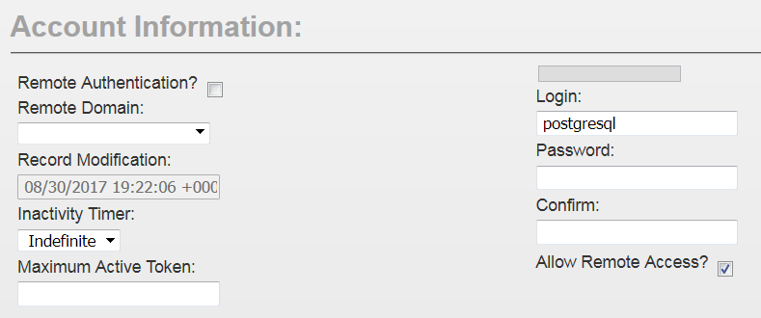

Give “Admin” role to created Identity.

To do this open “Roles” tab, select “Admin” in “Available” box and click on “Right arrow” button. Click “Save” button at the end.

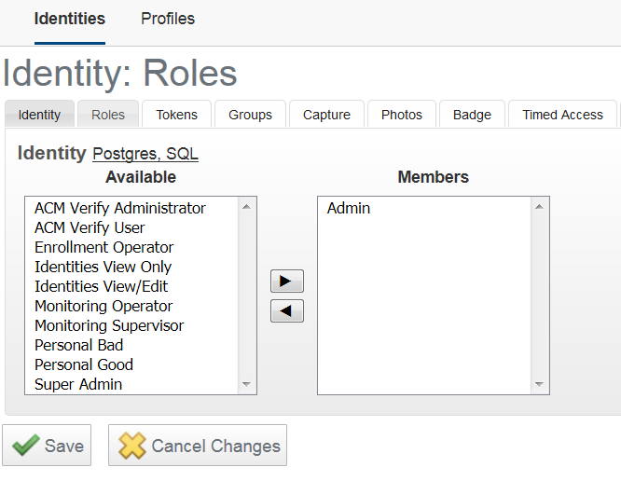

## Time settings

Check the time settings. All panels and ACM appliance should be synchronized and have the correct timezones.

Select Timezone for appliance and set the current time. Button “Now” synchronized the time with workstation over web browser.

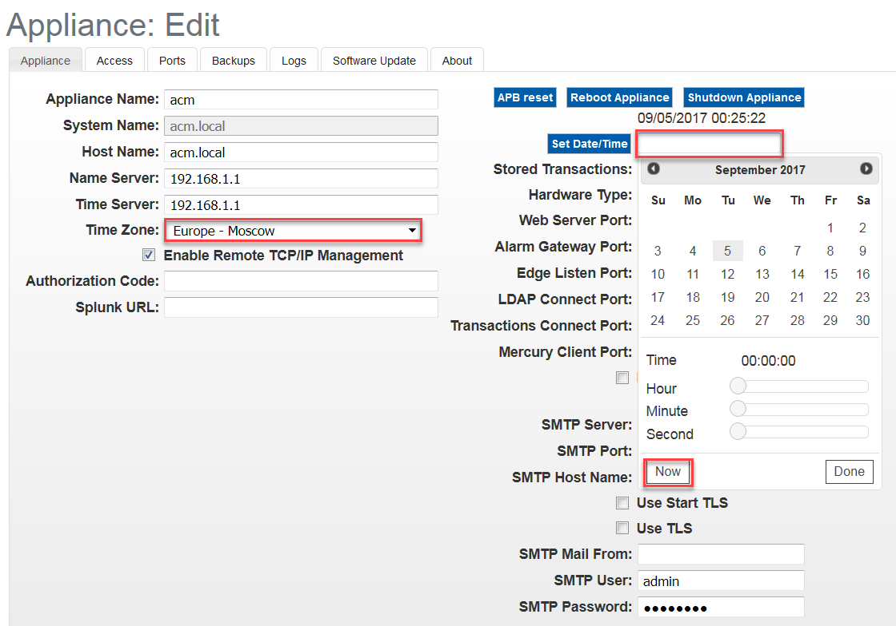

Go to “Physical Access”, Select “Panel” and appropriate panel name (click on “EP1501” link for this example).

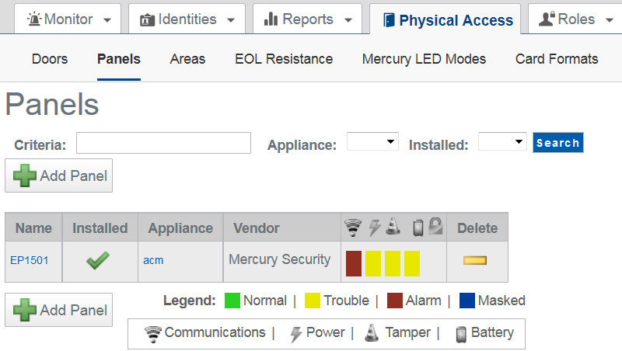

Check the timezone settings for each panel and save them.

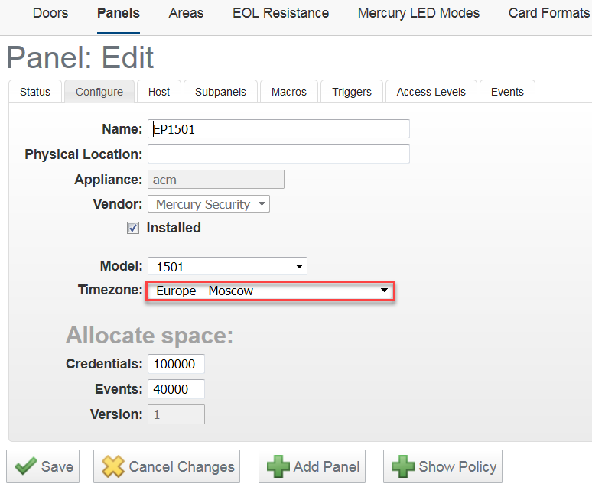

# Select the Events and Door

ACMReport could be configured to use specific Events and Sources from ACM.

Go to monitor mode in ACM, emulate entrance and leaving events by using access cards (tokens) for different users. Catch up the event name and source name for these transactions.

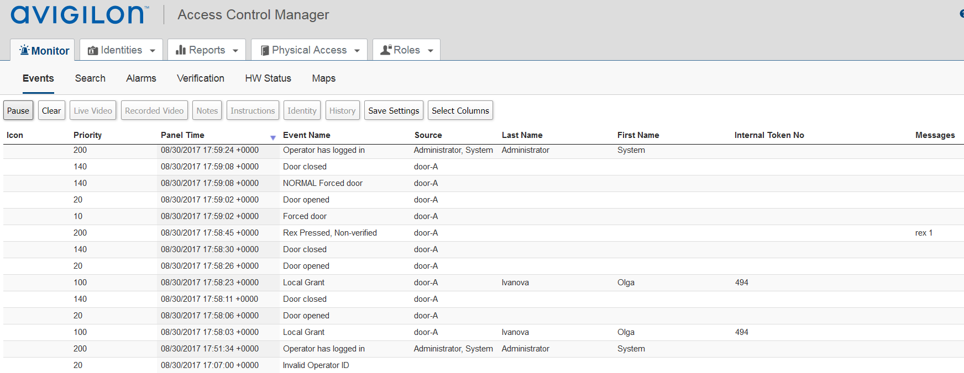

For example Event name = “Local Grand”, Source name = “entrance”. This will be enter event.

For exit event the Event name = “Local Grand” as well, and Source name = “door-A” will be the same.

This mean one door is used to enter and exit from the facility.

If there is a group of doors to enter all of them should have some common part in Source name. For example: entrance-A, entrance-B, entrance-C. In this case, all of them could be joined by common name “entrance” in ACMReport settings.

The same for Event name.

Any type of events of sources could be used.

REX event could be used as well. But as soon this event could not be verified in ACMReport it will not have the exit time.

# ACMReport configuration

Start ACMReport.exe

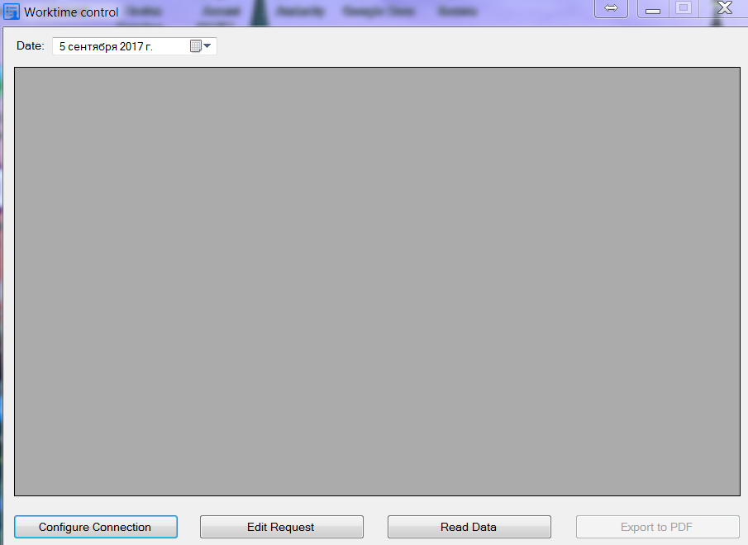

## Configure connection

Click on “Configure Connection” button.

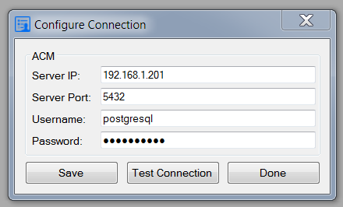

Enter ACM Server IP address, port number (which was selected above).

Username previously created Identity.

Password is the password for that Identity.

To check the connection with ACM click “Test Connection” button.

If everything is working confirmation message appears.

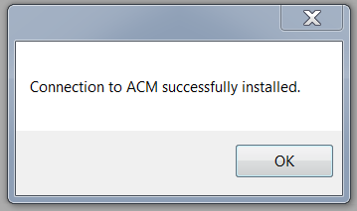

Click “Save” button and then “Done” to close the dialog window.

All ACMReports settings are user specific. They are saving personally for each Windows user in hidden folder.

%userprofile%\appdata\local or

%userprofile%\Local Settings\Application Data

Depending on which version of Windows it is running.

## Edit Request

Click on “Edit Request” button.

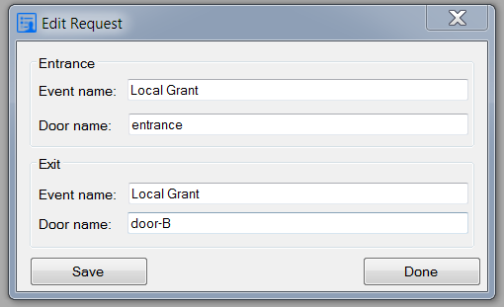

In this example “entrance” is common name for 3 doors: entrance-A, entrance-B and entrance-C.

Rules for fields:

* All fields are case sensitive.
* Special character will be filtered out.
* Spaces not removed. Pay attention on spaces at the end of string.
* Any part of field will be used as template.

Template example:

“Local Grant”: “Local”, “ocal Gra”, “Grant”

Click “Save” and “Done” buttons.

## Read Data

Select the date for work time report in the top left part of main window.

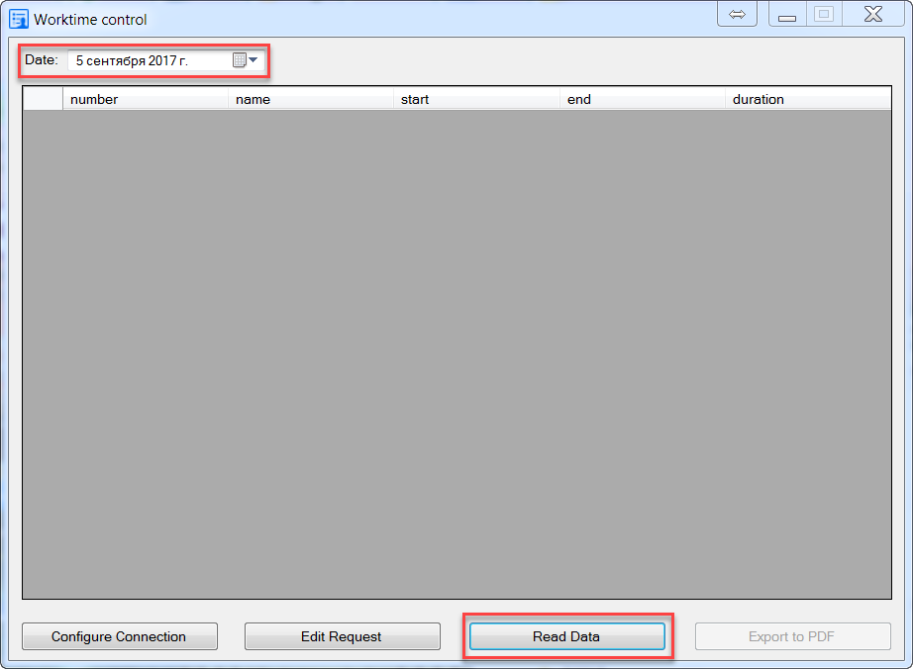

Click “Read Data”.

Information will be received from ACM transaction database using Request settings.

If the result is empty, the hidden button “Export to PDF” keeps inactive.

If the result is not empty “Export to PDF” button will be activated.

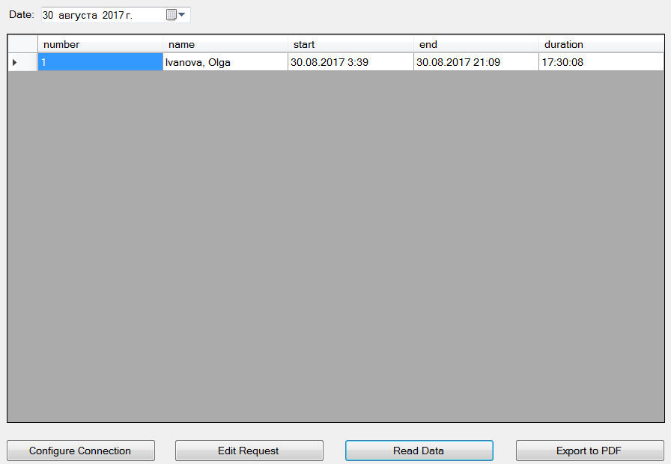

# Export to Microsoft Word or Excel

Select specific row(s) and press “Ctrl-C” to copy them in Clipboard.

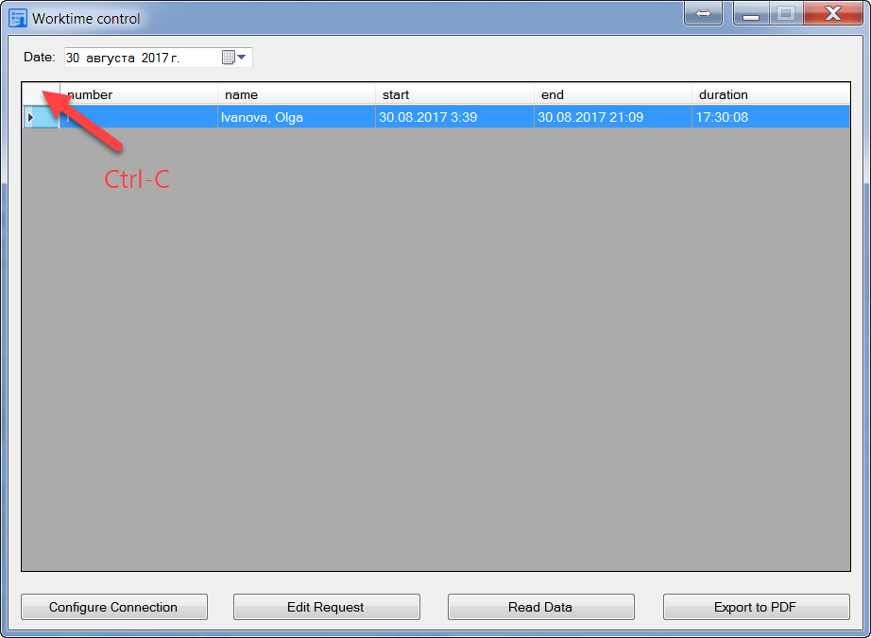

Click on the left top space in table to select all elements.

To paste the copied result from Clipboard into Word or Excel use “Ctrl-V”.

# Export in PDF

Click on “Export to PDF” button to save the current report in PDF file and open it in installed PDF Viewer.

After the first time of saving pdf file the folder “Reports” will be created in ACMReport folder. All PDF files will be stored there.

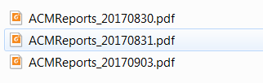

File format for PDF files: **ACMReport_YYYYMMDD.pdf**

Where YYYYMMDD is the selected date for report.

# Sample PDF file

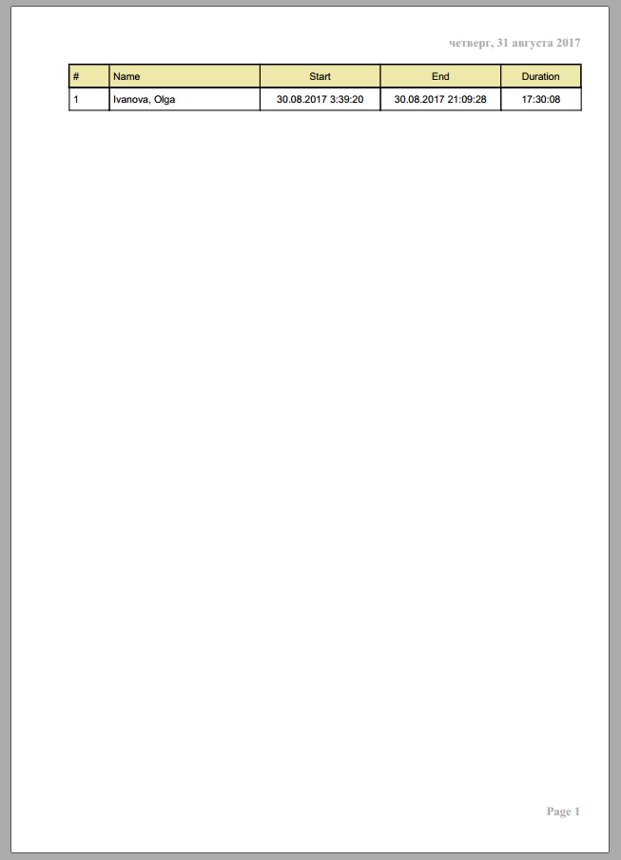

# Known issues

1. Night shifted staff could not be calculated in the right way. If the person enter into facility in one day and exit in another day the information in Report will not be complete.
2. Localization is required.

# Credentials

Author: Vladimir Artyukhov

E-mail: [knave2000@gmail.com](mailto:knave2000@gmail.com)

# License

MIT License

Copyright (c) 2017 Vladimir Artyukhov

Permission is hereby granted, free of charge, to any person obtaining a copy of this software and associated documentation files (the "Software"), to deal in the Software without restriction, including without limitation the rights to use, copy, modify, merge, publish, distribute, sublicense, and/or sell

copies of the Software, and to permit persons to whom the Software is furnished to do so, subject to the following conditions:

The above copyright notice and this permission notice shall be included in all copies or substantial portions of the Software.

THE SOFTWARE IS PROVIDED "AS IS", WITHOUT WARRANTY OF ANY KIND, EXPRESS OR IMPLIED, INCLUDING BUT NOT LIMITED TO THE WARRANTIES OF MERCHANTABILITY, FITNESS FOR A PARTICULAR PURPOSE AND NONINFRINGEMENT. IN NO EVENT SHALL THE AUTHORS OR COPYRIGHT HOLDERS BE LIABLE FOR ANY CLAIM, DAMAGES OR OTHER LIABILITY, WHETHER IN AN ACTION OF CONTRACT, TORT OR OTHERWISE, ARISING FROM, OUT OF OR IN CONNECTION WITH THE SOFTWARE OR THE USE OR OTHER DEALINGS IN THE SOFTWARE.