Karissa Bowser

knb@csu.fullerton.edu

CPSC 386 Game Design – Project 5

# Introduction:

This program is a single player top-down space themed shooter game. The player is tasked with defending Earth and eliminating the aliens. The goal of the game is to kill the mothership that will spawn randomly somewhere between levels 5 and 10.

# Design:

## Rules:

* You only have one life per game.
* You have 100 HP to start the game, and each hit taken reduces that by 5.
* The player can shoot at the enemies and move around the game display.
* The player can kill the smaller alien ships with a single shot, but the mothership has 100 HP, and takes multiple shots to kill.
* Each time an alien reaches Earth, the Earth's defense drops 5 percent.

## Sources of Uncertainty:

Sources of uncertainty include the spawn placement of enemies on the right side of the screen, as well as when the mothership will spawn. The mothership will spawn randomly sometime between levels 5 and ten.

## Win state and Lose State:

The player will lose the game if they do any of the following (Lose State):

1. Collide into an alien (Be careful, they get faster as the levels increase)
2. Allow Earth's Defense to drop to 0 (Each time an alien reaches Earth, the Earth's defense drops 5 percent).
3. Allow their own HP to drop to zero (Player has 100 HP, each shot from the AI reduces HP by 5)
4. Let the mothership reach Earth.

The player will win if they do the following (Win State):

1. Kill the mothership that will spawn randomly somewhere between levels 5 and 10, before it reaches Earth. The mothership has 100 HP, each shot reduces HP by 5

## Skill Requirements:

The skill requirements are very low, so only basic gaming skills are required.

## Controls:

* To move the player ship: W, A, S, D, or arrow keys
* To shoot: Spacebar
* To quit: Esc

## Expected Duration of Game:

The expected duration of the game is five to ten minutes.

## Scoring:

Each time an alien ship is destroyed, the player gains 2 points.

The equation used to calculate the levels is: level = (score / 50) + 1

## Visual representation of game state:

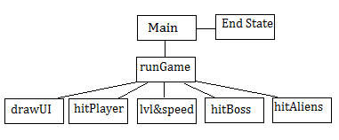

# Software Architecture Detail:

This program has not been optimized at all. The code is inefficient, but it is at a working state that appears to be bug free from data gathered from preliminary tests. The design implemented for this working state is a functional design.

Major functions include:

* main
* runGame()
* calcLvlAndAlienSpeed(int score)
* cleanUp(bullets, alien1, alien2)
* drawText(text, font, surface, width, height, text_color)
* getLoadingScreenInput()
* hitBoss(bullets, boss_rect)
* hitAlien1(bullets, alien1, a1)
* hitAlien2(bullets, alien2, a2)
* hitPlayer(alien_bullets,player_rect)
* playerCollision(player_rect, alien)
* terminate()

# Game Demonstration:

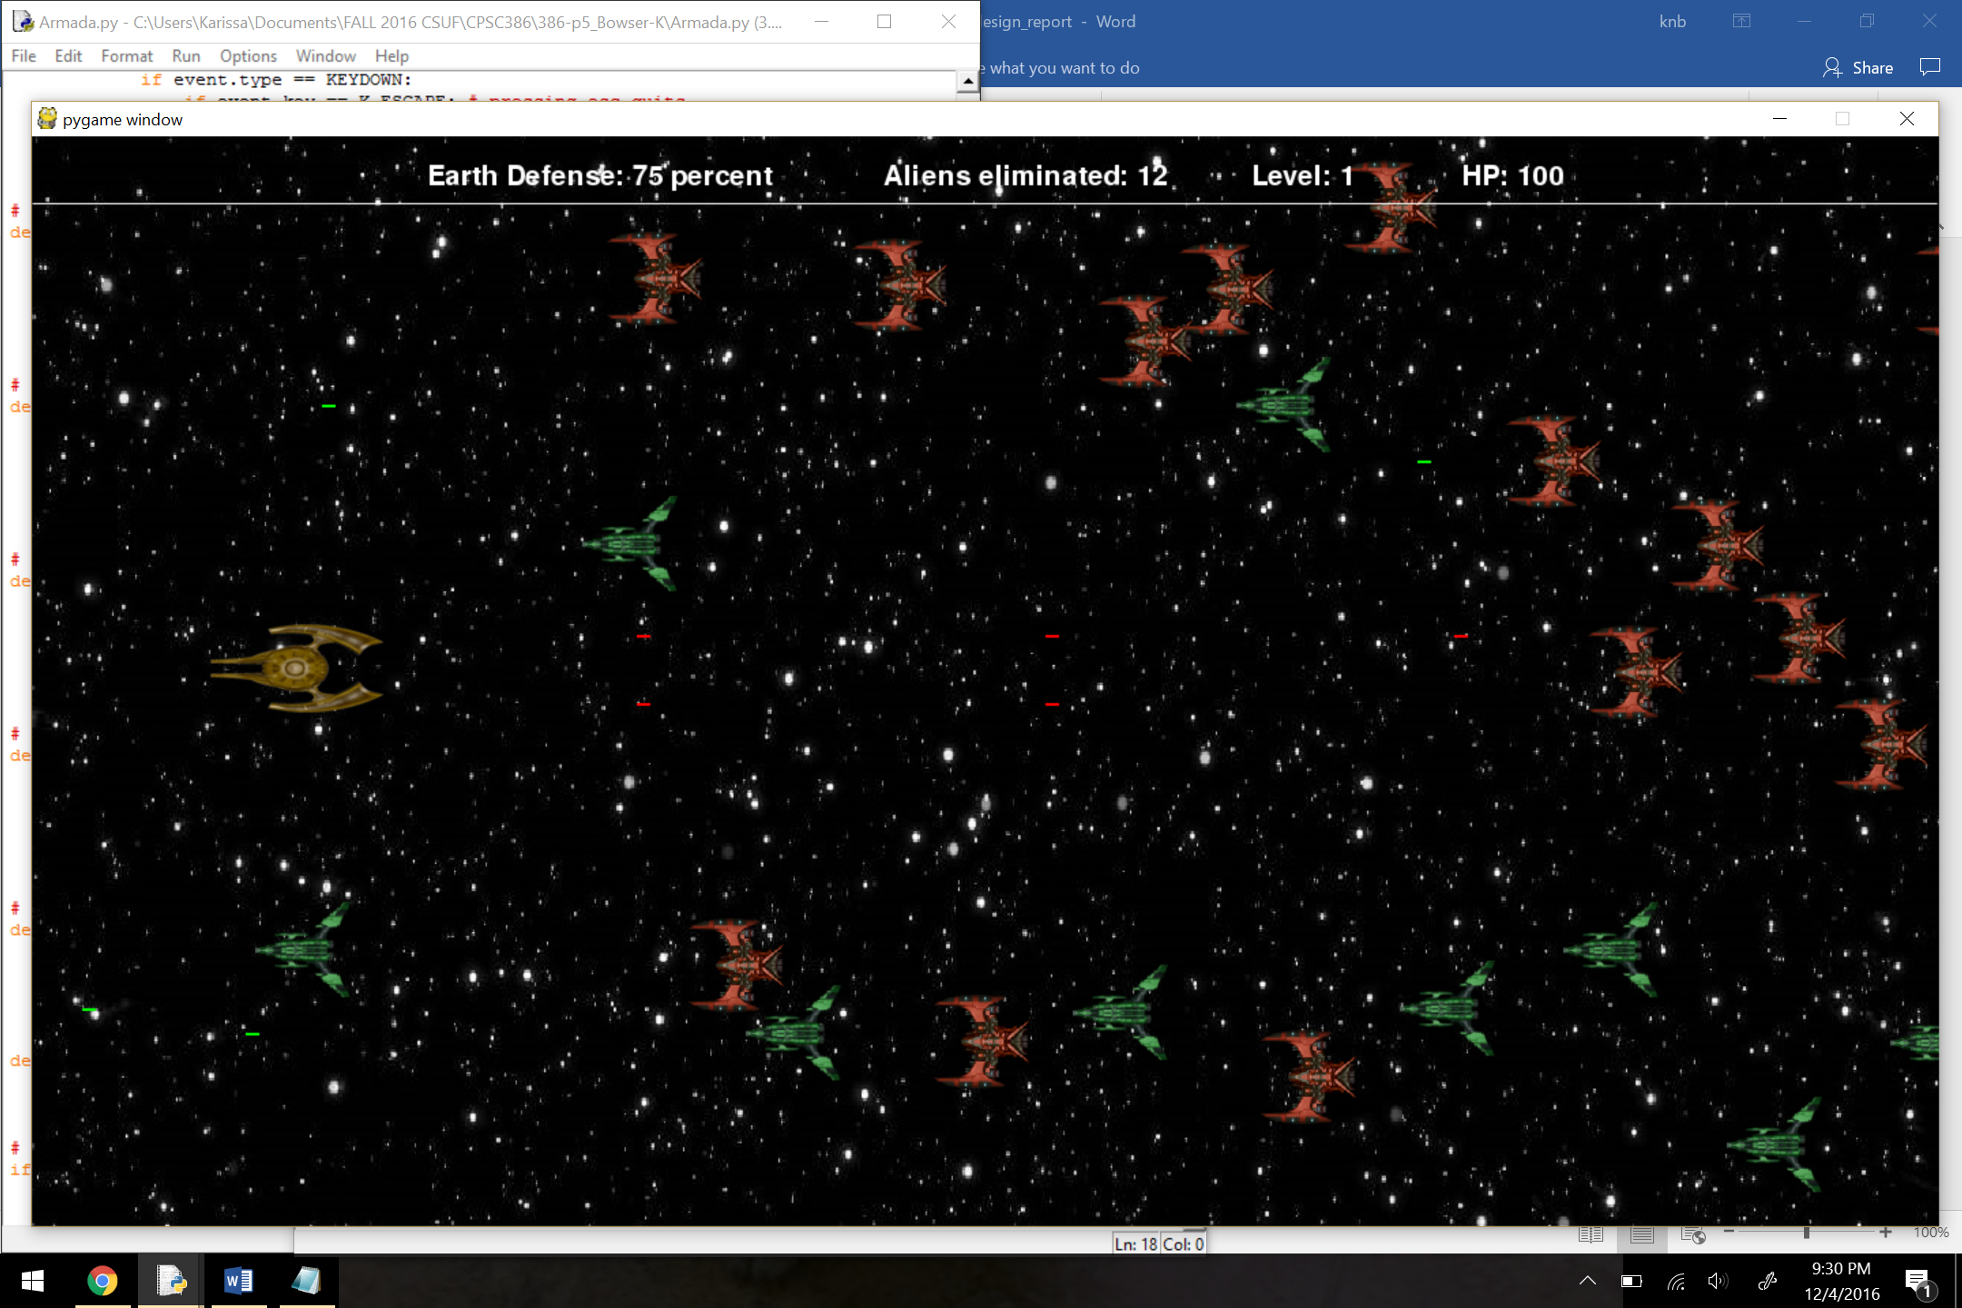

The player is the gold ship on the left side of the screen. The player has red-colored lasers.

The green and red alien ships are coming in from the right side of the screen. The enemies have green-colored lasers.

The player can move up, down, left, right, and shoot the enemies.

The player movement was implemented by using keyboard input with pygame’s “event.type” and “event.key”.

The aliens (both ship types) and bullets(player bullets and enemy bullets) were all stores in lists, to spawn new ones, just append more to the list according to the spawn rate variable.

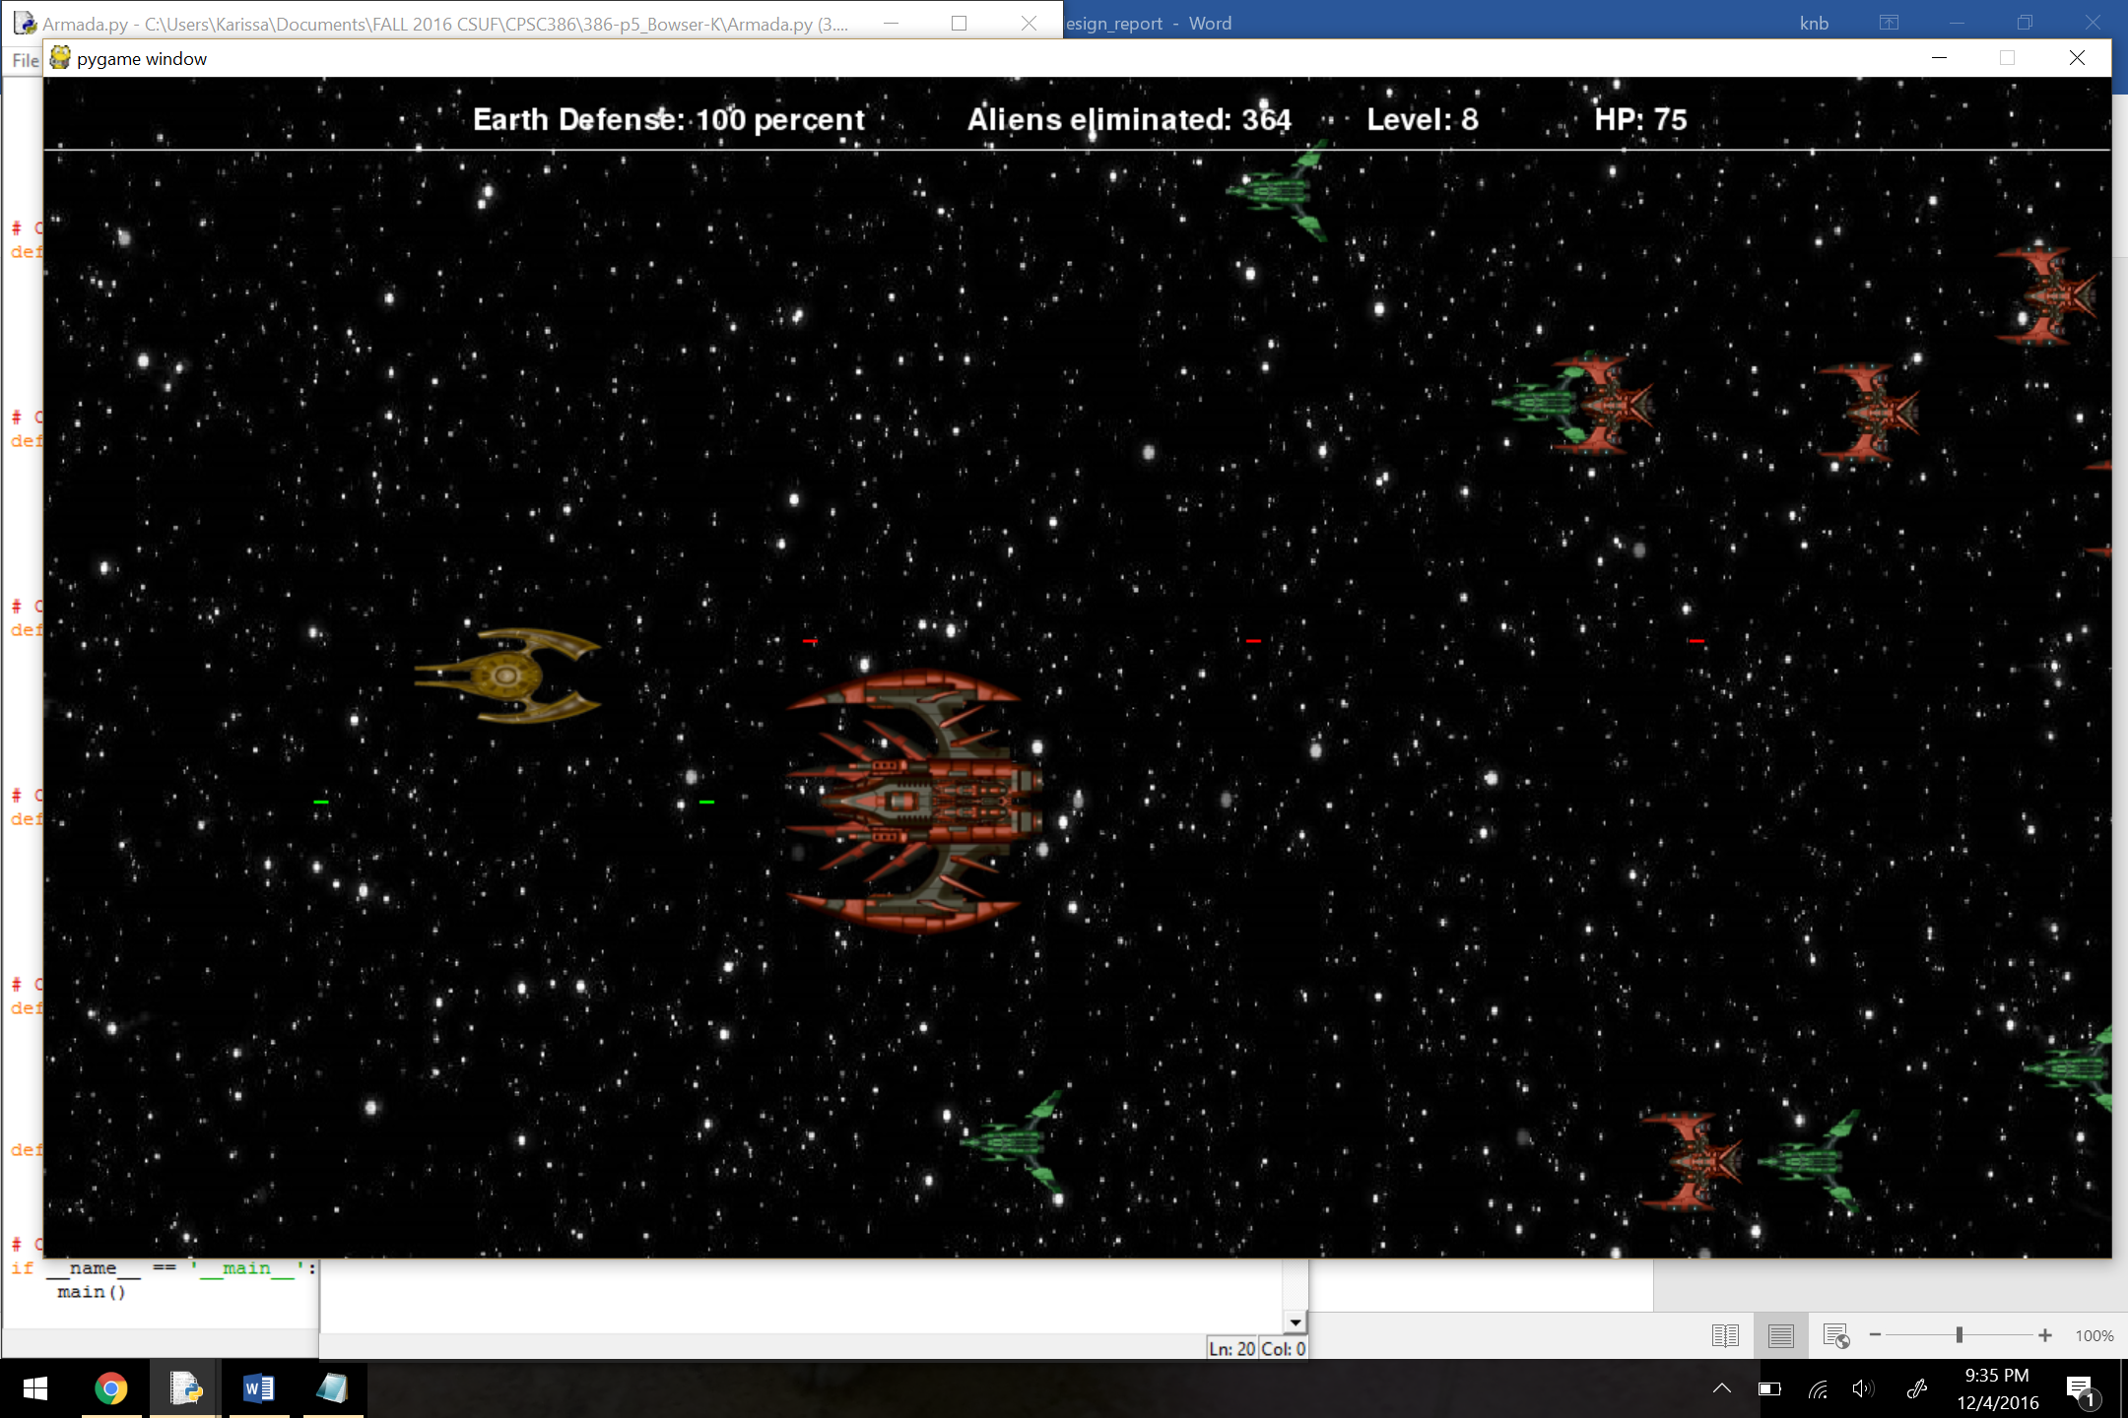

The boss level variable is set to a random variable. So, at some point between levels 5 and 10, the mothership appears and must be eliminated to win the game. The player loses if the mothership makes impact with the player, kills the player, or reaches Earth. There is also background music and sound effects, which could not be demonstrated with screenshots.

# Bibliography:

## ART CREDITS:

* **Enemy Art:** (alien1.png, alien2.png, boss.png) http://opengameart.org/content/spaceship-6 by wubitog and Skorpio (http://opengameart.org/users/skorpio)
* **Player Art:** (player_ship.png) this work has been released under the Creative Commons License: https://creativecommons.org/licenses/by/4.0/ By MillionthVector (http://millionthvector.blogspot.de)
* **Explosion Art:** (big_explosion.png, explosion.png) by Retimer at http://opengameart.org/content/wgstudio-explosion-animation
* **Title Screen Art:** https://www.reddit.com/r/wallpaper/comments/1oljxk/the_sun_behind_the_earth_1920_x_1080/
* **In-game Background Art:** http://www.gunnars.com/space/
* **Instructions Screen Art:** http://www.jpl.nasa.gov/assets/images/content/tmp/home/missions_bg_image.jpg

## MUSIC CREDITS:

* **Non in-game music:** (death.mid) by Jan125 http://opengameart.org/content/stereotypical-90s-space-shooter-music
* **In-game music:** (boss.mid) by Jan125 http://opengameart.org/content/stereotypical-90s-space-shooter-music
* **Laser Fire Sound Effect:** (laser_fire.wav) by dklon http://opengameart.org/content/laser-fire

## CODE REFERENCES:

* Source code was used from http://www.cs.rutgers.edu/~biglars/pycs4hs/pydemo4.html