Map Series Layout Manager
For ArcGIS Pro version: 2.4 and later
Internet connection required: you must be able to connect to Esri base maps in order to see the full results of the sample.
Summary:
This sample demonstrates how to rearrange page layout elements such as inset maps, north arrows and text on different map series pages all using a single layout. For example, on one page you may have a single inset map displayed on the layout while on other pages you may have 3, 4 or even more inset maps displayed. This is accomplished by storing all the layout element information in a table. Each page in a map series has a single row in the table with all placement, extent, and scale information stored for each map frame and placement information for other elements. As the page is being drawn the row information is used to dynamically place the elements on the layout for each map series feature. Below are two sample pages that are generated from a single map series layout:

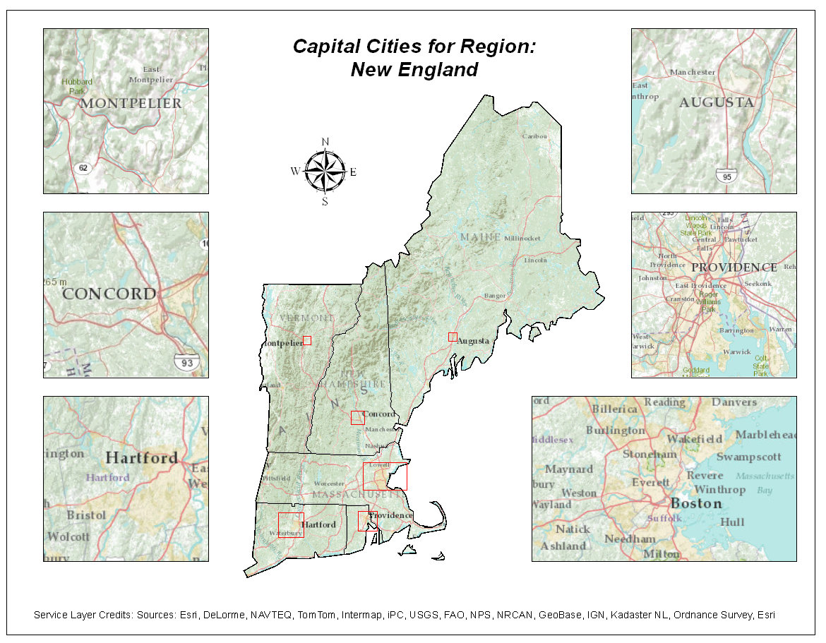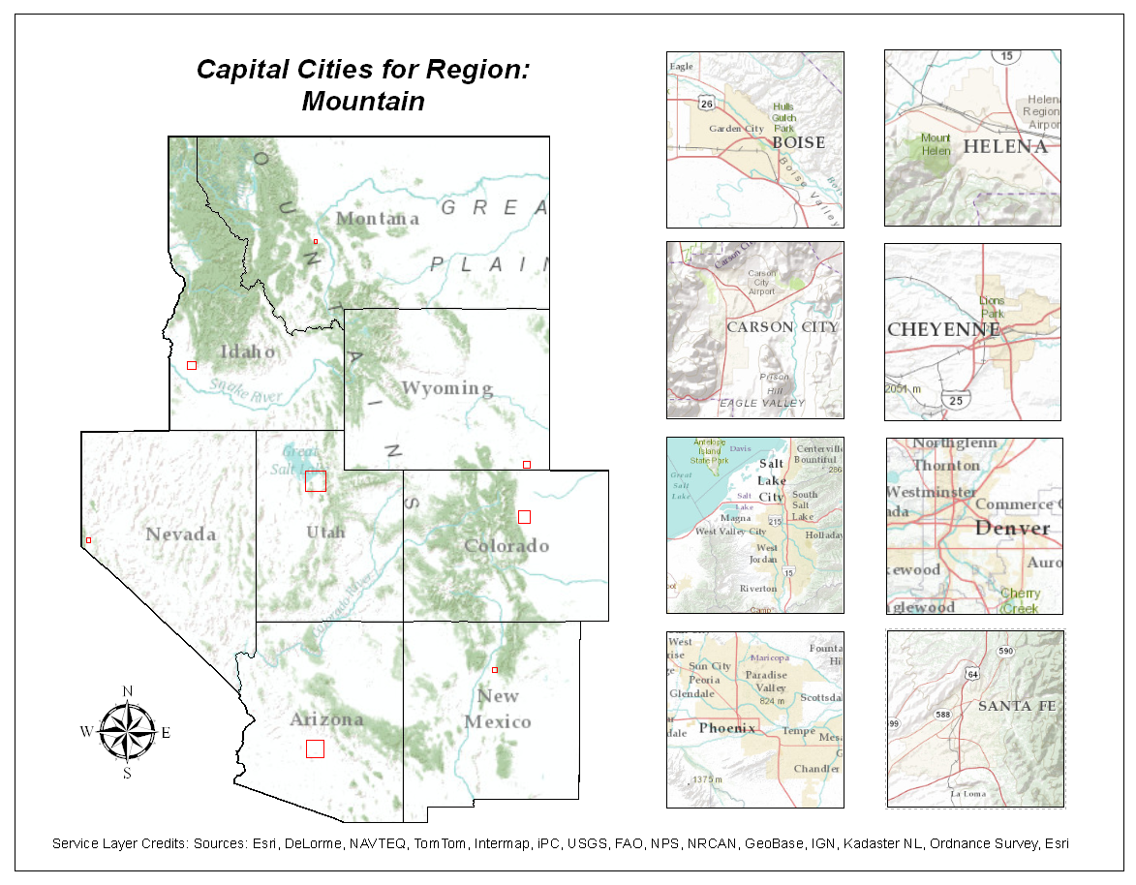

Data, Layout, and PageLayoutElements Table Design Considerations:
The StateRegions_Index feature class was created from the States feature class by performing a dissolve using the SUB_REGION field. An additional feature class was created for display purposes. It is called StateRegions_Mask. It is identical to the StateRegions_Index feature class but it has one additional polygon that covers the area outside the United States boundary. It was created by performing a Union of StateRegions_Index and a single polygon feature class. This additional layer is needed so that areas outside of each index feature can be masked using a Page Definition Query. The Page Definition Query is set to be the opposite of the current Map Series feature. This way all features outside the current index feature are masked as white areas making room on the layout to place the inset maps.
With this map series sample, there are a minimum of 3 and a maximum of 8 inset maps on any given page. Therefore, the layout was authored with one main map frame and 8 inset map frames, all located off the side of the page. Below is a graphic of the default template layout. The main map frame has a default extent set to empty space and the 8 inset map frames all have the same initial extent.
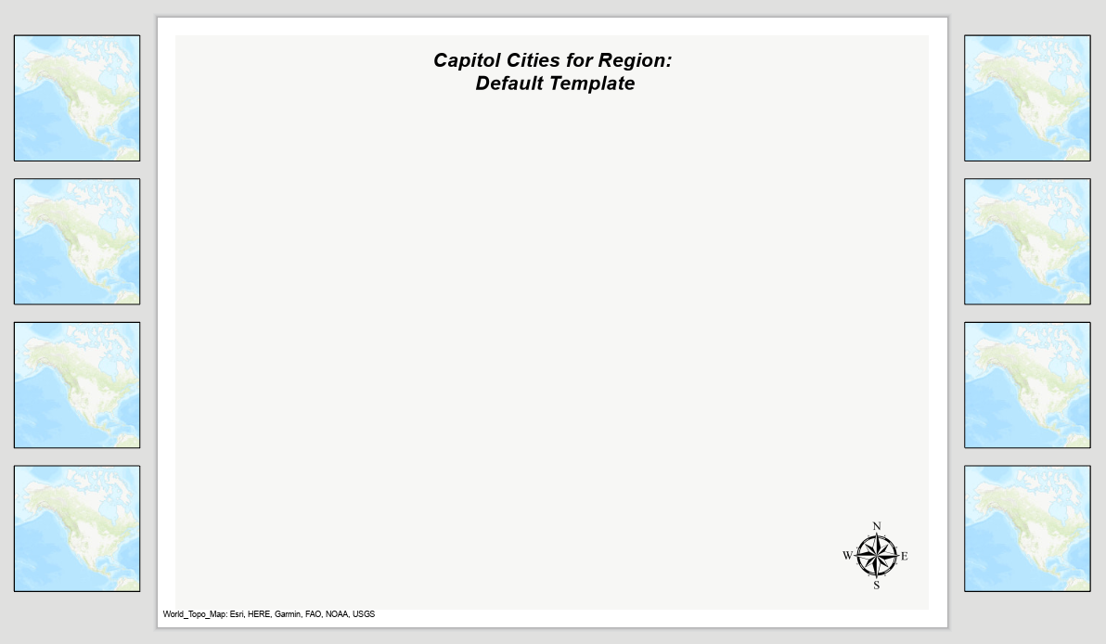
When a script tool is executed, the main map frame extent gets set to the appropriate index feature and the appropriate number of inset maps are sized and positioned on the page and their extents are set. In addition, the title text and the north arrow objects are repositioned on the page.
All of this is possible because the properties of all layout elements are stored in a table called PageLayoutElements.
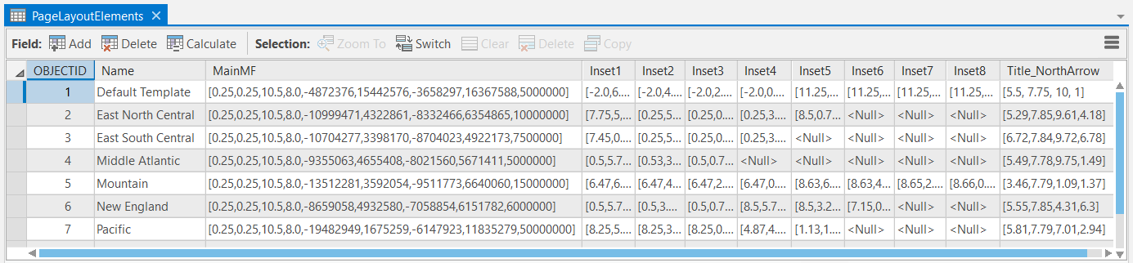
The table has a field called Name that matches the unique map series page names. It also has 9 fields that match the names of the 9 map frames (1 MainMF map frame and 8 inset map frames). Each map frame value is stored and interpreted as a Python comma delimited list object that contains the following 9 map frame and camera properties: elementPositionX; elementPositionY, elementWidth, elementHeight, XMin, YMin, XMax, YMax, and scale. The last field called Title_NorthArrow is simply the X, Y element positions for the title and north arrow objects.
As the script reads each map frame field value in a row, it positions the associated elements accordingly. If the inset value is <null> then that inset is skipped and is left off the layout. When the script tool is execute, all inset map frames are returned to their original position off the side of the page and then the new positions are regenerated.

Steps to run the sample script tools:
Part 1: View individual pages for existing records
- Open the MapSeries_LayoutManager_Pro24.aprx
- Open and dock the Catalog pane
  - Expand the Toolbox.tbx
  - Expand the MapSeries_LayoutManager_Pro24.tbx
  - Open the “1_Zoom To Page” script tool.
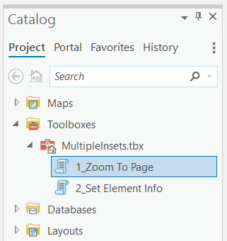
- From the “Select Page” pull down control, select an existing page name. It will only list the pages that are currently configured with a row in the PageLayoutElements table. There is one additional value called “Default Template” which can optionally be used to create new pages/records from scratch.
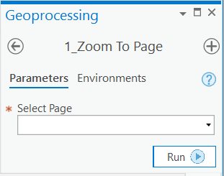
- Click Run
- You should see a resulting page drawn to the display.
Note – the Select Page input parameter is updated by a validation script which is a property of the script tool. The validation script generates a list of the page names from the PageLayoutElements table and automatically populates the input parameter with the current list of existing, configured pages.

Part 2: Update existing records
It is possible to reconfigure existing map series pages using the “2_ Set Element Info” script tool.
- If necessary, expand the MapSeries_LayoutManager_Pro24.tbx.
- Use the “1_Zoom To Page” to generate the map series page you want to reconfigure.
- Resize and move insets around on the layout.
- Optionally change map frame scale
  - Activate a map frame, pan/zoom/scale and close activation
- Optionally move the title or north arrow to different locations

- From the MapSeries_LayoutManager_Pro24.tbx, open the “Set Element Info” script tool.
- Click Run
The appropriate PageLayoutElements table row gets updated using all the current settings. If you zoom to another page and then return to the updated page following the steps from Part 1, all elements will be in their new positions.
- If you want to save your changes then click Save via the Edit tab (for an active map) or choose yes when prompted after closing the project.

Part 3: Create new pages/records
Create two additional rows in the PageLayoutElements table for the two United States sub regions that do not exist yet. They are West North Central and South North Central. Things to consider are:
- Use the “1_Zoom To Page” and select “Default Extent”
- Toggle to the List Map Series Pages tab in the Contents pane.
- Double click one of the two remaining pages to configure.
- Move the appropriate number of insets on the page and set the correct extent, size, and scale.
- Use the “2_Set Element Info” tool to set the information.
- Confirm that insets that are not supposed to be on the page have a <null> table value.

