A survey-anchored synthetic persona dataset with crime-prevention behavioral attributes for Korean police-administration research

Manuscript type: Data Descriptor (target: Scientific Data; fallback: Data in Brief)

1. Background & Summary
Korean police-prevention research needs persona populations that are demographically faithful and carry the behavioral variables prevention work turns on — digital-payment unfamiliarity, financial strain, social isolation, prior victimization, willingness to report. Demographically realistic synthetic populations already exist: NVIDIA’s Nemotron-Personas-Korea [1] provides one million Korean personas validated against KOSIS census margins [2]. The behavioral and victimization layer is missing. A researcher assembling an elderly voice-phishing cohort can filter on age, household type, and education, but cannot read off that cohort’s digital literacy or authority deference — those fields are not in the backbone.
This dataset adds that layer. The method is survey-conditioned enrichment. Each behavioral attribute is sampled from the conditional distribution of a real Korean survey, and a pinned language model only renders the sampled value into first-person narrative. The model is given each value and writes the narrative around it; it does not infer the value. Because attributes are drawn from survey conditionals, each attribute’s marginal — conditional on its anchor cell — matches the source survey by construction, not by assertion. §4.1 reports this cell by cell (largest per-attribute deviation 0.0020 in total variation); it is mainly a claim about marginals. The joint distribution is modeled only partially — §4.5 characterizes what is captured (shared-demographic conditioning plus one observed survey joint) and what is left as stated conditional independence.
Four pieces make up the release: the enriched one-million-persona dataset, the construction code, the anchor-table specifications with their survey provenance, and a technical validation covering distributional fidelity, round-trip consistency, and a worked cohort demonstration. The contribution is the anchoring procedure, not the backbone. Provenance is layered: NVIDIA supplies the demographic spine (CC-BY-4.0), national surveys supply the conditional distributions, and this work supplies the schema, the sampling, and the validation. Nothing here claims the personas are real or that the attributes were measured on individuals.
A companion study (Paper F, in preparation) works the other side of the same data: whether synthetic Korean personas are demographically and structurally faithful enough to stand in for a real population. This dataset assumes that faithfulness and builds on top of it. The two share raw survey inputs but separate cleanly — one validates the backbone, the other augments it — and cite each other to keep the boundary visible. In practice this lets a researcher assemble a cohort, inspect its risk profile, and test a prevention message in simulation before any contact with a real population — none of which the demographic backbone alone supports. The cohorts this builds are susceptibility segments, not realized-victim predictions: §5.1 shows that for voice-phishing, realized loss tracks exposure and income, so the layer constructs who is vulnerable to an approach, not who loses most. The inter-attribute joint is adjudicated out-of-sample against a same-respondent elderly survey (§4.6) — quantifying the conditional-independence under-capture, with the elderly single-attribute prevalences recalibrated to that survey (low digital literacy 35% against its 37%) — for the elderly cohort only; the non-elderly joint is not externally identifiable from existing Korean surveys and rests on stated conditional independence. That validation also surfaced a policy-relevant victimology result reported separately.

2. Methods

2.1 Demographic backbone
NVIDIA Nemotron-Personas-Korea (1,000,000 personas, CC-BY-4.0) is the backbone, retained unmodified. Enrichment is strictly additive: no backbone column is altered. Twelve demographic columns are used for conditioning and selection (sex, age, marital_status, military_status, family_type, housing_type, education_level, bachelors_field, occupation, district, province, country). Long-form persona text is kept for downstream simulation but is never used as a selection or conditioning criterion, to avoid encoding stereotype content into the filter logic. Coverage is ages 19–99, single country (대한민국); there are no minors.

2.2 Attribute schema
Six behavioral attributes form the released layer. Four are ordinal Likert (1–5): financial_vulnerability, digital_literacy, authority_deference, social_isolation. Two are binary: prior_victimization, reporting_propensity. Each attribute names its anchor source and an anchor-strength tier (Tier 1 = a national survey measures the attribute directly; Tier 2 = anchored on a related survey item through a documented mapping; Tier 3 = no clean survey anchor, qualitative-only). One further attribute, scam_susceptibility, is Tier 3 and is excluded from the quantitative release.

2.3 Survey anchoring
Each attribute is conditioned on demographic cells and sampled from a weighted survey conditional P(level | cell). Anchor tables and their provenance:
Attribute | Anchor source | Survey N | Conditioning cell
financial_vulnerability | 가계금융복지조사 2024 [3] | 18,314 | age_band × education_tier (sex-invariant; household-head proxy)
digital_literacy | 디지털정보격차 2024 (NIA) [4] (19–59); 노인실태조사 2023 [8] (60+, activity instrument) | 7,000; 10,078 | age_band × education_tier
authority_deference | KGSS (AUTHORT, 2016) [5] | 922 | age_band × sex × education_tier
social_isolation (structural v2) | KGSS (support battery, 2004+2012) | 2,686 | age_band × sex × education_tier
prior_victimization | KCVS 2018 [6] | 12,601 | age × sex × edu (observed joint with reporting)
reporting_propensity | KCVS 2018 | victims, joint | age × sex × edu, conditional on victimization
Sampling is seed-fixed (random_state=42). The reporting_propensity cell among the oldest victims is low-N (a survey subsample), flagged for interpretation in §5. Most attributes now condition on age × sex × education where their survey records all three on the same respondents (KGSS, KCVS); financial vulnerability conditions on age × education only and is held sex-invariant (§4.3, §4.5); sparse cells fall back to a coarser demographic subset rather than to a fabricated value. Education tier is higher = {4-year university, 2–3-year college, graduate school} and lower otherwise. Attributes are not drawn fully independently, but the structure between them is deliberately modest and we are explicit about its limits. Where two attributes come from the same survey and the same respondents — victimization and reporting in KCVS — the dataset samples them from the observed joint, so that pair carries the covariance the survey itself measured. For the rest, conditioning each attribute on shared demographics (age, plus sex and education where a survey records them on the same respondents) lets common demographic causes induce some cross-attribute association instead of forcing independence. This is a partial, demographic-channel structure rather than a full joint model. Associations that no single survey measures on the same people — most cross-survey pairs — still rest on conditional independence given the demographic vector. How closely this conditioning approximates the real Korean joint distribution is an open question, and one we expect reusers to test further; the release labels throughout which associations are measured and which are assumed.

2.4 LLM narrative realization (render-not-estimate)
Stage 2 hands each persona’s fixed attribute vector to a pinned LLM and asks for a 4–6 sentence first-person Korean narrative consistent with those values. The prompt states the values are fixed inputs to express, not to estimate. The model snapshot is pinned (no floating alias) and the actual responding model id is captured per record. The released code reads the key from the environment; no key is embedded. A deterministic stub allows the pipeline to run without a key for plumbing tests.

2.5 Round-trip consistency audit
Stage 3 re-extracts each Likert attribute’s level from the generated narrative and compares it to the sampled value. Agreement measures whether the narrative faithfully encodes the fixed input. The audit covers all four Likert attributes; each adds one extractor call per record in the real pass.

3. Data Records
This release comprises:
- Enriched personas (v4, Route-B) — 1,000,000 rows, backbone columns plus attr_{financial_vulnerability, digital_literacy, authority_deference, social_isolation, prior_victimization, reporting_propensity}, in partitioned parquet (enriched_1M_v4_parts/, 9 parts, footer-verified) and CSV samples. v4 is the validated artifact: B1 conditioning (age × sex × education where a survey records all three on the same respondents), the B2 observed PV × RP joint, and the elderly digital-literacy anchor recalibrated to 노인실태조사 2023 (§2.3, §4.6); it is otherwise identical to v3. Schema note: the elderly (65+) attr_digital_literacy is anchored to the 노인실태조사 2023 activity instrument (§2.3, §4.6); its elderly low-literacy marginal (35%) matches that survey’s 37%. The non-elderly digital-literacy marginal reflects the NIA competency instrument.
- Narratives — JSONL (enriched_stage23.jsonl full release; enriched_stage23_N2000.jsonl the stratified round-trip probe of §4.2): per-record attr, attr_narrative, roundtrip_<attr>, mismatch flags, and gen_meta (actual model, provider, pinned model).
- Anchor tables — base CSVs plus the anchors (config/anchors/*_b1.csv for the age × sex × edu conditioning, kcvs_joint_b2.csv for the observed PV × RP joint) with .source.json provenance.
- Code — construction (build_anchor_b1.py, build_anchor_kcvs_joint.py, build_anchor_fv_b1.py, enrich_stage1.py --b2, enrich_stage2_3.py) and validation (validate_fidelity.py --v3, validate_roundtrip.py, audit_joint.py, crossmodel_extract.py, demo_cohort.py, fig_pipeline.py, audit_stereotype.py, build_face_validity_sheet.py).
The raw 1M backbone is not redistributed; users download it from the upstream source. Aggregate anchor tables are public with source attribution. Code is MIT; derived data and docs are CC-BY-4.0. A Zenodo deposit and DOI are pending (§6).

4. Technical Validation

4.1 Distributional fidelity to anchors (Figure 2)
Over the full one million records, the synthetic conditional P(level | cell) matches each anchor closely. Weighted mean per-cell Total Variation Distance ranges from 0.0007 (prior_victimization × reporting joint) to 0.0034 (authority_deference); the largest single-cell TVD is 0.0163, in a small authority-deference cell (n ≈ 2,556). The residual is sampling noise, not estimation error — attributes are drawn from the anchors, so the match holds by construction and the deviation shrinks with cell size. Figure 2 plots synthetic against anchor probability across all 80 cell-level pairs (points on the diagonal), digital literacy by age band for the lower-education tier, and the per-attribute deviation. This figure checks the sampler, not the world: because the levels were drawn from these anchors, agreement is expected and the residual is Monte-Carlo noise. It establishes that the construction reproduces its inputs faithfully. Whether the anchors themselves model the Korean population is a separate question, carried by the choice of national-survey sources (§2.3) and, for the realized narratives, by §4.2 and §4.4. One out-of-sample check now addresses this directly. The digital-literacy attribute is anchored on the 디지털정보격차 실태조사 competency battery and never ingests internet-use rates; yet its competency gradient by age rank-predicts the age gradient of internet use measured by a separate national survey (인터넷이용실태조사) [7], across five age bands — Spearman ρ = 0.975 (n = 5; the p-value is uninformative at this n), with both series showing the same elderly cliff (KVRB high-literacy share 28.9% → 5.3% across 45–59 → 75+; external use rate 98.5% → ≈52%). Two instruments from two surveys recover the same latent gradient. We report this as suggestive only: with five age bands and both series declining monotonically with age, the rank agreement is close to automatic and carries little independent information — consistent with the competency anchor not being far off for one attribute, no more. (The non-elderly synthetic digital-literacy marginal samples the NIA competency distribution; the elderly marginal is recalibrated to the activity-based 노인실태조사 instrument — see §2.3, §4.6.) The joint across attributes is adjudicated more directly in §4.6. External figures are approximate and the test is rank-based; convergent validity, not identity. (results/C1_external_validity.png.)

4.2 Round-trip agreement (Figure 3)
The round-trip ran on a stratified 2,000-persona sample (200 per age-band x sex cell) with gemini-2.5-flash, after which the level extractor re-read each Likert value from the generated narrative. On quadratic weighted kappa — the metric that fits an ordinal scale [11] — agreement is substantial to almost perfect: 0.885 for social isolation, 0.879 for financial vulnerability, 0.875 for authority deference, and 0.730 for digital literacy. Agreement within one level runs from 91.7% (digital literacy) to 96.6% (authority deference and social isolation); mean absolute error stays between 0.33 and 0.59 of a level. Exact five-level recovery is lower, 58.1% to 73.4%, because natural-language rendering blurs adjacent levels — a narrative written for level 4 (“재정적으로 빠듯”) is sometimes read back as 3 or 5. The confusion matrices in Figure 3 concentrate on the diagonal and its neighbors. Digital literacy is the weakest, and for a closed-loop encode-decode a kappa of 0.730 with 58.1% exact recovery is mediocre rather than reassuring: a single combined-extraction call recovers all four levels at once, and digital competence is the attribute a reader most often places one step off. This reverses the smaller N=200 pilot, where digital literacy round-tripped best — the larger stratified sample, which loads more sparse elderly and low-education cells, is the more honest estimate.
A separate check addresses whether agreement is merely a model agreeing with itself. A different provider — OpenAI gpt-4o-2024-11-20 — re-extracted every level from the same 2,000 Gemini narratives. Between-model agreement held, and in fact ran at or above the within-model pass: weighted kappa 0.882 (authority deference), 0.887 (financial vulnerability), 0.927 (social isolation), and 0.926 for digital literacy, with within-one agreement 0.988 to 1.000. The digital-literacy result is the informative one. The attribute that round-tripped weakest when Gemini re-read its own output (0.730) recovers at 0.926 when an independent model reads the identical narratives — most of the within-model digital-literacy gap therefore sits in the generator’s own decode step, not in the narrative. The encoded level survives a provider boundary, so it is in the text rather than an artifact of one model reading its own output. Two cautions still hold. The round-trip is synthetic throughout — no human re-read — so it measures whether the narrative faithfully encodes the fixed input, not whether a person would read it the same way; a human-coding study in which independent raters score a stratified 100–200-narrative sample blind to the sampled values is the planned extension that breaks this all-synthetic loop, and the rater protocol and sheet are released with the code (src/build_human_reread_sheet.py). And N = 2,000 is a 0.2% probe of the million, stratified to span the cell range rather than to be representative. Summaries: within-model results_N2000/roundtrip_summary.csv, cross-model results_xmodel_N2000/roundtrip_summary.csv.

4.3 Stereotype audit (Figure 5)
The attributes are sampled on age band, and digital literacy also on education tier. A protected-attribute audit asks whether the released attributes carry association with sex or province that the conditioning does not justify. Two patterns matter. First, digital literacy by sex: its marginal association (Cramér’s V [9] = 0.078) shrinks to 0.005 within the justified age × education cells — the marginal link runs through education tier, a justified conditioner, not through sex itself. Second, and the largest residual in the set under v3 conditioning, authority deference by sex (Cramér’s V = 0.145). This is not an artifact the pipeline introduced: authority deference is anchored on KGSS, which records a real individual-level sex difference in deference, so conditioning on age × sex × education reproduces that measured relationship rather than fabricating one. We checked this against the source survey directly: the synthetic authority-deference × sex residual (0.145) falls within KGSS’s own AD × sex confidence interval (V = 0.077, 95% bootstrap CI 0.042–0.164, n = 974), confirming a reproduced rather than an introduced association. Social isolation by sex is the one case where the conditioning mildly over-induces: its synthetic residual (0.084) sits just above the KGSS SI × sex interval (0.025, 95% CI 0.011–0.072, n = 2,708), so we flag it as a small amplification, not a faithful reproduction. The two KCVS attributes by sex (≈0.04) are measured relationships; province residuals stay ≤ 0.021 across all attributes. The audit also caught one association the pipeline did introduce, and we removed it: an earlier financial-vulnerability-by-sex link of 0.245, traced to household-head sex (heads are 71% male, which does not proxy persona sex). We cut it by making financial vulnerability sex-invariant, after which its residual falls to 0.033. The distinction the audit enforces — measured-and-surfaced versus introduced-and-removed — is the point: Figure 5 reports the full table for the reuser to weigh, flagging authority-deference × sex as a KGSS-grounded relationship to interpret, not a defect to discount. Audit code: src/audit_stereotype.py; full table: results/stereotype_audit_v3.csv; source-survey magnitude check: src/validate_residual_magnitude_match.py, results/residual_magnitude_match.csv.

4.4 Face validity
Two raters — one author and one independent domain expert — scored the same blind 50-persona sample on two axes: demographic plausibility (1–5) and whether the narrative carried all four codes in the right direction. Mean plausibility was 4.54 and 4.68; the two raters placed 42 and 47 of 50 personas at 4 or 5. Both recorded directional consistency on every narrative for all four attributes (100% / 100%), including the reversed coding of financial vulnerability (higher = more vulnerable) — complete agreement on that axis. The strongest reliability signal is that the two raters independently flagged the same personas: the below-4 cases are demographic, not attribute, failures, and both raters named them — two life-course timing errors (a 20-year-old described as a junior-college graduate already in work, which leaves no room for study plus military service; a 23-year-old four-year graduate working as a professional), elderly personas paired with high digital literacy, and family-cohabiting personas sampled at maximum isolation. That convergence both supports inter-rater reliability and confirms these are real limitations (§5.3), not one rater’s idiosyncrasy. The family-cohabiting maximum-isolation cases remain consistent under the structural definition of social_isolation (support-network deficit, not physical aloneness; §2.3). Attribute intensity sometimes softened — an extreme code such as authority-deference 1 (“rarely defers”) occasionally read as a moderate “tends not to” — but never flipped. Inter-rater reliability on the ordinal plausibility is substantial: quadratic-weighted Cohen’s kappa [10] = 0.63 (exact 78%, within-one-level 92%, mean absolute difference 0.30) — a kappa deflated by restriction of range, since both raters placed most personas at 4–5, so the 78% raw agreement is the fairer read, computed by src/face_validity_kappa.py from the two released score sheets (results/face_validity_rater_A.xlsx, results/face_validity_rater_B.xlsx).

4.5 Inter-attribute structure (Figure 6)
A reuser running a multi-attribute simulation needs to know what joint structure the dataset carries, and how far to trust it. There is some structure, from two routes, and it is bounded. Figure 6 reports pairwise correlations both marginally and within age band. Conditioning each survey-direct attribute on shared demographics — age, plus sex and education where a survey records them on the same respondents — lifts the within-age correlations off zero; the largest is financial vulnerability with digital literacy at |r| ≈ 0.08, both tied to education. These stay small because the demographic channel only carries part of the real covariance. One pair is sampled from a genuine observed joint rather than two independent marginals: victimization and reporting (KCVS, same respondents). The released pair matches that survey joint to within a per-cell total variation distance of 0.002 — but by construction, since it is drawn from it, so the number confirms faithful sampling, not that the survey’s joint transfers to any other population. Every other cross-survey pair rests on conditional independence given the demographic vector — an assumption we state plainly and have not verified.
Two cautions bound the gain. The conditioning induces correlation but not a within-cell joint, so the simultaneous-extreme combinations a tighter model would suppress fall only modestly — personas at once maximally financially vulnerable and maximally digitally literate move from 4.81% to 4.72%. And conditioning on real survey demographics also reproduces real demographic associations: authority deference varies with sex in KGSS (residual Cramér V ≈ 0.15), which the stereotype audit (§4.3) flags for the reuser to weigh — a measured relationship rather than one the pipeline introduced. We did remove one that was introduced: an earlier financial-vulnerability-by-sex association traced to household-head conditioning, which we cut by making that attribute sex-invariant. Whether these anchors and this conditioning represent the Korean population well enough for a given use remains open to the further, and likely adversarial, validation a dataset like this should invite. Audit code: src/audit_joint.py, src/audit_stereotype.py; table: results/joint_audit.csv.

4.6 External validation of joint structure (Figure 7)
The fidelity and round-trip checks above stay inside the construction: they confirm the sampler reproduces its anchors and the narrative encodes the sampled value. Neither reaches the one thing a multi-attribute reuser most needs and the anchors never observed — the joint across attributes drawn from different surveys. We test it against a survey that was not an anchor and that measures three of the attributes on the same elders: the 2023 National Survey of Older Koreans (노인실태조사 [8]; N = 10,078 aged 65+). Financial vulnerability maps to its household-income quintile (inverted), digital literacy to a count of thirteen device activities, and social isolation to the support-availability battery — people to turn to when depressed, ill, or short of money — the same structural-support construct the KGSS anchor uses. The survey shares no respondents and no instrument with the anchors, so for the joint the comparison is genuinely out-of-sample.
Two results follow. The inter-attribute joint comes first: the real attributes are positively dependent. The share of elders who are at once high financial vulnerability, low digital literacy, and high social isolation is 2.36 times what their marginals give under independence (95% bootstrap CI 2.20–2.55 [12]), and the real pairwise associations (Cramér’s V: financial × digital 0.21, digital × isolation 0.13, financial × isolation 0.11) run two to six times the released dataset’s (0.07, 0.04, 0.02). The conditional-independence structure the fusion rests on [13,14] under-states real compounding — a limitation §4.5 stated and we can now quantify rather than assert. The marginals come second, and here recalibration has closed the gap that an earlier version of this dataset carried. After re-deriving the elderly digital-literacy anchor from this same survey’s activity instrument (§4.1, §2.3), the dataset places 35% of elders at low digital literacy against the survey’s 37%; the high-financial-vulnerability (0.42 vs 0.40) and high-social-isolation (0.30 vs 0.14) shares bracket the real values. The simultaneous-extreme rate is 5.5% in the dataset against 4.8% in the survey, within a percentage point of the real tail — it over-stated that tail twofold before the digital- literacy recalibration.
Quantity (elderly 65+) | Real (노인실태조사 2023) | KVRB
High financial-vulnerability share | 0.40 | 0.42
Low digital-literacy share | 0.37 | 0.35
High social-isolation share | 0.14 | 0.30
Simultaneous-extreme rate | 0.048 | 0.055
Independence-implied rate | 0.021 | 0.043
Dependence ratio (extreme ÷ independence) | 2.36 | 1.29
Pairwise V (FV×SI / FV×DL / DL×SI) | 0.11 / 0.21 / 0.13 | 0.02 / 0.07 / 0.04
The reading is that the dataset is a faithful sampler of its anchors (§4.1) whose single-attribute elderly prevalences now match an independent same-respondent survey, while its realized joint stays partial and conservative in dependence: a reuser building compound-vulnerability cohorts should treat the co-occurrence of extremes as under-modelled — the real 2.36× dependence against the dataset’s 1.3× is the scale of that under-capture — even though the marginals are calibrated.
This external check is elderly-scoped (65+) because the only same-respondent multi-attribute Korean survey available covers the elderly. We tested whether the non-elderly joint could be validated the same way and found that it cannot: the KGSS administers the authority-deference battery (2016) and the social-isolation support battery (2004, 2012) to disjoint respondents, so those attributes are never jointly observed and their joint cannot be validated, only assumed — the defining condition of statistical matching [13,14]. For the 19–64 core, then, one inter-attribute joint is observed rather than assumed (prior-victimization × reporting-propensity, from KCVS, §4.5); the remaining pairs rest on conditional independence and run near-zero in the release by construction (Cramér’s V below 0.05 across pairs). Reusers should treat non-elderly compound-vulnerability cohorts as lower bounds on real co-occurrence, with the elderly 2.36× as the best available indication of the direction and scale of the under-capture. Code: src/validate_joint_external_noin2023.py, src/validate_nonelderly_joint.py; tables results/joint_external_noin2023.csv, results/nonelderly_joint_bound.txt.

5. Usage Notes
Caveat for compound-risk use. The inter-attribute joint under-states the real co-occurrence of vulnerabilities (elderly dependence 2.36× real against 1.29× in the release; §4.6). Cohorts defined by several simultaneous extremes — for example high financial vulnerability and high social isolation together — are therefore lower bounds. Do not size or target real interventions on a released compound rate without applying the §4.6 under-capture factor; the marginals are calibrated, the joint tail is conservative.

5.1 Demonstration — elderly voice-phishing cohort (Figure 4)
Selecting the cohort prevention work targets (age ≥ 65, single-person household, lower education) returns 44,362 personas, 4.4% of the million. The cohort separates from the population on the dimensions voice-phishing exploits — low digital literacy 0.43 versus 0.24 (×1.8) and high authority deference 0.61 versus 0.41 (×1.5) — while financial vulnerability and social isolation stay flat (×1.0 each); isolation because its defining axis here, single-person household, is not one of its anchor conditioners (§2.3). The attribute draw runs through age, sex, and education, so selecting on occupation, region, or household type does not shift the attribute profile. This is a query demonstration, not a targeting recommendation: it builds a high-susceptibility cohort, which is not the same as a high realized-loss cohort.
A second query on the same external survey shows why the distinction matters. Among the 10,078 elders, voice-phishing financial loss rises with digital engagement (smartphone users 1.75% versus non-users 0.34%; odds ratio 3.0), not with digital exclusion — realized loss tracks exposure, the opposite of the susceptibility a low-digital-literacy cohort captures. The full income × engagement × loss analysis is developed separately (in preparation).

5.2 Other uses
The first-person narrative layer is the interface that lets a persona enter an LLM-agent context directly: GABM/agent-based simulation, prevention-message A/B testing, and officer-training victim interviews consume the narrative, not the structured row, so the narrative is what makes the structured attributes usable as agents rather than as a table. The shared persona pool also serves as a robustness substrate for related tracks.

5.3 Limitations
Personas are synthetic; behavioral attributes are proxies, not measured traits. Conditioning uses age, sex, and education but not every relevant variable — family type, for one, is not a conditioner — so an attribute and a non-conditioned selection variable can still move independently: a family-cohabiting persona can draw maximum structural isolation. Narrative realization also produces occasional life-course timing that does not cohere with the sampled demographics — a 20-year-old already holding a college degree and a job — which both face-validity raters independently flagged (§4.4). The release carries a boolean life_course_valid (117 records, 0.01%, flagged False where the backbone education level is chronologically impossible for the age); exclude them with df = df[df.life_course_valid] in pandas or WHERE life_course_valid in SQL. This deterministic life_course_valid flag that marks records whose education level is chronologically impossible for the persona’s age, so reusers can filter them; because these originate in the demographic backbone rather than the behavioral layer, we flag rather than delete them, preserving the backbone’s calibration. Inter-attribute structure is partial and runs mainly through shared demographics: conditioning induces only modest within-age correlation (§4.5), one pair (victimization–reporting) comes from an observed joint, and most cross-survey correlations among vulnerabilities — financial strain and isolation, say — are not directly modeled but rest on stated conditional independence, so simulation users needing fuller covariance should add it and validate against their own target. The reporting_propensity 75+ cell is low-N. scam_susceptibility is Tier-3 qualitative-only and excluded from quantitative claims. Two limits remain quantified rather than asserted. First, the cross-survey conditional-independence assumption under-states the elderly compound-vulnerability tail by about 2.4× (§4.6); for the non-elderly core this under-capture cannot be measured directly, because no Korean survey observes these attributes on the same working-age respondents — the KGSS administers the authority-deference and social-isolation batteries to disjoint waves (§4.6) — so non-elderly multi-attribute extremes should be read as lower bounds. Second, the elderly digital-literacy marginal, previously implausibly pessimistic against a same-respondent survey, has been recalibrated to that survey’s activity instrument (35% low against 37%; §2.3, §4.6); it now carries a population prevalence rather than a within-cohort ordinal only. The non-elderly digital-literacy marginal still reflects the NIA competency instrument and should be read on that construct. Results should be replicated on real population data before any operational use.

5.4 Ethics & dual-use
No record corresponds to a real person. Every persona is synthetic, carries no personally identifying information, and cannot be traced to an individual; the attribute layer is sampled from aggregate survey distributions, never from microdata about a person. Coverage stops at adults — ages 19 to 99 — so no minor is represented; the backbone fixes every age at 19 or above, and the face-validity screen (§4.4) checks that the narrative does not misstate it.
The attributes exist to direct protection, not to describe individuals. A cohort names a population segment a prevention program might prioritize, such as isolated older adults with low digital literacy; it is not a list of people and must not be used as one. Targeting real individuals, offender profiling, and presenting synthetic personas as real victims are out of scope and prohibited.
A profile built to direct prevention could also point an offender toward softer targets. The release limits that exposure in ways that do not depend on withholding the method. No record corresponds to a real person, so there is no individual to re-identify; the protection differential privacy gives survey microdata is not the relevant control for a fully synthetic population. The demographic intersections the dataset exposes (for example, low-digital-literacy high-authority-deference elders) already appear as marginals in the official statistics it is built from, so what is released is population-level structure that is already public, not individual targeting information. The one attribute that would turn vulnerability description into operational targeting, scam_susceptibility, has no survey anchor and stays Tier-3 qualitative-only, out of the quantitative release. Published anchors are aggregate conditional tables; the underlying survey microdata is not.
Two anchor sources carry use restrictions that the release honors. The NIA digital-divide survey is classified 제2유형 (non-commercial) and the KCVS is 제4유형 (non-commercial, no-derivatives). For both, only aggregate conditional probabilities appear in the anchor tables, with source attribution, and the raw microdata is not redistributed. Full statements are in ETHICS.md and LICENSE-DATA.md.

6. Code & Data Availability
- Code: MIT, https://github.com/kncop0526-star/korea-victimization-risk-benchmark (release v1.0).
- Derived data & docs: CC-BY-4.0; archived at Zenodo, DOI 10.5281/zenodo.20484546.
- Backbone: NVIDIA Nemotron-Personas-Korea (release 2026-04-20, revision d0a9272116a2ebf139b964ca72b8b8f604616689), CC-BY-4.0; reproduce from this pinned upstream revision; not redistributed here.
- Citation: Lee, Chihwa (ORCID 0009-0009-6959-1797); see CITATION.cff.

References
- NVIDIA. (2026). Nemotron-Personas-Korea [Data set]. Hugging Face. Released 2026-04-20.
- Statistics Korea. (2021). 2020 Population and Housing Census. Korean Statistical Information Service (KOSIS).
- Statistics Korea. (2024). Survey of Household Finances and Living Conditions (가계금융복지조사).
- National Information Society Agency. (2024). The Report on the Digital Divide (디지털정보격차 실태조사). Ministry of Science and ICT.
- Korean General Social Survey (KGSS). Survey Research Center, Sungkyunkwan University (AUTHORT module 2016; social-support battery 2004, 2012).
- Korean Crime Victim Survey (KCVS) 2018. Korean Institute of Criminology and Justice.
- National Information Society Agency. Survey on Internet Use (인터넷이용실태조사). Ministry of Science and ICT.
- Korea Institute for Health and Social Affairs. (2023). National Survey of Older Koreans (노인실태조사). Ministry of Health and Welfare.
- Cramér, H. (1946). Mathematical Methods of Statistics. Princeton University Press.
- Cohen, J. (1960). A coefficient of agreement for nominal scales. Educational and Psychological Measurement, 20(1), 37–46.
- Landis, J. R., & Koch, G. G. (1977). The measurement of observer agreement for categorical data. Biometrics, 33(1), 159–174.
- Efron, B. (1979). Bootstrap methods: Another look at the jackknife. The Annals of Statistics, 7(1), 1–26.
- D’Orazio, M., Di Zio, M., & Scanu, M. (2006). Statistical Matching: Theory and Practice. Wiley.
- Rässler, S. (2002). Statistical Matching: A Frequentist Theory, Practical Applications, and Alternative Bayesian Approaches. Springer.
(Survey years are those cited in §2.3; DOIs/URLs and access dates to be finalized at journal formatting.)

Appendix A. Generation prompt and model
Stage-2 narrative realization used the verbatim Korean prompt below, with the persona’s demographics and fixed attribute levels interpolated. The instruction states the levels are fixed inputs to express, not to estimate.
다음은 합성 페르소나의 인구통계와, 실제 조사 분포에서 '이미 정해진' 속성값(1~5)이다.
이 값들은 고정 입력이다. 추정하거나 바꾸지 말고, 값과 모순되지 않는 1인칭 한국어 서술(4~6문장)만 작성하라.
네 속성(재정 취약성/디지털 활용/권위 순응/사회적 고립) 각각이 서술에서 드러나야 한다.
인구통계: {demographics JSON}
고정 속성값(1=낮음~5=높음): {attribute levels JSON}
서술:
Stage-3 re-extraction asked the model for a single integer 1–5 per attribute, no explanation. The generation and extraction model was requested as gemini-2.5-flash; this is a stable pointer, not a dated snapshot, because the dated gemini-2.0-flash-001 was retired for new accounts at the time of the run. The exact responding model id is captured per record in gen_meta.actual_model; for this release it is uniformly gemini-2.5-flash across all 1M records. Temperature was 0.7 for generation. The dated snapshot gemini-2.5-flash aliased at run time was the provider default; a dated snapshot id should be pinned at the revision stage when the provider exposes one.

Figures
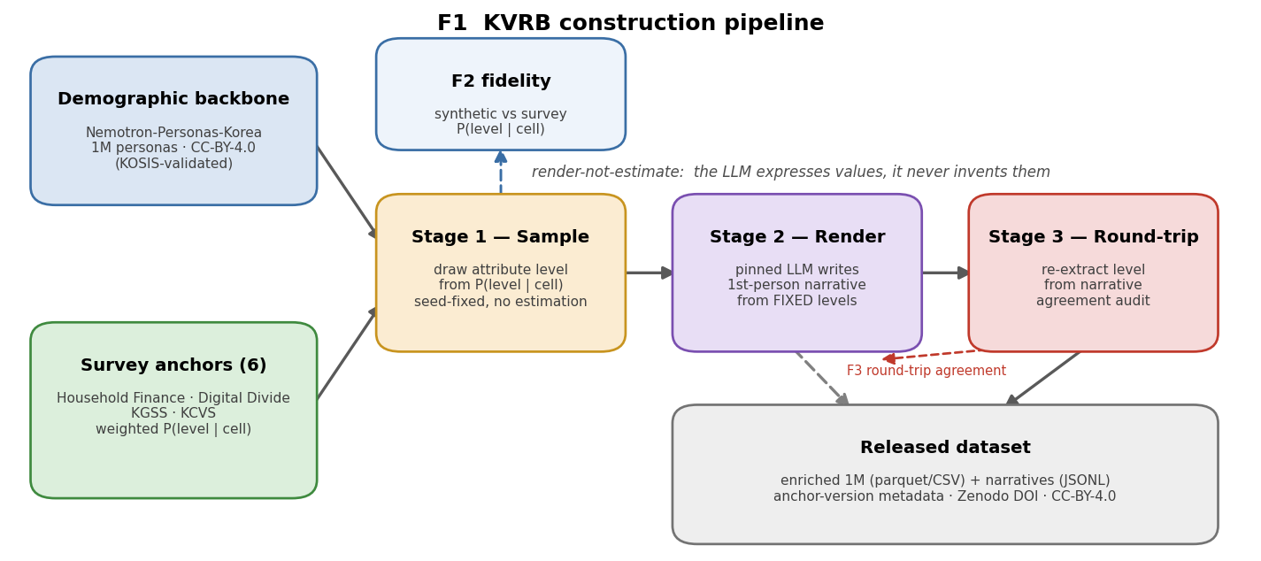
Figure 1. Construction pipeline (sample to render to round-trip).
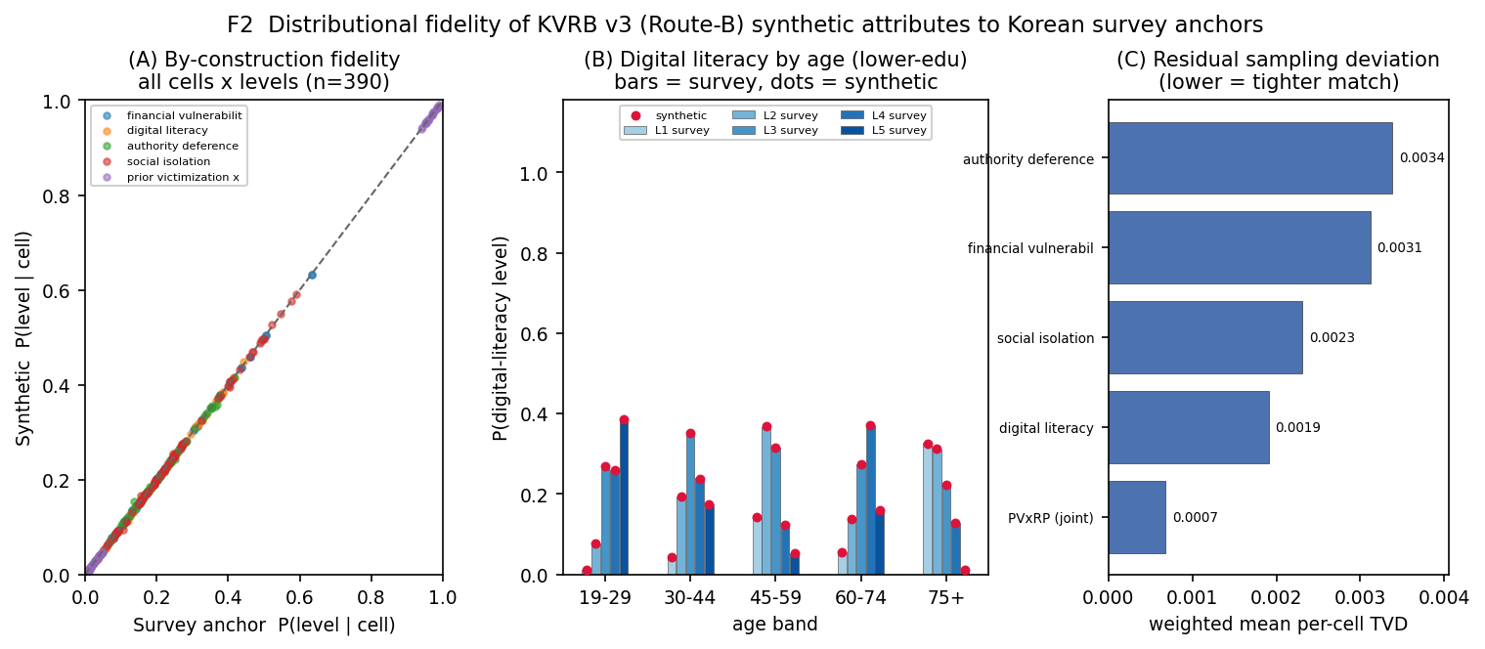
Figure 2. By-construction fidelity to survey anchors (v4, 1M; weighted per-cell TVD <= 0.0034; digital literacy 0.0019 against the recalibrated anchor).
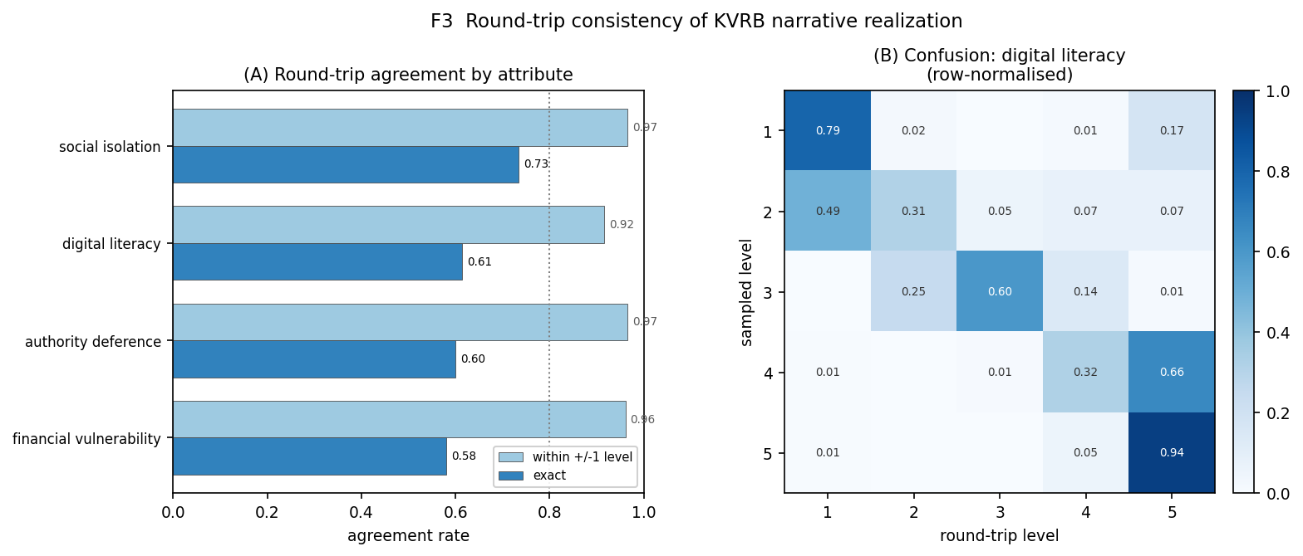
Figure 3. Round-trip reliability (gemini-2.5-flash, N=2000; QWK 0.73-0.89). Cross-model (gpt-4o-2024-11-20, N=2000; QWK 0.88-0.93) in results_xmodel_N2000/.
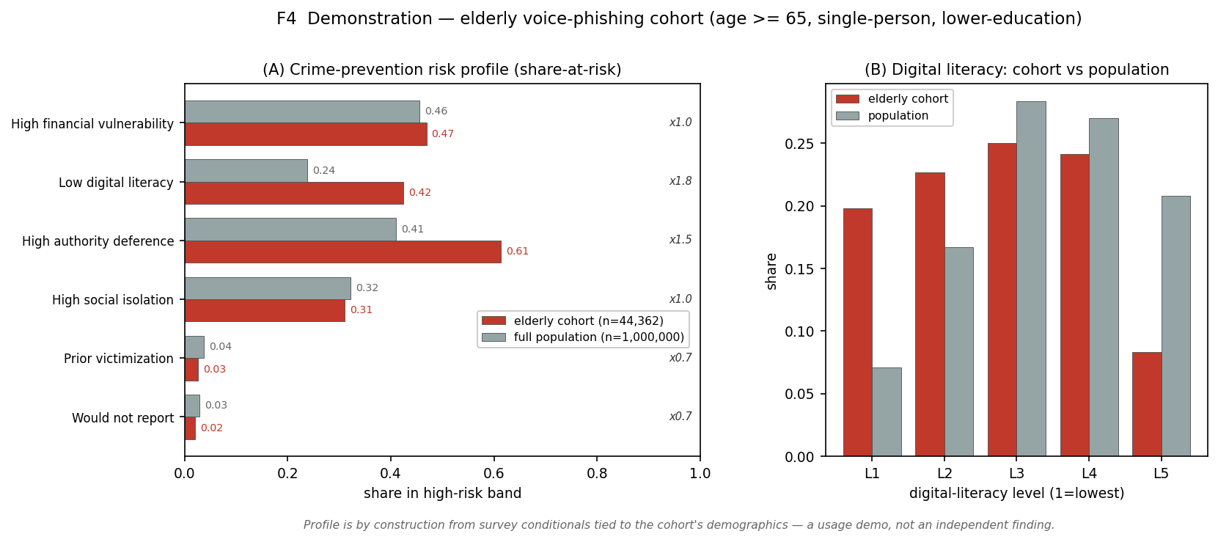
Figure 4. Elderly voice-phishing cohort (usage example, not validation; v4, 1M; low digital-literacy lift x1.8 against a recalibrated 24% population rate).
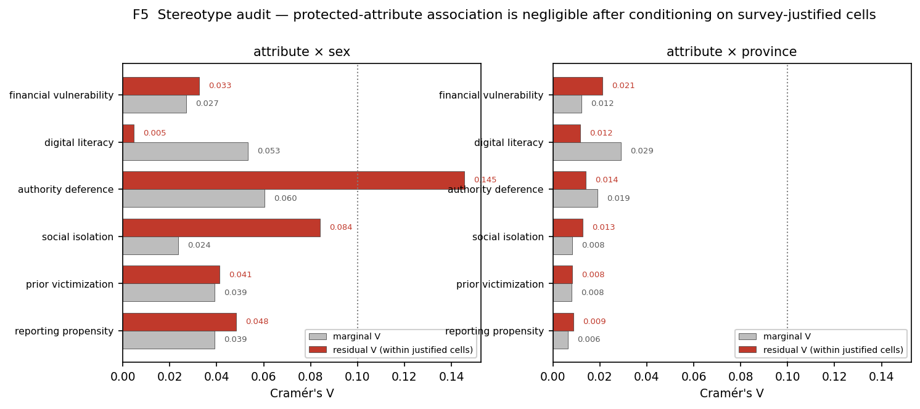
Figure 5. Protected-attribute audit (v4; max residual Cramer V = 0.145, authority-deference x sex; digital-literacy x sex residual 0.005).
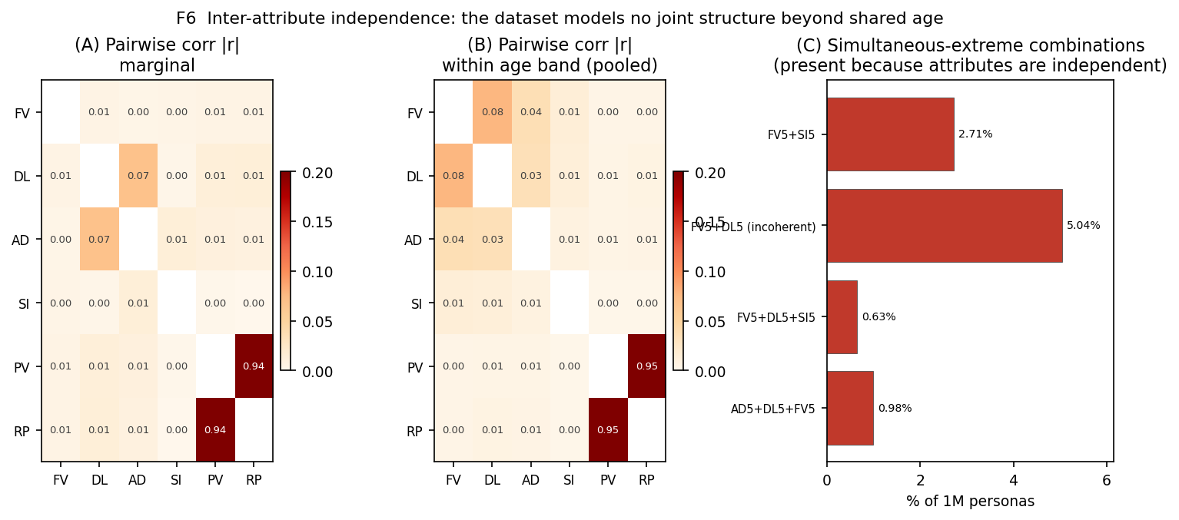
Figure 6. Inter-attribute structure under Route-B (v4; within-age |r| up to 0.077; observed PV x RP joint reported separately).
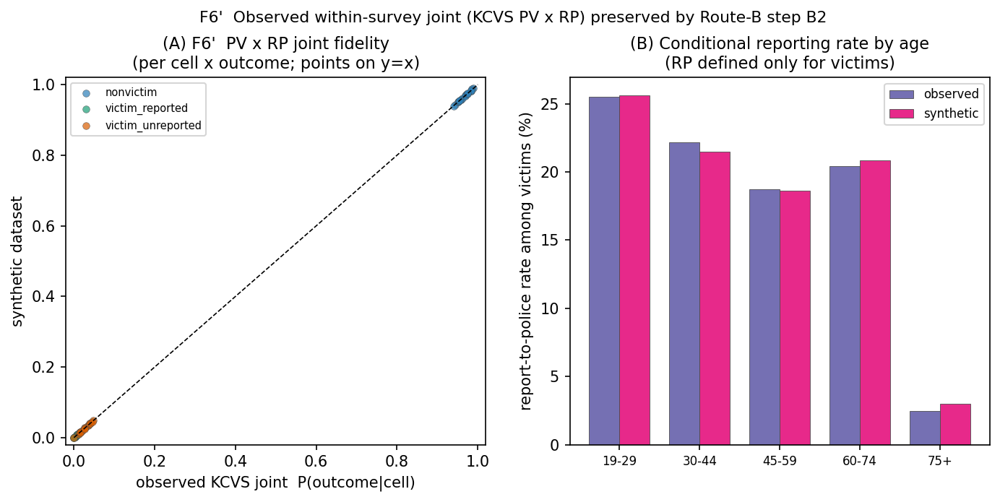
Figure 6 (supplement a). Observed prior-victimization x reporting-propensity joint (per-cell TVD <= 0.002).
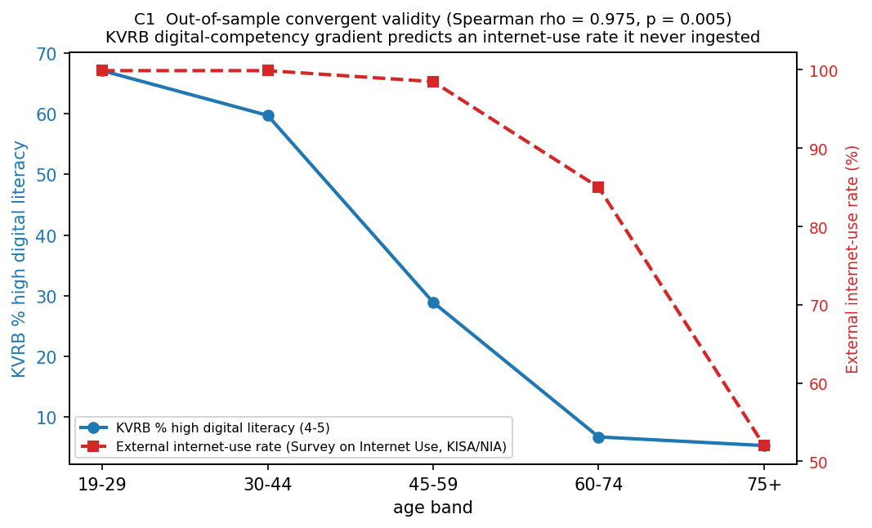
Figure 6 (supplement b). Convergent validity for the competency-anchored digital-literacy gradient (Spearman rho 0.975, n=5 age bands; p-value uninformative).
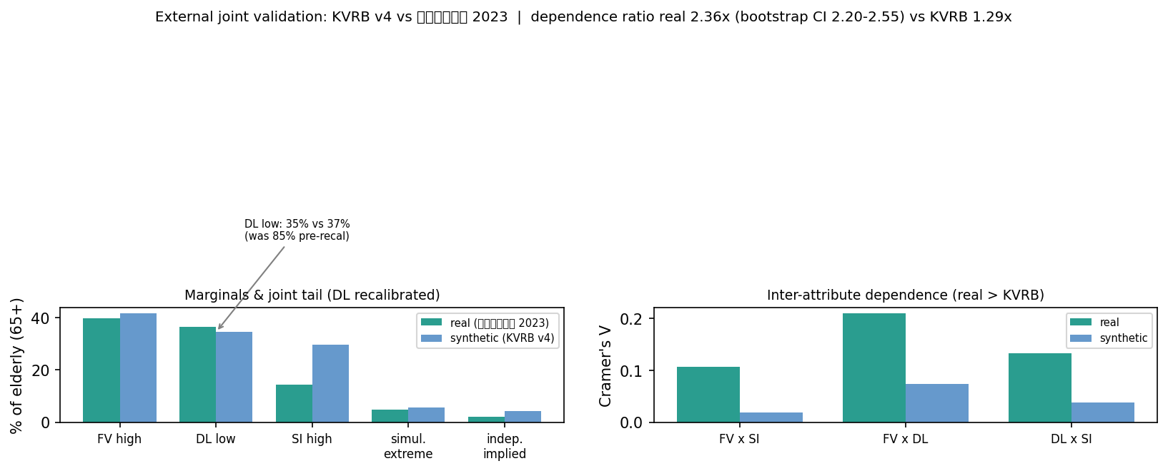
Figure 7. External joint validation vs the 2023 National Survey of Older Koreans (노인실태조사), elderly 65+: real dependence 2.36x independence (bootstrap CI 2.20-2.55) vs KVRB 1.29x; the recalibrated digital-literacy marginal now matches (35% low vs 37%); pairwise Cramer’s V real > KVRB on all three pairs.

