5CCSAGAP – Small Group Project Report
Plant Disease Classification System
Team Members: Vishal Thakwani (Model Lead, ClearML & Report), Dmytro Syzonenko (Data Preparation & Deployment), Aditya Ranjan (UI, Resnet development & Deployment), Kamyar Nadarkhanidinehkaboudi (Model Developer), Jaroslav Rakoto-Miklas (Architecture Research)
Deployed App: https://huggingface.co/spaces/Vinuit/PlantDiseaseClassifier
GitHub: https://github.kcl.ac.uk/k23149795/PlantDiseaseClassifier

Abstract
This project delivers an end-to-end plant disease detection system classifying leaf images into disease categories using deep learning. Using the PlantVillage dataset, we implemented three modelling approaches: (i) a CNN trained from scratch, (ii) fine-tuned ResNet-18, and (iii) fine-tuned Vision Transformer (ViT_b_16) for architectural comparison. All experiments were tracked with ClearML, including configuration logging, metrics per epoch, and automatic checkpointing. The final models are deployed through a Gradio-based web interface on Hugging Face Spaces, supporting single-image inference, batch processing, model switching, and user feedback via flagging. Results show that fine-tuned ResNet-18 achieves the strongest accuracy and stability, while the scratch CNN provides a competitive baseline. Both convolutional models outperform the attention-based model on this dataset. Error analysis via confusion matrices identifies systematically confused classes. Beyond core modelling, the system incorporates software-engineering practices including a CI pipeline with pre-commit formatting, linting, unit tests, and automated dependency checks, ensuring reproducible, maintainable and deployable ML workflows.

1. Introduction

1.1 Purpose of the App
The goal is to develop a web-based application detecting plant diseases from leaf images. Given a photo of a leaf, the system predicts the most likely disease class (or "healthy") and presents confidence scores. Intended users include farmers and students who need a quick screening tool.

1.2 Problem Formulation
We treat plant disease detection as a multi-class image classification problem. Each input is a colour image x ∈ ℝ^(H×W×3), and the output is a class label y ∈ {1, ..., C}. The model f_θ(x) → y is trained to minimise cross-entropy loss over labelled training images. Our curated PlantVillage dataset contains 38 distinct class folders, verified programmatically when constructing the class mapping.

1.3 Technology Stack
PyTorch for model implementation and training; ClearML for experiment tracking, configuration logging, and checkpointing; Gradio for the interactive UI; Hugging Face Spaces for deployment.

2. Data Preparation

2.1 Dataset Overview
We used the PlantVillage dataset, accessed via versioned ClearML Datasets created from Hugging Face/Kaggle sources. The dataset contains approximately 55,000 RGB leaf images covering multiple crops and disease/healthy conditions.

2.2 Dataset Subsets
To accelerate development, we created three ClearML dataset variants: Tiny (~5%) for smoke tests and debugging; Medium (~30%) for hyperparameter tuning; Full (100%) for final training and evaluation.

2.3 Preprocessing and Augmentation
All images are resized to 224×224 for model input. Normalisation is applied consistently using ImageNet statistics. Augmentations (geometric and colour transforms) are applied only on the training set to encourage generalisation, while validation/test use deterministic preprocessing. We used a reproducible seeded split into training/validation/test partitions. We additionally implemented a modular dataset loader supporting multiple data modalities (colour, grayscale, segmented), class-mapping verification, optional weighted sampling, and a reproducible splitting strategy validated through unit tests.

3. Model Development and Training

3.1 Scratch CNN Baseline
We implemented a custom CNN from scratch in PyTorch. The architecture follows a standard design: progressively reducing spatial resolution while increasing channel depth, then applying dense layers for classification with optional dropout and batch normalisation. The architecture is fully modular, enabling interchangeable blocks via configuration files, and includes unit tests verifying output shapes and forward-pass correctness.

3.2 Transfer Learning: ResNet-18
For the strongest model, we fine-tuned ResNet-18 with 224×224 input size, dropout in the classification head, and full backbone fine-tuning rather than only training the head. This achieved the best validation accuracy and most stable optimisation behaviour. We also validated the model-loading pipeline to infer classifier dimensions dynamically from checkpoint weights, enabling flexible deployment.

3.3 Vision Transformer (ViT_b_16)
To contrast convolutional and attention-based models, we experimented with ViT_b_16, which applies a transformer encoder directly to image patches. While achieving competitive accuracy, ViT showed more sensitivity to hyperparameters and dataset size. The convolutional ResNet-18 remained the best trade-off, though ViT_b_16 is included in the UI for pedagogical comparison.

3.4 Training Configuration
Training follows standard mini-batch workflow using nn.CrossEntropyLoss, AdamW optimiser (primary), and optional CosineAnnealingLR scheduler controlled via YAML configs. We implemented early stopping based on validation accuracy with configurable patience and min_delta, including unit tests to verify early stopping behaviour. All training parameters, including optimiser choice, scheduler behaviour, model depth, regularisation, and dataset variants, are configured exclusively through YAML files, enabling reproducible experiment reruns. ClearML automatically records these configurations for every task, ensuring traceability.

4. Experimental Evaluation

4.1 Experiment Tracking with ClearML
All runs are registered as ClearML tasks and log: YAML hyperparameters connected to the task, train/val loss and accuracy per epoch, learning rate when scheduler enabled, and best checkpoint uploaded automatically. We organised experiments through multiple config files covering dataset size, architecture, and hyperparameter variants. Runs were tagged using a consistent naming scheme (architecture, subset size, regularisation strategy), enabling meaningful filtering and comparison across >30 tracked experiments. We used ClearML Models to store versioned model checkpoints, ensuring that the exact artefact powering the deployed app is preserved with full lineage.
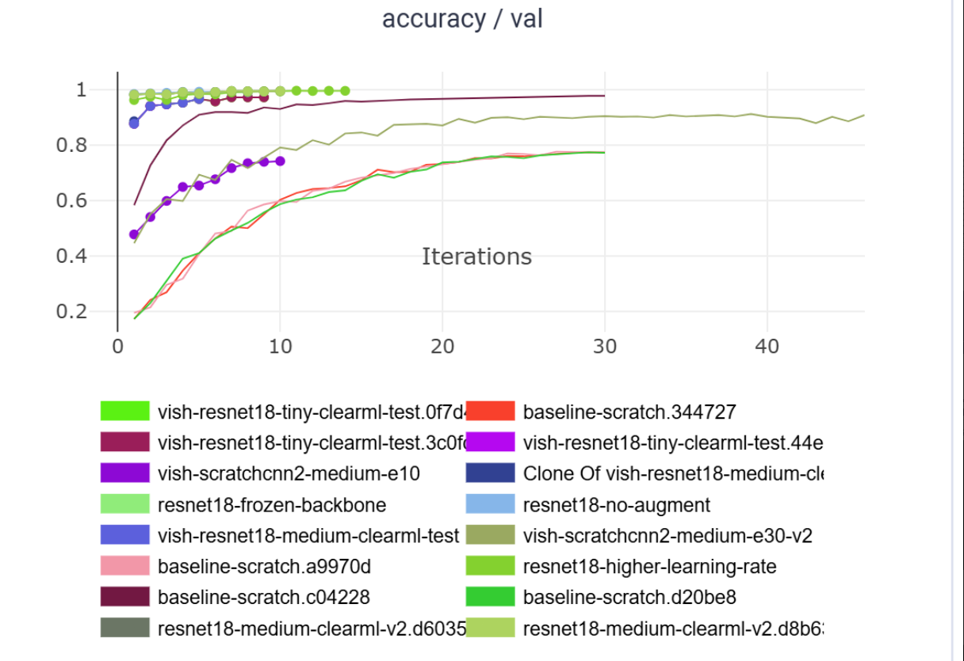
[Figure 1: ClearML comparison plot of validation accuracy across experiments]

4.2 Results Summary
We compared configurations by varying subset size, architecture (scratch vs ResNet-18 vs ViT), regularisation (none/dropout/batch norm), optimiser (Adam/AdamW), and learning rate. Key findings: the default ResNet-18 configuration achieved best validation accuracy with stable training, higher learning rates converged faster but showed unstable validation curves, and frozen backbone configurations underperformed full fine-tuning.
Model | Subset | Regularisation | Optimiser | LR | Val Acc
Scratch CNN (best) | Large | None | AdamW | 1e-3 | ~98%
ResNet-18 (best) | Medium | Dropout | AdamW | 1e-4 | ~99%
ViT_b_16 | Medium | Dropout | AdamW | 1e-4 | ~96%
Table 1: Accuracy across selected configurations
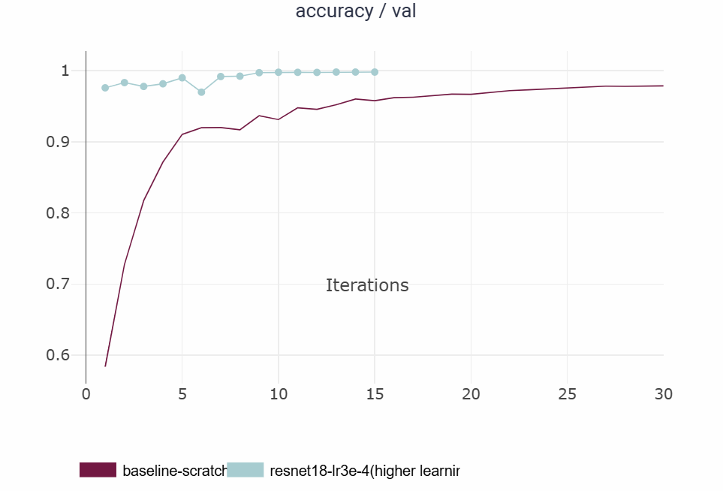
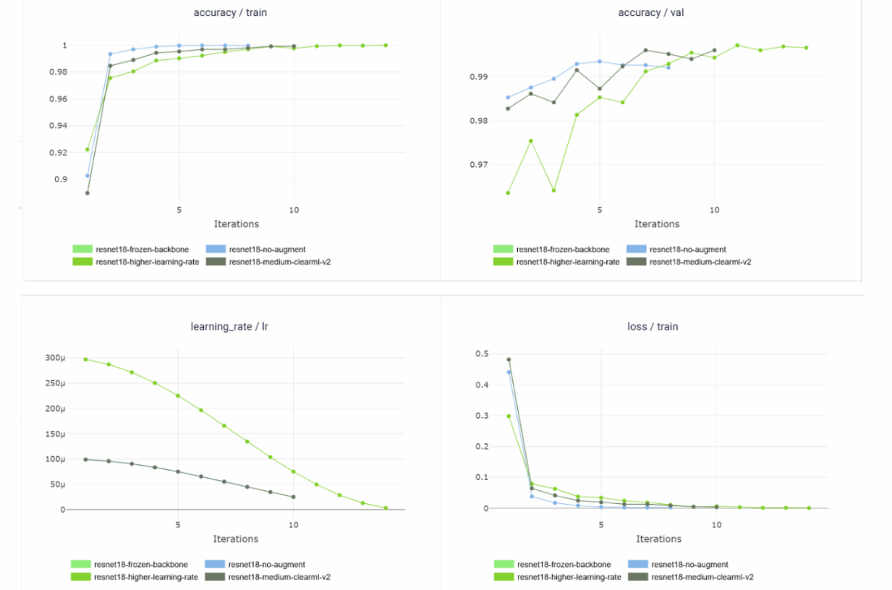
[Figure 2: Training/validation curves showing accuracy, learning rate, and loss]

4.3 Error Analysis
We computed confusion matrices for both the best ResNet-18 model and the scratch CNN baseline on the held-out test set. For ResNet-18, most mass lies on the diagonal; the model rarely confuses healthy vs diseased leaves, with remaining errors occurring between visually similar disease patterns on the same crop (e.g., tomato leaf diseases). The scratch CNN shows more off-diagonal entries as expected, with similar qualitative error patterns but a less crisp diagonal. This supports our decision to use ResNet-18 as the primary deployed model. To complement confusion matrices, we inspected per-class precision/recall, identifying specific disease classes where additional augmentation or targeted oversampling could improve recall.
Scratch CNN evaluation accuracy: 0.997, top-5: 1.0. Resnet eval accuracy: 0.996, top-5: 1.0.
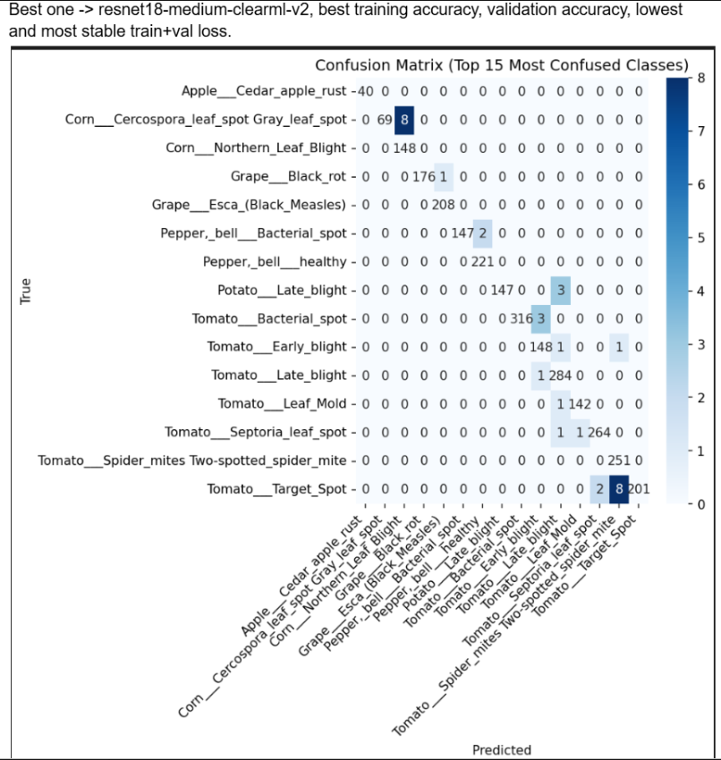
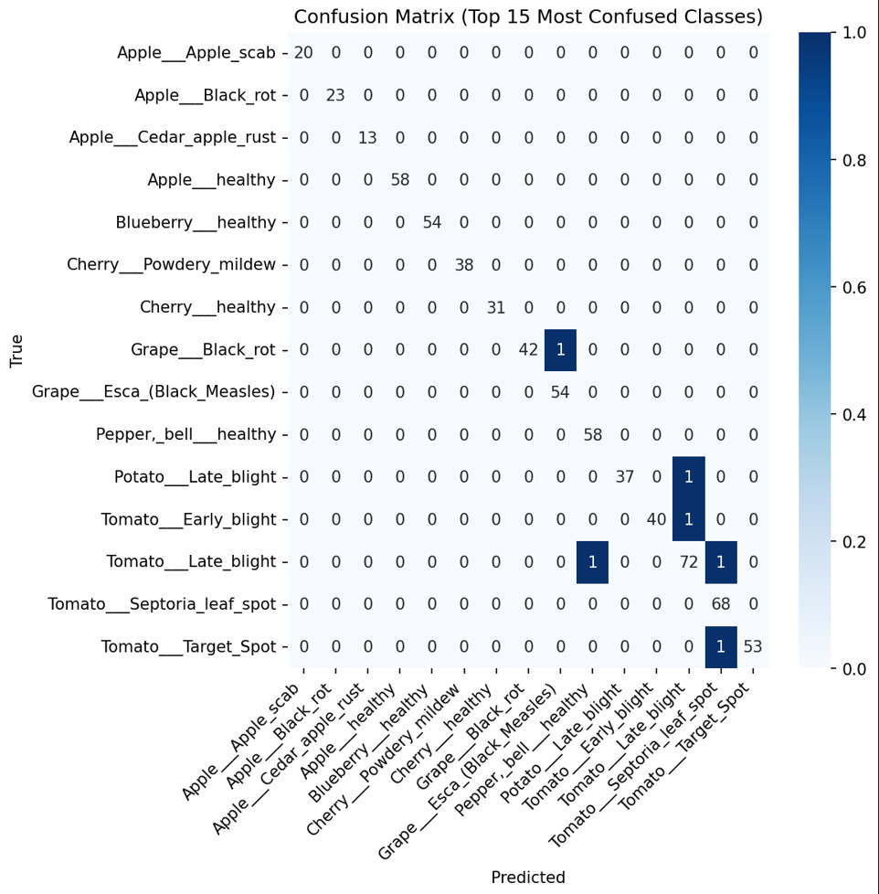

[Figure 3: Confusion matrices for ResNet-18 and Scratch CNN]

5. User Interface and Deployment

5.1 Gradio UI
Our UI implements core requirements and advanced features: upload component with automatic resizing to model resolution, top-5 predictions with confidence scores, example gallery for quick testing, model selector (Baseline CNN, ResNet-18, ViT_b_16) allowing convolutional and transformer comparison, prediction flagging for user feedback, disease descriptions, and batch processing mode for multiple images. The interface is backed by a unified inference pipeline capable of dynamically routing images through different architectures while applying consistent preprocessing. The UI automatically extracts top-5 probabilities, formats results into tables, and displays class-specific descriptions.
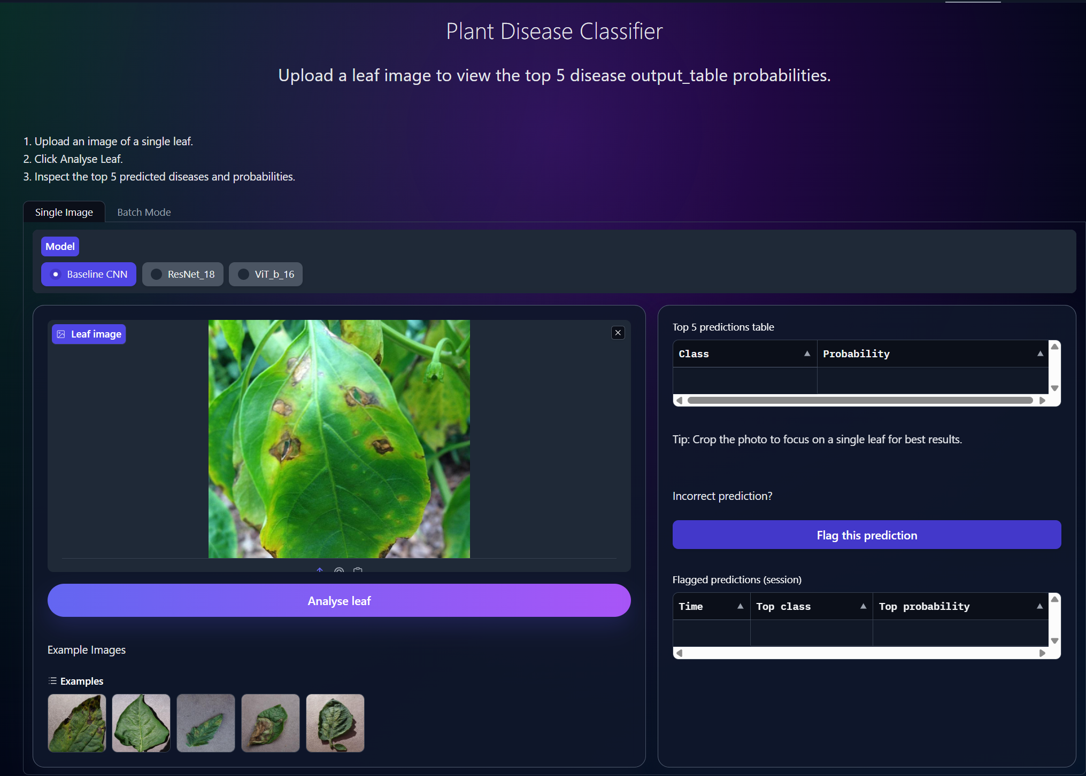
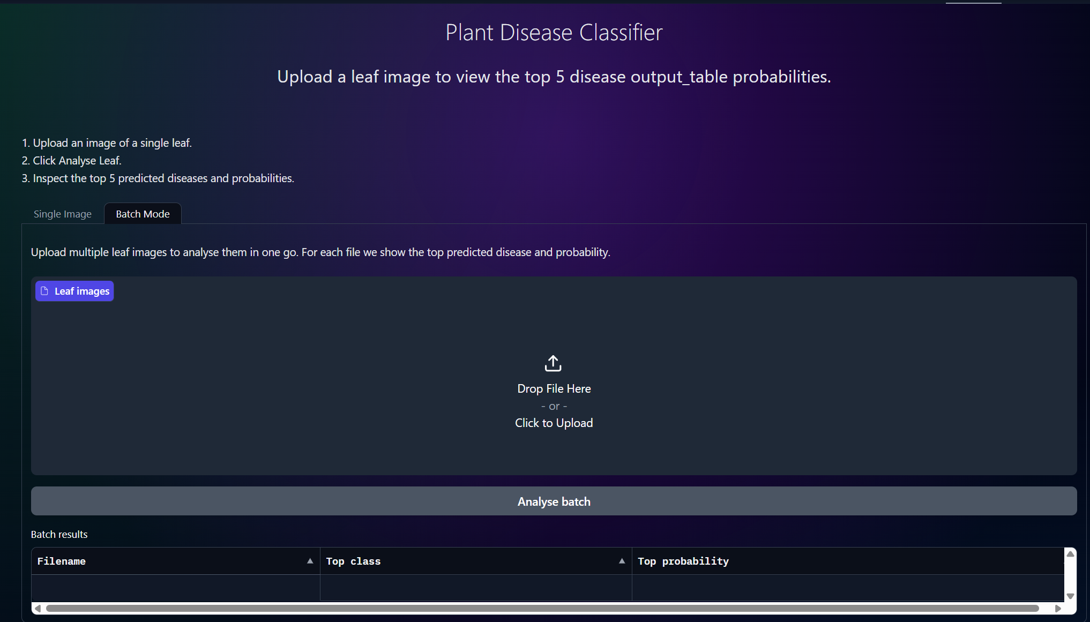
[Figure 4: UI screenshots – Single Image mode and Batch mode]

5.2 Deployment
The Gradio app is deployed as a public Hugging Face Space, accessible via shareable URL with a reproducible build environment. Dependencies are specified in the repository requirements file.

6. Conclusions
We delivered an end-to-end plant disease classifier with reproducible training via ClearML, strong performance using ResNet-18 transfer learning, and a feature-rich deployed UI. ClearML enabled rapid and systematic comparison across architectures and hyperparameters with reliable checkpointing and metric tracking. The integration of robust engineering practices (versioned datasets, CI-tested code, automated experiment tracking) ensured that the final system is not only accurate but also reproducible, maintainable, and deployment-ready.
Challenges: Key challenges included dataset size management, class imbalance, and remote GPU execution integration—mitigated using dataset subsets for fast iteration, structured configs, and robust experiment logging.
Future Work: Potential improvements include systematic imbalance handling, alternative architectures (EfficientNet), and interpretability features (Grad-CAM) within the UI.

7. Project Management
Roles: Work was split into named roles: Dmytro (data preparation/processing, deployment), Kamyar (model developer), Jarek (architecture research), Adi (UI/deployment, resnet model developer + evaluation), and Vishal (model lead, ClearML integration, reporting).
Schedule: Week 1-2: Dataset setup and baseline CNN. Week 3-4: Transfer learning and ClearML integration. Week 5-6: UI development and hyperparameter tuning. Week 7: Final evaluation, deployment, and report.
Risk Management: Initial risks (accuracy targets, GPU availability, time constraints, coordination) were mitigated through dataset subsets enabling fast iteration, config-driven reproducibility, and regular team check-ins. To mitigate integration errors, we enforced a strict CI pipeline requiring all branches to pass linting, formatting, and unit tests before merging.
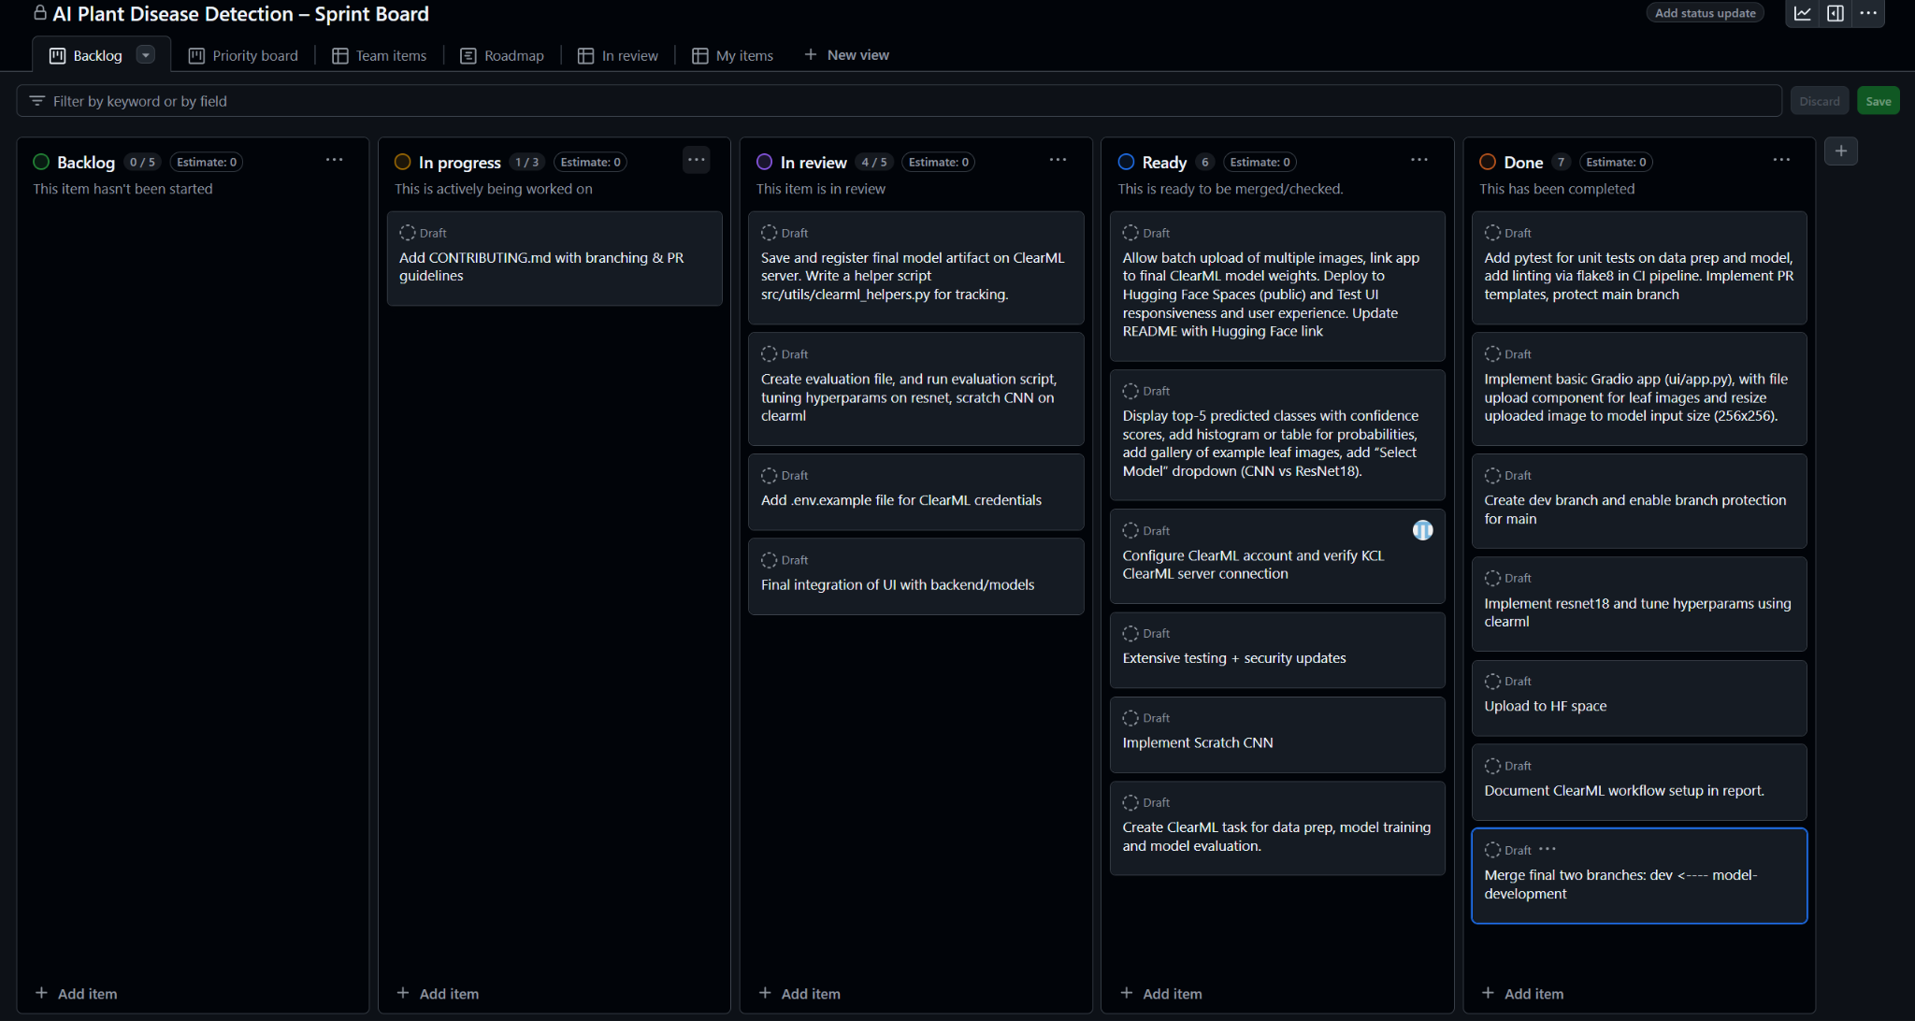

Appendix: AI Use Statement
Generative AI tools (ChatGPT, Claude) were used during this project for: debugging assistance when encountering PyTorch errors, suggesting code refactoring improvements, helping structure the report outline, and rewording technical explanations for clarity. All AI-generated suggestions were independently verified, tested, and adapted by team members. The core model implementations, experimental design, ClearML integration, and UI development were completed by the team with AI used as a supplementary tool rather than a primary source of code or content.

