**Isha Kundra**

**Vba_Challenge**

**Tab 2014**

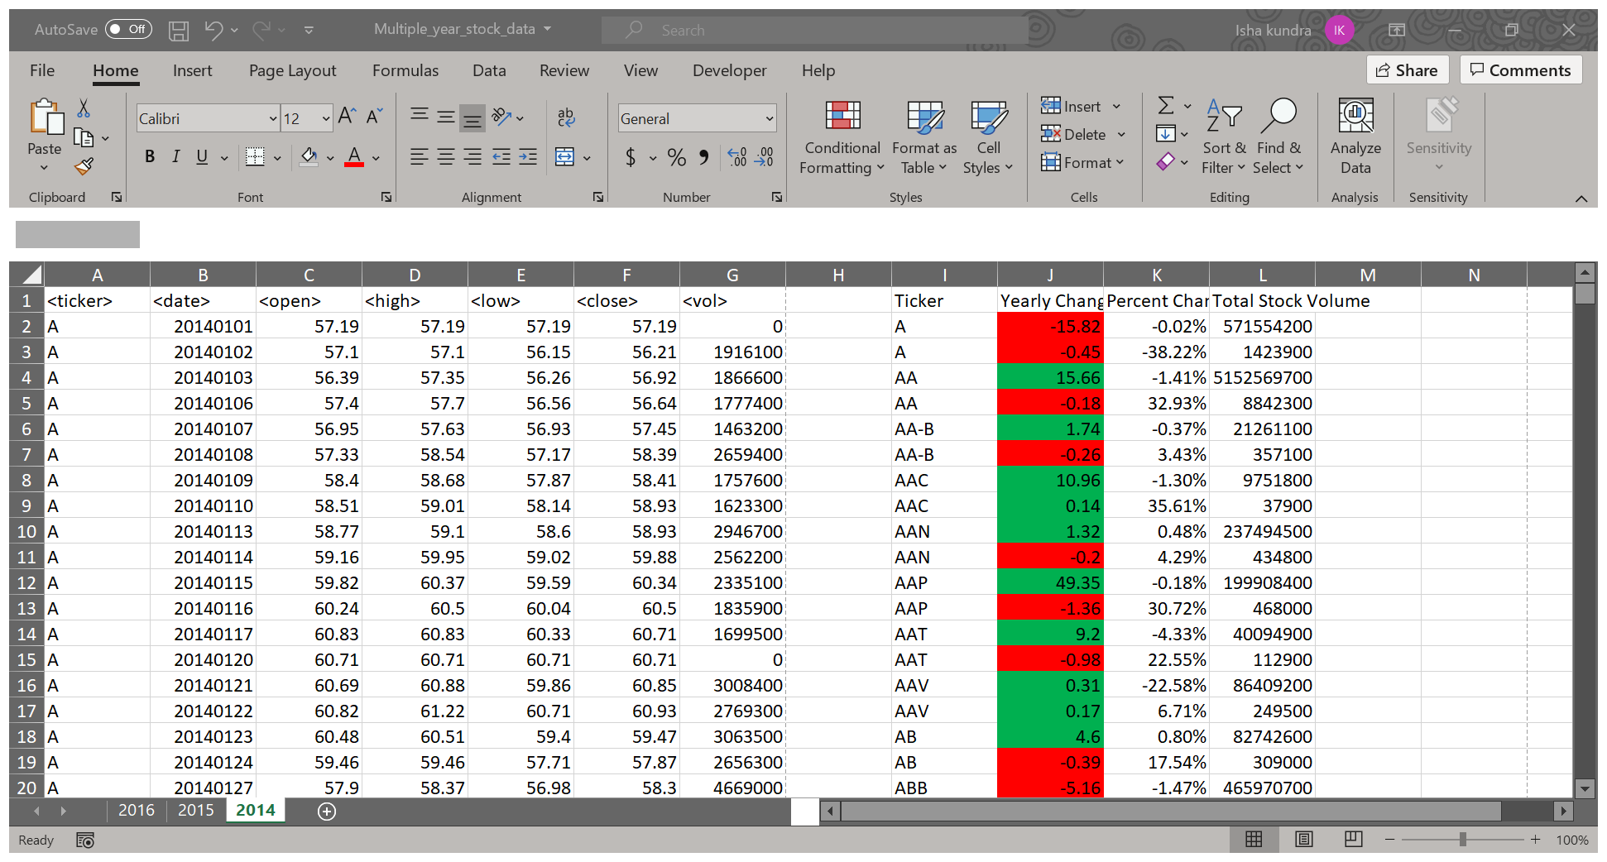

Tab 2015

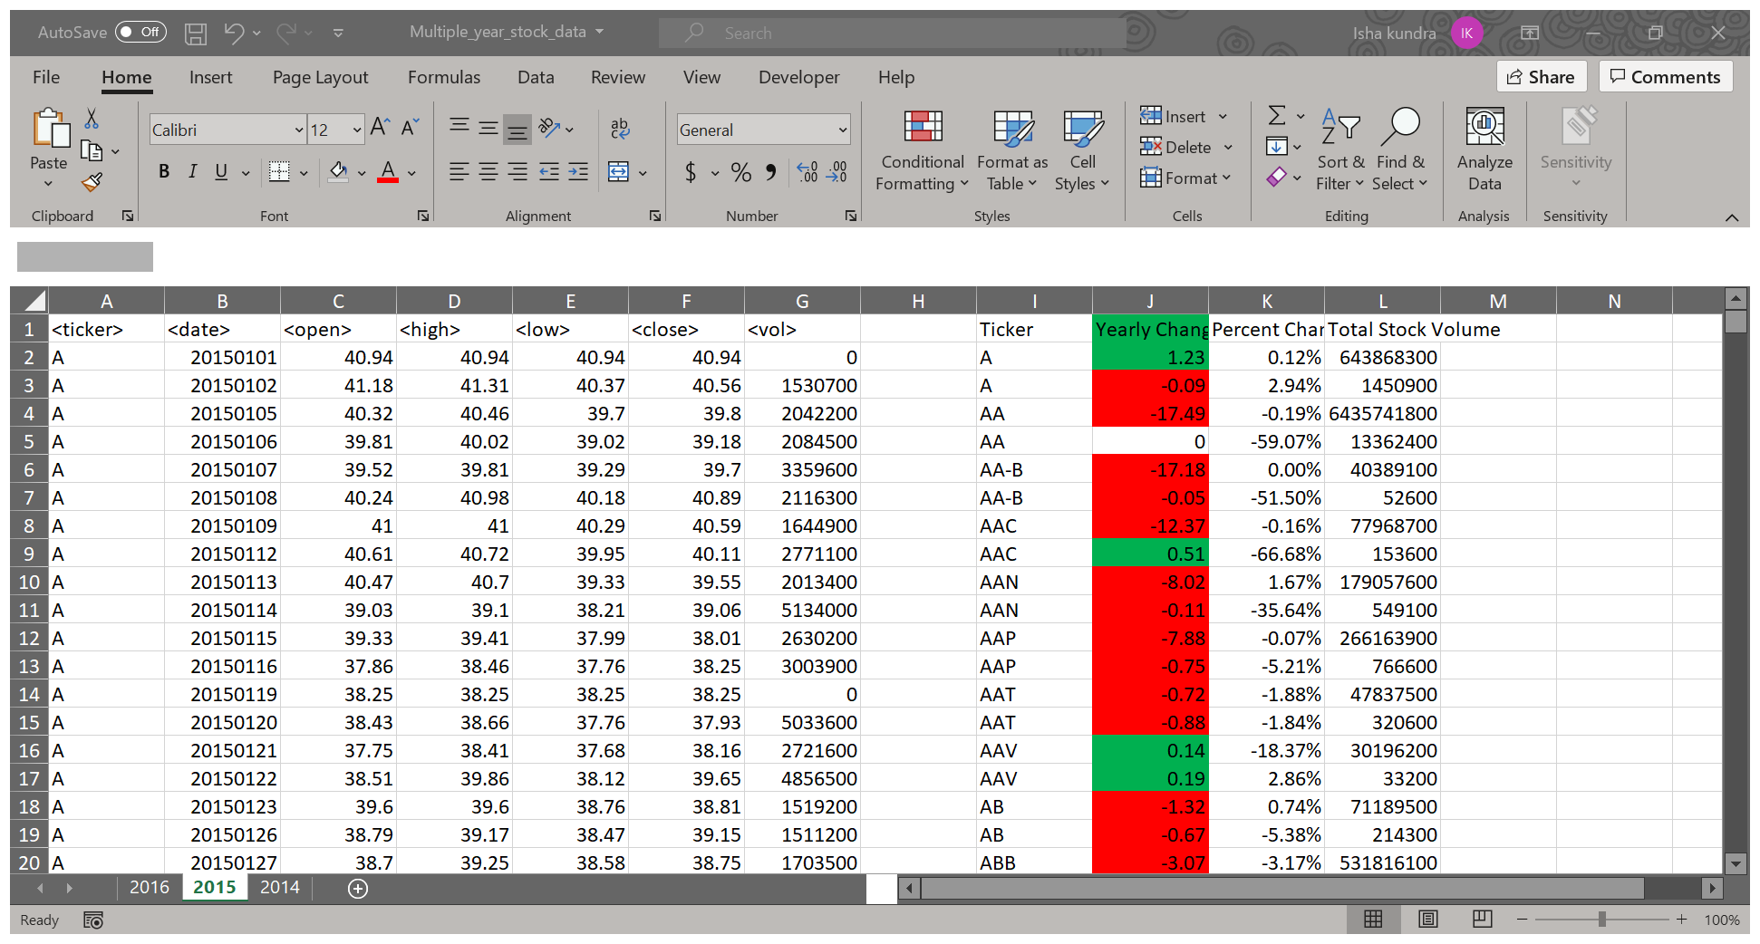

Tab 2016

