Kyle Nealy

12/5/15

G138

Saugatuck Dunes Field Guide

Introduction

The Saugatuck Dunes State Park land spans approximately 4.5 square km along Lake Michigan, situated between Saugatuck and Holland in Allegan County, Michigan. This day-use year-round recreational park features large sand dunes, beaches, and various hiking trails. The park provides a 2.5-mile expanse of secluded beachfront on the Lake Michigan coastline, and freshwater coastal dunes further inland, some of which exceed 200 feet in height (1). Thus the terrain varies throughout the park between steep dunes of soft sand, rugged hills of harder sand and vegetation, and wide flat beaches. In the summer, visitors can go hiking, fishing, swimming, or sight seeing, and in the winter they can country ski, snowshoe, and sled along the snow covered dunes. The park should be a major attraction to nature enthusiasts and hikers alike, showcasing long beaches of soft white sand, a scenic view of Lake Michigan, and a 300-acre nature preserve built on coastal dune systems. Other major attractions adjacent to the park include Oval beach, and the Saugatuck Dune rides. Oval beach is known as one of the most pristine beaches on Lake Michigan, and the Saugatuck Dune rides feature a fun, scenic and educational ride through the more secluded, undeveloped areas of the Dune’s designated ‘nature area’, that are otherwise inaccessible to visitors.

Trip Outline

Macintosh HD:Users:knealy:Desktop:g138_final:source:saugatuck_dunes_map.pdf (4).

Saugatuck Dunes State Park can be entered through one of two major trail start entrances shown on the map above just west 138th street, on either side of the Felt Mansion in Saugatuck, Michigan. The Northern entrance leads to the parking lot and picnic shelter area, as well as the Beach trail, which can be traveled further north, until it leads into the North trail, or further east toward Lake Michigan. The Southern entrance leads directly to the Livingston trail, which can be followed either east, toward Lake Michigan, or southwest along the South trail into the designated ‘nature area’, consisting of undeveloped, forested dunes. Stretching along the entire western edge of the park expanse is a narrow white beach forming a portion of the Lake Michigan Eastern shoreline. All of the trails can be traversed within a three-day trip. On a hot or humid day, with little cloud coverage, a short trek heading straight to the beach may be ideal. Traveling through the middle of the park starting at the North entrance and heading along the easy beach trail straight to the beach site C shown on the map is the fastest way to start tanning or swimming along lake Michigan. On a cool day with clouds or a nice breeze, a more challenging hike or bike ride could be fun. The North trail provides a nice easy walk or ride, with less variation in the terrain, while the South trail, measuring at 5.5 miles, is the longest trail with the most difficult terrain in the park (4). Any lunch breaks should be taken at the picnic shelter area, at the beginning of the north trail. At the south entrance to the park, Shore Acre Bike Park is available to those who enjoy riding bikes through the rugged sand dunes. The 1.6-mile open area bike track circles an expanse of sand dunes in the middle of the park open to the public year round (4).

Geologic Sites

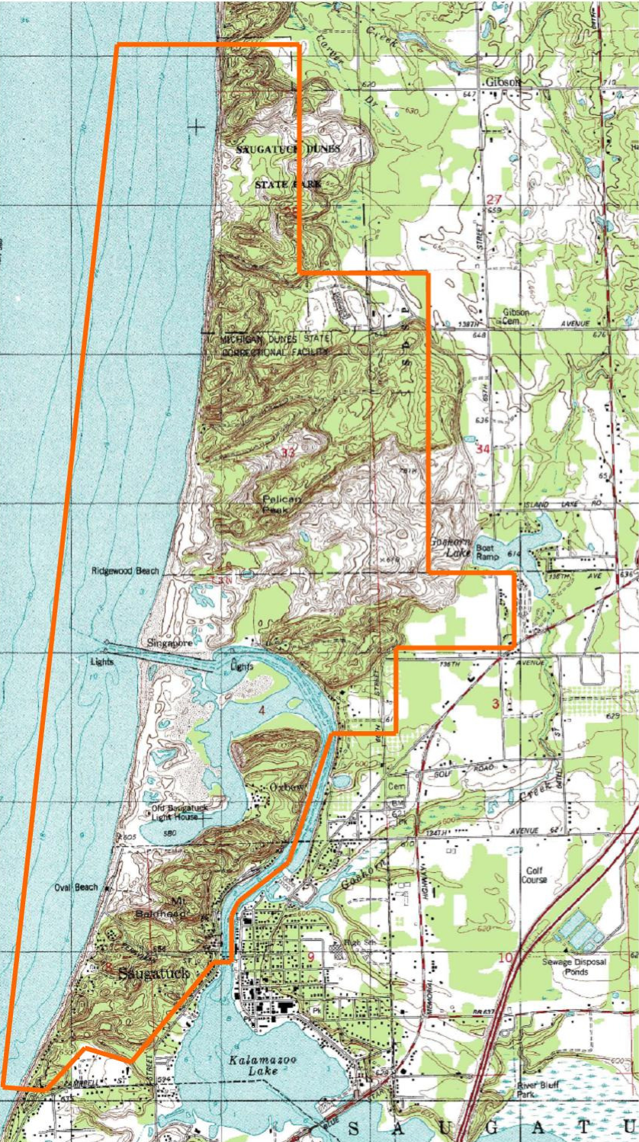 (5).

Three keys sites that represent various environmental settings present at Saugatuck Dunes State Park include the point 3 on the North trail and point 13 on the South trail in the previous map, as well as another site just south of Ridgewood Beach shown in the map directly above. Point 3 and point 13 on the first map represent the open dunes settings and the southern mesic forest settings of the park, respectively, while the site south of Ridgewood beach represents the interdunal wetland setting of the park. The entire park shares a subsection of Paleozoic bedrock of Mississippian shale and sandstone with the Lake Michigan basin. The last major period of dune formation occurred during the Nipissing Great Lakes time period, roughly 4,500 years ago, but smaller foredunes have formed since then during low water levels (5 8). During repeated expansion and retraction of the North American ice sheet complex during the Wisconian glaciation, what is today Michigan was covered by thick glacial ice containing a mix of various sediment and debris (5 8). During the next glacial melting, these various sediments were deposited, along with pools of glacial water that did not dissipate. The sediments were then eroded by a waves and currents over time, forming beaches as sand is deposited along Lake Michigan (5 8). Strong winds continue to move the larger grained sand inland over time, until the sand is obstructed by vegetation that deflects the wind and lets the sand drop and accumulate, forming a clump, and eventually sand dune.

The dunes that formed along the east shore of Lake Michigan comprising the Saugatuck State park lands, and by extension, all three key sites, are parallel dunes. Approximately 4,000 years ago, water levels were 25 to 30 feet higher than present day Lake Michigan levels, and rivers like what is now Kalamazoo emptied abundant sand particles into the lake, which were then deposited along the shore (1 16). Over time, this process of layering sand along the shore during water level fluctuations created the modern system of parallel dunes that comprises Saugatuck Dunes State Park today.

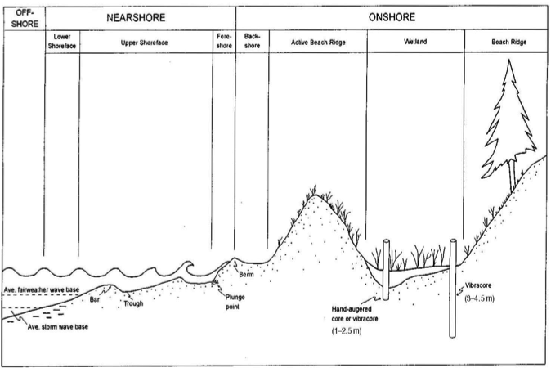 (5 17)

Point 3 on the first map above represents the open dunes environmental parkland setting. The site features an expansive area of beach and freshwater coastal foredunes containing scattered vegetation and gently sloping successions of parallel dunes further inland. This site is likely to have the youngest geology among the three, since older sands are continuously eroded further inland as newer sands are deposited from the Kalamazoo River and Lake Michigan onto the shoreline (5 9). As each new sediment layer is deposited, each previous layer gets built up and pushed further inland, and eventually forming a foredune zone, which is distinct from the beach and backdune, or secondary dune. The foredune and secondary dune are separated by a trough, or valley. The trough tends to fill with water and become an interdunal wetland.

The key site slightly southeast of Ridgewood beach represents the parkland’s interdunal wetland environmental setting. Interdunal wetlands are shallow pools of water or just moist ground that form in the troughs between foredunes and secondary dunes. Strong wind currents have continued to push sand particles inland from Ridgewood beach since the formation of Saugatuck dunes over the past 4,000 years (5 8). At the same time, sand has continued to flow out into Lake Michigan from the Kalamazoo river drainage, and is deposited along the shoreline regularly. This subsequent influx of new sand has continued to create new parallel sand dunes while pushing the older dunes inland. The troughs that form between tall sand dunes tend to fill with water through natural precipitation and groundwater processes, forming interdunal wetlands (1 16).

As sand continues to accumulate and push foredunes into secondary dunes, eventually the secondary dunes continue to erode and deposit further inland before growing large amounts of vegetation to help anchor the dunes. The last key site, shown at point 13 on the first map above, represents the parkland environmental setting of a mesic backdune forest. The backdune zone in the southern region of the Saugatuck Dunes in the ‘nature area,’ consists of a rich mesic forest, built atop nutrient dense, sandy topsoil that retains moisture from the surrounding groundwater and landscape drainage. The backdune zone consists of secondary dunes, containing a moderate level of biodiversity. Secondary dunes often have more nutrient rich soil components, as well as increased wind protection from the foredunes, and thus can support a greater range of hardier plant species, which in turn provides even greater protection from erosion (5 10). The backdune zone where point 13 is in Saugatuck Dunes is situated low in a valley, and naturally collects the surrounding groundwater as it drains, which helps to support its thriving young tree canopy.

The Saugatuck Dunes State Park represents three important environmental parkland settings relating to the formation of sand dunes. The open dune setting, which was the first to form after thousands of years of glacial expansion and retraction across Michigan. As natural processes began to erode and weather what was left of said glacial deposits, beaches formed along Lake Michigan, followed by sand dunes. For a while, the sand dunes continued to grow and accumulate, before eroding even further inland. As secondary sand dunes begin to form behind the larger foredunes, a valley (trough) separates the foredunes from the secondary dunes. As the trough widens, it tends to fill with water, and become an interdunal wetland. As the secondary dunes continue to grow and erode inland, they accumulate nutrients and moisture from the interdunal wetlands, eventually forming a nice nutrient rich foundation for a mesic forest are on the secondary dunes.

References

1.

Saugatuck Dunes State Park, General Management Plan, 2010, Phase 1:

https://www.michigan.gov/documents/dnr/saugatuck\_dunes\_gmp\_complete\_322078\_7.pdf (accessed December 2015).

2.

Schmiechen, James. The Saugatuck Dunes, History:

http://www.saugatuckdunescoastalalliance.com/history/index.php (accessed December 2015).

3.

Olson, Jerry. (1958). Rates of Succession and Soil Changes on Southern Lake Michigan

Sand Dunes. *Botanical Gazette*, *119*(3), 125–170.

http://www.jstor.org/stable/2473440 (accessed December 2015).

4.

Saugatuck Dunes State Park. Map.

http://www.michigandnr.com/publications/pdfs/RecreationCamping/saugatuck

dunes\_map.pdf (accessed December 2015).

5.

Kidorf, Kristine. January 2010. Saugatuck Historical Coastal Survey Report.

http://sdhistoricalsociety.org/sites/dunes/coastal\_survey\_2010.pdf (accessed December 2015).

6.

Wilson, Steven. 2000. Michigan’s Sand Dunes.

http://www.michigan.gov/documents/deq/PA07\_304669\_7.pdf (accessed December 2015).

7.

Baca, Joy Kira. 2013. Environmental impacts on the development and dune activity of Oxbow Lake along the southwest coast of Lake Michigan at Saugatuck, Michigan USA.

http://utdr.utoledo.edu/cgi/viewcontent.cgi?article=1038&context=theses-dissertations (accessed December 2015).

8.

2010. Open Dunes Community Abstract.

http://mnfi.anr.msu.edu/abstracts/ecology/open\_dunes.pdf (accessed December 2015).