CV

giorgi vaSakiZe

misamarTi: q. Tbilisi, mixeil mesxis ¾ #68 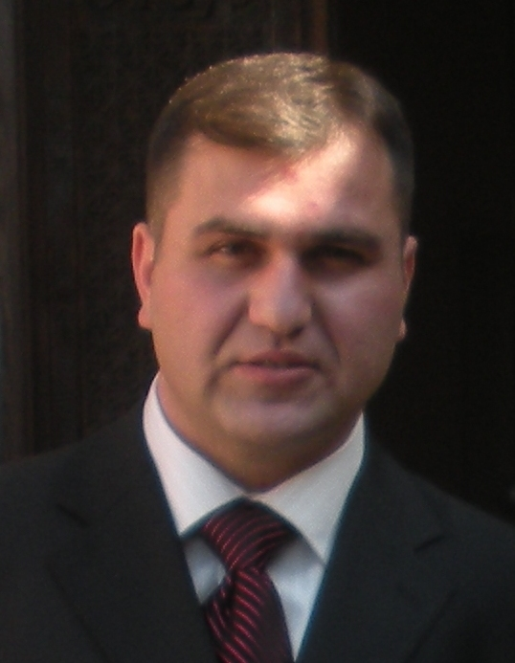
Mob: 893 28 44 78
E-mail: natinato15@mail.com
dabadebis TariRi: 06. 07. 1980
ojaxuri mdgomareoba: daojaxebuli

ganaTleba:

1986-1995ww. vswavlobdi q. Tbilisis me-5 saS.
skolaSi.

2000-2002ww. vswavlobdi q. Tbilisis samSeneb-
lo avto-meqanizaciis prof-sas-
wavlebelSi, sabaJo-sagadasaxado
komerciuli saqmis menejer-buRalt-
ris specialobaze.

2006 wels nebayoflobiT gavewvie savaldebulo samxedro samsaxurSi, romelic gaviare Sss spec-operaciebis centris pirveli ganyofilebis pirvel qveganyofilebaSi (Savnabada), romelic davamTavre 2007 wlis 20 oqtombers saq. kanonis 37-e muxlis 1 punqtis safuZvelze.
samuSao gamocdileba:
2003-2004ww. vmuSaobdi usafrTxoebis dacvis samsaxur “atlantaSi”.
2008-2009ww. vmuSaobdi dacvis samsaxur “viqtoriaSi”
(prokredit bankis filialSi).
2009-2010ww. vmuSaobdi sastumro “aWaraSi”.
2011-2013ww vmuSaobdi Sps “deakosmetiks” –Si mesawyobed
2014w –2016ww vmuSaob Sps “furSet jorjia”- Si sawyobis
mimRebis Tanamdebobaze.

enebis floba:

qarTuli – mSobliuri, rusuli - saSualod
kompiuteruli programebis codna: MS OFFICE PROGRAMS: WINDOWS, WORD, EXCEL, INTERNET.
მართვის მოწმობა: B კატეგორია

