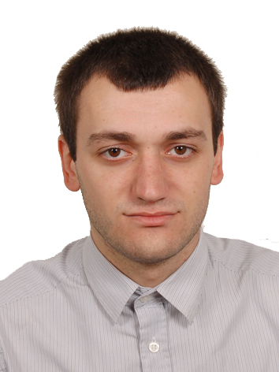
Name: Valeri Tsintsadze
Address: Wminda ninos 17 str. Batumi, Georgia Mobile: +995599497644
Mail: Tsintsadze.90@gmail.com
Nationality: Georgian
Date of birth: 17.03.1990
ID N: 60006055161

PERSONAL PROFILE
Graduated from Girne American University as a Business and Economic faculty of International Business Management Department.
Have experience in operational Management, import and category manager.

EDUCATION
October 2008 - January, 2013
Bachelor of International Business Management
Girne American University

Module included:

Business Finance
Business Marketing
Operational Management
Human Resource Management
Communication skills
Strategic Management
Economic and Globalization skills
E-trade
Import and Export
Accounting Management

International Management

September, 1996 – June, 2007
Gonio public school.

Module included:
Math
Computer
English
Russian

WORK EXPERIANSE
August, 2011- September, 2011
StiepfAG, Germany
Operational Manager,
Responsibilities: the goal of work was marketing research, operating business agreement, monitoring import and export of Security and IT Technology trades in East and North Europe.

Environment: Microsoft (Word, Excel and Power point)

February, 2013 – November, 2013
Beltexcomcentr, Belarus (Minsk)
Operational manager,
Responsibilities: the goal of work was to participate, governmental tenders of repairing and washing steam boilers, making contracts and purchasing raw materials for object. Also during process, controlling and taking responsibilities.

December, 2013- till now
Bmc Gorgia Ltd, Georgia
Category and import manager,
Responsibilities: the goal of work are import water supply goods, heating and cooling systems for distribution, showrooms, project department, cooperative clients and consumers. Operating business meetings, finding new suppliers in international exhibitions cooperating with them for the long term relationship. Make trainings for consultants. Controlling all the heating and cooling category department in Bmc Gorgia Ltd.

SKILLS

Computing: Microsoft (Word, Excel and Power point)
Languages: Georgian – mother tongue, Russian – very good, English –very good and Turkish good.
Educational back ground: E-tread, Internship, Strategic management, International Business Management, Organizational and theory Business management.
In addition: I have experience in the field of customs and international transport carriage.

