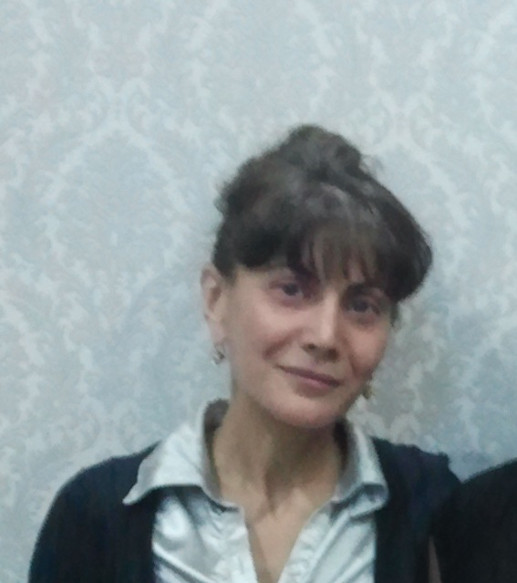 | reziume / CV

cnobebi aplikantze
gvari | WavWaniZe |  | saxeli | ana |  | mamis saxeli |  | anzori
dabadebis TariRi (Tve, ricxvi, weli)  da adgili | 30.09.1969 q. Tbilisi
mimdinare sruli misamarTi | q.Tbilisi arbos q. korp. “a” bina 2
sapasporto monacemebi: | seria 13IG05821 | nomeri 01023009732 |  |  | gacemis TariRi 25.08.2014 |  | gacemis organo  iusticiis saministro

ojaxuri mdgomareoba | dasaojaxebeli
miuTiTeT ojaxis wevrebis saxeli, gvari, dabadebis weli da samuSao adgili:
deda | luiza WavWaniZe
mama | anzori WavWaniZe
da | manana WavWaniZe, cira WavWaniZe
Zma | -
meuRle | -
Svilebi: | -

miuTiTeT sakontaqto telefonebi
saxli: 261-58-03 | mobiluri: 599 30-30-58 | samsaxuri: 291-13-66

ganaTleba/kvalifikacia
gTxovT detalurad da Tanmimdevrulad miuTiToT swavlebis etapebi
saswavlo dawesebuleba | fakulteti | specialoba | xarisxi | swavlis TariRebi
teqnikuri universiteti | satransporto (avtomatika, telemeqanika da kavSirgabmuloba rkinigzis transportze) | mimosvlis gzaTa inJiner-eleqtrikosi | magistri | 1987-1992
samedicino koleji “orbi” | farmacia | farmacevti | serTificirebuli | 2005-2007

miuTiTeT damatebiTi, kvalifikaciis asamaRlebeli treiningebi da serTificirebis kursebi
saswavlo dawesebuleba | saswavlo kursis (treiningis) dasaxeleba | periodi (weli) | saswavlo kursis xangrZlivoba
teqnikuri universiteti | “cifruli komunikaciis sistemebis eqspluatacia” | 2001 | 3 Tve
133-e sajaro skola | Tbilisis meriis proeqtis farglebSi SeZenili codna inglisursa da kompiuterul unarCvevebSi | 2009-2010 | 1 weli

damatebiTi informacia aplikantze
teqnikuri unar-Cvevebi
miuTuTeT kompiuteris saofise programebis codnis done (daasaxeleT programa da codnis/ gamoyenebis done miuTiTeT Sesabamis grafaSi)

programis dasaxeleba | codnis done
programis dasaxeleba | Zalian kargad | kargad | momxmareblis doneze
Windows |  | +
MS Office |  | +
Internet | +
Email | +

ucxo enebis codna
flobT Tu ara sxva enebs qarTuli enis garda? diax
dadebiTi pasuxis SemTxvevaSi, gTxovT 5 baliani Sefasebis mixedviT moniSnoT “X”-iT grafebi

ucxo ena | 5 | 4 | 3 | 2 | 1
qarTuli | +
rusuli |  | +
inglisuri |  | +
germanuli |  |  |  |  | +
franguli |  |  |  |  | +
italiuri |  |  |  |  | +

samuSao gamocdileba
gTxovT miuTiToT bolo samuSao gamocdileba, maT Soris: moxalised muSaobis gamocdileba,
staJireba, droebiTi samuSao.
1
periodi (dawyebisa da dasrulebis Tve/weli) | 1993-2002 w.-mde | samuSao adgilis mdebareoba | q. Tbilisi, iosebiZis q.
organizacia | eleqtro kavSiri
dakavebuli pozicia | inJineri | anazRaureba | 350 lari
mokled aRwereT Tqvenze dakisrebuli funqcia-movaleobebi | kordinatiuli sadguris momsaxureoba. sakomutacio mowyobilobis monitoringi da dazianebebis aRmofxvra.
wasvlis mizezi | saerTaSoriso sadgurSi gadasvla
2
periodi (dawyebisa da dasrulebis Tve/weli) | 2002-dRemde | samuSao adgilis mdebareoba | winamZRvriSvilis q.
organizacia | silqneti
dakavebuli pozicia | cvlis inJineri | anazRaureba | 1000 lari
mokled aRwereT Tqvenze dakisrebuli funqcia-movaleobebi | saerTaSoriso da saqalaqTaSoriso satelefono sadguris, aparaturis monitoringi da dazianebebis aRmofxvra. saerTaSoriso da adgilobriv operatorebTan urTierToba.
wasvlis mizezi | sadguris likvidacia

TqvenTvis sasurveli samuSao grafiki

- sruli samuSao ganakveTi

SemoTavazebis SemTxvevaSi ra periodi dagWirdebaT axal poziciaze muSaobis

dasawyebad? (igulisxmeba mimdinare samsaxuridan wamosvlis periodi)
maSinve

mimdinare an bolo samsaxurSi sargeblodbiT Tu ara socialuri daxmarebebiT?
(igulisxmeba dazRveva, zeganakveTuri samuSao anazRaureba, satelefono saubrebi,
avtomobiliT sargebloba da sxv). daasaxeleT dadebiTi pasuxis SemTxvevaSi
unisonis dazRveva

