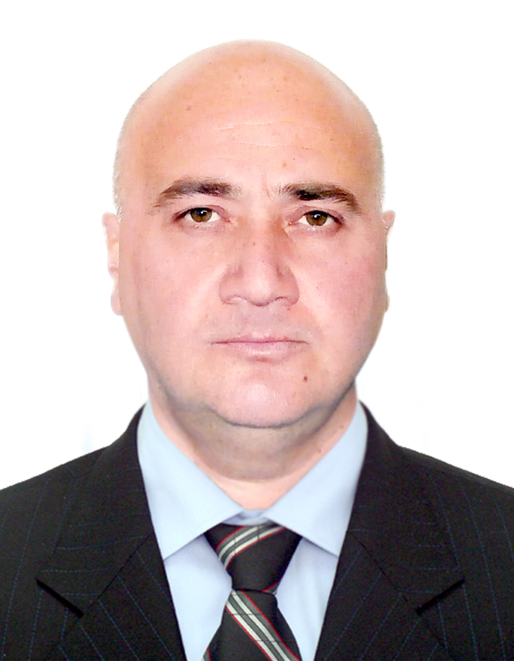

36B Kakheti Highway, Apt 30  0190, Tbilisi, Georgia | Mobile: +995 (577) 448100  Home: +995 (32) 2778100  E-Mail: o_samushia@hotmail.com
Otar Samushia
Experience – Full Time Positions | 2019-2021 Company “M” Group  Logistic Specialist  June,2016-December,2018  Touristic Company Concord Travel  Driver- Guide  September, 2014 – June,2016  B P – F S G  Driver-Technician (Fair Safety Georgia)  July, 2013- July, 2014 Radisson Blu Iveria  Logistic Specialist  April, 2006 – June, 2013 Embassy of the United States of America  Regional Security Office Specialist  recognize and report hostile surveillance directed at or unusual events involving U.S. Government employees, dependents and facilities in Georgia
August, 2004 – September, 2005 Amec Spie Petrofac International AGT pipeline project, Baku-Tbilisi-Ceyhan
Security Control Officer
* Supervising guard force at appropriate locations;
* Implementing physical security procedures and processes for all of the site locations;
* Conducting continual surveys of the site to determine the need for additional security services and making appropriate recommendations;
* Maintaining corporate investigative practices and standards, investigating all suspected criminal violations, suspicious incidents and policy violations that may become security issues;
* Providing reports to senior security officer concerning security issues.
October, 2002–April, 2004 Georgian Training and Equipment Program (Brown& Root Services)
Security/Driver

* Transport Security, GTEP personnel and official visitors within the city and surrounding areas;
* Process customs clearance;
* Delivery by hand letters and packages;
* Complete daily vehicle records;
* Ensure that assigned vehicle is in a road-worthy condition;
* Carry out periodic preventive maintenance

September,1999-October,2002 United Global Technologies
Security/ Driver

Assist Mrs. Sarah Williamson during her meetings within and around Tbilisi, provide protection
June, 1995– August,1999 Embassy of Germany
Transport Administrator / Ambassador Driver

*Procurement and transportation of supplies and equipments;
*Planning and supply local procurement;
*Making customs clearance;
*Provide transport support;
*Assist Ambassador with armored car
September 1992 – June, 1995 Embassy of Germany
Ambassador Driver / Security

* Control over the entrance- Screen personnel before they enter the Embassy;
* Provide protection of the Embassy - Ensure that no weapons or dangerous materials are brought into the Embassy;
* Maintain the post logbook and notify supervisors of actual or potential security problems requiring emergency attention;
* Conduct vehicle inspections
*Assist Ambassador with armored car
Education | 1986 – 1992 Georgian Technical University Tbilisi, Georgia  Faculty of Information Technologies  Diploma of Bachelor, Qualifying as System – Engineer
Trainings | 1972 – 1983 Secondary School N139 Tbilisi, Georgia  Driving Trainings and BP Permit  Security Trainings provided by the Embassy of USA  Trainings Smith system defensive driving course  USA Embassy Tbilisi, Georgia
Armored vehicles and safe driving courses
German Embassy
Security Trainings provided by the Embassy of Germany
Tbilisi, Georgia
 | Security Training provided by Amec Spie Petrofac International Tbilisi, Georgia
 | First Aid advanced Training provided by Amec Spie Petrofac International Tbilisi, Georgia
Other qualification | Driver’s license of all categories (A, B, C, D and E)
 | MS Windows, MS word, Power Point, Internet
References | Mrs. Sarah Williamson  Vice President UGT Company  17a Chavchavadze avenue  Phone: +995 (32) 2220505  Mr. George Chirakadze  President and CEO UGT Company  17a Cavchavadze avenue  Phone: +995 (32) 2220505
Languages
  Georgian | Native
  English | Good working knowledge
  German | Good
  Russian | Fluent

