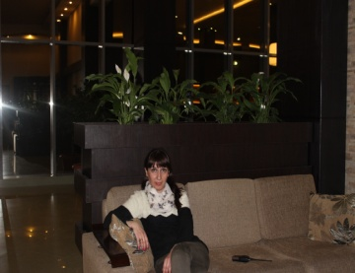**Curriculum Vitae**

**Name:** Tamar Vachnadze

**Address:** Tbilisi,temqa,11 mkr.

**Telephone:** 2 308347.593741521

**E mail:** [tamrikovachnadze@gmail.com](mailto:tamrikovachnadze@gmail.com)

**Education:**

1995-2000 State University DEPARTMENT of sociology

**Qualifications:**Higher education diploma of SOCIOLOGY

2002-2005 Computer training courses.

**Emloyment:**

2005-2010 **State University**

Position:lector of sociology.

2010-2015 **Hotel Golden Palace**

Position**:Administrator**

**Skills:**Good typing skills,strong organizational skills,ability to work under .pressure.

**Computer literacy:**Word perfect,e-mail.internet user,Excel.**Languages:**Native Georgian,Professional level of English and Russian.