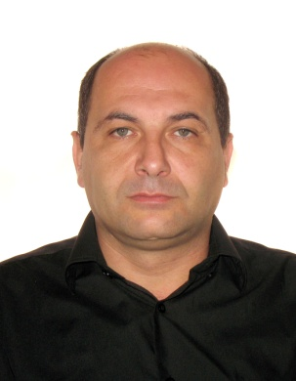**CV**

**Name**: Gurami

**Surname**: Kharaishvili

**Address**: 8 leonidze str. Tbilisi

**Telephone: 2 51 08 50/568 73 77 44**

**Date of Birth: 07 May 1971**

**Education**: Georgian Rural University.

An accountant.

Cook.

**Employment**:

2008-2010 café “coffee.ge”

(European cuisine)

Cook.

2010 “kustba”

chef

2011 m-group “cook house”

Cook.

Responsibilities: preparing food for bp and

Other top ivents..

Ministry of Defense–chef

**Training courses in**

**“holiday inn”-for “rooms**

**Hotel”- in Borjomi**

**Executive chef**

Restaurant “Dzveli Ubani”-chef

Chef -”CRAFT”-café

Wine Gallery- chef

(Mc Lab) café”El Passo”-chef

Mexican cuisine

Café “Burito”Mexican-gril

Chef

**At present Turkish company- preparing**

**Food for workers-(330)**

**Language**: Georgian(native)

Russian(good)

English(working level)

Turkish (spoken level)

**Skills**: excellent knowledge of

Europian , Georgian and

Mexican cuisine,special

Ability of making

Tasty Dishes,

Good calculating skill,

Work under pressure,

Punctual, non-drinker

Very honest, cleanliness . **Computer literacy:** Word, excel, windows

**”**