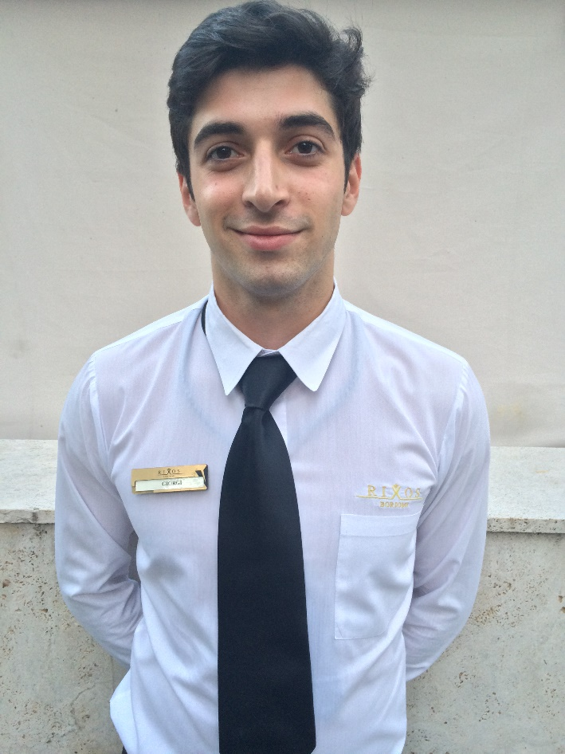

**Name: Giorgi Maisuradze**

**Date of Birth:** 04/'08/1995

**Marital Status**: Single

**Height:** 185 Cm

**Weight:** 75kg

**Mobile**: +995 574 515 766;

**Email** : **giorgimaisuradze9544@gmail.com**

**Skype** : Gold9544

**EDUCATION:**

|  |  |
| --- | --- |
| **2001-2013** | N6 georgia borjomi school – (Graduated with a high grades) |
| **2013-2015** | I.javakhishvili named tbilisi state university  Faculty of |

**TRAININGS AND CERTIFICATES:**

|  |  |
| --- | --- |
| **2014-2016** | Accounting System - World Finance |
| **2015-2016** | 1. Fidelio Suite8 2. Dealing with Guests Complaints 3. Grooming Standarts 4. Orientation Trainings |

**WORK EXPERIENCE:**

|  |  |
| --- | --- |
| **2006-2014** | Georgian National Dancin Agency – Georgian Dancer |
| **2013-2015** | Cable Way Caffe Working as a **PR Manager** |
| **2015-2016** | **Rixos Borjomi Hotel** **– 5* hotel**  -working in Front Office Department Night Audit possition |

|  |  |  |  |  |  |  |  |  |  |
| --- | --- | --- | --- | --- | --- | --- | --- | --- | --- |
| **Foreign Languages** | **Speaking** | | | **Understanding** | | | **Reading – Writing** | | |
| **Perfect** | **Good** | **Fair** | **Perfect** | **Good** | **Fair** | **Perfect** | **Good** | **Fair** |
| **1 - Georgian** | **✓** |  |  |  | **✓** |  |  | **✓** |  |
| **2 - English** | **✓** |  |  |  | **✓** |  |  | **✓** |  |
| **3 - Russian** | **✓** |  |  |  | **✓** |  |  | **✓** |  |

**COMPUTER SKILLS:**

Word, excel, Microsoft office; Outlook; E-mail.

**JOB DESCRIPTION:**

**Check in,Check out Billing and accounting system.Prepare fidellio system for NIGHT AUDIT,Compearing Z reports and Xreports,Cashiering checking  
Correction financial mistakes in Fidellio and terminals  
Making rezervations  
Working in daytime too as receptionist**

**RECOMENDATOR:**

Position: Asst. Front Office Manager

Name: Natia Margvelashvili

Company: Rixos Borjomi Hotel

Mail: [Natia.margvelashvili@rixos.com](mailto:Natia.margvelashvili@rixos.com)

TEl : +995 593 264 724

Position: Director of Human Resources

Name: Artem Ratush

Company: Rixos Borjomi Hotel

Mail: [Artem.ratush@rixos.com](mailto:Artem.ratush@rixos.com)

Tel: +995 551 739 779

Position: Director Of Café Cable way

Name: Maka Nozadze

Company: Cable way

TEL: +995 571 900 467