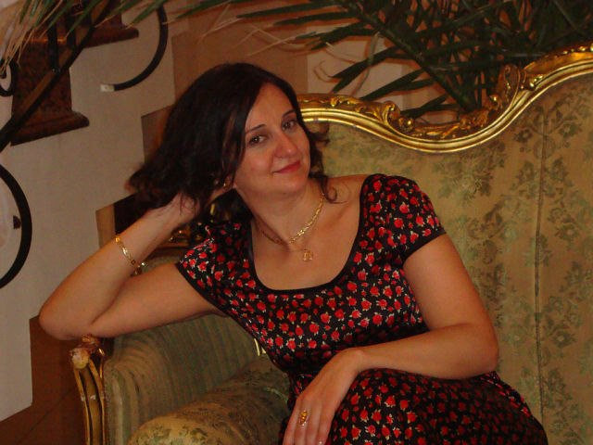 

PERSONAL DATA

**Current Address** : Tbilisi, Georgia

**Nationality** : Georgian

**Date of Birth** :12/07/1979

**Marital Status** : married

**Height** : 170 Cm

**Weight** : 70 kg

**Mobile** : +995593419560 / +995591292827

**Email** : laitadze79@mail.ru

**Employment History**

**Employer :** Clinic Esthetic Service

**Position :** Head Masseuer

**Website :** [**www.esthetic.ge**](http://www.esthetic.ge)

**Duration :** may/2010-oct/2013

**Reason for leaving :** Better conditions

**Responsibilities :**

* Making therapeutic massage, beauty massage, Havaiian massage lomi lomi, swedish massage,anti-cellulite, LPGO- vacuum apparatus, ultrasound therapy, SPA Procedure: T'E'N, OLOS, D'vine, DIBI MILANO.

**Employer :** Premier spa deluxe

**Position :** Professional masseur

**Duration :** Nov/2011-June/2014

**Leaving reason :** Better conditions

**Employer :** GINO PARADISE TBILISI

**Position :** Main masseur

**Duration :** SEP/2013-2016/JAN

**Website :** [**www.Ginoparadise.ge**](http://www.Ginoparadise.ge)

**Education :**

**1996-1997** College of chemical and bacteriological

**2002-to 2004** Institute of Hygiene massage 's school

**2010-2011** massage vocational qualification training course

Certificate of professional masseur

**Internet Applications**

**Microsoft Office (Word, Excel, PowerPoint)**

**Interests**

* **Traveling , Reading books, cooking**
* **Drive License : B**

**Languages**

Georgian : Mother Tangue

Russian : Fluent

English : Satisfactorily

**Training:**

STENDERS SPA, THALASSO APY

**Add Informations** :

Since 2015 I have been working in parallel lopota forest spa, hotel ,, CONTINET '', the

hotel Tbilisi ,, '' ( part-time ) and also the hotel “New Gudauri” Spa Manager.

**References**

**Name:** Maka Berozashvili

**Position:** Ceo & founder at Premier Spa Consulting

Simultaneous Interpreter, English- Georgian at [Freelance](https://www.facebook.com/Freelance/?ref=br_rs)

**Company:** Premier Spa Consulting

**Telephone: +995599553407**

**Email address:** makaberozashvili@gmail.com

**Name:** Maia Khoshtaria

**Position:** New Gudauri Apart Hotel Manager

**Company: Redco**

**Telephone:** +995593175084

**Email Adress :** [Maiakhoshtaria@yahoo.com](mailto:Maiakhoshtaria@yahoo.com)