Mrs. Khatuna Somkhishvili, worked in my home with my family, between the dates September 2020 and September 2017 for 3 years. She has done all the house work My son started when he was 3 months old and took care of him until he was 3 years old.

She had a fantastic job with my son. She played creative and developmental games and read to her lots of books. She is so trustable and such as a good person.

She has done all duties related with house work like cooking, cleaning, ironing.

All my family trusted in her forever

Best Regards

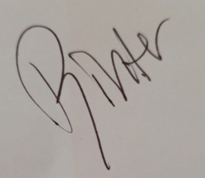

Bihter TÜRKEINAN SARI

+905322940107

Zümrütevler Mah. Emek Cad. Nish Adalar 33.Blok Kat:5 D:39

Maltepe/Istanbul/Turkey

[bihtersari@gmail.com](mailto:bihtersari@gmail.com)