CURRICULUM VITAE

**saxeli**  ***maia*** 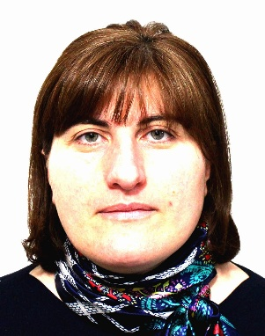

**gvari** ***xuciSvili***

**sqesi *mdedrobiTi***

**moqalaqeoba *qarTveli***

**dabadebis TariRi *20.07.1982 w.***

**dabadebis adgili *ambrolauri, saqarTvelo***

**misamarTi *q. Tbilisi, muxiani 3/m/r k.#5 b.#89***

**telefoni *593 15 54 44 ;***

**ojaxuri mdgomareoba** ***daojaxebuli***

**ელ-ფოსტა:**[maia.maia82@mail.ru](mailto:maia.maia82@mail.ru)

|  |  |
| --- | --- |
| ***1999*** | ambrolauris #2 saSualo skola |
| ***2000-2005*** | Tbilisis ekologiur-ekonomikuri instituti |
| **specialoba** | buraltruli aRricxva auditi da sabanko saqme |
|  |  |
| **samuSao gamocdileba** | |
| ***2004-2007*** | saxelmwifo statistikis ambrolauris sammarTvelo buRaltri. |
| ***2007-2009*** | raWa lecxumisa da qvemo svaneTis gubernia administraciis specialisti |
| **kompiuteri** | Microsoft Office Word  Microsoft Office Excel  Microsoft Office PowerPoint |
| 2017-2018წწ. ორ ნაბიჯი. მოლარე-ოპერატორი |  |
|  |  |
|  |  |
|  |  |
|  |  |
|  |  |

|  |  |
| --- | --- |
|  |  |